*COMPUTER NETWORKS (CN)*

*LAB 5 ASSIGNMENT*

# Objective

*SREENATH R RA2211026050042*

*CSE AIML A*

*3rd Year*

* To configure static and default routing on routers to enable communication between different network segments.
* Using cisco packet tracer, to create a network with multiple routers and PCs, and configure routing to ensure proper data transfer.

# Steps taken to set up the network

## Step 1:

Select and drag required network devices (2 Router-PTs, 2 2960-24TT Switches) and end devices (2 PC-PTs).

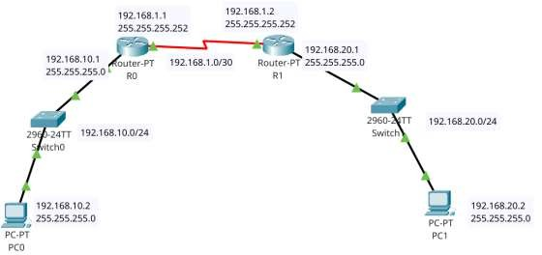

## Step 2:

Open Routers and add PT-ROUTER-NM-1CFE and PT-ROUTER-NM-1S Modules.

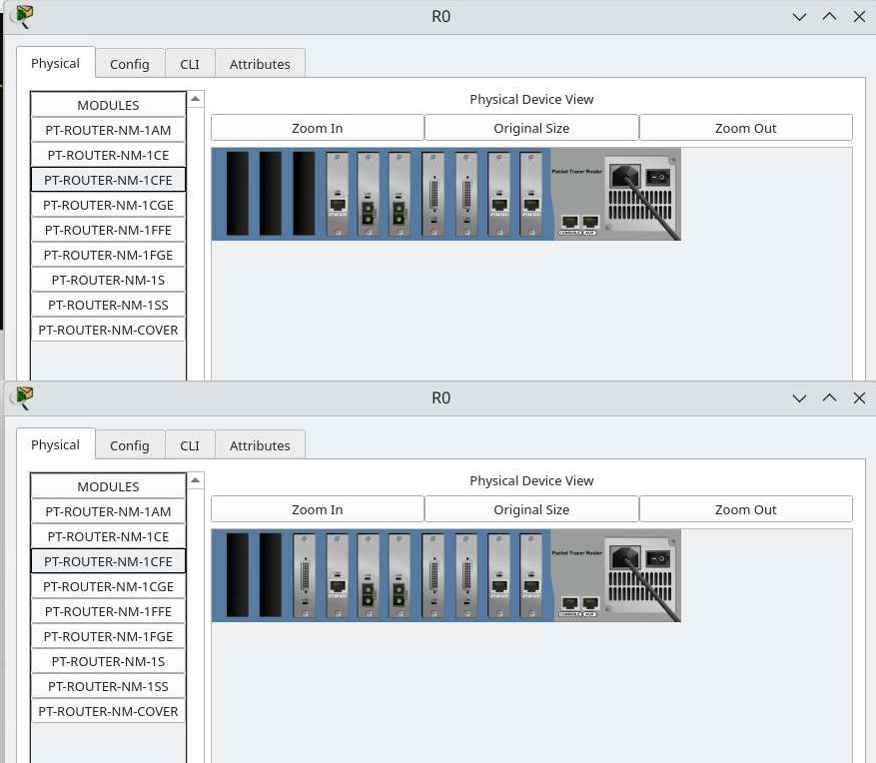

## Step 3:

Connect the cables (Straight through cables for different devices) and Serial DCE (between routers).

## Step 4:

Open the routers CLI and type in the following commands (R0)

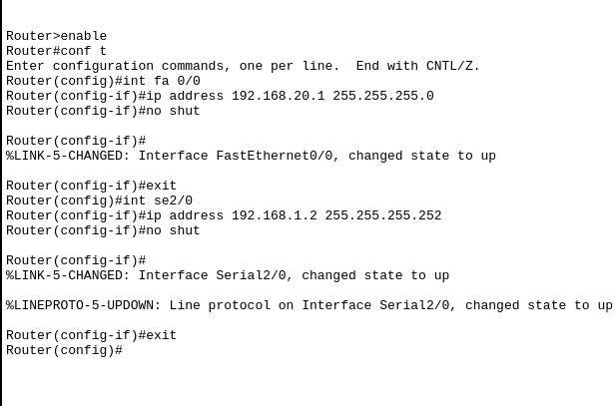

Similarly do it for R1.

## Step 5:

Configure IP addresses for PC1 and PC2

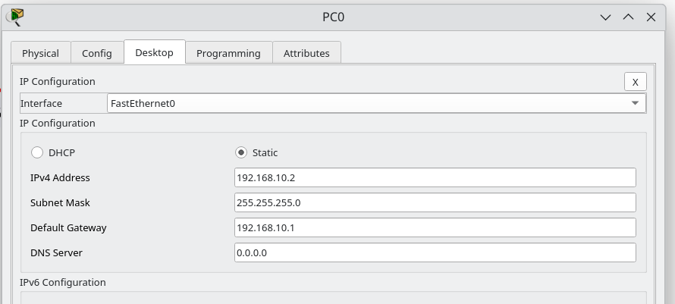

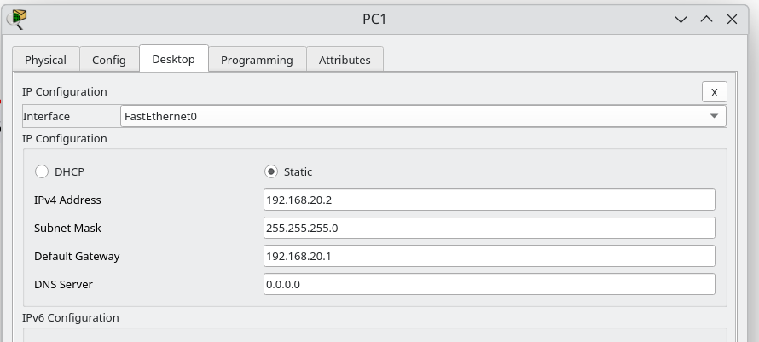

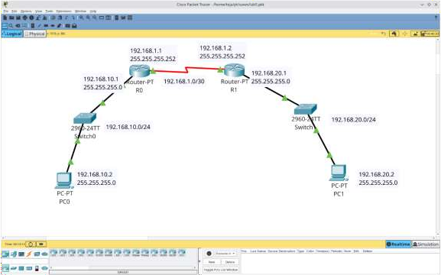

## Step 6:

Configure Static Routing and Default Routing for Routers.

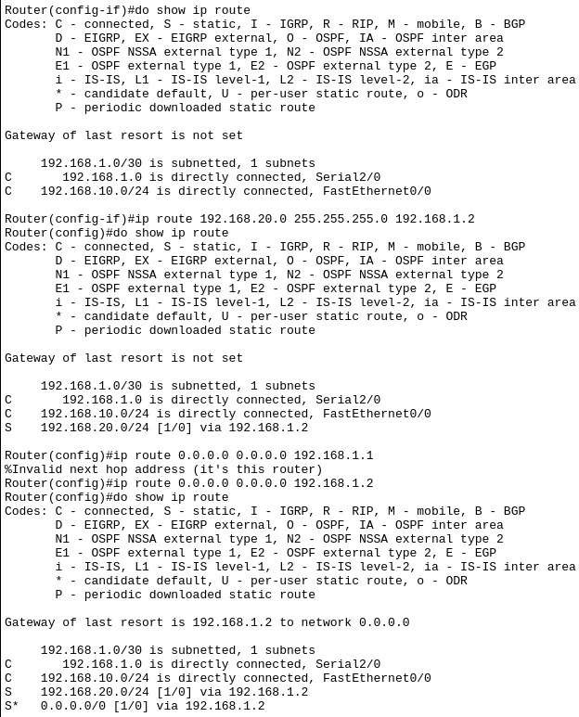

This is for R0, Implement the similar for R1 (default and static pointing to R0).

# Simulation:

Pinging PC1 from PC0 ICMP ECHO RESPONSE:

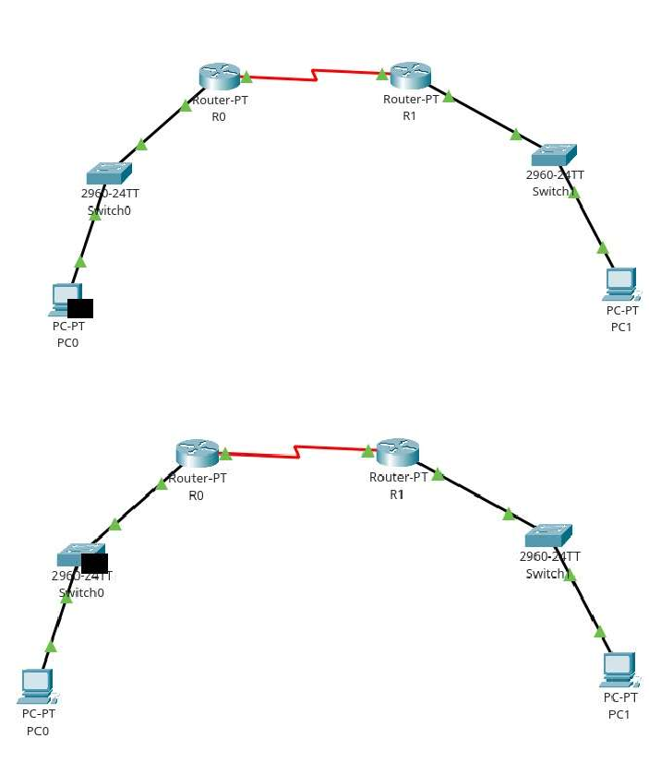

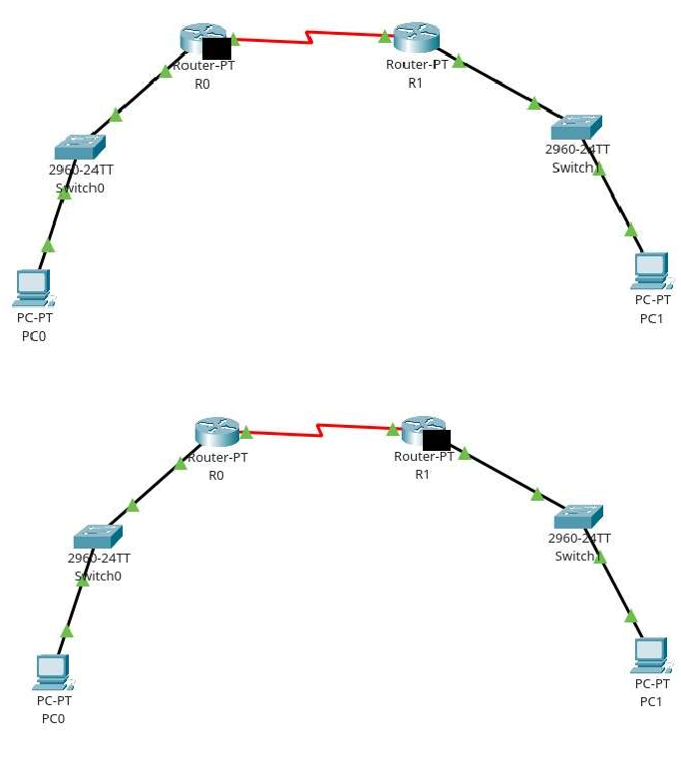

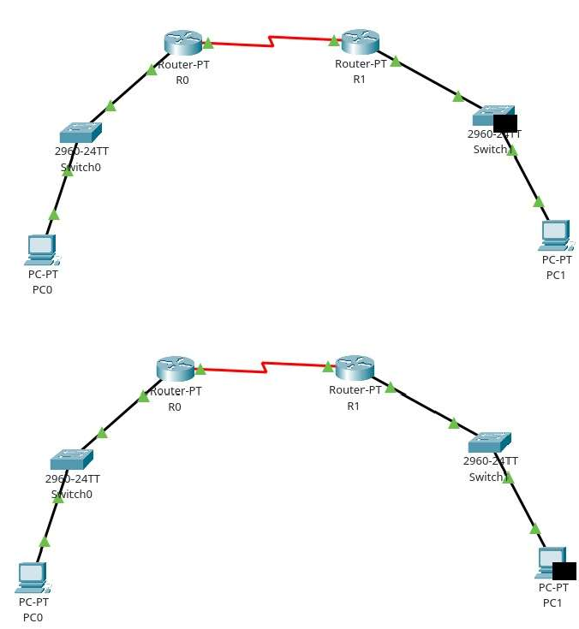

ICMP ECHO REPLY:

