*COMPUTER NETWORKS (CN)*

*LAB 6 ASSIGNMENT*

# Objective

*SREENATH R RA2211026050042*

*CSE AIML A*

*3rd Year*

* To configure Network Address Translation (NAT) on a router using Cisco Packet Tracer
* To demonstrate the setup and configuration of NAT to allow internal network devices to communicate with external networks.

# Steps taken to set up the network

## Step 1:

Drag and drop required Network devices (2 Router-PT's and 1 Switch-PT) and End devices (2 PC-PT's and a Server-PT) as shown below.

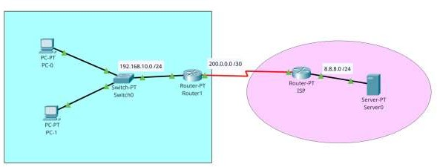

## Step 2:

Open each Router and navigate to physical tab, and add PT-ROUTER-NM-1CGE, PT- ROUTER-NM-1S, PT-ROUTER-NM-1FFE Modules to the Router1 and add the same

modules as Router1 except for PT-ROUTER-NM-1FFE, add PT-ROUTER-NM-1CGE module.

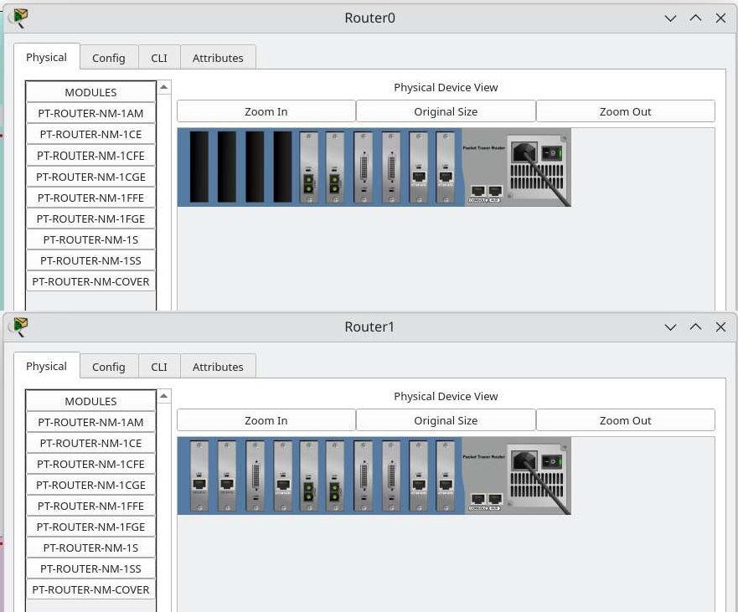

## Step 3:

Make connections using cables between all the devices as shown in the picture.

Use Copper Straight through cable to connect different devices and use a Serial DCE cable to connect ISP Router and Router 1.

## Step 4:

Now, Configure IP address of the routers and end devices according to the configuration table below;

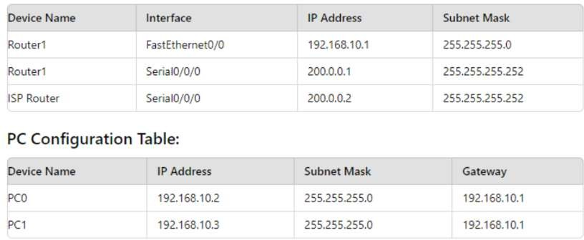

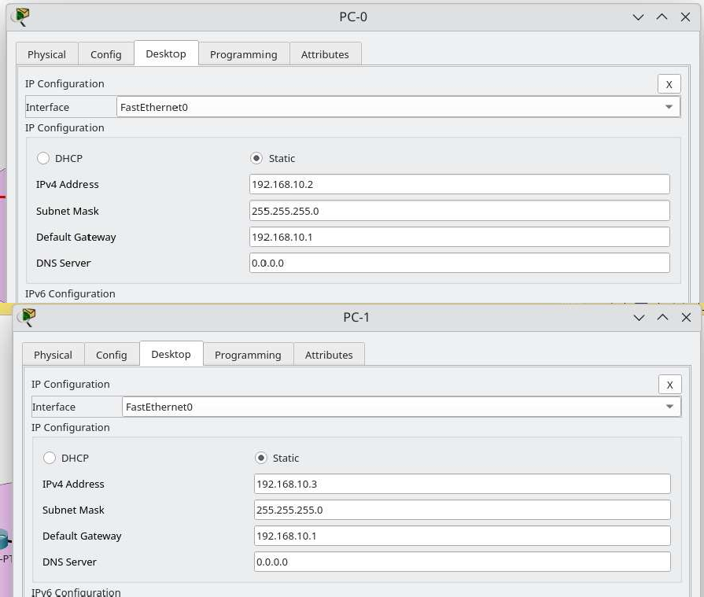

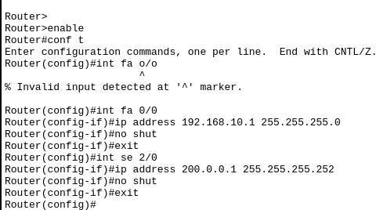

Router1

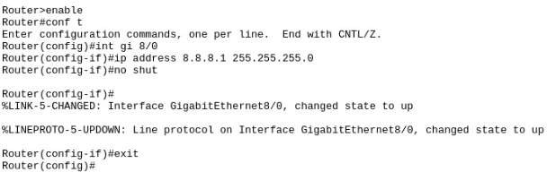

ISP Router

And configure the Ip address of the server as ;

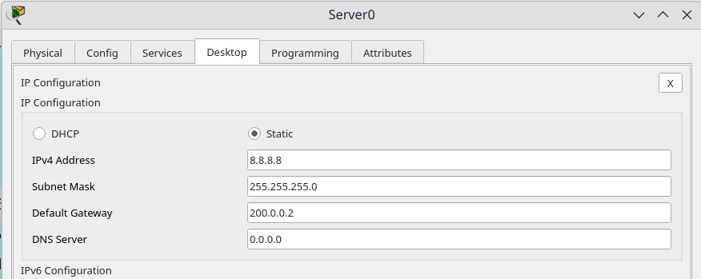

## Step 5:

We shall enable ospf routing protocol between both routers. In Router 1;

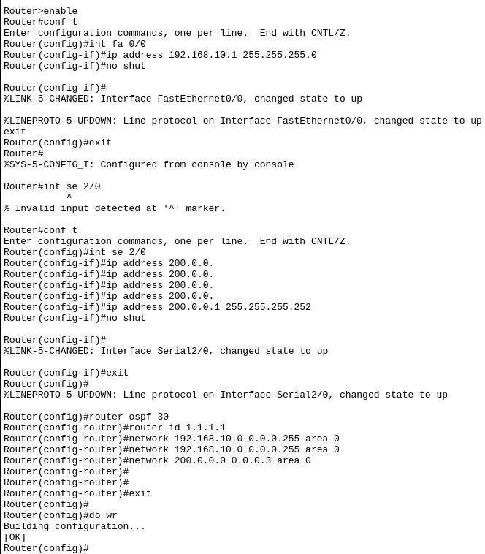

In ISP router;

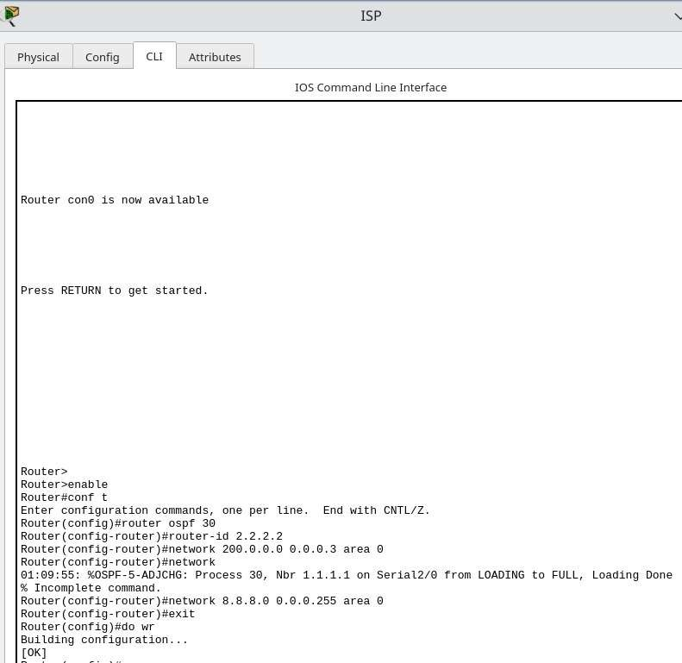

## Step 6: Ping Server (8.8.8.8) from PC-1

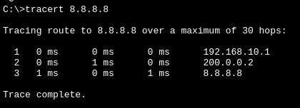

Step 7: Check for Address Translation

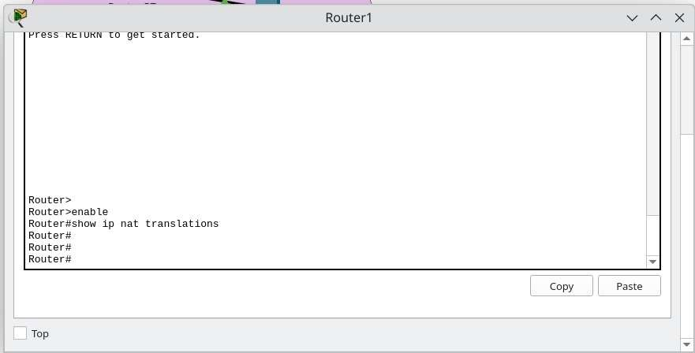

## Step 8:

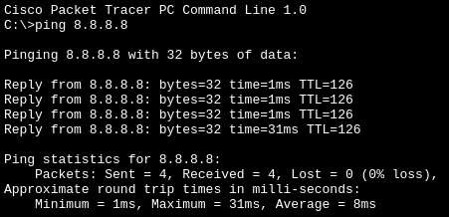Configure Static NAT and configure interfaces as NAT inside and outside.

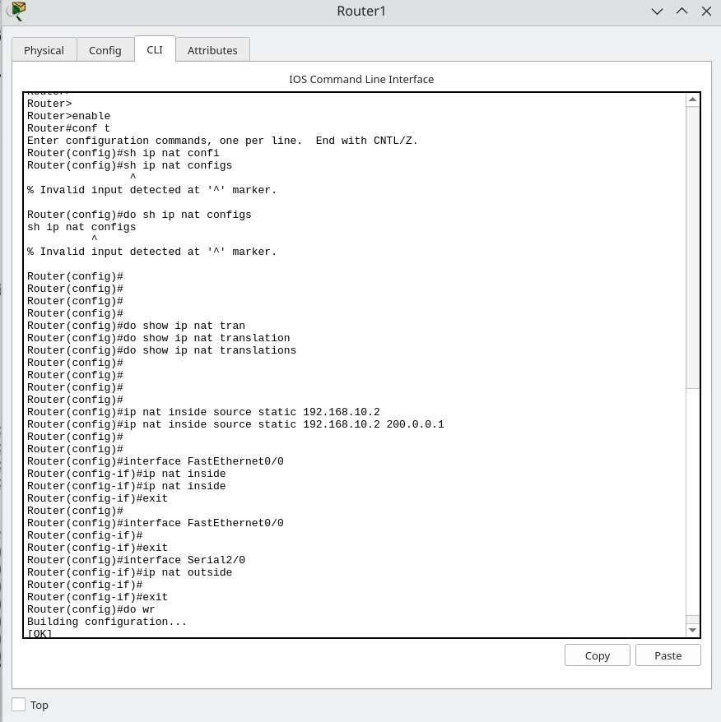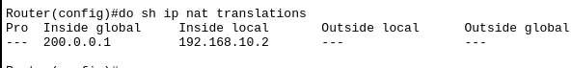

Now, let us ping again and verify the NAT; In Router1;

