**DIMAULOACALSCHOOL**

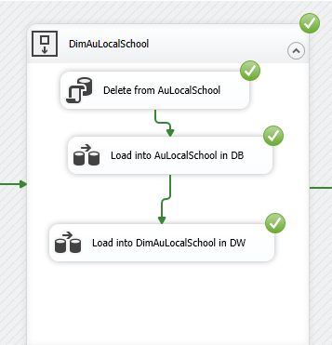

**Load from Excel to DB**

**Load from DB to DW**

