**DIMSTATE**

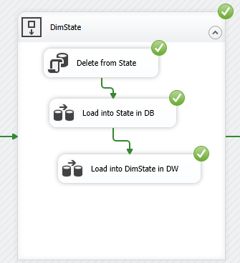

**Load from DB to DW**

