**FACTSUBURBPOPULATION**

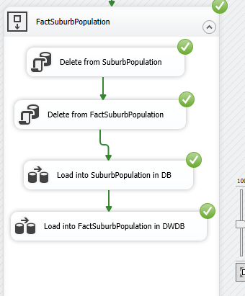

**Load to DB**

**Load from DB to DW**

