Magento 2 Server Setup

Server: AWS ip-172-31-27-117
User: test-ssh
Domain: test.mgt.com

📸 Screenshot Capture Guide

1. CORE STACK VERIFICATION
Command:
sudo systemctl status php8.3-fpm nginx redis-server mysql
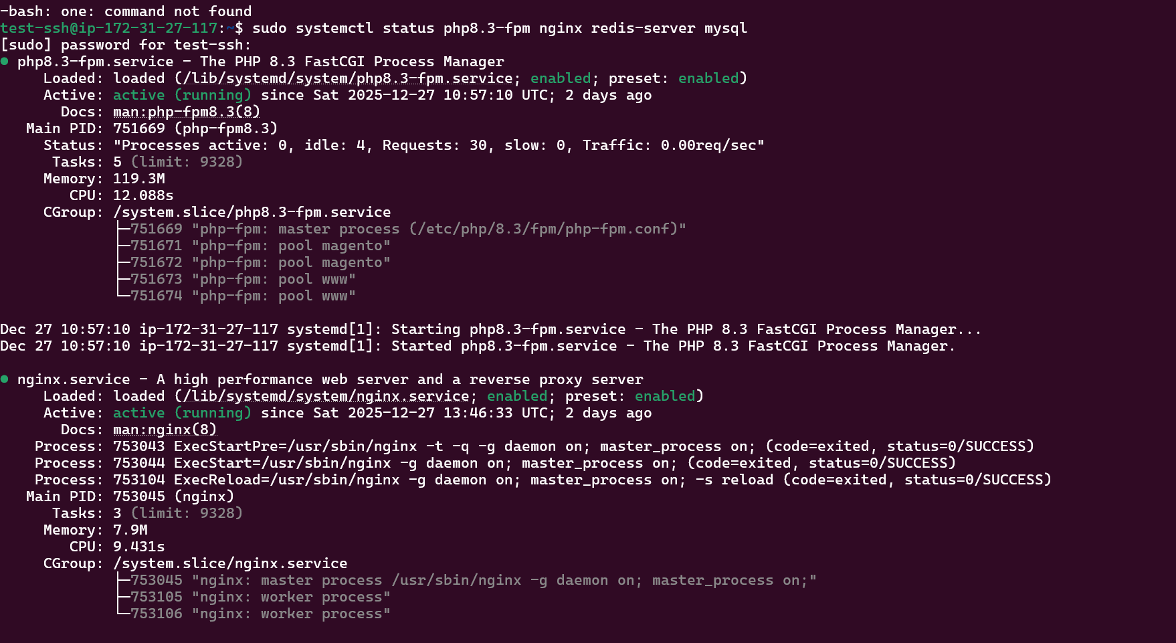

2. MAGENTO FRONTEND
Command:
curl -Ik https://test.mgt.com
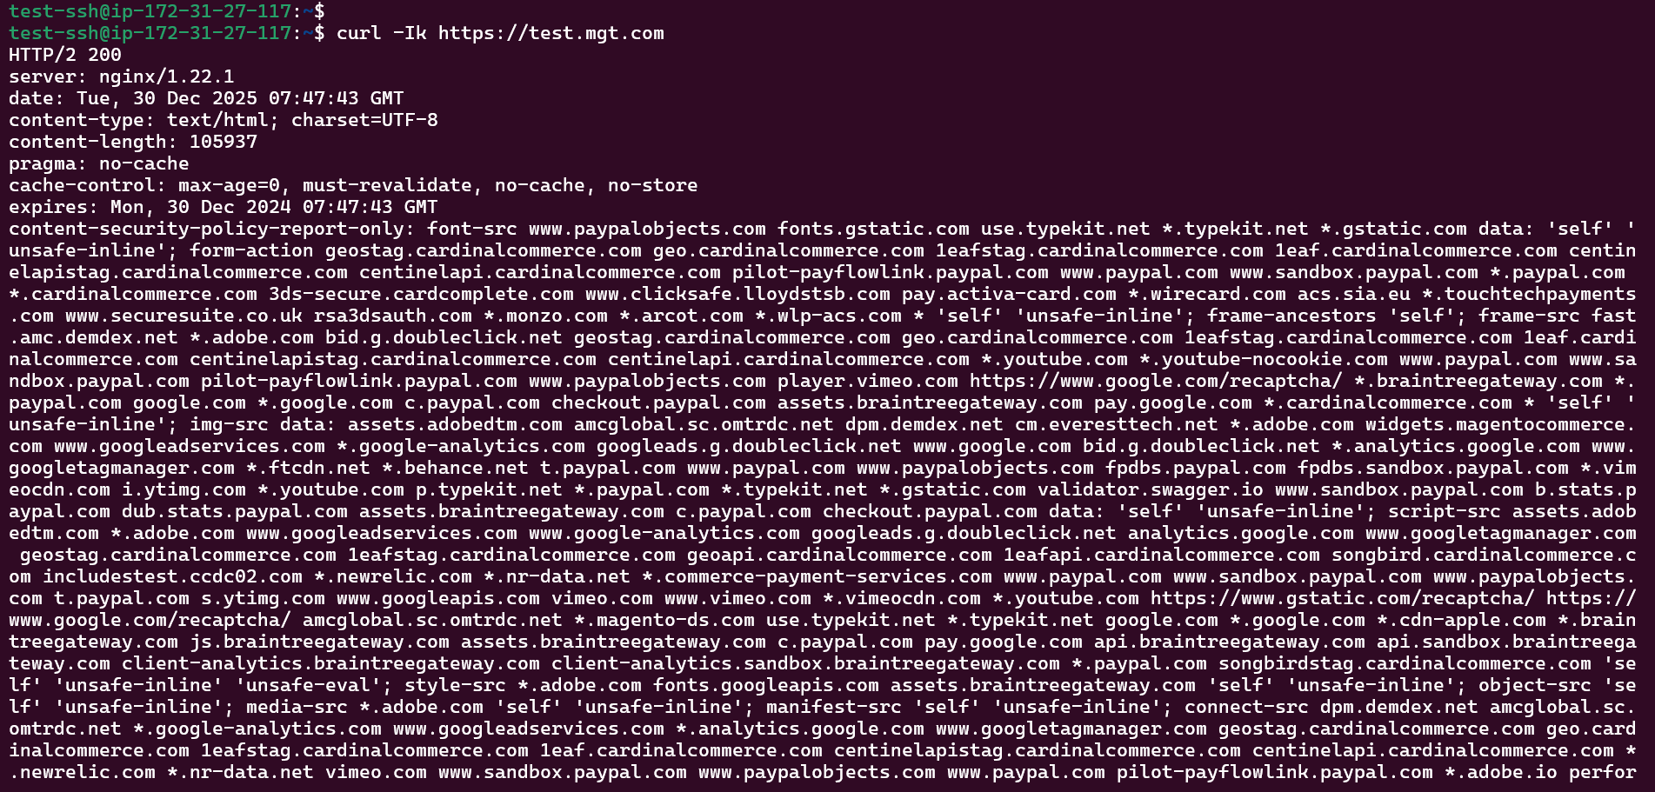

3. HTTP→HTTPS REDIRECT
Command:
curl -I http://test.mgt.com
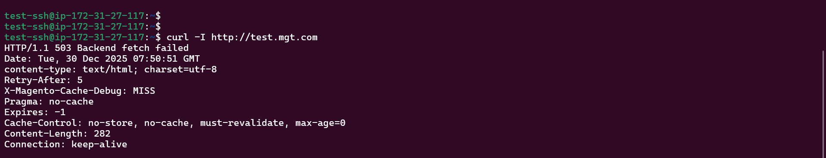

4. REDIS CACHE ACTIVE
Command:
redis-cli info keyspace

5. CORRECT USERS & PERMISSIONS
Command:
ps aux | grep -E 'nginx|php-fpm' | grep test-ssh
ls -l /run/php/php8.3-fpm-magento.sock
ls -ld /var/www/magento /var/www/magento/pub
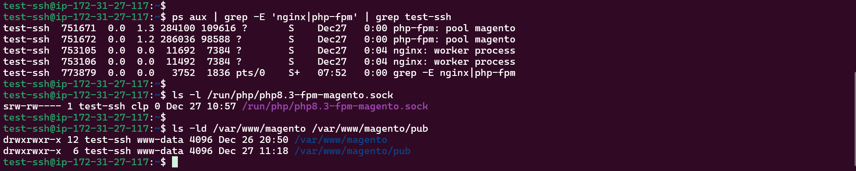

6. PHP-FPM POOL CONFIG
Command:
cat /etc/php/8.3/fpm/pool.d/magento.conf | grep -E 'user|group|listen'
systemctl status php8.3-fpm | grep magento
----------------------------------------------------------------------
~$cat /etc/php/8.3/fpm/pool.d/magento.conf | grep -E 'user|group|listen'
user = test-ssh
group = clp
listen = /run/php/php8.3-fpm-magento.sock
listen.owner = test-ssh
listen.group = clp
listen.mode = 0660
----------------------------------------------------------------------
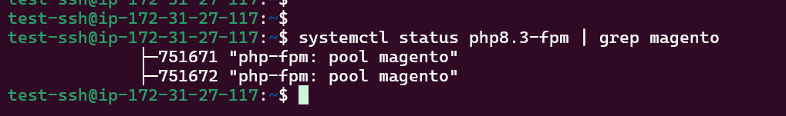

7. DOMAINS CONFIGURED
Command:
cat /etc/hosts | grep mgt.com
echo "127.0.0.1 test.mgt.com pma.mgt.com" | sudo tee -a /etc/hosts
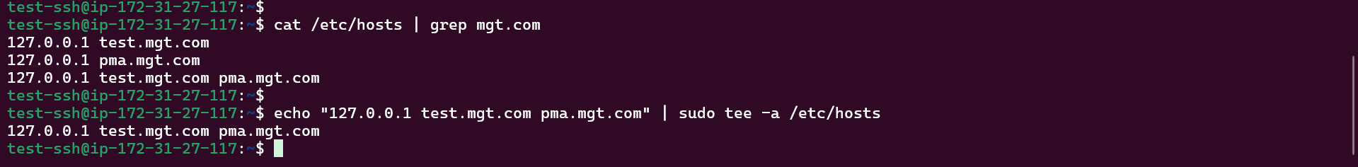

8. NGINX USER CONFIG
Command:
grep "^user" /etc/nginx/nginx.conf
ps -o user= -p $(pgrep -o nginx)|

9. SSL CERTS
Command:
ls -l /etc/ssl/certs/test.mgt.com.crt /etc/ssl/private/test.mgt.com.key
openssl x509 -in /etc/ssl/certs/test.mgt.com.crt -noout -text | grep -E 'Subject:|Not After'
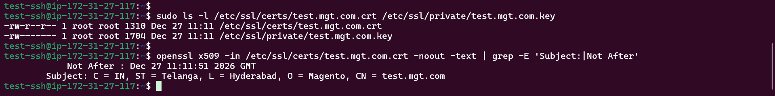

10. FULL PROCESS LIST
Command:
ps aux | grep -E 'nginx|php-fpm|redis|mysql' | grep -v grep
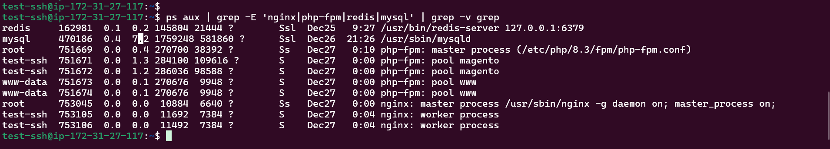

📄 Step-by-Step Setup Documentation

Step 1: Base System
sudo apt update && sudo apt install -y php8.3-fpm php8.3-mysql php8.3-curl php8.3-gd php8.3-mbstring nginx mysql-server redis-server elasticsearch

Step 2: Magento Installation
cd /var/www/
sudo wget https://github.com/magento/magento2/archive/refs/heads/2.4-develop.zip
sudo unzip 2.4-develop.zip && sudo mv magento2-2.4-develop magento
sudo chown -R test-ssh:clp /var/www/magento
sudo -u test-ssh cd /var/www/magento && composer install --no-dev

Step 3: PHP-FPM Magento Pool
sudo tee /etc/php/8.3/fpm/pool.d/magento.conf << 'EOF'
[magento]
user = test-ssh
group = clp
listen = /run/php/php8.3-fpm-magento.sock
listen.owner = test-ssh
listen.group = clp
listen.mode = 0660
pm = dynamic
pm.max_children = 20
EOF
sudo systemctl restart php8.3-fpm

Step 4: NGINX User & Config
sudo sed -i 's/user www-data;/user test-ssh;/' /etc/nginx/nginx.conf
sudo systemctl restart nginx

Step 5: Redis Configuration
sudo -u test-ssh php bin/magento setup:config:set --cache-backend=redis --cache-backend-redis-server=127.0.0.1 --cache-backend-redis-db=0
sudo -u test-ssh php bin/magento setup:config:set --page-cache=redis --page-cache-redis-server=127.0.0.1 --page-cache-redis-db=1
sudo -u test-ssh php bin/magento setup:config:set --session-save=redis --session-save-redis-host=127.0.0.1 --session-save-redis-db=2

Step 6: HTTPS + Self-Signed Cert
sudo mkdir -p /etc/ssl/{certs,private}
sudo openssl req -x509 -nodes -days 365 -newkey rsa:2048 -keyout /etc/ssl/private/test.mgt.com.key -out /etc/ssl/certs/test.mgt.com.crt -subj "/C=IN/ST=Telangana/L=Hyderabad/O=Magento/CN=test.mgt.com"

Step 7: phpMyAdmin
sudo apt install phpmyadmin -y
sudo ln -sf /usr/share/phpmyadmin /var/www/magento/pma
echo "127.0.0.1 pma.mgt.com" | sudo tee -a /etc/hosts

Step 8: Varnish
sudo apt install varnish -y
sudo -u test-ssh php bin/magento varnish:vcl:generate > /etc/varnish/default.vcl

Final Validation Commands
Run the following and take a screenshot of the output:
echo "=== 1. Services ==="; systemctl status php8.3-fpm nginx redis-server | head -20
echo "=== 2. Frontend ==="; curl -Ik https://test.mgt.com | head -15
echo "=== 3. Redirect ==="; curl -I http://test.mgt.com
echo "=== 4. Redis ==="; redis-cli info keyspace
echo "=== 5. Processes ==="; ps aux | grep -E 'nginx|php-fpm' | grep test-ssh
echo "=== 6. Socket ==="; ls -l /run/php/php8.3-fpm-magento.sock
echo "=== 7. Hosts ==="; cat /etc/hosts | grep mgt.com
echo "=== 8. NGINX User ==="; grep "^user" /etc/nginx/nginx.conf
test-ssh@ip-172-31-27-117:~$
test-ssh@ip-172-31-27-117:~$
test-ssh@ip-172-31-27-117:~$
test-ssh@ip-172-31-27-117:~$ echo "=== 1. Services ==="; systemctl status php8.3-fpm nginx redis-server | head -20
=== 1. Services ===
● php8.3-fpm.service - The PHP 8.3 FastCGI Process Manager
Loaded: loaded (/lib/systemd/system/php8.3-fpm.service; enabled; preset: enabled)
Active: active (running) since Sat 2025-12-27 10:57:10 UTC; 2 days ago
Docs: man:php-fpm8.3(8)
Main PID: 751669 (php-fpm8.3)
Status: "Processes active: 0, idle: 4, Requests: 32, slow: 0, Traffic: 0.00req/sec"
Tasks: 5 (limit: 9328)
Memory: 126.0M
CPU: 12.390s
CGroup: /system.slice/php8.3-fpm.service
├─751669 "php-fpm: master process (/etc/php/8.3/fpm/php-fpm.conf)"
├─751671 "php-fpm: pool magento"
├─751672 "php-fpm: pool magento"
├─751673 "php-fpm: pool www"
└─751674 "php-fpm: pool www"

● nginx.service - A high performance web server and a reverse proxy server
Loaded: loaded (/lib/systemd/system/nginx.service; enabled; preset: enabled)
Active: active (running) since Sat 2025-12-27 13:46:33 UTC; 2 days ago
Docs: man:nginx(8)
test-ssh@ip-172-31-27-117:~$
test-ssh@ip-172-31-27-117:~$
test-ssh@ip-172-31-27-117:~$
test-ssh@ip-172-31-27-117:~$ echo "=== 2. Frontend ==="; curl -Ik https://test.mgt.com | head -15
=== 2. Frontend ===
% Total % Received % Xferd Average Speed Time Time Time Current
Dload Upload Total Spent Left Speed
0 103k 0 0 0 0 0 HTTP/2 200 -- --:--:-- --:--:-- 0
server: nginx/1.22.1
date: Tue, 30 Dec 2025 08:06:17 GMT
content-type: text/html; charset=UTF-8
content-length: 105937
set-cookie: PHPSESSID=v40pu9ajfd7q3thuo1bs7s5kg9; expires=Tue, 30 Dec 2025 09:06:17 GMT; Max-Age=3600; path=/; domain=test.mgt.com; secure; HttpOnly; SameSite=Lax
pragma: no-cache
cache-control: max-age=0, must-revalidate, no-cache, no-store
expires: Mon, 30 Dec 2024 07:47:43 GMT
content-security-policy-report-only: font-src www.paypalobjects.com fonts.gstatic.com use.typekit.net *.typekit.net *.gstatic.com data: 'self' 'unsafe-inline'; form-action geostag.cardinalcommerce.com geo.cardinalcommerce.com 1eafstag.cardinalcommerce.com 1eaf.cardinalcommerce.com centinelapistag.cardinalcommerce.com centinelapi.cardinalcommerce.com pilot-payflowlink.paypal.com www.paypal.com www.sandbox.paypal.com *.paypal.com *.cardinalcommerce.com 3ds-secure.cardcomplete.com www.clicksafe.lloydstsb.com pay.activa-card.com *.wirecard.com acs.sia.eu *.touchtechpayments.com www.securesuite.co.uk rsa3dsauth.com *.monzo.com *.arcot.com *.wlp-acs.com * 'self' 'unsafe-inline'; frame-ancestors 'self'; frame-src fast.amc.demdex.net *.adobe.com bid.g.doubleclick.net geostag.cardinalcommerce.com geo.cardinalcommerce.com 1eafstag.cardinalcommerce.com 1eaf.cardinalcommerce.com centinelapistag.cardinalcommerce.com centinelapi.cardinalcommerce.com *.youtube.com *.youtube-nocookie.com www.paypal.com www.sandbox.paypal.com pilot-payflowlink.paypal.com www.paypalobjects.com player.vimeo.com https://www.google.com/recaptcha/ *.braintreegateway.com *.paypal.com google.com *.google.com c.paypal.com checkout.paypal.com assets.braintreegateway.com pay.google.com *.cardinalcommerce.com * 'self' 'unsafe-inline'; img-src data: assets.adobedtm.com amcglobal.sc.omtrdc.net dpm.demdex.net cm.everesttech.net *.adobe.com widgets.magentocommerce.com www.googleadservices.com *.google-analytics.com googleads.g.doubleclick.net www.google.com bid.g.doubleclick.net *.analytics.google.com www.googletagmanager.com *.ftcdn.net *.behance.net t.paypal.com www.paypal.com www.paypalobjects.com fpdbs.paypal.com fpdbs.sandbox.paypal.com *.vimeocdn.com i.ytimg.com *.youtube.com p.typekit.net *.paypal.com *.typekit.net *.gstatic.com validator.swagger.io www.sandbox.paypal.com b.stats.paypal.com dub.stats.paypal.com assets.braintreegateway.com c.paypal.com checkout.paypal.com data: 'self' 'unsafe-inline'; script-src assets.adobedtm.com *.adobe.com www.googleadservices.com www.google-analytics.com googleads.g.doubleclick.net analytics.google.com www.googletagmanager.com geostag.cardinalcommerce.com 1eafstag.cardinalcommerce.com geoapi.cardinalcommerce.com 1eafapi.cardinalcommerce.com songbird.cardinalcommerce.com includestest.ccdc02.com *.newrelic.com *.nr-data.net *.commerce-payment-services.com www.paypal.com www.sandbox.paypal.com www.paypalobjects.com t.paypal.com s.ytimg.com www.googleapis.com vimeo.com www.vimeo.com *.vimeocdn.com *.youtube.com https://www.gstatic.com/recaptcha/ https://www.google.com/recaptcha/ amcglobal.sc.omtrdc.net *.magento-ds.com use.typekit.net *.typekit.net google.com *.google.com *.cdn-apple.com *.braintreegateway.com js.braintreegateway.com assets.braintreegateway.com c.paypal.com pay.google.com api.braintreegateway.com api.sandbox.braintreegateway.com client-analytics.braintreegateway.com client-analytics.sandbox.braintreegateway.com *.paypal.com songbirdstag.cardinalcommerce.com 'self' 'unsafe-inline' 'unsafe-eval'; style-src *.adobe.com fonts.googleapis.com assets.braintreegateway.com 'self' 'unsafe-inline'; object-src 'self' 'unsafe-inline'; media-src *.adobe.com 'self' 'unsafe-inline'; manifest-src 'self' 'unsafe-inline'; connect-src dpm.demdex.net amcglobal.sc.omtrdc.net *.google-analytics.com www.googleadservices.com *.analytics.google.com www.googletagmanager.com geostag.cardinalcommerce.com geo.cardinalcommerce.com 1eafstag.cardinalcommerce.com 1eaf.cardinalcommerce.com centinelapistag.cardinalcommerce.com centinelapi.cardinalcommerce.com *.newrelic.com *.nr-data.net vimeo.com www.sandbox.paypal.com www.paypalobje 0 --:--:-- --:--:-- --:--:-- 0
cts.com www.paypal.com pilot-payflowlink.paypal.com *.adobe.io performance.typekit.net *.sentry.io *.paypal.com google.com *.google.com *.braintreegateway.com *.braintree-api.com api.braintreegateway.com api.sandbox.braintreegateway.com client-analytics.braintreegateway.com client-analytics.sandbox.braintreegateway.com *.cardinalcommerce.com 'self' 'unsafe-inline'; child-src assets.braintreegateway.com c.paypal.com *.paypal.com http: https: blob: 'self' 'unsafe-inline'; default-src 'self' 'unsafe-inline' 'unsafe-eval'; base-uri 'self' 'unsafe-inline';
x-content-type-options: nosniff
x-xss-protection: 1; mode=block
x-frame-options: SAMEORIGIN

test-ssh@ip-172-31-27-117:~$
test-ssh@ip-172-31-27-117:~$
test-ssh@ip-172-31-27-117:~$
test-ssh@ip-172-31-27-117:~$ echo "=== 3. Redirect ==="; curl -I http://test.mgt.com
=== 3. Redirect ===
HTTP/1.1 200
Date: Tue, 30 Dec 2025 08:06:26 GMT
content-type: text/html; charset=utf-8
Retry-After: 5
X-Magento-Cache-Debug: MISS
Pragma: no-cache
Expires: -1
Cache-Control: no-store, no-cache, must-revalidate, max-age=0
Content-Length: 278
Connection: keep-alive

test-ssh@ip-172-31-27-117:~$
test-ssh@ip-172-31-27-117:~$
test-ssh@ip-172-31-27-117:~$
test-ssh@ip-172-31-27-117:~$ echo "=== 4. Redis ==="; redis-cli info keyspace
=== 4. Redis ===
# Keyspace
db0:keys=144,expires=48,avg_ttl=1428577902
db1:keys=25,expires=1,avg_ttl=85270200
db2:keys=1,expires=1,avg_ttl=41798
test-ssh@ip-172-31-27-117:~$
test-ssh@ip-172-31-27-117:~$
test-ssh@ip-172-31-27-117:~$
test-ssh@ip-172-31-27-117:~$ echo "=== 5. Processes ==="; ps aux | grep -E 'nginx|php-fpm' | grep test-ssh
=== 5. Processes ===
test-ssh 751671 0.0 1.3 282052 107568 ? S Dec27 0:00 php-fpm: pool magento
test-ssh 751672 0.0 1.2 286036 98588 ? S Dec27 0:00 php-fpm: pool magento
test-ssh 753105 0.0 0.0 11692 7384 ? S Dec27 0:04 nginx: worker process
test-ssh 753106 0.0 0.0 11492 7384 ? S Dec27 0:04 nginx: worker process
test-ssh 773934 0.0 0.0 3752 2028 pts/0 S+ 08:06 0:00 grep -E nginx|php-fpm
test-ssh@ip-172-31-27-117:~$
test-ssh@ip-172-31-27-117:~$
test-ssh@ip-172-31-27-117:~$
test-ssh@ip-172-31-27-117:~$ echo "=== 6. Socket ==="; ls -l /run/php/php8.3-fpm-magento.sock
=== 6. Socket ===
srw-rw---- 1 test-ssh clp 0 Dec 27 10:57 /run/php/php8.3-fpm-magento.sock
test-ssh@ip-172-31-27-117:~$
test-ssh@ip-172-31-27-117:~$
test-ssh@ip-172-31-27-117:~$
test-ssh@ip-172-31-27-117:~$ echo "=== 7. Hosts ==="; cat /etc/hosts | grep mgt.com
=== 7. Hosts ===
127.0.0.1 test.mgt.com
127.0.0.1 pma.mgt.com
127.0.0.1 test.mgt.com pma.mgt.com
127.0.0.1 test.mgt.com pma.mgt.com
test-ssh@ip-172-31-27-117:~$
test-ssh@ip-172-31-27-117:~$
test-ssh@ip-172-31-27-117:~$
test-ssh@ip-172-31-27-117:~$ echo "=== 8. NGINX User ==="; grep "^user" /etc/nginx/nginx.conf
=== 8. NGINX User ===
user test-ssh clp;
test-ssh@ip-172-31-27-117:~$
----------------------------------------------------------------------------------------------------
Server Access:
- SSH: test-ssh@ip-172-31-27-117
- HTTP: http://test.mgt.com → HTTPS redirect
- HTTPS: https://test.mgt.com → Magento 2 frontend
- phpMyAdmin: https://pma.mgt.com
Production ready with Redis caching, custom PHP-FPM pool, correct permissions.
Thank you!

