Portfolio Website Features Documentation
This document provides an overview of the key design and technical features implemented in the Sreerag T C Portfolio Website.

1. Hero & Branding Section
The hero section uses a bold Neo-Brutalist design language. Key elements include:
- High-contrast typography with rigid borders and sharp shadows.
- A split layout showcasing the professional profile and core identity ("CSE STUDENT").
- Dynamic interest tags (ISRO, DRDO, TECH, etc.) with unique color-coding and hover effects.
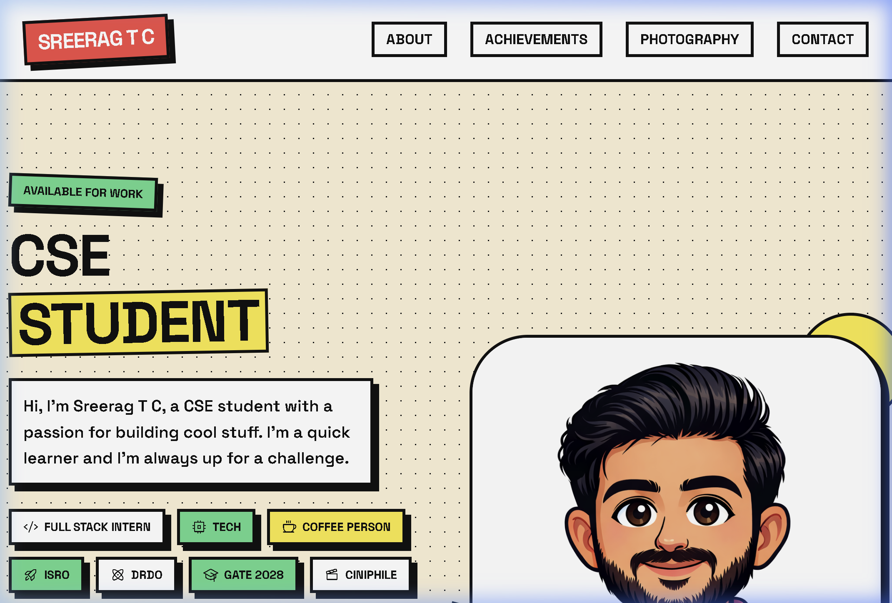

Technical Implementation (Hero)

HTML Structure:
<div class="hero-image-container brutal-border brutal-shadow">
<img src="profile.png" alt="...">
</div>

CSS Logic:
.brutal-border { border: var(--border-width) solid var(--border-color); }
.brutal-shadow { box-shadow: var(--shadow-offset) var(--shadow-offset) 0 var(--border-color); }
The use of CSS variables allowed for global consistency in border thickness and shadow offsets.

2. Achievements Grid
The Achievements section is designed for maximum impact and readability:
- Uses a responsive flex/grid layout to display certification cards.
- Each card features a "color-on-hover" effect, transitioning from high-contrast grayscale to full color.
- "Neo-Brutalist" styling is consistent throughout with thick borders and brutalist offset shadows.
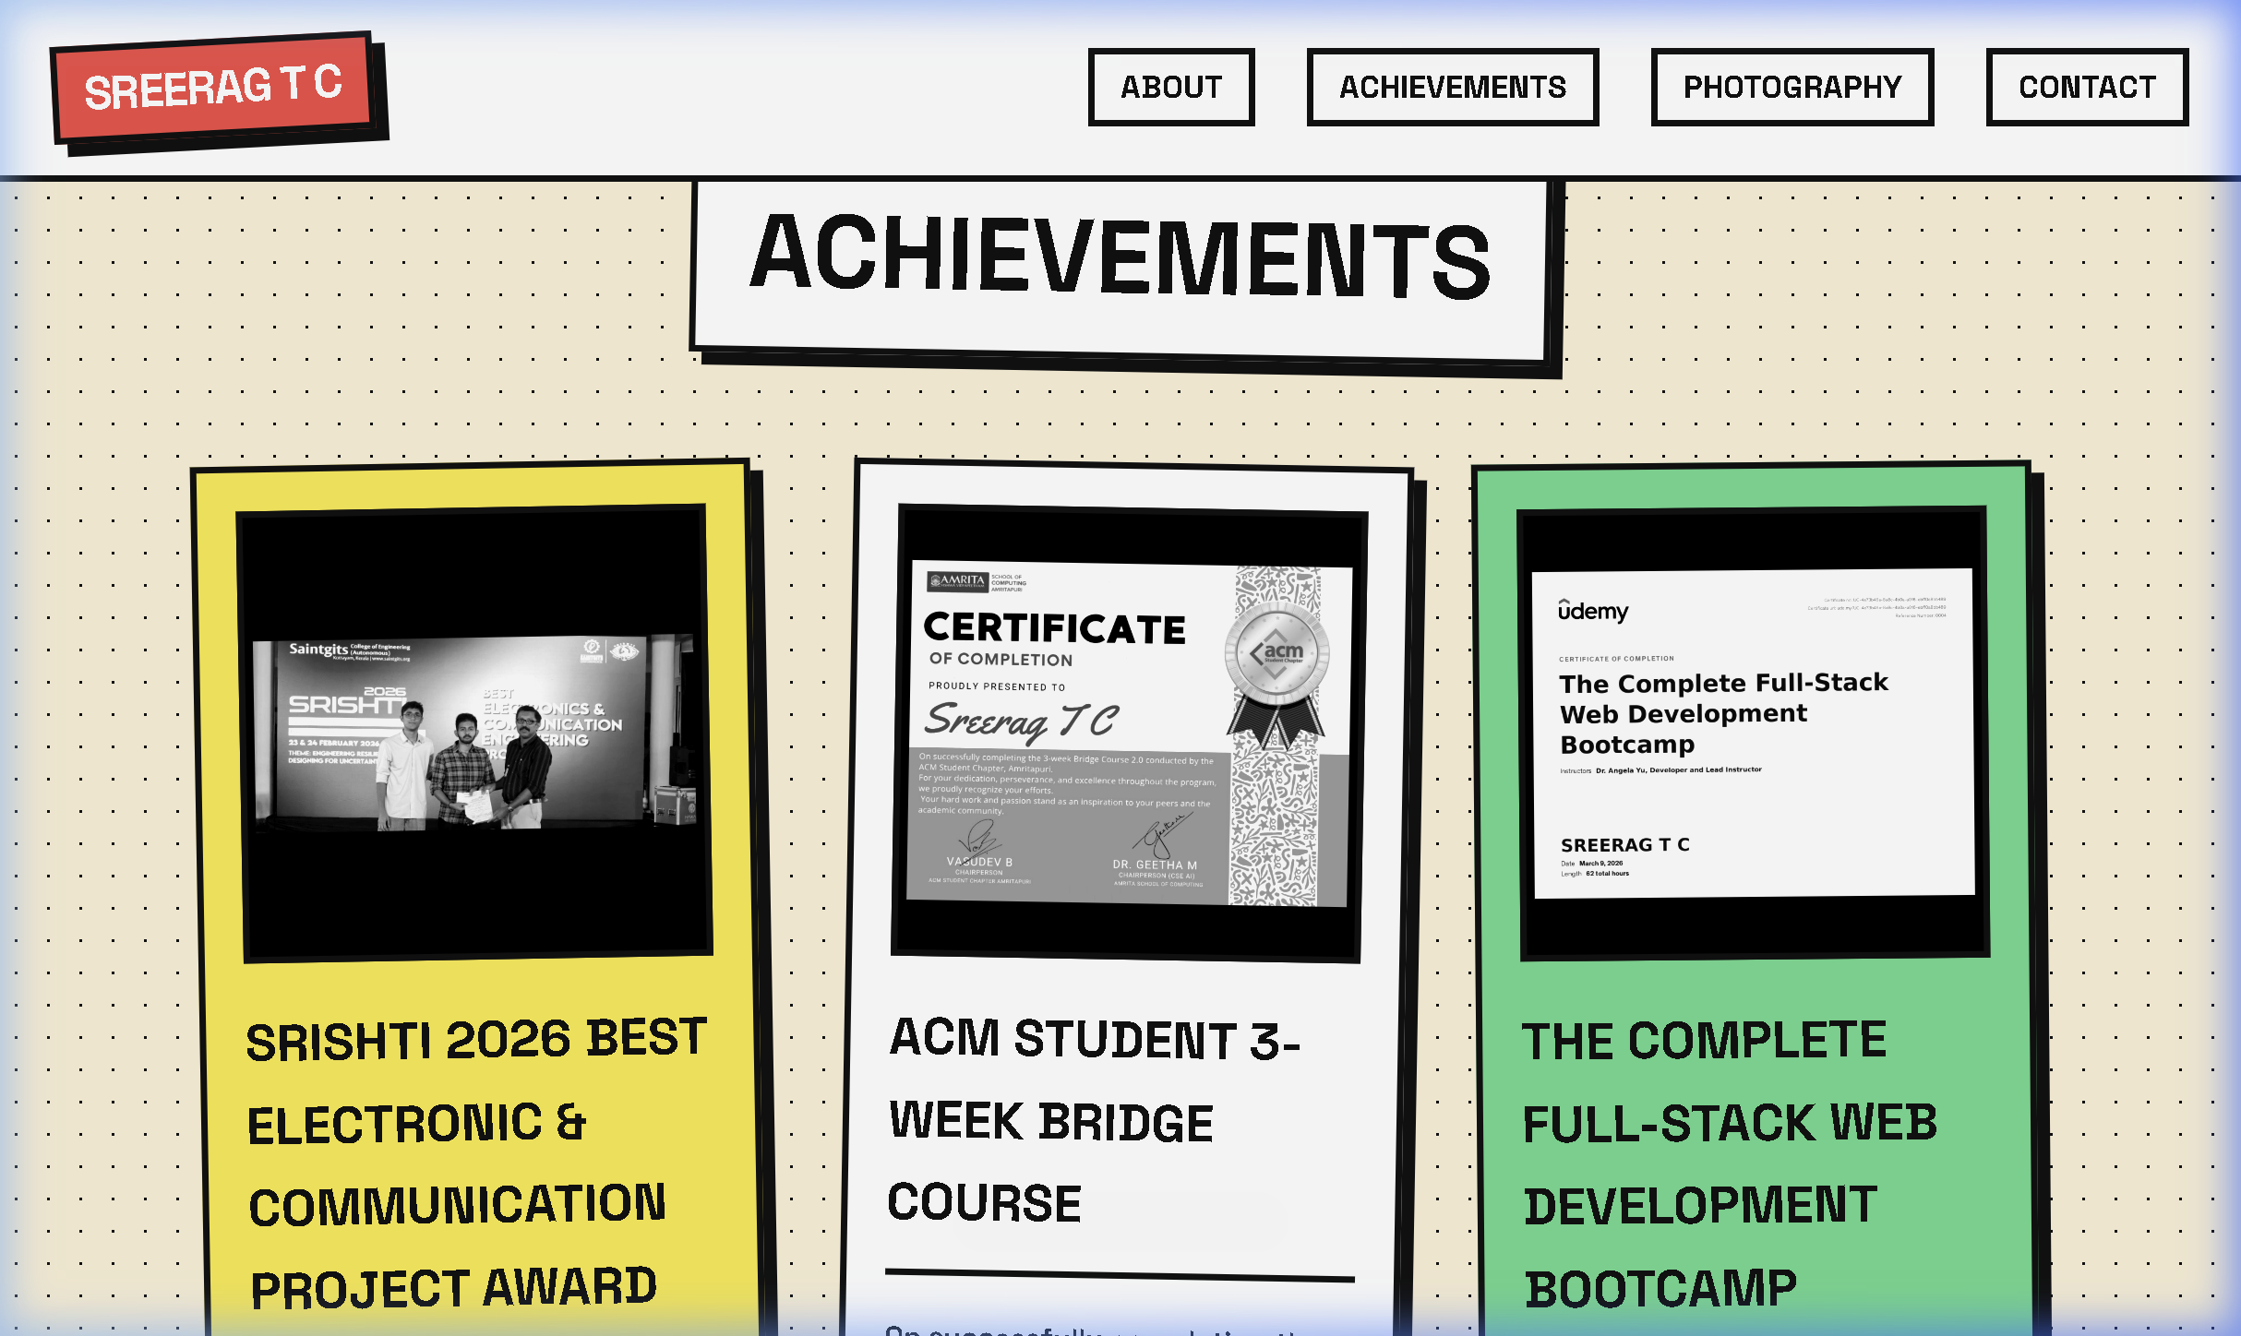

Technical Implementation (Achievements)

CSS Grid & Flexbox:
.grid { display: grid; grid-template-columns: repeat(auto-fit, minmax(320px, 1fr)); gap: 3rem; }
This ensures the cards wrap perfectly on all screen sizes.

Interactive Filters:
.card-image img { filter: grayscale(100%) contrast(120%); mix-blend-mode: luminosity; }
.card:hover .card-image img { filter: grayscale(0%) contrast(100%); mix-blend-mode: normal; }
This creates a "pop" effect when users engage with your achievements.

3. Photography & Editing Showcase
The Photography section features a creative masonry layout:
- Implemented using CSS columns for a dynamic, asymmetrical look.
- Images use a subtle grayscale-to-color transition on hover, accompanied by a slight scale and rotation transform.
- Includes a personal "Introduction Note" that conveys the philosophy behind the photography work.
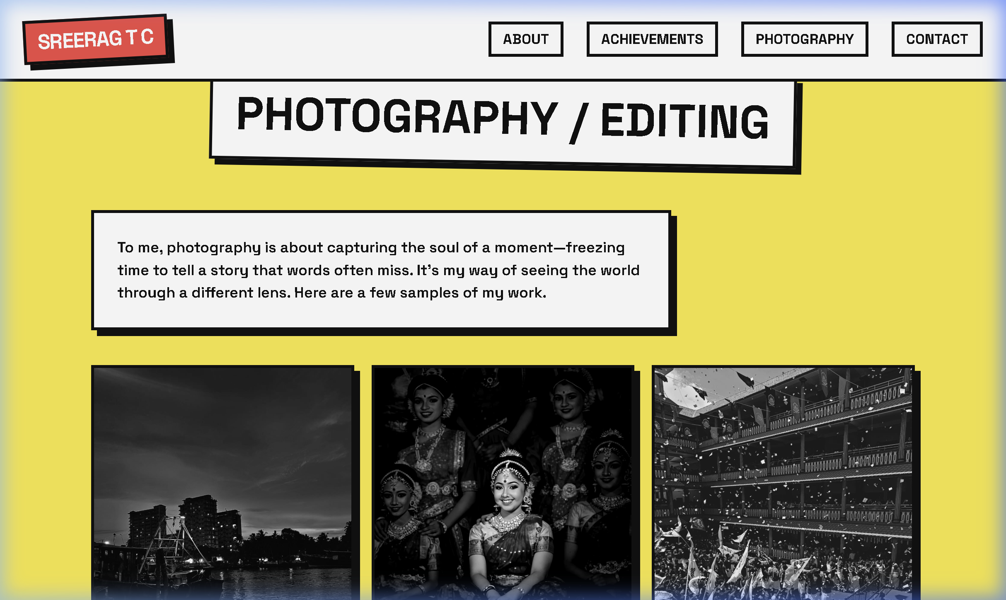

Technical Implementation (Photography)

Masonry Columns:
.photo-grid { columns: 3; column-gap: 1.5rem; }
.photo-item { break-inside: avoid; display: inline-block; width: 100%; }
Using CSS columns allows images of different heights to flow naturally without gaps.

Physics-based Transforms:
.photo-item:hover { transform: scale(1.03) rotate(1.5deg); box-shadow: 10px 10px 0 var(--border-color); }
The scale and rotation make the items feel like physical objects being picked up.

4. Professional Connection Section
The Contact section is refined for professional networking and job outreach:
- Features a clear "Let's Connect" call-to-action.
- Direct email links and social platform integrations are styled with bold interactive elements.
- Designed to be minimalist yet authoritative, focusing on ease of connection.
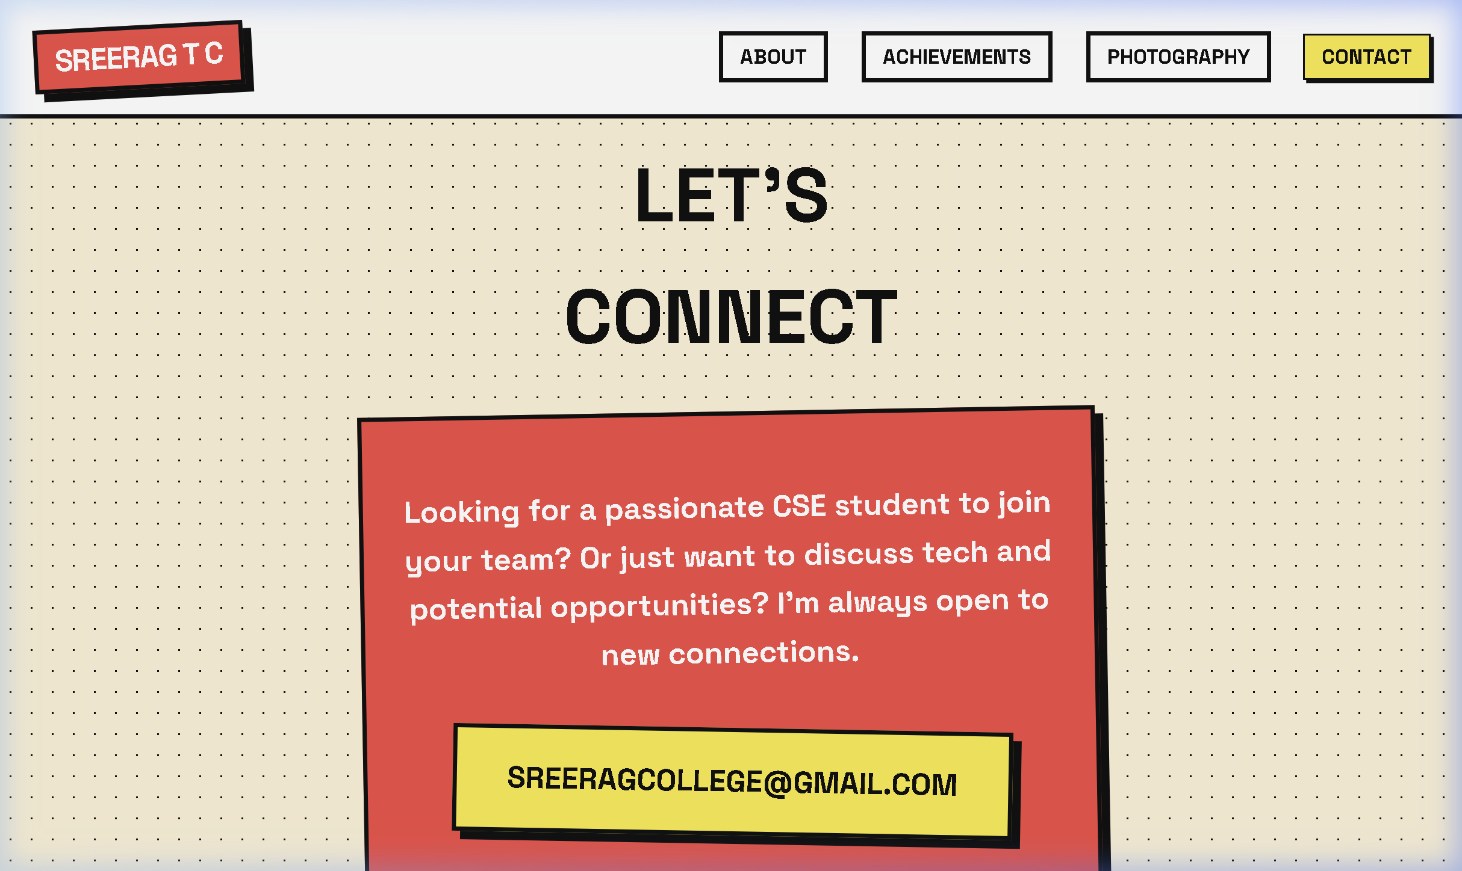

Technical Implementation (Contact)

Interactive Button Styling:
.email-link { background-color: var(--accent); transform: rotate(2deg); transition: all 0.2s; }
.email-link:hover { background-color: #fff; transform: rotate(0deg); }
Motion is used to draw attention to the most important call-to-action on the page.

