**INTRODUCTION:**

LiFi is light fidelity. Lifi uses the light to transmit the data. The speed of the LiFi is more when compared to the Wifi. Currently many countries were using this LiFi and a lot of research was going on. Now we are seeing that Wifi is helping us to make the things better, fast and easier. In this LiFi we are going to transmit the information using the LED (Light Emitting Diode). If we’re going to use this technology, then speed of the data transmission can be improved. As every technology evolves from the draw back of the existing technology even LiFi have a drawback i. e, it has the limited range of transmission. As we know that light can’t be passed through the opaque substances that are the obstacles for the data transmission.

**METHODOLOGY:**

The methodology used here - we will transmit the data using the LED .so we need to build the systems separately. In this separate LED’S were built in which the circuit diagram consists of the data transmission and other important tasks.

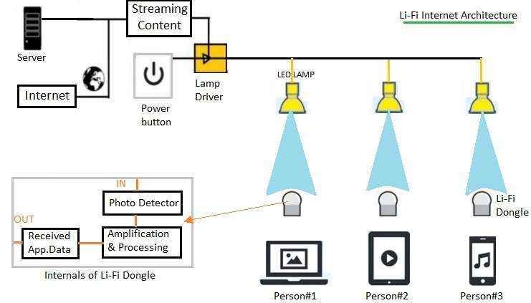

As shown lamp driver is connected with internet on one end and with LED lamps on the other end. Streaming content from internet are pushed to the LED lamps through Lamp driver software.

LED lamps are placed at different locations as per requirement in the office or home premises for multiple users. Li-Fi dongle is used in order to use Li-Fi internet services by various users. As shown Person#1 is browsing internet in Laptop, Person#2 in tablet and Person#3 in smartphone. As shown LiFi dongle is composed of photodetector, amplification & processing and applications for different types of data. All the LED lamps can be swithed on and off using a power button switch provided. Li-Fi internet provides very fast data rate at 1 Gbps speed.

By seeing the above diagram, we can understand that the LED’s are going to be get connected to the lamp driver. This lamp driver is connected to the internet and server.it is clear that here that leds are used as the routers in the data transmission.it is very easy to operate the LiFi so most of the countries are shifting to the LiFi.

**HISTORY:**

Professor Harald Haas coined the term "Li-Fi" at his 2011 TED Global Talk where he introduced the idea of "wireless data from every light". He is a Chair Professor of Mobile Communications at the [University of Edinburgh](https://en.wikipedia.org/wiki/University_of_Edinburgh), and the co-founder of pureLiFi along with Dr Mostafa Afgani.

The general term "[visible light communication](https://en.wikipedia.org/wiki/Visible_light_communication)" (VLC), whose history dates back to the 1880s, includes any use of the visible light portion of the electromagnetic spectrum to transmit information. The D-Light project at Edinburgh's Institute for Digital Communications was funded from January 2010 to January 2012. Haas promoted this technology in his 2011 [TED Global](https://en.wikipedia.org/wiki/TED_Global) talk and helped start a company to market it. PureLiFi, formerly pureVLC, is an [original equipment manufacturer](https://en.wikipedia.org/wiki/Original_equipment_manufacturer) (OEM) firm set up to commercialize Li-Fi products for integration with existing [LED](https://en.wikipedia.org/wiki/LED)-lighting systems. Oledcomm, French company founded by Pr Suat Topsu from Paris-Saclay University.

In October 2011, a research organisation [Fraunhofer](https://en.wikipedia.org/wiki/Fraunhofer_Society) IPMS and industry Companies formed the [Li-Fi Consortium](https://en.wikipedia.org/wiki/Li-Fi_Consortium), to promote high-speed optical wireless systems and to overcome the limited amount of radio-based wireless spectrum available by exploiting a completely different part of the electromagnetic spectrum.

Several companies offer uni-directional VLC products, which is not the same as Li-Fi - a term defined by the IEEE 802.15.7r1 standardization committee.

VLC technology was exhibited in 2012 using Li-Fi By August 2013, data rates of over 1.6 Gbit/s were demonstrated over a single color LED. In September 2013, a press release said that Li-Fi, or VLC systems in general, do not require line-of-sight conditions. In October 2013, it was reported Chinese manufacturers were working on Li-Fi development kits.

In April 2014, the Russian company Stins Coman announced the development of a Li-Fi wireless local network called BeamCaster. Their current module transfers data at 1.25 gigabytes per second (GB/s) but they foresee boosting speeds up to 5 GB/s in the near future.[[33]](https://en.wikipedia.org/wiki/Li-Fi#cite_note-33) In 2014 a new record was established by Sisoft (a Mexican company) that was able to transfer data at speeds of up to 10 GB/s across a light spectrum emitted by LED lamps.[[34]](https://en.wikipedia.org/wiki/Li-Fi#cite_note-34)

**COMPARISION OF LIFI WITH WIFI:**

**RESULTS:**

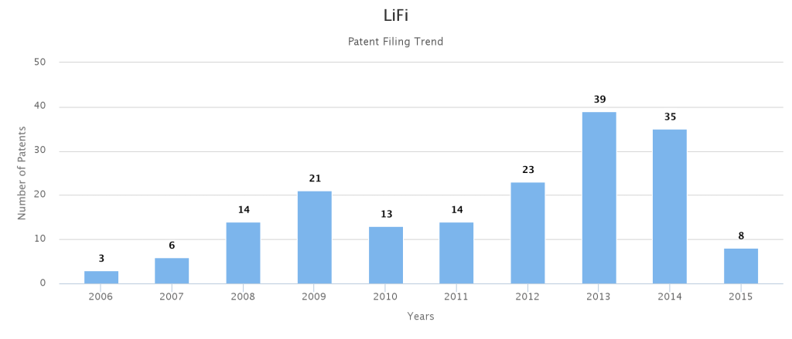

In 2013, we can observe that patents on Lifi is more because then only the real time application of the lifi started. Before that it was just a theory-based data transformation method. Now we can see the technology was already developed well and the research was going on the draw backs of it, to make it more effective.

**FUTURE SCOPE:**

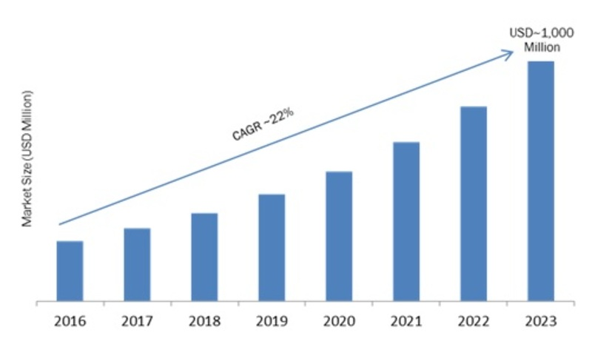

**APPLICATIONS:**

* Security:In contrast to radio frequency waves used by Wi-Fi, lights cannot penetrate through walls and doors. This makes it more secure and makes it easier to control access to a network.[48] As long as transparent materials like windows are covered, access to a Li-Fi channel is limited to devices inside the room.
* Underwater application: Most remotely operated underwater vehicles (ROVs) are controlled by wired connections. The length of their cabling places a hard limit on their operational range, and other potential factors such as the cable's weight and fragility may be restrictive. Since light can travel through water, Li-Fi based communications could offer much greater mobility.[50] Li-Fi's utility is limited by the distance light can penetrate water. Significant amounts of light do not penetrate further than 200 meters. Past 1000 meters, no light penetrates.
* Aviation: Efficient communication of data is possible in airborne environments such as a commercial passenger aircraft utilizing Li-Fi. Using this light-based data transmission will not interfere with equipment on the aircraft that relies on radio waves such as its radar.
* Hospital: Many treatments now involve multiple individuals, Li-Fi systems could be a better system to transmit communication about the information of patients.[53] Besides providing a higher speed, light waves also have little effect on medical instruments and human bodies.[54] Wireless communication can be done during the use of such medical instruments without having to worry about radio interferences hindering the efficiency of the task.
* Vehicles: Vehicles could communicate with one another via front and back lights to increase road safety. Street lights and traffic signals could also provide information about current road situations.
* Industrial automation: Anywhere in industrial areas data has to be transmitted, Li-Fi is capable of replacing slip rings, sliding contacts and short cables, such as Industrial Ethernet. Due to the real time capability of Li-Fi (which is often required for automation processes) it is also an alternative to common industrial Wireless LAN standards. Fraunhofer IPMS, a research organisation in Germany states that they have developed a component which is very appropriate for industrial applications with time sensitive data transmission.
* Advertising: Street lamps can be used to display advertisements for nearby businesses or attractions on cellular devices as an individual passes through. A customer walking into a store and passing through the store's front lights can show current sales and promotions on the customer's cellular device.
* Education: Students and teachers can be part of a more active educational community in a classroom that is Li-Fi enabled. Students with devices such as smartphones or laptops can communicate with the teacher, or with each other, to create a more efficient learning environment. Teachers can be able to collaborate with students to help better understand class material.

**REFERENCES:**

<http://www.rfwireless-world.com/Terminology/LiFi-vs-WiFi.html>

<http://www.rfwireless-world.com/Vendors/LiFi-products.html>

**DISADVANTAGES:**

* The light range is limited to some extent only.
* The obstacles for light are the obstacles for the data transmission.
* The initial cost to launch is little costly.
* If there is any power loss, then information also will be lost.
* If a single part in the circuit got damaged entire communication will be lost.

**CONCLUSION:**

We can conclude that in future lifi is going to replace the wifi. Li-Fi is the most ideal solution for effective data transmission due to its basic building block : Light. Inexhaustible, accurate, fast, safe and cost effective, Li-Fi could potentially be the successor of Wi-Fi upon further development. Its working centers around the principle of varying the electrical signal based on the required output. Its applications range widely from toys to communication and can find uses in critical fields like military and medicine. Further research on Li-Fi is gaining pace in the recent times which will potentially resolve the many unsolved mysteries of the world.