Steven Gibson
Outcome 1 and 2
Technical Guide
Table of Contents
Requirement Specification:
Requirement Specification | 2
Detailed Design | 3
Testing Strategy | 4
Pseudocode | 5
Code | 6
Testing Log | 11
Data Dictionary | 14
Write a program that asks he user to enter their name and presents them with 3 options for 2 programs and a quit option, the program is to until the user selects option 3.
Option 1: User name program, Admin user enter the person first-name and surname the program then makes a user-name by taking the first letter of their first-name and adding it to their surname (example Steven Gibson user-name is SGibson),

Option 2: Is to ask the user for a number and show its factorial (example number = 5 factorial is 5*4*3*2*1=120.

Option 3: Quits with a goodbye message.

Detailed Design:
My plan is to divide the program into 3 separate class,

Class 1 (main class)
Will have the main method where the program will start. It will ask the user to input their name

Class 2 (options class)
This will have the method for displaying the options available to the user.
Option 1: create user-name
Option 2: Factorial of a number
Option 3: Exit

Class 3 (programs class)
This is where the programs will be written and called from when need. This will have 3 methods
Method 1 “string_function” this is where the user will enter a full name
Method 2 “create_name” this is where the user-name will be generated
Method 3 “number_function” this is where the user will enter a number and the factorial will be displayed on the screen.

Testing Strategy:
Testing will be done by white house testing by myself, I will test the menu to only allow the 3 predefined options to be selected, the user name will be tested by myself entering names of people. The factorial will be tested by me as well for a verity of numbers.
Testing will be conducted as the program develops. Testing for full functionality will be done when he program is fully completed, A full test log will be shown later in the documentation.

Pseudocode:

Main method:
declare variables (administrator as string)
prompt user for User-name

Options Class
Selection method (pass administrator's name)
declare variables (loop as integer)
loop until option 3 selected
show an option menu
Option 1: create user-name (call program class string_function method)
Option 2: Factorial (call program class number_function method)
Option 3: exit (exit loop and display goodbye “user”)

Programs class(pass administrator's name to all methods)
string_function
prompt the admin to enter a person full name
pass the full name to create_name method

create_name
declare variables (space as char, string1 and string2 as String)
search for a space (using index of)
if a space is not found
Prompt user that the name was invalid and return to main menu.
if a space is found
Make and display the user-name as the first letter of their first name and all the their surname without a space.
Example: Steven Gibson user-name would be SGibson

Return to main menu

number_function
declare variables (count, factorial as integer and number as float)
prompt the user for a number
error check: see if a number has been entered

if the number is <0
show error
if the number is > 1000
show number is too large
output the factorial to the screen in the format
NxNxN=F
example: Factorial of 5
output should be: 5 x 4 x 3 x 2 x 1=120
Return to main menu

Code:

package outcome_one;

import java.util.Scanner;

/**
* 10/11/2015
* @author Steven
* This program will ask the administrator's name, present them with 3 options
* Option 1 Create a user name.
* Option 2 Calculate the Factorial of a number entered by the user.
* Option 3 Exits the program
*
*/
public class Outcome_One
{

public static void main(String[] args)
{
//ask for the admins name
Scanner adminsc = new Scanner(System.in);
options Option = new options();
System.out.println("Hello, Please enter your username");
String administrator= adminsc.nextLine();
//send the admin's name to the option class
Option.selection(administrator);

}

}

package outcome_one;

import java.util.Scanner;

/**
*
* @author Steven
*/
public class options
{
public void selection(String admin)
{
int loop = 1;
while (loop == 1) // make the program run until the user quits
{
System.out.println("Welcome "+ admin);
System.out.println("Please select an option");
System.out.println("Option 1: Create a username");
System.out.println("Option 2: Find the Factorial");
System.out.println("Option 3: Quit");
Scanner Option = new Scanner(System.in);
String choice = Option.nextLine();
switch (choice)
{
case "1":
{
programs.string_function(admin); //run the string_function
break;
}
case "2":
{
programs.number_function(admin);// run the number_function
break;
}
case "3":
{
System.out.println("Goodbye "+ admin); // quit the program
loop = 2;
break;
}
default:
{
System.out.println("Invalid Selection"); // default if an invalid option is not picked
}
}
}
}
}

package outcome_one;

import java.util.Scanner;
/**
*
* @author Steven
*/
public class programs
{

public static void string_function(String Admin)
{
System.out.println("Welcome "+Admin+", You have selected Option 1, Creating a username");
// askes the user to enter a full name
Scanner usersc = new Scanner(System.in);
System.out.println("Enter User's fullname");
String user = usersc.nextLine();
//passes the the name the user entered to the create_name function
create_name(user);
}

public static void number_function(String Admin)
{
// asks the user to input a number
System.out.println("Welcome "+Admin+", You have selected Option 2, Factorial of a number");
System.out.println("Please enter a number ");
Scanner numbersc = new Scanner(System.in);
int number = 0;
//error check to see if the user has entered something other than a number
try
{
number = numbersc.nextInt();
}
catch (Exception e)
{
System.out.println("Not a vaild number");
}

int count;
float factorial = 1;
if (number>=30)
{
System.out.println("Number is to large");
}
else if (number>0)
{
//starts a counter for what ever number the user input
for ( count = number; count > 1; count--)
{
System.out.print(count + " X " );

factorial *= count;
}
//prints the factorial
System.out.println(count+" = "+factorial);
System.out.println("Thank you for using the Factorial Funcuntion, Returning to Main Menu");
System.out.println("");
}
else if (number <=0)
{
//tests if the number is less than 0
System.out.println("Not a vaild number");
}

}

public static void create_name(String username)
{
//gets the username from the string_function
int pos;
char space = ' ';
//looks for the space
pos = username.indexOf(space);
if ((pos == -1))
//is a space is not found
{
System.out.println(username+" is not a valid username");
System.out.println("Returning to Main Menu.");
}

else
{
//if a space is found
String string1=username.substring(0,1), string2 = username.substring(pos+1,username.length());
//prints the user name to the screen
System.out.println(username+"'s username will be \n"+string1+string2);
System.out.println("Thank you for using the Create Username Function, Returning to Main Menu.");
System.out.println("");
}
}
}

Testing Log

SUBROUTINE NAME | TEST CASE | TEST DATA | EXPECTED RESULT | COMMENTS with date
main() | Enter an administrator name at prompt | Steven Gibson | Name accepted and displayed in welcome message | Test was successful.  24/11/15  User name was displayed correctly (fig1)
selection() | Menu option 1 | 1 | Message informing that this is option 1, with the name of the administrator  e.g This is option 1, Steven | Test was successful.  24/11/15  User taken to string_function()  With welcome message (fig2)
 | Menu option 2 | 2 | Message informing that this is option 2 with the name of the administrator | Test was successful.  24/11/15  (fig3)
 | Menu option 3 | 3 | Message goodbye with user name  System exits | Test was successful.  24/11/15  (fig4)
 | Menu option 6 | 6 | Error message – invalid option | Test was successful.  24/11/15  Asked for another option  (fig5)

SUBROUTINE NAME | TEST CASE | TEST DATA | EXPECTED RESULT | COMMENTS with date
string_function() and create_user | Create a username from two words | David Lister | Prompted to enter a name which is then displayed as DLister | Test was successful.  24/11/15  (fig6)
Number_function | Invalid data | 0 | Message prompting user that the data is invalid | Test was successful.  24/11/15  (fig7)
 | Normal valid data | 5 | Factorial of 5 result displayed | Test was successful.  24/11/15  (fig8)
 | Invalid data | -8 | Message prompting user that the data is invalid | Test was successful.  24/11/15  (fig9)
 | Invalid data | 8.4 | Message prompting user that the data is invalid | Test was successful.  24/11/15  (fig10)
 | Invalid data | 100 | Message prompting user number is too big | Test was successful.  24/11/15  (fig11)

Testing Log cont.…
Screenshots
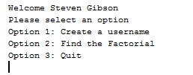
Fig1

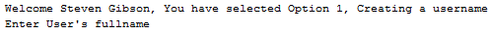
Fig2

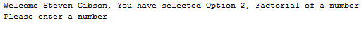
Fig3

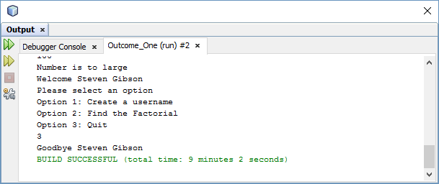
Fig4

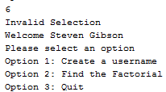
Fig5

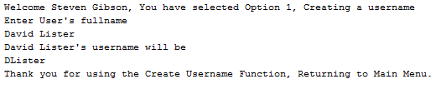
Fig6

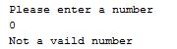
Fig7

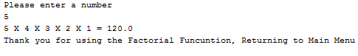
Fig8

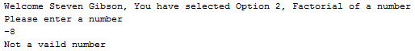
Fig9

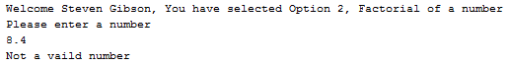
Fig10

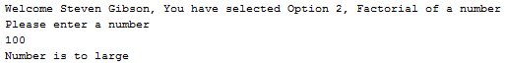
Fig11

Data Dictionary

NAME | TYPE | SCOPE | DESCRIPTION
administrator | string | Global | Used to store administrator name which is then used as output for each option
choice | integer | Local to method selection() | Used to hold value of input from user from menu options and will be used in the case statement
Loop | Integer | Local to method selection()  option | Used to keep the program running until exit condition met.
user | string | Local to method string_function() | Used in conjunction with prompt to hold value of input box for name input
username | string | Input parameter of create_name() method | Parameter which holds the value of user from string_function() method and used throughout function create_name()
string1 | string | Local to create_name () method | Variable used to store substring –first character of username
pos | integer | Local to create_name () method | Variable to hold the position of the space in username
string2 | string | Local to create_name () method | Variable to hold substring of all characters after the space
number | Integer | Local to number_function() method | Variable, initialised to 0 to store value of user entered number
factorial | float | Local to number_function() method | Variable, initialised to 1 to store value of calculated factorial of number
count | integer | Local to for number_function() method | Variable used in loop to count number of times loop is executed and for performing factorial calculation

FUNCTIONS

NAME | Description
main() | Displays options to the screen and displays a prompt for input.
selection() | Repeats indefinitely until user selects the quit option. Methods must be called dependant on user input.
string_function() | Displays an output to screen, printing the value held in administrator variable and message informing that this is option 1. Then prompts for a name to be entered in the box. This is in the format of a first name and a last name and is stored in the variable user. The create_name() method is then called passing the variable user as a parameter.
number_function() | Displays an output to screen, printing the value held in administrator variable and message informing that this is option 2. Then prompts user to enter a number and check that it is an integer greater than zero. Then calculates and outputs the factorial of the given number or prints an error message and returns to the menu().
create_name(username) | Carries out string manipulation on the parameter username. It extracts the first character then extracts the text after the space and joins the two to create the username.

