Real-Time Multi-Class Face Mask Detection Using YOLOv8

Mentor : DR. Ranjeet Kumar Ranjan

Team Members
1. Rohit Reddy (23bcs205)
2. Raj Harsha (23bcs234)
3. Sai Sangeeth (23bcs177)
4. Sharvaani (23bcs230)
5. Vyshnavi (23bcs156)

1. Abstract
With the rise of global pandemics like COVID-19, wearing face masks has become a critical public health measure. Manual surveillance to ensure mask compliance is inefficient and non-scalable. CamMask AI is an automated, real-time face mask detection system built on the YOLOv8 object detection framework.
The system accurately classifies five different mask-related behaviors: mask worn properly, nose visible, mouth visible, no mask, and hand removing the mask. Our model is trained using a diverse dataset and leverages data augmentation and transfer learning for high accuracy and speed. This report presents the complete methodology, implementation, evaluation, and results of CamMask AI.
This research explores the development of a real-time face mask detection system capable of classifying five distinct mask usage scenarios: Mask worn properly, No mask, Nose visible, Mouth visible, and Hand obstructing the face. Leveraging the YOLOv8n architecture, this work presents a deep learning solution trained on curated datasets from Kaggle. The system operates efficiently with high precision (0.971) and recall (0.959), and achieves a mAP50 of 0.9798 and mAP50-95 of 0.776. Real-time inference is enabled through webcam input using OpenCV and PIL libraries. The model has strong implications for public safety and compliance monitoring in a post-pandemic world.

2. Introduction
The global COVID-19 pandemic has significantly increased the need for automated systems that monitor mask compliance in public areas. While many face mask detection systems exist, most are limited to binary classification, identifying only whether a mask is worn or not. This simplification ignores critical cases such as improper mask usage, including exposed nose or mouth, or when the face is obscured by hands or other objects. To address these limitations, our research proposes a real-time face mask detection model based on the YOLOv8 architecture, capable of classifying five nuanced face-covering conditions with high accuracy and inference speed.
Manual mask monitoring is not scalable in crowded environments. Hence, we leverage YOLOv8, a powerful object detection model, to create a system that detects mask-wearing conditions in real time.
CamMask AI improves upon traditional systems by introducing fine-grained classification, ensuring better public safety compliance. This system is ideal for deployment in institutions, workplaces, malls, and transport hubs.

3. Problem Statement
Most existing mask detection systems offer only binary outputs: mask or no mask. This overlooks partial mask violations like nose or mouth uncovered, which still pose health risks. Moreover, manual detection is costly and prone to fatigue.
We propose a system that can classify:
1. Mask worn properly
2. Nose visible
3. Mouth visible
4. No mask
5. Remove hand (gesture of removing mask)
The goal is to enable automated, high-accuracy surveillance.

4. Related Work
Previous approaches in face mask detection have included Convolutional Neural Networks (CNNs), MobileNet, and earlier versions of the YOLO algorithm such as YOLOv3 and YOLOv5. Most existing models focus on binary classification (mask or no mask). While these methods offer reasonable accuracy, they fall short in detecting improperly worn masks. YOLOv8, released by Ultralytics, introduces architecture enhancements such as better feature aggregation, improved backbone structure, and advanced training heuristics, making it ideal for real-time multi-class object detection.

5. Objectives
• Build a multi-class YOLOv8-based face mask detection model
• Achieve real-time inference with high accuracy
• Train with data covering multiple demographics and conditions
• Visualize detections with color-coded bounding boxes
• Prepare the system for practical deployment
6. YOLOv8 Detection Pipeline
Training Phase
1. Data Cleaning & Labeling – Bounding boxes + class ID
2. Augmentation – Mosaic, HSV, flipping, blurring
3. Dataset Splitting – Train/Val/Test
4. Model Training – YOLOv8 with 5 classes
Inference Phase
1. Preprocessing – Resize, normalize
2. YOLOv8 Prediction – Face & mask type detection
3. Post-processing – Confidence threshold, NMS
4. Output – Color-coded bounding boxes

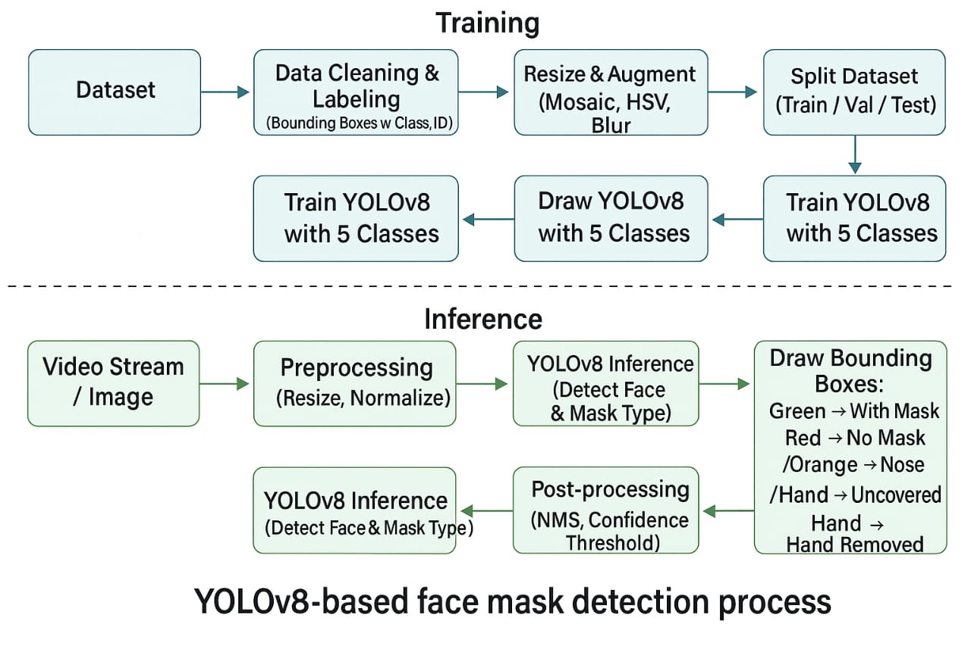

- Architecture Overview
Our architecture consists of:
- Input from camera or image
- OpenCV frame extraction
- YOLOv8 inference
- Output classification & bounding boxes
- Optional logging and alert system
YOLOv8 backbone includes:
- Pretrained weights
- C2f modules
- Feature aggregation via neck
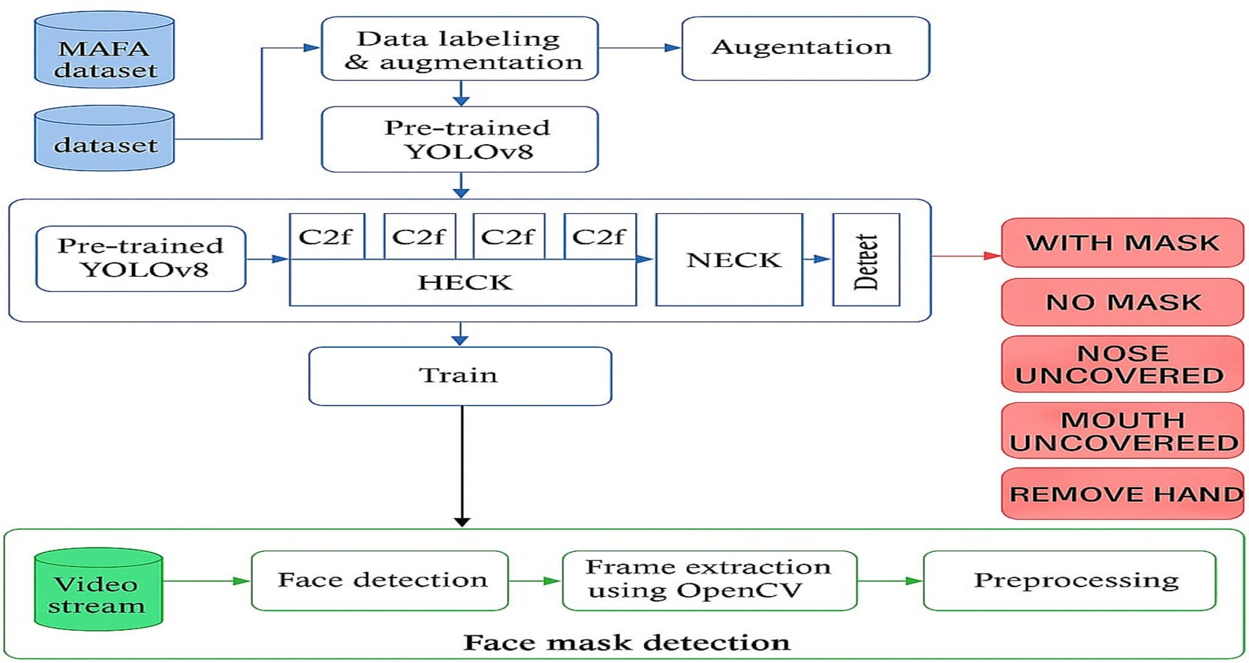

8. Dataset
The system uses two datasets from Kaggle:
1. Medical Masks Dataset: Focuses on faces with and without masks.
2. Face Obstructions Dataset: Contains images with hands or objects partially covering faces.
These datasets were merged and manually annotated into five classes:
- Mask worn properly
- Nose visible
- Mouth visible
- No mask
- Remove hand (face obstruction)
Images were resized to 412×412 and augmented using Albumentations library with techniques like CLAHE, grayscale conversion, blur, and horizontal flips.
Dataset Details
We used a custom dataset combining MAFA and manually labeled samples, annotated in YOLO format.
Classes
• 0: Mask worn properly
• 1: Nose visible
• 2: Mouth visible
• 3: No mask
• 4: Remove hand
Image Distribution
Train Set
• Class 0: 6389, Class 1: 6759, Class 2: 6945, Class 3: 6855, Class 4: 4606
Validation Set
• Class 0: 1755, Class 1: 1977, Class 2: 1963, Class 3: 2004, Class 4: 658
Test Set
• Class 0: 900, Class 1: 953, Class 2: 975, Class 3: 1023, Class 4: 1323
Total: 45,000+ labeled images.
Feature aggregation via NECK

9.Sample Detections per Class
Visual output showing how the model detects and classifies all 5 classes across diverse examples.

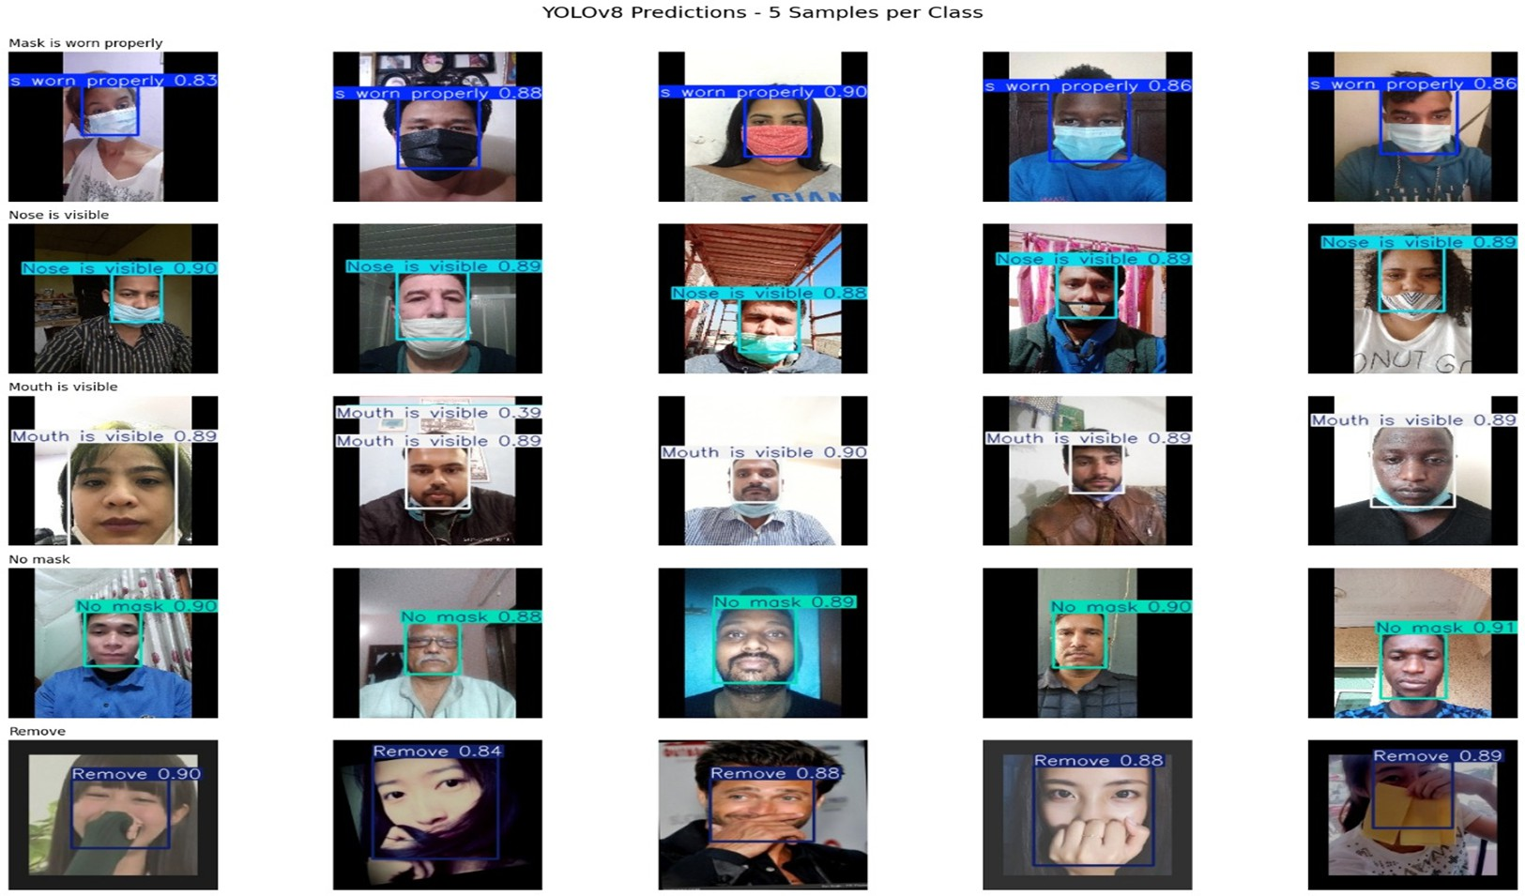

10. Real-time Webcam Results
Model was tested on a live webcam stream using OpenCV. All 5 classes were correctly detected under regular lighting.

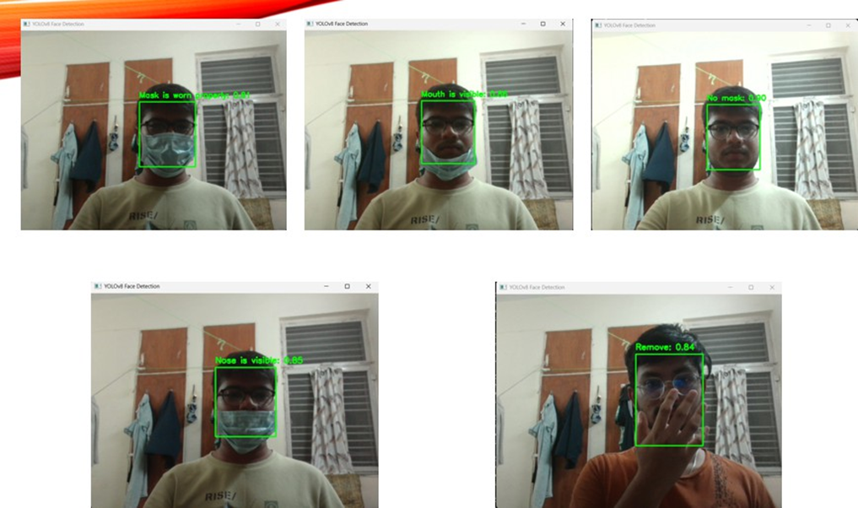

11. Training Performance
Model trained for 30 epochs using YOLOv8 on Google Colab with Tesla T4 GPU.
Loss dropped from ~3.2 to ~2.0
mAP@50 improved from ~91% to ~97.98%

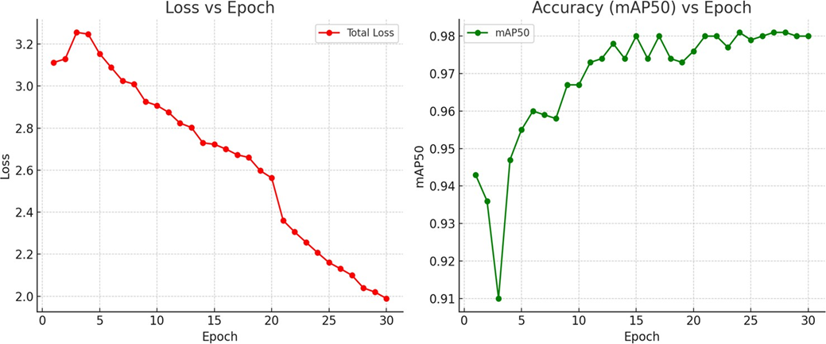

12. Experimental Results
After training, the model achieved the following performance metrics on the validation dataset:
- mAP50: 0.9798
- Precision: 0.971
- Recall: 0.959
-F1 score-0.9648

13. Future Work
Future directions for improvement include:
- Increasing 'Remove hand' samples for better class balance
- Adding tracking for continuous detection in multi-person scenes
-Extend to mask type classification (N95, cloth, surgical).
-Improve detection in low-light environments.
-Integrate alert system for non-compliance.

14. Conclusion
This paper presented a real-time face mask detection system based on YOLOv8 capable of classifying nuanced face covering scenarios. With high accuracy and fast inference speed, the system demonstrates potential for use in public monitoring and smart surveillance. Our multi-class approach addresses real-world needs better than binary mask detectors and sets the stage for future enhancements.

15. References
[1] Medical Mask Dataset – Kaggle. https://www.kaggle.com/datasets/tapakah68/medical-masks-part1/data
[2] Face Obstructions Dataset – Kaggle. https://www.kaggle.com/datasets/janwidziski/face-obstructions
[3] Ultralytics YOLOv8 Documentation. https://docs.ultralytics.com

