**WEEK 8 GIT**

**1.GIT_HOL**

**git --version**

**git config --global user.name "SRI SABARI RAJAN M S"**

**git config --global user.email "mssrisabari363@gmail.com"**

**git config –list**

**notepad++**  
**git config --global core.editor "\"C:/Program Files (x86)/Notepad++/notepad++.exe\" -multiInst -nosession"**

**Output**

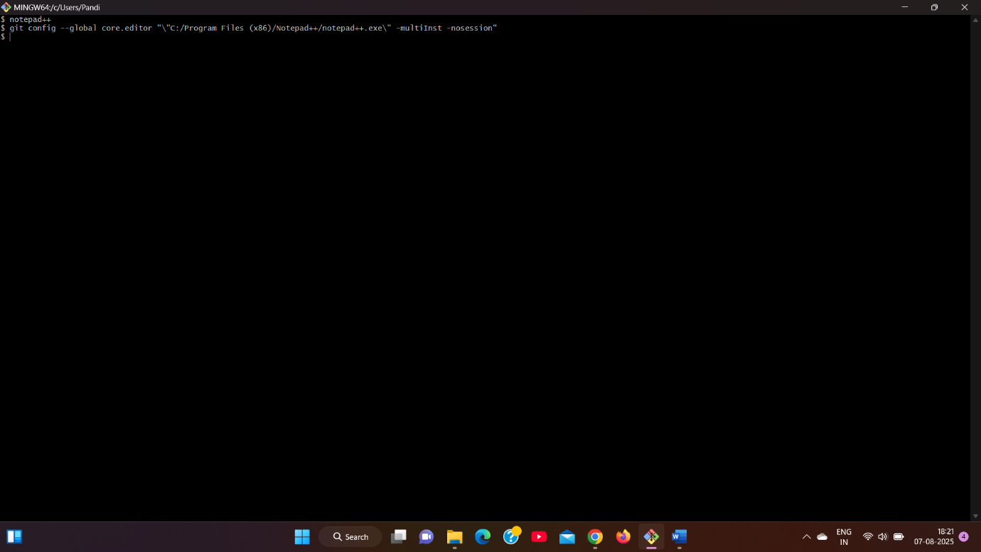

**cd ~**

**mkdir GitDemo**

**cd GitDemo**

**git init  
  
echo "Welcome to Git Hands-On Lab" > welcome.txt**

**ls**

**cat welcome.txt  
  
git status**

**git add welcome.txt**

**git commit**

**git remote add origin https://gitlab.com/Abi2711/gitdemo.git**

**git pull origin master**

**git push origin master  
  
  
Output:  
  
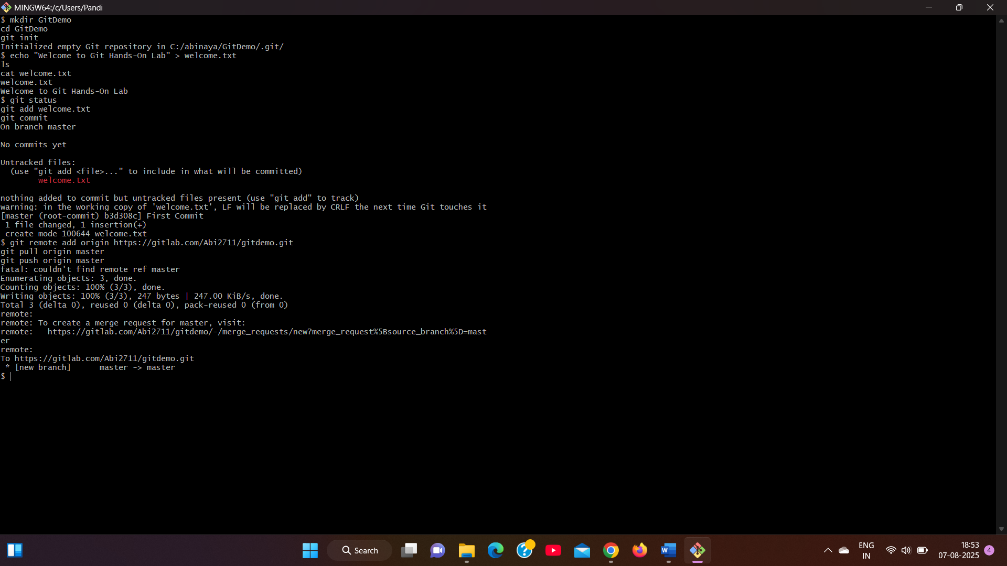**

**2 GIT_HOL**

**touch debug.log**

**mkdir log**

**touch log/system.log  
  
  
touch .gitignore  
  
Add:  
  
*.log**

**log/  
  
git status**

**git add .gitignore**

**git commit -m "Added .gitignore to ignore .log files and log folder"**

**git push origin master  
  
Output:**

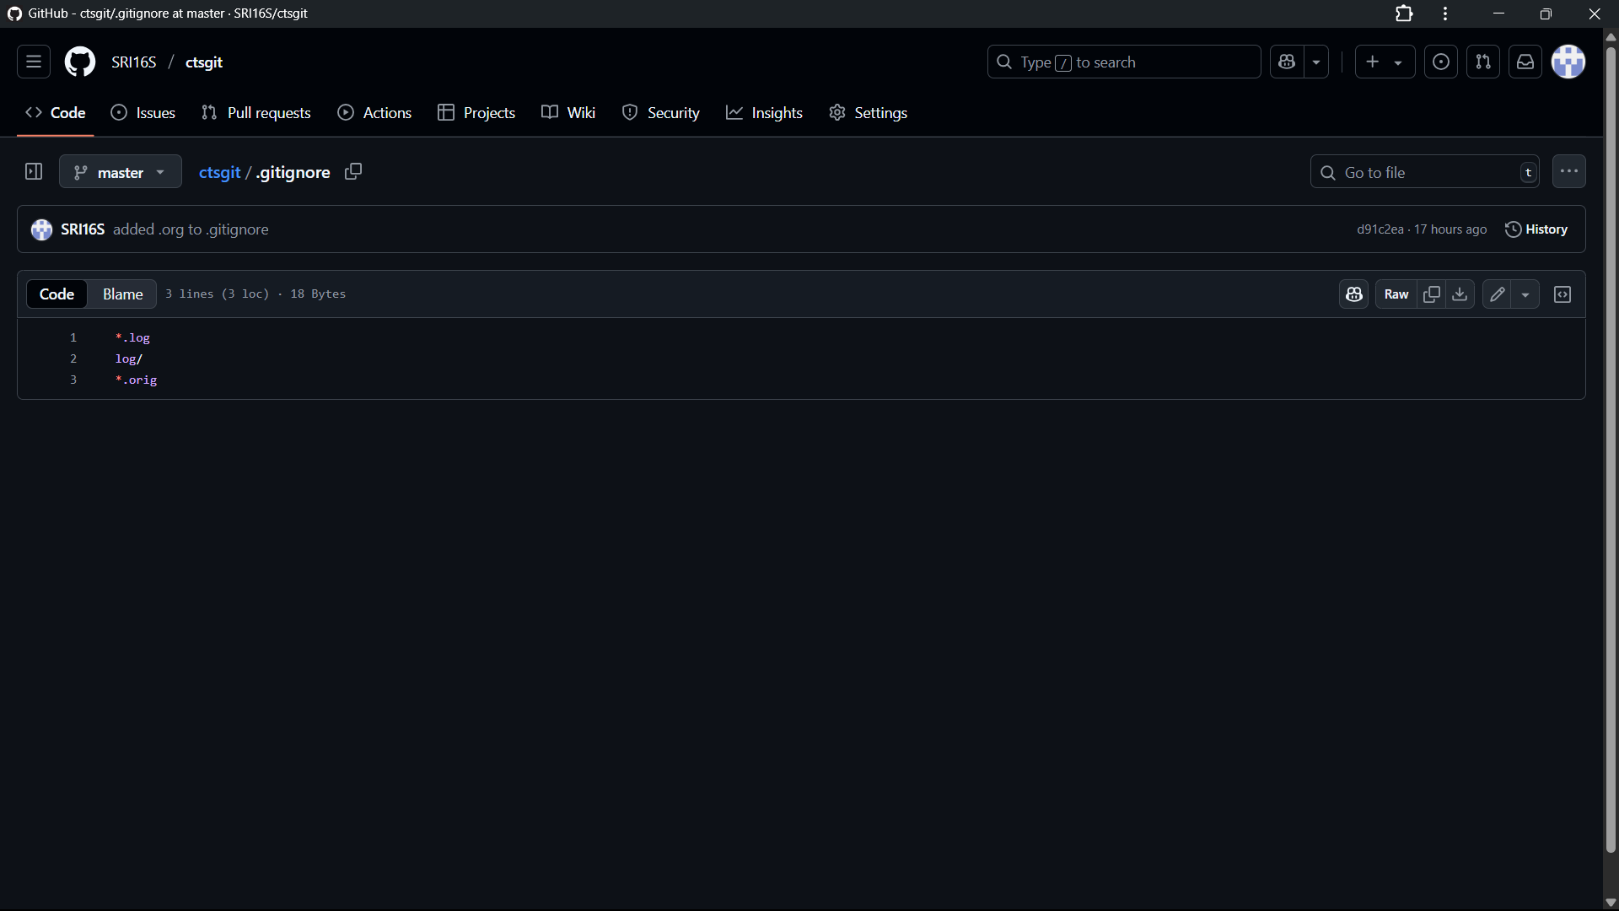

**3 GIT_HOL**

**git checkout -b GitNewBranch  
git branch -a  
echo "This is from GitNewBranch" > branchfile.txt**

**git add branchfile.txt**

**git commit -m "Added branchfile.txt in GitNewBranch"  
git checkout master**

**git diff master..GitNewBranch**

**Output:**

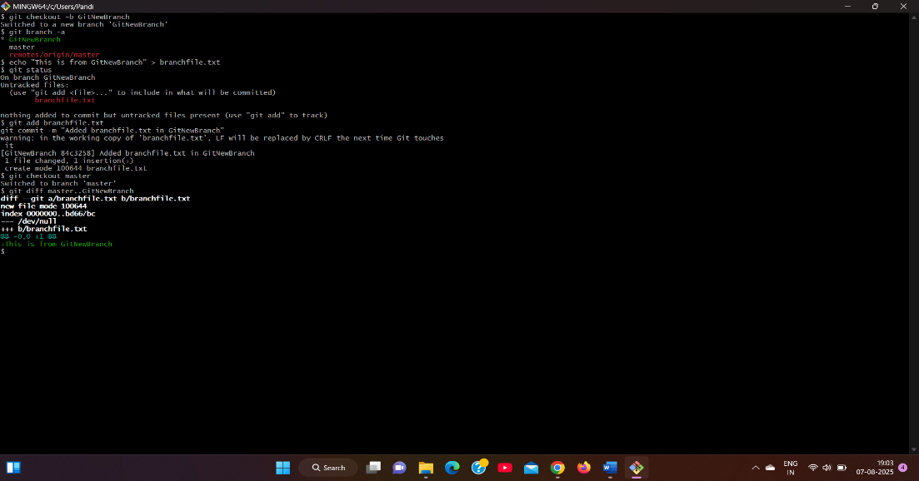

**git merge GitNewBranch  
git log --oneline --graph –decorate  
git branch -d GitNewBranch**

**git push origin master  
  
Output:  
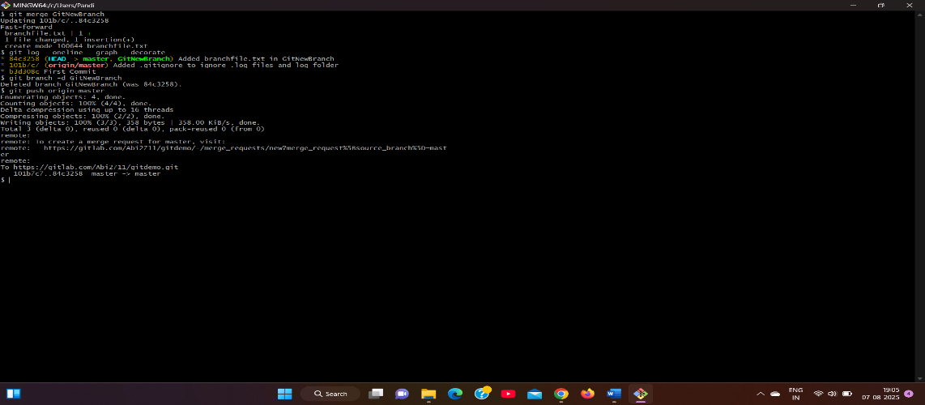**

**4 GIT_HOL**

**git checkout -b GitWork  
echo "<message>Hello from GitWork</message>" > hello.xml**

**git add hello.xml**

**git commit -m "Added hello.xml in GitWork branch"  
git checkout master**

**echo "<message>Hello from master branch</message>" > hello.xml**

**git add hello.xml**

**git commit -m "Added hello.xml in master with different content"  
  
git merge GitWork  
  
Output:  
  
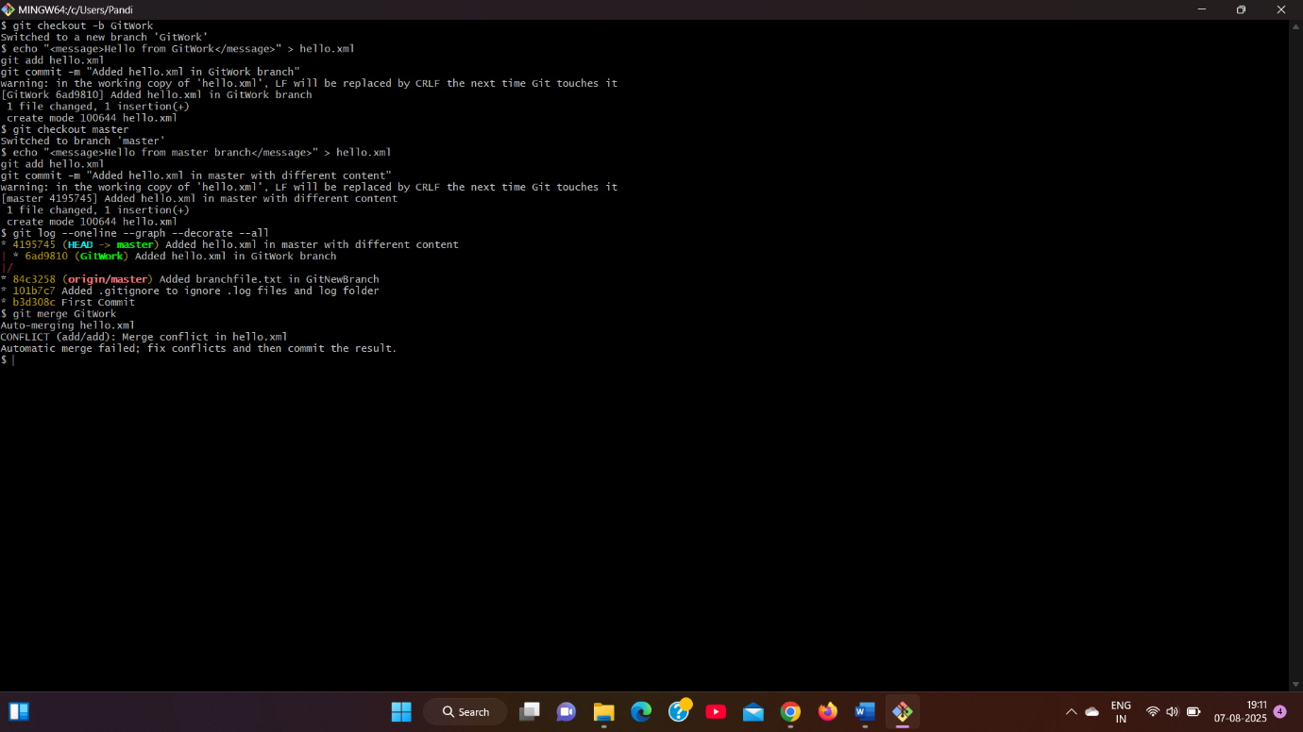**

**git add hello.xml**

**git commit -m "Resolved merge conflict in hello.xml"  
echo "*~" >> .gitignore**

**git add .gitignore**

**git commit -m "Updated .gitignore to ignore backup files"  
git branch -d GitWork  
git log --oneline --graph --decorate  
  
Output:  
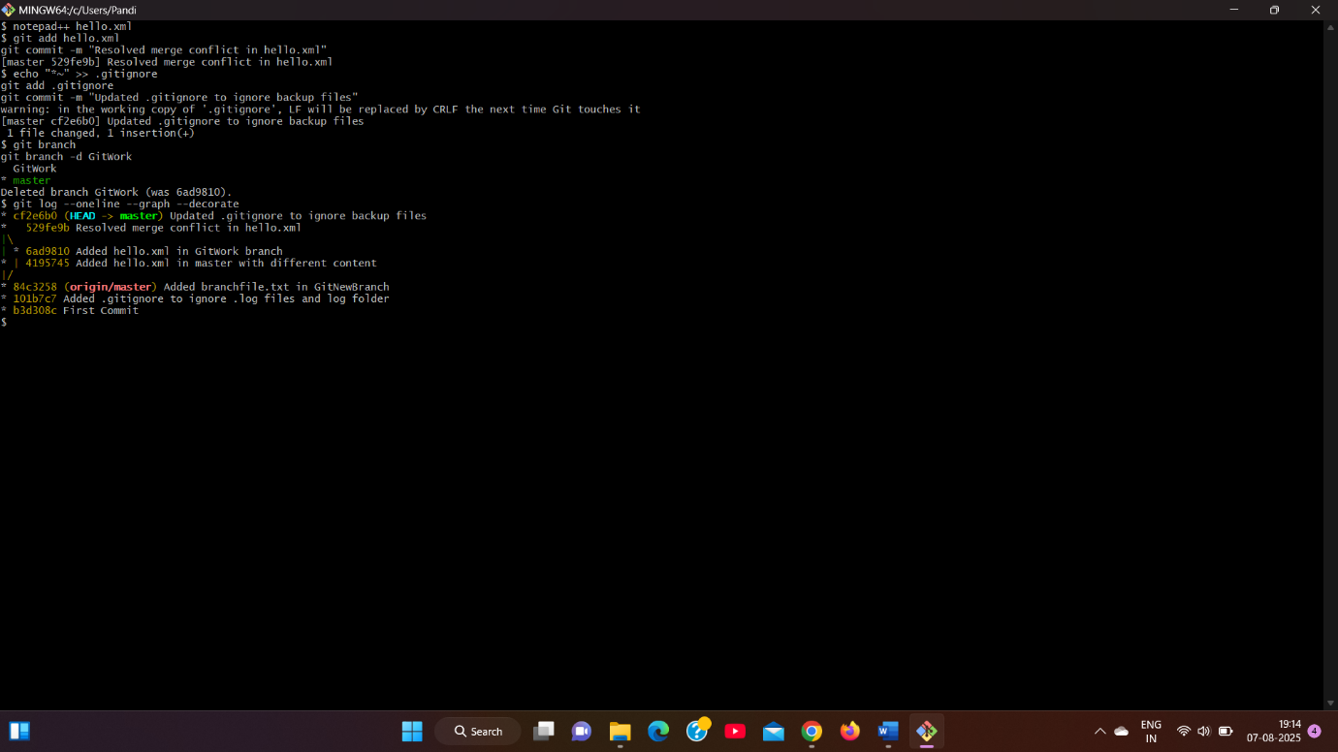**

**5 GIT_HOL**

**git checkout master  
git status  
git branch -a  
git pull origin master  
git push origin master**

**Verified updates in GitLab repo**