Shinigami, Mr Brain, Sandy:

Ohh jeez 😬😬😬😬😬 man you are doing good you are just an digit away from capturing the Secret Key so be prepared for this!!!

Shinigami: Oh my god you made it till here its great achievement no worries you can leave now and resign from this World hahahahaa

Shinigami: Coz u never gonna find the Last 6th digit 😜😜😜 of the Secret Key because Unlike others this time I had not hidden it in the Realm of Words.. but in the realm of Landscapes, Potraits and in Images..

I beleive image speaks more than words !!!



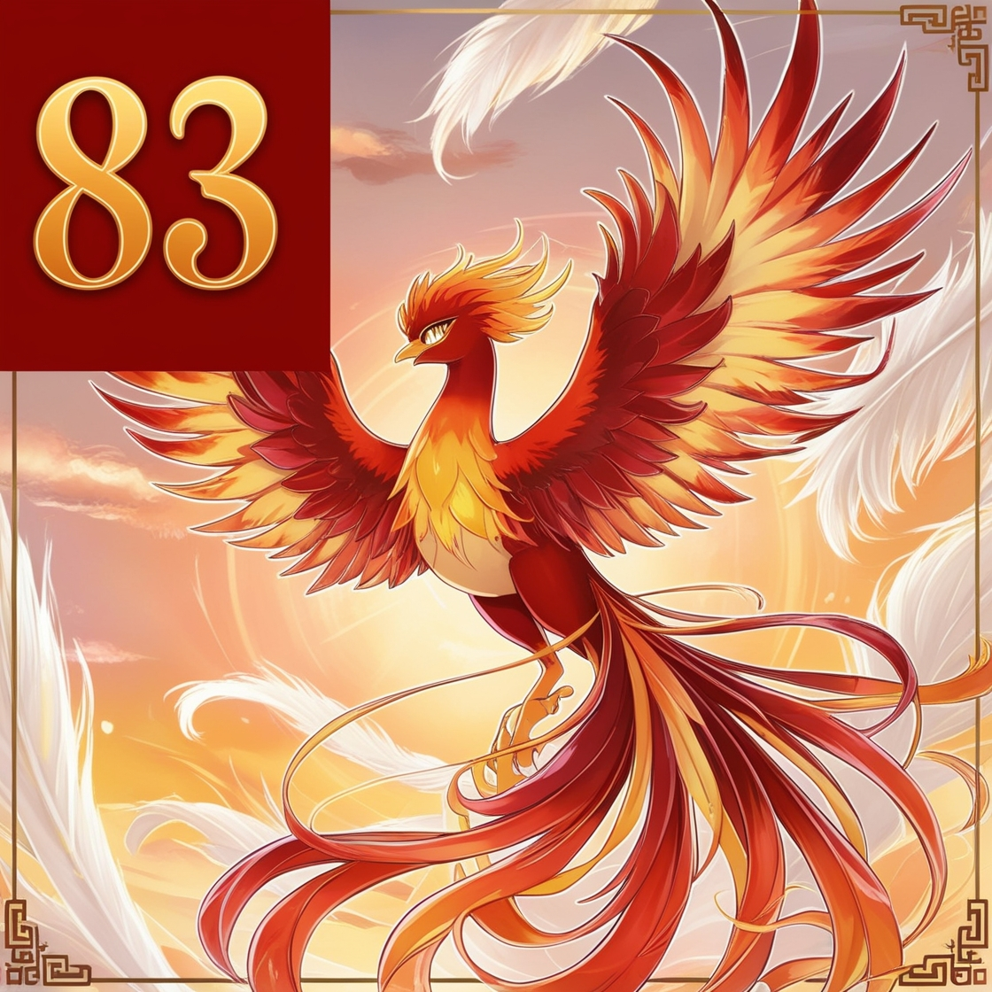



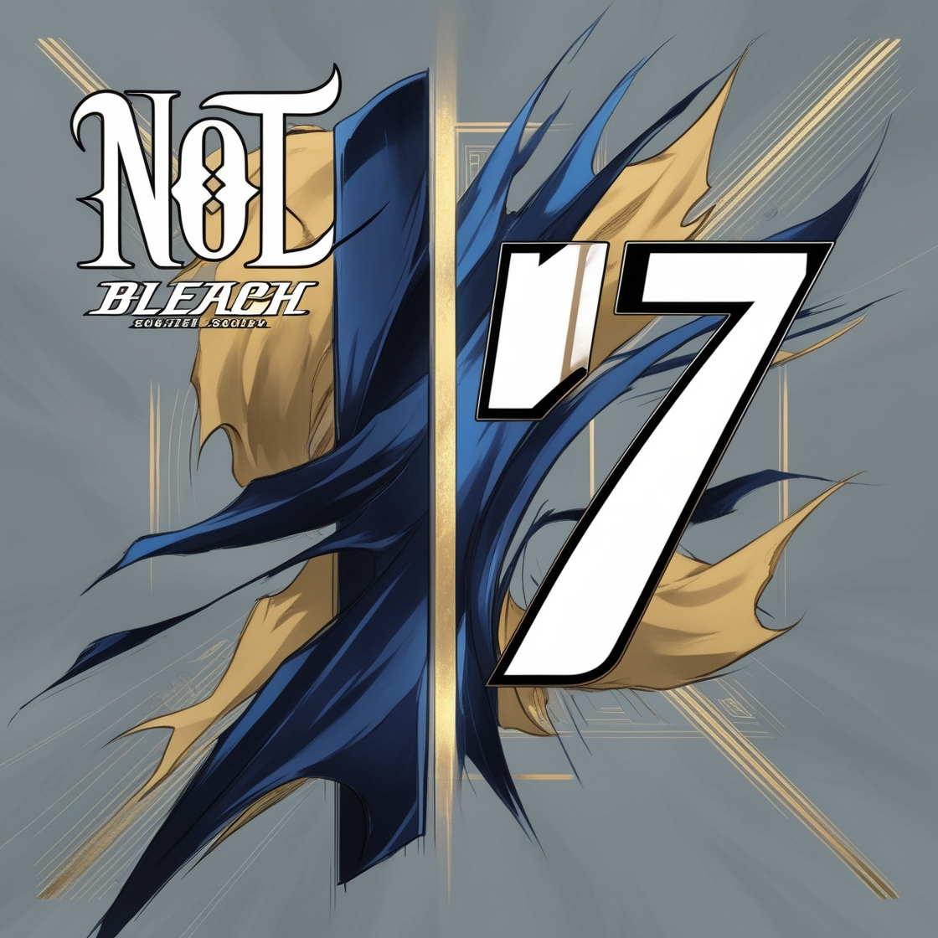



Shinigami: Decode it If you can!!!!! 😂😂😂😂😂😂😂

IF YOU REALLY ENJOYED THIS ROUND JUST GIVE A POSITIVE FEEDBACK TO ANY ONE OF UR EVENT CO-ORDINATOR AFTER COMPLETING THIS ROUND 🤝😊 🤝😊 🤝😊

By your Beloved Author:

Event Coordinator as Shinigami 😂😂