Shinigami,Mr Brain, Sandy: Ohh jeez man you are doing good you are just an digit away from capturing the Secret Key so be prepared for this!!!

Shinigami: Oh my god you made it till here its great achievement no worries you can leave now and resign from this World hahahahaa

Shinigami: Coz u never gonna find the Last 6th digit of the Secret Key because Unlike others this time I had not hidden it in the Realm of Words.. but in the realm of Landscapes, Potraits and in Images..

I beleive image speaks more than words!!!!!



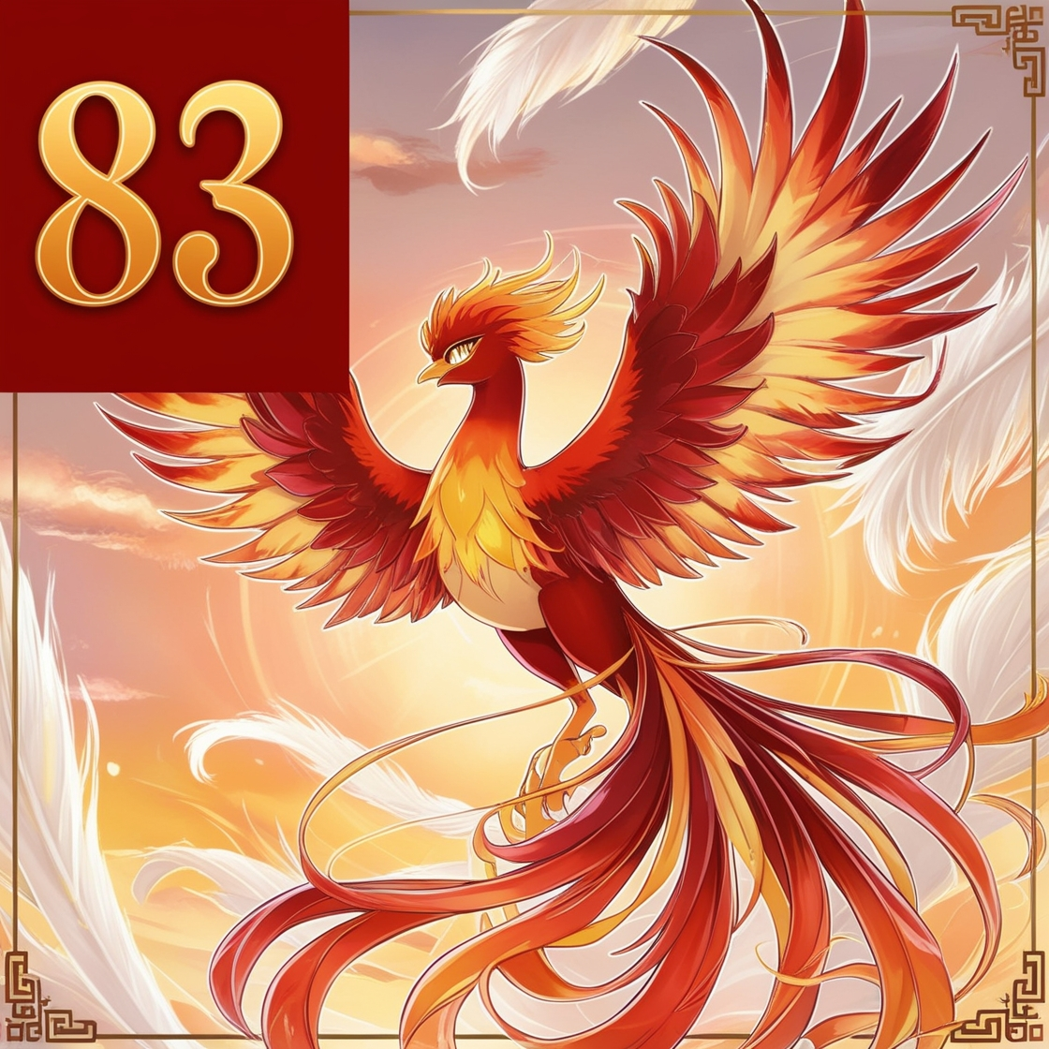



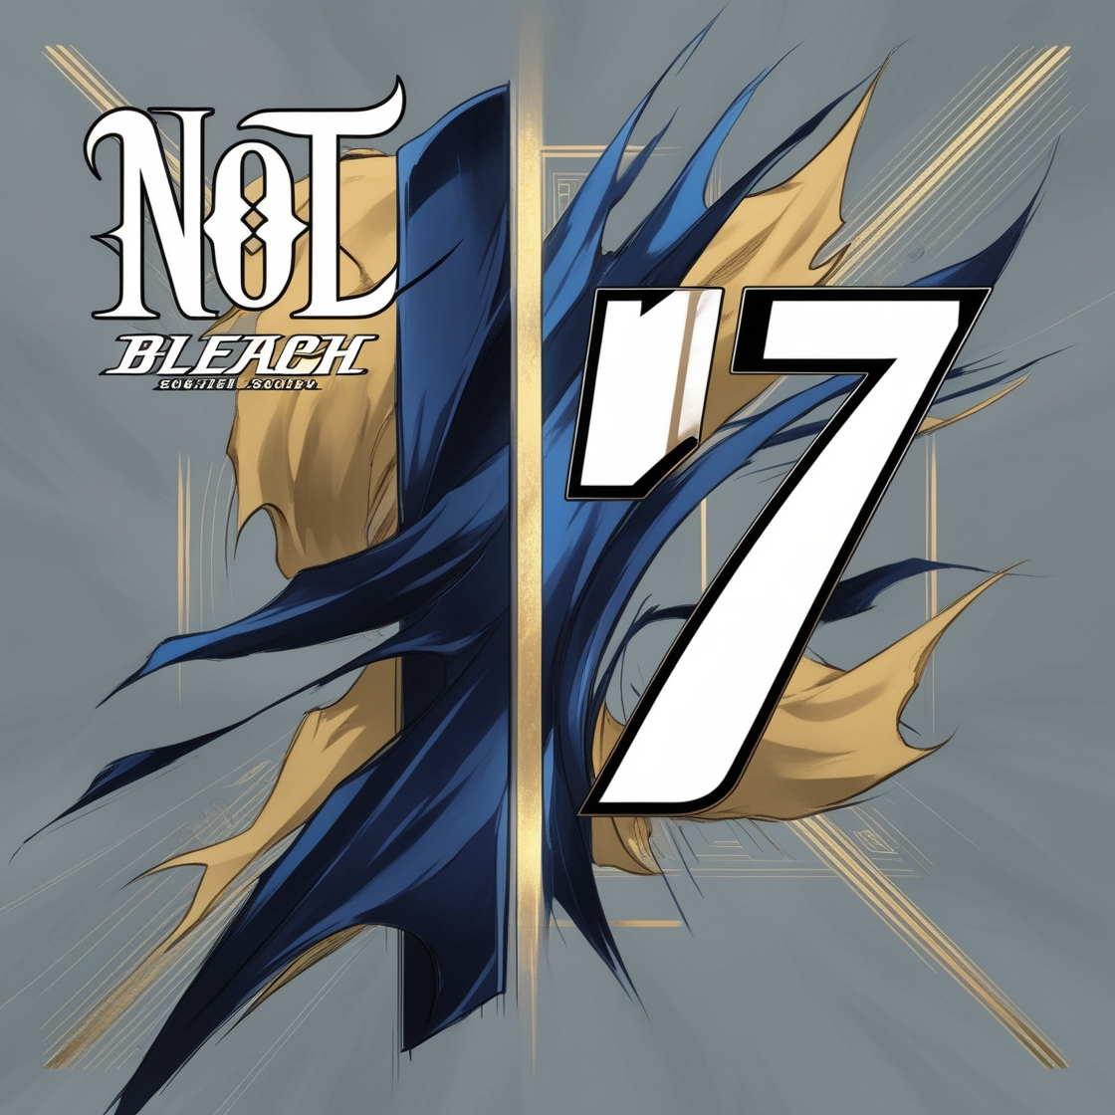



Shinigami: Decode it If you can!!!!!

By your Beloved Shinigami!!!