CLASS EXERCISE 1:

**package** com.Test.Test;

**import** org.testng.annotations.Test;

**import** org.testng.Assert;

**import** org.testng.annotations.DataProvider;

**public** **class** d91 {

@Test(dataProvider = "dp")

**public** **void** add(Integer n1, Integer n2) {

**int** n3=6;

**int** n4=n1+n2;

Assert.*assertEquals*(n3,n4);

System.***out***.println(n4);

}

@Test(dataProvider = "dp")

**public** **void** subtract(Integer n1, Integer n2) {

**int** n3=2;

**int** n4=n1-n2;

Assert.*assertEquals*(n3,n4);

System.***out***.println(n4);

}

@Test(dataProvider = "dp")

**public** **void** multiply(Integer n1, Integer n2) {

**int** n3=8;

**int** n4=n1*n2;

Assert.*assertEquals*(n3,n4);

System.***out***.println(n4);

}

@Test(dataProvider = "dp")

**public** **void** divide(Integer n1, Integer n2) {

**int** n3=2;

**int** n4=n1/n2;

Assert.*assertEquals*(n3,n4);

System.***out***.println(n4);

}

@DataProvider

**public** Object[][] dp() {

**return** **new** Object[][] {

**new** Object[] { 4, 2 }

};

}

}

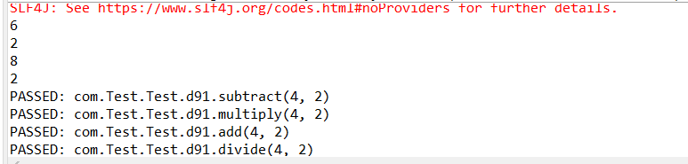

CLASS EXERCISE 2:

**package** com.Test.Test;

**import** java.util.concurrent.TimeUnit;

**import** org.openqa.selenium.By;

**import** org.openqa.selenium.WebDriver;

**import** org.openqa.selenium.chrome.ChromeDriver;

**import** org.openqa.selenium.chrome.ChromeOptions;

**import** org.testng.Assert;

**import** org.testng.annotations.Test;

**import** io.github.bonigarcia.wdm.WebDriverManager;

**public** **class** d92 {

WebDriver d;

@Test

**public** **void** f1() {

ChromeOptions co=**new** ChromeOptions();

co.addArguments("--remote-allow-origins=*");

WebDriverManager.chromedriver().setup();

d=**new** ChromeDriver(co);

d.get("https://www.godaddy.com/en-in");

d.manage().window().maximize();

String eurl="https://www.godaddy.com/en-in";

String curl=d.getCurrentUrl();

Assert.assertEquals(eurl,curl);

String etitle="Domain Names, Websites, Hosting & Online Marketing Tools - GoDaddy IN";

String ctitle=d.getTitle();

Assert.assertEquals(etitle, ctitle);

d.close();

}

@Test

**public** **void** f2() {

ChromeOptions co=**new** ChromeOptions();

co.addArguments("--remote-allow-origins=*");

WebDriverManager.chromedriver().setup();

d=**new** ChromeDriver(co);

d.get("https://www.godaddy.com/en-in");

d.manage().window().maximize();

d.manage().timeouts().implicitlyWait(10,TimeUnit.SECONDS);

d.findElement(By.xpath("//*[@id=\"id-631b049a-e9c0-4d24-8710-c504745206dd\"]/div[2]/div[1]/ul/li[1]/button")).click();

d.findElement(By.xpath("//*[@id=\"id-631b049a-e9c0-4d24-8710-c504745206dd\"]/div[2]/div[1]/ul/li[1]/div/div[2]/div[1]/ul/li[2]/a")).click();

d.close();

}

@Test

**public** **void** f3() {

ChromeOptions co=**new** ChromeOptions();

co.addArguments("--remote-allow-origins=*");

WebDriverManager.chromedriver().setup();

d=**new** ChromeDriver(co);

d.get("https://www.godaddy.com/en-in");

d.manage().window().maximize();

d.manage().timeouts().implicitlyWait(10,TimeUnit.SECONDS);

d.findElement(By.xpath("//*[@id=\"id-631b049a-e9c0-4d24-8710-c504745206dd\"]/div[2]/div[1]/ul/li[1]/button")).click();

d.findElement(By.xpath("//*[@id=\"id-631b049a-e9c0-4d24-8710-c504745206dd\"]/div[2]/div[1]/ul/li[1]/div/div[2]/div[1]/ul/li[2]/a")).click();

String et="GoDaddy Domain Search - Buy and Register Available Domain Names";

String ct=d.getTitle();

System.out.println(ct);

Assert.assertEquals(et,ct);

d.close();

}

}

CLASS EXERCISE 3: