ANMIAL SPECIES DATABASE
ABSTRACT:

An animal species database is a collection of comprehensive information on various species of animals, including their taxonomic classification, physical characteristics, habitat, behavior, and geographical distribution. Such databases serve as valuable resources for researchers, conservationists, educators, and the general public to enhance their understanding of the diversity and complexity of the animal kingdom. The abstract aims to provide a brief overview of the importance of animal species databases and their potential applications in various fields.

ENTITIES USED:
- Location Sighting
- Behavior
- Diet
- Habitat
- Species

ER-DIAGRAM:
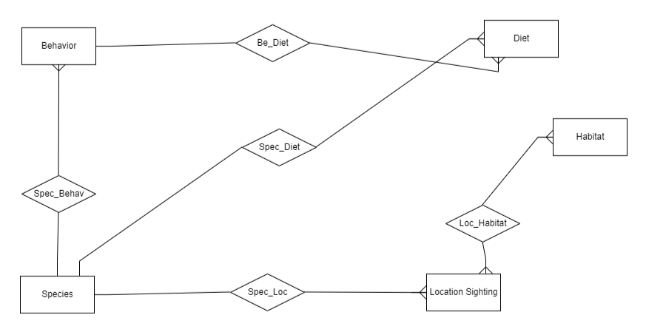

CREATE TABLE LocationSighting (
sighting_id INT PRIMARY KEY,
species_id INT NOT NULL,
location VARCHAR(255) NOT NULL,
date_time DATETIME NOT NULL,
observer_name VARCHAR(255) NOT NULL,
FOREIGN KEY (species_id) REFERENCES Species(species_id)
);
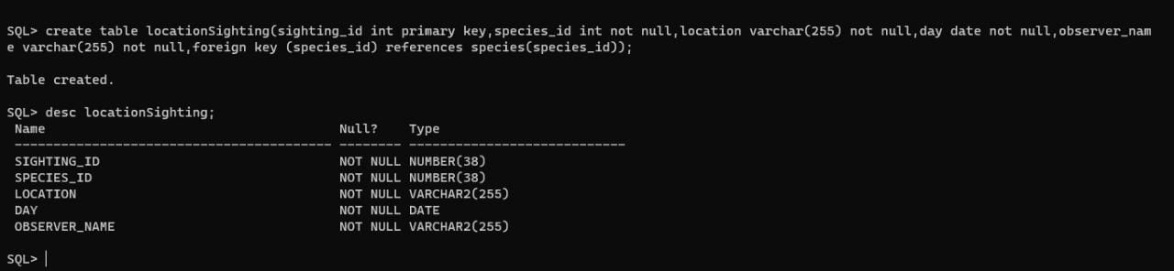

CREATE TABLE Behavior (
behavior_id INT PRIMARY KEY,
species_id INT NOT NULL,
social_structure VARCHAR(255) NOT NULL,
mating_habit VARCHAR(255) NOT NULL,
communication_method VARCHAR(255) NOT NULL,
FOREIGN KEY (species_id) REFERENCES Species(species_id)
);
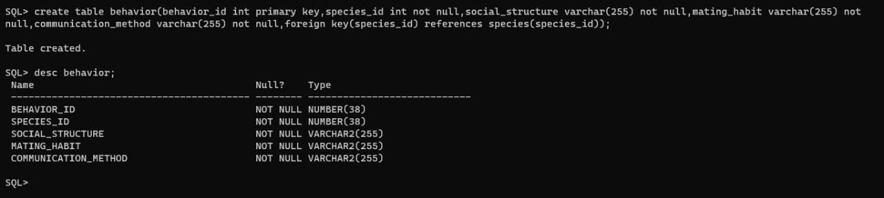
CREATE TABLE Diet (
diet_id INT PRIMARY KEY,
species_id INT NOT NULL,
food_type VARCHAR(255) NOT NULL,
feeding_habit VARCHAR(255) NOT NULL,
dietary_restrictions VARCHAR(255) NOT NULL,
FOREIGN KEY (species_id) REFERENCES Species(species_id)
);
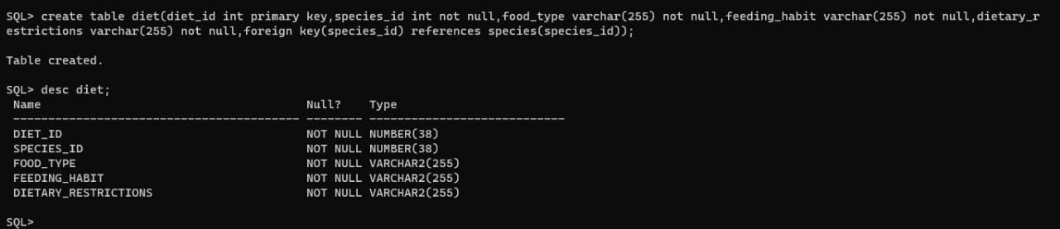
CREATE TABLE Habitat (
habitat_id INT PRIMARY KEY,
habitat_type VARCHAR(255) NOT NULL,
location VARCHAR(255) NOT NULL,
temperature FLOAT NOT NULL,
precipitation FLOAT NOT NULL
);
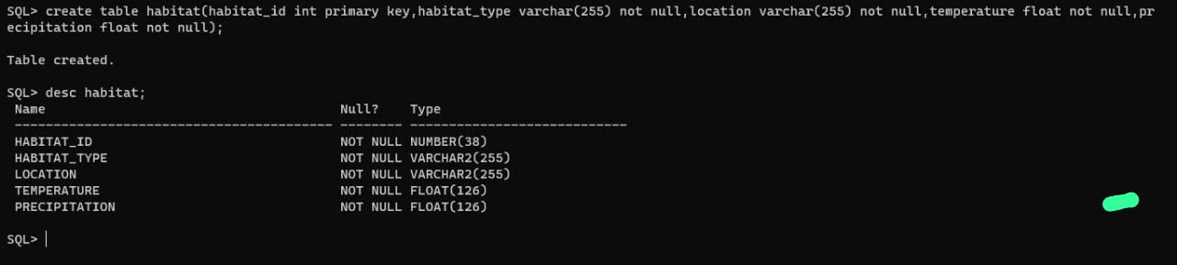

CREATE TABLE Species (
species_id INT PRIMARY KEY,
common_name VARCHAR(255) NOT NULL,
scientific_name VARCHAR(255) NOT NULL,
conservation_status VARCHAR(255) NOT NULL
);
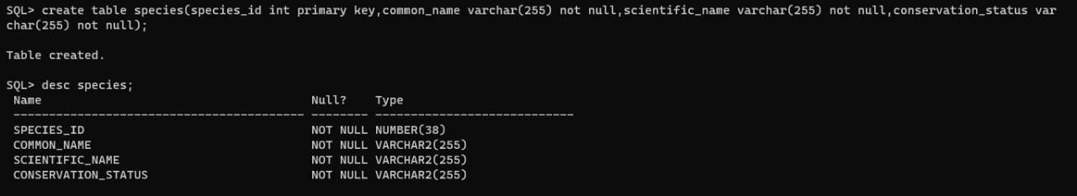

INSERT INTO Behavior (behavior_id, species_id, social_structure, mating_habit, communication_method)
VALUES (1, 1, 'Herd', 'Polygamous', 'Vocalizations'),
(2, 2, 'Solitary or territorial', 'Polygamous', 'Vocalizations and scent marking'),
(3, 3, 'Solitary', 'Monogamous', 'Vocalizations'),
(4, 4, 'Solitary or in small groups', 'Unknown', 'Songs and calls'),
(5, 5, 'Solitary or territorial', 'Polygamous', 'Vocalizations and scent marking');
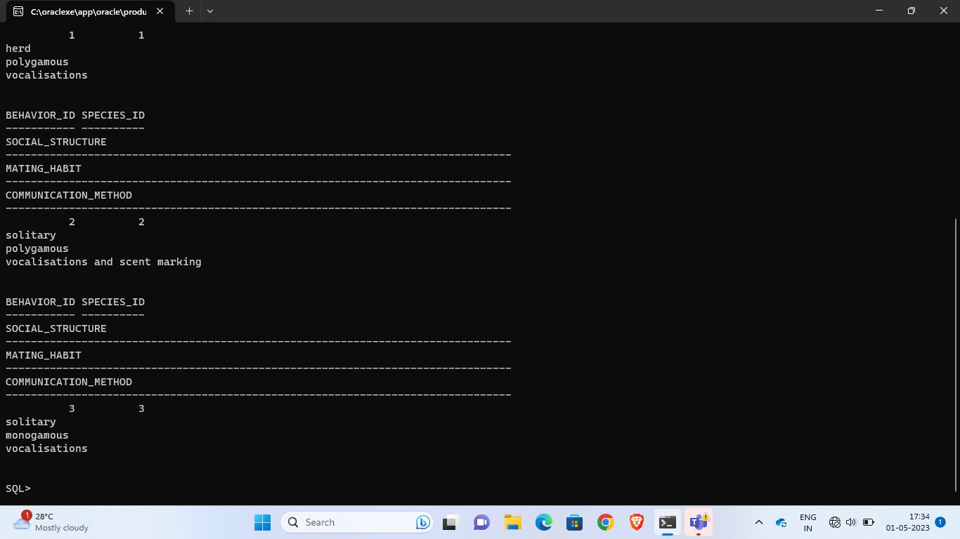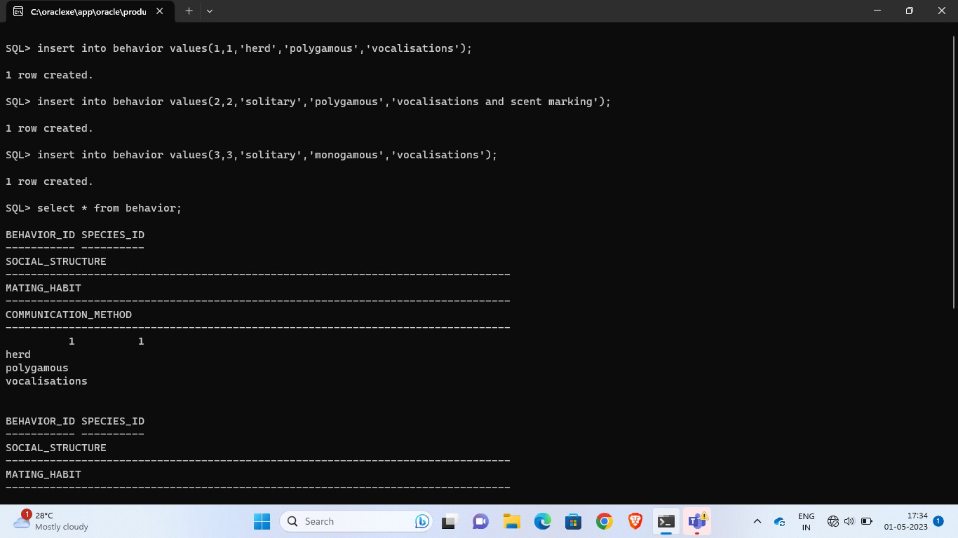

INSERT INTO Diet (diet_id, species_id, food_type, feeding_habit, dietary_restrictions)
VALUES (1, 1, 'Grass', 'Herbivorous', 'None'),
(2, 2, 'Meat', 'Carnivorous', 'None'),
(3, 3, 'Bamboo', 'Herbivorous', 'None'),
(4, 4, 'Krill', 'Filter feeder', 'None'),
(5, 5, 'Wild goats, sheep, and ibex', 'Carnivorous', 'None');
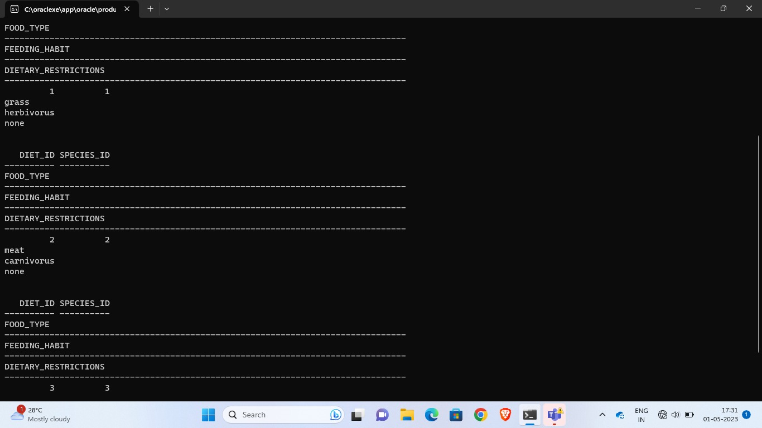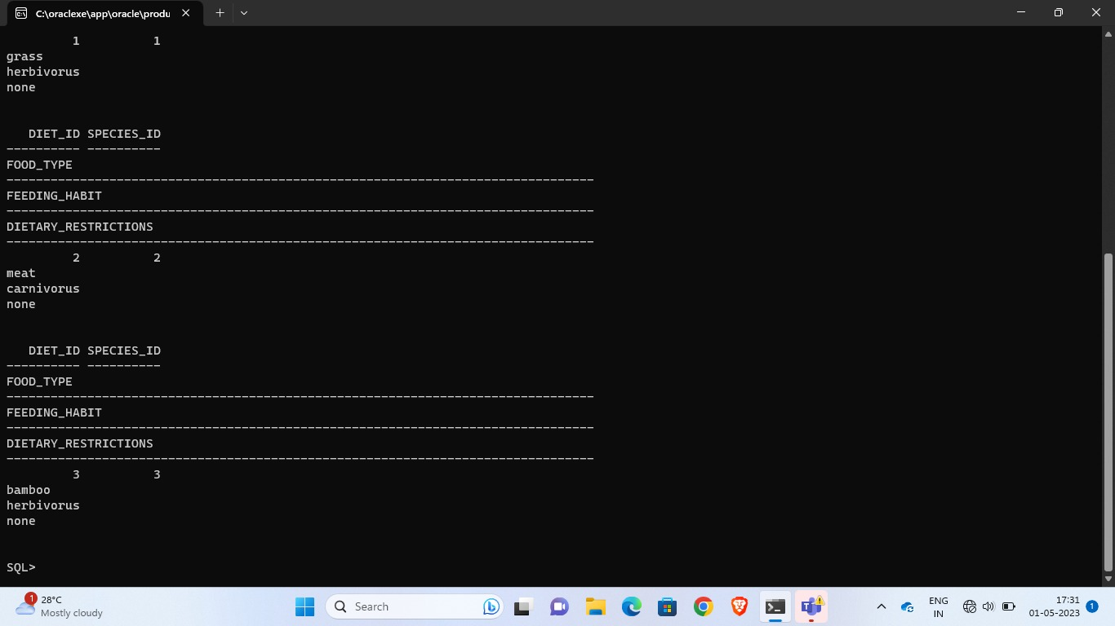

INSERT INTO Habitat (habitat_id, habitat_type, location, temperature, precipitation)
VALUES (1, 'Tropical rainforest', 'Amazon Basin', 25.0, 2000.0),
(2, 'Savanna', 'Serengenti', 30.0, 500.0),
(3, 'Temperate forest', 'Appalachian Mountains', 10.0, 1000.0),
(4, 'Arctic tundra', 'Alaska', -10.0, 250.0),
(5, 'Coral reef', 'Great Barrier Reef', 25.0, 2000.0);
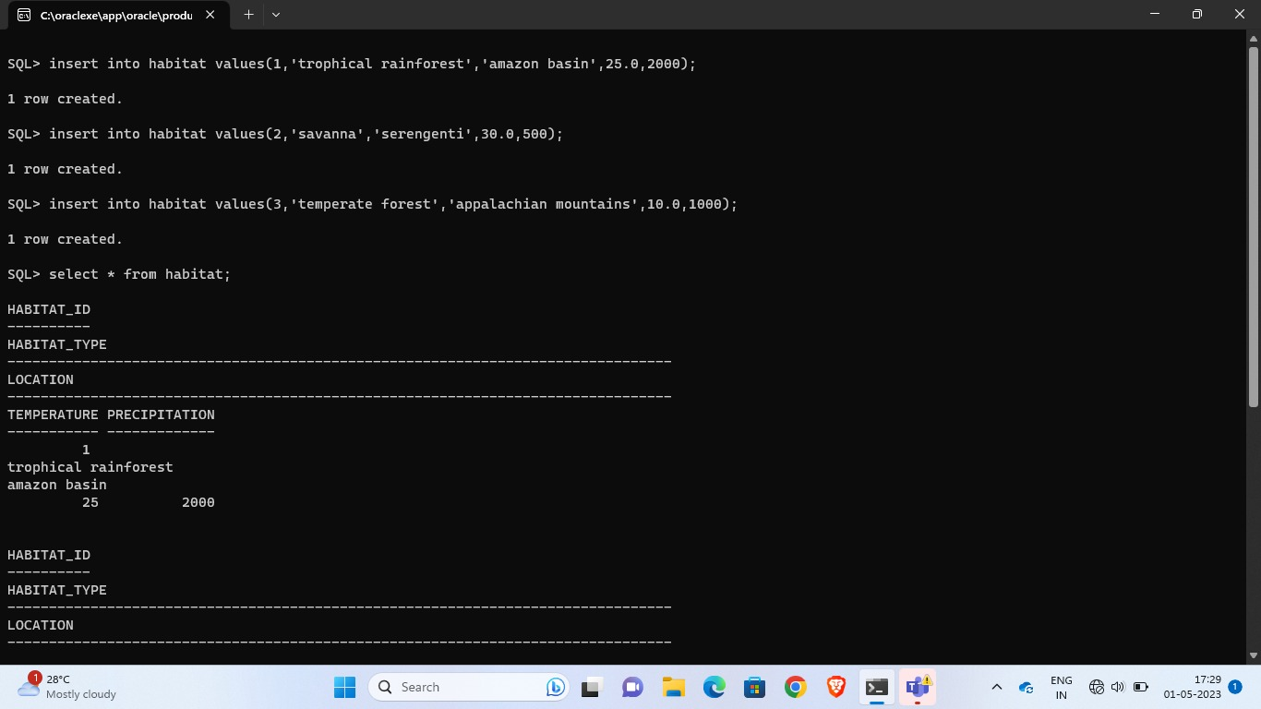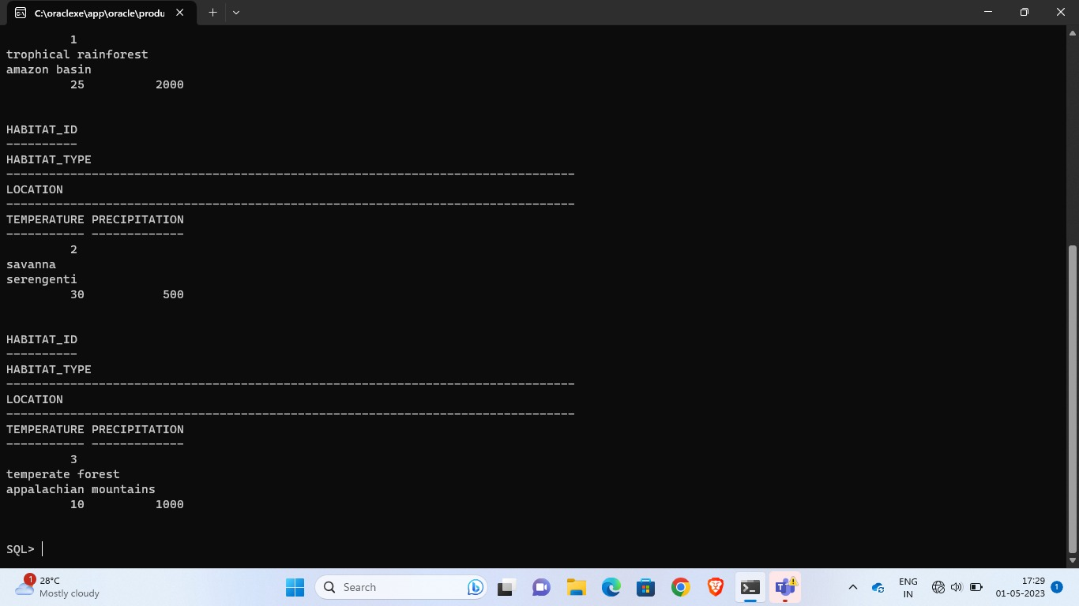

INSERT INTO Species (species_id, common_name, scientific_name, conservation_status)
VALUES (1, 'African elephant', 'Loxodonta africana', 'Vulnerable'),
(2, 'Bengal tiger', 'Panthera tigris tigris', 'Endangered'),
(3, 'Giant panda', 'Ailuropoda melanoleuca', 'Vulnerable'),
(4, 'Blue whale', 'Balaenoptera musculus', 'Endangered'),
(5, 'Snow leopard', 'Panthera uncia', 'Vulnerable');
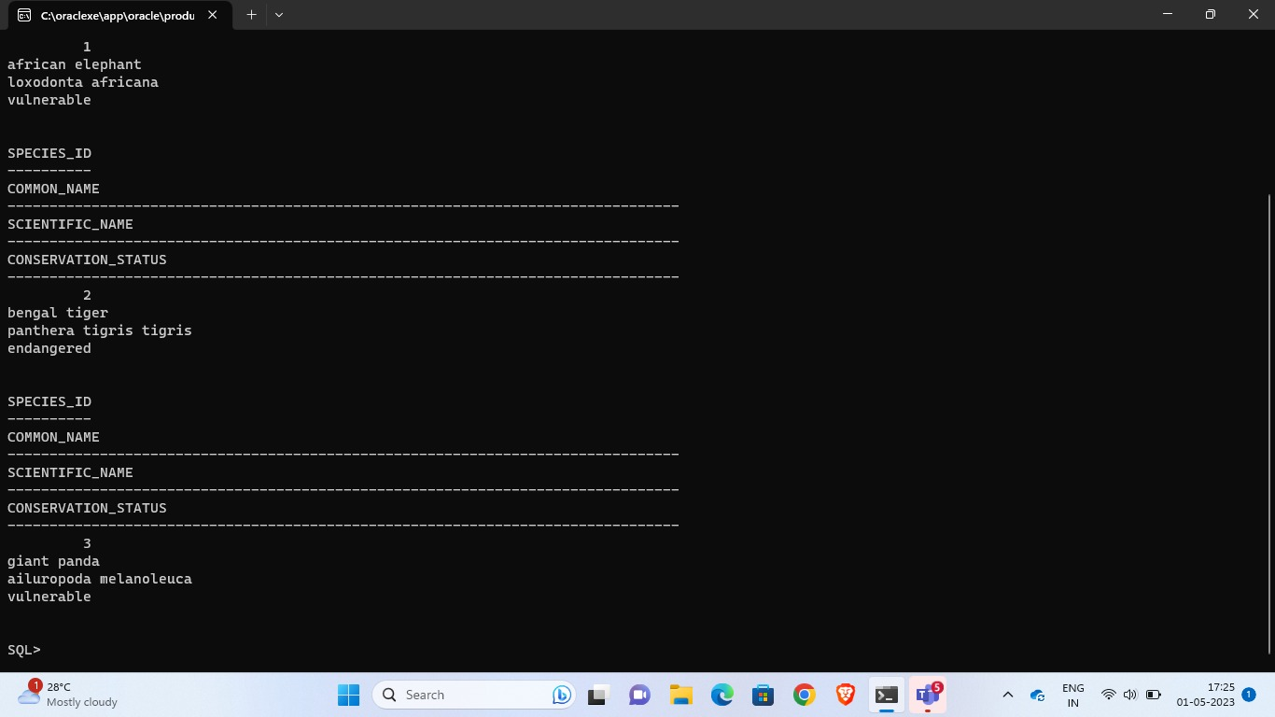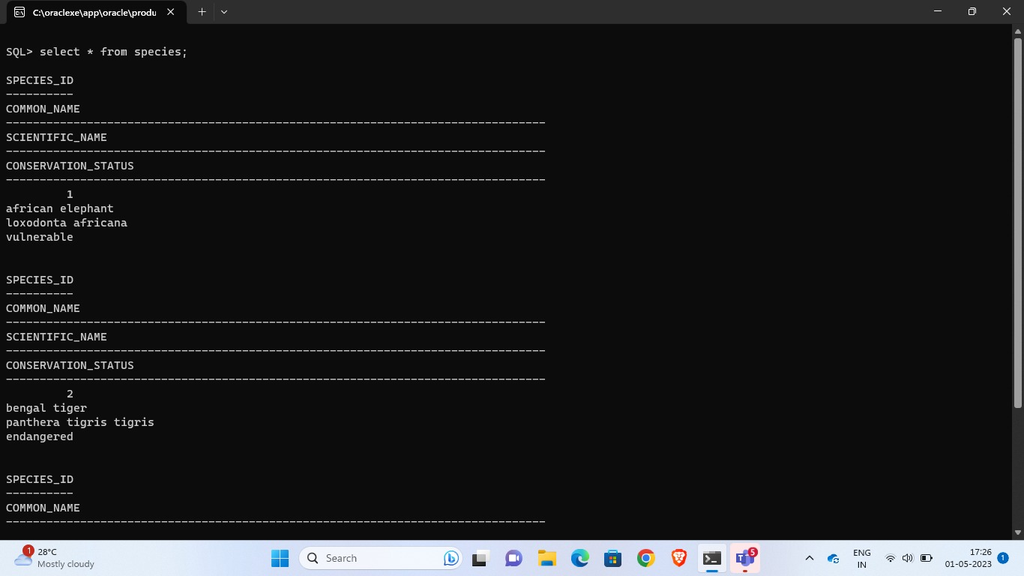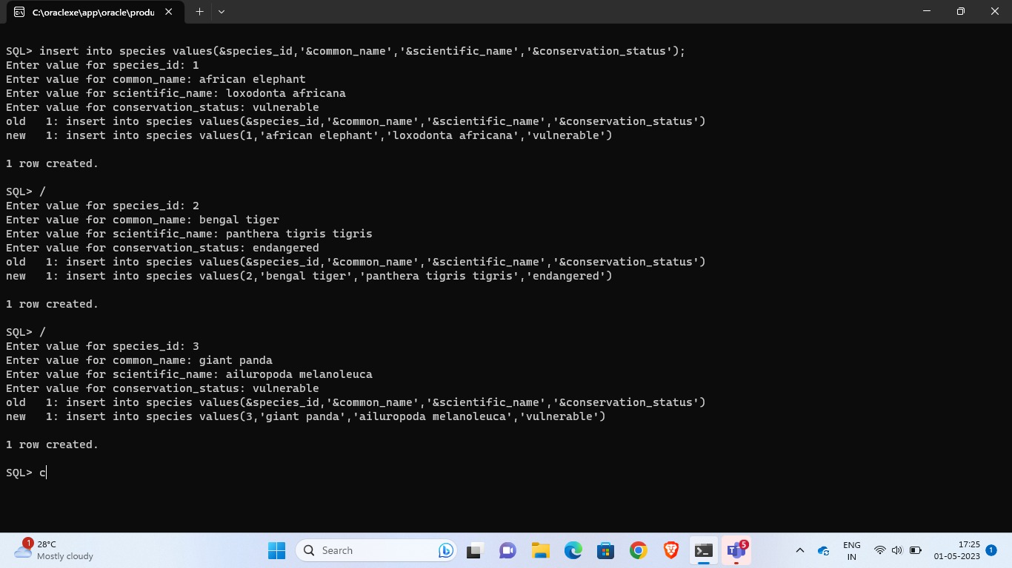

INSERT INTO LocationSighting (sighting_id, species_id, location, date_time, observer_name)
VALUES (1, 1, 'Kruger National Park, South Africa', '2022-04-15 10:30:00', 'John Doe'),
(2, 2, 'Sundarbans, Bangladesh', '2022-02-25 15:45:00', 'Jane Smith'),
(3, 3, 'Sichuan Province, China', '2022-03-10 08:00:00', 'Alice Brown'),
(4, 4, 'Gulf of Maine, USA', '2022-01-20 12:15:00', 'Bob Green'),
(5, 5, 'Himalayas, Nepal', '2022-05-01));
