1. Git-HOL
   1. Clone the repository cd ~/Desktop

git clone https://gitlab.com/Srihitha_Simhadri/GitDemo.git cd GitDemo

* 1. Set local Git identity (one-time for the repo) git config user.name "Srihitha Simhadri"

git config user.email ["srihithasimhadri@gmail.com"](mailto:srihithasimhadri@gmail.com)

* 1. Create and switch to a new branch git checkout -b GitNewBranch
  2. Verify branches git branch -a
  3. Open project in VS Code & add a file code .

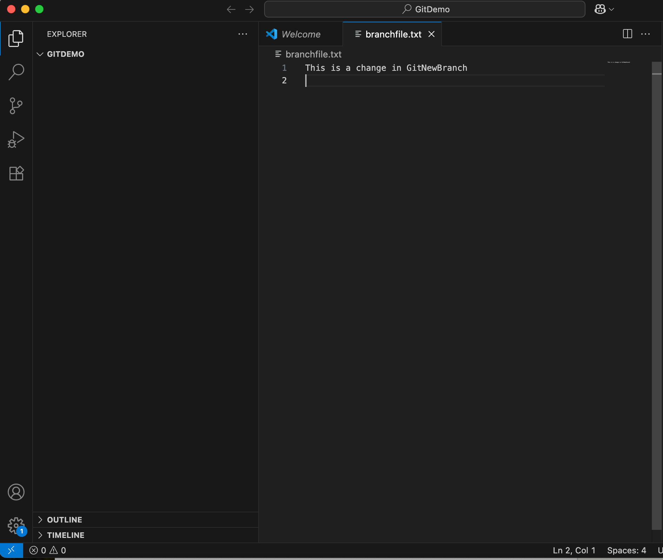

* 1. Stage, commit, and push the branch git add branchfile.txt

git commit -m "Add branchfile.txt in GitNewBranch”

* 1. On GitLab) Create & Merge the Merge Request

Visit the MR creation link provided by the push output or go to **Project → Merge requests →**

**New merge request**.

Set Source branch = GitNewBranch, Target branch = main. Create MR, review, and click **Merge**.

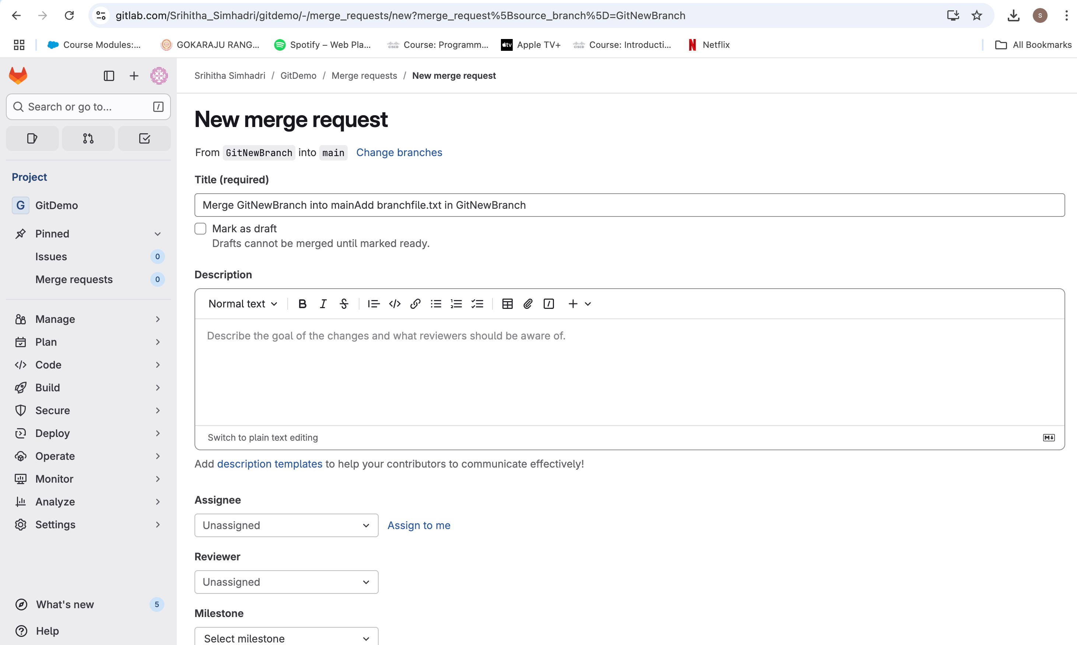

* 1. Get the merged changes into local main git checkout main

git pull origin main

* 1. Delete the local branch

git branch -d GitNewBranch

