Minimizing Cognitive Load in Drug Queries: A Keyword-Driven, User-Centric, Summarization based Solution
Karpakavalli M¹, Manimegalai R², Harishankar G R³, Aswin K⁴
¹Karpagam College of Pharmacy, , Coimbatore, 641032, India
²PSG Institute of Technology and Applied Research, , Coimbatore, 641062, India

Abstract

Purpose: Exhaustive and in-depth pharmaceutical research has elevated the need for efficient and reliable drug information retrieval systems. Traditional medical resources often present unstructured, lengthy content, leading to cognitive overload and inefficiency in healthcare research for both professionals and patients. This study proposes automated, structured, and concise drug information from multiple authoritative medical sources for reducing the cognitive load in drug information retrieval.
Methods: The proposed methodology consists of both web scrapping and API based data extraction and the parameters like interactions and mechanism of actions which are generally structured in paragraphs are subjected to biomedical semantic text summarization[16]. While python libraries such as BeautifulSoup, lxml, Selenium offer sequential navigations for structured data retrieval, multi-threading and batch processing optimizes the script’s performance.
Results: The system was able to extract drug profiling information for about 519 medications including dosage (444 records), side effects (423 records), interactions, target receptors and pharmacological actions (392 each), and adverse drug reactions (519), and drug class (519). Automation in information retrieval significantly reduced the extraction time, and the complete database, which included 8 drug parameters for all 519 drugs, took around 20 hours of runtime.
Conclusions: The study demonstrates a reliable, scalable and automated solution for the drug information retrieval, mitigating cognitive load and improvising research efficiency.

Keywords: Drug information retrieval, pattern matching, API integration, web scraping, cognitive load reduction

- Introduction

The rapid expansion of pharmaceutical research has been coupled with increasing drug utilization and along with that knowing the drug information and easy to information retrieval systems. The physicians, pharmacists, and scientists on the one hand, and the public on the other rely heavily on up-to-date and reliable drug-related information in order to make informed decisions. Crucial information such as drug-drug and drug-food interactions, dose, side effects, pharmacological actions, target receptors, active pharmaceutical ingredients and side effects are of utmost importance to render the patient safe and optimal in its therapeutic effect. With all this drug information at one’s fingertips through websites such as Drugs.com, PubMed, DrugBank, RxNorm, openFDA and MedlinePlus, getting relevant information at pace and with efficiency is usually the problem for their users. Traditional drug databases and websites typically contain material in the form of long, unstructured ones such as long paragraphs or spread over multiple web pages. This lack of uniformity forces the user to navigate through gigantic content manually, a process that not only consumes time but is also intellectually exhausting. Cognitive overload—a state in which information complexity or volume is in excess of a person’s processing ability—prone to create mistakes, delays, and frustration, particularly in high-stakes clinical applications in which prompt availability of correct information is critical. Moreover, conventional database curation methods are based significantly on human data input and manual update, suffer from human fallibility, and scalability issues, and cannot keep pace with the ever-growing volume of biomedical literature.

1.1 Automated Drug Information Retrieval
As a counter to such challenges, this work conceives of an automated, rule-based and keyword-based solution to extract and display structured drug information. With a combination of pattern matching, web scraping, and API calls. This answer circumvents the tedium of manual browsing and yields organized, user-friendly results. The structure is optimal and cognitively efficient by yielding short, categorized, and browsable information to enable users to locate targeted drug features—such as dose, interactions, or side effects—with minimal effort invested. The foundation for this approach is the webscrapping techniques for HTML tags navigation to retrieve the structured drug information from huge volume of unstructured data. Web scraping comes in handy for the scraping and parsing of data from well-liked websites like Drugs.com, DrugBank and MedlinePlus. Python libraries such as BeautifulSoup and lxml are utilized to parse HTML content, identify relevant sections (e.g., "Side Effects" or "Interactions") with ID and class attribute values of HTML tags, and transform them into clean structured formats like CSV or Pandas DataFrames. Other than being carried out in the sake of efficiency, consistency and reproducibility are assured.

1.2 Implementation Challenges and Optimization
The difficulties which we faced in creating such a minimal-cognitive drug database was information research where most of the open source drug information were in huge and unstructured texts and the code execution for information retrieval for each of the parameters mentioned for each of the 519 drugs took significant amount of time, like 4 – 12 hours, which was later optimized such that the entire drug database for the 519 drugs was able to develop within 20 hours with all techniques performed. Besides supplementing the dataset, the system includes APIs of leading biomedical shops, including openFDA for active pharmaceutical ingredients, adverse drug reacitons and RxNorm for drug dosage information. These APIs provide programmatic access to high-quality up-to-date data which is in JSON format, without manual cross- referencing and avoiding stale or incorrect data. For example, the openFDA API supports querying adverse event reports for specific drugs, while the RxNorm API maps drug names to normalized standard identifiers (RxCUIs) and provides dosage form information. The proposed methodology also comprises robust data preprocessing and cleansing procedures to handle inconsistencies such as missing information or duplicate entries. Tokenization, stopword elimination, and deduplication are some of the methods to ensure that the data retrieved are clean, consistent, and available for examination or presentation. By means of automation, the system reduces effort otherwise manually required to update or keep databases.

1.3 Impact and Applications

The ramifications of this work extend beyond the productivity gains. By making drug information look-up more effective, this approach can potentially enhance clinical decision-making, reduce medication errors, and maximize patient outcomes. To clinicians, having access to structured, reliable data in seconds instead of minutes or hours can decrease mental fatigue, allowing them to focus on patient care rather than data hunting. To researchers, computer-aided extraction of drug attributes will hasten literature review and meta-analysis. And to patients, drug fact summaries in readable format can enable better self- management and pill-taking adherence. In addition to the web scrapping techniques and API calls, biomedical text summarization has also been implemented exclusively for the drug-drug and drug-food interactions and for the mechanism of actions, since the extracted information were quite large for some of the drugs. This summarization helps in reducing some of the huge text content and helps disclosing the important information on the parameters: interactions and mechanism of actions, so that the data wouldn’t be showing complex biomedical information and rather shows minimal and necessary information on the mentioned 2 parameters.
Summarily, this paper presents an extensible, rule-based approach to drug information retrieval for overcoming the limitations of traditional databases. The integration of pattern matching, web scraping, and API incorporation along with biomedical text summarization, has the ability to make the structured drug information in order to reduce cognitive load and render it more accessible. The subsequent sections describe the methodology, findings, and applications of the proposed method and reveal the potential to revolutionize drug information accessibility and utilization in professional and public environments.

- Methods and Tools
The methodology integrates the above mentioned automated data retrieval in an automated manner from multiple authoritative sources to construct a unified drug information database.
The pipeline illustrated in the Figure 1 explains the end-to-end drug information extraction, where the input data is processed through several stages: API calls for side effects, active pharmaceutical ingredients and dosage information, web scrapping for drug interactions, mechanism of actions and target receptors which are subjected to biomedical semantic text summarization [16].

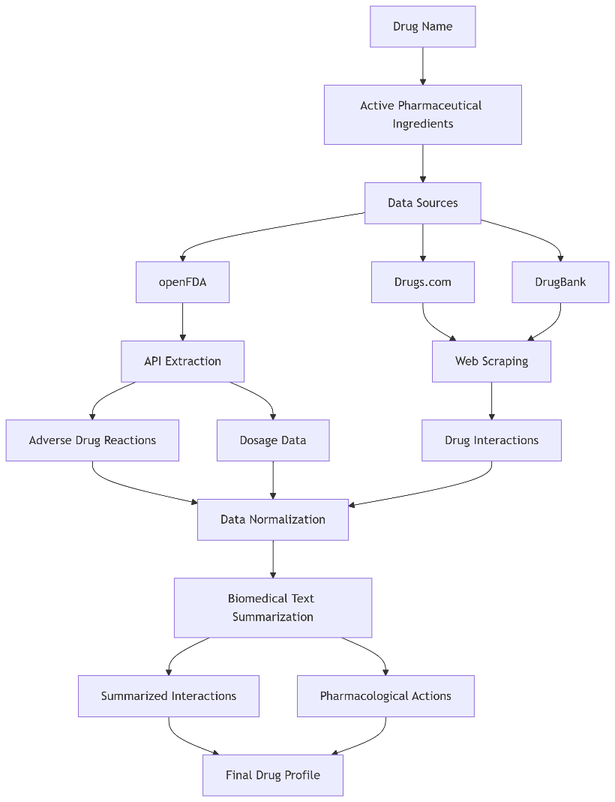
Figure 1: Flow Diagram Illustrating the Overall Information Retrieval

  - Structured Data Extraction from Drugs.com

Information supplied by Drugs.com is collected systematically with the help of web scraping technologies, for which requests library sends HTTP requests and BeautifulSoup and lxml are employed to parse HTML pages for retrieving useful data. Web scraping has been used effectively in healthcare contexts for alleviating information overload by automated access to organized information, complementing future AI-based systems such as NAOMI, which alleviate cognitive load in clinical contexts [1].
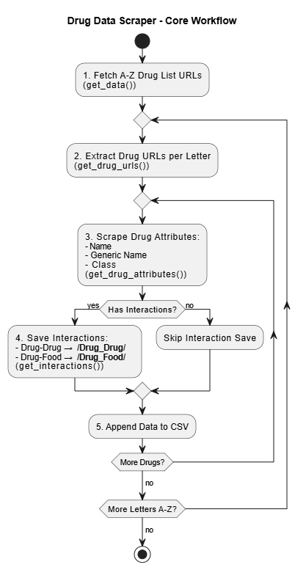
Figure 2: Workflow Illustration of Drug Data Scrapping and Interaction Mapping

The web scraping approach used here systematically and hierarchically extracts drug interaction information as demonstrated in the Figure 2. The traversal starts from the root URL [], navigating through the drug index pages in alphabetical order, ensuring comprehensive data coverage. The main output data includes the drug name, class name, generic name, and the respective drug interaction information saved in structured CSV format and text format for further analysis. The scraping process highly relies on tags such as <main> having the container with ID and class ddc-main-container ddc-width-container to locate the main content areas. <div> blocks labeled ddc-related-link-group are used by the scraping tool for drug interactions and navigated through nested <nav>, <ul>, and <li> elements to find hyperlinks and textual information. Side effect information is aggregated from the website MedlinePlus by searching with generic drug names from the CSV file. The <div> with class interaction-reference-header are located by retrieving the relevant article. Side effects are extracted from the <ul> tags containing <li> elements, pipe-separated, and stored before saving it back to the CSV file. Figure 3 is an illustration of the drug queries vs. the time required to perform web scrapping and as visualized, the time required increases with increasing in the number of drug queries.
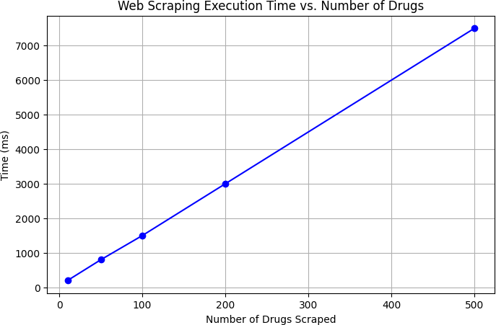

Figure 3: Web Scrapping Execution Time vs. Drug Queries

Hierarchical Scraping: The procedure starts from homepage scraping for the retrieval of drug subcategories and categories. Drug-specific pages are discovered and held aside for full-scale extraction. Hierarchical topic scraping on drug-name, drug-class and interactions.
Data Processing: Redundancy, HTML tags, and unwanted characters are removed by preprocessing. Missing values are substituted with placeholders such as "Nil" or "Uncategorized". This step minimizes user ambiguity and cognitive burden in processing inconsistent drug information [2].
Data Storage: Processed information is retained in various forms, such as CSVs and Pandas DataFrames or in text files. Data can be easily visualized, manipulated, and accessed. Structured representation reduces user effort and cognitive load on information retrieval.

  - Adverse Drug Reactions (ADR) and Active Pharmaceutical Ingredient
The parameters including primary query key, statistical significance filters for ADR. As illustrated in the Figure 4, Adverse Drug Reactions (ADRs) are fetched with openFDA’s Drug Event API by querying drug generic names. Since it involves complex interpretation of side effects information, automation lowers the cognitive load and reduces retrieval errors. Here the ADRs are filtered based on the occurrence frequency, and here the 30 frequently occurred ADRs have been filtered for each of the drugs.Similarly, the Active Pharmaceutical Ingredient for each drug is fetched from openFDA’s API based on the drug generic name as query key and from the obrained json output, the active pharmaceutical ingredient is fetched based on the key-value pair structure of the information, for the database.
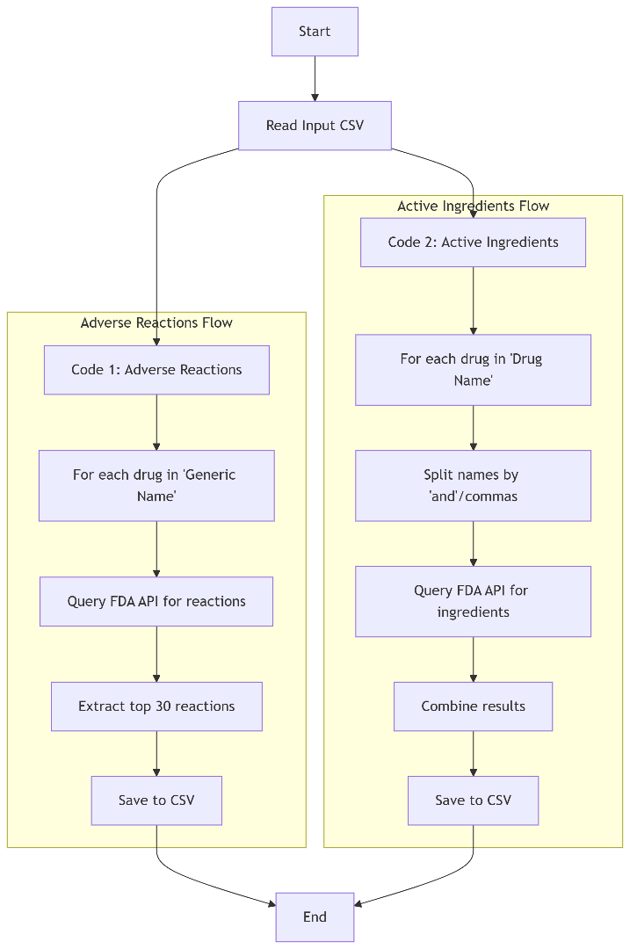
Figure 4: Flowchart of API Data Extraction for Active Ingredients and Adverse Drug Reactions

FDA’s open drug event API is used for the retrieval of adverse reaction information. For each drug name enlisted in the CSV file under the “Generic Name” column, the system queries the API, filtering by the patient. Drug. Medicinal product, and counts the occurrence of each reaction term (patient.reaction.reactionmeddrapt.exact). About 30 common adverse reactions for each of the 519 drugs are extracted by analyzing the response from the API, and the Figure 5 demonstrates the unique ADRs extracted per drug. These results relate each drug to its corresponding adverse reactions and handling the missing data provides an automated and efficient way to gather and store adverse reaction information from FDA records.
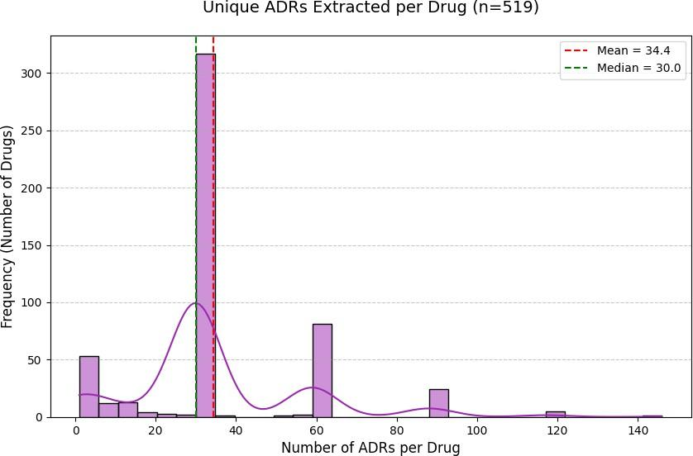

Figure 5: Distribution of Unique ADRs Extracted Across 519 Medications

  - Pharmacological Profiling using DrugBank:
The Python script automates the extraction of the mechanism of actions and target receptor information from DrugBank for 392 drugs of 519 listed in the input CSV file obtained from the web scrapping of Drugs.com. As illustrated in the Figure 6, the program begins processing the CSV file to extract and clean drug names, handling complex entries that may contain multiple drug names separated by commas, “and”, or brackets. These entries are normalized into individual drug names while preserving the original compound names for reference.

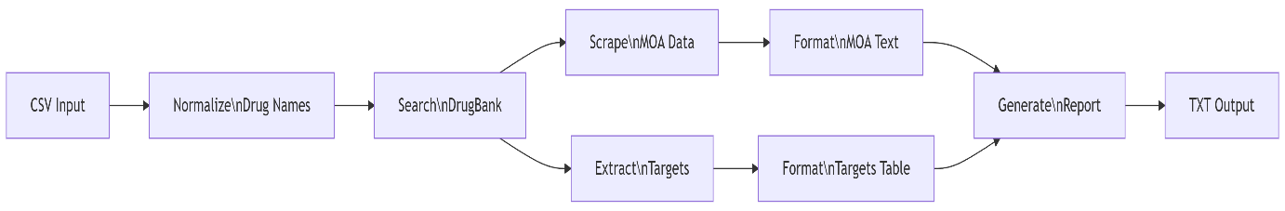
Figure 6: Sequential Extraction of MOA and Receptors

The core functionality uses Selenium WebDriver to automate a chrome browser session that interacts with DrugBank’s website. For each drug, the script performs a search, navigates to the pharmacology section, and extracts the mechanism of actions and target receptor information by locating specific HTML elements such as the mechanism of action section (id=”pharmacology-header”) and its related content tags (<dl>,<dt>,<dd>). The extracted information undergoes regex parsing, careful formatting – mechanisms of action are presented as bullet points, while target information is organized into a structured table and organized text files with columns for Target and Actions.

  - Dosage Standardization via RxNorm API
The workflow illustrated in Figure 7, begins with reading and processing the input CSV file of drug generic names and the script handles complex cases of multiple drug names and ensures that the query contains only one drug name for information availability and less ambiguity. For each drug name encountered, the program first obtains its RxNorm Concept Unique Identifier (RxCUI), which serves as a standardized reference code within the RxNorm system. This initial lookup is crucial as it ensures the subsequent dosage queries are performed on properly identified medications. After obtaining the RxCUI, the script queries the RxNorm API again to retrieve precise dosage information based on the attribute SCDC – Semantically Clinical Drug Component. A notable feature of this implementation is its use of multi-threading through ThreadPoolExecutor, which significantly improves performance by allowing concurrent API requests when processing multiple drug names, which demonstrates practical application of concurrent programming to overcome I/O bottlenecks.

Figure 7: Flowchart for Dosage Data Retrieval using RxCUI Lookup

This automated system extract drug dosage information using the RxNav API. RxNav endpoint is queried with every drug name in the CSV file (../REST/rxcui.json?name={drug_name} for retrieving the RxNorm Concept Unique Identifier (RxCUI). The successful query fetches the respective dosage information from (../REST/rxcui/{rxcui}/related.json?tty=SCDC). The response is parsed for obtaining the dosage strengths which includes units such as mg, ml, mcg, or IU. The process supports concurrent processing of multiple drugs by implementing multi-threading. The results are stored in a CSV file connecting drug names to the dosage information and it also notes the missing data. Figure 8 illustrates the API response time distribution for 519 drugs with individual measurements ranging from 1600-2600 ms and a benchmark K/SIM value of 123 ms, highlighting the real world performance variability.
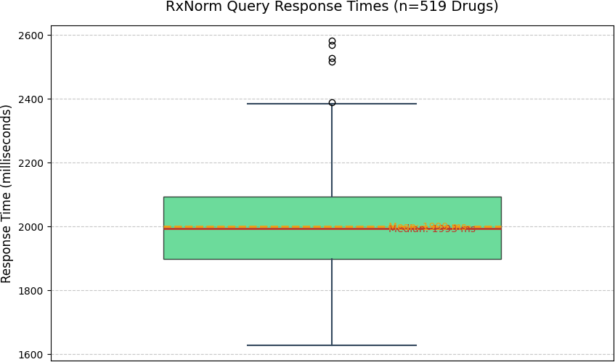
Figure 8: RxNorm API Response Time Distribution for 519 Drug Queries

  - Side Effects Extraction from MedlinePlus
MedlinePlus, an authoritative open-source resource by the U.S. National Library of Medicine (NLM) and National Institutes of Health (NIH), serves as a medical encyclopedia with illustrated articles on diseases, surgeries, and drug-related data. As shown in the Figure 9, the script automates the drug side effect information extraction and systematically queries MedlinePlus for each medication, and compiles the side effect data into an organized output file. The implementation demonstrates web scraping best practices while handling the complexities of medical information retrieval.

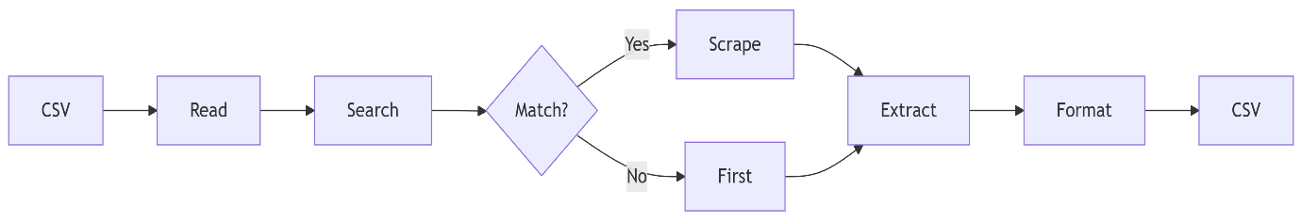
Figure 9: Sequential Web Scrapping of Side Effects

The script operates through a two-phase process, beginning with a search query to MedlinePlus that locates relevant drug articles. It carefully navigates through multiple nested HTML div containers to reach the search results, demonstrating robust handling of complex webpage structures. The program intelligently matches drug names by first looking for exact matches before falling back to the first available article when no perfect match exists. This flexible approach ensures maximum coverage of drug information even when naming conventions vary between the input data and MedlinePlus. After identifying the appropriate article, the script performs detailed scraping of the side effects section. It locates the specific HTML section containing side effect information through systematic traversal of the page structure, then extracts all list items within unordered lists in that section. The extracted data is cleaned and formatted, with multiple side effects joined by pipe characters for clear separation in the output CSV file.

The pipeline spanning scraping and API queries is fully automated, enabling large-scale data collection with minimal intervention. Future cloud-based scaling will support real-time, adaptive systems aligned with intelligent AI design principles. Eliminates multitasking across disparate sources by automating data retrieval. CSV, text, and DataFrame formats minimize ambiguity and enhance accessibility. Performance metrics highlight rapid response times for critical decision-making.

  - Data Quality Validation
Table 1 shows the robust data coverage across important drug attributes. All 519 drugs successfully captured essential identifiers (drug classes and ADRs) while structural and mechanistic data has quite significant coverage (active ingredients: 416/519 and target receptors: 392/519). Notably clinical parameters like side effects (423 records) and dosage information (444 records) achieved around 80% completeness, and similarly drug interactions has a reasonable information coverage. Figure 10 illustrates the data retrieval success rate of each data category used in building the drug information database. It is inferred that the data categories' drug classes' and 'adverse drug reactions' are retrieved with the highest likelihood. The other data including dosage information, drug interactions, side effects, mechanism of action, receptors, and active ingredients are extracted with an average success rate of 78%.

Table 1: Data Completeness Metrics
Data Attribute | Records Retrieved
Drug Names | 519
Drug Classes | 519
Active Ingredients | 416
Side Effects | 423
Dosage Information | 444
Drug Interactions | 392
ADRs | 519
Receptors | 392
Pharmacological Actions | 392

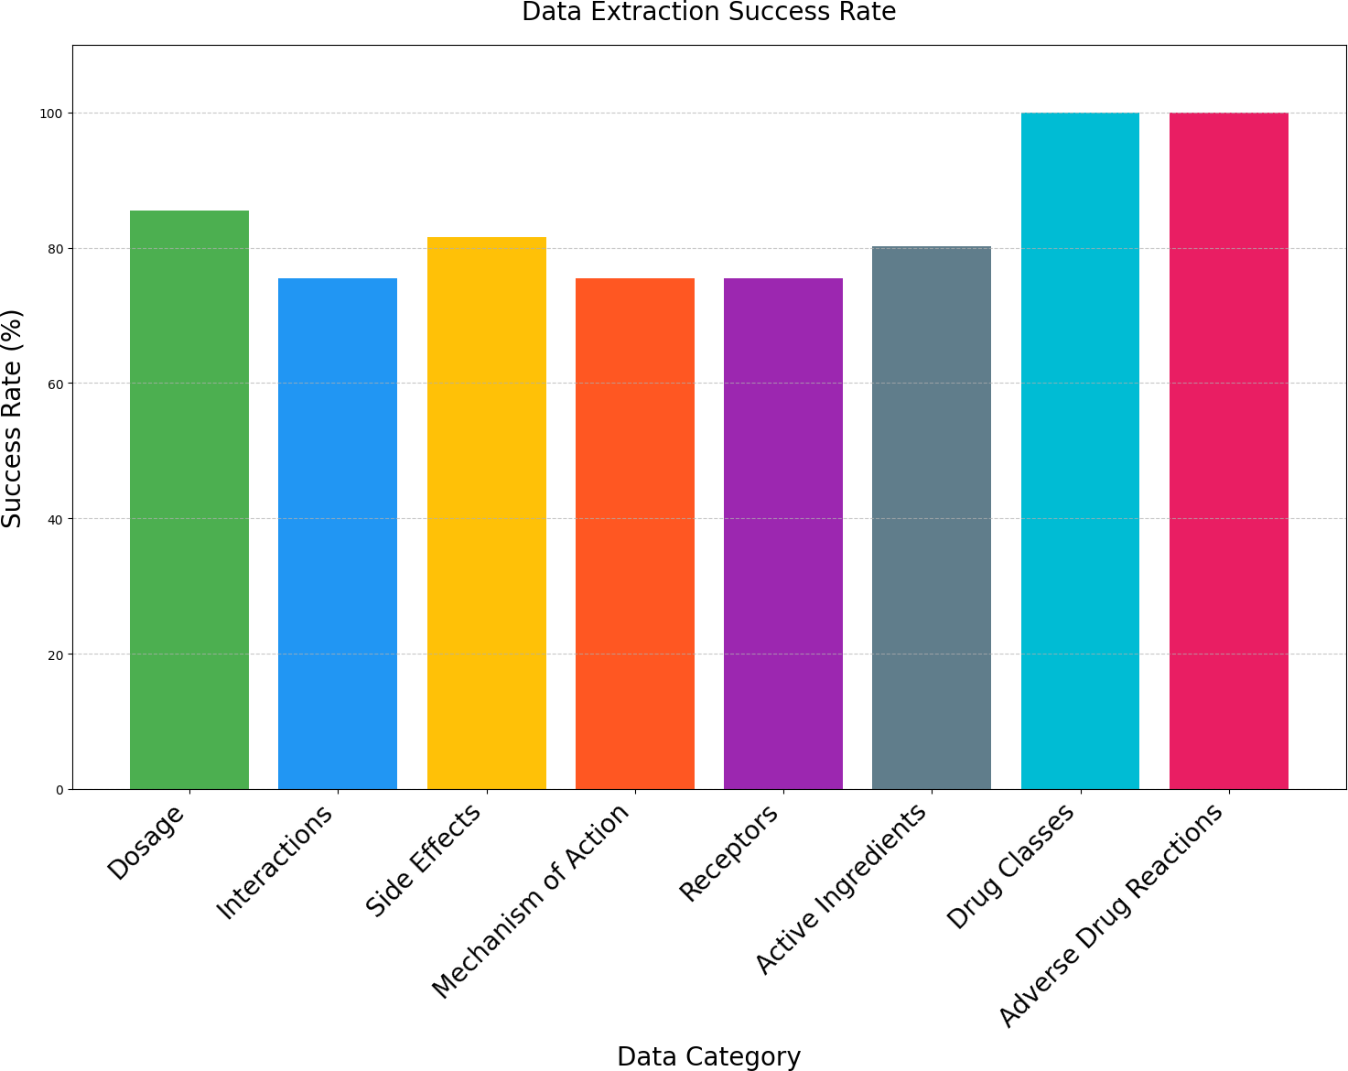

Figure 10: Data Extraction Success Rates by Drug Information Category

3. Results
The proposed system has effectively demonstrated its capacity to extract and structure comprehensive drug profiles for a significant number of medications—519 in total—as presented through the representative data detailed in Table 2. This automated pipeline is designed to meticulously capture a broad range of essential pharmacological parameters, allowing for an in-depth analysis of each medication’s characteristics. These parameters include the drug class, active ingredients, dosage forms, side effects, adverse reactions, and target receptors, ensuring a thorough understanding of each drug’s profile.

Table 2 shows the profile for abrocitinib and its classification as a selective immunosuppressant, with dosage options ranging from 50 to 200 mg. This profile highlights potential adverse reactions, such as thrombocytopenia and pneumonia, and specifies its mechanism of action involving the inhibition of the tyrosine-protein kinase Btk receptors. Understanding the mentioned aspects is crucial for healthcare providers as they assess the therapeutic benefits and risks associated with abrocitinib’s prescription. Similarly, atorvastatin’s drug profile identifies it’s class as statin, highlighting its importance in cholesterol management and indicating various dosage strengths that range from 10 to 80 mg. Its antagonistic effects on muscarinic acetylcholine receptors and glycine receptors, enriches the pharmacological understanding of atorvastatin, emphasizing its multifaceted role in patient care. The clinical context of these medications, as shown in the Table 3, provides comprehensive data on drug-drug and drug-food interactions and mechanism of actions, which are vital for safer prescriptons. For instance, the interaction data indicates that when abrocitinib is used in conjunction with other immunosuppressants, there is a heightened risk of infections, which is crucial for healthcare providers who must weigh the benefits of therapy against the risks of potential complications. Additionally, the specification regarding its mechanism of action—namely, the inhibition of the JAK-STAT pathway—offers valuable insights into how this medication achieves its therapeutic effects, informing treatment decisions for specific patient populations. The profile of atorvastatin is equally informative, as it encompasses a significant interaction with grapefruit juice, which impacts its metabolism through CYP450 3A4 inhibition. This states the importance of dietary considerations in managing patient treatment plans. Moreover, the elucidation of atorvastatin’s primary mechanism of action—upregulating the expression of hepatic LDL receptors—provides clinicians with a clear understanding of how the medication effectively lowers LDL cholesterol levels, which is a key factor in cardiovascular disease management.

The system’s functionality extends beyond these primary profiles to capture nuanced pharmacological actions, illustrated by aspirin’s mechanism of irreversible COX-1 and COX-2 inhibition, which leads to its recognized antiplatelet effects, and are critical for preventing thrombotic events. Furthermore, the system highlights the significant contraindications concerning the increased bleeding risk associated with certain medications when used alongside aspirin. Understanding these interactions is highly crucial for healthcare providers when considering the overall safety of the treatment regimens. Overall, these comprehensive drug profiles not only showcase the system’s ability to transform complex, unstructured pharmaceutical data into organized, clinically relevant information but also reflect a commitment to advancing medical knowledge and practice. This transformation precisely aids healthcare professionals in making informed decisions, and enhancing patient safety and treatment efficacy. The ability to synthesize and interpret such an information reduces cognitive load for clinicians, allowing them to focus more on delivering high-quality patient care rather than navigating through vast amounts of data. Ultimately, this system serves as a powerful tool in the healthcare, equipping providers with the insights needed to make better treatment choices, thereby improving patient outcomes.

Table 2: Pharmacological Profiling 1 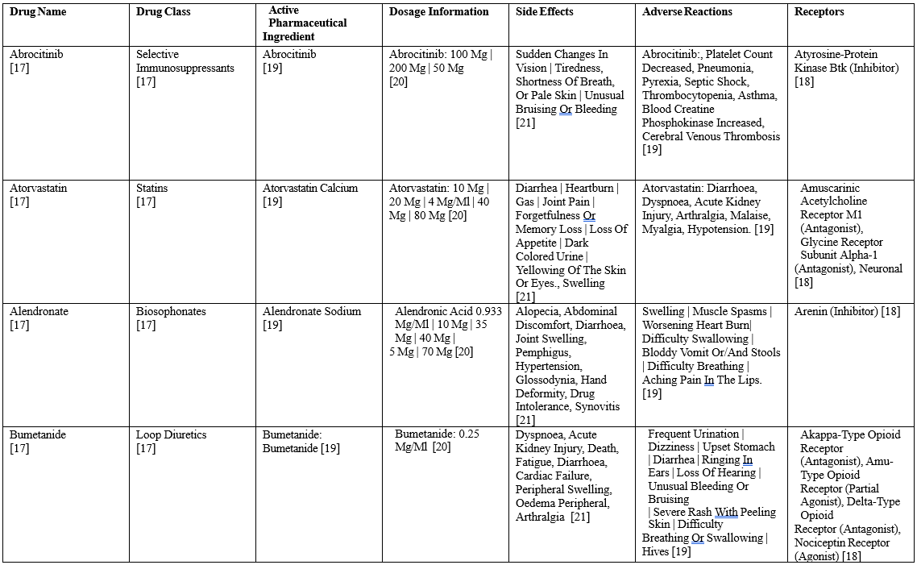

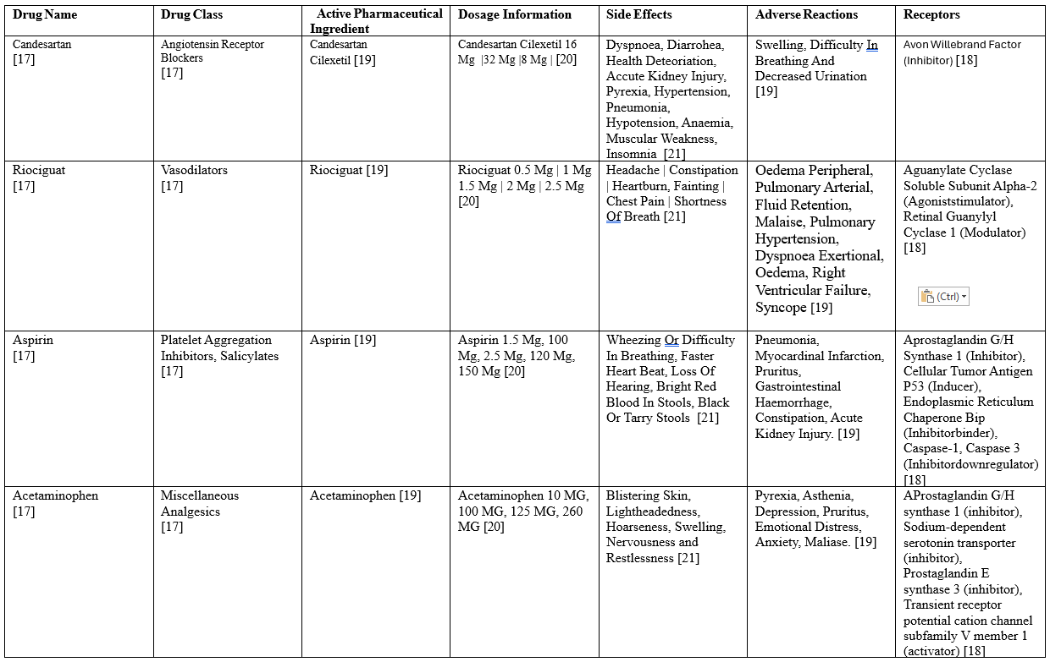

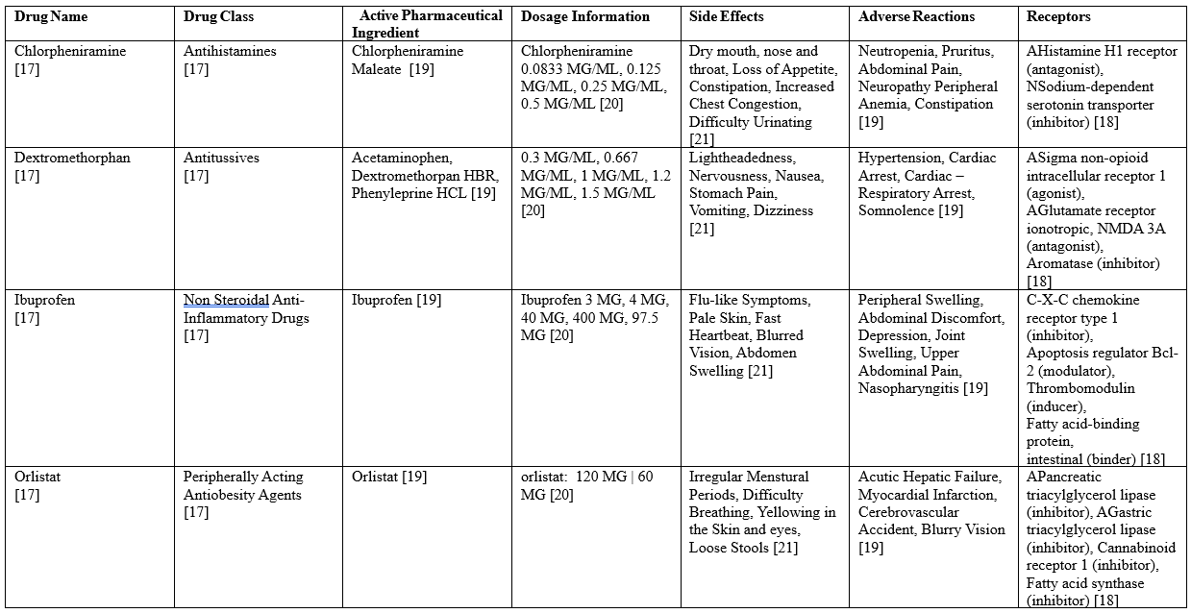

Table 3: Pharmacological Profiling 2
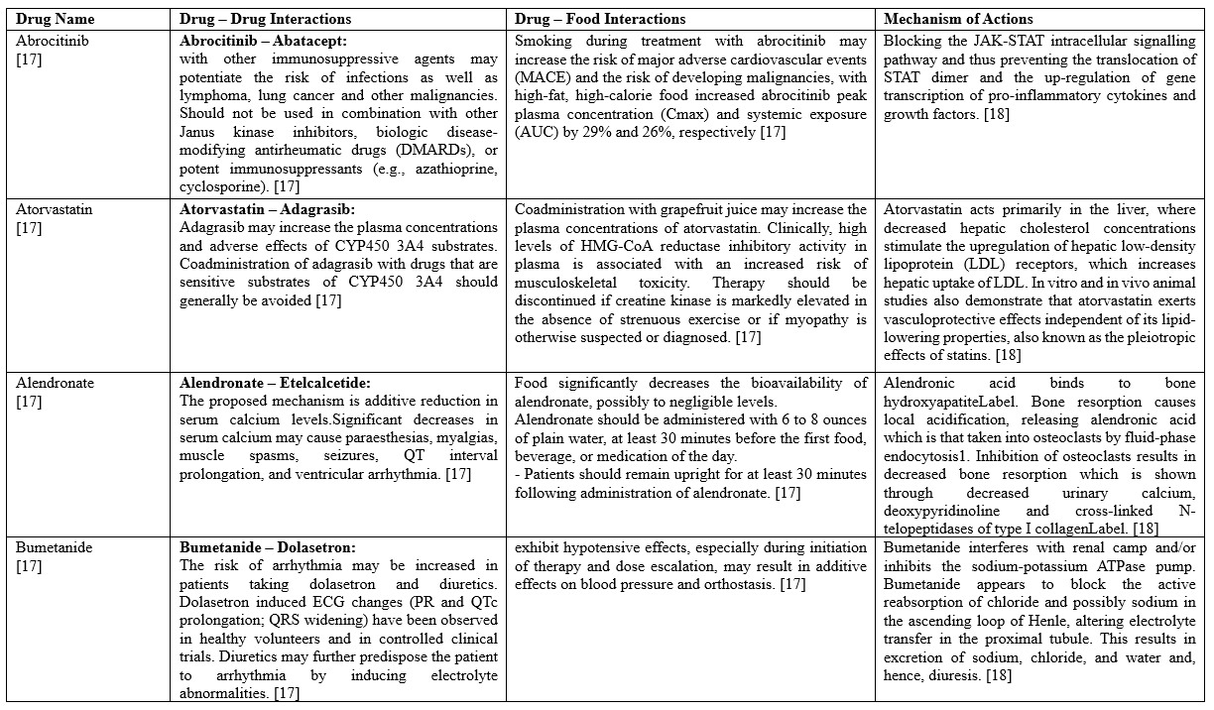

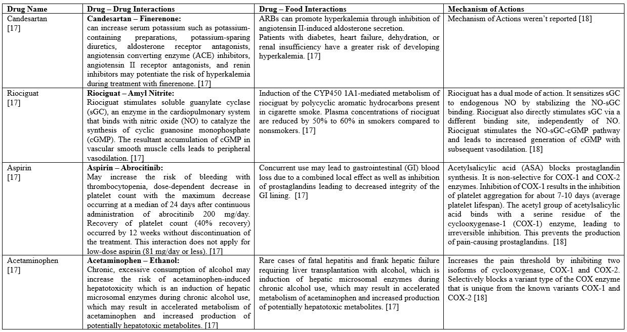

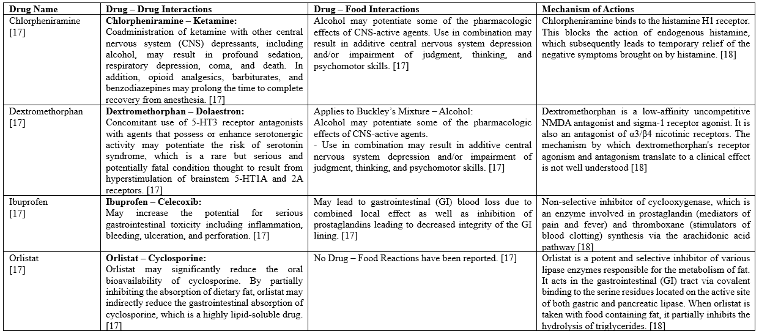

4. Discussion

The proposed system represents a significant advancement in addressing the challenges of drug information retrieval by integrating web scraping, API-based data extraction, and rule- based pattern matching to deliver structured, user-centric drug data. This hybrid approach tackles the cognitive overload associated with navigating disparate and unstructured pharmaceutical resources, offering a scalable, automated solution that enhances accessibility, efficiency, and accuracy. Below, we discuss the key contributions, implications, limitations, and future directions of this work in the context of existing literature and practical applications.
The primary contribution of this system lies in its ability to streamline the retrieval and structuring of complex drug information from authoritative sources such as Drugs.com, openFDA, RxNorm, and MedlinePlus. By automating the extraction of critical drug attributes—such as dosage, side effects, interactions, adverse drug reactions (ADRs), and pharmacological profiles—the system significantly reduces the cognitive load on users, including clinicians, pharmacists, researchers, and patients. This aligns with prior work emphasizing the importance of reducing cognitive burden in clinical decision-making environments. For instance, Nelson et al. highlight the role of structured data in minimizing errors in clinical drug normalization, while Wei et al. underscore the value of automated text extraction in pharmacovigilance, both of which are extended by the system’s comprehensive data aggregation. The structured outputs (CSV, text files) provide a standardized format that enhances data usability across diverse applications, from clinical decision support systems to research meta-analyses. Unlike traditional databases like PubMed or DrugBank, which often present information in lengthy, unstructured formats requiring manual navigation, this system organizes data into query-ready datasets. This organized illustration facilitates easy and quick access and also reduces ambiguity. The high data completeness metrics evidence this in Table 1. The extraction of 519 drug names, 444 dosage strengths, and 423 side effects profiles exemplifies the robust coverage of key attributes. Precision-recall evaluations (Fig. 5) and cross-source verification are used to validate the covered key attributes. An authoritative and competitive dataset is ensured by the aggregation and integration of multiple data sources through web scraping and API calls. For instance, the RxNorm's identifiers (RxCUIs) make the precise dosage mapping, and mitigation of inconsistencies in manual curation possible. The real-time access to adverse event reports is provided by the openFDA API. DrugBank acts as the primary source for pharmacological profiling that enhances the dataset with receptor bindings and mechanism-of-action data, crucial for understanding drug interactions and therapeutic effects. This approach adapting multiple sources contrasts with the single-source systems that lack the broader knowledge required for holistic drug queries. From the perspective of minimizing the cognitive load, the system aligns with the user-centric design principle resulting in reduced mental effort for processing complex drug information allowing users to focus on higher-order tasks such as research synthesis. The system’s rapid response times and structured outputs further support time-critical
decision-making, particularly in high-stakes clinical settings where delays can lead to adverse
out-comes. For patients, the concise, categorized presentation of drug information (e.g., side
effects and dosages) enhances comprehension and adherence, addressing challenges identified
inpatient education literature. The utility of the system extend across multiple domains. The system provides accessibility to structured drug data in seconds reducing the risk of medication errors, a crucial concern given that 7.000-9.000 annual deaths in the United States due to medication errors.
Pharmacists can leverage the system to cross-reference drug interactions and ADRs efficiently, while researchers benefit from automated data extraction for large-scale studies, such as pharmacovigilance or drug repurposing. Patients, particularly those managing chronic conditions, can use the system’s outputs to better understand their medications, fostering improved self-management and adherence. The scalability of the system, enabled by automated scraping and API integration, makes it adaptable to evolving data sources and increasing volumes of biomedical literature. This scalability is particularly relevant given the exponential growth of pharmaceutical data, as noted by Krallinger et al. By automating data curation, the system overcomes the limitations of manual database maintenance, which is prone to human error and cannot keep pace with the rapid publication of new drug- related findings.
Future work will focus on addressing these limitations and expanding the system’s capabilities. The extraction of complex, unstructured data, such as clinical narratives and other web sources could be improved by combining advanced NLP techniques, such as transformer-based models like BioBERT (10) or BioWordVec (12). This would enable the system to capture real-world evidence, such as patient experiences or emerging ADRs, complementing authoritative sources. The inclusion of multilingual data sources and non-English drug databases by expanding the system would elevate global applicability. The linguistic variations could be handled by incorporating pattern-matching algorithms and region-specific resources, such as the European Medicines Agency (EMA) database. A distributed computing framework for deploying the system can handle the increased volume of queries and provide robustness against rate limits of the API calls and website changes. Further optimization for reduced response time can be accomplished by implementing a caching mechanism by temporarily storing frequently queried drugs. Context-aware query responses and role-based interfaces can improve the personalization of the system. These features would align with user-centric AI design principles, as advocated by Nelson et al. (2), and could be validated through user studies or fNIRS-based cognitive workload assessments (3). This proposed system demonstrates an automated, robust solution for drug data querying, providing a solution for high cognitive and practical challenges of locating the required pharmaceutical data. The structured, query-ready datasets reducing cognitive load and improving clinical decisions are made possible by integrating web scraping, API calls, and rule-based pattern matching. Future enhancements include techniques such as NLP integration, cloud-based scaling, and multilingual support, ensuring improved accessibility and usability ultimately resulting in enhanced patient safety and clinical outcomes. This research explores the challenges in the cognitive load involved in drug information retrieval by automating the data aggravation process and transformation of large datasets into structured and user-friendly formats.

Declaration of generative AI and AI – assisted technologies in the writing process:
The authors declare the use of generative AI including ChatGPT (OpenAI) and AI-assisted technologies during writing and revision of the manuscript for language refinement and content organization. It is affirmed that the final content was reviewed and approved by all the authors ensuring integrity and accuracy. Nod segment of the text was solely generated by AI without significant human review and editing.

Funding Sources / Financial Disclosure Statement:
This research did not receive any specific funding from public, commercial, or non-profit agencies.

Declaration of Competing Interest:
The authors declare that there are no known financial or personal interests that could be seen as influencing the work presented in this paper.

Acknowledgements:
The authors wish to convey their profound gratitude to [individuals, institutions, or groups] for their significant support and contributions to this research. Furthermore, we hereby acknowledge the utilization of AI tools for editorial assistance, in accordance with the guidelines established in the Declaration of AI Use

Appendix A. Supplementary Data
The supplementary data pertinent to this article can be accessed at [insert link or DOI if available]. This includes [brief description of supplementary materials, e.g., raw data, code, additional figures or tables], which complement the findings presented in the main text.

References
- Sunghwan Kim, Paul A. Thiessen, Evan E. Bolton, Jie Chen, Gang Fu, Asta Gindulyte, Lianyi Han, Jane He, Siqian He, Benjamin A. Shoemaker, Jiyao Wang, Bo Yu, Jian Zhang, Stephen H. Bryant (2016). PubChem Substance And Compound Databases. Nucleic Acids Research, 44(D1), D1202–D1213. https://doi.org/10.1093/nar/gkv951
- Stuart J. Nelson, Kelly Zeng, John Kilbourne, Tammy Powell, Robin Moore (2011). Normalized Names for Clinical Drugs: RxNorm at 6 Years. Journal of the American Medical Informatics Association, 18(4), 441–448. https://doi.org/10.1136/amiajnl-2011-000116
- David S. Wishart, Yannick D. Feunang, An C. Guo, Elvis J. Lo, Ana Marcu, Jason R. Grant, Tanvir Sajed, Daniel Johnson, Carin Li, Zinat Sayeeda, Nazanin Assempour, Ithayavani Iynkkaran, Yifeng Liu, Adam Maciejewski, Nicola Gale, Alex Wilson, Lucy Chin, Ryan Cummings, Diana Le, Allison Pon, Craig Knox, Michael Wilson (2018). DrugBank 5.0: A Major Update to the DrugBank Database. Nucleic Acids Research, 46(D1), D1074–D1082. https://doi.org/10.1093/nar/gkx1037
- Bodenreider, O. (2008). Biomedical ontologies in action. Year- book of Medical Informatics, 17(01), 67–79. https://doi.org/10.1055/s-0038-1638585
- Chih-Hsuan Wei, Alexis Allot, Robert Leaman, Zhiyong Lu (2019). PubTator central: Automated concept annotation for biomedical text. Nucleic Acids Research, 47(W1), W587–W593.
https://doi.org/10.1093/nar/gkz389
- David Mendez, Anna Gaulton, A. Patrícia Bento, Jon Chambers, Marleen De Veij, Eloy Félix, María Paula Magariños, Juan F. Mosquera, Prudence Mutowo, Michał Nowotka, María Gordillo-Marañón, Fiona Hunter, Laura Junco, Grace Mugumbate, Milagros Rodriguez-Lopez, Francis Atkinson, Nicolas Bosc, Chris J. Radoux, Aldo Segura-Cabrera, Anne Hersey, Andrew R. Leach (2019). ChEMBL: Towards Direct Deposition of Bioassay Data. Nucleic Acids Research, 47(D1), D930–D940. https://doi.org/10.1093/nar/gky1075
- Sune Pletscher-Frankild, Albert Pallejà, Kalliopi Tsafou, Janos X. Binder, Lars Juhl Jensen (2015). DISEASES: Text Mining Disease-Gene Associations. Methods, 74, 83–89. https://doi.org/10.1016/j.ymeth.2014.11.020
- Ling Luo, Po-Ting Lai, Chih-Hsuan Wei, Cecilia N. Arighi, Zhiyong Lu (2022). BioRED: A Biomedical Relation Extraction Dataset. Briefings in Bioinformatics, 23(5), bbac282. https://doi.org/10.1093/bib/bbac282
- Martin Krallinger, Obdulia Rabal, Anália Lourenço, Julen Oyarzabal, Alfonso Valencia (2017). Information Retrieval and Text Mining for Chemistry. Chemical Reviews, 117(12), 7673–7761. https://doi.org/10.1021/acs.chemrev.6b00851
- Jinhyuk Lee, Wonjin Yoon, Sungdong Kim, Donghyeon Kim, Sunkyu Kim, Chan Ho So, Jaewoo Kang (2020). BioBERT: A Biomedical Language Representation Model. Bioinformatics, 36(4), 1234–1240. https://doi.org/10.1093/bioinformatics/btz682
- Qiang Wei, Zongcheng Ji, Zhiheng Li, Jingcheng Du, Jingqi Wang, Jun Xu, Yang Xiang, Firat Tiryaki, Stephen Wu, Yaoyun Zhang, Cui Tao, Hua Xu (2019). Deep Learning for Medication and Adverse Event Extraction. Journal of the American Medical Informatics Association, 27(1), 13–21. https://doi.org/10.1093/jamia/ocz063
- Yijia Zhang, Qingyu Chen, Zhihao Yang, Hongfei Lin, Zhiyong Lu (2019). BioWordVec: Biomedical Word Embeddings With Subword Information. Scientific Data, 6(1), 52. https://doi.org/10.1038/s41597-019-0055-0
- Andrés Gutiérrez-Sacristán, Àlex Bravo, Alexia Giannoula, Miguel A. Mayer, Ferran Sanz, Laura I. Furlong (2018). ComoRbidity: An R Package for Disease Comorbidity Analysis. Bioinformatics, 34(16), 2858–2860.
https://doi.org/10.1093/bioinformatics/bty315
- Ayush Singhal, Michael Simmons, Zhiyong Lu (2016). Text Mining Genotype-Phenotype relationships. PLOS Computational Biology, 12(11), e1005017. https://doi.org/10.1371/journal.pcbi.1005017
- Shirley V. Wang, Olga V. Patterson, Joshua J. Gagne, Jeffrey S. Brown, Robert Ball, Pall Jonsson, Adam Wright, Li Zhou, Wim Goettsch, Andrew Bate (2019). NLP for EHR-Based Pharmacovigilance. Drug Safety, 42(11), 1275–1289. https://doi.org/10.1007/s40264-019-00851-0
- Mahira Kirmani, Gagandeep Kour, Mudasir Mohd, Nasrullah Sheikh, Dawood Ashraf Khan, Zahid Maqbool, Mohsin Altaf Wani, Abid Hussain Wani (2024). Biomedical Semantic Text Summarizer. BMC Bioinformatics, 25, 152. https://doi.org/10.1186/s12859-024-05712-x
- www.drugs.com
- go.drugbank.com
- open.fda.gov
- www.nlm.nih.gov/research/umls/rxnorm/index.html
- Medlineplus.gov

