A Computational Framework for ESG Data Orchestration - A preliminary proof of concept for Multi-Format Data Fusion

${Manimegalai R}^{*}$, Ganesh Balaji V, Siddiq M, and
Sivanandhini N

PSG Institute of Technology and Applied Research
Coimbatore – 641 062, India

*drrm@psgitech.ac.in – Corresponding Author

Abstract. In this research, A computational framework for the organised and coordinated extraction of Environmental, Social, and Governance (ESG) information from various sources is proposed. The architecture proposed here utilises a deterministic extraction pipeline with a fallback to integrated Optical Character Recognition (OCR), ensuring high-quality text recovery across various file formats. To maximise computational efficiency, Keyword-based deterministic filtering is used to separate ESG-relevant input. The central component of the framework, the Adaptive Weighted Fusion Algorithm (AWFA), captures the semantic connections between input signals to dynamically prioritise the candidate evidence. In our evaluation of the variations of AWFA with the baseline algorithms, it is found that the introduction of adaptive weighting significantly improves classification accuracy and information retention. In particular, the AWFA v2 demonstrated significant improvement and superior performance compared to baseline and heuristic-based filtering techniques in all tested parameters, resulting in a substantial increase in F1 score and a notable decrease in the miss rate. Additionally, the evidence alignment provided by the system was excellent, ensuring constant traceability of structured outputs to their source documents. These findings confirm that, for consistent and repeatable ESG data orchestration, the adaptive weighting is a reliable middleware approach.

Keywords: ESG Extraction, Optical Character Recognition, Adaptive Weighted Fusion Algorithm, Document Intelligence, Schema Validation

Introduction to ESG and orchestration of ESG information

For corporate disclosure, Environmental, Social and Governance (ESG) reporting has become an essential part of corporate disclosure, driven by regulatory requirements, the expectations of the investors, and global sustainability goals. The production of ESG related content is started to be produced by the organizations in the large scale, including annual reports, policies, disclosures regarding sustainability and documents specific to the industry, i.e., the file source. The schema varies in terms of structure, format, and data quality, making it difficult to extract ESG information using manual methods. Traditional document processing techniques struggle with multi-format inputs, scanned documents, and inconsistency in terminology, resulting in inappropriate and incomplete extraction. The time taken to process these documents is also high. This shows the need for automation in the ESG extraction and the intelligence that would handle unstructured and semi-structured inputs at the needed scale.

Recently, Natural Language Processing (NLP) has been used mainly to extract the information from complex documents. However, many existing systems rely on LLMs to perform NLP at every possible stage of extraction of information, which increases cost, delay and the risk of hallucination. For these challenges to be addressed, for applications that demand traceability and data fidelity, deterministic and hybrid approaches are preferred. This paper presents an end-to-end pipeline for ESG document intelligence, which is completely designed to automate the extraction of ESG-related information, increasing the accuracy and reproducibility. The system supports various file types, not limited to pdf, docx, pptx, xlsx, csv and image-based documents. The deterministic text extraction is combined with an OCR fallback using Azure Document Intelligence to ensure coverage even when the text is not of sufficient quality to be identified easily. Filtration of ESG-relevant content is performed using the keywords present to avoid unnecessary LLM usage, and allows the categorisation into Environmental, Social and Governance domains consistently.

The Adaptive Weighted Fusion Algorithm (AWFA) is used to prioritise ESG sentences prior to LLM processing to increase system efficiency. AWFA is a hybrid scoring system that combines several signals, such as contextual importance determined by adaptive weighting and keyword strength, to give each candidate sentence a relevance score. Only high-confidence and contextually relevant content can advance to the next stage since the system eliminates noise by assigning and processing these weights before LLM involvement. This method preserves the precision and clarity needed for efficient data organisation while reducing token usage and computing expense.

Related Work for the automated orchestration of ESG Data

Rozman used domain-specific fine-tuning to optimise the large language models for structured ESG data extraction [1]. In this work, various open source LLMs such as Meta’s LLaMA, Mistral, etc. and commercial models such as GPT-4o-mini are used. In this work, Techniques such as Parameter Efficient Fine Tuning (PEFT) and Quantised Low-Rank Adaptation (QLoRA) were employed to optimise the resource usage. It was concluded that, with the appropriate adaptation, LLMs could be utilised to automate the extraction and structurization of ESG data, easing the work of analysing large volumes of ESG data. Bronzini introduced ESGReveal, a metadata-guided retrieval system that utilises an LLM agent to extract and generate ESG reports [2]. 76.9% accuracy for data extraction and 83.7% for disclosure analysis was reported, which showed the clear outperformance of the baseline models. The work confirms that multi-stage preprocessing and Retrieval before generation were valuable, despite the cost and orchestration difficulties. Graph-based representations were utilised to conduct statistical analysis, along with the insights extracted with the help of LLMs.

Masciola and Ramachandran’s AWS Solutions reference architecture suggests a sustainable RAG workflow that combines Amazon Kendra’s hybrid/semantic retrieval with Bedrock models [3]. This emphasises secure indexing, governance, and serverless scaling. The LLM usage is controlled and retrieval-driven with a production-grade blueprint for ESG-based insights and analytics. A high-performance computing environment is utilised here to enhance the processing speed. Here, ESG enhanced hybrid RAG (ESGH-RAG) allows for the retrieval of ESG guidelines and dynamically adjusts retrieval methods. Also, ChatGPT-4o Report Synthesiser (CRS) generates the report through a multi-prompt module. Lei Xia investigates pre-trained and domain-adapted models for ESG categorisation, including ESGLlama and FinLlama, and discusses dataset construction workflows that combine the heuristics present in the keyword, along with LLM-assisted labelling [4]. According to the results, the domain specialisation provides insights better than the traditional baselines. Also, the keyword-guided sampling is effective, which paved the way for deterministic ESG sentence filtering ahead of any generation step and then combining those signals with ranking before structuring the output.

Rachana, Mahmoud and Doaa created a panel dataset of 386 S&P 500 firms and 4246 firm-year observations. Panel data regression models with fixed effects were used in the analysis to assess the relationship between two financial indicators and ESG scores [5]. These findings clearly state the positivity shown by the investors towards the company and contribute to the long-term market value. The strength of the ESG performance is directly proportional to effective management and lower investment risk. This study shows how the corporate leaders and policy makers lean towards the long-term value driven by the ESG integration. Choi proposes an automation system that integrates Retrieval-Augmented Generation (RAG) and Optical Character Recognition (OCR) technologies to enhance the efficiency of the ESG documentation process [6]. The system proposed in this study enhances text recognition accuracy by employing an ensemble model-based image processing algorithm and hybrid information extraction models in the OCR process. Additionally, a RAG pipeline uses ensemble retrievers, layout analysis algorithms, and re-ranking algorithms to optimise information retrieval and response production dependability. A variety of photographs were gathered from a variety of sources, including the company's websites, certificate images from online portals and corporate internal regulations.

The development of Optical Character Recognition (OCR) to transform data entry procedures is discussed by Aaryan Raj, Sakshi Sharma, Janvee Singh, and Aastha Singh [7]. This paper provides a thorough examination of the history, present situation, and application of OCR technology in information extraction, indexing, and efficient document management. This study also highlights how using OCR technology improves accuracy, speeds up processes, and reduces costs. Abhishek Jain [8] analyses well-known algorithms and approaches to find the relevant word present in the document with the search query provided as input. This study mainly focuses on utilising the vector model along with two subordinate models – Boolean and TF/IDF models. The Boolean model works solely by getting Boolean queries as input, and matches the document based on Boolean logic, whether the required terms are present in the document or not. But the problem in this model is that it often gives too few or too many documents. The TF/IDF model works based on a weighting scheme where the weight is provided to the word based on its frequency in a document, along with how rare the word is in the document. Then, the log frequency is calculated to dampen the effect of the frequency. They are used together to compute the TF and IDF weight. So, this weighting scheme provides the best results and insights in information retrieval, according to the study.

Guang Lu uses the Adaptive Weighted Fusion Algorithm in a wireless network system for forest fire monitoring [9]. Various components such as temperature, humidity and ultraviolet variable measurement components are used in the Network circuits. Each sensor node's data fields contain embedded signal process rule attributes and requirements. In order to improve the accuracy and dependability of fire characteristic recognition, this work attempts to implement the traditional self-adapting weighted fusion technique. Jian Tang utilises the Adaptive Weighted Fusion Algorithm to estimate what’s happening inside a ball mill without directly measuring it, using vibration signals and smart prediction models [10]. In this study, the Grinding Production Ratio (GPR) is utilised to determine how effective the grinding is. In a ball mill, the balls are utilised to crush and grind the material. With the identification of the mill load, the amount of material and the number of balls inside the machine can be computed. The sensors are utilised to know how the mid shell vibrates while running. Then, the raw signals are converted into the signal’s frequency spectrum, which is used by a statistical method called Partial Least Squares to build sub-models, one for each band. For the combination of Sub models, the Adaptive Weighted Fusion Algorithm is utilised effectively and intelligently to influence a model’s presence, which should be dynamic according to the band of the signals.

Haifeng Liu utilises the Adaptive Weighted Fusion Algorithm for performing image fusion for image mosaic [11]. The choice of the fusion algorithm affects the visual effect and quality of the mosaic images directly. In this study, the algorithm adjusts the weighted coefficients adaptively along with the changes in the range and shape of the overlapping regions. To identify the feature points, coarse matching and precise matching, the Normalised Cross Correlation (NCC) and Random Sample Consensus (RANSAC) algorithms are used, respectively, in the study. Finally, the AWFA is used to fuse images. Compared with other fusion algorithms, the results of AWFA in the study seem more effective. Shao proposes a solution for the drawback that arises when the noisy data from multiple sources is combined by the Adaptive Weighted Fusion Algorithm [12].

Adaptive Weighted Fusion Algorithm (AWFA) Framework
This section discusses the theoretical and mathematical implications of Adaptive Weighted Fusion Algorithm. To understand the motivation behind AWFA, first, it is necessary to examine the early fusion strategies and their disadvantages. These fusion techniques are used widely to merge multiple feature representations to a single unified representation which enables the model to use the information from different inputs. In the fusion techniques, Static fusion serves as one of the most basic approaches. It relies on the constant weights that are predefined, hardcoded and assigned to each input signal. Because of the manual selection of these weights, the model could not learn on adjusting the importance of different signals based on the context or the distribution of the data. This results in the limitation of the adaptability and the overall performance of the model when there is always a possibility for complex scenarios in the real world. Consider a set of N input signals, where each signal represents a feature vector, corresponding to each sentence. These signals are denoted by $s_{1}$, $s_{2}$, $s_{3}$, …, $s_{N}$. Each feature vector is a numerical representation that captures the semantic information of the corresponding sentence. In this static fusion setting, each signal has its own fixed weight $w_{1}$, $w_{2}$, $w_{3}$, …, $w_{N}$, where these weights do not change dynamically. Each signal contributes proportionally according to the weight assigned to compute the fused representation. This is mathematically represented as Equation 1 where all the input signals are made into a single feature representation [18].
(1)
$$F=\sum{w_{i }* s_{i}}$$

Although this static fusion is mathematically simple and intuitive, It helps in understanding more advanced fusion strategies. By representing the fusion process as a combination of input signals, it creates a framework with which, more adaptive methods can be introduced. A simpler variant of static fusion is mean fusion where, all input signals are provided equal importance. Rather than specifying the weights manually, this approach assumes that each feature vector contributes equally to the result. Consider a set of N feature vectors $s_{1}$, $s_{2}$, $s_{3}$, …, $s_{N}$, mean fusion assigns a weight $1/N$ to each vector. This weight is allocated to denote the equal participation of each vector in the result. Therefore, the fused representation is computed as the mean of all input feature vectors, as presented in Equation 2 [18].
(2)
$$F= \frac{1}{N} \sum{s_{i}}$$

Although this approach provides a straightforward combining mechanism, it fails to adapt to the different signals, which limits its effectiveness in adapting itself to the real-world scenarios. In domains such as ESG analysis, the input data is obviously heterogeneous and noisy. Different signals do not contribute to the final representation of the structured result at all. Also, the importance of a sentence varies according to the domain and industry. For instance, in companies operating in Energy sector, environmental factors impact directly due to their role in utilizing the resources and providing sustainability. Technology driven companies like the companies in IT sector mostly focus on social aspects, particularly related to privacy, user safety and the practices of how safely AI is used. Similarly, in the banking and financial sector, governance plays a critical role due to the compliance on the governance, risk management etc. These instances clearly show how dynamical the weights should be. This leads to the concept of adaptive or dynamic fusion, where weights are not predefined or hardcoded, but instead computed based on the relative importance of the signal in the document. This leads to the introduction of Adaptive Weighted Fusion Algorithm (AWFA), which aims to learn the weights through a small neural network. With that, AWFA adjusts the contribution of each feature vector depending on its importance in the document. In this work, two variants of AWFA are explored, namely AWFA v1 and AWFA v2, each enhances the capability of the dynamic weight estimation progressively. Let $s_{1}$, $s_{2}$, $s_{3}$, …, $s_{N}$ denote a set of input signals, where each $s_{i}$ $∈ R^{d}$. Here, $R$ refers to the real numbers and d refers to the dimensionality of each feature vector. This helps in capturing the semantic representation of the corresponding input signal. To enable the combined processing of all the input signals, these individual feature vectors are concatenated to form a single combined representation, referred to as context vector. This concatenation helps to aggregate the input from all the signals, allowing the model to learn relationships and dependencies across different inputs. The resulting context vector is expressed as Equation 3 [17].
(3)
$$c=concat\left(s_{1}, s_{2}, …, s_{n}\right)$$

The concatenation of the input signals helps to provide a global view of all the signals simultaneously. Without this concatenation, each signal looks independent, that prevents the model from capturing the dependencies between the signals. Following the computation of the context vector, the next step includes the creation of context encoding. Here, the aggregated representation is encoded to extract meaningful patterns and relationships among the input signals. In context encoding, to introduce nonlinearity to enhance the process of learning by the model, an activation function is introduced to the transformed representation. It improves the model’s ability to deduce complex relationships between the signals. For this context encoding, Rectified Linear Unit (ReLU) activation function [13] is used. It helps in learning non-linear feature interaction while maintaining the efficiency of computation. It also helps to mitigate the issues such as Vanishing Gradient. The encoded context representation, after applying the ReLU activation function is displayed in equation 4 [14].

$$h=ReLU\left(W_{i}c+ b_{i}\right)$$
(4)
Here, $W_{i}$ denotes the weight matrix and $b_{i}$ denotes the bias vector, where both are learnable parameters optimized during training. The concatenated context vector is passed through this transformation, allowing the model to mix information from different signals. This transformation effectively performs the operation of reshaping and reencoding the combined input, allowing the model to capture the interactions between different components of the input signals. Following this context encoding step, the model proceeds to compute the attention logits. Attention logits are the scalar scores that are unnormalized for representing the relative importance of each input signal prior to normalization. The encoded representation help to derive these scores and serve as the basis for determining how much each signal should contribute to the final fused output. Equation 5 defines the attention logits computation mathematically [14].
(5)
$$z= W_{i}h+ b_{i}$$

The z, which is computed in Equation 5, serves as a preliminary importance score. But, they are not directly utilised as weights, because they are unbounded real values, which include negative numbers too. Because of the lack of normalisation here, these weights are unsuitable for controlling each signal’s contribution directly. To avoid this, a softmax function is used, which transforms these attention logits into a normalised weight distribution. The unbounded logits are converted into non-negative values that sum to one, to have a valid probability distribution over input signals. This confirms that a relative importance score is assigned to each signal, which can be further used in weighted fusion. An important and notable property of attention logits is that only the relative difference in their weight signals influences the final weight distribution. For example, if a constant value is added to all the logits, the output of the softmax function does not change. This confirms that the attention logits are more stable, and so the model can focus on the relationship between the signals, rather than the absolute values. Equation 6 represents the mathematical formulation of the softmax function, which is used for normalising the attention logits [14].
(6)
$$w_{i}= \frac{exp\left(z_{i}\right)}{\sum{exp\left(z_{j}\right)}}$$

The normalised weights are obtained by applying the softmax function, which can be directly used in the fusion process. Equation 1 can be used for the final fusion process. It computes a weighted sum of all the input signals using the learned importance scores. Through this mechanism, the high weighted signals can be provided with more influence, while the low weighted signals can be suppressed. The resulting vector effectively captures the most relevant information across all signals and can be utilized for tasks such as classification, structured prediction, or analytical processing. This describes the workflow of AWFA v1, where weights are learned based on the encoded representation of input signals. To further enhance the process, AWFA v2 uses additional factors such as semantic importance and confidence scores. They further enhance the relevance of a sentence to the context of the document. These scores are computed and combined by, typically a concatenation, are passed through normalization step using softmax to produce the final weights. The semantic importance score that measures the importance of each signal is formulated as equation 7 [15].
(7)
$$c= \frac{1}{N}\sum{e_{i}}$$

This document context vector is computed by computing the mean of all sentence embeddings, thereby combining the information from each sentence into a single vector. It is constructed to capture the overall semantic representation of the entire document. It provides a global view of the document’s semantic content, ensuring that the representation aligns with the context of the document. Consider a given set of embeddings $s_{1}$, $s_{2}$, $s_{3}$, …, $s_{N}$. The document context vector represents their collective meaning. By comparing each sentence signal with the overall document context embedding, the model can determine how well a particular sentence aligns with the document. This leads to the computation of semantic importance score, which computes the relevance of each sentence with respect to the document context. Sentences that receive higher importance scores align more with the central theme of the document. Equation 8 formulates the computation of the semantic importance score [17].
(8)
$$s_{i}= e_{i} . c$$

A uniform weighting mechanism is established by the Adaptive Weighted Fusion Algorithm (AWFA) v2 by combining the robust classifier output with the semantic scores. For each sentence, the framework extracts a confidence score which is defined as the maximum predicted probability for the probability distribution vector ($p_{i}$) for the Environmental, Social and Governance classes. This score helps in quantifying the model’s certainty in the assignment of categories, which enhances both the extraction reliability and the semantic relevance of the extraction. The final priority is computed by fusing the confidence score with the semantic importance score using a linear combination, which is regulated by the two coefficients α and β. These hyperparameters take care of the calibration between contextual relevance and classification certainty with high precision. Finally, the relative aggregate scores are normalised by a softmax function to produce a definitive, relative weight for each sentence, which ensures a traceable and prioritised information flow within the pipeline.

Workflow of the AxiomESG Data Pipeline

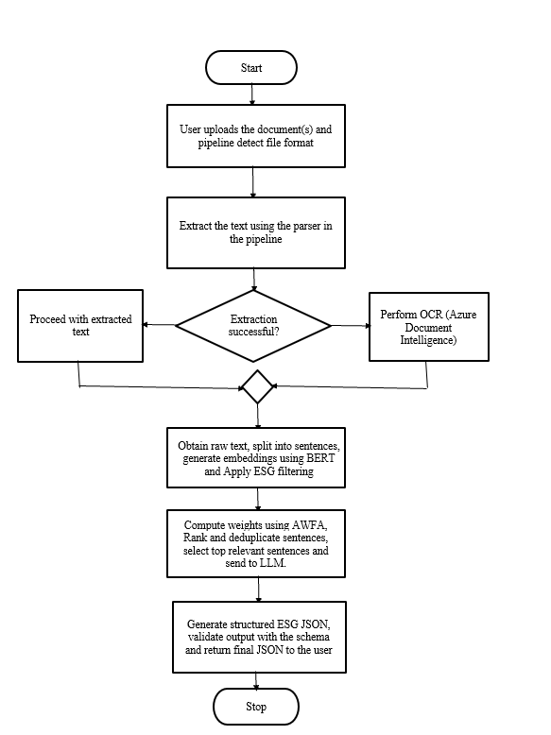
Fig. 1. Flow Diagram of the Pipeline

The proposed ESG intelligence pipeline allows the extraction of structured and relevant ESG specific information from different document formats and transforming into a single structured JSON representation. In the final stage, a LLM is incorporated to generate the structured output. This aligns with the established best practices for document processing pipelines [16]. The pipeline begins with the user uploading one or more documents. After receiving the files, the backend identifies the format of the file and performs the text extraction using format specific tools and libraries. In cases where it is difficult to extract meaningful sentences using these tools, such as files like images and pdfs, an OCR fallback mechanism is used using Azure Document Intelligence, enabling the text extraction in a seamless manner across various formats. Once the raw text is obtained, it is segmented into sentences and passed through an ESG filtering module where the sentences that does not contribute to the ESG are removed using the filters. Then, the final qualified sentences are passed to BERT classifier where each sentence is transformed into embeddings and signals, that act as input signals for the AWFA, where the importance weights are calculated based on how relevant the sentence is to the document. The sentences are then scored and ranked. The redundancy is removed to ensure that only the most relevant and non-redundant sentences are used. The top ranked sentences form an evidence set, which is passed to an LLM call for structured generation. It converts the evidence into well -defined ESG-specific JSON format. Finally, a schema validation layer ensures the reliability, completeness and correctness of the json generated using a validation framework.

AWFA provides a clear advantage in this pipeline because it introduces dynamic and adaptive control over the information flow before the generation of the structured JSON, which is critical while dealing with domains like ESG due to the presence of non-uniform documents. Traditional pipelines often include rule based or uniform concatenation, both of which fail in handling the heterogeneity of the documents. But, AWFA operates directly on the embeddings based on the semantic and confidence score, assigns weights based on the learned patterns, allowing the system to emphasize selectively present high value signals, while suppressing irrelevant or redundant content. This is important for this pipeline to avoid unnecessary content present in the structured ESG schema. The document may contain boilerplate sentences, disclaimers or sentences which does not even relate to the ESG at all. So, By doing the filtering by assigning the weights based on the relevancy, AWFA reduces ambiguity and assures that only needed sentences are present in the structured schema.

Structured JSON
Proposed System (Acts as Middleware)
Unstructured Documents

Fig. 2. Representation of the proposed system in the overall infrastructure of ESG

Another strength of this pipeline is the presence of both representational learning (conversion of raw data into numerical vectors and embeddings) and generation (Production of model from input data). BERT ensures that each sentence is encoded correctly from the raw data, while AWFA models and maps the encodings with weights, where the combined output is sent to the LLM for generation. Without the representational learning, even though LLM can generate the structured JSON, it’s difficult to reason the decision of the LLM on providing importance to a sentence and less importance to others. With the weights, the importance that should be provided to a sentence can be controlled. The quality of the sentence has also improved. The inclusion of semantic importance and confidence scores in AWFA v2 further strengthens this process by ensuring that both relevance and reliability are considered during selection. As a result, AWFA is a suitable choice for structured ESG intelligence.

Data Schema and Output Format
The final stage of the pipeline involves the generation of the standardized JSON structure, ensuring the intelligence extracted is both machine readable and audit ready. Following Table 1 defines the functional significance of the primary data fields.

Component | Key Attribute | Description and Research Significance
Audit Metadata | extraction_date, model_name | These ensure the reproducibility and provide a temporal audit trail for compliance.
Processing Logs | ocr_used, total_weighted_blocks | These are the indicators of the extraction method (deterministic vs OCR) and the computational density of the source.
Orchestration | awfa_weights_preserved | A Boolean flag helps to confirm the integrity of the AWFA prioritization through the LLM synthesis stage.
Dimension Scores | confidence_scores | A reliability metric derived from the categorical probability distribution
Evidence Layer | top_evidence | An array of weighted text fragments providing traceability to get back to specific source locations.

Table 1. Functional representation of the JSON output in the pipeline

Evaluation and Validation of the Proof of Concept
The ESG framework underwent a multi-stage performance study intended to isolate the impact of each architectural component in order to establish an empirical proof-of-concept. In order to give a baseline for unpolished system performance, the validation started with a baseline configuration that processed raw data without filtering or weighing. Deterministic ESG filters were then added to measure how well noise reduction techniques isolated pertinent content. Two algorithmic variations were compared during the core validation phase, AWFA v1, which substitutes a dynamic, attention-based weighting mechanism for conventional manual heuristics, and AWFA v2, which adds a reliability-weighted fusion of semantic and confidence signals. By showing how the shift from static heuristics to adaptive, non-linear transformations directly correlates with the observed increases in extraction accuracy and evidence traceability, this progressive assessment methodology offers an open proof-of-work. The study progressively benchmarks different configurations and verifies that the AWFA v2 architecture is a reliable method for controlling the signal-to-noise ratios in heterogeneous ESG documents.

The framework’s performance, in terms of classification accuracy, operational efficiency and the integrity of data, is assessed with a number of indicators including F1 score, recall rate, miss rate, latency and evidence alignment. The main indicator of overall classification efficiency is the F1 score, which offers a fair assessment of precision and recall. The system is penalised for both the inclusion of irrelevant noise (false positives) and the absence of important data (false negatives) with the help of the harmonic mean. When the F1 score is better, the capacity of the framework to establish a strong border between tangential material and ESG-relevant content is interrelated. The gradual accuracy gains attained through adaptive weighting are demonstrated by the comparative distribution of F1 scores across the baseline, filtered and AWFA setups, as shown in Figure 3.

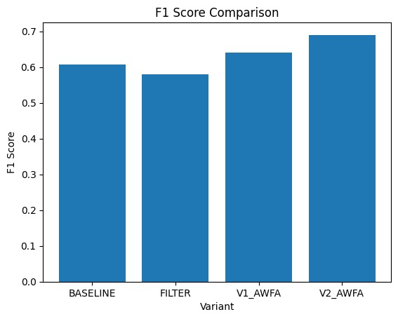
Fig. 3. Comparative assessment via F1 score distribution

The percentage of ESG-relevant data that the system misses during the orchestration process is measured using the Miss Rate, a crucial diagnostic metric unique to AWFA. AWFA’s distinct value lies in leveraging the Miss Rate, mathematically defined as the complement of Recall, to specifically minimise information loss. This offers a transparent and precise evaluation of the trade-offs AWFA enables during data refinement. The Miss Rate is decreased in this initial proof of concept, which indicates that the architecture’s efficiency in the elimination of peripheral noise while maintaining the core ESG signal has been improved. On the other hand, if there is a high miss rate, there could be possibilities for an overly strong filtering approach that may leave out crucial company disclosures. This study shows that the adaptive weighting mechanism is more effective than the baseline in retaining the overall document content. The resulting ESG intelligence is kept thorough and audit-ready due to this strict monitoring of information retention. Figure 4 shows the progressive decrease in Miss Rate across the AWFA variations, which offers proof that the framework suggested reduces the loss of information without sacrificing the purity of extracted data.

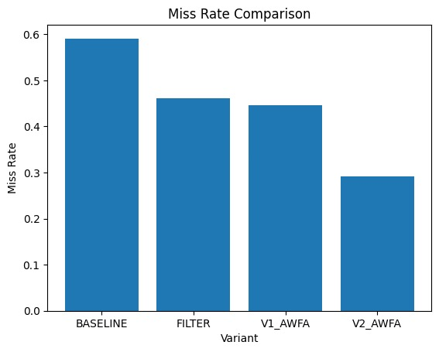

Fig. 4. Comparative Assessment via Miss Rate Performance

The Recall Rate shows the system’s ability to extract and remember relevant ESG-related data from the source documentation, which is computed and utilised in this study using the Grounded Percentage. The Grounded percentage measures the percentage of the original, closely connected data that makes it perform well in the extraction and orchestration levels, in contrast to the general recall metrics. In this initial proof of concept, the recall scores are high, indicating a thorough coverage of the data from the input documents. Additionally, this metric ensures document traceability by offering a verifiable audit trail that connects the extracted final intelligence to the respective context of the input files. The AWFA v2 architecture captures different data points across multiple documents without any omission of data, thus maintaining a high-grounded final output. Figure 5 shows the comparison of recall rates across various configurations, which confirms the improvement of the system’s sensitivity to tiny ESG signals with the help of an adaptive weighted mechanism.

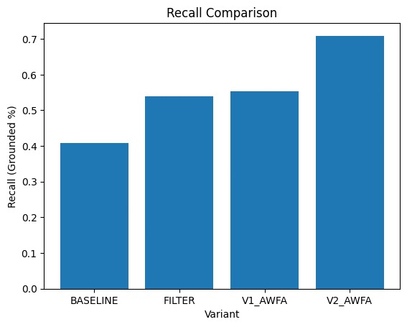

Fig. 5. Comparative Assessment via Recall Rate Analysis

The Evidence Alignment score acts as the ultimate indicator that shows systemic dependability, checking whether the output produced is rooted in the source documents, which ultimately prevents hallucinations. This measure estimates the percentage of extracted intelligence that keeps a direct, uninterrupted connection to pertinent textual fragments, hence serving as a protective measure against algorithmic delusions and unproven forecasts. A higher evidence alignment score in this initial proof-of-concept shows that the system is successfully synthesising information that is firmly rooted in the raw data rather than just detecting keywords. This score offers the empirical guarantee that each extraction is supported by a 'top_evidence' block, as specified in our output architecture, since traceability and justification are essential needs in modern ESG audits. The AWFA v2 architecture's notable improvement in alignment scores, as shown in Fig. 6, confirms that the adaptive weighting mechanism greatly improves the system's accountability and guarantees that the final data pipeline generates reliable, audit-ready sustainability intelligence.
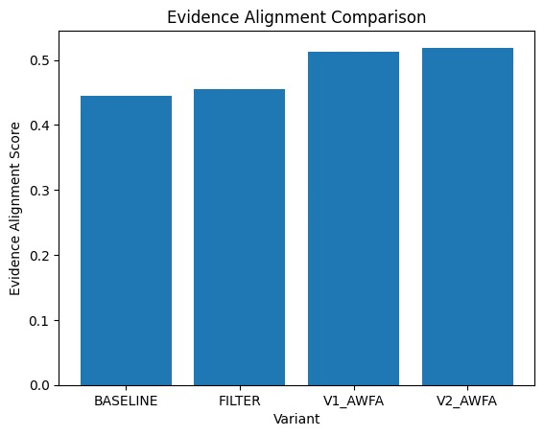

Fig. 6. Comparative Analysis via Evidence Alignment Scores

Conclusion and future directions for ESG intelligence
With only one LLM invocation, the AxiomESG architecture creates a reliable, end-to-end pipeline for ESG document intelligence, converting diverse company disclosures into validated JSON information. The design guarantees the repeatability needed for stringent corporate audit trails by giving priority to deterministic processes, such as multi-format extraction, OCR fallback, and ESG-specific filtering. The AWFA v2 variation offers higher performance, producing notable gains in classification balance, signal retention, and evidence alignment, according to experimental results carried out in a controlled evaluation environment. Even though the large language models are probabilistic, these measures obtained under consistent parameters show the capability of the framework to limit algorithmic hallucinations while maintaining repeatability at a high level. In the end, a scalable framework has been developed with this initial proof of concept for independent ESG reporting and compliance orchestration. Concentration on dynamic keyword expansion can be performed as subsequent research.

References

- Rozman, R. (2024). Optimizing large language models for structured ESG data extraction through Domain-Specific Fine-Tuning. In Master’s of Business Analytics. https://vu-business-analytics.github.io/internship-office/reports/report-rozman.pdf
- Bronzini, M., Nicolini, C., Lepri, B. et al. Glitter or gold? Deriving structured insights from sustainability reports via large language models. EPJ Data Sci. 13, 41 (2024). https://doi.org/10.1140/epjds/s13688-024-00481-2
- Masciola, M., Ramachandran, S. “Guidance for Querying Sustainability Documents Using Generative AI for ESG Reporting on AWS,” AWS Solutions Library and sample code, 2024.
- Xia, L., Yang, M., Liu, Q. “Using Pre-trained Language Model for Accurate ESG Prediction,” ACL Anthology (FinNLP 2024).
- Lunawat, R. M., Elmarzouky, M., & Shohaieb, D. (2024). Integrating Environmental, Social, and Governance (ESG) Factors into the Investment Returns of American Companies. Sustainability, 17(19), 8522. https://doi.org/10.3390/su17198522
- Choi, E.-S. “Development of an Automated ESG Document Review System using Ensemble-Based OCR and RAG Technologies,” Journal of the Korea Society of Computer and Information, 2024.
- Raj, Aaryan, et al., "Revolutionizing data entry: An in-depth study of optical character recognition technology and its future potential," International Journal for Research in Applied Science & Engineering Technology, Vol. 11, No. 2, pp. 645-653, Feb 2023. DOI: 10.22214/ijraset.2023.49108
- Jain, N. “Information Retrieval using Cosine and Jaccard Similarity Measures in Vector Space Model,” IJCA, 2017; OpenGenus IQ, “Find similarity between documents using TF-IDF” (n.d.); Bakiyev, B. “Method for Determining the Similarity of Text Documents… Extension to TF-IDF,” SIST 2022.
- G. Lu and W. Xue, "Adaptive Weighted Fusion Algorithm for Monitoring System of Forest Fire Based on Wireless Sensor Networks," 2010 Second International Conference on Computer Modeling and Simulation, Sanya, China, 2010, pp. 414-417, doi: 10.1109/ICCMS.2010.274. keywords: {Monitoring;Fires;Wireless sensor networks;Signal processing algorithms;Temperature sensors;Humans;Ecosystems;Circuits;Humidity measurement;Signal processing;forest fire;wireless sensor networks;data fusion},
- J. Tang, T. Chai, L. Zhao, W. Yu, and H. Yue, “Soft sensor for parameters of mill load based on multi-spectral segments PLS sub-models and on-line adaptive weighted fusion algorithm,” Neurocomputing, vol. 78, no. 1, pp. 38–47, Aug. 2011, doi: 10.1016/j.neucom.2011.05.028.
- H. Liu, M. Deng, C. Xiao and X. Xu, "Image fusion algorithm based on adaptive weighted coefficients," IEEE 10th INTERNATIONAL CONFERENCE ON SIGNAL PROCESSING PROCEEDINGS, Beijing, China, 2010, pp. 748-751, doi: 10.1109/ICOSP.2010.5655767. keywords: {Pixel;Image fusion;Correlation;Shape;Algorithm design and analysis;Transforms;Mathematical model;image fusion;Harris;normalized cross correlation (NCC);random sample consensus (RANSAC);adaptive weighted coefficients},
- Shao, S., & Zhang, K. (2019). An Improved Multisensor Self-Adaptive Weighted Fusion Algorithm Based on Discrete Kalman Filtering. Complexity, 2020(1), 9673764. https://doi.org/10.1155/2020/9673764
- V. Nair and G. E. Hinton, “Rectified linear units improve restricted Boltzmann machines,” in Proceedings of the 27th International Conference on Machine Learning (ICML), vol. N/A, no. N/A, pp. 807–814, Jun. 2010.
- Ashish Vaswani, Noam Shazeer, Niki Parmar, Jakob Uszkoreit, Llion Jones, Aidan N Gomez, Łukasz Kaiser, Illia Polosukhin “Attention is All you Need”, NIPS 2017
- Yoav Goldverg, Omer Levy “word2vec Explained: deriving Mikolov et al.'s negative-sampling word-embedding method” https://doi.org/10.48550/arXiv.1402.3722
- Jeffrey Pennington, Richard Socher, Christopher D. Manning “GloVe: Global Vectors for Word Representation” Computer Science Department, Standford University, Standford CA 94305.
- Goodfellow, I.; Bengio, Y.; Courville, A. Deep Learning; MIT Press, 2016; Available online: http://www.deeplearningbook.org
- Hall, D.L.; Llinas, J. “An Introduction to Multisensor Data Fusion,” Proceedings of the IEEE, vol. 85, no. 1, pp. 6–23, 1997.

