An effective three phase clustering algorithm
for Spatial Data
K. Lakshmaiah¹*, M .Veeresh Babu², U.Rakesh^{3,} D.Y.B.Priyadarshini⁴,D.Ramakanth⁵
1. Professor, Department of CSE, Aditya College of Engineering, Madanapalle, Andhra Pradesh India
2. Associate Professor , Department of CSE, Aditya College of Engineering, Madanapalle, Andhra Pradesh India
3. . Associate Professor, Dept. of Computer Science, Geethanjali college of engineering &Technology, Hyderabad, India.
4. Research Scholar, Dept. of Computer science and Technology,Dravidian University,Kuppam.
5. Assistant Professor , Department of CSE, Aditya College of Engineering, Madanapalle, Andhra Pradesh India

Corresponding Author: klakshmaiah78@gmail.com, phone:+919885206562

ABSTRACT:
Spatial data clustering has played an important role in the knowledge discovery in spatial data. However, due to the increasing volume and diversity of data, conventional spatial clustering methods are inefficient even on moderately large data sets, and usually fail to discover clusters with diverse shapes and densities. To address these challenges, we propose a three-phase clustering method named OKMDD (Optimized clustering by combining K-means with density and distance-based method) to fast find clusters with diverse shapes and densities in spatial databases. In the first phase, OKMDD uses a partition-based algorithm (K-means) to cluster the data set into several relatively small spherical or ball-shaped subclusters. After that, each subcluster is given a local density; to merge subclusters, OKMDD utilizes the idea that genuine cluster cores are characterized by a higher density than their neighbor subclusters and by a relatively large distance from subclusters with higher densities. So far, many spatial clustering algorithms have been proposed. In the recent work two-phase clustering method named KMDD (clustering by combining K-Means with Density and Distance-based method) to fast find clusters with diverse shapes and densities in spatial databases is proposed. But, it also exhibits many drawbacks. First, it considers only the spatial attributes, without taking the non-spatial attributes in spatial databases into account. Secondly, it tends to become hard to have the K-Value predicted and the choice of centroid values from the dataset. In order to resolve this issue, the proposed system developed an Optimized clustering by integrating K-Means with Density and Distance-based method (OKMDD) technique. At first, a hybrid Differential Evolution (DE) and bat optimization algorithm is used for selecting the k values and centroid values from the dataset. Next, enhanced partition-based algorithm is used for clustering the data set into multiple comparatively smaller spherical or ball-shaped sub clusters. Then, every sub cluster is provided with a local density and combines the sub clusters to get real cluster cores with greater densities. The novel clustering is carried out with efficiency for spatial attributes and non-spatial attributes. Elaborate experiments carried out on standard data sets show that the proposed algorithm performs better than the available system in terms of adjusted rand index, rand index, mirkins index and Hubert’s index.

Keywords: Bat optimization, Centroid value, Differential Evolution (DE), K-Means, Spatial clustering.

1. INTRODUCTION
Spatial data clustering has played an important role in the knowledge discovery in spatial data. However, due to the increasing volume and diversity of data, conventional spatial clustering methods are inefficient even on moderately large data sets, and usually fail to discover clusters with diverse shapes and densities. To address these challenges, we propose a three-phase clustering method named OKMDD (Optimized clustering by combining K-means with density and distance-based method) to fast find clusters with diverse shapes and densities in spatial databases.The extensive amount of hidden data in big databases has generated an exciting focus on the data-mining field. Data mining consists of spatial data mining, a novel and rapidly growing area that is related to the discovery of fascinating spatial patterns from data that is being stored in geographic information systems and spatial databases [1-2]. Capture, storage, analysis, and management of data and related attributes are facilitated by geographic information, whose spatial reference is with the Earth [3]. GIS is being employed in several areas, possibly cartography, urban planning, environmental impact analysis, traffic analysis, criminology etc. Global Positioning Systems (GPS) and sensor networks facilitate the aggregation of data, while the computer storage technology supports tremendous amount storage of the data collected. There is a rising number of spatial databases owing to these specialized technologies. Usage of advanced data mining approaches is necessary for managing the size and complexity involved in spatial attributes [4]. Distance characteristics and spatial location are made up of spatial objects. Also, the correlation between spatial data would be sophisticated (the distance between the spatial location and the spatial objects is associated with the measurement of association that accounts just for the topological relationship and direction relationships) if a relationship between neighboring objects exists. Spatial data comprises of two types, which are spatial and non-spatial attributes.
Clustering refers to the process that permits the generation of a set of objects, which is organized on some kind of similarity existing among the members and is used for huge datasets [5- 8]. A data mining performed with success is allowed by generalizing the spatial component rendered by clustering in spatial datasets [9]. Clustering is carried out based on the number of different techniques, but the three important groups of clustering are hierarchical clustering, partition clustering, and locality-based clustering. Partitioned clustering (or partitioning clustering) is the clustering technique utilized for classifying the observations, present within a data set, in to a number groups depending on their similarity. The k-means and k-medoid technique are variants of partitioned clustering. Hierarchical clustering carries out a set of partitioning operations [10].
This could be conducted in a bottom-up fashion, by carrying out repetitive aggregations on a set of data until the predetermined threshold is attained to some degree, or top- down, by recursively splitting the data until some pre-set threshold is attained. Document and text analysis often uses hierarchical clustering. Grid-based clustering also exhibits hierarchical behavior. Depending on the local relationships, the objects are classified by locality-based clustering, and hence the scanning of the full database could be done in one single pass. Few locality based algorithms are based on density based, while the others belong to the random distribution model. In [11], is designed a scheme for spatial clustering algorithm depending on spatial Topological Relations (SCTR) for spatial clustering in GML data? After evaluating them against spatial clustering techniques, SCTR- GML clusters based on topological relationships are of spatial objects, while simultaneously, the techniques such as DBSCAN will simply classify the spatial objects that are near to one another into one individual cluster. Density and Distance-based clustering are the recently introduced important clustering algorithms (DD) where the consumption of time consumption would be much high, however the core concept is new [12].
1.1 Problem
Based on the literature study, Spatial data clustering has played an important role in the knowledge discovery in spatial databases. Jaing Wang et.al (4) have been found a two-phase clustering method named KMDD (clustering by combining K-means with density and distance-based method) to fast find clusters with diverse shapes and densities in spatial databases. In the first phase, KMDD uses a partition-based algorithm (K-means) to cluster the data set into several relatively small spherical or ball-shaped subclusters. After that, each subcluster is given a local density; to merge subclusters,KMDD utilizes the idea that genuine cluster cores are characterized by a higher density than their neighbor subclusters and by a relatively large distance from subclusters with higher densities. But, it also exhibits many drawbacks. First, it considers only the spatial attributes, without taking the non-spatial attributes in spatial databases into account. Secondly, it tends to become hard to have the K-Value predicted and the choice of centroid values from the dataset.
Based on above drawbacks, we have been found a scope to develop three-phase clustering called an Optimized clustering by integrating K-Means with Density and Distance-based method (OKMDD).
- At first, a hybrid Differential Evolution (DE) and bat optimization algorithm is used for selecting the k values and centroid values from the dataset.
- Next, enhanced partition-based algorithm is used for clustering the data set into multiple comparatively smaller spherical or ball-shaped sub clusters.
- Then, every sub cluster is provided with a local density and combines the sub clusters to get real cluster cores with greater densities.
- The novel clustering is carried out with efficiency for spatial attributes and non-spatial attributes,. With simulation results.
1.2 Research Objectives
- The paper objectives are following as
- To apply a hybrid Differential Evolution (DE) and bat optimization algorithm is used for selecting the k values and centroid values from the dataset
- To improve the clustering accuracy and performance for spatial attributes and non-spatial attributes, with simulation results.
- To discovery the clusters with different densities and shapes in the spatial databases.
The rest of this paper is structured as: Section 2 reviews previous work related to ours. Section 3 provides preliminaries and proposes KMDD clustering method. In Section 4, to measure the performance of KMDD, extensive experiments on both synthetic and real-world datasets are conducted. Conclusions and possible further work on this research are given in Section 5.

2. RELATEDWORK
Rituchauhan et al. (2010) developed a data clustering technique for finding clusters in spatial cancer databases. The data analyzing tools and data mining approaches used for the analysis of medical data and also spatial data is also briefly reviewed. The spatial database is generated by classifying the objects into clusters. Their research work highlighted on discrete and continuous spatial research, and on the discrete and continuous database on which clustering approaches are used for the clusters’ creation. Conventional clustering and hierarchical clustering on the spatial data sets for the generation of effective clusters constituted the important part of this research work. The experimental results showed few facts, which are developed and cannot be recovered from raw data in another way.
Qin et al. (2011) introduced a novel spatial clustering scheme that depends on the spatio-temporal correlation. Time- series dissimilarity and spatial dissimilarity constitute the techniques of dissimilarity measures, which are introduced by the proposed work, and then by including the dissimilarity into fuzzy C-means clustering, and it the spatial clustering technique is proposed. At last, this technique would be used for GDP clustering that has 31 mainland provinces in China. Density-based clustering has been used extensively in several fields.
Deng et al. (2018) designed a novel and efficient density based and grid based spatial clustering algorithm. It provides support to both multi-density clustering and parallel clustering. The novel system is made up of hyper-square cells and constructed grids and then the users are provided with the parameter k for regulating the balance between efficiency and accuracy for maximizing the flexibility of the algorithm. In comparison with the classical density-based algorithms, much superior performance is accomplished on the reduction of distance computations among points that are dependent on the novel idea of ε-neighbor cells.
Pereira and Mello (2015) studied about a technique of data clustering that depends on the topological characteristics and are computed over the persistence diagram, whose estimation is done using the theory of persistent homology. Topological characteristics are specified by characteristics like Betti numbers, i.e., n-dimensional number holes present in the discretized data space. The novel scheme makes the primary contribution of facilitating the clustering of time series that exhibit identical repetitive behavior and is defined by their attractors in the phase space and the spatial data would depict an almost equal scale-invariant spatial distributions.
Deng et al. (2011) suggested an Adaptive Spatial Clustering algorithm that depends on Delaunay Triangulation (ASCDT). The ASCDT algorithm renders both the statistical characteristics of edges of Delaunay triangulation and it also defines a new spatial proximity that depends on Delaunay triangulation for the detection of spatial clusters. Generally, this algorithm could help in the automatic detection of the clusters of complex shapes, and in a spatial database, non- homogeneous densities are identified, without needing beforehand knowledge or the parameter set. The user could also modify the parameters to suit the specific applications. Moreover, the algorithm is resilient against noise.
3. PROPOSED METHODOLOGY
Generally, the Density and Distance-based technique (DD) is possible only in smaller datasets as the computation time of it is strongly quadratic such that it would consume an extremely longer time period for attaining the exact clusters. Moreover, the apparent disadvantage found in K-means is that it could get just spherical or ball-shaped clusters. The drawbacks in this research work have been defeated by the proposed research work by combining these two techniques and then it presents the concept of KMDD that is developed for replacing DD on the big datasets.
Created by users in the form of an input to the K Means algorithm; the next important work is choosing the K numbers of cluster centroid points from the dataset provided in which the normal K-Means algorithm arbitrarily performs. However, the random selection results in more number of iterations resulting due to the random selection and also selecting multiple centroid points that yields different clusters every time, thereby rendering nearly an incorrect output. Centroid determination technique has been introduced to get over these problems that use neighborhood distance between the points for deciding the best probable cluster centroid points that could at least minimize the number of times required for the K-Means algorithm to be re-iterated. It is regarded a fitness function.
Consider the very first point in the dataset consisting of n points for the dataset provided and it computes its distance to every other (n-1) points present in the dataset by employing equation(1):
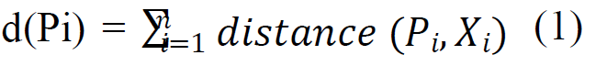
Here d(Pi) = distance of the first point that is stored in the dataset to every other one.
The next step involves sorting all the points and then getting it arranged based on this sorted distance. On the assumption that the user has submitted the K value i.e. the number of clusters created, the entire dataset is divided into k numbers that are of equal size and the very first point of each size is selected to be a centroid cluster. When this selection has The proposed technique is developed in the form of a two- phase clustering technique that integrates the Optimized K- Means in addition to the Density and Distance-based technique (OKMDD) to get the clusters rapidly with different densities and shapes in the spatial databases. Differential evolution and bat optimization algorithm have been presented in the first stage for having an optimal selection of k range and centroid values. Several considerably small spherical or ball- shaped sub-clusters are clustered with the help of K-means clustering for the dataset that is used by KMDD. Every sub cluster present in the second stage is provided a local density for combining the sub clusters.
3.1 Notion of clusters
Assume d-dimensional space R^d consists of X = x1, x2… xn, a set of n points. Suppose K sub clusters consists of set S = s1, s2,..,sK acquired by dividing X with the K-means. |sk | specifies the number of elements of sk. Dk refers to a |sk| ×K matrix, which is retrieved by K-means, in which the entries indicate the distances from every point of sk to all K centroids. This is represented by dij specifying the distance between si and sj. Dc specifies the cutoff distance. C = c1, c2,..,cG refers to the genuine cluster sets that are hidden in X. The value of K as provided, specifies the number of clusters described in flowchart 1. It uses the similar operators, such as mutation, crossover, and selection [18]. The population of every generation G consists of N individuals in every iteration process. The individual i of generation G is represented in equation (2)
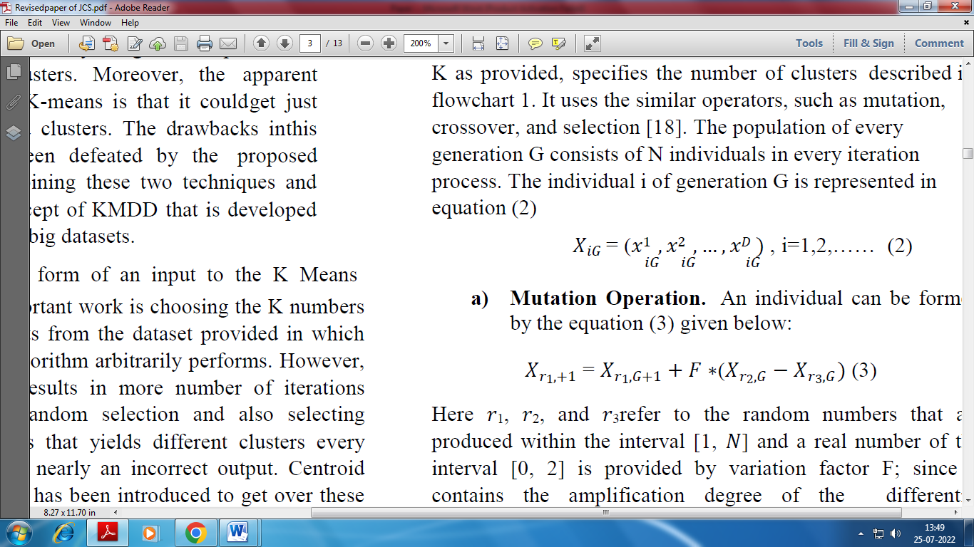
a) Mutation Operation. An individual can be formed by the equation (3) given below:

Here 𝑟1, 𝑟2, and 𝑟3refer to the random numbers that are produced within the interval [1, 𝑁] and a real number of the interval [0, 2] is provided by variation factor F; since it contains the amplification degree of the differential variable 𝑋𝑟2,𝐺 − 𝑋𝑟3,𝐺 .
b) Crossover Operation.The diverseness of the new population is provided according to the cross operation in difference algorithm. A new individual is generated by exchanging the old and new individual code based on the crossover mechanism. New individuals could be computed in equation (4-5):

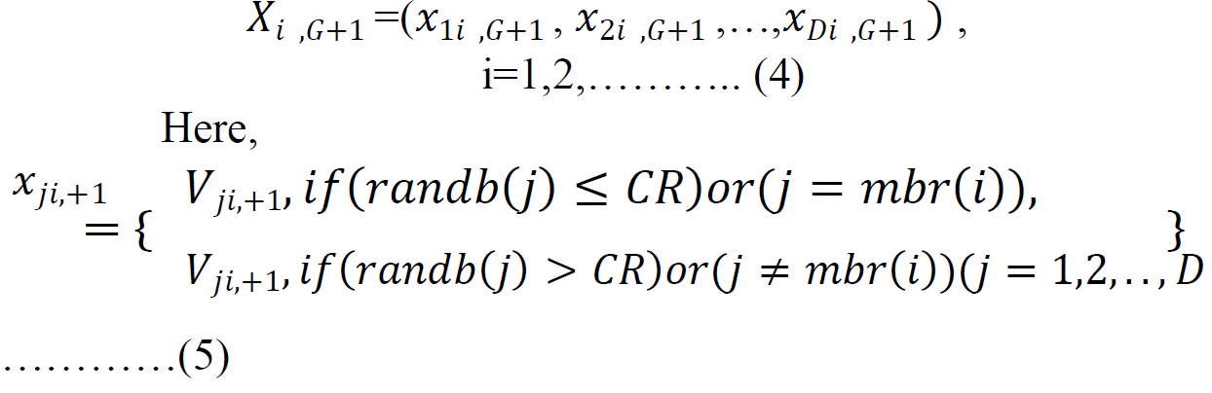
been carried out with the help of bat optimization and hybrid differential evolution, the next step involves the application of the usual k- Means algorithm.
3.2 Hybrid Differential evolution and bat optimization
Where, rand (𝑗) is being evenly distributed within the interval [0, 1] and crossover probability CR in the interval [0, 1]. 𝑚𝑏𝑟 (𝑖) indicates a random integer ranging between [0, 𝐷].
c) Selection Operation.
Basically, it uses an optimization technique for choosing the centroid values and k values from the dataset. In this scheme, different evolution and bat optimization algorithm have been presented for the optimally selecting the centroid values and k range.
Differential Evolution algorithm (DE)
Similar to genetic algorithm, the Differential Evolution algorithm (DE) is also a population-based algorithm that is
Selection operation shows a greedy mechanism; and the target individual, the candidate individual gets generated from the crossover and mutation operation contention, it is computed with equation (6):
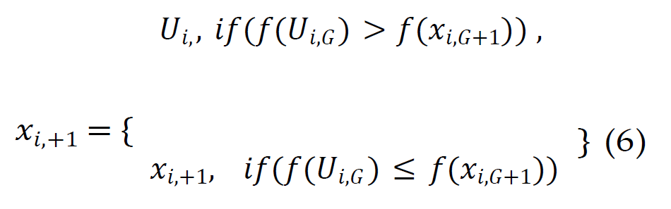
Where, 𝑓indicates the fitness function.
Figure 1: Flowchart of the DE algorithm

Figure1 illustrates the iterative operational flow of a Genetic Algorithm (GA), an evolutionary optimization technique inspired by the process of natural selection. In this process, the algorithm begins with the initialization of a population of candidate solutions, followed by fitness evaluation to assess their performance based on a predefined objective function. The population then undergoes genetic operations such as mutation, crossover, and selection to generate improved offspring. These steps are iteratively executed until a specified termination condition—such as convergence criteria or a maximum number of generations—is met, resulting in an optimal or near-optimal solution to the given problem.

The Algorithm 1 shows the fundamental Differential Evolution (DE) algorithm.
Algorithm 1:
1. Initialization
2. Evaluation
3. Repeat
4. Mutation
5. Recombination
6. Evaluation
7. Selection
8. Until (termination criteria are met)
Bat Algorithm (BA)
The simulation behavior of microbats has been performed with the multi-agent scheme BA. Every pulse in an echolocation just stays for a few thousandths of a second (up to about 8–10 ms).Below are the rules for the idealization of the echolocation characteristics of microbats in BA:
- All the bats sense the distance with the help of echolocation, and they would also ‘‘be aware” of the difference between background hurdles and food/prey in some super natural means;
- Velocity vi at position xi specify the positions in which the birds fly with a constant frequency fmin, loudness A0 and changing wavelength k for locating the prey. They can automatically adjust the wavelength (or frequency) using the pulses and the pulse emission rate rϵ[0,1] has been adjusted based on the proximity of their target;
- But the loudness could differ in several ways; it has been presumed that the loudness differs from a large (positive) A0 to that of minimum fixed value Amin
The elementary steps of BA could be summarized. For every bat (i), the position xi and velocity vi for every bat (i) in a d-
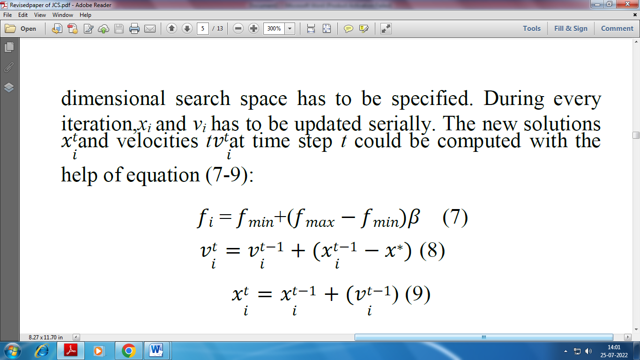
Where the random vector 𝛽present in the range of [0,1] is obtained from a uniform distribution. Here, x* refers to the current global best location (solution) that has been found after comparing each solution among that belonging to all the n bats. Since the product 𝜆𝑖𝑓𝑖indicates the given velocity increase, either fi (or 𝜆𝑖) could be used for adjusting the variation in velocity when determining the other factor 𝜆𝑖 (or𝑓𝑖), based on the kind of the problem focused. fmin= 0 and fmax= 100 are used for implementation purposes, based on the size of the domain problem of interest. Initially, every bat has been randomly designated a frequency that is obtained uniformly from the range [fmin, fmax].
Once a solution is chosen for the local search step among the best of the current solutions, a new solution would be created for every bat locally using a local random walk, as represented in equation (10)
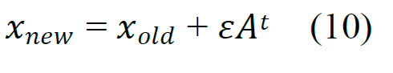
Where 𝜀 refers to the random number is obtained from [−1, 1], at the same time 𝐴𝑡 (𝐴𝑡) is regarded to be the mean loudness of all those bats during this time period. The update of the positions and velocities of bats have exhibited few similarities with the procedure used in standard particle swarm optimization denoted as fith at generally helps in controlling the range and speed of the movement of the swarming particles. BA could be regarded as a balanced combination to some level as the standard particle swarm optimization and therefore the loudness and pulse rate has a control on the rigorous local search. When the prey has been got by the bat, there is an increase in the pulse emission rate and the loudness, generally reduces. The loudness could be selected to beany value of convenience here. For simplicity sake,A0= 1 and Amin= 0 could be utilized. Amin= 0 has been presumed that a bat has just got the prey and stop letting out sound for the time being, and therefore:

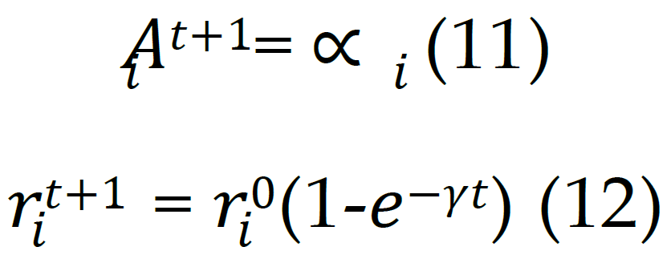

Where, ∝ and 𝛾 refers to constants.
The loudness and pulse emission rate need to get updated as per the equation (11) and (12)
In this proposed research work, Differential evolution and bat optimization algorithm has been presented for computing the centroid optimal selection values and k range. The entire workflow is illustrated in figure 2.

Figure 2: Flowchart of the Hybrid Differential evolution and bat optimization

Algorithm 2: Hybrid Differential evolution and bat optimization
- Initialize the population
- For i = 1 to N (size of population) do
- Choose randomly r1, r2, r3 ∈ N // r1, r2, r3 has been chosen such that r1≠ r2 ≠ r3//
- For j = 1 to D (dimension) do
- Choose𝑚(𝑖)∈D
- If (rand () < CR or j = 𝑚(𝑖)

// uniformly distributed random number has been represented by rand () between 0 and 1//
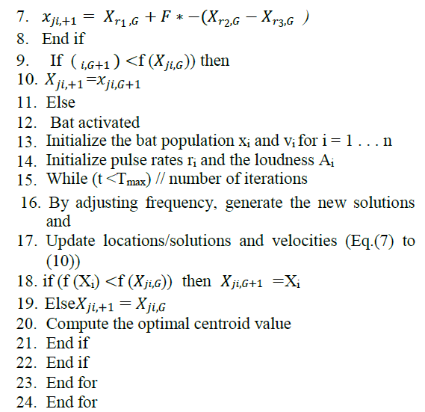

3.3 OKMDD clustering
K–mean clustering
The popular clustering problem would be resolved using the simplest unsupervised learning algorithm known as K-means. Clusters are entirely based on the selection of the initial clusters centroids according to the fundamental K-means clustering algorithm. An extensively used clustering approach requires the user defined parameters like the number of clusters k, cluster metric and cluster initialization. The classical K-means is shown in figure 3.
Algorithm 3: K–mean clustering
Input: Let X = {x1,x2,x3, ......... ,xn} refers to the set of data points and V = {v1,v2, ........ ,vc} is the set of centers.
Output: A set of sub clusters K
- Initialize the cluster centroids in random
- For every cluster
- Repeat
- Compute the distance between every data point and cluster centers.
- Allocate the data point to the cluster center whose distance from the cluster center is the minimum of all of the cluster centers.
- Re-compute the new cluster center with the equation (13)
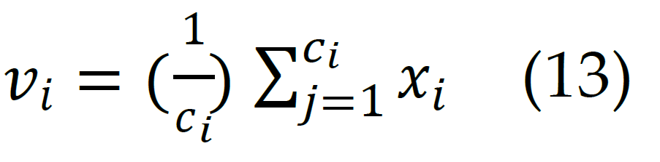
Where,
ci - number of data points in the i^{th} cluster
Xi–data points
- Re-compute the distance between each data point and newly computed cluster centers.
- Stop till the data point is reassigned
- End for

The number of sub clusters (K) is the resultant output of k mean clustering algorithm.

Figure 3: Flowchart of the K–mean clustering algorithm

Lemma 1: K-means could help in partitioning the datasets when K is sufficiently huge (with random densities and shapes) into a considerably smaller sub clusters and it guarantees that each one belongs to only one real cluster (hard partition). The sub clusters are adequately small such that every point in a sub cluster is not a member of two or more real clusters.

Proof: Let K=n, every sub cluster consists of just one point and it is not a member of two or more clusters, which are real. The dataset with no noise and its clusters would be partitioned in a better manner by space; when compared to that of n, K is not very big. If the clusters are overlapping or the dataset exhibits more noise, smaller K might not be enough. In the worst case scenario, K might be allocated to n such that the sub clusters exhibit the small size (one point). In this algorithm, and this scenario will be exactly the same as DD.
Also, KMDD demonstrates more efficiency when less precision is required (i.e. a smaller K) practically.

Definition 1: The least distance between the points of si andthe centroid of sj is always not equivalent to that of points between sj and the centroid of si. Therefore, the distance among si and sj is denoted as the average of the two:
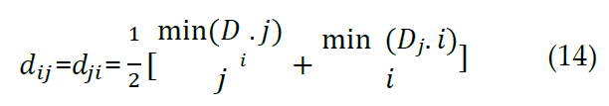
Where, Di:j refers to the jth column of Di and Dj:I indicates the ith column of Dj.

The distance specified is used in (14) in place of distance between the sub clusters comprising of the centroids. The former yields good information regarding the proximity of sub clusters of two for getting the clusters with a non-convex shape.

Definition 2:By The local density 𝜌𝑖of sub cluster iby redefining the exponential kernelcan be expressedin equation (15)

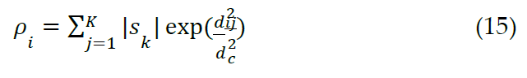
Definition 3: The least distance 𝛿 between sub cluster I and that of any other sub clusters having higher density is measured with the help of equation (16):
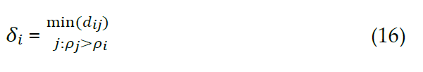
In the case of the high density sub cluster δi = maxj (dij). The neighbor of sub cluster i (except the sub cluster having the highest density) is acquired applying the equation (17):

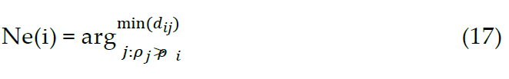
Figure 4: flowchart of the proposed OKMDD algorithm

Algorithm 4: OKMDD algorithm
Input: dataset X, number of sub clusters K, number of clusters G, cut off distance 𝑑_{𝑐}.

Output: Cluster C
- Initialize dataset
- Apply K-means for partitioning the dataset X into K sub clusters (employing hybrid DE and bat optimization), return sub clusters {1, 𝑠₂, . . 𝑠_{𝐾}} and distance matrices (𝐷₁, 𝐷₂, … , 𝐷_{𝐾}}
- Compute the distance between every pair of sub clusters 𝑑_{𝑖𝑗}
- Compute 𝜌 of every sub cluster by (15)
- Compute 𝛿 of every sub cluster by (16), and obtain its neighbor by (17)
- Use the decision graph to choose G cores and (if required) noise sub clusters.
- Generate G clusters for G cores
- If sub cluster i(i=1,2,..,K) is not a core or does not belong to noise
- Assign it to the cluster its neighbor is a member of
- Else combine them
- End if
- Mark every point in accordance with the cluster label of its being a member of a sub cluster, and obtain the final clusters C={ 𝑐₁, 𝑐₂, … , 𝑐_{𝐺}}.

The OKMDD consisting of the partition-and-merge procedure primarily comprises of four steps: procedure of K- means (Step 1-2), computation of 𝜌 and 𝛿 for every sub cluster (Steps 3-5), core selection core (Step 6) and assignment of The implementation of the available k means, KMDD clustering and the newly introduced OKMDD clustering algorithms were done in the MATLAB environment. The performance in terms of the data (Step 7-12). The algorithm is described in detail in the flow chart shown in Figure 4, in which cl(s_{k}) denotes the cluster label of s_{k}, Ne(s_{k}) refers to the neighbor of s_{k}, and point(s_{k}) retrieves each point from sub cluster s_{k}.
The proposed clustering scheme not just helps in clustering large spatial databases with efficiency, but also takes spatial attributes and non-spatial attributes into consideration. Spatial attributes are helpful in defining the spatial location e.g., longitude, latitude and elevation, in addition to the shape and degree of spatial objects. Non spatial attributes are utilized for defining the non spatial features of objects, like name, population, and unemployment rate for a city.
TABLE 1. Description of the clustering algorithms:
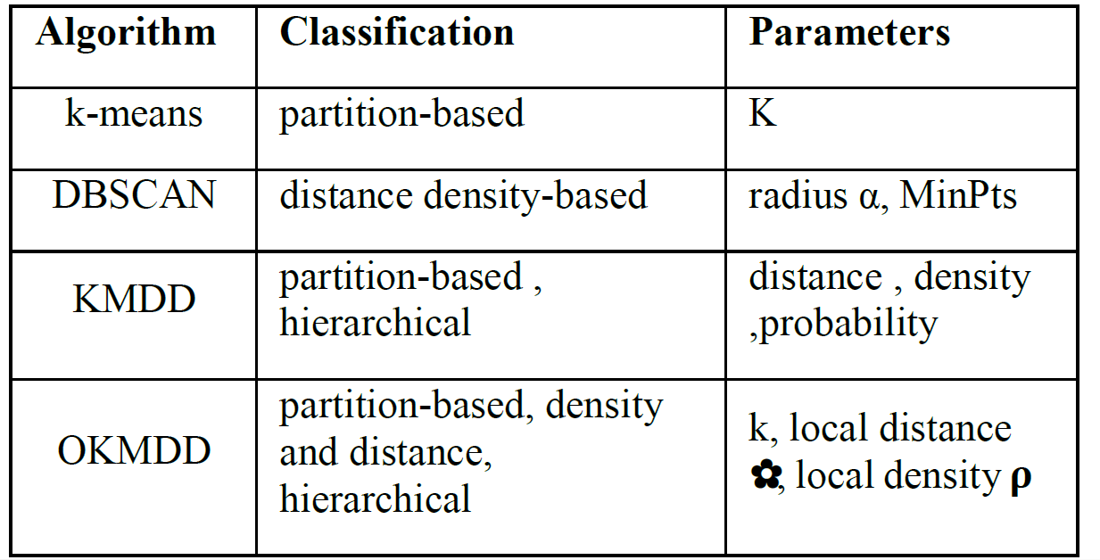
The table1 compares clustering algorithms by type and parameters. k-means uses partitioning with parameter K. DBSCAN applies density-based clustering using radius (α) and MinPts. KMDD combines partition and hierarchical methods using distance, density, and probability. OKMDD enhances this with k, local distance, and local density (ρ) for better detection of complex cluster
4. RESULTS AND DISCUSSION
4.1 DATA SETS:
A. SYNTHETIC DATA:

TABLE2. Detailed description of the parameters for the datasets.
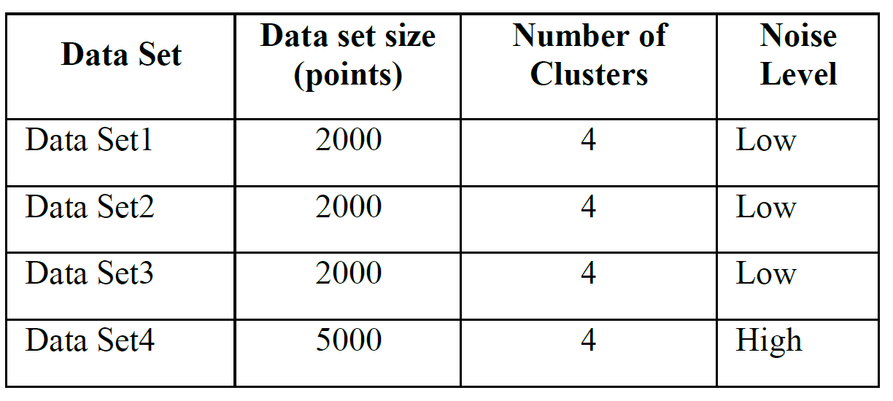
The table2 shows details of four datasets used for clustering. Data Sets 1–3 each contain 2000 points with 4 clusters and low noise, while Data Set 4 has 5000 points, 4 clusters, and a high noise level.
TABLE3.Results in ARI, RI, Mirkins index, Hubert’s index. 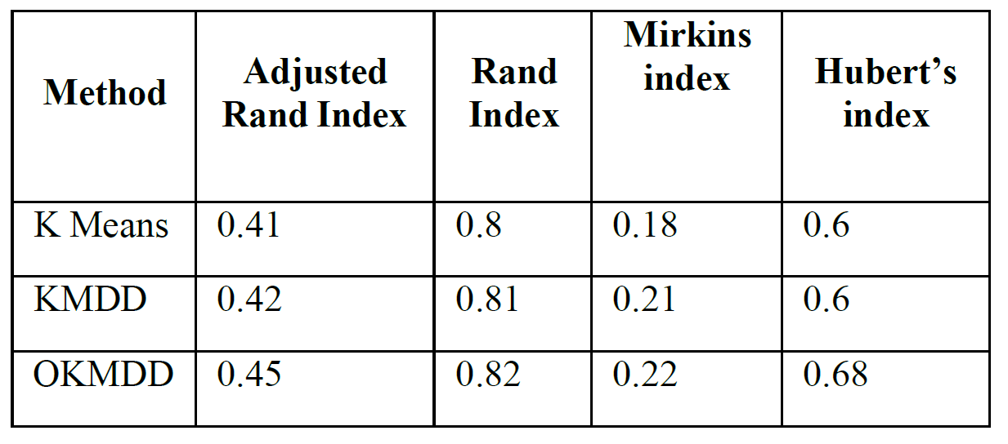
The table3 compares clustering performance using different evaluation indices. OKMDD shows the best results with higher Adjusted Rand (0.45), Rand (0.82), and Hubert’s index (0.68) values, indicating better clustering accuracy than KMDD and K-means.
Figure 5. Clustering results

Figure 5 shows the clustering results of K-means, KMDD clustering and Optimized KMDD clustering. The proposed work is primarily focused on the realization of Optimized K- Means with Density and Distance-based algorithm (OKMDD).

Adjusted rand index
The similarity between the two assignments has been computed with the help of Adjusted Rand index function by not considering permutations and with the probability of normalization.

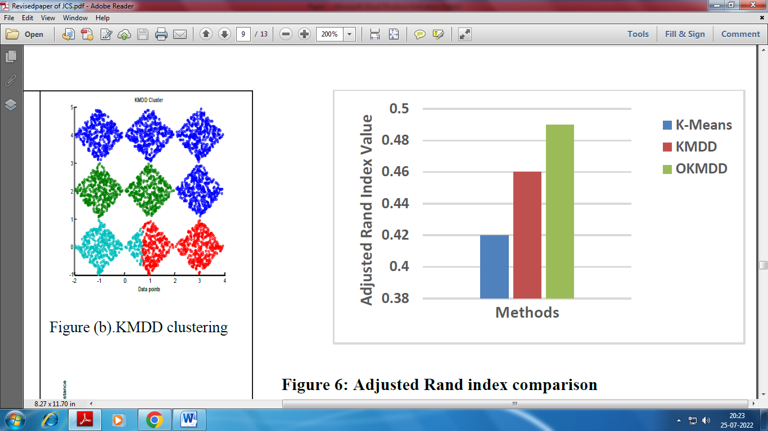
Figure 6: Adjusted Rand index comparison

The comparison analysis of the adjusted rand index of the newly introduced OKMDD based spatial clustering is done with the available k means, KMDD based spatial clustering. The proposed and existing techniques are plotted along the x-axis and the adjusted rand index is plotted along the y-axis. It can be proven from the figure6 that the novel OKMDD attains 0.45 to be adjusted rand index while; the other available K-means and KMDD achieves the adjusted rand index as 0.41 and 0.42 correspondingly. A much better performance has been attained by the proposed technique in comparison with that of the available KMDD based clustering and k-means schemes.

Rand index
The Rand index computes the similarity of the clusters (retrieved by the clustering algorithm) and the benchmark classification approaches. Also the Rand index can be considered to be the measurement of the percentage of the right decisions taken by algorithm.
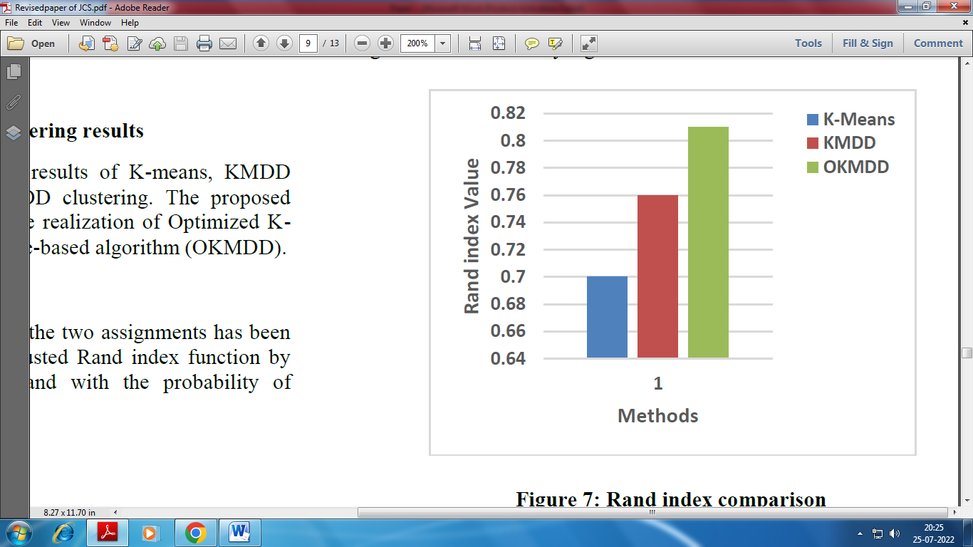

Figure 7: Rand index comparison

Figure 7 shows the evaluation chart of rand index
performance for k means, KMDD and OKMDD based spatial clustering. The proposed and existing techniques are plotted along the x-axis and the rand index is plotted along the y-axis. As observed from the figure 7, the performance of novel OKMDD achieves a rand index of 0.82 while, the other available K-means and KMDD attains a rand index for 0.80 and 0.81 correspondingly. The experimental results reveal that the presented system yields a superior performance in comparison with the available k means and KMDD based clustering schemes.

Mirkins index
Mirkin index is also called as equivalence mismatch distance. Mirkin metric exhibits sensitivity to that of cluster sizes.
e the other available K-means, KMDD yields a Mirkins index as 0.6 and 0.6 correspondingly. The results obtained from the experiments reveals that

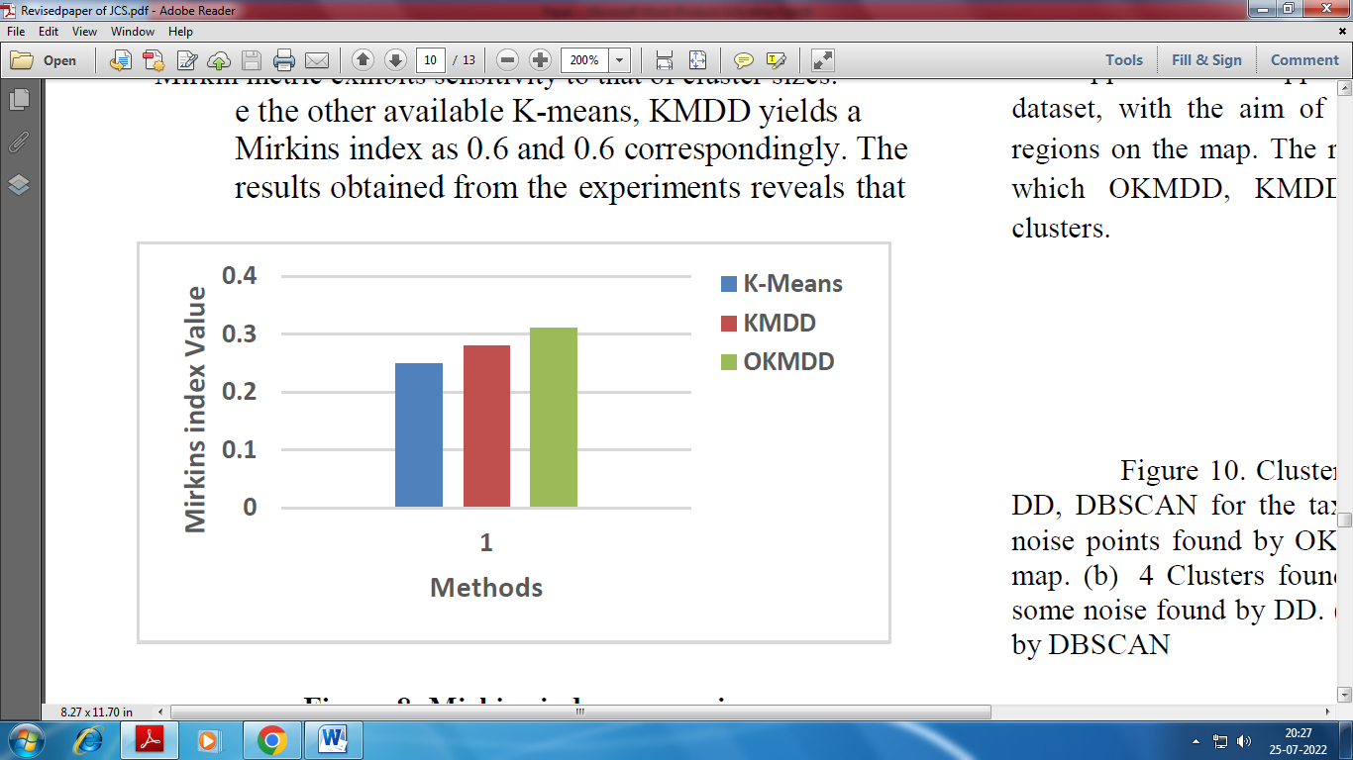
Figure 8: Mirkins index comparison

Figure 8 shows the evaluation chart of Mirkins index performance for k means, K MDD and OKMDD based spatial clustering. The proposed and existing techniques are plotted along the x-axis and Mirkins index is plotted along the y-axis. The proposed OKMDD achieves a Mirkins index of 0.22 while, the other available K-means, KMDD yields a Mirkins index of 0.18 and 0.21correspondingly. The results obtained from experiments show that the novel system attains a better performance in comparison with the available k means and KMDD based clustering schemes.

Hubert’s index
Figure 9: Hubert’s index comparison

Figure 9 shows the evaluation chart of Huberts index performance for k means, KMDD and OKMDD based spatial clustering. The proposed and existing techniques are plotted along the x-axis and Hubert’s index is plotted along the y-axis. The proposed OKMDD achieves a Hubert’s index of 0.68, the proposed system attains a much better performance in comparison with the available k means and KMDD based clustering schemes.

B. REAL SPATIAL DATA:

We take a part set of taxicab data in New York City from [19], which has 36382 taxicab coordinates produced from 2nd, 2014 to June 30th, 2014 within a range of longitude: 40.645o N ~ 40.795ºN and latitude: 73.85º W ~ 74.02º W .We also applied the 4 approaches to the New York taxicab dataset, with the aim of identifying the possible functional regions on the map. The results are presented in Figure.10 in which OKMDD, KMDD, DD, DBSCAN discovered 4 clusters.

DD, DBSCAN for the taxicab data set. (a) 4 clusters and 4 noise points found by OKMDD, platting on the back ground map. (b) 4 Clusters found by KMDD. (c) 3 Clusters and some noise found by DD. (d) 4 Clusters and some noise found by DBSCAN

This experiment examines how each method scales with data size n and dimension d. For this purpose, we used SS dataset [20] of 5D,7D, and 9D Datasets in Figure11. By varying n from 1k to 10m to examine the running time of K- Means, OKMDD, KMDD,DD, DBSACN, Chameleon. Note that the axis of running time is in log scale.
It is interesting that the time efficiency of our method is not influenced by data dimension d .

Figure10. Clusters discovered by OKMDD, KMDD, DD, DBSCAN for the taxicab data set. (a) 4 clusters and 4 noise points found OKMDD, platting on the back ground map. (b) 4 Clusters found by KMDD. (c) 3 Clusters and some noise found by DD. (d) 4 Clusters and some noise found by DBSCAN

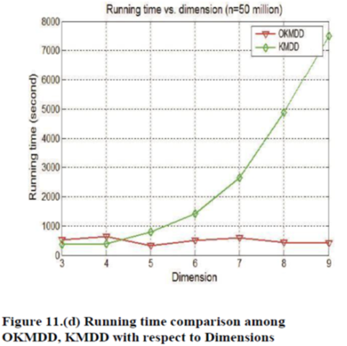
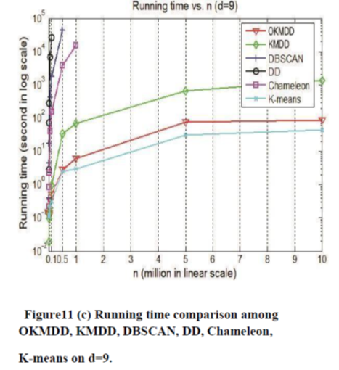

Figure11. X-axis represents the number of data points (in millions) on a linear scale. It ranges from 0.1 to 10 million. Y-axis represents the running time in seconds on a logarithmic scale, showing how computation time grows with dataset size.
.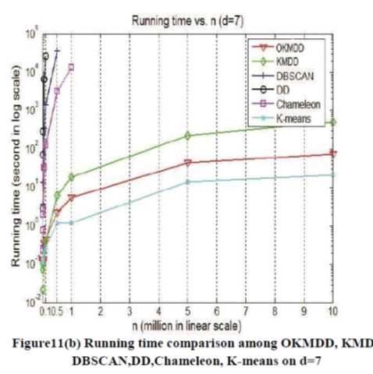
Figure11: Indicates that K-means is the most time-efficient algorithm among the compared methods, while DBSCAN and Chameleon are computationally expensive for large datasets. The OKMDD and KMDD algorithms maintain a balanced performance between efficiency and accuracy, making them suitable for large-scale data clustering where both speed and precision are essential

5. CONCLUSION
The new spatial clustering method has been implemented by the proposed system known as OKMDD, which uses a partition-and-merge technique for rapid discovery of clusters having different densities and shapes in the spatial databases. The initial centroid and k values are selected in OKMDD based clustering technique using Hybrid Differential evolution and bat optimization algorithm. Three-phase clustering technique has been implemented in accordance with these optimal values. K-means is integrated with the novel algorithm with density and distance-based technique for rapid discovery of clusters with different densities and shapes in the spatial databases. The newly introduced system yields a superior performance as revealed by the experimental results in comparison with the previously existing system in terms of adjusted rand index, Mirkins index, rand index and Hubert’s index. It's interesting that the time efficiency of our method isn't influenced by data dimension d.
In future, we can use more number of machine-learning algorithms for better results.
Acknowledgement
I express my gratitude to Prof. V.Senhil Murgan for her invaluable motivational support and guidance in the composition of this article..
Funding Information
The authors did not receive any monetary assistance for the investigation, composition, and/or publication of this manuscript..
Author’s Contributions
Lakshmaiah: Contributed to the conceptualization, formal analysis, methodology section, coding, validation,
and original drafted written phases of the study.
Veersh Babu: Contributed to the conceptualization, supervision, reviewed, edited and administration of the project.
Ethics
The work accurately and thoroughly represents the
Authors' research and analysis. The work acknowledges the valuable contributions of co-authors and core searchers. The findings are properly put in research history. Text cites all references and related works
References
- Han, J., Kamber, M., and Tung, A. K. H. (2001): Spatial clustering methods in data mining: A survey. In Miller, H.J. and Han, J. (Eds.): Geographic Data Mining and Knowledge Discovery, 3-32, Taylor and Francis.
https://www.comp.nus.edu.sg/~atung/publication/gkdbk01
- Tan, P.-N., Steinbach, M., and Kumar, V. (2006): Introduction to Data Mining. Pearson Addison Wesley.
- Bernhardsen, T. (2002): Geographic Information Systems: An Introduction, New York: Wiley.
- J. Wang et al.: 2017, From Partition-Based Clustering to Density-Based Clustering, IEEE Access ( Volume: 6),Pp. 1718 – 1729
https://doi.org/10.1109/ACCESS.2017.2780109
- Yan, Z., Luo, W., Bu, C. and Ni, L., 2016, December. Clustering spatial data by the neighbors intersection and the density difference. In Proceedings of the 3rd IEEE/ACM International Conference on Big Data Computing, Applications and Technologies (pp. 217-226). ACM.
https://doi.org/10.1145/3006299.3006332
- Yan, Z., Luo, W., Bu, C. and Ni, L., 2016, December. Clustering spatial data by the neighbors intersection and the density difference. In Proceedings of the 3rd IEEE/ACM International Conference on Big Data Computing, Applications and Technologies (pp. 217-226). ACM.
https://www.wseas.org/multimedia/journals/computers/2015/a745705-775
- Guo, Y., Liu, K., Wu, Q., Hong, Q. and Zhang, H., 2015. A new spatial fuzzy c-means for spatial clustering. Wseas Transactions on Computer, 14, pp.369-381.
https://dx.doi.org/10.17485/ijst/2016/v9i3/75971
- Sajana, T., Rani, C. S., and Narayana, K. V. 2016. A survey on clustering techniques for big data mining. Indian journal of Science and Technology, vol.9,no.3, pp.1-12.
- D., Bezdek, J. C., Palaniswami, M., Rajasegarar, S., Leckie, C., and Havens, T. C. 2016. A hybrid approach to clustering in big data. IEEE transactions on cybernetics, vol46, no.10, pp.2372-2385.
https://link.springer.com/chapter/10.1007/978-981-13-0344-9_33
- Hung, W.L., 2019. Flexible EM-Type Algorithms for Spatial Clustering. In Advances in Computer Communication and Computational Sciences (pp. 383- 392). Springer, Singapore.
https://link.springer.com/book/10.1007/978-981-96-6906-6
- F. Murtagh and P. Contreras, ``Algorithms for hierarchical clustering: An overview,'' Data Mining Knowl., Discovery, vol. 2, no. 1, pp. 86-97, 2012.
https://doi.org/10.1002/widm.53
- Rodriguez and A. Laio, ``Clustering by fast search and find of density peaks,'' Science, vol. 344, no. 6191, pp. 1492_1496, Jun. 2014.
DOI: 10.1126/science.1242072

- GenlinJi; Jianxin Miao; PeimingBao, “A Spatial Clustering Algorithm Based on Spatial Topological Relations for GML Data”, International Conference on Artificial Intelligence and Computational Intelligence, Pp. 298 – 301, 2009.
DOI:10.1109/ETCS.2009.69
- Ritu Chauhan, “Data Clustering Method for Discovering Clusters in Spatial Cancer Databases”, International Journal of Computer Applications (0975 – 8887) Volume 10– No.6, November 2010.
https://www.ijcaonline.org/volume10/number6/pxc3872004.pdf
- Kun Qin, YixiangChen , Yong Zhan and Fangyuan Cheng, “Spatial Clustering Considering Spatio-temporal Correlation”, IEEE, 2011.
https://doi.org/10.1109/GeoInformatics.2011.5980866
- Deng, C., Song, J., Sun, R., Cai, S. and Shi, Y., 2018. GRIDEN: An effective grid-based and density-based spatial clustering algorithm to support parallel computing. Pattern Recognition Letters, 109, pp.81-88.
https://doi.org/10.1109/ACCESS.2021.313470
- Pereira, C.M. and de Mello, R.F., 2015. Persistent homology for time series and spatial data clustering. Expert Systems with Applications, 42(15-16), pp.6026-6038.
https://doi.org/10.1016/j.eswa.2015.04.010
- Deng, M., Liu, Q., Cheng, T. and Shi, Y., 2011. An adaptive spatial clustering algorithm based on Delaunay triangulation. Computers, Environment and Urban Systems, 35(4), pp.320-332.
https://doi.org/10.3390/ijgi6090272
- Elsayed, S. and Sarker, R. 2016. Differential evolution framework for big data optimization. Memetic Computing, vol.8, no.1, pp.17-33.
https://dokumen.pub/big-data-analytics-for-intelligent-healthcare-management-1nbsped-012818146x-9780128181461.html
- Y. Zheng, H. Zhang, and Y. Yu, ``Detecting collective anomalies from multiple spatio-temporal datasets across different domains,'' in Proc. SIGSPA-TIAL, 2015, p. 2.
https://dl.acm.org/doi/10.1145/2820783.2820813
- J. Gan and Y. Tao, ``DBSCAN revisited: Mis-claim, un-xability, and approximation in Proc. SIGMOD, 2015, pp. 519_530.
https://dl.acm.org/doi/10.1145/2723372.2737792

