Finding Minimum Dominating Set
Using Python Program in Certain Graphs
R. Manimegalai¹[0000-0003-1398-4080], J. Anitha²[0000-0003-3564-2305], B.K. Danush Pranav³, S. Karthikeyan⁴
^{1,3,4} Department of Computer Science and Engineering, PSG Institute of Technology and Applied Research, Coimbatore, India
¹Email: drrm@psgitech.ac.in
² Rajalakshmi Institute of Technology, Chennai, India
²Email: anithaharish78@gmail.com

Abstract. This work explores the Minimum Dominating Set (MDS) problem, focusing on developing and applying an algorithm suited to different graph structures. The algorithm is tested on various graphs, including path, ladder, cycle, comb, binary trees, and sibling trees. Through extensive testing, the paper evaluates the algorithm's performance in terms of solution quality, runtime efficiency, and scalability across diverse graph types. The findings provide valuable insights into algorithmic solutions for practical graph-based scenarios. Furthermore, the algorithm exhibits potential applications in fields such as facility location, surveillance, and network design, demonstrating its versatility and relevance in real-world contexts.
Keywords: Dominating set, Facility location problem, Python program, Greedy algorithm, Algorithm optimization.
- Introduction

[1] The Minimum Dominating Set (MDS) in [22] graph is a subset S of vertices within a graph such that every vertex in the graph is either included in the set or directly connected to the set of vertices. The cardinality of the minimum dominating set represents the least number of vertices that are required to achieve the condition of domination over the graph. The minimum dominating set (MDS) problem plays a crucial role in the domain of facility location, where the objective is to position the fewest number of facilities to serve efficiently for set of demand points. Minimum Dominating Set problem (MDSP) also applied in various domain like network monitoring, social networking etc. It is an optimization problem in computer science and it is Np - hard. Identification of MDS is important as it have various application, starting from designing an efficient communicational network to reduce the spread of diseases in a population. Other than facility location and new monitoring, nowadays communication is growing exponentially and they play an important role in our daily life. They influence all the politics and economics. We communicate more with our friends and family using social networks than the face-to-face meeting. This connection forms a network so we need to reach all the nodes in the network quickly and directly due to other constraints. This is possible if all the nodes are connected by at least one single node who is connected directly to them. So, we need to select a set of nodes in the network which can enable us to directly contact with all the other nodes in the network. In this case our main goal is to find a set which has minimum number of such nodes. In Graph theory this is known as the minimum dominating set problem [2]. There are several methods to solve the Minimum Dominating Set problem. Most methods used to solve this problem using approximation algorithms and heuristic methods [1]. Over the decades many greedy algorithms have been developed, each of this approach has its own strengths and limitation. Graphs with substantially large number of vertices present a computational challenge when we try to identify the Minimum Dominating Set.

Literature Review
Guan, L., Wang, H. [1] presented a heuristic approximation algorithm for the minimum dominating set problem in undirected graphs. Their Heuristic Approximation Algorithm for Minimum Dominating Set (HAAMDS) utilizes principles from rough set theory . This employed a heuristic approach involving stepwise accumulation of data and forward/backward search mechanisms to enhance solution accuracy. The algorithm's feasibility is demonstrated through experimentation on public datasets, showcasing its practical applicability. Mofidi, A. [2] dove deep into the equivalence of properties related to dominating graphs, median graphs, and the complement of minimal dominating sets in graphs devoid of isolated vertices. Through an exploration of graph theoretical methods and concepts from domination theory, median graphs, partial cubes, and other graph properties, the study established connections between the discussed conditions, contributing to a deeper understanding of these graph structures and their interrelationships. Boyar, et al. [3] examined the challenges inherent in online algorithms for the dominating set problem. Their research highlighted the difficulties posed by making irreversible decisions without foreknowledge of future input and the need to maintain solutions for all input prefixes. Through competitive analysis, the study sheds light on the performance of online algorithms in dominating set problems, offering insights into algorithmic abilities and their efficiency. Ching-Hao Liu et al. [4] focused on the Independent Dominating Set Problem (IDS) within graph theory. Their analysis covers various aspects of the IDS problem, including its NP completeness in cubic grid and cubic bipartite graphs, fixed parameter tractable algorithms, and applications in identifying influential individuals in positive information propagation in social networks. By addressing different facets of the IDS problem, the study provided a comprehensive understanding of its complexity and applications. Foucaud et al. [5] discussed identification, location-domination, and metric dimension problems, particularly in permutation graphs. Their work aimed to locate vertices within a graph using a minimal subset of selected vertices, proving the NP completeness of associated decision problems, including interval graphs of diameter 2. By addressing these fundamental problems in graph theory, the study provides insights into the complexity of graph structures and their associated decision problems. Ding, X et al. [6] proposed a fast and differentiable optimization model for finding the minimum dominating set in large-scale graphs. By converting the coordinated model into a differentiable problem using gradient descent, the approach accesses all vertices simultaneously with linear time complexity. Comparative analysis demonstrates its efficiency, offering a promising alternative for solving the minimum dominating set problem and similar NP-hard problems. The study contributed to algorithmic advancements in graph theory, particularly in optimizing solutions for large-scale graph problems. Katrin Casel et al. [7] extended several edge graph problems by examining their standard parameterized and approximation complexity. Their study provided insights into various edge graph problems and contributed to understanding the computational complexity and potential approximation strategies for these problems. Fateme Fotouhi et al. [8] addressed communication overhead in decentralized deep learning (DDL) and proposed the Minimum Connected Dominating Set Model Aggregation (DSMA) algorithm. Utilizing the Minimum Connected Dominating Set concept from graph theory, DSMA efficiently managed information flow among agents in DDL, showcasing scalability and competitive performance across various datasets, model architectures, and agent numbers. The study contributed to addressing scalability challenges in DDL, offering an efficient solution for information aggregation in decentralized environments. Misa Nakanishi [9,24] focused on the Minimum Dominating Set problem for graphs with a minimum degree of at least 3. The study proposed a scheme to identify certain vertices in the minimum dominating set by transforming the graph, contributing to understanding the complexity of the Minimum Dominating Set problem for cubic graphs. By addressing specific graph structures, the study provides insights into the complexity of dominating set problems in graphs with minimum degree constraints. Rui Sun et al. [10] addressed the Minimum Positive Influence Dominating Set (MPIDS) problem in graph theory, particularly its applications in social networks. Their proposed Fast PIDS algorithm utilizes reduction-based initialization and a novel vertex exchange strategy to improve performance, outperforming [10] state-of-the-art MPIDS algorithms on various benchmarks. By addressing efficiency challenges in MPIDS algorithms, the study contributes to advancing algorithms for positive influence propagation in social networks. S Sangeetha and M Swarnamalya [11] investigated paired domination in simple graphs, presenting results in the context of AIP Conference Proceedings. Their study emphasized the computational challenges and potential applications of paired domination, contributing to the broader understanding of graph theory and its practical implementations in network analysis and optimization. Nicolas Bousquet et al [12] explored the concept of locating-dominating sets, extending it from traditional graphs to oriented graphs. Their research, published in a recent volume, addressed the complexities and unique properties of oriented graphs, offering new insights into the applications and theoretical underpinnings of locating-dominating sets. John McCoy and Michael A. Henning [13] analysed the properties and applications of locating and paired-dominating sets in graphs. Their comprehensive study provided foundational knowledge and advanced the theoretical framework necessary for understanding the role of these sets in various graph structures. Mikko Koivisto et al [14] examined the NP-completeness results for partitioning a graph into total dominating sets. Their findings, published in a prominent journal, highlighted the computational difficulties associated with this problem, offering valuable insights for researchers and practitioners working on graph partitioning and related optimization challenges. Iain Beaton and Jasin I. Brown [15,21] investigated the average order of dominating sets in graphs. Their research provided statistical insights and theoretical foundations for understanding the distribution and characteristics of dominating sets across different types of graphs, contributing to the broader field of graph theory and its applications. Abdel-Basset et al [16] presented a hybrid intelligent method that integrates swarm intelligence and metaheuristic techniques to solve the MDS problem in large-scale networks. The approach demonstrates improved performance, scalability, and solution quality compared to conventional algorithms, particularly in handling large network graphs. Li, Y. et al [17] proposed an enhanced Ant Colony Optimization algorithm tailored for solving the MDS problem in wireless sensor networks. By refining pheromone updates and incorporating heuristic ant movements, the algorithm achieves greater energy efficiency and faster convergence in highly dynamic sensor network environments. Yang, X. [18] introduced a multi-objective evolutionary algorithm to address the MDS problem in complex networks. By optimizing solution quality, network coverage, and computational efficiency, the algorithm outperforms traditional methods across multiple graph structures, making it highly applicable to real-world network scenarios. Sun, J. [19] applied reinforcement learning to the MDS problem in dynamic social networks, allowing real-time node selection and adaptation. Their algorithm demonstrates improved accuracy and efficiency over greedy and heuristic methods, especially in handling the evolving nature of large social networks. Zhang, Y. [20]
presented a distributed algorithm for solving the MDS problem in Mobile Ad Hoc Networks (MANETs). It efficiently manages decentralized decision-making, reducing communication overhead and power consumption while maintaining effective network coverage in rapidly changing network topologies.

Paper Organization

Section 1 provides an introduction [21] to the Minimum Dominating Set (MDS) problem, including its significance in various domains like facility location and network security. It also presents a comprehensive Literature Review, detailing previous approaches to solving the MDS problem and identifying the research gaps addressed by this work.
Section 2 describes the proposed methodology for solving the MDS problem. This section discusses the graph representation and the implementation of a greedy approximation algorithm in Python for different types of graphs, such as paths, cycles, and trees.
Section 3 explores the practical applications of the MDS, showcasing its relevance in [21] fields such as wireless sensor networks, social network analysis, and resource allocation.
Section 4 outlines the algorithms employed to compute the MDS for specific graph structures, accompanied by visualizations and illustrative examples of graphs including binary trees, ladder graphs, and fan graphs.
Section 5 presents the simulation results, including runtime analysis and performance evaluation of the algorithm across various graph types. It also includes a discussion of the accuracy and computational efficiency of the proposed solution.
Section 6 provides a conclusion, summarizing the key findings of the research and offering insights into potential future directions for optimizing MDS algorithms for larger and more complex graphs.
Section 7 lists all the References cited throughout the paper, providing full bibliographic details for the literature used.

2 Terminology and Basic Concepts:

By definition, a Graph is a collection of vertices and edges. Consider that vertices are dots and the edges are used to connect the dots. In mathematics a graph is denoted as and the finite set of vertices and a set of edges which are connected to each other to form a graph / network. We can take Königsberg Bridge Problem as example. This problem consists of two islands which has 7 bridges and we need to start at one place and need to travel through all the bridges and reach the starting point again and we can travel only once in a bridge. However, this is realized to go through every bridge and reach the same starting point. But we can represent this problem as a graph where all island can be represented as vertices and the bridges are the edges which forms and undirected graph network between the two islands.
A path graph is a graph whose vertices can be considered in the order such that the edges are where . A cycle is consist of n vertices and edges . [25] A comb is a graph acquired by connecting a single pendant edge to each and every vertex of a path. A complete graph is a simple undirected graph where every pair of distinct vertices is connected by a unique edge and is denoted by of order .
The star graph of order , is a tree of nodes with one node having vertex degree and the other having vertex degree 1. The Cartesian product of graphs and is a graph such that:
- The vertex set of is the Cartesian product
- Two vertices and are adjacent in if and only if either
- and is adjacent to in H, or and is adjacent to in G.
The [23] ladder graph can be acquired as the Cartesian product of two path graphs, where there is only one edge for either of them:

The friendship graph or fan graph can be constructed by joining copies of the cycle graph with a common vertex, which becomes a universal vertex for the graph. has 2n + 1 vertices and 3n edges.
A binary tree is a hierarchical data structure where every node has at most two child nodes, referred as left and right child of a node.
A sibling tree is a hierarchical data structure which is similar to a binary tree, where each node can have more than two child nodes and these child nodes are all siblings of each other.

- Proposed Methodology
Due to the computational complexity of finding an exact solution to the MDS problem in large graphs (an NP-hard problem), a heuristic or approximation algorithm is often used. Here is a practical approach using a greedy approximation algorithm implemented in Python:
- Graph Representation: Represent the graph using adjacency lists or matrices, which are common and efficient ways to handle graph data structures.
- Greedy Algorithm: Implement a greedy approach that iteratively selects the node with the highest degree (i.e., the most connections) that is not yet dominated. This method aims to cover the most nodes with the fewest selections.
- Validation: Ensure that the selected nodes form a valid dominating set, meaning every node in the graph is either in the dominating set or adjacent to a node in the set.
- Optimization: Optionally, apply further optimization techniques like local search or metaheuristic algorithms to refine the solution and potentially reduce the size of the dominating set.

4 Applications

Other than facility location and new monitoring, nowadays communication is growing exponentially and they play an important role in our daily life. They influence all the politics and economics. We communicate more with our friends and family using social networks than the face-to-face meeting. This connection forms a network so we need to reach all the nodes in the network quickly and directly due to other constraints. This is possible if all the nodes are connected by at least one single node who is connected directly to them. So, we need to select a set of nodes in the network which can enable us to directly contact with all the other nodes in the network. In this case our main goal is to find a set which has minimum number of such nodes. In Graph theory this is known as the minimum dominating set problem.
Engineering Applications of Minimum Dominating Set:
- Wireless Sensor Networks: Optimizing sensor placement is crucial to ensure full coverage while minimizing the number of sensors used, reducing costs, and improving network efficiency.
- Network Security: Identifying critical nodes for monitoring and deducting intruders is essential to maintaining network security.
- Social Network Analysis: Finding influential figures who can effectively spread information is common in social network analysis. An MDS helps identify these key influencers.
- Resource Allocation: An MDS ensures all necessary areas are served with minimal resources. For example, health care facilities, schools, libraries, police stations etc.
- Power Grids: Making sure that substations are operational and secure with the fewest of resources is vital for operational efficiency and reliability.

5. Algorithm for Finding Minimum Dominating Set of a Graph

let be a graph with vertices
set of nodes which gives the dominance over all the nodes.
function
end function

function
end function
function
end function

Cycle Graph

Edges= {1: [2,8], 2: [1,3], 3: [2,4],4: [3,5],5: [4,6], 6: [5,7], 7: [6,8],8: [1,7]}
(See Fig. 1)

Linear Path Graph
Edges = {1: [2],2:[3],3:[4],4:[5],5: [6],6:[7],7: [8 ] }
(See Fig. 2)

Star graph

Edges3 = {1: [2,3,4,5,6,7,8]}
(See Fig. 3)

Fan graph

Edges = {1: [2,11],2: [1,11],3: [4,11],4: [11,3],5: [11,6],6: [5,11],7: [8,11],8: [7,11],9: [10,11],10: [9,11],11: [1,2,3,4,5,6,7,8,9,10]}
(See Fig. 4)

Ladder graph

Edges = {1: [2,6,7],2: [1,3,7,8],3: [2,4,8,9],4: [3,5,9,10],5: [4,10],6: [1,7],7: [1,2,6,8],8: [2,3,7,8],9: [3,4,8,10],10: [9,5,4]}
(See Fig. 5)

Binary tree

Edges =
{1:[2,3],2:[1,4,5],3:[1,6,7],4:[2,8,9],5:[2,10,11],6:[3,12,13],7:[3,14,15],8:[4,16,17],9:[4,18,19],10:[5,20,21],11:[5,22,23],12:[6,24,25],13:[6,26,27],14:[7,28,29],15:[7,30,31],16:[8],17:[8],18:[9],19:[9],20:[10],21:[10],22:[11],23:[11],24:[12],25 : [12],26:[13],27:[13],28:[14],29:[14],30:[15],31:[15] }
(See Fig. 6)

Sibling Tree

Edges =
{1:[2,3],2:[4,5,1,3],3:[1,6,2,7],4:[2,5,8,9],5:[2,4,10,11],6:[3,7,12,13],7:[3,6,14,15],8:[4,9,16,17],9:[4,8,18,19],10:[5,11,20,21],11:[5,10,22,23],12:[6,13,24,25],13:[6,12,26,27],14:[7,15,28,29],15:[7,14,30,31],16:[8,17],17:[8,16],18:[9,19],19:[9,18],20:[10,21],21:[10,20],22:[11,23],23:[11,22],24:[12,25],25:[12,24],26:[13,27],27:[13,26],28:[14,29],29:[14,28],30:[15,31],31:[15,30]}
(See Fig. 7)

Comb Graph
Edges =
{1: [2,7], 2: [1,3,8], 3: [2,4,9], 4: [3,5,10], 5: [4,6,11], 6: [5,12], 7: [1], 8: [2], 9: [3],10: [4], 11: [5], 12: [6]}
(See Fig. 8)
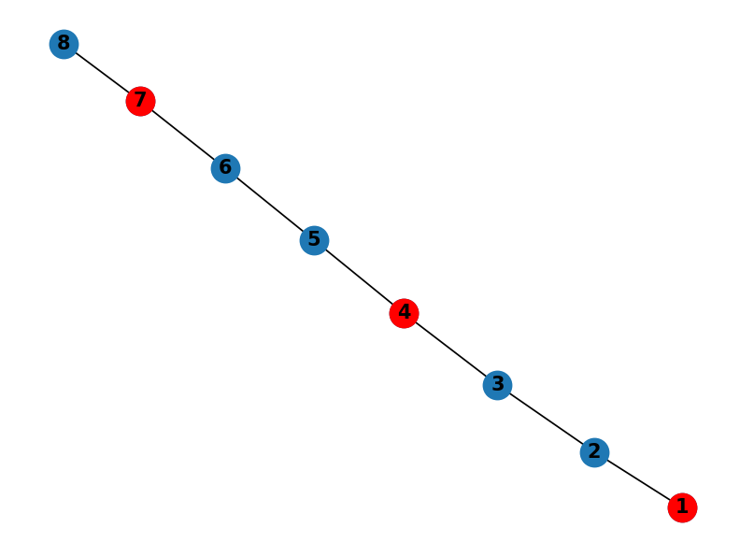
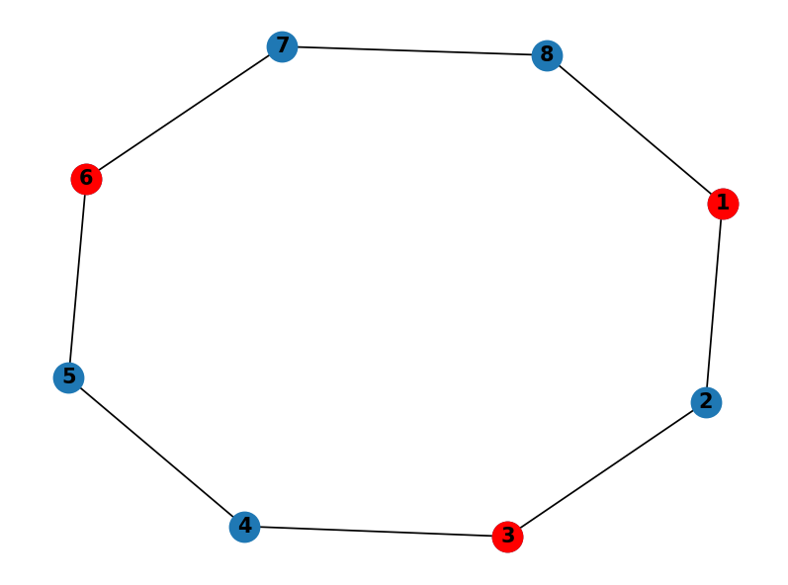

Fig 1. Fig 2.
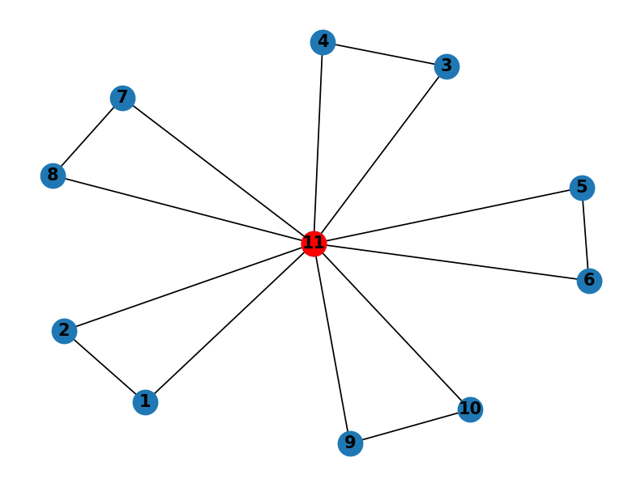
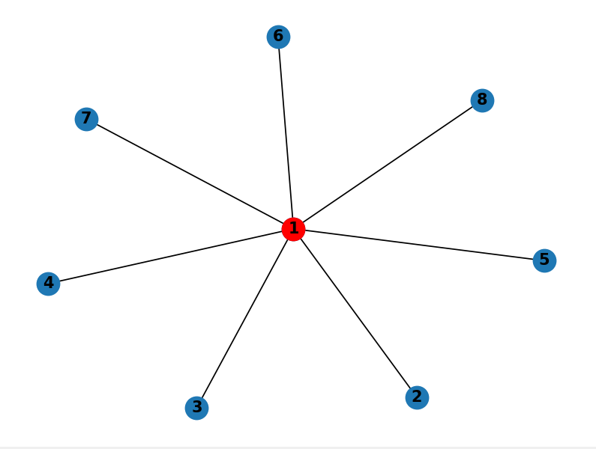

Fig 3. Fig 4.

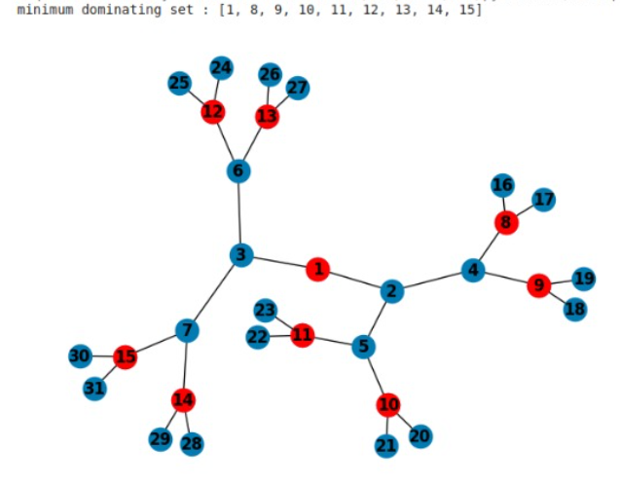
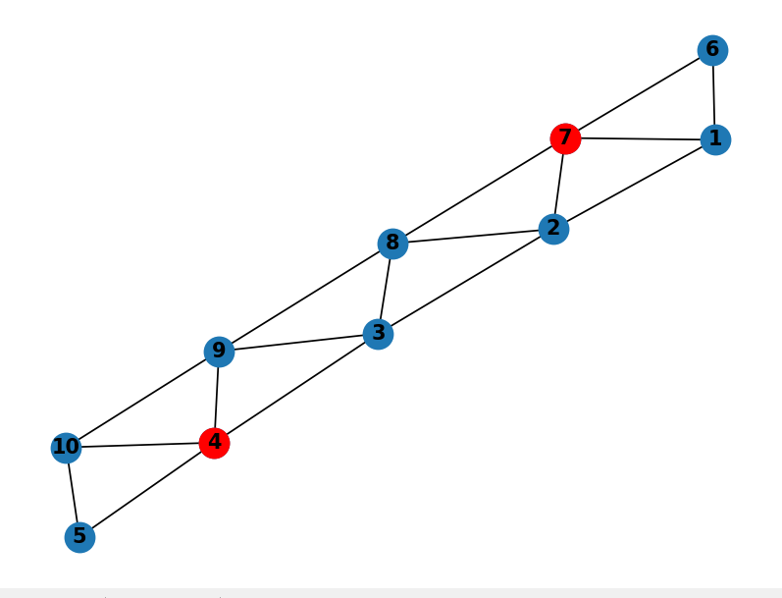

Fig 5. Fig 6.

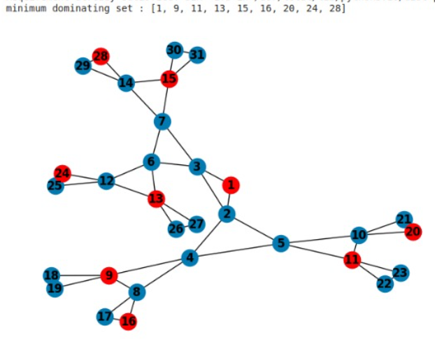
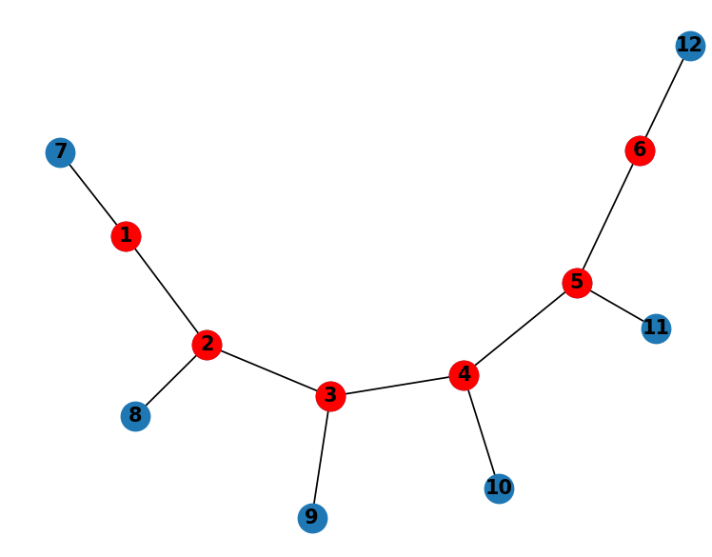

Fig 7. Fig 8.

Table 1. The Minimum Dominating Set and the Execution Time for Various Type of Graphs
TYPE | NUMBER OF NODES | RUNTIME
Cycle Graph | 8 | 0.000997s
Line Graph | 8 | 0.004002s
Star Graph | 8 | 0.002003s
Wheel Graph | 11 | 0.028002s
Graph 5 | 10 | 0.018001s
Binary Tree | 31 | 1.323242s
Sibling Tree | 31 | 1868.682s
Ladder Graph | 12 | 0.029000s
Comb Graph | 12 | 0.045004s

6 Conclusions

In this work, an algorithm designed to address the Minimum Dominating Set (MDS) problem across various graph structures including paths, cycles, ladder graphs, binary trees, and sibling trees is presented. The proposed algorithm computes the minimum dominating set for various types of graphs with minimal time, and thereby provides a practical solution to this fundamental problem in graph theory. By presenting the running time analysis for each network type, we offer insights into the algorithm's computational efficiency and scalability. These findings not only contribute to the theoretical understanding of the MDS problem but also provide practical implications for its application in real-world scenarios. Moreover, the algorithm's ability to handle diverse graph structures underscores its versatility and utility in addressing a wide range of graph-based optimization challenges. Overall, this research lays the groundwork for further exploration and refinement of algorithms for the MDS problem, paving the way for advancements in graph theory and optimization techniques.

References
- [1] Guan, L., Wang, H. A heuristic approximation algorithm of minimum dominating set based on rough set theory. J Comb Optim 44, 752–769 (2022)
- [2] Mofidi, A. On Dominating Graph of Graphs, Median Graphs, Partial Cubes and Complement of Minimal Dominating Sets. Graphs and Combinatorics 39, 104 (2023)
- [3] Boyar, J., Eidenbenz, S.J., Favrholdt, L.M. et al. Online Dominating Set. Algorithmica 81, 1938–1964 (2019)
- [4] Ching-Hao Liu, Sheung-Hung Poon, Jin-Yong Lin et al. Independent dominating set problem revisited. Volume 562, 11 January (2015), Pages 1-22
- [5] Foucaud, F, Mertzios, G.B., Naserasr, R. et al. Identification, Location-Domination and Metric Dimension on Interval and Permutation Graphs. II. Algorithms and Complexity. Algorithmica 78, 914–944 (2017)
- [6] Xiaojun Ding, Jianmei Chen, Jie Qiu et al. A fast and differentiable optimization model for finding the minimum dominating set in large-scale graphs. Volume 73, November (2023), 102146
- [7] Katrin Casel , Henning Fernau ,Mehdi Khosravian Ghadikolaei, Jerome Monnot, Florian Sikora et al. Extension of some edge graph problems: Standard, parameterized and approximation complexity. Volume 340, 15 December (2023), Pages 183-201
- [8] Fateme Fotouhi, Aditya Balu , Zhanhong Jiang, Yasaman Esfandiari , Salman Jahani ,Soumik Sarkar et al. Dominating Set Model Aggregation for communication-efficient decentralized deep learning. Volume 171, March (2024), Pages 25-39
- [9] Misa Nakanishi. A note on vertices contained in the minimum dominating set of a graph with minimum degree three. Volume 956, 4 May (2023), 113831
- Rui Sun , Jieyu Wu , Chenghou Jin , Yiyuan Wang , Wenbo Zhou , Minghao Yin et al . An efficient local search algorithm for minimum positive influence dominating set problem. Volume 154, June (2023), 106197
- S Sangeetha and M Swarnamalya . Paired domination for some simple graphs,AIP Conference Proceedings, vol. 2112, AIP Publishing LLC, (2019), p. 020068
- Nicolas Bousquet , Quentin Deschamps , Tuomo Lehtilä , Aline Parreau et al . Locating-dominating sets: From graphs to oriented graphs , Volume 346 , Issue 1 , January (2023), 113124
- John McCoy, Michael A. Henning . Locating and paired-dominating sets in graphs , Volume 157 , Issue 15 , 6 August (2009), Pages 3268-3280
- Mikko Koivisto , Petteri Laakkonen , Juho Lauri et al . NP-completeness results for partitioning a graph into total dominating sets , Volume 818, 24 May (2020), Pages 22-31
- Iain Beaton, Jason I. Brown The average order of dominating sets of a graph , Volume 344, Issue 12 , December (2021), 112595
- Abdel-Basset, M., & Manogaran, G. (2023). "A Hybrid Intelligent Approach for Solving the Minimum Dominating Set Problem in Large-Scale Networks." Computers & Operations Research, 148, 105872.
- Li, Y., Wei, L., & Fang, J. (2022). "An Enhanced Ant Colony Optimization Algorithm for Minimum Dominating Set in Sensor Networks." Sensors, 22(15), 5689.
- Yang, X., Zhao, H., & Zhu, J. (2021). "A Multi-objective Evolutionary Algorithm for the Minimum Dominating Set Problem in Complex Networks." Applied Soft Computing, 112, 107765.
- Sun, J., Liu, L., & Chen, G. (2023). "A Reinforcement Learning-based Algorithm for Minimum Dominating Set Problem in Social Networks." Knowledge-Based Systems, 255, 109351.
- Zhang, Y., & Dong, S. (2022). "Distributed Algorithms for the Minimum Dominating Set Problem in Mobile Ad Hoc Networks." Ad Hoc Networks, 131, 102752.
- Okumuş, F.; Karcı, Ş. MDSA: A Dynamic and Greedy Approach to Solve the Minimum Dominating Set Problem. Appl. Sci. 2024, 14, 9251. https://doi.org/10.3390/app14209251.
- R. Liu, H. -S. Shin and A. Tsourdos, "Mission Planning for a Multiple-UAV Patrol System in an Obstructed Airport Environment," 2023 IEEE/AIAA 42nd Digital Avionics Systems Conference(DASC),Barcelona,Spain,2023,pp.1-8,doi: 10.1109/DASC58513.2023.10311218.
- N. Sudheer, A. C. George, A. Aniyan, S. Naduvath , ”Some new results on colour-induced signed graphs” Volume 14, No. 2, 2022 , Acta Univ. Sapientiae Informatica 14, 2 (2022) 338–353.
- Misa Nakanishi, "A note on vertices contained in the minimum dominating set of a graph with minimum degree three", Theoretical Computer Science, Volume 956, 2023, 113831, ISSN 0304-3975.
- P. Chakradhar and P. Venkata Subba Reddy, "Complexity issues of perfect secure domination in graphs", RAIRO-Theor. Inf. Appl., 55 (2021) 11.

