Trend Analysis and Short-term Time Series Forecasting of Wind Speed Patterns

Arvind Madhavan
Computer Science and Engineering
PSG Institute of Technology and Applied Research
Coimbatore, Tamil Nadu, India
arvind200230@gmail.com
Manimegalai R
Computer Science and Engineering
PSG Institute of Technology and Applied Research
Coimbatore, Tamil Nadu, India drrm@psgitech.ac.in
Kani Mozhi D
Computer Science and Engineering
PSG Institute of Technology and Applied Research
Coimbatore, Tamil Nadu, India
mozhikani283@gmail.com
Kirthic M
Computer Science and Engineering
PSG Institute of Technology and Applied Research
Coimbatore, Tamil Nadu, India
muthukirthic@gmail.com

Abstract— Accurate wind speed forecasting is critical for optimizing wind energy production. Time series analysis is used to examine wind speed trends and predict upcoming wind speeds. In order to find patterns and trends in the data, this work focuses on gathering wind speed datasets and applying statistical techniques to the data to perform trend analysis, seasonal decomposition, and wind speed prediction. The work investigates how to forecast time series using machine learning methods such as the Baseline model and the ARIMA model. An ARIMA (3,1,4) model is fitted to the differenced data to capture autocorrelation. The generated model achieved a high accuracy of 95.3% and a low Mean Absolute Percentage Error (MAPE) of 4.77% in predicting wind speeds for a specified period in 2021, demonstrating its effectiveness. Based on the obtained insights into the behavior of wind speed over time, the results of the analysis and forecasting can aid in predicting the production of energy. This work provides support to researchers and policymakers to comprehend and forecast trends in wind speed and their effects on various industries.
Keywords— Machine Learning, Wind Speed Prediction, Time-series Analysis, ARIMA, Forecasting.

Introduction

Background
The escalating demand for wind powers worldwide, propelled by population growth, heightened energy requirements, and environmental concerns, necessitates accurate wind power forecasting. Recent advances in wind power forecasting systems have demonstrated their capacity to optimize power generation by bolstering system dependability and curbing operational expenses [10]. Researchers [9] have proposed diverse statistical methodologies pertaining to wind power, velocity, and energy estimation. Among these approaches, the focal point of this study lies in the ARIMA model which is an extensively used statistical model [2]. A key challenge in comprehending wind power lies in the subjectivity of wind speeds across disparate time frames and geographical locations. Consequently, time-series analysis is conducted to scrutinize and investigate wind speed patterns, facilitating the prediction of future wind speeds. Energy production can be predicted by harnessing insights into the long-term behavior of wind speed and the outcomes of analysis and forecasting. Researchers, energy providers, and policymakers keen on understanding and prognosticating wind speed trends and their implications for various sectors will find this work invaluable.

Trend Analysis
The notion of trend analysis is used in exploratory data analytics to find patterns and trends in data across time. It involves understanding and analyzing past data to identify significant changes or patterns that will help to predict the future. This will be helpful in detecting trends that could affect renewable energy sources such as wind turbines. Wind speed data is gathered from a wide range of sources, including meteorological stations, sensors, and satellite imagery to perform trend and pattern analysis. This data can then be examined to spot any patterns or trends in the wind speed over a specific time frame. For instance, an increase in wind speed over the past ten years may indicate that wind energy is a viable solution for generating renewable energy in a specific area. On the other side, if wind speeds are decreasing over time, it indicates that wind power is not a reliable source of energy there. This aids in evaluating viability and enhancing wind farm planning based on local wind trends. Analysis confirms whether real winds match projections and keeps track of any shifts. Models can be created to predict future wind speeds based on the previous trend detected[11], which will eventually help in energy production decisions.

Time-series Forecasting
Short-term time series forecasting is also an exploratory data analytic method that helps in predicting future values of a time series based on past values. The proposed work employs the Autoregressive Integrated Moving Average (ARIMA) model for forecasting short-term time data. The key rationale for choosing ARIMA is that it is primarily developed for forecasting time series data such as wind speed. ARIMA uses autocorrelation in time-data to make predictions [8]. It can also model normal wind speed data trends, seasonality, and cyclic behavior. As a result, it is more appropriate than basic regression models. ARIMA does not require any external predictor variables except past wind speed data. This eliminates the overhead of choosing predictor variables. ARIMA models assume that the underlying process generating the time series data can be modeled as a combination of Auto-Regressive (AR), Differencing (I), and Moving Average (MA) components. ARIMA models will be used to construct short-term forecasts by calculating the model's parameters based on previous data and subsequently using these values to anticipate future time periods [8]. The prediction's accuracy is determined by the quality of the data, the suitability of the model, and the duration of the forecast spectrum. The biggest challenge endured is fitting the data into the ARIMA model and tuning it to obtain optimal forecasts.

Literature Review
Heckenbergerova et al. [1] have proposed an approach for parametric analysis of time series data. The methodology presented is based on probabilistic data analysis. In the time series data, the methodology looks for dependencies and patterns. In order to create more effective and precise wind power forecasting systems, the suggested methodology is examined using electricity generation and wind speed data gathered at a wind farm in a windy area of southern Alberta, Canada, between August 2011 and July 2012.
Mehrmolaei et al. [2] have proposed a novel approach to improve the ARIMA model's performance for time series forecasting by incorporating the mean estimation error. The work in [2] has focused on time series data forecasting in different application fields. It focuses on identifying common trends, gaps, and limitations in the current forecasting techniques used for time series data. The proposed method's effectiveness was evaluated through experiments, which showed a significant improvement in the time series data prediction performance. It is observed that the proposed method has the potential to enhance the accuracy and reliability of time series data forecasting, making it a valuable tool for various application fields, including finance, energy, and climate prediction. The work done in [2] improves the performance of the ARIMA model and thereby, aids in designing better and more advanced time series forecasting techniques.
Su et al. [3] have discussed solving the difficulty caused by the strong non-linearity and non-stability of wind power, which makes it hard to predict. The research offers an ultra-short-term wind power solution that makes use of the Elman Neural Network (Elman NN), wind direction, and wind speed components. Wavelet Packet Decomposition (WPD) and Ensemble Empirical Mode Decomposition (EEMD) are used to decompose the wind speed series. Several wind parameters including wind velocity are used to estimate the wind power component using an Elman NN. A second Elman NN is used to combine different types of wind energy to predict wind power while taking wind direction into account. The results demonstrate that the proposed method in [3] which combines WPD and EEMD, successfully removes wind speed series volatility while reducing prediction error. The wind-driven model can correctly represent the regularity of wind power fluctuations. The proposed model follows wind power changes and manages accurate prediction.
Liu et al. [4] have recognized that the randomness and volatility of wind power generation can create adverse effects on the power grid operation, owing to the increasing proportion of wind power generation in the power grid. Therefore, the precise forecasting of wind power is needed for safe and stable operation. Wind power is mainly impacted by wind speed, therefore there is a need for accurate forecasting models for wind speeds. The proposed work creates a wind speed matrix from historical wind speed data, by combining information from two dimensions of space and time. A grayscale map is used for visual processing. The mapping association between the pixels and wind speed is then established using the wind speed of the pixels and their associated places in the image. The wind speed image is subsequently forecasted using CNN, and the wind speed data is discovered inversely using the predicted wind speed image with the help of the corresponding mapping. The outcomes demonstrate that the wind speed image approach outperforms the LSTM [ ] method in terms of accuracy. It provides strong support for the outcomes of the extremely precise wind power cluster power forecasts.
Colak et al. [5] have explored both medium and long-term wind speed and wind power forecasts using multi-time series and time-scale modeling. Models such as MA, WMA, ARMA, and ARIMA are employed. The work done in [5] compares and analyses the prediction performance of these models with reference to wind speed and wind power forecasting. This helps in the assessment of best and worst models, based on prediction accuracy. It also suggests the suitability of models for various scenarios. For example, proposed time series forecasting models are not suitable for long-term wind power prediction.

Proposed methodology for wind speed trend analysis and time series forecasting

Collection of Data
In this work, historical wind speed data is collected between 2020 and 2021 in the southern regions of India, specifically from locations such as Aravoyal, Palakkad, and Sengottai. The datasets containing historical wind speed information are obtained from Leap Green Energy, which is a company specializing in the distribution of green energy. These datasets provided the necessary inputs and insights for generating and deploying the proposed model to conduct comprehensive wind speed analysis. By leveraging the authentic and reliable wind speed data obtained from these sources, this work aims to enhance the accuracy and effectiveness of the forecasting model, contributing to the understanding and prediction of wind power generation in the southern regions of India.

Data Pre-processing
The obtained wind speed data points are meticulously pre-processed to account for missing values and anomalies. Any missing data points are filled with the proper imputation methods. Additionally, the data is filtered with consideration for the effects on the outcomes of the analysis. Harmonizing the raw data includes handling duplicate records and combining datasets from various sources. The visualization of raw datasets is depicted in Figure 1. The data pre-processing step improves the quality of data and makes it possible for more precise analysis.

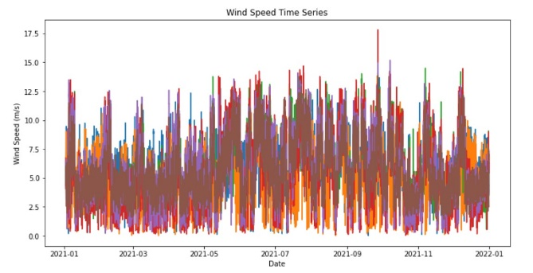
Figure 1. Visualization of Daily Wind Speeds based on Hourly Records

Wind Pattern Analysis

The raw dataset included wind speed measurements that were taken each day at specified intervals of 15 minutes. Therefore, there are 96 readings for each day and approximately 2880 readings for a month. The average daily wind speed is calculated from the hourly measurements and is plotted in Figure 2, in which A1 and A2 refer to wind speed data points at the Aruvayal region, S1, S2 refer to the data points at the Sengottai region, and P1, P2 refers to Palakkad region. The average hourly, daily, and monthly wind speed data points are identified to analyze the trends using aggregation methods. These mean monthly wind speed measurements are represented with the mean wind speed on the y-axis in terms of meters per second (m/s) and the months represented on the x-axis. The graph in Figure 2 shows the trend of monthly averages throughout the year. The graph shows the fluctuation in the wind speeds, a positive slope indicates that wind speed is increasing, and a negative slope indicates that the wind speed is decreasing. Through the aggregate and averaging of the detailed hourly data, the visualization made the yearly and seasonal trends in wind speed more understandable as shown in Figure 2. Seasonal decomposition is also performed on these patterns to identify seasonality components. Seasonal decomposition is a technique for dissecting a time series into parts, which include seasonality, trend, and random fluctuation. This approach provides a deeper understanding of patterns and allows analysts to identify significant changes and make more informed decisions. A non-parametric technique called Seasonal and Trend decomposition using Loess (STL) can be applied to decompose the time series using the additive model. This approach fits a smooth curve to the time series data and extracts the residual trend and seasonal components as illustrated in Figure 3. The y-axis indicates the wind speed in m/s and the x-axis indicates months. For example, 2021-01 indicates the month of January in the year 2021.

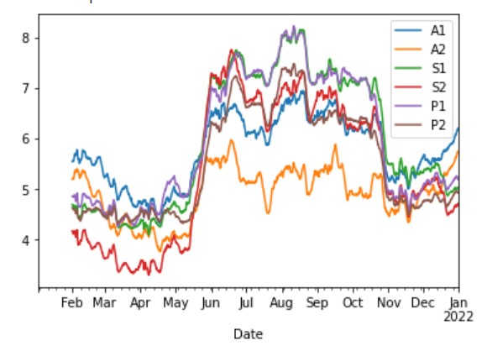
Figure 2. Monthly Wind Speed Patterns

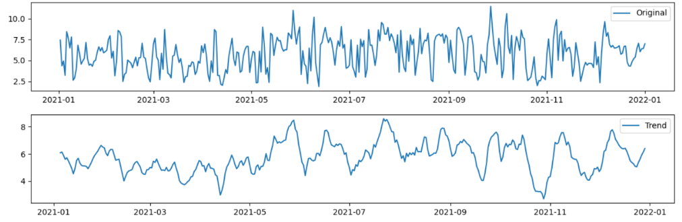

Figure 3. Observed Seasonal Trends in Monthly Wind Speeds

Baseline Model
A simple linear regression model is used as a starting point to study the trend of wind speed at a particular place. This model attempts to determine the line of best fit that minimizes the gap between the projected values and the actual values in the training data by fitting a straight line to a series of data points to represent the connection between a dependent variable, i.e. wind speed, and an independent variable, i.e. time. The baseline linear regression model is a simple starting forecasting strategy that can be used to establish a performance benchmark and verify the necessity for a more advanced model such as ARIMA. Testing the residuals of the baseline model for stationarity validates the applicability of ARIMA, which assumes stationarity.

Performance of Stationary Test
Stationarity is an important concept in time series analysis because when a time series is non-stationary, it can be difficult to model and predict because the statistical properties of the data change over time. Here the Augmented Dickey-Fuller (ADF) test is used to check if a time series is stationary or not. It tests the null hypothesis that the time series is non-stationary, which means it has a unit root. If p-value of the test is less than the chosen significance level, i.e. 0.05 in the given model, then the null hypothesis is rejected, and the time series is considered as stationary. The ADF test is performed on the extracted residuals of the baseline model. These residuals represent the difference between the actual wind speed measurements and the predicted values from the model. Then, the ADF test applied to the residuals helps in the determination of stationarity. If the residuals are stationary, it indicates that the model has captured all the trends and patterns in the wind speed data. If the residuals are non-stationary, it suggests that there are still trends or patterns in the data that the model has not captured.

The Augmented Dickey-Fuller test is applied again to confirm stationarity in the wind speed time series data, before using an ARIMA model. ARIMA model requires stationary data as seasonality and trends in non-stationary data can result in erroneous forecasts. The ARIMA parameter - I, which is reflected in the results of the ADF test, specifies the order of differencing necessary to convert a non-stationary process into a stationary one. The performance of the ADF test can result in differing wind speed data that induce stationarity and avoids over-differencing which can have adverse effects on the performance of the model. The ADF test makes sure that a suitable ARIMA model is selected for wind speed forecasting.

Implementation of ARIMA model

There are three main components of the ARIMA model, namely, Autoregression (AR), Integrated (I), and Moving Average (MA).

1. Autoregression (AR): The correlation between an observation and one or more of its historical values is represented by this component. The number of lagged data required to model this relationship is determined by the order of the AR component, denoted by p.

2. Integrated (I): This component uses differentiation to change the time series into a stationary one. The term d stands for the applied level of differentiation.

3. Moving Average (MA): When a moving average model is applied to lag-timed observations, this component models the connection between observations and residual errors. The number of lag errors utilized in the model is indicated by the order of the MA component
The Augmented Dickey-Fuller test indicates that first-order differencing is required to make the wind speed data stationary, supporting the use of an ARIMA (p, 1, q) model structure. The baseline model served as a performance standard that the ARIMA model will enhance. The autocorrelation (ACF) and partial autocorrelation (PACF) plots of the differenced data were visually examined to find appropriate values for p and q in order to detect the AR and MA terms. The moving average term is indicated by the ACF plot's sluggish decay, whilst the autoregressive component is suggested by the PACF plot's spikes at early lags. An ARIMA (3,1,4) model is chosen using a grid search of model configurations and performance indicators such as AIC and MAPE. Maximum likelihood estimation is used to fit the 3 AR and 4 MA terms model to the different wind speed data. With the expected accuracy gains over the baseline model, the fitted model successfully captured the autocorrelation structure in the time series and could now be used to provide multi-step forecasts. Regular model validation on new test data ensured optimal performance.
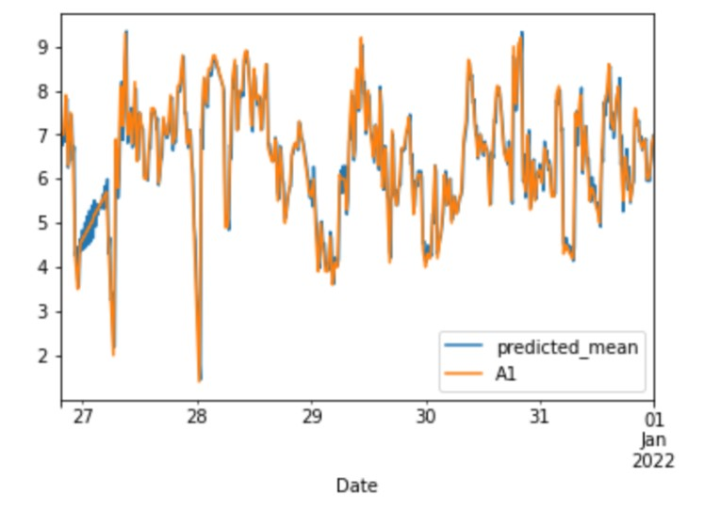
Figure 4. Actual vs. Predicted Wind Speed for site A1

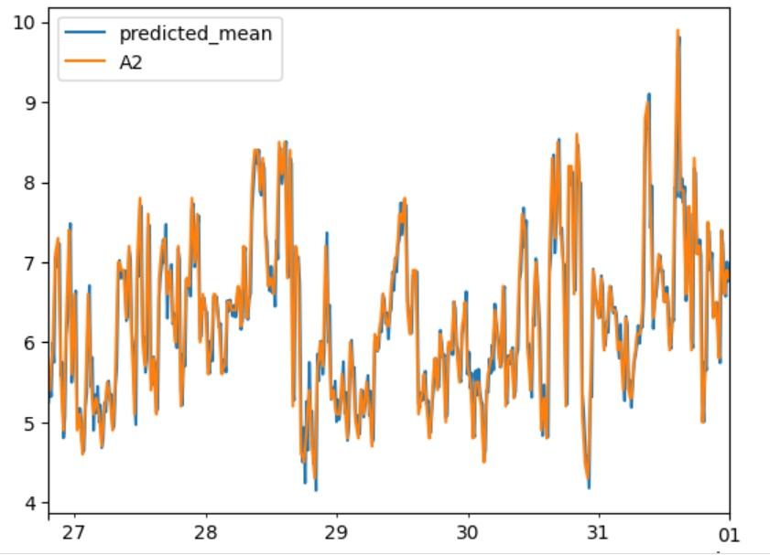
Figure 5. Actual vs. Predicted Wind Speed at Site A2

The implementation is performed using a Jupyter Notebook with Python 3. The key libraries used are Pandas, Numpy, Statsmodels, Matplotlib, and Scikit-learn. The wind speed time series data is loaded into a Pandas data frame. Basic exploratory analytics such as summary statistics and visualizations are done to understand the distribution and patterns. The data is split into training and test-sets. The training set comprises a larger portion of the historical data points, around 80%, and is used to fit and tune the ARIMA forecasting models. During the development and training of the model, this test data is not at all used. It serves as a stand-in for hidden real-world data. The fitted models are run on the test set to produce forecasts after the ARIMA model training is finished. These forecasts can be compared to the actual wind speeds to assess and validate the models.

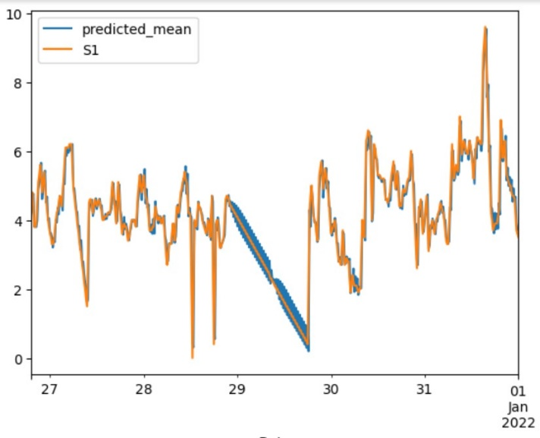
Figure 6. Actual vs. Predicted Wind Speed for Site S1

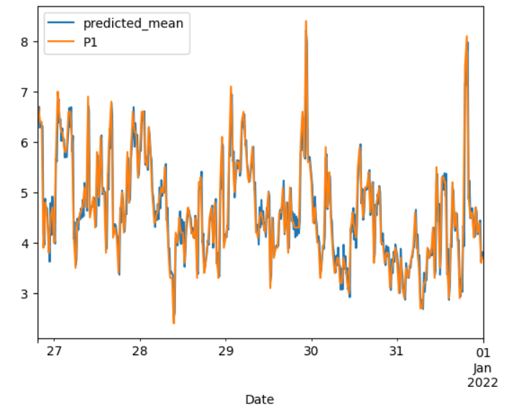
Figure 7. Actual vs. Predicted Wind Speed at Site P1

Experimental Results
From experimental results, it is observed that wind gusts range from 2 to 10 m/s, with an average of 6 m/s and a standard deviation of 1.5 m/s. Gaining a fundamental grasp of the wind patterns at the specified sites is made possible by this information. ARIMA models exhibit remarkable adaptability in adjusting and predicting wind speed profiles over a concise time frame. Notably, the model demonstrated its prowess by accurately forecasting the wind speed pattern for the final week of 2021 as shown in Figures 4 - 8, with the highest accuracy rate of 97% based on the training datasets employed. Figures 4 and 5 represent the predicted wind speeds in the Aruvayal region with A1, A2 indicating the actual wind speed data points of a windmill in the Aruvayal region. Similarly, Figure 5 shows the estimated wind speeds in the Sengottai region of Tamil Nadu with S1 depicting the actual wind speed data points during the last week of December 2021. Figures 7 and 8 show the wind speed patterns of the Palakkad region, with P1 indicating the actual wind speed data points of a single windmill and P2 indicating the data points of another windmill in the region. The key takeaway from this context is that the ARIMA (3,1,4) model stands as the most suitable choice for short-term wind speed forecasting, leveraging historical data as its foundation. The model is further enhanced by thorough analysis of residual plots and histograms, confirming the acceptability of the obtained results. The average of the Mean Absolute Percentage Error (MAPE) calculated is 4.77%, with the lowest MAPE error of 3%. This indicates the effectiveness of the generated ARIMA model, thereby making it a reliable tool for decision-makers in the field of wind speed forecasting and wind energy production.

Conclusions and future work
The primary objective of this work was to evaluate wind speed patterns and create a reliable short-term forecasting model to aid in wind energy planning and production. Historical wind speed data from multiple sites in Southern India is collected and preprocessed. Both visual and statistical analysis like seasonal decomposition were utilized to understand trends and seasonality in the time series data. The generated ARIMA model has an average accuracy of 95.3% and a MAPE of 4.77%, indicating that it can predict wind speed patterns and anticipate future wind speeds accurately. This level of precision makes it a trustworthy instrument for a wide range of applications, including renewable energy, weather forecasting, and air quality control. These findings support the effectiveness of the ARIMA model in analyzing wind speed patterns and forecasting wind speed. However, continuous evaluation and refinement are necessary to maintain the model's accuracy and reliability over time, as is the case with any forecasting model. By incorporating the autocorrelations and lag effects, the ARIMA model can aptly capture the intricate dynamics inherent in wind speed behavior, resulting in forecasts of heightened accuracy. While the current model demonstrates strong performance, there are several avenues for advancing the modeling approach in future work. One potential area of improvement is ensemble forecasting, where multiple models like ARIMA, Prophet, and LSTM neural networks could be combined to leverage their complementary strengths. Another enhancement is incorporating exogenous variables such as temperature and air pressure as additional predictors in the model to capture more complex wind speed dynamics. The framework could be tested on wind speed data sets from diverse geographical locations and climate conditions to improve generalizability. In terms of implementation, deploying the model on scalable cloud-based infrastructure would enable faster training and inferences for real-time forecasting. The precise forecasting and analysis of wind speed patterns assume paramount significance in risk assessment. Industries spanning aviation, construction, and agriculture, among others, stand to benefit immensely from comprehending wind speed fluctuations, as it facilitates the mitigation of potential risks and bolsters safety measures. In essence, the implications derived from the work's findings encompass superior wind power planning, cost reduction, well-informed decision-making, risk mitigation, and prospects for further research in the realm of wind speed forecasting. These wide-ranging implications hold the potential to exert a positive impact on the renewable energy sector, infrastructural advancement, and initiatives aimed at fostering sustainable energy transition.

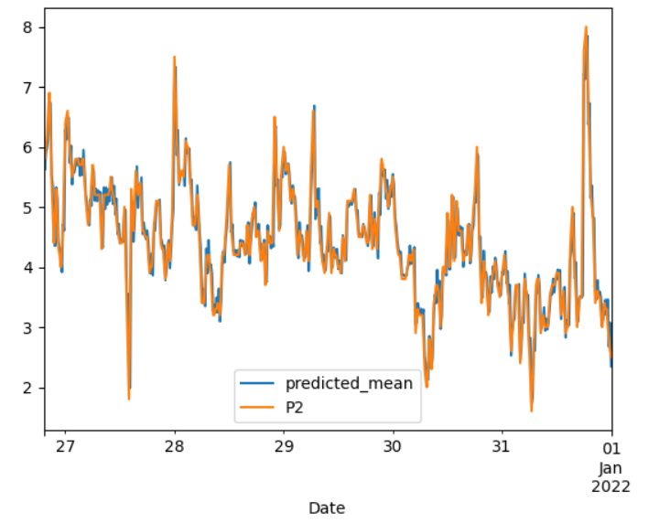
Figure 8. Actual vs. Predicted Wind Speed at Site P2

References

- J. Heckenbergerova, P. Musilek, and J. Marek, “Analysis of Wind Speed and Power Time Series Preceding Wind Ramp Events”, Proceedings of the 15th International Scientific Conference on Electric Power Engineering, pp. 279-283, 2014.
- S. Mehrmolaei and M. R. Keyvanpour, “Time Series Forecasting using Improved ARIMA,” In Proceedings of Artificial Intelligence and Robotics, pp. 92-97, 2016.
- Y. Su, S. Wang, Z. Xiao, M. Tan and M. Wang, “An Ultra-Short-Term Wind Power Forecasting Approach Based on Wind Speed Decomposition, Wind Direction and Elman Neural Networks” 2018, 2nd IEEE Conference on Energy Internet and Energy System Integration, pp. 1-9,2018.
- J. Liu, F. Wang and Z. Zhen, “Deep Learning Based Visualized Wind Speed Matrix Forecasting Model for Wind Power Forecasting”, 2020 IEEE 3rd Student Conference on Electrical Machines and Systems (SCEMS), Jinan, China, pp. 952-958.
- Colak, S. Sagiroglu, M. Yesilbudak, E. Kabalci and H. I. Bulbul, “Multi-time series and -time scale modeling for wind speed and wind power forecasting part II: Medium-term and long-term applications” 2015 International Conference on Renewable Energy Research and Applications (ICRERA), pp. 215-220
- T. C. Akinci, O. Topsakal, and A. Wernerbach, “Machine learning-based wind speed time series analysis,” 2022 Global Energy Conference (GEC), Batman, Turkey, pp. 391-394.
- I. Colak, S. Sagiroglu, M. Yesilbudak, E. Kabalci and H. I. Bulbul, “Multi-time series and -time scale modeling for wind speed and wind power forecasting part II: Medium-term and long-term applications,” 2015 International Conference on Renewable Energy Research and Applications, pp. 215-220,2015.
- A. K. Nayak, K. C. Sharma, R. Bhakar and J. Mathur, “ARIMA based statistical approach to predict wind power ramps,” 2015 IEEE Power & Energy Society General Meeting, pp. 1-5,2015.
- W. Deng et al., “Short-Term Wind Power Prediction Based on Wind Speed Interval Division and TimeGAN for Gale Weather,” 2023 International Conference on Power Energy Systems and Applications (ICoPESA), Nanjing, China, pp. 352-357, 2023.
- L. Li, Y. Wang and Y. Liu, “Impact of wake effect on wind power prediction,” 2nd IET Renewable Power Generation Conference (RPG 2013), pp. 1-4.
- R. Kingsy Grace, R. Manimegalai, “Design of Neural Network based Wind Speed Prediction model using GWO”, Computer Systems Science and Engineering, vol.40, no.2, pp. 593 – 606,

