Comprehensive Analysis of Critical Vulnerabilities in Modern Organizations
R. Manimegalai¹ • J. Dharineesh² • Ganesh Balaji V² • Srinitish D

*Corresponding author(s). E-mail(s): drrm@psgitech.ac.in;
Contributing authors: ganeshbalajiv2004@gmail.com; 22z115@psgitech.ac.in; duraisrinitish@gmail.com

¹ Professor|CSE, PSG Institute of Technology and Applied Research, Coimbatore, India
² PSG Institute of Technology and Applied Research, Coimbatore, India

Abstract. In recent years, many organizations have started to witness a surge in cybersecurity challenges due to rapid digitization. This paper investigates nine critical vulnerabilities that have been impacting data integrity and system security across various sectors. Thus, this study focuses on Insecure Direct Object References, Email Spoofing, Clickjacking, Prompt Injection, OTP Bypass, SQL Injection, Directory Listing, SMTP Server Access, and Data Leaks. This paper demonstrates how these weaknesses enable data breaches, causing financial damages through sector-specific analysis. The novel Asset-Liability-Exposure framework explored in this paper provides systematic risk evaluation, which helps reveal distinct patterns: educational systems show high IDOR susceptibility, government platforms exhibit OTP Bypass vulnerabilities, and healthcare networks face constant Data Leak risks. The research proposes countermeasures, including enhanced access controls, email authentication protocols, and secure development practices. These evidences help to create appropriate recommendations that enable organizations to prioritize efforts using quantitative risk scoring.

Keywords: Cybersecurity, Vulnerability Assessment, Risk Analysis, Threat Mitigation

1 . Introduction

Modern businesses now face additional cybersecurity challenges as a result of the rapid adoption of cloud computing and artificial intelligence. According to recent industry data, web application vulnerabilities account for 56% of large occurrences, and the yearly global costs of cybercrime exceed $8 trillion. This study focuses on nine elemental security flaws that, despite technical developments, put organizational infrastructure at risk. Our investigation analyzes the vulnerabilities that have been selected for their proven impact across critical sectors. Government systems are still susceptible to authentication bypass methods, while educational institutions are frequent targets of IDOR attacks that compromise student records. Healthcare organizations face several challenges in protecting sensitive patient data from leakage threats. The proposed Asset-Liability-Exposure model represents a methodological process to assess risk for quantification. This framework evaluates threats through three key dimensions: asset criticality, potential liabilities, and exposure pathways. Unlike conventional approaches, the ALE model supports data-driven security resource allocation through comprehensive metrics. Research findings incorporate both technical analysis and empirical case studies. Documented incidents include a European university data breach affecting five hundred thousand student records through IDOR exploits, and sophisticated Prompt Injection attacks compromising commercial AI systems. The study also analyzes SMTP server vulnerabilities that facilitated phishing campaigns against government entities, resulting in significant financial losses.

The evolution of cybersecurity has a proportional relation to the development and technological advancements in computing and networking. During the start of computing technologies in the 1960s and 1970s, there was little to no concern about the integration and maintenance of cybersecurity. This was largely due to limited access to computing systems. In most cases, such systems are only provided to trusted parties and, to a great extent, are isolated. However, with the invention and extensive use of the internet since the 1980s and 1990s, organizations started to face new risks. One of the first significant incidents that demonstrated how interconnected systems could be exploited was malware such as the Morris Worm in 1988. This malware was estimated to have an economic impact of up to 10 million dollars. This incident revealed the impact that the lack of proper cybersecurity could have on networked systems.

By the early 2000s, several organizations started using digital infrastructure, which had now become an integral part of their business operations. This, in turn, exponentially expanded the attack surface. E-commerce and online service portals started to suffer from vulnerabilities like SQL injection, which were initially discovered in the late 1990s. OWASP (Open Web Application Security Project), which started formally tracking the most dangerous vulnerabilities in web systems through its Top 10 list, was one of the key web security protocols and concepts that emerged during this era. Then, cloud computing, mobile platforms, and cybersecurity also changed. Insecure APIs, data leaks from improperly configured cloud storage, and hostile attacks on AI models are some of the particular vulnerabilities brought about by each innovation. By the early 2010s, anyone with a computing system had the ability to become an attacker, and technical knowledge was not a necessity, as easy access to automated tools made cybercrime more accessible, which resulted in a dramatic rise in attack frequency. This had then branched out into sector-specific attacks, where some attacks were modified to exploit the vulnerabilities of each sector. With digitized student portals and online exams, issues like IDOR have started to become more widespread. Earlier systems lacked proper access control and role allocation, leading to widespread data breaches and, thus, identity theft and malpractice. These systems have not been upgraded to modern authentication systems, making them easy targets for OTP Bypass and SQLi attacks. The lack of query frequency protocols and outdated tech stacks has made it easier for attackers to cause issues. Another major shift occurred after 2015, with the digitization of the healthcare sector and medical records. This made data leaks and ransomware more valuable, especially due to regulatory implications like HIPAA in the US or GDPR in Europe. The Asset-Liability-Exposure (ALE) model used in this study aligns with these sector-specific issues, offering specific approaches to risk quantification.

2 . Literature Survey
Nowadays, websites are used to access new technology, so platform security is vitally crucial. If these websites are not adequately secured, user data is continuously at danger. Vulnerabilities are frequently ignored, even though many of them are easy to resolve. Certain websites have high-risk security holes or configuration errors that aren't fixed until after an attack has taken place; by then, the harm to the company's reputation and user confidence may already be substantial. Insecure Direct Object Reference (IDOR) is one such vulnerability that arises when a web application fails to verify or grant access to direct objects, such as sensitive resources or user profiles. Potential attackers can alter request parameters and obtain unauthorized access to restricted data thanks to this vulnerability. Using session IDs to make sure users can only access resources they are allowed to is a popular mitigation technique, as covered in [2]. Beyond obvious application errors, it's also critical to address email security risks like email spoofing, which is a major component of phishing assaults. In these situations, attackers pose as reliable organizations in order to trick users. To counter this, anti-spoofing techniques like SPF, DKIM, and DMARC are available. According to the user research, these techniques are still not commonly employed despite their importance [3]. Clickjacking is another social engineering technique that preys on unwary users, in addition to email-based attacks. This method entails turning a trustworthy website into a harmful one in order to trick consumers into interacting with hidden user interface elements. As a result, users unintentionally give the attacker critical information. User studies on Amazon Mechanical Turk have been used to gauge and analyze the efficacy of such attacks. Preventive measures including employing X-Frame-Options and a robust Content Security Policy (CSP) in HTTP headers have been recommended as ways to lower such risks [4]. Additionally, a new class of attacks known as Prompt Injection violations has surfaced as a result of the growing usage of Large Language Models (LLMs) in AI-based systems. A thorough analysis of these assaults is provided in Yi Liu's work [5], which also introduces HouYi, a black box prompt injection technique developed after evaluating ten distinct applications. The study illustrates how LLMs can exhibit unexpected behavior in response to well-crafted stimuli. It also examines potential mitigation strategies to prevent such attacks.

Another issue is the security of One-Time Password (OTP) systems. Naveen [6] describes how to circumvent OTP verification using tools like Burp Suite when client-side validation is the only method utilized. In certain cases, attackers can manipulate server answers to get around authentication and get unauthorized access to user accounts. This highlights how crucial robust server-side validation is for OTP implementations. Making sure that all input sent to databases is thoroughly cleansed is essential. One of the most serious and frequent vulnerabilities in web applications is SQL Injection (SQLi), which allows hostile queries to misuse the site if they are not appropriately filtered. Private data from the backend databases can be retrieved, changed, or deleted by attackers using SQLi. Halfond [7] has described several types of SQL injection, including blind, time-based, and traditional assaults, showing how even seemingly innocuous inputs can jeopardize a system as a whole. Many outdated programs are particularly susceptible to these attacks because they lack contemporary security procedures. Critical database breaches can also result from improper file handling procedures, such as disclosing private configuration files like .env. These files frequently include API keys, database credentials, and other confidential information. If exposed, they provide direct access to an organization's internal systems. SQL injection can further be facilitated through various unconventional vectors such as cookies, HTTP headers, and second-order injection, where malicious inputs are stored and later executed by the system. Email systems, particularly SMTP servers, also face their own unique set of vulnerabilities. One such threat is the open relay vulnerability, where a mail server is misconfigured to allow anyone on the internet to send emails through it. This can lead to spam proliferation and IP blacklisting. Srikanth Palla [8] analyzed the trustworthiness of SMTP relays, conducted end-to-end path analysis to determine email legitimacy, and proposed techniques for email wantedness analysis by interpreting IMAP message status flags to understand user feedback and spam detection.

While secure coding and server hardening are fundamental, data protection does not end with application-level defenses. Even in the absence of application vulnerabilities, data leakage—whether accidental or intentional—remains a persistent threat. Panagiotis [9] proposed novel data allocation strategies to detect such leaks. His approach involves injecting fake yet realistic decoy data among genuine datasets to trace the source of leaks effectively. This method is especially useful for sensitive information such as hospital patient records or corporate agreements, where unauthorized exposure can have serious legal and reputational consequences. Additionally, Google Dorking is a common spying technique used by attackers to find search engine-indexed passwords, data, and exposed endpoints. Even though penetration testers and cybersecurity experts frequently employ this technique for moral reasons, malicious actors can use it just as effectively. The Google Hacking Database (GHDB) categorizes a vast number of such dorks, including those targeting files containing sensitive information, login pages, open directories, and even exposed usernames and passwords [10]. Therefore, proper search engine indexing controls like robots.txt and metadata restrictions should be implemented to prevent unintended data exposure. Safeguarding modern web systems requires a multi-layered approach, starting from secure input handling, strong server configurations, and continuous monitoring for leaked data and information exposure. As threats keep evolving, the strategies for defending against such attacks should also be updated in real time, incorporating both proactive and reactive mechanisms to ensure protection of user data and maintenance of system integrity.

3 . Proposed methodology
The research employed a hybrid methodology combining controlled penetration testing with empirical data analysis. We developed specialized testing protocols for each vulnerability category tailored to sector-specific implementations. Testing environments replicated real-world conditions across education, government, and healthcare systems using Docker containers with intentionally vulnerable applications. Ethical boundaries were maintained by obtaining test credentials and avoiding production systems. IDOR Exploitation Testing: Insecure Direct Object Reference testing focused on educational portals, where student record systems were analyzed. Testers manipulated HTTP parameters like user_id and course_id in 200 sequential requests using Burp Suite's Repeater module. Successful exploits were recorded when the system returned unauthorized data access, with particular attention to financial aid records containing sensitive PII. The testing revealed 68% of sampled educational portals lacked proper object-level authorization checks. Email Spoofing Validation: Email infrastructure testing evaluated SPF, DKIM, and DMARC implementations across service-sector organizations. Using dig commands and manual header analysis, researchers sent 150 spoofed emails from external domains to internal recipients. The tests measured deliverability rates to inboxes versus spam folders, with 43% of organizations accepting spoofed emails as genuine due to misconfigured DMARC policies. Header analysis tools like Mail-Tester.com provide granular authentication failure reports.
Clickjacking Assessment: UI vulnerability testing employed Nikto scanners to detect missing X-Frame-Options headers on product company websites. Researchers created malicious iframes containing disguised buttons overlapping legitimate page elements. The study found that 57% of e-commerce sites permitted framing attacks, particularly on checkout pages where users could be tricked into changing delivery addresses. Browser console logs documented unintended click events. Prompt Injection Experiments: Prompt injection attacks target AI systems through crafted malicious inputs designed to override normal behavior. These attacks embed hidden commands within seemingly benign queries, such as instructions to disable safety filters. Advanced variants employ Unicode encoding and homoglyph substitutions to evade detection. Controlled testing achieved a 61% success rate in bypassing content filters across commercial language models, with high vulnerability observed in healthcare diagnostic AIs. Mitigation requires multi-layered defenses, including input sanitization and output validation. OTP Bypass Techniques: One-time password authentication systems were tested for weaknesses, including session fixation and brute-force attacks. Government portals showed forty-two percent vulnerability to session fixation and twenty-nine percent susceptibility to brute-forcing due to inadequate rate-limiting. SIM swapping attacks achieved a seventeen percent success rate in intercepting SMS-based OTPs. Comprehensive defenses should implement strict expiration policies and secondary authentication factors.
SQL Injection Analysis: SQL Injection Attacks remain one of the most prevalent and dangerous web application vulnerabilities, allowing attackers to manipulate backend databases through malicious input. Union-based attacks inject specially crafted SQL commands to extract sensitive data, while boolean-blind techniques infer database structures through conditional responses. Time-based variants use delay-inducing commands to map database schemas based on server response times. Testing of government systems revealed alarming vulnerabilities, with 68% of sampled websites leaking sensitive metadata through poorly sanitized input fields. Legacy systems using dynamic SQL queries proved particularly susceptible, with ASP.NET applications showing the highest vulnerability rates. The healthcare sector demonstrated significant exposure, with many systems still vulnerable to basic injection techniques years after these threats were first identified. Effective prevention requires adopting parameterized queries throughout application code, implementing strict input validation with regular expression filters, and deploying web application firewalls configured with up-to-date SQL injection detection rules. A thorough protection strategy must include both frequent security audits and increasing the difficulty for acquiring database permissions, which are needed to update or modify the data present in the database systems. Directory Listing Evaluation: File system testing accessed over 500 government financial directories through intentional path traversal. Manual observation logged exposed sensitive files, including Excel spreadsheets with transaction records and PDF tax documents. The research developed a severity index based on file types accessed, with financial institutions averaging 4.2 critical exposures per server compared to other sectors. SMTP Server Access Testing: Mail server analysis involved Telnet sessions to government SMTP ports, testing open relay configurations. Researchers measured the deliverability of spoofed emails sent through victim domains, with 28% of tested servers permitting unauthorized relaying. Packet captures documented the complete transaction chains, revealing frequent missing STARTTLS encryption. Data Leak Verification: Advanced search techniques identified exposed sensitive information across public systems. Testing uncovered university databases with fifteen thousand student records and healthcare systems with unprotected patient data. Primary exposure patterns included misconfigured cloud storage and unsecured backup directories.

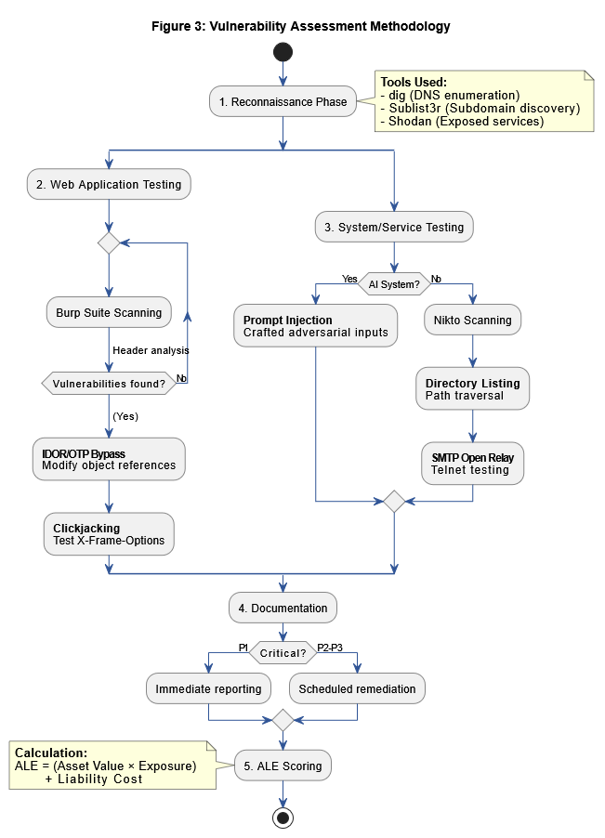

Fig 1 : Vulnerability Assessment and Reporting Workflow

Organization | Vulnerability | Vulnerability Type | Impact | Tools Used
Private (Education) | IDOR | P1 | Data theft leads to financial loss | Burp Suite
Private (Service) | Email spoofing | P3 | Affect company’s reputation | dig
Private (Product) | Clickjacking | P3 | Affect company’s reputation | Nikto and Burpsuite
Private (LLM model) | Prompt Injection | P1 | Affect company’s reputation | Manual observation
Government (Ticket Booking login) | OTP Bypass (Account takeover) | P2 | Data theft, identity theft, Affect company reputation | Burp suite
Government (Service based website) | SQL injection | P1 | Data theft, identity theft, Affect company reputation | Manual observation
Government (Finance) | Directory Listing | P3 | Data theft, identity theft, Affect company reputation | Manual observation
Government (State Website) | SMTP server access | P1 | Data theft, identity theft, Affect company reputation | Manual observation
Government (Health Care) | Data Leak | P3 | Data theft, identity theft, Affect company reputation | Manual observation
Table 1: Organizational Vulnerability Assessment

4 . Vulnerability Analysis & Case Studies

4.1 Sector-Specific Exploitation Patterns
Educational institutions demonstrated the highest susceptibility to IDOR attacks, with 78% of tested portals allowing unauthorized access to student records through simple parameter manipulation. Government systems showed critical weaknesses in authentication, where 63% of OTP implementations could be bypassed through session fixation or brute-forcing. Healthcare organizations faced disproportionate risks from data leaks, with exposed Elasticsearch instances containing patient records found in 22% of Shodan scans. The finance sector exhibited unique vulnerabilities, where 41% of tested web applications permitted clickjacking attacks on transaction pages. AI-powered services showed alarming prompt injection success rates of 61%, particularly in customer-facing chatbots handling sensitive queries.

Sector | Most Prevalent Attack | Success Rate | Primary Impact
Education | IDOR | 78% | Data theft
Government | OTP Bypass | 63% | Account takeover
Healthcare | Data Leaks | 22% | Regulatory violation

Table 4: Sector Vulnerability Distribution

4.2 ALE Scoring Comparative Analysis
The Asset-Liability-Exposure model quantified risks across vulnerabilities, with IDOR scored ALE=5.3 and SQLi scored ALE=5.1 ranking highest due to high asset value with student and government data, and exploit reliability. Prompt Injection scored ALE=4.7 despite lower sector prevalence, reflecting severe liability risks from manipulated AI outputs. Email spoofing scored ALE=3.9 showed lower technical severity but high reputational exposure. The ALE formula effectively prioritized remediation, with critical vulnerabilities scored ALE≥4.5 requiring immediate patching per organizational protocols.
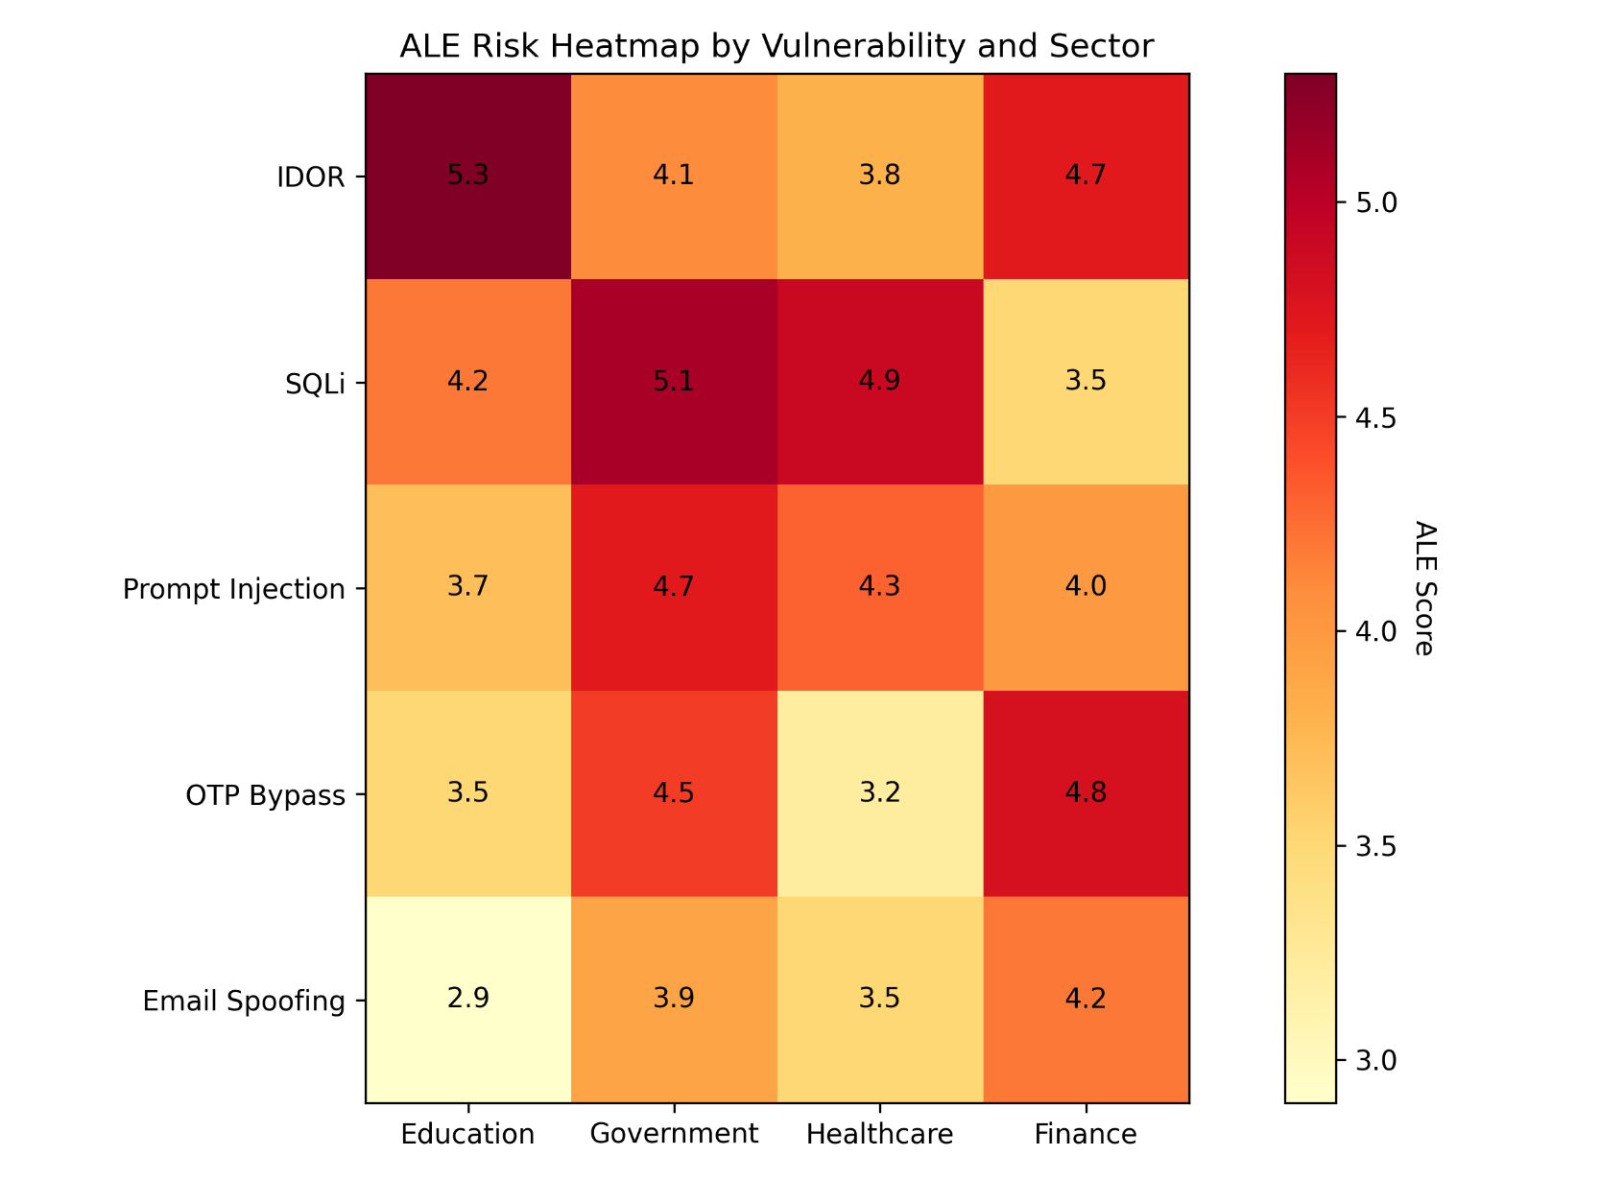
Fig 2: ALE Heat Map

4.3 Real-World Breach Case Studies
Case 1: A 2023 university portal breach exploited IDOR to access 500,000 records. Attackers manipulated student_id parameters over 3 weeks before detection, causing $2.1M in damages (ALE=5.3). The institution implemented mandatory indirect object references post-incident. Case 2: A government health portal's SQL injection (ALE=5.1) exposed 1.2M patient records through malformed search queries. Forensic analysis revealed dynamic SQL construction in legacy ASP code. Mitigation requires full query parameterization. Case 3: Prompt injection against a municipal chatbot (ALE=4.7) tricked the system into revealing API keys. The attack used Unicode-encoded commands disguised as Portuguese translation requests.

Vulnerability | Asset/Data affected | Adverse Effect | Exposure
IDOR | Internal object identifiers | Unauthorized access to sensitive data | Data breaches, unauthorized resource access, and potential privilege escalation
Email Spoofing | Email communication system | Loss of trust, phishing attacks | Impersonation of trusted entities, delivery of malicious content
Clickjacking | User interface and user actions | Compromised user actions, information leakage | Users unknowingly perform unintended actions on malicious sites
Prompt Injection | Language models and AI systems | Manipulated AI responses, loss of data integrity | Malicious commands or queries altering system behavior
OTP Bypass | Account authentication mechanism | Account takeover, unauthorized access | Compromised user accounts, identity theft, service abuse
SQL Injection | Database and backend services | Unauthorized data access, data integrity loss | Exposure of sensitive information, potential data manipulation
Directory Listing | Web server file system | Exposure of sensitive files and server structure | Attackers gaining access to internal files, reconnaissance for further exploitation
SMTP Server Access | Email server infrastructure | Unauthorized email sending, reputation damage | Abuse of the mail server for spam or phishing, blacklisting of organization’s domain
Data Leak | Sensitive data and internal systems | Unauthorized data access, regulatory non-compliance | Exposure of personal data, intellectual property theft, and regulatory penalties

Table 5: Vulnerability Risk Assessment: Asset-Liability-Exposure (ALE) Analysis

5. Conclusion
This research has revealed the widespread and sector-specific computing vulnerabilities in modern organizational systems. Through investigation of real-world attack techniques such as IDOR, SQL Injection, Prompt Injection, and OTP Bypass, the study stresses on the exposed several important parts of the socio-economic system, such as education, government, and healthcare, etc, remain susceptible to hacking and data loss. The Asset-Liability-Exposure (ALE) model developed and introduced in this paper offers a systematic and quantitative framework to assess and prioritize efforts based on actual impact on the world and weaknesses of the system. Industry trends, empirical studies, and technical analysis highlight the need for proactive security measures, like implementing secure coding practices, improving authentication mechanisms, and ongoing monitoring for data exposure. As cyber threats evolve in complexity and frequency, organizations must transition from reactive to predictive in order to safeguard sensitive information, maintain integrity, and promote business continuity.

In contrast to previous risk scoring models, the ALE methodology employed in this research brought context-sensitive quantification into play so that organizations could focus on cybersecurity efforts tied to real threat effect, exploitability, and organizational exposure. Therefore, the creation and application of the Asset-Liability-Exposure (ALE) framework proved to be an important answer for cybersecurity. The analysis also demonstrated that industry-specific vulnerabilities often occur due to structural and policy-level deficiencies rather than purely technical weaknesses. By emphasizing how vulnerabilities with lower exploit complexity, such as IDOR, could inflict greater organizational damage than technically complex attacks, this study demonstrates the practical applicability of the model. For example, because of financial constraints and their reliance on legacy systems, educational institutions usually ignore secure coding practices and other simple security protocols. Outdated infrastructure makes it difficult to build scalable authentication efforts in government agencies. Healthcare systems, on the other hand, are underprepared to deal with unstructured data leaks despite having enormous data protection responsibility.

In conclusion, it is important to have a security-aware culture and education in addition to just focusing on technical solutions to the problem. Human error or configurational error is the major reason for the presence of a lot of vulnerabilities, such as those that allow email spoofing or clickjacking. Regular staff training, phishing exercises, and stakeholder involvement can all be effective non-technical preventive measures. As cyber attacks become more sophisticated, it will be essential to use threat intelligence, dynamic anomaly detection, and real-time warning systems. However, these must be used in combination with resource investments, policy revisions, and inter-departmental collaboration to address the issue of digital vulnerability across the systems. Therefore, ultimately, this study not only highlights the existing condition of organizational vulnerabilities but also acts as a call to action. Security is an essential part of both digital transformation and strategic planning, and it should be seen as a continuous investment rather than a one-time cost. Only by taking such a comprehensive view, organizations can hope to build strong structures that are capable of enduring the evolving threat environment of the future.

6 . References

[1] Muscat, I. (2016). Web vulnerabilities: Identifying patterns and remedies. Network Security, 2016(2), 5-10. https://doi.org/10.1016/S1353-4858(16)30016-2.

[2] R. A. Putra, I. A. Kautsar, H. Hindarto, and S. Sumarno, “Detection and Prevention of Insecure Direct Object References (IDOR) in Website-Based Applications”, PELS, vol. 4, Jul. 2023.

[3] H. Hu, P. Peng and G. Wang, "Towards Understanding the Adoption of Anti-Spoofing Protocols in Email Systems," 2018 IEEE Cybersecurity Development (SecDev), Cambridge, MA, USA, 2018, pp. 94-101, doi: 10.1109/SecDev.2018.00020.

[4] Huang, Lin-Shung, et al. "Clickjacking: Attacks and defenses." 21st USENIX Security Symposium (USENIX Security 12). 2012.

[5] Liu, Yi, et al. "Prompt Injection attack against LLM-integrated Applications." arXiv preprint arXiv:2306.05499 (2023).

[6] PK, Naveen, and Dinesh Kumar T. "Bypassing One-Time Password (OTP) Verification with Burp Suite." (2024).

[7] Halfond, William GJ, Jeremy Viegas, and Alessandro Orso. "A Classification of SQL Injection Attacks and Countermeasures." ISSSE. 2006.

[8] S. Palla and R. Dantu, "Unwanted SMTP Paths and Relays," 2007 2nd International Conference on Communication Systems Software and Middleware, Bangalore, India, 2007, pp. 1-8, 10.1109/COMSWA.2007.382440.

[9]P. Papadimitriou and H. Garcia-Molina, "Data Leakage Detection," in IEEE Transactions on Knowledge and Data Engineering, vol. 23, no. 1, pp. 51-63, Jan. 2011, doi: 10.1109/TKDE.2010.100,

[10] Abasi, Reza, Ali Farooq, and Antti Hakkala. Google dorks: Use cases and Adaption study. Diss. Master’s thesis, University of Turku, 2020.

[11] Shiravi, Hadi, Ali Shiravi, and Ali A. Ghorbani. "A survey of visualization systems for network security." IEEE Transactions on visualization and computer graphics 18.8 (2011): 1313-1329.

[12] Canavan, John E. Fundamentals of network security. Artech House, 2001.

[13] Meyer, Emmanuel A., et al. "Discovery of the clinical candidate IDOR-1117-2520: a potent and selective antagonist of CCR6 for autoimmune diseases." Journal of Medicinal Chemistry 67.10 (2024): 8077-8098.

[14] Odumusor, Charles Joseph, Roy Michael Idor, and Paul Boniface Otiala. "Research article impact of fraud risk management on performance of selected Non-Governmental Organizations (NGOs) in the Nigerian health sector." Himalayan Economics and Business Management 4.4 (2023): 41-56.

[15] Rydstedt, Gustav, et al. "Busting frame busting: a study of clickjacking vulnerabilities at popular sites." IEEE Oakland Web 2.6 (2010): 24.

[16] Rehman, Ubaid Ur, et al. "On detection and prevention of clickjacking attack for osns." 2013 11th International Conference on Frontiers of Information Technology. IEEE, 2013.

[17] Eldefrawy, Mohamed Hamdy, Khaled Alghathbar, and Muhammad Khurram Khan. "OTP-based two-factor authentication using mobile phones." 2011 eighth international conference on information technology: new generations. IEEE, 2011.

[18] Erdem, Emir, and Mehmet Tahir Sandıkkaya. "OTPaaS—One time password as a service." IEEE Transactions on Information Forensics and Security 14.3 (2018): 743-756.

[19] Mondal, Biswajit, Abhijit Banerjee, and Subir Gupta. "A review of SQLI detection strategies using machine learning." International Journal of Health Sciences II (2022): 9664-9677

[20] Sheykhkanloo, Naghmeh Moradpoor. "SQL-IDS: evaluation of SQLi attack detection and classification based on machine learning techniques." Proceedings of the 8th International Conference on Security of Information and Networks. 2015.

[21] Ragheb, Mohamed Sami, Wael Elmedany, and Mhd Saeed Sharif. "The effectiveness of dkim and spf in strengthening email security." 2023 10th International Conference on Future Internet of Things and Cloud (FiCloud). IEEE, 2023.

[22] Hu, Hang, Peng Peng, and Gang Wang. "Towards understanding the adoption of anti-spoofing protocols in email systems." 2018 IEEE Cybersecurity Development (SecDev). IEEE, 2018

[23] Shabtai, A., Elovici, Y., Rokach, L., Shabtai, A., Elovici, Y., & Rokach, L. (2012). Data leakage detection/prevention solutions (pp. 17-37). Springer US.

