Algorithmic Approach of Chromatic Number in Networks

Abstract
The chromatic number $χ(G)$ stands as a fundamental concept, representing the minimum number of colors required to properly color the vertices of a graph such that no adjacent vertices share the same color. This paper provides a focused exploration of the chromatic number, emphasizing its mathematical significance and practical applications. We investigate the behavior of the chromatic number across various graph structures. Leveraging computational tools, we develop algorithms to analyze the chromatic number across diverse graph structures and explore its implications for graph coloring problems. Additionally, we introduce visualization techniques to graphically represent graph coloring, providing intuitive insights into the dynamics of the chromatic number.
Keywords: Chromatic coloring, Networks, Scheduling, Algorithms.

1. Introduction

In Graph theory, the chromatic number emerges as a fundamental property with profound implications across diverse applications. For a graph G = (V, E), where V represents a finite nonempty set of vertices and E represents a set of edges consisting of unordered pairs of different vertices, the chromatic number χ(G) denotes the minimum number of colors required to color each vertex of G. properly The constraint is that adjacent vertices should be in different colors. This concept lies at the core of graph coloring problems, which are of paramount importance in both theoretical and practical contexts. By elucidating the fundamental principles governing the chromatic number and its implications for graph theory, our research aims to contribute to the theoretical understanding of graph coloring problems and inform the development of efficient coloring algorithms. Through empirical analysis and theoretical inquiry, we endeavor to deepen our comprehension of the chromatic number's role in graph theory and its broader significance in various mathematical and computational domains. Chromatic numbers can be implemented for all kinds of graphs, due to this diverse nature it can be used in multiple applications. In this work, we have also created an algorithm to implement chromatic numbers which can handle n-number nodes with different graph structures.

A complete graph is an undirected graph in which every vertex is connected with every other vertex by a unique edge. It is denoted by $K_{n}$, where n represents the vertex count. The total edges in a complete graph are given by the formula $|E|$= $n(n-1)/2$.
A cycle graph forms a single cycle, meaning it is a closed loop with no self-intersections. It is denoted by $C_{n}$, where n represents the vertex count. The total edges in a cycle graph are $|E|$ = $n$.
A star graph consists of a single central vertex which is connected to all other vertices. It is denoted by $K_{1,n}$, where n represents the outer vertex count. The total edges in a star graph are $|E|$ = $n$.
A fan graph consists of a single central vertex which is connected to all other vertices arranged in a sequential manner. It is denoted by F_{n}, where n represents the outer vertex count.The total edges in a fan graph are $|E|$ =$n+1$.
A path graph consists of vertices which are arranged in a linear sequence, and each vertex is adjacent to its immediate neighbors. It is denoted by P_{n}, where n represents the vertex count. The total edges in a path graph are $|E|$ = $n-1$.
A binary graph represents a binary tree, where each vertex has at most two children.It is denoted by T_{n}, where m represents the vertex count. The total edges in a binary graph are $|E|$ = $|v|-1$.
A sibling graph represents a tree structure where each vertex (except the root) has exactly one parent and one or more siblings. It is denoted by ST¹_{n} , where m represents the vertex count. The total edges in a sibling graph are $|E|$= $|v|-1$.
The chromatic number of a graph is the minimum colors needed to properly color the vertices of the graph such that adjacent vertices should be in different colors, denoted by χ(G). The formula for the Chromatic Number is$χ(G) =. min\{k:there exists a proper k-coloring of G\}$

2. Literature review

Discrete optimization is one of the optimization techniques in which the variables can take only discrete values, typically integers or other countable sets. E. Malaguti et al proposed various algorithms to provide this optimization technique. Malaguti et al. [17] proposed a heuristic algorithm that improves the performance used within the exact algorithm. For the initial feasible solution and with a suitable set of columns model (7)–(9) algorithm MMT is used within the exact algorithm. The Tabu Search algorithm is used to determine a maximal stable set of graph G, having a large weight concerning vector π of non-negative weights associated with the vertices. Grosso et al. [19] used effective neighborhoods for local search algorithms which are based on swap moves to design one of the state-of-the-art algorithms for the maximum clique problem. The swap move involves removing a vertex from the current clique if doing so allows one or more new vertices to join the clique. The paper also proposed the benchmark system which includes random graphs vertices that are randomly distributed within a unit square according to the DIMACS benchmark. Some instances from the DIMACS benchmark can be reduced by removing vertices with the property that, if they are eliminated from the graph, any coloring of the resulting graph may be extended to a coloring of the original graph with no extra color. Finally, the results are obtained with the variable branching scheme.
Bart M.P. Jansen and Jesper Nederlof et al proposed a way to find the chromatic number through graph decompositions using matrix rank.[18]. The deterministic algorithm runs in time O∗(2ω·ctw) where ω is the square matrix multiplication exponent and a randomized algorithm with runtime O∗(2 ctw) are the two algorithms proposed. The complexity of the graph coloring problem has been under the framework of parameterized algorithms which was governed by the characteristics of the input. This framework aims to develop algorithms with a running time of the form f(k) · n^O(1), where k is a parameter measuring the complexity of the instance, independent of the number of vertices n in the input graph. At the end, the paper tells how to show graph decompositions using small edge separators that can be used to solve chromatic coloring. Noga Alon and Benny Sudakov have proposed a method to increase the chromatic number of a random graph Gn,p[20]. In a probability of space whose points are graphs on n labeled vertices in which each pair of vertices forms an edge, randomly and independently with probability p. The most important parameter of the random graph is the chromatic number.
3. Algorithm

Through a computational lens, we develop algorithms to generate various graph structures and meticulously compute their chromatic numbers. We conduct empirical analyses, uncovering the structural intricacies that influence the chromatic number across different graph types. The algorithm is separated into modules and grouped to form a package. Vertex class, Edge class, a class for various graph structures, and a main class for getting the number of nodes and type of graph from the user as input, are the modules of the package. The algorithm starts by building a given graph structure and assigning a color to each node in which the adjacent nodes do not share the same color. It then iterates through each of the vertices and finds the smallest available color that hasn't been used by its neighbors by keeping track of the coloring dictionary. After processing, it determines the chromatic number of the graph and also provides the execution time of the given graph. Furthermore, we introduce a novel visualization methodology to graphically represent graph coloring, providing intuitive insights into the chromatic number's behavior and its correlation with graph structure.

Algorithm COLORING_NODES(){

pos := networkx.spring_layout(Graph);
graph_coloring := networkx.greedy_color(Graph);
unique_colors := Set of graph_coloring.values();
diff_colors := Dictionary where each color in unique_colors maps to generate_random_color();
node_colors := List of colors where each node n in Graph.nodes() is colored with diff_colors[graph_coloring[n]];
show the graph image;
cover := graph.find_chromatic_number();
return cover, time;
}

Algorithm FIND_CHROMATIC_NUMBER(){

coloring := Empty dictionary;
for each vertex in vertices {
available_colors := Set of integers from 1 to the number of vertices;
for each edge in vertex.edge_list {
neighbor_color := coloring.get(edge.destination_vertex_id);
if neighbor_color is not None then {
Remove neighbor_color from available_colors;
}
}
if available_colors is empty then {
print "Graph is not properly colored.";
}
chosen_color := Minimum value in available_colors;

coloring[vertex.state_id] := chosen_color;
}
chromatic_number := Maximum value in coloring.values() if coloring is not empty else 0;
return chromatic_number;
end}

- Chromatic Number Algorithm of a Path graph${ P}_{n}$:
Input: Let $P_{n}$ be the Path graph of length $n$.
Algorithm:
- Name the nodes of the path $P_{n}$ as $1,2,…n.$
- Initialize $S=\left\{∅\right\}$ to store the chromatic set.
- Start color the nodes, from left to right o the path with adjacent nodes receives different colors.
- Return S as the chromatics set.
Output: $χ\left(P_{n}\right)=2$.
- Chromatic Number Algorithm of a Cycle graph$C_{n}$:
Input: Let $C_{n}$ be the Cycle graph of length $n$.
Algorithm:
- Name the vertices of the cycle $C_{n}$ as $1,2,…n.$
- Initialize $S=\left\{∅\right\}$ to store the chromatic set .
- Start color the nodes ,in the clockwise direction with adjacent nodes receiving different colors.
- Return S as the chromatics set.
Output: $χ\left(C_{n}\right)=2$.

- Chromatic Number Algorithm of a Star graph $K_{1,n}$:
Input: Let $K_{1,n}$ be a star graph on $n+1$ nodes.
Algorithm:
- Name the vertices of the star $S_{n}$ as $0,1,2,…n.$
- Initialize $S=\left\{∅\right\}$ to store the chromatic set .
- Color the central node and pendant node with adjacent nodes in different colors.
- Return S as the chromatics set.
Output: $χ\left(K_{1,n}\right)=2.$
- Chromatic Number Algorithm of a Fan graph $F_{n}$:
Input: Let $F_{n}$ be a Fan graph on $n+1$ nodes.
Algorithm:
- Name the nodes of the Fan $F_{n}$ as $1,2,…n.$
- Initialize $S=\left\{∅\right\}$ to store the chromatic set.
- Color the central node and pendant node with adjacent nodes in different colors.
- Return S as the chromatics set.
Output: $χ\left(F_{n}\right)=3$

- Chromatic Number Algorithm of a Complete graph $K_{n}$ :
Input: Let $K_{n}$ be a Complete graph on $n$ nodes.
Algorithm:
- Name the nodes of the complete $K_{n}$ as $1,2,…n.$
- Initialize $S=\left\{∅\right\}$ to store the chromatic set.
- Start coloring the nodes in any direction with adjacent nodes that receive different colors.
- Return S as the chromatics set.
Output: $χ\left(K_{n}\right)=n.$

- Chromatic Number Algorithm of a Binary graph $T_{n}$:
Input: Let $T_{n}$ be a Binary graph on $n$ nodes.
Algorithm:
- Name the nodes of the complete $T_{n}$ as $1,2,…n.$
- Initialize $S=\left\{∅\right\}$ to store the chromatic set.
- Start coloring the root node, color the nodes in the branch with adjacent nodes receiving different colors
- Return S as the chromatics set.
Output: $χ\left(T_{n}\right)=2$

- Chromatic Number Algorithm of a Sibling graph ST¹_{n}:
Input: Let $ST1n$ be a Sibling graph on $n$ nodes.
Algorithm:
- Name the nodes of the complete ${ST}_{n}^{1}$ as $1,2,…n.$
- Initialize $S=\left\{∅\right\}$ to store the chromatic set.
- Start coloring the root node, color the nodes in the branch with adjacent nodes receiving different colors
- Return S as the chromatics set.
Output$: χ\left({ST}_{n}^{1}\right)=2$

4. Results and Discussion

The chromatic number can be found easily for graphs except for complete graphs for n number of nodes. It is because, in a complete graph all the nodes must be connected to every other node which increases the execution time of the code. The general idea is that the chromatic number for n number of nodes can be found but for a complete graph, it takes much computational resources. We can solve this problem by running the program on the GPU on a powerful machine. The chromatic number has various applications in the real world and is widely used in many areas. Various use cases are discussed below,
In scheduling, the well-known problem is examination scheduling [16] in which no person should participate in two or more exams at the same time. The aim is to schedule the exams so that the total periods required for the examinations are minimized. The major problem while designing routing protocols in an all-optical network is Routing and wavelength assignment (RWA). In an optical network, data is transmitted in the form of waves. The same wavelength of two connections must not transmit over the same physical link (optical fiber). For this, the network can be represented as a graph, vertices are network nodes, and the edges are the physical connection. The chromatic number of this graph represents the minimum number of distinct wavelengths (colors) needed to assign to the edges incident to each node such that no two adjacent edges (links) sharing the same node use the same wavelength [2]. Map coloring is a classic problem in graph theory in which no two adjacent regions have the same color. The minimum number of colors used is the chromatic number of that map. Map coloring can be implemented in cartography. In Register allocation, each vertex represents a variable, and an edge is drawn between two vertices. The goal is to assign a register to each variable such that no two interfering variables are assigned the same register. The minimum colors represent the minimum number of registers required for the program. In frequency assignment problems, the network of communication links can be represented as a graph, vertices represent transmitters or communication nodes, and edges represent interference relationships between them. If two transmitters are too close and operate on the same frequency, they will interfere with each other. The chromatic number represents the minimum number of frequencies or channels required to assign to the transmitters such that no adjacent transmitters use the same frequency.

Table 1. Execution time for various networks of 1024 nodes with graph visualization.

Types of graphs | Number of nodes | Execution time(sec) | Chromatic number
Complete graph K_{n} | 1024 | 40.724 | 1024
Cycle graph C_{n} | 1024 | 0.080 | 2
Star graph K_{1,n} | 1024 | 0.067 | 2
Fan graph F_{n} | 1024 | 0.104 | 3
Path graph P_{n} | 1024 | 0.084 | 2
Binary graph T_{n} | 1024 | 0.015 | 2
Sibling graph ST¹_{n} | 1024 | 0.20 | 2

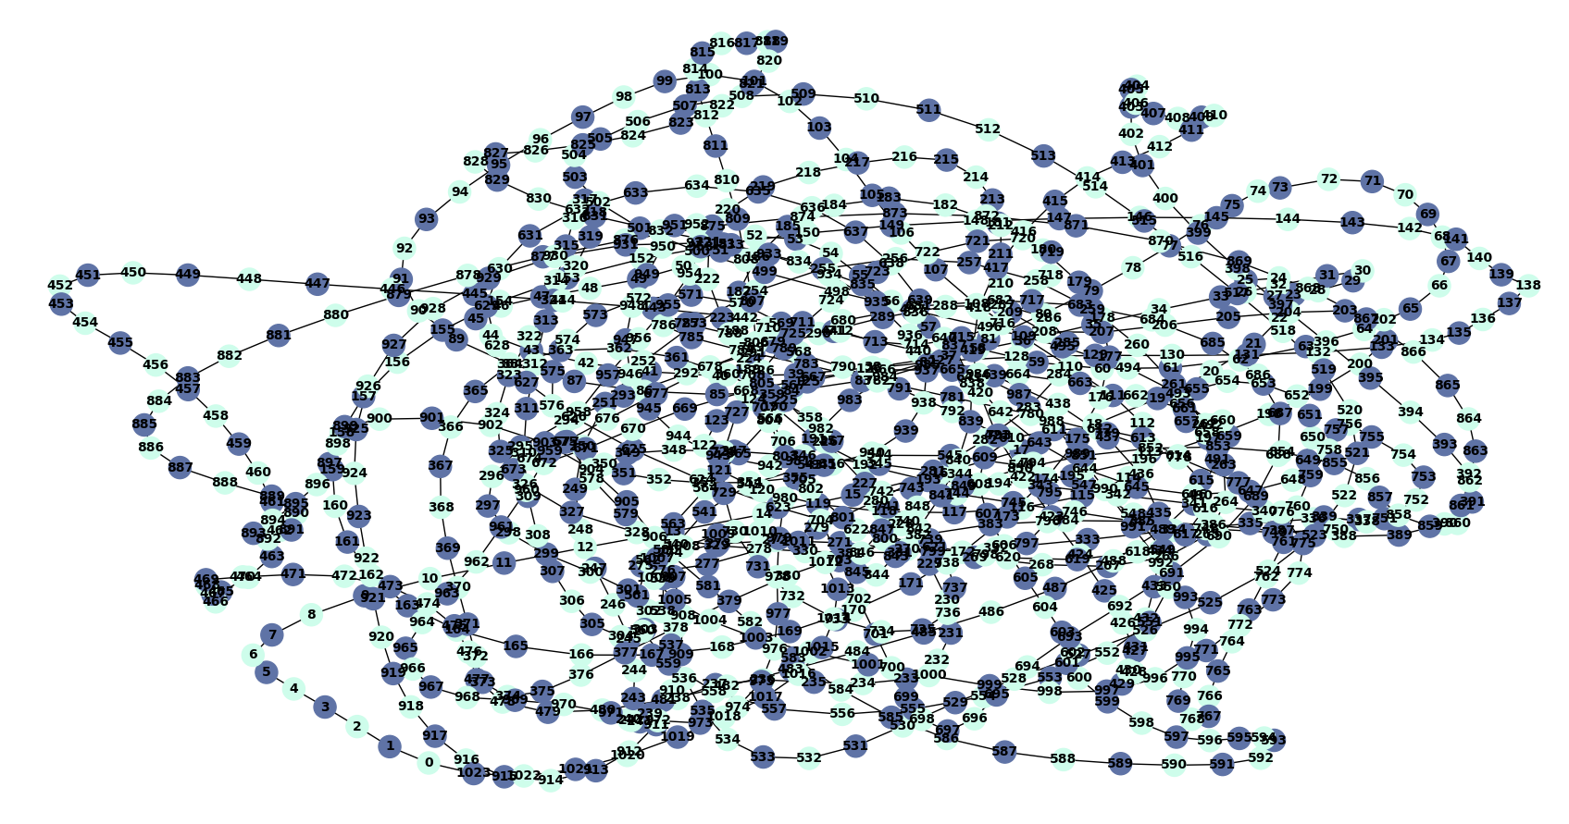
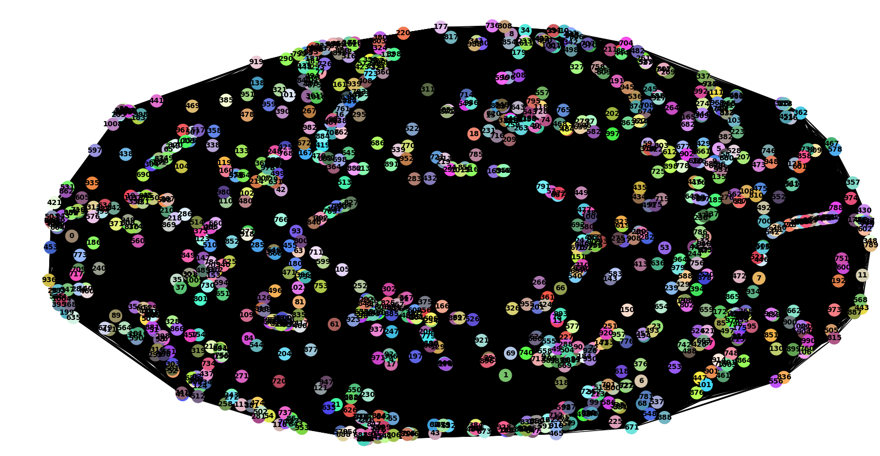

‘

(b) Cycle graph C_{n}
- Complete graph K₁₀₂₄

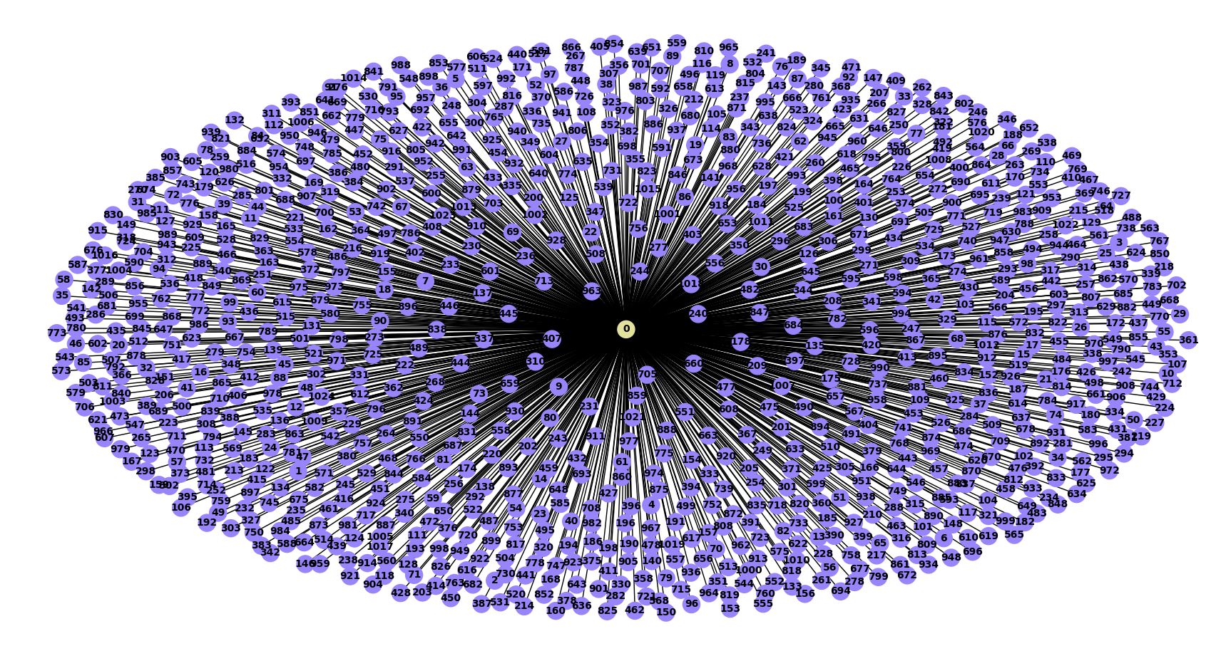
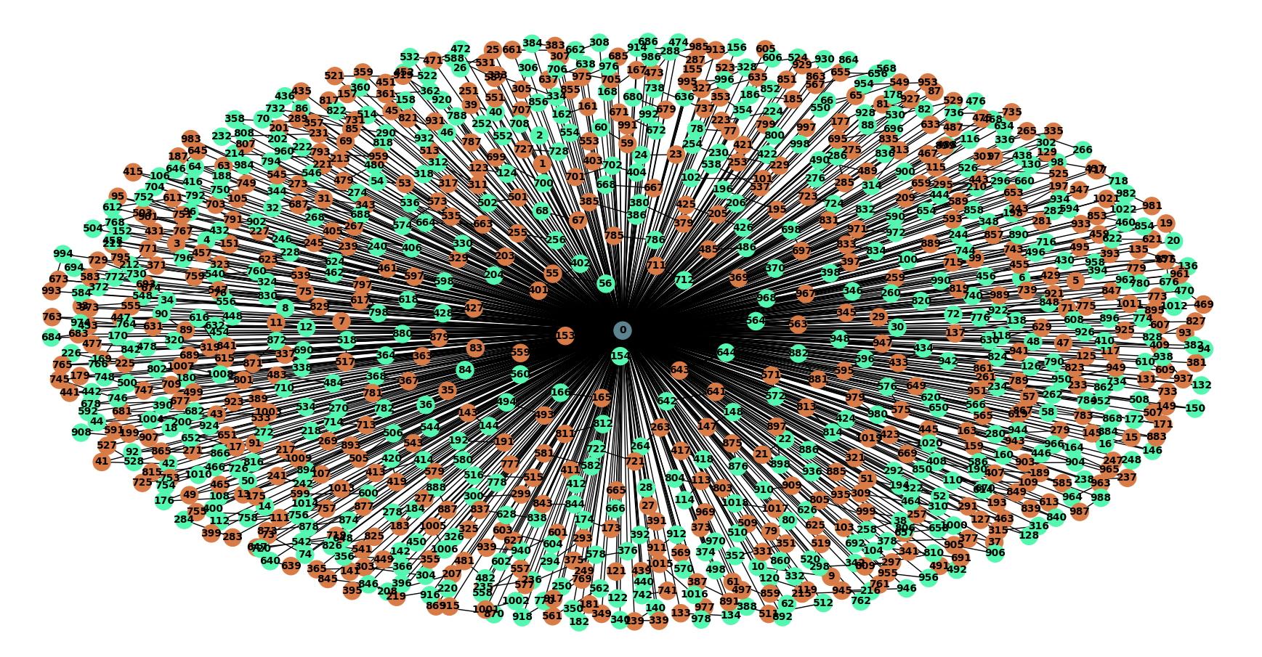

(c) Star graph K_{1024,n} (d) Fan graph F_{n}
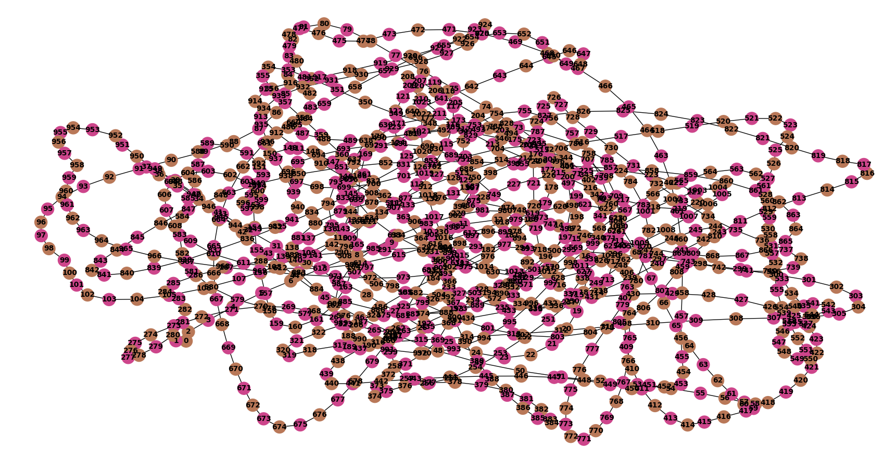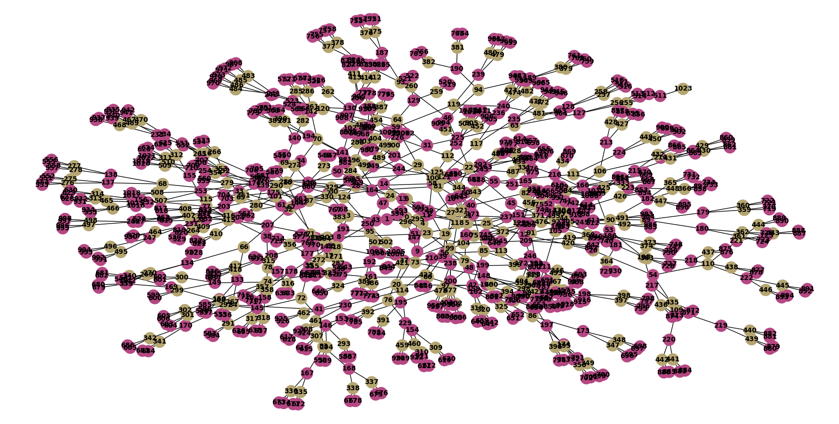
(e) Path graph P₁₀₂₄ (f) Binary graph T₁₀₂₄

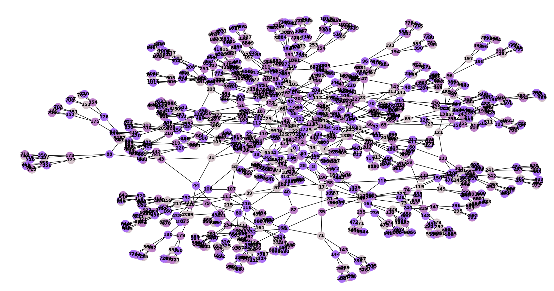
(g) Sibling graph ST¹₁₀₂₄
Figure 1. Chromatic coloring for different graph structures

5. Conclusions

In this paper, we have implemented algorithms for finding the chromatic number for the complete graph, cycle graph, path graph, fan graph, star graph, sibling graph, and binary graph with execution time and visual representation of the respective graphs. The code can handle $n$ number of nodes, we tested for 1024 nodes and we tabulated along with the execution time and chromatic number of the respective graph. In future, we can extend the algorithm to provide the result for other graphs and can be implemented in other applications.

Declaration of Competing Interest The authors declare that they have no known competing financial interests or personal relationships that could have appeared to influence the work reported in this paper.

