

DETECT THE PRESENCE OF HUMANS IN AN IMAGE ROI AREA
A PROJECT REPORT
Submitted by
KAVISRI S (715520104022)
MEGADARSHINI V (715520104028)
KARTIK R (715520104303)

in partial fulfilment for the award of the degree of
BACHELOR OF ENGINEERING

IN

COMPUTER SCIENCE AND ENGINEERING

PSG INSTITUTE OF TECHNOLOGY AND APPLIED RESEARCH, COIMBATORE 641 062

ANNA UNIVERSITY: CHENNAI - 600 025

MAY 2024

ANNA UNIVERSITY: CHENNAI - 600 025

BONAFIDE CERTIFICATE

Certified that this project report “Detect the presence of humans in an image ROI area” is the bonafide work of “KAVISRI S (715520104022), MEGADARSHINI (715520104028), KARTIK R (715520104303)” who carried out the project work under my supervision.

------------------------- -------------------------

SIGNATURE SIGNATURE

Dr. R. Manimegalai Dr. R. Manimegalai

HEAD OF THE DEPARTMENT SUPERVISOR

Professor and Head Professor and Head

Computer Science and Engineering Computer Science and Engineering PSG Institute of Technology and PSG Institute of Technology and Applied Research, Applied Research,
Coimbatore – 641 062 Coimbatore – 641 062

Submitted for the project viva-voce Examination held on

----------------------------------- ----------------------------------

INTERNAL EXAMINER EXTERNAL EXAMINER

ACKNOWLEDGMENT

First and foremost, we express our deep sense of gratefulness to our respected Managing Trustee, Shri. L. GOPALAKRISHNAN for providing the necessary facilities in the institution.
We express our heartfelt gratitude to our beloved Principal of our institution, Dr. N. SARAVANAKUMAR, Professor, for his support to carry out this project.
We are greatly indebted to Head of the Department Computer Science and Engineering and our project guide, Dr. R. MANIMEGALAI for her guidance and continuous support which was instrumental in the completion of this project.

We are thankful to our mini project coordinator Dr. I. KALA Associate Professor, Department of Computer Science and Engineering, PSG Institute of Technology and Applied Research.

Finally, we thank all the faculty and staff members in the Department of Computer Science and Engineering, PSG Institute of Technology and Applied Research, our friends and family members who helped us in getting the required instruments for our project and provided constant support and motivation to complete it successfully.

ABSTRACT
Accurate people counting within defined regions of interest (ROIs) is paramount in numerous domains such as retail, public safety, transportation, and event management. However, traditional methods often suffer from real-time limitations and imprecise results, leading to operational inefficiencies. To tackle this challenge, we propose an innovative approach that harnesses advanced object detection algorithms, specifically YOLOv8, to enhance precision and efficiency in real-time people counting applications.
Our methodology encompasses several key steps in implementation. First, we meticulously curate and preprocess datasets to ensure robust model training. Next, leveraging the power of YOLOv8, we train our model on the prepared datasets, fine-tuning it to accurately detect and count people within defined ROIs. Subsequently, we seamlessly integrate the trained model into a comprehensive system, complete with a user-friendly frontend interface for intuitive interaction and result presentation. This holistic approach streamlines the process from data collection to system deployment, ensuring optimal performance and usability.
Through rigorous evaluation and comparative analysis, the implementation using YOLOv8 emerges as highly effective, boasting a precision rate of 90.4%. By offering results in various formats, including images, videos, and real-time camera feeds, our system significantly enhances accuracy and efficiency in real-world people counting applications. The robustness and versatility of our approach pave the way for improved decision-making and resource allocation in diverse domains reliant on precise people counting capabilities.

TABLE OF CONTENTS
SNO TITLE PAGE NO
ACKNOWLEDGEMENT iii
ABSTRACT iv
LIST OF ABBREVATIONS vi
LIST OF FIGURES vii
LIST OF TABLES ix
- INTRODUCTION 1
  - OVERVIEW OF HUMAN DETECTION 1
  - PROBLEM STATEMENT AND OBJECTIVES 2
  - ORGANIZATION OF THE THESIS 6
- LITERATURE SURVEY 7
  - SUPERVISED LEARNING 7
  - UNSUPERVISED LEARNING 9
  - DRAWBACKS IN EXISTING SYSTEM 12
- HUMAN DETECTION USING MACHINE LEARNING TECHNIQUES 13
  - SOFTWARE AND HARDWARE REQUIREMENTS 13
  - DATA ENGINEERING 16
  - MODELS FOR HUMAN DETECTION 17
  - MODULES IMPLEMENTED 24
- EXPERIMENTAL RESULTS 31
- CONCLUSIONS AND FUTUREWORK 45
  - CONCLUSIONS 45
  - FUTURE WORK 45
REFERENCES 48

LIST OF ABBREVATIONS
ABBREVATION EXPANSION
CSS Cascading Style Sheets
FPN Feature Pyramid Networks
GPU Graphics Processing Unit
HOG Histogram of Oriented Gradients
HTML Hypertext Markup Language
I/O Input/Output
mAP Mean Average Precision
ROI Region Of Interest
SVM Support Vector Machine
YOLO You Only Look Once

LIST OF FIGURES
FIGURE NO TITLE PAGE NO

3.1 Feature Extraction Using HOG 18
3.2 Target Detection Using YOLOv5 19
3.3 Process of Developing YOLOv8 21
3.4 YOLOv8: Overall Architecture 22
3.5 Flow of Human Detection 25
3.6 Process Involved in Implementation 29
4.1 Results Obtained Using Roboflow 3.0
Object Detection Model 31
4.2 (a) Box_Loss, Cls_Loss, Dfl_Loss for Training
and Testing Using Roboflow Model 31
4.2 (b) Precision, Recall And mAP for
Roboflow Model 32
4.3 Roboflow 3.0 Object Detection model mAP 33
4.4 Roboflow 3.0 Box Loss, Class Loss,
Object Loss 33
4.5 HOG Results 34
4.6 Results Obtained Using YOLOv5 34
4.7 Confusion Matrix for YOLOv5 35
4.8 (a) Box_Loss, Cls_Loss for Training and
Testing Using YOLOv5 35
4.8 (b) Precision, Recall And mAP for YOLOv5 36
4.9 Results obtained using YOLOv8 model 36
4.10 YOLOv8 Dataset Split-up 37
4.11 YOLOv8 Confusion Matrix 37
4.12 (a) Box_Loss, Cls_Loss and dfl_loss for
Training and Testing Using YOLOv8 38
4.12 (b) Precision, Recall And mAP for YOLOv8 39
4.13 Precision For Various Models Under
Various Epochs 39
4.14 Recall For Various Models Under
Various Epochs 40
4.15 mAP For Various Models Under
Various Epochs 40
4.16 GUI for the Login Page of Application 42
4.17 GUI for the Index page of Application 42
4.18 Prediction of Human Count by
Uploading Video 43
4.19 Prediction of Human Count by
Uploading Image 43
4.20 Prediction of Human Count using
Real Time Camera 44

LIST OF TABLES
FIGURE NO TITLE PAGE NO

3.1 Comparison of Results for Human
Detection Using Various Models 41

CHAPTER 1
INTRODUCTION

  - OVERVIEW OF HUMAN DETECTION
A complex and vital component of contemporary technology, human detection in crowded areas has applications in public safety, security, and effective crowd control. Strong and precise human detection systems are increasingly needed as society continues to see an increase in population density and urbanization. The motivation driving this project is rooted in the critical and evolving nature of crowd management across diverse environments. As society experiences increasing complexity in public spaces, events, and transportation hubs, there arises a compelling need for a revolutionary system capable of dynamic crowd monitoring and counting. Conventional methods, often manual and static, struggle to meet the demands of real-time adaptability and accuracy required for effective crowd management. The project is fuelled by the vision to pioneer an intelligent and responsive solution, addressing the gaps in existing methodologies.

The project's motivation is underscored by the imperative to enhance public safety during events. Accurate and real-time crowd monitoring is pivotal for enforcing safety protocols, particularly in scenarios like the ongoing COVID-19 pandemic. In transportation hubs, the project aims to optimize operational efficiency by dynamically adapting to fluctuating crowd sizes, ultimately improving resource allocation and queue management. Similarly, in retail spaces, the goal is to elevate the overall customer experience through intelligent crowd management.

This project is not solely about technological advancement, it is about strategically responding to the intricate challenges of contemporary dynamic environments. By fostering adaptability and responsiveness, the project seeks to contribute to societal well-being, ensuring that public spaces remain safe, efficient, and conducive to positive experiences [1]. In essence, the motivation transcends the boundaries of traditional crowd management, envisioning a transformative system that seamlessly integrates with the evolving needs of society.
The task of recognizing humans can be summed up as follows: locate every human subject in an image or video sequence. This problem is identifying the areas in the image or video sequence that contain humans, usually the smallest rectangular bounding boxes [2].
Because it allows for so many different applications, human detection has garnered a lot of attention in computer vision and pattern recognition during the past 10 years. One common responsibility in visual content management is to tag, or label, the objects in the photographs and videos—especially the people. Such labeling will make it possible for annotation, search, and retrieval in the future. An integral part of automatic tagging is human detection. One of the main responsibilities of video-based surveillance is to locate, recognize, and keep an eye on people in crowded, public areas like train stations, supermarkets, and airports.
Issues and Challenges: Human detection, a fundamental task in computer vision, faces several significant challenges and issues that hinder its effectiveness and reliability. Understanding these obstacles is essential for advancing the field and developing more robust detection systems. Here are the key issues and challenges in human detection:

1. Variability in Appearance: Humans exhibit significant diversity in appearance due to factors such as clothing, pose, occlusion, and lighting conditions. This variability makes it challenging for detection algorithms to generalize effectively across different environments and scenarios.

2. Scale and Perspective: Humans can appear at various scales and perspectives within an image or video frame, from close-up shots to distant views. Detecting humans accurately across different scales and perspectives remains a challenging task, particularly in scenarios with large crowds or varying distances.

3. Complex Backgrounds and Clutter: Human detection often occurs in cluttered environments with complex backgrounds, such as urban streets, crowded public spaces, or natural scenes. Distinguishing humans from background clutter and other objects poses a significant challenge for detection algorithms, leading to false positives or missed detections.

4. Occlusions: Occlusions occur when objects or other humans partially or fully obstruct the view of the target human. Handling occlusions robustly is essential for accurate detection, as failure to do so can lead to missed detections or false alarms, particularly in crowded scenes.

5. Real-Time Processing: Many applications require real-time human detection, such as surveillance systems, robotics, or interactive interfaces. Achieving real-time processing while maintaining high detection accuracy and efficiency remains a significant challenge, especially for computationally intensive algorithms operating on resource-constrained devices.

6. Privacy and Ethical Considerations: The widespread deployment of human detection systems raises privacy concerns and ethical considerations regarding surveillance, data collection, and potential misuse of technology. Balancing the need for security and public safety with individual privacy rights and ethical considerations poses a complex challenge for researchers and practitioners in the field.

7. Adaptability and Generalization: Human detection algorithms must be adaptable to various environmental conditions, such as changes in lighting, weather, or scene dynamics. Ensuring the generalization of detection models across different datasets and scenarios is crucial for practical deployment in real-world settings.

1.2 PROBLEM STATEMENT AND OBJECTIVES
The core problem addressed by this project lies in the limitations of existing methods for crowd counting, especially in scenarios that require adaptability to changing conditions. Traditional approaches struggle to provide accurate and real-time insights, hindering effective crowd management. The main goal is to use YOLOv8's capabilities for accurate people detection and counts within a

predetermined ROI, emphasizing functionality in real-time and flexibility to accommodate changing circumstances. To recognize people using thermal images effectively and accurately for search and rescue operations, our research investigates the latest developments in deep learning algorithms. The goal of this work is to investigate the detection of humans in various contexts using YOLOv8, the most recent iteration of the You Only Look Once (YOLO) object detection model [3].

Specific objectives include:
- Develop a System for Real-time People Counting
- Enhance Crowd Management Efficiency
- Support Social Distancing Measures during COVID-19
- Dynamic Adaptation to Varying Queue Lengths
- User-friendly Frontend for Seamless Interaction
- Contribute to Improved Operational Efficiency
- Adaptive Crowd Management Support
- Integrate Privacy Preservation Measures
- Explore Integration with IoT and Sensor Networks
- Continuous Evaluation and Iterative Development
The objectives guide the project towards not only technological proficiency but also practical usability and applicability in real-world scenarios, addressing the fundamental challenges associated with crowd monitoring.

Addressing these challenges requires interdisciplinary research efforts spanning computer vision, machine learning, sensor technology, and ethics. By understanding and mitigating these issues, the state-of-the-art in human detection technology can be advanced and develop more robust, accurate, and ethically responsible systems with broader societal impact.

The project's scope spans the entire development lifecycle of a comprehensive system geared towards accurately counting people within a designated Region of Interest (ROI). It involves the integration and optimization of YOLOv8, Roboflow, HOG and YOLOv5 models for object detection, ensuring precise identification and counting of individuals. Additionally, the project includes the implementation of a user-friendly frontend interface to facilitate seamless interaction and visualization of the detected results. With a focus on versatility and adaptability, the system aims to address the needs of diverse environments such as public events, transportation hubs, and retail spaces, offering a robust solution for dynamic crowd management and surveillance.
However, it is crucial to recognize certain limitations to ensure a realistic and balanced approach to the project:
- Environmental factors may impact the system's effectiveness.
- Highly dynamic scenarios may pose challenges to real-time functionality.
- Continuous adaptations may be required to meet the diverse challenges of different environments.

Acknowledging these limitations ensures a pragmatic approach to the project's development, paving the way for future enhancements and improvements. The project's scope, therefore, extends beyond solving isolated problems, aiming to create a tool that can actively contribute to the evolving needs of crowd management in various real-world situations.

1.5 ORGANIZATION OF THESIS
Chapter 2 explores related works in crowd monitoring and object detection. Chapter 3 provides details on human detection using machine learning techniques. The outcomes of the approaches are discussed in Chapter 4. Finally, Chapter 5 concludes the project, outlining potential future applications and enhancements, particularly in real-time scenarios across diverse sectors.

CHAPTER 2
LITERATURE SURVEY
Chapter 1 gives the overall introduction about human detection. In chapter 2 the scope and extent of work already done in human detection using deep learning algorithms are determined and a detailed study was conducted using available resources.
2.1 SUPERVISED LEARNING
Nguyen [3] introduced a widely adopted approach for human object detection by utilizing multi-scale detection windows. This method assumes that each human object can be encapsulated within a detection "window" extracted at diverse scales and positions, accommodating variations in size and location. To address the challenge of unknown object properties, Nguyen's approach includes the post-processing step of merging nearby windows classified as human. This step is crucial for refining results, considering the inherent tolerance of human descriptors to certain transformations.
The flexibility in accommodating transformations, such as translation and scaling, is acknowledged, ensuring the adaptability of the detection algorithm. This strategy has laid the foundation for subsequent research, leading to advancements in the accuracy and robustness of human object detection systems. Furthermore, the suggested descriptor performed well in the human detection experiment. The experimental evaluation demonstrated the descriptor's efficiency in identifying individuals in both static images and videos, using popular pedestrian datasets like the MIT and INRIA datasets. In particular, the descriptor obtained detection accuracy of 78% on the harder INRIA dataset and 85% on the MIT dataset. These results highlight the resilience and dependability of the suggested descriptor in many real-world situations, improving its usefulness for tasks involving human detection.
Dalal [4] presents a paper that focuses on the creation of efficient motion characteristics, using a simple learning framework as a starting point for most of the experiments. Identifying upright people who are fully or nearly totally visible against a potentially moving or stationary background is the main objective, independent of the subject's motion or stationary status. The baseline classifier of choice is the Linear Support Vector Machine (SVM), which is well-known for its dependability, speed, and outstanding performance, making it appropriate for real-time detection. Its three main qualities—reliable and repeatable training, smooth handling of huge datasets, and robustness to various feature set and parameter selections—make it an asset for comparison testing.
The research claims that the basic results about feature sets remain unchanged, and that linear SVMs are more practical due to their higher runtime, even though nonlinear SVMs might give slightly lower error rates. The suggested person detector combines motion descriptors obtained from spatiotemporal derivatives or optical flow against the next frame with appearance descriptors from the previous frame. The linear SVM classifier is trained on manually labelled training windows and can make person/no-person decisions by operating on a 64x128 pixel window at several scales. It essentially offers a practical approach to person detection that puts an emphasis on solid performance, real-time capabilities, and simplicity.
Redmon [5] has made a substantial contribution to object detection research by putting up a fresh strategy that challenges accepted ideas. Traditionally, object identification systems use complex pipelines with separate components to perform detection tasks by repurposing classifiers. However, Redmon et al. make a paradigm change by interpreting bounding boxes and related class probabilities as spatially separated entities, and by framing object detection as a regression problem. This break from conventional wisdom is consistent with the authors' overall objective of optimizing the detection process as a single, cohesive architecture. The authors offer a novel neural network design that may be used to predict class probabilities and bounding boxes straight from full images in a single assessment. This end-to-end optimization of the entire detection pipeline within a single network stands out as a key innovation, allowing for direct enhancement of detection performance. The efficiency of this unified architecture is particularly noteworthy, with the base YOLO (You Only Look Once) model processing images in real-time at an impressive rate of 45 frames per second. This capability positions YOLO as a frontrunner in real-time object detection. In the pursuit of even greater efficiency, Redmon et al. introduce a smaller version of the network known as Fast YOLO. These variants are remarkably efficient and successful in real-world circumstances, processing an incredible 155 frames per second while still reaching double the Mean Average Precision (mAP) of other real-time detectors.
This achievement emphasizes the scalability and adaptability of the YOLO architecture, making it a compelling choice for applications demanding swift and accurate object detection. One notable characteristic of YOLO is its propensity to make more localization errors compared to state-of-the-art detection systems. However, this trade-off is balanced by a reduced likelihood of predicting false positives on background elements. This nuanced performance characteristic showcases the practical advantages of YOLO in scenarios where minimizing false positives is critical, such as in crowded or dynamic environments.
2.1 UNSUPERVISED LEARNING
A methodical strategy for creating Region of Interest (ROI) masks was put forth by Christopoulos [6], who specifically addressed the issues caused by ROIs with arbitrary shapes. With this method, all samples between two corner points are immediately known to belong to the ROI; hence, when working with a rectangular ROI, just the two corner points need to be verified. This greatly lowers the computational complexity involved in creating a ROI mask. Notably, in contrast to generic scaling-based approaches, the MAXSHIFT method simplifies the process for arbitrarily shaped ROIs. By doing away with form encoding, the technique simplifies the decoding procedure and requires the creation of a ROI mask without extra procedures. Christopoulos's method provides a computationally effective solution that is especially useful for handling various ROI shapes in an easy-to-use and efficient manner.
In the context of the forthcoming JPEG2000 standard, the paper introduces a method for Region of Interest (ROI) mask generation, particularly emphasizing a straightforward algorithm tailored for rectangular-shaped ROIs. Additionally, the paper presents a refined technique, namely the MAXSHIFT method, as an alternative to the general scaling-based method. A notable feature of the MAXSHIFT method is its capacity to dispense with the transmission of shape information to the decoder. This innovation eliminates the need for shape decoding and ROI mask generation at the decoder, allowing the incorporation of arbitrarily shaped ROI coding in JPEG2000 without adding complexity.
The MAXSHIFT approach was found to be highly successful based on the experimental results. When compared to traditional techniques, lossy decoding times of a progressive bitstream at 2 bpp were significantly decreased. Furthermore, the PSNR comparison between the encoding of the complete image and the ROI made clear how much better the ROI encoded with the MAXSHIFT approach was, especially at low bit rates. These results serve to clearly demonstrate the useful benefits of the suggested technique in improving ROI coding efficiency in the JPEG2000 framework, highlighting its importance in modern image processing applications.
Yeong [7] explores the use of deep learning for behavior recognition, concentrating on body and hand–object Regions of Interest (ROIs). Video-based behavior recognition is a crucial technique that is used in automatic criminal monitoring, sports video analysis, and context awareness for robots, particularly in the context of elder care [8]. It is necessary for automatically determining a target person's actions through digital data processing. The need for silver robots to handle problems in senior care brought on by an aging population is increasing, which makes behavior recognition an increasingly important core technology. The paper highlights the possibility of enhanced recognition performance by merging the data analysis with various features. The behavior recognition data is mainly composed of photos and skeletons. The individual carrying out the action is the essential component in behavior recognition.
Consequently, concentrating on the behavior itself improves feature analysis. Yeong suggests putting the ROI on the subject and then training the neural network after eliminating background noise. Furthermore, the study indicates that, considering how people actually use tools, emphasizing tool information by placing a ROI on hand-object interactions during neural network training can produce better execution. It is expected that the incorporation of data from models trained in the Regions of Interest will improve behavior recognition systems' overall performance. The experimental results showed that the proposed model improved recognition by at least 4.27% and up to 20.97% compared to other behavior recognition methods.
Zhu [9] discusses the Dalal & Triggs algorithm, which incorporates three essential components for effective object detection. Firstly, the algorithm employs Histogram of Oriented Gradients (HoG) as a fundamental building block, leveraging the power of this feature descriptor for capturing key visual information. Secondly, a dense grid of HoGs is strategically placed across the entire detection window. This configuration ensures a comprehensive description of the detection window, contributing to the algorithm's capacity to discern complex visual patterns. Thirdly, the algorithm incorporates a normalization step within each block. This step is crucial for emphasizing relative behavior concerning neighboring cells rather than relying on absolute values. The emphasis on relative behavior enhances the algorithm's robustness and adaptability, making it a valuable tool in object detection scenarios.
In the system, the integral image representation and a rejection cascade are utilized, significantly speeding up the computation. For a 320 × 280 image, the system can process 5 to 30 frames per second depending on the density in which the image is scanned, while maintaining an accuracy level similar to existing methods.

  - DRAWBACKS IN THE EXISTING SYSTEM
The reliance on a dense grid of Histogram of Oriented Gradients (HoGs) across the entire detection window in existing systems poses a limitation, potentially leading to increased computational complexity, especially in scenarios with large detection windows. Moreover, algorithms with intricate components may introduce complexities, making their implementation and fine-tuning challenging. Some systems may lack explicit focus on Region of Interest (ROI)-specific object detection, limiting their utility in scenarios where precise localization is crucial.
Additionally, the normalization step within each block, emphasizing relative behavior, may pose challenges in handling variations in lighting and background conditions.

A detailed study was conducted about the existing methods for human detection along with its merits, demerits and limitations in this chapter, in chapter 3 the complete implementation and its requirements are discussed in detail.

CHAPTER 3
HUMAN DETECTION USING
MACHINE LEARNING TECHNIQUES

This chapter discusses the software required and the languages used for the development of the proposed system, the system flow, and the implementation.
3.1 SOFTWARE AND HARDWARE REQUIREMENTS
Jupyter Notebook: Jupyter Notebook serves as the primary development environment, offering an interactive platform for prototyping, experimenting, and documenting machine learning workflows. Its ability to seamlessly integrate code, visualizations, and narrative text within a single document streamlines the development process and facilitates collaboration.
The requirements for setting up Jupyter Notebook include having Python installed on the system, installing Jupyter Notebook using pip or conda, and installing additional Python libraries such as NumPy, Pandas, Matplotlib, Seaborn, TensorFlow, PyTorch, and scikit-learn for data analysis and machine learning tasks. Once installed, Jupyter Notebook can be launched from the terminal or command prompt, providing a user-friendly interface for creating and running Python code cells, exploring data, visualizing results, and sharing insights with team members.
Python Libraries:
Python Installation: Install Python from the official website or using package managers like Anaconda.
Virtual Environment: Set up a virtual environment to manage dependencies and avoid conflicts with other projects.
Package Manager (pip): Utilize pip to install and manage Python packages.
PySSTx: PySSTx is a Python library for Singular Spectrum Transform (SST) analysis, enabling time series decomposition, forecasting, and efficient handling within Python environments. It offers functionalities for decomposing time series into trend, seasonal, and noise components, and for forecasting future values based on historical data.
NumPy: NumPy is a core library for Python numerical computation. Large, multi-dimensional arrays and matrices are supported, and a number of mathematical operations are available for effective manipulation of these arrays. Scientific computing, data analysis, and machine learning applications all make extensive use of NumPy.
PyTorch: Facebook's AI Research lab created this open-source machine learning framework. It offers a dynamic and adaptable computational graph that makes it simple for developers to create and train deep learning models. PyTorch facilitates deployment across several platforms, distributed training, and automatic distinction.
OpenCV (cv2): For computer vision applications including object detection, feature extraction, and image and video processing, OpenCV (Open Source Computer Vision Library) is an effective library. It offers a broad range of tools and algorithms for working with photos and videos, identifying objects and patterns, and effectively completing different computer vision tasks.
Flask: Designed to help developers rapidly and efficiently create online apps and APIs, Flask is a lightweight and adaptable web framework for Python. With Flask's straightforward and modular framework, learning web development is a breeze. With its capabilities, which include routing, request processing, templating, and session management, developers may design web applications that are both scalable and manageable.
Threading: Threading is a built-in module in Python that provides support for multi-threading programming. It allows developers to run multiple threads concurrently within the same process, enabling parallel execution of tasks and improving performance for I/O-bound operations. Threading in Python is useful for tasks such as network communication, file I/O, and concurrent processing.
Time: The time module in Python provides various functions for working with time, including measuring time intervals, formatting dates and times, and performing time-related calculations. It allows developers to manipulate timestamps, measure execution time, and schedule tasks based on time intervals or specific time points. The time module is essential for tasks involving time-sensitive operations and performance profiling.

3.1.3 Visual Studio Code IDE
Begin by downloading and installing Visual Studio Code, a lightweight and powerful code editor. VS Code supports web development languages such as HTML, CSS, and JavaScript out of the box. Enhance functionality with extensions like "HTML CSS Support" for autocompletion and "Live Server" for real-time updates during frontend development.
Visual Studio Code (VS Code) played a pivotal role in facilitating the project's development process. Its versatile code editor provided an intuitive interface for writing, editing, and managing code efficiently. With built-in Git support, developers could seamlessly manage code revisions, collaborate with team members, and ensure the project's codebase remained organized and up-to-date. The extensive ecosystem of extensions tailored to various programming languages, frameworks, and tools further enhanced VS Code's functionality, allowing developers to customize their development environment to suit project requirements.
Additionally, VS Code's built-in debugging capabilities enabled developers to identify and resolve issues promptly, ensuring the reliability and stability of the web application. Integration with Jupyter Notebooks and an integrated terminal streamlined data analysis tasks and project management, eliminating the need for switching between different applications or windows. Overall, VS Code's versatility, integration with essential tools and technologies, and robust feature set significantly contributed to the project's success, improving productivity and code quality throughout the development lifecycle.
3.2 DATA ENGINEERING
To start with, Kaggle provides a platform for datasets, and in this case, a dataset containing 550 images is sourced from Kaggle. These images likely contain objects or scenes that need to be detected and localized, hence the need for bounding box annotations. The dataset is then processed using Roboflow, an open-source tool commonly used for data preprocessing tasks in computer vision projects.
Roboflow is employed to convert the raw dataset into a format suitable for training with YOLOv8, a popular object detection algorithm. This likely involves resizing images, converting annotations into YOLO format (which includes bounding box coordinates and class labels), and possibly augmenting the data to improve model generalization.
Following preprocessing, the dataset is divided into three groups; training (70%), validation (20%), and test (10%). This segmentation is essential for both training and assessing the performance of the model. The YOLOv8 model is trained using the training set, hyperparameters are adjusted and overfitting is monitored during training using the validation set, and the trained model's performance is assessed

on untested data using the test set. The split and preprocessed dataset is then imported into Google Colab, a cloud-based Python programming environment. GPU resources are freely accessible through Google Colab and are necessary for effectively training deep learning models.

In Google Colab, the YOLOv8 model is implemented using a deep learning framework like PyTorch or TensorFlow. The training process involves iterating over the training dataset multiple times (epochs), adjusting model parameters based on feedback from the validation set, and ultimately evaluating the trained model on the test set to assess its real-world performance.

3.3 MODELS FOR HUMAN DETECTION
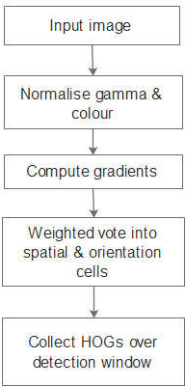
Roboflow 3.0 Object Detection Model: Roboflow offers a comprehensive platform for managing and preprocessing datasets for machine learning tasks, including object detection. While not a specific model architecture, Roboflow provides a suite of tools and pipelines for data preprocessing and augmentation. This includes resizing images to a standardized format, cropping to focus on relevant regions of interest, and augmenting data through techniques like rotation, flipping, and color jittering. Roboflow's architecture consists of a cloud-based infrastructure for dataset storage and processing, coupled with user-friendly interfaces for data management and visualization. Additionally, Roboflow supports integration with various deep learning frameworks and platforms, allowing seamless integration of preprocessed datasets into training pipelines. Histogram of Oriented Gradients (HOG): HOG is a classical feature extraction method used for object detection tasks before the widespread adoption of deep learning. The architecture of HOG involves several key steps: first, the input image is divided into small cells, typically 8x8 pixels in size. Within each cell, gradient orientations and magnitudes are computed using local image gradients. These gradient values are then used to construct histograms of gradient orientations, capturing shape and texture information within each cell. To account for local variations in lighting and contrast, these histograms are normalized using block normalization techniques. Finally, the normalized histograms are concatenated to form feature vectors, which are used as input to machine learning classifiers, such as support vector machines (SVMs), for object detection [4]. Figure 3.1 depicts the feature extraction using HOG.

Figure 3.1: Feature Extraction Using HOG

YOLOv5: YOLOv5 represents a streamlined and efficient variant of the YOLO model, designed for simplicity and ease of use [13]. Figure 3.2 illustrates the target detection using YOLOv5. The architecture of YOLOv5 follows the principles of the YOLO family, with a focus on lightweight design and model scalability. YOLOv5 typically consists of a backbone network, responsible for feature extraction and representation learning.
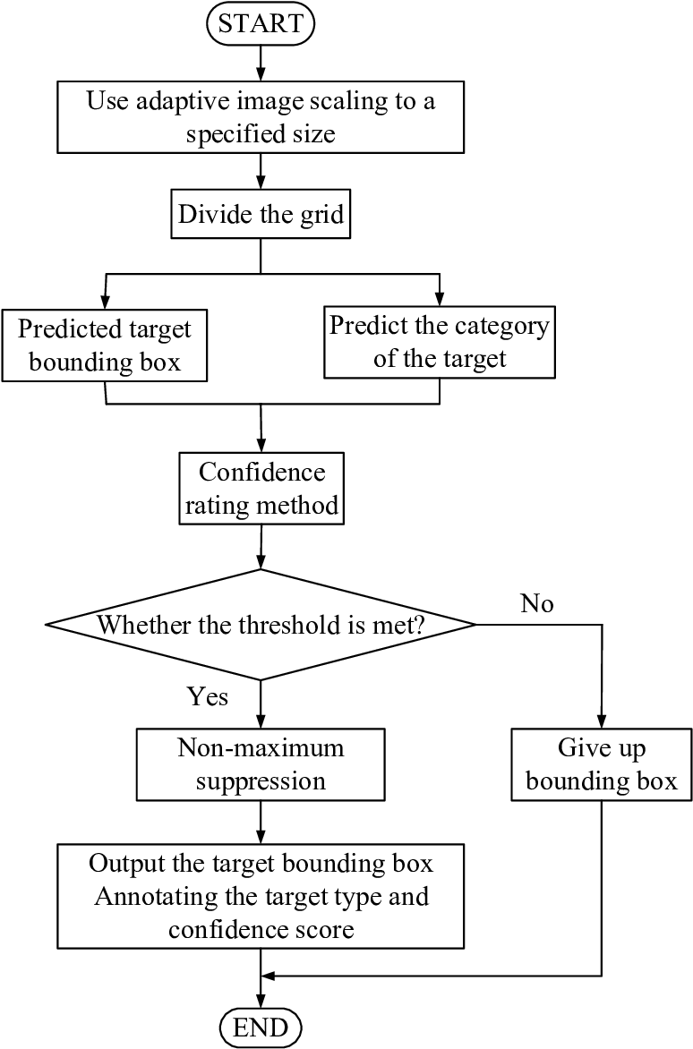

Figure 3.2: Target Detection Using YOLOv5

These features are then passed through detection heads, comprising convolutional layers and prediction layers, to generate bounding box coordinates and class probabilities. YOLOv5 also introduces advancements in training strategies, including class balancing, data augmentation, and model scaling, to improve object detection performance and robustness [14].

YOLOv8: YOLOv8 builds upon the previous versions of the YOLO model, incorporating advancements in deep learning techniques and architecture design [15]. At its core, YOLOv8 follows the single-shot detection approach, dividing the input image into a grid and predicting bounding boxes and class probabilities for objects within each grid cell. The architecture typically consists of a backbone network, such as Darknet or ResNet, responsible for feature extraction and representation learning. These features are then fed into detection heads, comprising convolutional layers and prediction layers, which generate bounding box coordinates and class scores. YOLOv8 also integrates techniques like anchor boxes, which help improve localization accuracy, and feature pyramid networks (FPNs), which enhance object detection across different scales.

3.3.4.1 Model Building Process
Figure 3.3 shows the process involved in building YOLOv8 model. To configure a GPU environment in Google Colab for training a YOLOv8 model, you can start by selecting a GPU runtime from the Colab settings. Once the GPU environment is set up, proceed to install PyTorch and other necessary dependencies using the appropriate commands. Import the trained YOLOv8 weights into your Colab environment, either by downloading them directly or using a tool like `wget`. Import your dataset into Colab, ensuring that it is properly formatted for YOLOv8 training. After setting up the environment and importing the pre-trained weights and dataset, install YOLOv8 from the official repository, making sure to install any required dependencies. Train the YOLOv8 model on your dataset by specifying the appropriate configurations and hyperparameters. Finally, test the trained model on new data to evaluate its performance [16]. This comprehensive approach allows you to leverage Colab's GPU capabilities for efficient training, making the entire process streamlined and accessible. Remember to check and update the YOLOv8 repository for any changes or updates to the training pipeline or configurations.

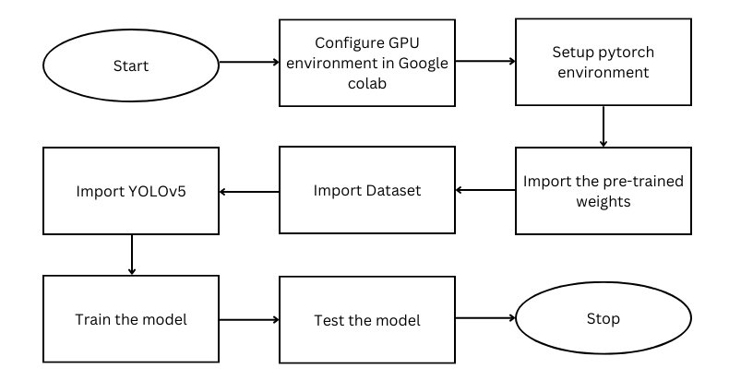
Figure 3.3: Process of Developing YOLOv8

Architecture:

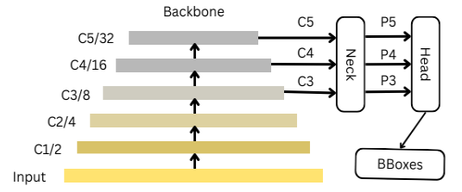
Figure 3.4: Overall Architecture of YOLOv8

The YOLOv8 architecture is an improvement over the earlier iterations of the YOLO algorithms. The convolutional neural network used by YOLOv8 is composed of two primary components: the head and the backbone. YOLOv8 is based on a modified version of the CSPDarknet53 architecture. With 53 convolutional layers, this architecture makes use of cross-stage partial connections to enhance the flow of information among the layers.
Multiple convolutional layers make up the head of YOLOv8, which is followed by a number of fully linked layers. For each object found in a picture, these layers forecast bounding boxes, objectness scores, and class probabilities. The implementation of a self-attention mechanism in the network's brain is one of YOLOv8's primary features. Through this technique, the model is able to focus on different areas of the image and modify the weighting of certain features according to how relevant they are to the job at hand. The capability of YOLOv8 to carry out multi-scaled object identification is another significant feature. The model detects items in a picture with varying sizes and scales by using a feature pyramid network. The model can identify both big and small items in a picture thanks to this feature pyramid network, which is made up of several layers that each recognize objects at a different scale.

Here are some reasons why YOLOv8 may be a suitable choice for such a task:
1. Increased Accuracy: By implementing novel strategies and improvements, YOLOv8 increases object detection accuracy in comparison to its predecessors.
2. Enhanced Speed: YOLOv8 maintains good accuracy but inference times are faster than those of other object detection algorithms.
3. Support for Multiple Backbones: YOLOv8 allows users to select the most appropriate model for their particular use case by supporting a number of backbones, including EfficientNet, ResNet, and CSPDarknet.
4. Adaptive Training: To improve model performance, YOLOv8 employs adaptive training to balance the loss function and optimize the learning rate during training.
5. Advanced-Data Augmentation: To increase the model's resilience and generalizability, YOLOv8 makes use of sophisticated data augmentation methods including MixUp and CutMix.
6. Highly flexible design: The structure and parameters of YOLOv8 can be readily altered by users to meet their specific requirements thanks to the model's highly flexible design.
7. Pre-Trained Models: To facilitate use and transfer learning across a range of datasets, YOLOv8 offers pre-trained models.

3.4 MODULES IMPLEMENTED
Figure 3.5 illustrates the system initialization marks the commencement of a well-coordinated sequence of operations. It begins with a login GUI for the user, where three options are presented: uploading a video file, accessing a live video feed, or inputting an image feed. Once the user selects the desired input method, the system proceeds accordingly. Following the user's input selection, the system captures a video feed from the designated source, which could either be a live camera feed or a pre-recorded video. Within this video stream, a Region of Interest (ROI) is delineated, defining the specific area where people counting will take place. This step allows for the precise targeting of the detection process, focusing solely on the relevant area of interest.
The pivotal role of the detection process lies in its ability to provide actionable insights into crowd dynamics and behavior. By accurately identifying and tracking individuals within the ROI, the system enables informed decision-making regarding crowd management strategies. Whether it's optimizing space utilization, ensuring compliance with social distancing measures, or enhancing security protocols, the real-time tracking capabilities facilitated by YOLOv8 empower stakeholders to proactively address evolving scenarios in crowded environments. In essence, the integration of a user-friendly interface with advanced object detection algorithms like YOLOv8 heralds a new era in crowd management and surveillance. By seamlessly combining intuitive user interaction with cutting-edge technology, the system not only enhances operational efficiency but also fosters a safer and more conducive environment for individuals within crowded spaces.

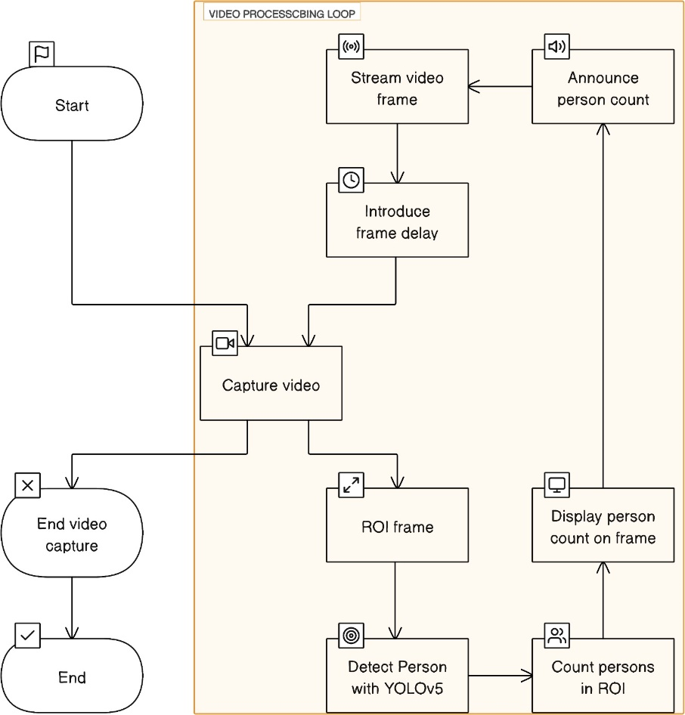
Fig 3.5: Flow of Human detection
After successful detection, the system transitions to the counting phase, utilizing the YOLOv8 results to enumerate the number of individuals within the specified ROI. The acquired count seamlessly integrates into the original video frame, generating an augmented display that offers an instant visual representation of the real-time people count. This overlay serves as a vital feedback mechanism for users and authorities overseeing the system, furnishing immediate insights into crowd dynamics within the designated area. Concurrently, the system implements an intelligent alert system. A predefined threshold is established, representing the maximum permissible number of people within the ROI. If the real-time count surpasses this threshold, an automatic announcement or alert is triggered, proactively notifying relevant personnel or entities. This feature holds significant relevance in scenarios such as crowd management during the COVID-19 pandemic or the regulation of queue lengths at bustling locations like airports.
To further augment the system's utility, the processed video frame, now enriched with the overlaid people count, can be streamed in real-time to a monitoring station or any designated display platform. This streaming capability ensures swift dissemination of critical information to those responsible for managing the environment. Whether it's security personnel, public health officials, or airport authorities, the streamed video furnishes a comprehensive view of the situation, facilitating timely decision-making.
Furthermore, the system incorporates a looping mechanism, ensuring seamless continuity in operations. After processing and displaying one frame, the system seamlessly transitions to the next, perpetuating the entire process in a continuous loop. This iterative approach ensures the system is continually monitoring the defined ROI, providing an uninterrupted and persistent solution for real-time people counting and management. Such an iterative approach is indispensable in dynamic environments where crowd dynamics can evolve rapidly.
In essence, the real-time people counting and management system amalgamates cutting-edge technology with practical applications. The integration of YOLOv8, real-time counting, dynamic frame display, and intelligent alerts positions the system as a versatile solution applicable across various domains [10]. The detailed flow ensures seamless operation, furnishing accurate and timely information to facilitate proactive decision-making in real-time.
Incorporating multiple models enhances the system's efficacy and adaptability to diverse scenarios. Alongside YOLOv8, the system integrates three additional models: Roboflow, HOG (Histogram of Oriented Gradients), and YOLOv5. Each model contributes unique strengths to the system's functionality, collectively bolstering its performance in real-time people counting and management tasks.
Roboflow streamlines the preprocessing of datasets, ensuring that input data is appropriately formatted and augmented for optimal performance. HOG, a classical feature extraction method, complements deep learning-based approaches by providing additional context and features for object detection. YOLOv5, a streamlined variant of the YOLO model, enhances the system's versatility and efficiency, offering an alternative solution for object detection tasks.
Among these models, YOLOv8 stands out as the most effective for several reasons. Its advanced architecture and optimization techniques enable precise and rapid detection of individuals within the defined ROI. By leveraging a deep neural network with multiple layers, YOLOv8 excels at capturing intricate features and patterns, facilitating accurate localization and identification of people in real-time [11]. Additionally, YOLOv8's robust training process ensures adaptability to varying environmental conditions and scenarios, making it highly suitable for dynamic crowd management tasks.
In the steps represented in Figure 3.6, the YOLOv8 model training process represents a critical phase in our project's development, harnessing the capabilities of this cutting-edge object detection framework to achieve precision in people counting within a defined Region of Interest (ROI).
To initialize a Flask app for real-time people counting, first establish the groundwork by creating a Flask application. This serves as the backbone for handling HTTP requests and responses. Within this app, define a function, count_persons_in_roi, responsible for processing video frames and detecting and counting persons within a specified Region of Interest (ROI). The count_persons_in_roi function is pivotal, as it encapsulates the core logic for our real-time people counting system. Next, implement a text-to-speech function, which enables the system to announce the total count of persons. This auditory feedback adds an extra layer of accessibility and information dissemination.
To generate frames from the video feed, create a function dedicated to capturing video frames, resizing them to a standardized dimension of 1020x500 pixels. This resizing step is crucial for consistency in processing and displaying frames. Subsequently, incorporate the YOLOv8 model into our workflow, running it on each resized frame. This model, designed for efficient object detection, identifies and localizes persons within the frame. Following detection, extract the Region of Interest (ROI) from the frame—defining the specific area where people counting will occur. This ensures that our counting process is focused and accurate.
Now, as delving into the index route function, establish the core structure of our web application. This function typically renders an HTML template, serving as the user interface for interacting with the real-time people counting system. Within this interface, users can view the video feed, witness the dynamic count of persons, and receive announcements through audio feedback.
The video feed route function complements the index route, providing a continuous stream of video frames to the user interface. The generate frames function plays a pivotal role in creating this stream. It orchestrates the capture, resizing, YOLOv8 model execution, ROI extraction, and person counting for each frame. Drawing rectangles around detected persons and the ROI boundary visually enhances the user interface, offering a clear representation of the detection process [12].
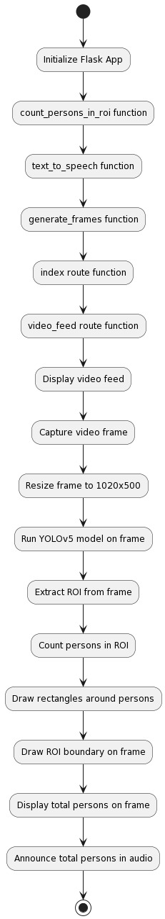
Figure 3.6: Process Involved In Implementation.
As the video frames are dynamically processed, the total count of persons within the ROI is displayed on each frame. This real-time count is not only visually informative but also contributes to effective crowd management and monitoring. Simultaneously, the text-to-speech function announces the total count, providing an auditory cue to users. This dual feedback mechanism caters to both visual and auditory preferences, ensuring a comprehensive user experience.
In essence, our Flask app orchestrates a seamless integration of video processing, YOLOv8 model inference, and user interface rendering. The capture and processing of video frames, coupled with the ROI-based people counting and dynamic visual feedback, create a robust real-time people counting system. The inclusion of audio announcements further enriches the user experience. This holistic approach transforms the Flask app into a versatile tool applicable in various scenarios, from crowd management in public spaces to monitoring queues in high-traffic areas. In conclusion, the process involves
- YOLOv8 Model Training
- Implement within the specified ROI
- Frontend Implementation
- Real-time Applications
- Dynamic Queue Management
- Adaptability and Versatility

CHAPTER 4
EXPERIMENTAL RESULTS

The following sections outline the experimental results obtained while implementing the proposed system.
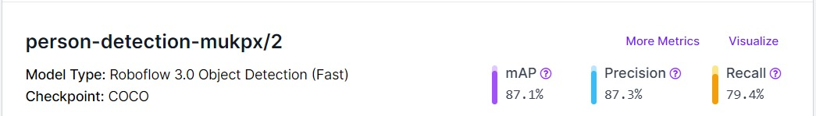

Fig 4.1: Results Obtained Using Roboflow 3.0 Object Detection Model

Figure 4.1 shows the results such as mAP, Precision, Recall for the trained Roboflow 3.0 Object Detection model.

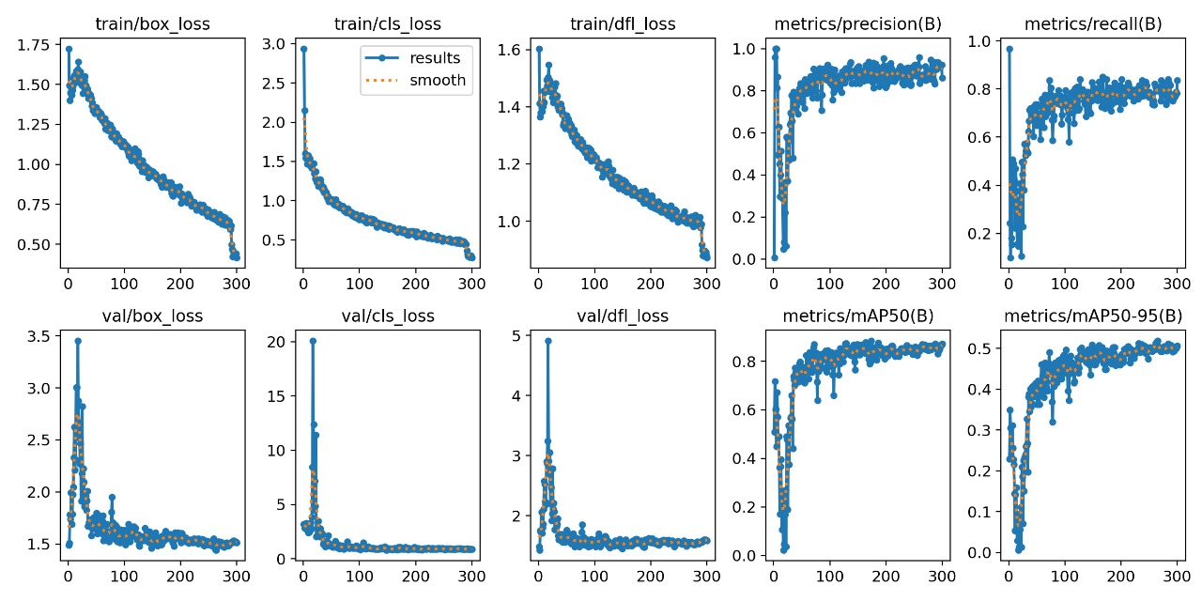

Fig 4.2(a): Box_Loss, Cls_Loss, Dfl_Loss For Training And Testing Using Roboflow Model

Fig 4.2(b): Precision, Recall And mAP For Roboflow Model

Figure 4.2 is a representation of various metrics and losses related to a training process. The information includes values for different losses, precision, recall, and other metrics for both training and validation data. The data is structured in a tabular format with lines and values indicated for different categories.

Figure 4.3 is a plot showing the mean Average Precision (mAP) values across different epochs. The x-axis represents the epochs, while the y-axis represents the mAP values ranging from 0 to 0.9. The plot is displayed as a line graph. The formula for mAP is:
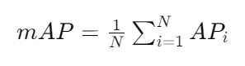
Equation 1: Mean Average Precision Formula
- where, N is the total number of classes.
- APi​ is the Average Precision for class i.

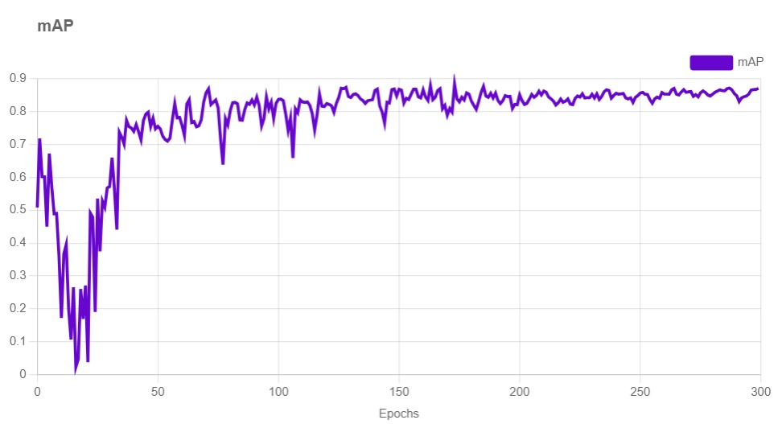

Fig 4.3: Roboflow 3.0 Object Detection Model mAP

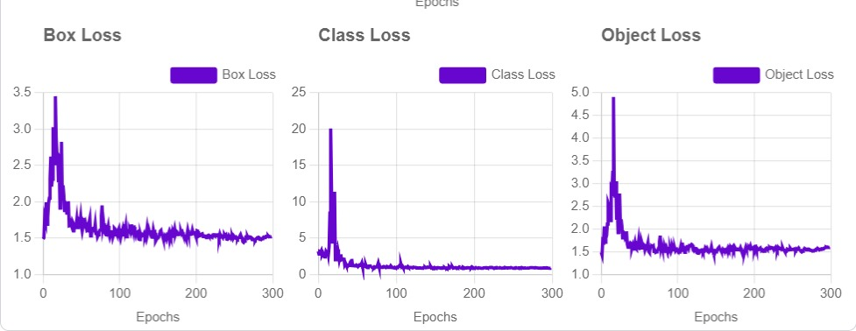

Fig 4.4: Roboflow 3.0 Object Detection model Box Loss, Class Loss, Object Loss

Figure 6.4 is a data chart showing different values for Box Loss, Class Loss, and Object Loss across multiple epochs. The chart displays values for each loss type at various epochs ranging from 0 to 300. The data is presented in a tabular format with corresponding values for each loss type at different epochs. Figure 4.5 shows the results such as accuracy, Precision, Recall and Confusion Matrix for the Histogram of Object Gradients (HOG) model.

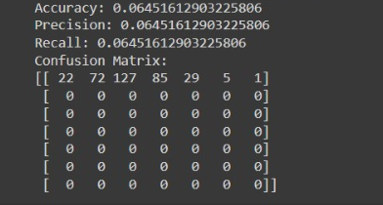

Figure 4.5: Hog Results

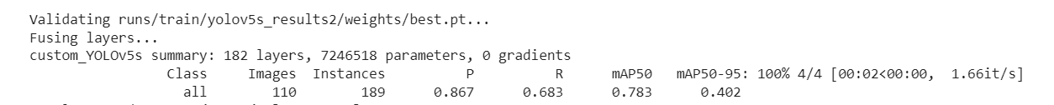

Figure 4.6: Results Obtained Using YOLOv5 Model

Figure 4.6 shows the results of validating a custom YOLOv5 model, showing information such as the number of layers, parameters, precision, recall, and mAP values. The image shows a table with columns for classes, images, instances, precision, recall, mAP50, and mAP50-95. Figure 4.7 is a treemap chart displaying a confusion matrix with values and labels related to predictions and true values for a person and background. The chart includes values ranging from 0 to 1.

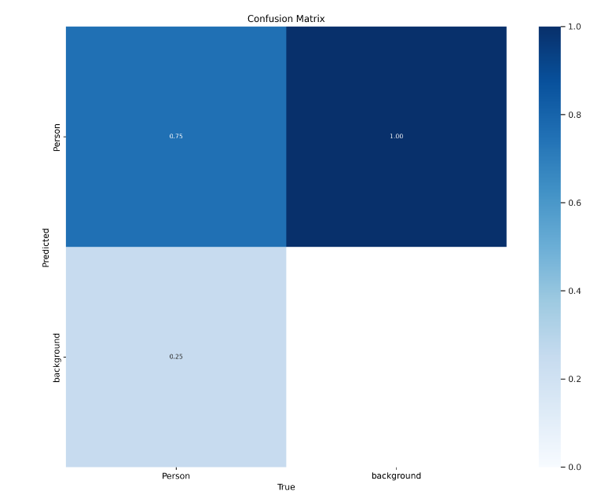

Figure 4.7: Confusion Matrix for YOLOv5

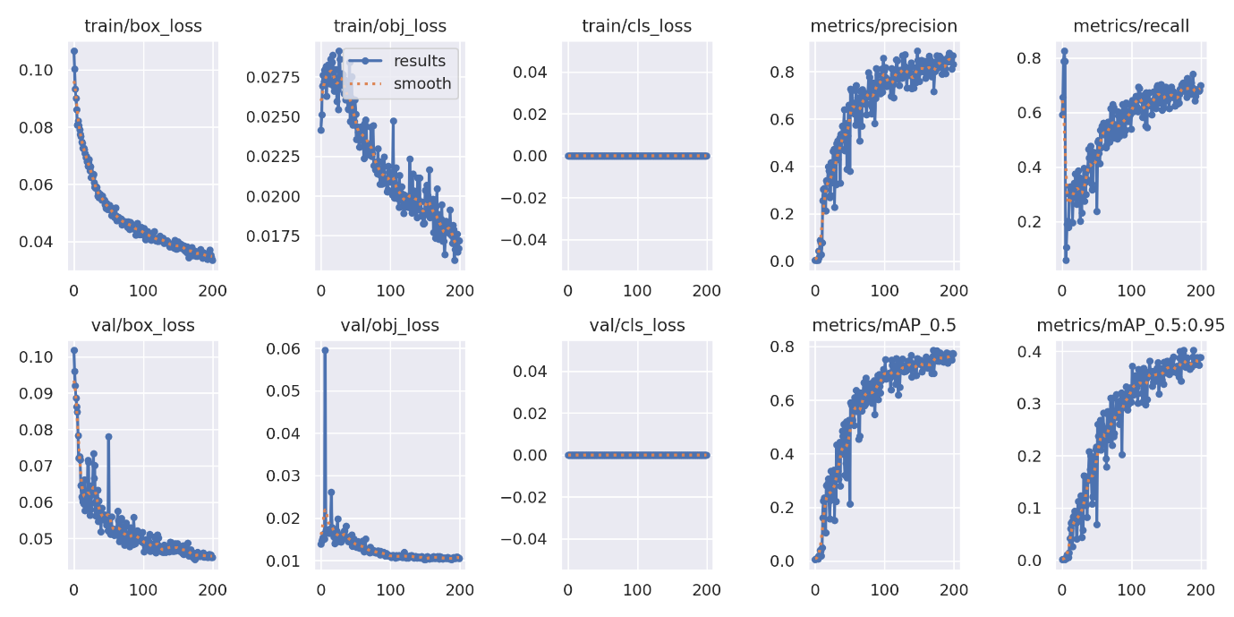

Figure 4.8(a): Box_Loss, Cls_Loss for Training and Testing Using YOLOv5

Fig 4.8(b): Precision, Recall And mAP for YOLOv5

Figure 4.8 provides data points related to training and validation metrics for a YOLOv5 model. The data includes values for different loss functions, precision, recall, and mAP scores at different thresholds. The values are presented in a structured format for visualization. Figure 4.9 shows a table data related to model validation using Ultralytics YOLOV8.0.0. It includes information about the model summary, number of layers, parameters, and performance metrics like mAP50 and mAP50-95.

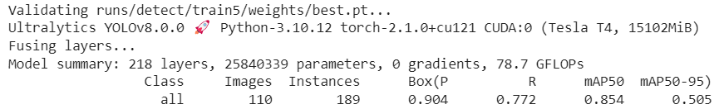

Figure 4.9: Results Obtained Using YOLOv8 Model

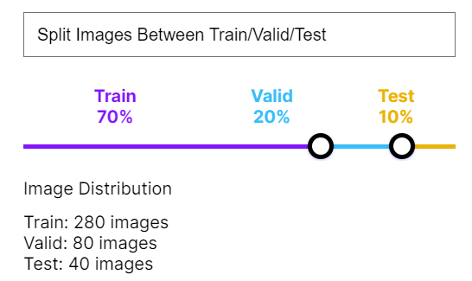

Figure 4.10: YOLOv8 Dataset Split-up

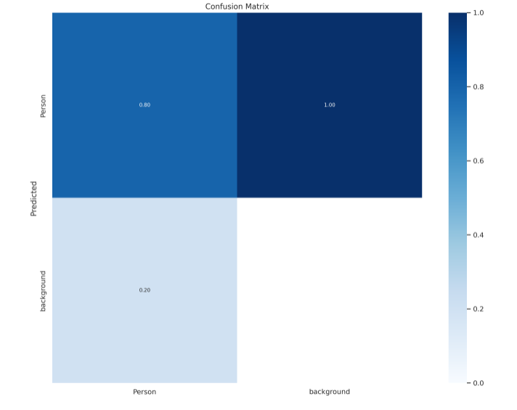

Figure 4.11: YOLOv8 Confusion Matrix

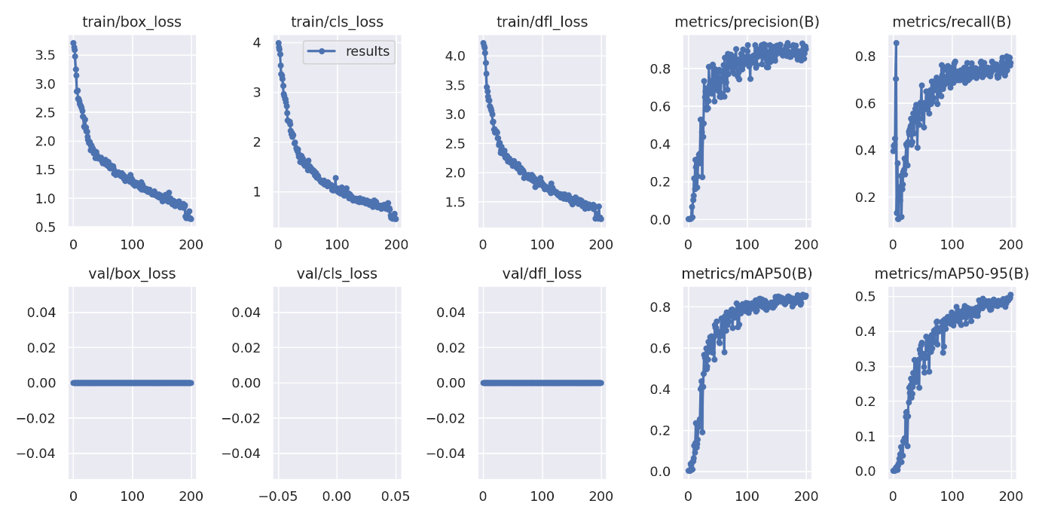

Figure 4.12 (a): Box_Loss, Cls_Loss and dfl_loss for Training and Testing Using YOLOv8

The table contains details about classes, images, instances, and specific box metrics like Precision (P), Recall (R), and mean Average Precision (mAP). Figure 4.10 is a diagram showing the distribution of images between training, validation, and testing sets. The split between the sets is 70% for training, 20% for validation, and 10% for testing. The number of images in each set is specified as follows: 280 images for training, 80 images for validation, and 40 images for testing. Figure 4.11 is a treemap chart displaying a confusion matrix. It consists of values ranging from -1.0 to 1.0, with categories like Person and background. Figure 4.12 provides data points related to training and validation metrics for a YOLOv5 model. The data includes values for different loss functions, precision, recall, and mAP scores at different thresholds. The values are presented in a structured format for visualization. Figure 4.13, 4.14, 4.15 shows bar graph of precision, recall and mAP for various models implemented such as Roboflow, YOLOv5, YOLOv8 under various epochs.

Fig 4.12 (b): Precision, Recall And mAP for YOLOv8

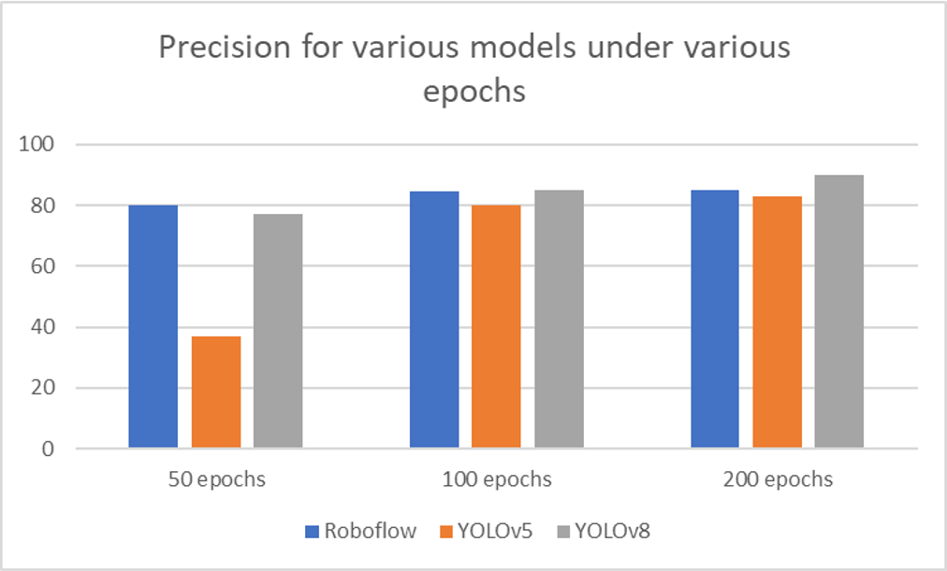
Figure 4.13: Precision For Various Models Under Various Epochs

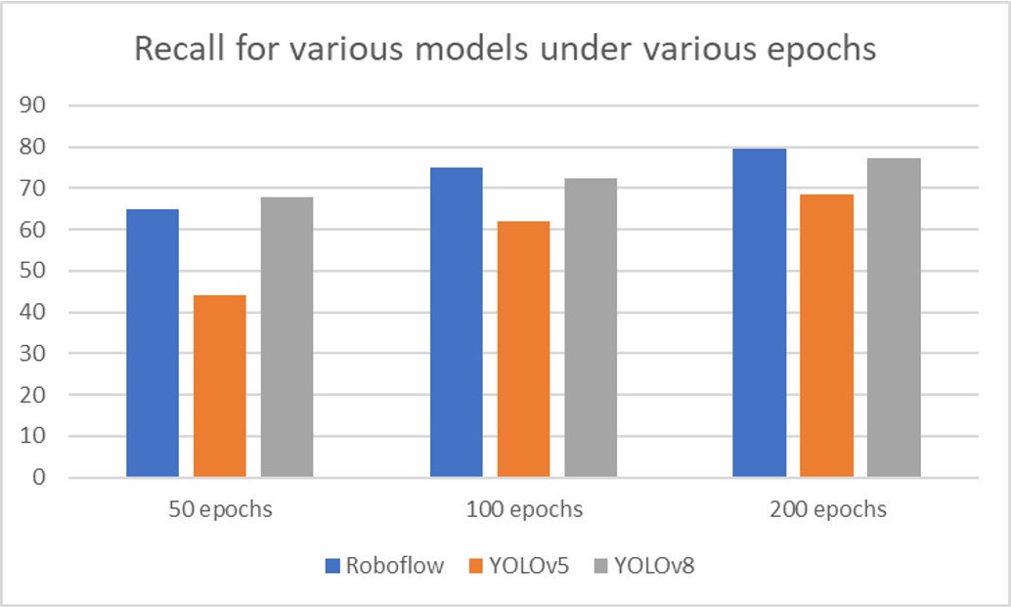
Figure 4.14: Recall For Various Models Under Various Epochs

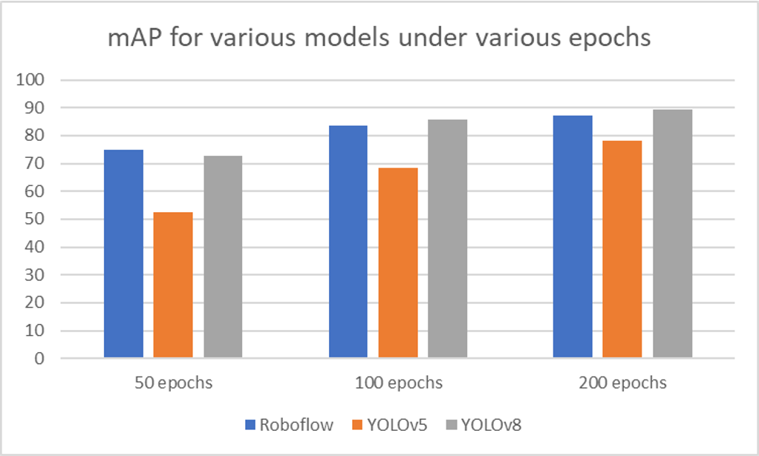
Figure 4.15: mAP .

Model/Metrics | Precision (%) | Recall(%) | mAP(%)
Roboflow 3.0 Object Detection | 87.3 | 79.4 | 87.1
HOG | 64.5 | 64.5 | 64.1
YOLOv5 | 86.7 | 68.3 | 78.3
YOLOv8 | 90.4 | 77.2 | 89.4
Tabel 4.1: Comparison of Results Using Various Models

A comparison of many object detection models, including Roboflow 3.0 Object Detection, HOG, YOLOv5, and YOLOv8, is shown in the table using metrics for mean average precision (mAP), recall, and precision. The accuracy with which each model can identify objects in photos is the basis for evaluating its performance. Roboflow 3.0 Object Detection has a mAP of 87.1% and shows good recall and precision scores of 79.4% and 87.3%, respectively. With a mAP of 64.1%, HOG trails slightly even with balanced precision and recall at 64.5%. While recall and mAP are both below average with 68.3% and 78.3%, respectively, YOLOv5 has good precision at 86.7%. With remarkable precision, recall, and mAP scores of 90.4%, 77.2%, and 89.4%, respectively, YOLOv8 is the clear winner in contrast. Consequently, the decision to employ YOLOv8 is substantiated by its superior performance across all metrics, ensuring more accurate human detection.

Figure 4.16 depicts the application's home screen, where the user was supposed to enter the username and password. With a click of the LOGIN button, the entered credentials were confirmed in the Cassandra database. Figures 4.17, 4.18 and 4.19 shows the output how humans are detected and counted from image, video and real-time camera respectively.

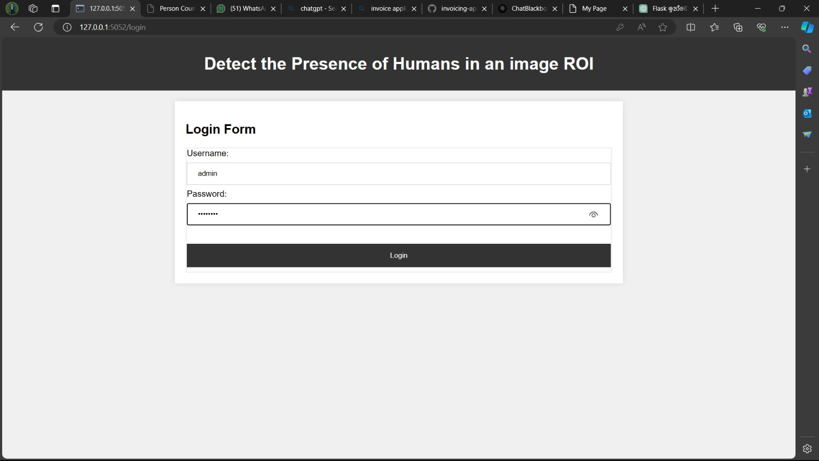
Figure 4.16: GUI for the Login Page of Application

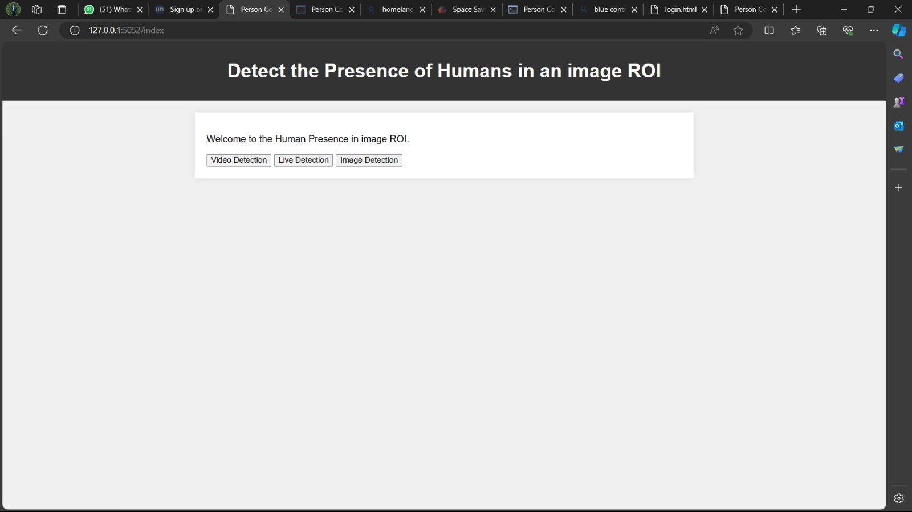
Figure 4.17: GUI for the Index page of Application

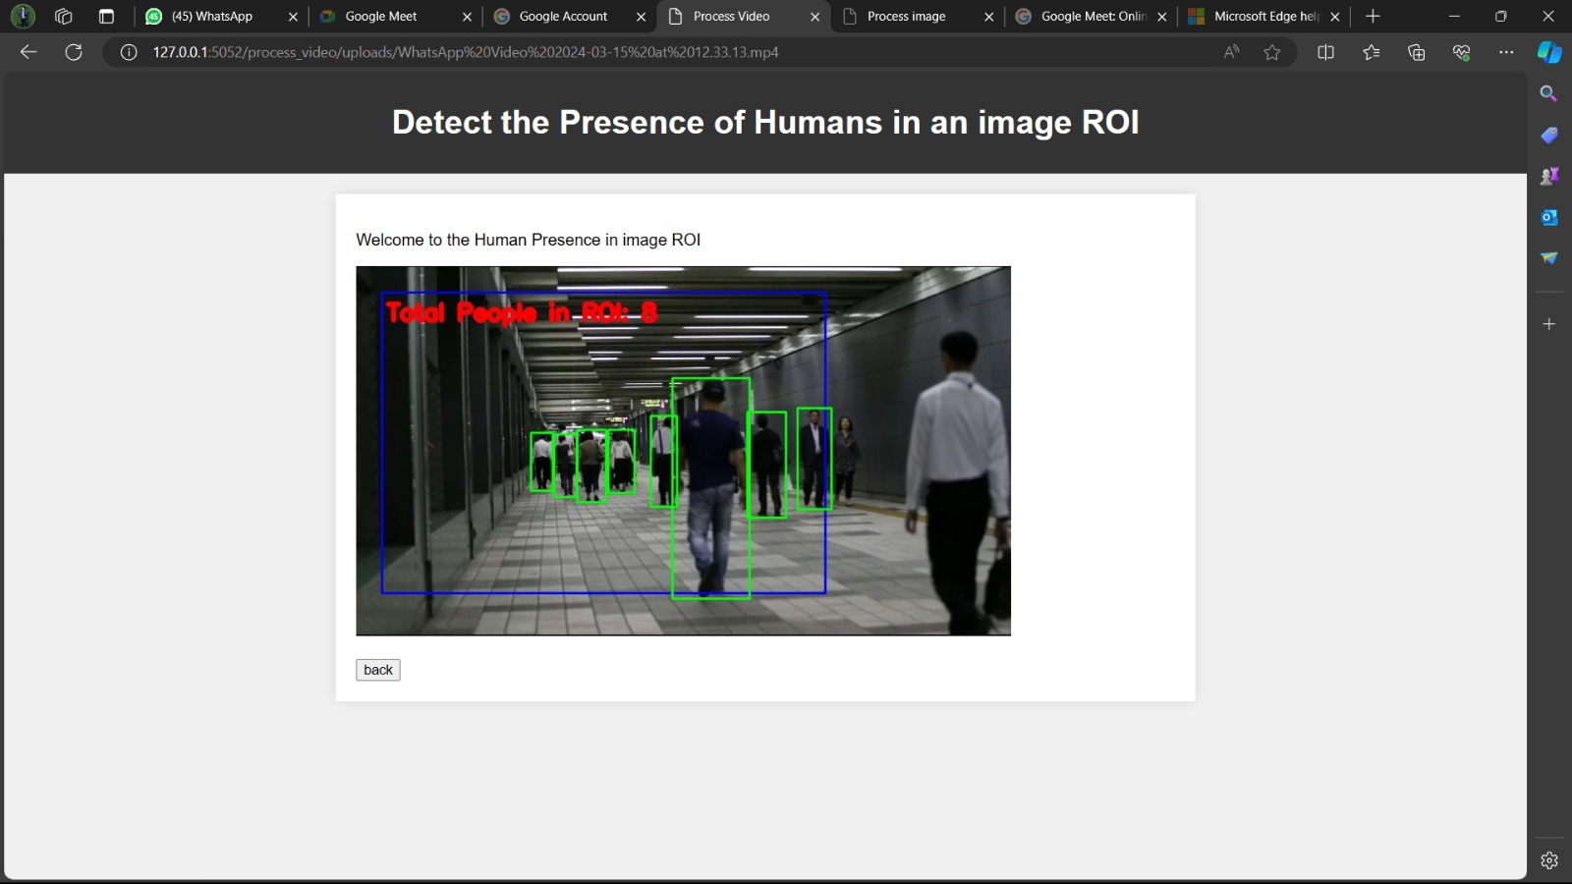
Figure 4.18: Prediction of Human Count by Uploading Video

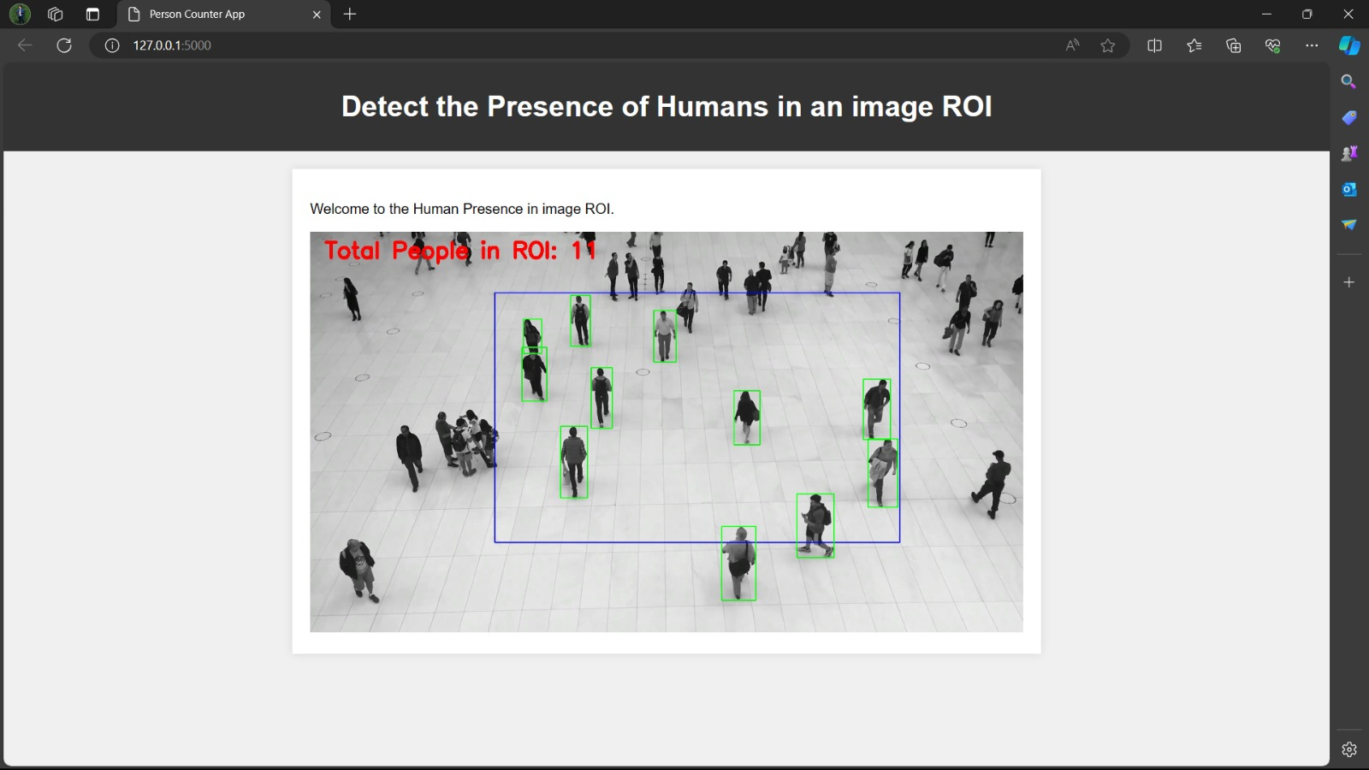
Figure 4.19: Prediction of Human Count by Uploading Image

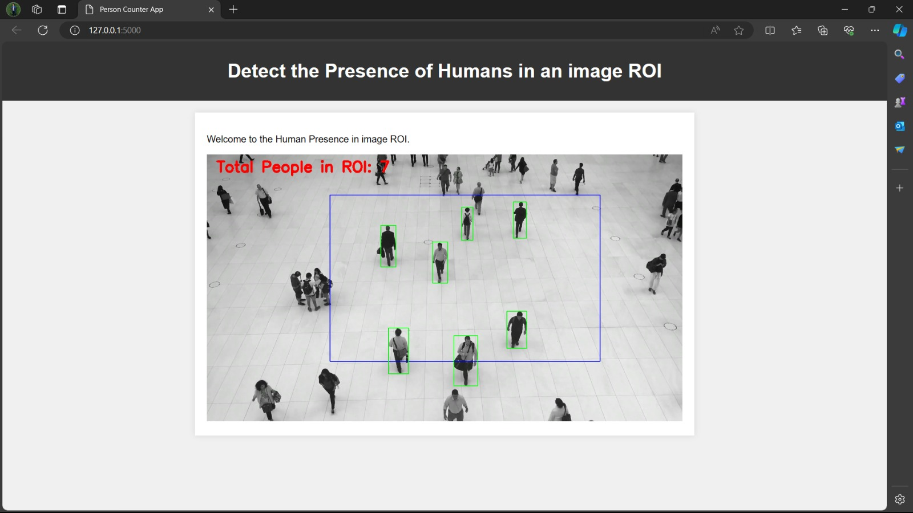
Figure 4.20: Prediction of Human Count Using Real Time Camera

CHAPTER 5
CONCLUSIONS AND FUTURE WORK
5.1 CONCLUSIONS
Accurate people counting within defined regions of interest (ROIs) is crucial in various domains such as retail, public safety, transportation, and event management. Traditional methods often lack real-time capabilities and struggle with precision, leading to inefficiencies. In this project, an innovative approach leveraging advanced object detection algorithms has been proposed, specifically YOLOv8, to address this challenge. Through rigorous evaluation and comparative analysis, YOLOv8 emerged as the most effective algorithm, boasting a precision of 90.4%. Our methodology involves dataset collection, preprocessing, model training, system integration, frontend interface design, and result presentation. The system offers seamless interaction and provides results in various formats including images, videos, and real-time camera feeds, contributing to enhancing accuracy and efficiency in real-time people counting applications.
5.2 FUTURE WORK
Looking forward, the trajectory of future work can traverse numerous dimensions aimed at fortifying the project's capabilities and broadening its applicability. Firstly, there exists ample room for the optimization of the YOLOv8 algorithm and the custom-trained model to bolster real-time processing speed and resource efficiency. Striking a balance between accelerated inference and unwavering accuracy will be paramount, ensuring that the system operates swiftly without compromising its ability to discern nuanced details in crowded scenarios. The integration of parallel processing techniques, model pruning, and hardware acceleration could be explored to attain these objectives. Secondly, the augmentation of advanced features within the system holds substantial promise [17]. The inclusion of multi-object tracking mechanisms, re-identification algorithms, and behavior analysis tools can markedly enhance the system's capabilities. This expansion beyond mere detection opens avenues for proactive threat detection and anomaly identification, contributing to a more sophisticated and preemptive surveillance infrastructure. The project can potentially evolve into a comprehensive solution capable of not only identifying individuals but also tracking their movements and understanding behavioral patterns over time.Moreover, sustained research into algorithmic comparison, deployment methodologies, and scalability considerations is pivotal for ensuring the project's viability in real-world deployment scenarios [18]. As the system progresses, the adaptability to diverse environments, varying lighting conditions, and dynamic crowd densities should be rigorously tested. This iterative process will facilitate the identification and mitigation of potential challenges, ensuring that the system remains robust and resilient in the face of real-world complexities [19].

Additionally, exploring avenues for seamless integration with emerging technologies such as edge computing, the Internet of Things (IoT), and 5G connectivity could further enhance the system's capabilities. By capitalizing on these technological trends, the project can position itself at the forefront of innovation, offering not just accurate human detection but a comprehensive solution that aligns with the evolving landscape of smart cities and connected environments. In essence, the future trajectory of this project encompasses a multidimensional approach that spans optimization, feature enrichment, research refinement, and seamless integration [20]. By addressing these facets, the project is poised to continue its evolution, making substantial contributions to the dynamic field of human detection using advanced computer vision algorithms. The ongoing pursuit of excellence in these areas ensures that the project remains not only relevant but also at the cutting edge of technological innovation, with far-reaching implications across diverse sectors.

REFERENCES
- Paul, M., Haque, S.M.E., & Chakraborty, S. "Human detection in surveillance videos and its applications - a review." EURASIP J. Adv. Signal Process., 2013.
- Rizk, M., & Bayad, I. "Human Detection in Thermal Images Using YOLOv8 for Search and Rescue Missions." Seventh International Conference on Advances in Biomedical Engineering (ICABME), 2023.
- Nguyen, Duc Thanh, Wanqing Li, and Philip O. Ogunbona. "Human detection from images and videos: A survey." Pattern Recognition 51, 2016.
- Dalal, Navneet, Bill Triggs, and Cordelia Schmid. "Human detection using oriented histograms of flow and appearance." Computer Vision–ECCV 2006: 9th European Conference on Computer Vision, 2006.
- Redmon, J.; Divvala, S.; Girshick, R.; Farhadi, A. "You only look once: Unified, real-time object detection." Proceedings of the IEEE Conference. Computer Vision and Pattern Recognition (CVPR), Las Vegas, NV, USA, 2015.
- Christopoulos, Charilaos, Joel Askelof, and Mathias Larsson. "Efficient methods for encoding regions of interest in the upcoming JPEG2000 still image coding standard." IEEE Signal Processing Letters, 2000.
- Byeon, Yeong-Hyeon, et al. "Body and hand–object ROI-based behavior recognition using deep learning." Sensors 21.5, 2021
- Stauffer C, Grimson W. "Adaptive background mixture models for real-time tracking." IEEE Conference on Computer Vision and Pattern Recognition (CVPR), 1999.
- Zhu, Qiang, Mei-Chen Yeh, K.-T. Tim Cheng, and Shai Avidan. "Fast Human Detection Using a Cascade of Histograms of Oriented Gradients." Proceedings of the IEEE Computer Society Conference on Computer Vision and Pattern Recognition, 2006.
- Ifeanyi, Nwakanma, Oluigbo Ikenna, and Okpala Izunna. "Text–To–Speech Synthesis (TTS)." International Journal of Research in Information Technology 2.5, 2014.
- M. Ivasic-Kos, M. Krišto and M. Pobar, "Human detection in thermal imaging using YOLO", Proceedings of the 2019 5th International Conference on Computer and Technology Applications, 2019.
- J. Redmon, S. Divvala, R. Girshick and A. Farhadi, "You only look once: Unified real-time object detection", Proceedings of the IEEE conference on computer vision and pattern recognition, 2016.
- H. Shi, Q. Peng, J. Yang, X. Bai and Y. Zhuang, "A Practical ROI and Object Detection Method for Vision Robot," IEEE International Conference on Integrated Circuits, Technologies and Applications (ICTA), Nanjing, China, 2020.
- Lu, Yao & Qiu, Zhibin & Liao, Caibo & Zhou, Zhibiao & Li, Tonghongfei & Wu, Zijian, "A GIS Partial Discharge Defect Identification Method Based on YOLOv5." Applied Sciences 12.16, 2022.
- Hussain, Muhammad, "YOLO-v1 to YOLO-v8, the Rise of YOLO and Its Complementary Nature toward Digital Manufacturing and Industrial Defect Detection", Machines 11, no. 7, 2023.
- Sulman N, Sanocki T, Goldgof D, Kasturi R. "How effective is human video surveillance performance?" 19th International Conference on Pattern Recognition, (ICPR), 2008.
- Kim W, Kim C. "Background subtraction for dynamic texture scenes using fuzzy color histograms." Signal Process. Lett. IEEE, 2012.
- Cheng F-C, Huang S-C, Ruan S-J. "Scene analysis for object detection in advanced surveillance systems using Laplacian distribution model." Syst. Man Cybern. Part C Appl. Rev. IEEE Trans. 2011
- Wang J, Bebis G, Miller R. "Robust video-based surveillance by integrating target detection with tracking." IEEE Computer Vision and Pattern Recognition Workshop (CVPRW), 2006.
- Kang, Wenxiong, and Feiqi Deng. "Research on intelligent visual surveillance for public security." 6th IEEE/ACIS International conference on computer and information science (ICIS 2007). IEEE, 2007.

