


Clinwise : An AI Chatbot for Prediction of Clinical Trial Completion

PROJECT REPORT

Submitted by

PADMA PRIYA R | (715522244032)
SANJEEVI V | (715522244044)
TARUNAA A C | (715522244054)
in partial fulfilment for the award of the degree of

BACHELOR OF TECHNOLOGY
IN

COMPUTER SCIENCE AND BUSINESS SYSTEMS

PSG INSTITUTE OF TECHNOLOGY AND APPLIED RESEARCH, COIMBATORE - 641 062

ANNA UNIVERSITY: CHENNAI - 600 025

APR 2026

ANN ANNA UNIVERSITY: CHENNAI - 600 025

BONAFIDE CERTIFICATE
Certified that this project report “Clinwise:An AI Chatbot for Prediction of Clinical Trial Completion” is the bonafide work of “Padma Priya R (715522244032), Sanjeevi V (715522244044) and Tarunaa A C (715522244054) “ who carried out the project work under my supervision.

----------------------------- ------------------------------

SIGNATURE SIGNATURE
Dr B Gomathy Dr R Manimegalai

HEAD OF THE DEPARTMENT SUPERVISOR
Professor and Head Professor
Computer Science and Engineering Computer Science and Engineering PSG Institute of Technology and PSG Institute of Technology and Applied Research, Applied Research,
Coimbatore – 641 062 Coimbatore – 641 062

Submitted for the project viva-voce Examination held on

----------------------------------- -----------------------------------

INTERNAL EXAMINER EXTERNAL EXAMINER

ACKNOWLEDGMENTS

"The real gift of gratitude is that the more grateful one is, the more present one becomes." - Robert Holden
First and foremost, a deep sense of gratefulness is expressed to the respected Managing Trustee, Shri. L. GOPALAKRISHNAN, for the provision to utilize all necessary facilities in the institution. Heartfelt gratitude is extended to the Principal of the institution, Dr. N SARAVANAKUMAR, for the overwhelming support and encouragement provided during this project.
A great debt is owed to the Head of the Department of Computer Science and Engineering, Dr. B GOMATHY, for the guidance and continuous support which was instrumental in the completion of this project. Gratitude is also extended to the project supervisor, Dr. R MANIMEGALAI, for the constant guidance and assistance provided throughout the research. Special thanks are given to the Class Tutor Dr. B. GOMATHI for the continuous academic support and motivation. Finally, appreciation is shown to all faculty and staff coordinators of the Department of Computer Science and Engineering, PSG Institute of Technology and Applied Research, as well as friends and family members who assisted in obtaining the required instruments and provided constant support and motivation to ensure a successful completion.

ABSTRACT

Clinical trials play a major role in biomedical research by evaluating the safety and effectiveness of medical interventions. However, an important portion of studies terminate because of problems such as improper research design, difficulties in recruiting participants, and several operational constraints. This leads to financial loss and wastage of resources.ClinWise is introduced as an interpretable machine learning framework implemented to assist in evidence-based decision-making during trial preparation and to predict the completion of clinical trials. For predicting completion, textual data such as brief summaries are combined with structural parameters including trial phase, enrollment size, and sponsor information.
A number of machine learning algorithms are considered, and tuning is done for improvement in predictive performance. From the experimentation, it can be observed that ensemble techniques perform much better than conventional techniques, where XGBoost performs best with an accuracy of about 92%, and also shows excellent ROC-AUC values, which means that it has high discriminatory ability between completed and non-completed trial groups. LightGBM also shows good performance, especially when different train-test splits are considered; this algorithm shows good generalization ability. On the other hand, logistic regression gives much poorer performance results. SHAPley Additive explanations (SHAP) is used to highlight the important variables that push predictions.Through an interactive chat interface users can input trial parameters and get probability of completion with explainability and recommendations.This helps in identifying parameters that influence outcome and boost success rate of clinical trials.
Keywords: Clinical Trial Prediction, Machine Learning, XGBoost, Explainable AI, SHAP, Multimodal Data Analysis

TABLE OF CONTENTS

CHAPTER NO | TITLE | PAGE NO
 | ABSTRACT | 4
 | LIST OF FIGURES | 7
 | LIST OF ABBREVIATIONS | 8
1 | INTRODUCTION  1.1 OVERVIEW OF CLINICAL TRIAL  1.2 NEED OF AI IN CLINICAL TRIAL  1.3 PROBLEM STATEMENT  1.4 OBJECTIVES  1.5 ORGANIZATION OF THESIS | 9
2 | LITERATURE SURVEY  2.1 RESEARCH GAPS IDENTIFIED | 15
3 | PROPOSED METHODOLOGY FOR CLINICAL TRIAL COMPLETION  3.1 CLINWISE OVERVIEW  3.2 SYSTEM ARCHITECTURE  3.3 DATASET DESCRIPTION  3.4 SYSTEM WORKFLOW  3.5 SYSTEM REQUIREMENTS | 22
4 | EXPERIMENTAL RESULTS | 35
5 | CONCLUSIONS  5.1 CONCLUSIONS  5.2 FUTURE WORK | 37
6 | REFERENCES | 40

LIST OF FIGURES

Figure Number | Description | Page number
1.1 | Phases of Clinical Trial | 10
3.1 | System Workflow of ClinWise | 26
3.2 | Feature Engineering and Representation Pipeline | 29
3.3 | SHAP Waterfall Plot Showing Feature Contribution for a Single Clinical Trial Prediction | 33
3.4 | SHAP Summary Plot Showing Global Feature Importance for Clinical Trial Completion Prediction | 34
3.5 | User Interface of ClinWise | 36

LIST OF ABBREVIATIONS

AI | Artificial Intelligence
AUC | Area Under Curve
LLM | Large Language Models
ML | Machine learning
NLP | Natural Language Processing
ROC | Receiver Operating Characteristic
RCT | Randomised Control Trial
SHAP | SHapley Additive exPlanations
TF-IDF | Term Frequency-Inverse Document Frequency

CHAPTER 1

INTRODUCTION

Clinical trials are used in medical research and in development of drugs. Many scientific investigations are conducted to evaluate the safety, effectiveness, and performance of new medications, medical devices, behavioral therapies, and treatment procedures. Before releasing any new drug to the public it must undergo several stages of testing.

1.1 PHASES IN CLINICAL TRIAL

Clinical trials are generally conducted in four major phases. Phase I uses a small group of volunteers to identify safe dosage levels and potential side effects caused.
Phase II evaluates the effectiveness of the treatment on a larger group of patients.
Phase III compares the new treatment with existing standard treatments while monitoring its effectiveness and possible adverse reactions. Phase IV takes place after regulatory approval and monitors the long-term effectiveness of the treatment in real-world conditions. By collaborating with several stakeholders such as researchers, pharmaceutical companies, hospitals, regulatory authorities, and patient clinical trials ensure participant safety and maintain the accuracy of collected data.Although clinical trials are essential. Though clinical trials are essential they encounter several obstacles.Previous research indicates that about 30–40% of clinical trials do not get completed often due to difficulties in recruiting participants, complicated study designs, limited funding, or delays in execution. Such things not only delay the progress of developing new treatments but also result in financial loss and wastage of resources due to inefficient usage. As the amount of publicly available clinical trial data continues to grow, there is a rising demand for data-driven methods to estimate whether a trial will succeed or be terminated early.
As pointed out by Kavalci and Hartshorn [1], aspects like the stage of the trial, the number of sites involved, and the qualities of the sponsors are key to predicting the success or failure of the trial. Likewise, in more recent research, the application of machine learning algorithms to clinical trial data analysis and outcome prediction, which involves recognizing hidden patterns in structured and unstructured datasets, has been found to be possible [2], [4]. However, even though there have been significant strides in this field, most current predictive models are solely based on structured attributes and are non-interpretable, thus limiting their usefulness.

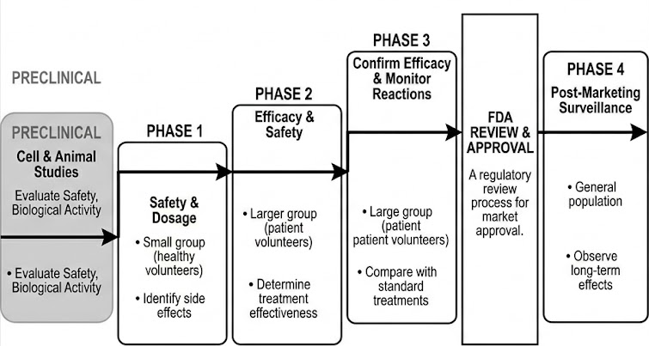
Figure 1.1 Phases of clinical trial

The figure 1.1 shows the standard lifecycle of a clinical trial, starting with the preclinical stage and processing is conducted through Phases 1 to 4 then with regulatory approval. Phase 1 focuses on assessing safety and dosage in a small group of healthy volunteers, while Phase 2 expands to a larger patient group to evaluate treatment effectiveness and further monitor safety. Phase 3 involves large-scale testing to confirm efficacy and compare the treatment with existing standards, after which regulatory approval is granted. Finally, Phase 4 includes post-marketing surveillance to monitor long-term effects in the general population. This structured progression highlights the complexity and multiple decision points involved in clinical trials. In the context of this project, each phase contributes critical data that can be utilized for predictive modeling, enabling early identification of risks related to trial completion and improving overall planning and decision-making.

Table 1.1 Important Milestones and Timeline of Clinical Trials
Year | Milestone | Significance
1747 | James Lind’s Scurvy Trial | Established the basis for evidence-based medicine by conducting the first known controlled clinical trial to cure scurvy in sailors using citrus fruits.
1900s | Introduction of Modern Experimental Methods | Development of systematic research plans and application of statistical techniques in medical examinations.
1946 | First Randomized Controlled Trial (RCT) | Randomization became the gold standard when the British Medical Research Council carried out the first RCT on streptomycin for tuberculosis.
1947 | Nuremberg Code Established | Presented the idea of voluntary consent and moral standards in the wake of unethical experiments conducted during the war.
1964 | Declaration of Helsinki | Internationally accepted ethical guidelines for medical research involving human subjects were established by the World Medical Association.
1979 | Belmont Report (U.S.) | Established the fundamental tenets of beneficence, justice, and respect for humans in research with human subjects.
1997 | Launch of ClinicalTrials.gov | Transparency, accessibility, and worldwide data exchange of research operations are ensured by the very first public clinical trial registry.
2000-2010 | Adoption of Electronic Data Capture (EDC) | Make the switch from a paper-based to digital patient monitoring and trial documentation.
2010-2020 | Rise of Machine Learning and Predictive Analytics | AI/ML applications for risk management, recruiting analysis, and trial outcome prediction.
2020-Present | AI-Driven Clinical Trials and Digital Twins | NLP, digital twin models, and artificial intelligence are combined to forecast trial completion and model patient outcomes. Give explainability and data openness top priority.

The table 1.1 outlines the major milestones in the evolution of clinical trials, highlighting how research practices have progressed from early experimental studies to modern, technology-driven approaches. It shows the development of ethical standards, regulatory frameworks, and methodological advancements that have improved the reliability and safety of clinical research. Overall, the timeline reflects the shift toward data-driven and AI-enabled clinical trials, aligning with the objectives of this project. Those days clinical trials depended on manual data collection, patient recruitment and design protocol. Though it helped in careful documentation it was not able to predict outcome in advance which slowed down the research process. As a result modern techniques combined predictive modelling and advanced machine learning models to predict outcomes to speed up the research process.
1.2 NEED FOR AI IN CLINICAL TRIALS

The larger number of participants, several outcomes, strict regulatory requirements, and overseas study locations have made clinical trials increasingly complex in recent times. While conventional approaches ensured scientific validity, they were not suitable for the amount and speed of data generated by modern clinical trials. Consequently, several studies are delayed, encounter challenges in recruiting patients, or are prematurely terminated. The need for artificial intelligence to aid clinical trials is becoming increasingly essential due to these constraints.

Rising Trial Complexity
Eligibility criteria, multiple arms of treatment, multiple country involvement, and the documentation of trials according to regulatory requirements are some characteristics of clinical trials today. Manual management of such aspects is impossible now. AI provides rapid handling of large and complex data and identifying connections that cannot be established using traditional methods.

Problems in Recruitment and Enrollment
Trial recruitment has been identified as the primary reason for delay or failure of clinical trials. Screening through manual processes and referral from doctors have remained the traditional means of recruitment despite their complexity and vulnerability to error. With AI, this process would be much faster and more accurate.

Early Termination of Clinical Trials is Widespread

Because of poor preparation, low enrollment rates, operational issues, or unreasonable deadlines, a substantial number of clinical trials end prematurely. The potential for terminating clinical trials before completion cannot be predicted using standard statistical techniques. Using artificial intelligence algorithms helps sponsors make well-founded decisions by predicting success or termination using previous clinical trials data.

Excess Information and Problems with Manual Examination

Clinical trials result in massive amounts of both structured and unstructured data ranging from tests results and patient history to eligibility criteria and outcomes measures. This process may be very laborious and miss subtle trends. AI approaches capable of automatically extracting valuable insights from the available data, detecting anomalies, and summarizing crucial data points include machine learning and NLP.

Expensive and Time-consuming

One full clinical study may consume several years of time and a huge amount of money. If there is any delay in the process, costs will be raised further. AI can help organizations save money and reduce operation costs by predicting possible risks, time consumption, site efficacy, and chances of dropout.

The Need for Better Decision-making

AI takes different data sources into consideration and utilizes historical experiences in clinical trials to support decision-making. It will help in better assessment of treatments, identify factors that contribute to the effectiveness of the treatment, and suggest better trial design.

1.2 PROBLEM STATEMENT
Inadequate research design, difficulties recruiting participants, and operational limitations frequently lead to the termination of clinical trials, resulting in substantial financial loss and resource wastage. Current prediction algorithms frequently ignore important insights found in unstructured textual data, such as trial summaries and eligibility requirements, and rely on structured features, such as trial phase and enrollment size. Additionally, many Traditional systems operate as black boxes, producing predictions without clear logic, which reduces their dependability and credibility in crucial medical decision-making situations.
The creation of ClinWise, an integrated, multimodal, and interpretable machine learning system, addresses these constraints. Transparency is added to the forecasting process to identify the important trial success determinants by applying SHAP-based explainability and using Natural Language Processing (NLP) to understand the textual semantics. A userfriendly chatbot interface also addresses the deficiency of accessible end-user tools noted in the earlier study, offering a complete solution to enhance trial planning and resource allocation for stakeholders.

1.3 OBJECTIVES OF CLINWISE
The main objectives of the ClinWise system are:
- Development of a data driven framework that predicts the completion of clinical trials and supports better trial planning.Building a model that predicts whether a clinical trial will be completed or not using features such as phase, sponsor type, enrollment size, and trial duration.
- Usage of NLP techniques such as TF-IDF to extract important information from textual data including trial summaries, conditions, and interventions.
- Combine structured, categorical, and textual features into a unified framework for efficient data processing and accurate prediction of clinical trial outcomes.
- To give proper prediction and insights that help researchers and sponsors improve trial design and resource allocation and deploy the system in dashboards for easy usage.

1.4 ORGANISATION OF THESIS
To analyse more volumes of clinical trial data and predict trial outcomes artificial intelligence techniques are used to support clinical trial design, risk assessment, and decision-making. The disadvantages, the evolution of clinical trials, the challenges of traditional methods, and the need for AI-based solutions were all covered in the first chapter.
Existing literature on clinical trials has been analysed such as the works that use text mining, machine learning, and predictive analytics in medical datasets. The literature also discusses many models that are used to forecast the duration, enrollment, and success of clinical trials. Chapter 2 presents the research gaps found in these investigations.
Chapter 3 explains ClinWise system’s architecture and methods used.Description about the dataset, preprocessing procedures, feature engineering methods, and machine learning models utilized for prediction are provided in this chapter. It also tells why TF-IDF is selected for semantic meaning capturing and SHAP to provide explainability.
Chapter 4 presents how several ML models have been trained and used for comparative results. Accuracy, precision, recall, F1-score, and ROC-AUC are used to evaluate these models and present the experimental outcomes.
Chapter 5 concludes by summarizing the contributions of the proposed system and presents the study's findings. Future developments for the ClinWise system are also covered, such as the incorporation of more datasets, sophisticated AI models, and real-time decision-support tools for clinical trial scheduling.

CHAPTER 2

LITERATURE REVIEW

This chapter is built in continuation to the previous introduction section, which discussed the present difficulties around the clinical trial predictions. Because of the wide availability of public dataset my approaches are used in analysing the trail design, predict outcomes. Traditional systems rely only on structured features,domain specific and do not provide interface to end users . All these studies form the foundation for the present work and highlight key limitations that the proposed solution seeks to address. In the beginning, much research depended largely on structured features from clinical trials. Makowiec et al.,by using more than 100,000 studies, said that metadata such as phase, enrollment, and sponsor help in building predictive models for completion such as likelihood [1]. Complexity in eligibility criteria hinders patient enrollment and extends recruitment timelines and so Liu et al. proposed systems to estimate recruitment feasibility [2].Thadani et al. examined what protocol amendments does and found them to be a strong indicator of operational risk and potential discontinuation [3].

Wang et al. have used domain-specific language models such as BioBERT and SciBERT to classify whether trials will complete or not using textual data, which improved prediction over general NLP models [4]. Text data was used by Zhang et al and he developed transformer based classifiers that led to the foundation that certain linguistic characteristics in eligibility criteria led to recruitment challenges [5].Advanced techniques were explored in many studies that led to improvement of clinical trial analysis and prediction.
Ni et al proved that summarizing long trial protocols can improve performance of models as shorter and more relevant text representations increase learning efficiency applying large language models [6]. Next research has focused more on combining together structured data with textual information. A deep learning approach that makes use of the numerical trial attributes with text embeddings that led to improving the accuracy in predicting early trial termination was developed by Fogel et al[7]. Das et al used operational features and BioBERT based representations and reported improvements in feasibility prediction [8]. A model was proposed by Marucci et al that was designed to find trial duration that can provide insights into expected completion timelines [9]. In another study, dropout trends were analyzed by Carlisle et al and observed that higher such likelihood of future discontinuation is caused if deviates from planned schedules[10]. A real-time monitoring framework was introduced by Huang et al that can identify trials at risk of non completion by using early recruitment patterns to[11].

A knowledge graphs linking entities such as diseases, interventions and trials was constructed by Gupta et al that shows graph neural networks can reveal many hidden patterns that are related to recruitment challenges [12]. A hybrid architecture was proposed by Zhou et al that combines the graph neural networks along with natural language processing to enable model interactions within protocol text and also improve the termination prediction [13]. This was further extended by Wang et al integrating BERT based embeddings with disease intervention graphs that resulted in even more better generalization across many different medical domains [14]. Artzi et al built new models to evaluate enrollment rates at both site and regional levels that can highlight the impact of both geographic and logistical factors [15]. The participant level recruitment behavior was examined deeper by Lee et al and it was found out that demographic and site specific characteristics were significantly influencing the enrollment variability [16]. The insufficient funding is strongly associated with higher discontinuation rates which was showed by Fogel et al [17]. Silcox et al connected the operational delays with increased termination risk to emphasize the importance of efficient resource management [18].Ribeiro et al used SHAP based explanations on structured clinical trial data and he proved that transparent insights can support better decision making [19]. LIME with BioBERT derived features was used by Murugesan et al to show on how textual elements within protocols can reveal the hidden risk factors [20].
The feasibility indicators, recruitment metrics, sponsor characteristics, and intervention details was integrated by Burgess et al to a single risk assessment score [23]. The importance of combining textual and structured data that can lead to development of comprehensive early-warning systems for trial non-completion was emphasized by Kim et al [24]. Overall, the literature shows that prediction of clinical trial outcomes is a multi factored problem that involves textual protocol information,structured metadata, operational factors and recruitment pattern. However, several already existing approaches also mention these components in isolation. Models that are based only on structured data fail to capture the important contextual insights while text only models fail to capture operational constraints. In addition to this, many systems do not have user focused outputs and interpretability. All these limitations have created the need for an integrated, explainable, and multimodal framework such as the one that is proposed in this work which will not only predict trial completion but also provide insights and guidance that can improve the trial planning and execution of clinical trials.
2.2 GAPS IDENTIFIED
- A large number of existing clinical trial studies has predicted just one aspect that could be trial termination, enrollment success, or study duration. But in reality the outcome of a trial depends on multiple factors such as participant recruitment, funding stability, operational efficiency and complexity of the study protocol.
- Clinical trial datasets contain large amounts of unstructured textual data such as trial summaries, eligibility criteria, and intervention descriptions. Many prediction models rely mainly on structured attributes such as phase, sponsor type, and enrollment size, ignoring valuable insights present in textual information.
- Many existing ml models that are used for predicting trial outcomes operate as black-box systems without clearly explaining how predictions are made. In some fields such as healthcare applications transparency is very important to trust AI systems.
- Some depend on domain specific structured data that are not available.
- Traditional systems did not provide a user -friendly interface for end users.

Table 1.2 Existing research papers on clinical trial

S. No. | Methodology | Data Type Used | Model / Approach | Evaluation Parameters | Performance
1 | Hierarchical Interaction Network (HINT) | Structured and Text | Deep and Cross Network with attention | Accuracy, Enrollment prediction | Improved prediction using hybrid features but limited to enrollment task
2 | Sequential Prediction using Meta-Learning (SPOT) | Temporal and Structured | Meta-learning model | Accuracy, Generalization | Handles early-stage prediction but depends on time-series data
3 | Multimodal AI-based Trial Outcome Prediction | Structured , Biomarkers , Text | BERT and ML models | Precision, Recall, Accuracy | Better performance using multimodal data but requires domain-specific inputs
4 | Digital Twin-based Simulation (TWIN-GPT) | Text , Simulation Data | LLM-based models | Prediction quality, Scenario analysis | Enables simulation of trials but computationally expensive
5 | Graph-based Risk Prediction Model | Multimodal | Graph Neural Network (GNN) | Risk detection, Accuracy | Captures complex relationships but lacks interpretability
6 | Trial Duration Prediction Models | Structured | Survival analysis , ML | Time prediction, Accuracy | Effective for duration prediction but ignores textual features
7 | Enrollment Prediction using DCN and LLM | Structured and Text | Deep and Cross Network , BioBERT | Accuracy, Enrollment rate | High accuracy but limited to enrollment prediction
8 | Regression-based Prediction Models | Structured | Random Forest, Linear Regression | Accuracy, Dropout rate | Simple models but unable to capture complex patterns
9 | Proposed ClinWise Framework | Structured and Text | XGBoost , NLP , SHAP | Accuracy, ROC-AUC, Explainability | Provides accurate predictions along with interpretability and user-friendly output

The table 1.2 gives a comparative analysis of various techniques used for clinical trial prediction, highlighting the methodologies, types of data utilized, modeling approaches, evaluation metrics, and their respective performance. It can be observed that traditional models relying only on structured data are limited in capturing complex relationships, while advanced approaches such as multimodal learning, graph-based models, and deep learning techniques provide improved predictive capabilities. However, many of these methods either lack interpretability or focus on specific aspects such as enrollment or duration. The proposed ClinWise framework addresses these limitations by integrating both structured and textual data, utilizing advanced machine learning models along with explainability techniques to deliver accurate and interpretable predictions.
It has been seen from the review of previous research work that remarkable strides have been taken in the application of machine learning and AI-based tools for analysis and prediction purposes in clinical trials. However, in most cases, the existing solutions have been based either on structured data or textual data alone, without considering the full context of the clinical trials. Moreover, due to lack of interpretability, understanding the rationale behind predictions becomes quite challenging for researchers. In addition, many solutions deal with only one aspect like enrollment, time period, or terminating the trials. Therefore, there is clearly a need for development of an integrative solution with the ability to process structured and unstructured information through machine learning and provide explanation for results generated. It is for this reason that the proposed ClinWise framework was developed, which is described extensively in the next chapter.

CHAPTER 3
PROPOSED METHODOLOGY FOR CLINICAL TRIAL COMPLETION PREDICTION

In the last chapter, there was an elaborated analysis of the available literature for the problem of clinical trial prediction including different methodologies utilized, their advantages and limitations. Some important research gaps were also discussed in this regard, such as the lack of comprehensive approaches utilizing structured as well as unstructured data. The current chapter, however, is focused on developing the proposed system in order to overcome those limitations discussed in the previous chapters. This would include discussing the whole process flow, characteristics of datasets, preprocessing technique, and methodology used for model development.
3.1 Overview of the system
The proposed system, ClinWise, is an interpretable multimodal machine learning framework developed to predict whether clinical trials will be completed or not using heterogeneous trial data. It combines structured clinical trial metadata with unstructured textual information to capture both operational characteristics and semantic context associated with trial execution. By this method the system aims to improve predictive accuracy while maintaining transparency suitable for clinical and regulatory decision support.

3.2 System Workflow

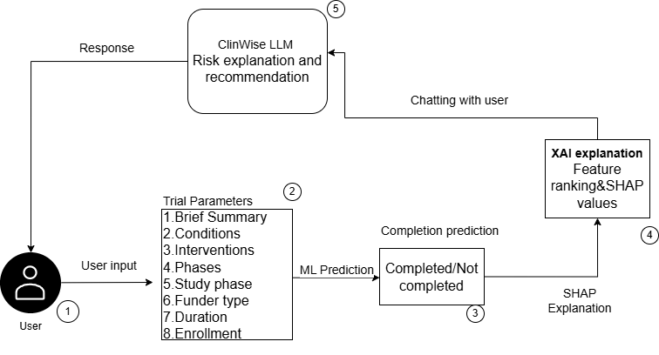
Fig 3.1 Workflow of the proposed Framework
The overall architecture of the proposed framework is illustrated in Figure 1, which presents a high-level representation of the end-to-end pipeline. As shown in figure 3.1 the workflow begins with the user interacting by using the chatbot interface which collects trial related inputs and sends them to the prediction engine. Many series of steps such as preprocessing, feature transformation, and applying of trained machine learning models was used by prediction engine to handle input data and to generate predictions regarding the trial completion. These results obtained in previous steps were passed to an explainability module that finds the contribution of each feature for the prediction.Atlast the system present the output in a natural language format that is understandable by the user.
The flow starts by collecting data from public registries, which was later filtered to include only relevant entries. Standardization on data was done by encoding categorical variables and changing it into a structured format suitable for machine learning models. Trial feasibility and operational risks was reflected after applying domain specific feature engineering techniques. These features includes indicators such as sponsor reliability, phase related metrics that was adjusted for finding the duration and some risk related insights derived from textual trial descriptions. Predictive models were trained on unified dataset that was done by combining both structures and textual data. The performance of these trained models is evaluated using by a method called stratified validation techniques and the best performing one is selected based on the objective evaluation metrics. Clear reasoning behind the model’s predictions was derived by combining it with explainability module. This framework helps stakeholders in assessing the potential risks before starting a trial and supports for a better decision making to plan and improve clinical studies.
3.3 Dataset Description
The clinical trial data was obtained from a public government website that contained both structured and unstructured attributes that revealed the individual feature importance . It had metadata related to study design, participant details, sponsor information, study status, and textual descriptions of study objectives and outcomes. Key attributes are trial identifiers, brief summaries, medical conditions, interventions, enrollment size, study phase, study type, sponsor details, and start and completion dates. The original dataset had 257,577 clinical trial records with 32 attributes. The main categories of attributes used in the study are shown in Table 3.1:

Table 3.1 Attributes used in ClinWise
Category | Example Columns
Identifiers | NCT Number
Text | Brief Summary, Conditions, Interventions
Categorical | Phase, Study Type, Sex
Numeric | Enrollment, Duration
Dates | Start Date, Completion Date
Target | Study Status
Preprocessing steps were applied to make it suitable for machine learning. Some columns such as identifiers, URLs, and administrative metadata were removed as they were non-informative. Numerical attributes such as enrollment size were converted to numeric format, and missing values were handled using median values to reduce the effect of outliers.Trial duration was derived by converting into datetime format. Target feature was created by treating Completed trials as positive class and other values such as suspended,terminated and withdrawn as negative class.Industry funded trials were filtered to ensure consistency. After preprocessing, the final dataset contained 73,019 samples with 26 predictive features.

3.4 Feature Engineering and Representation
Feature engineering was applied to derive some useful features to capture clinical and operational patterns that are not directly available from raw attributes.
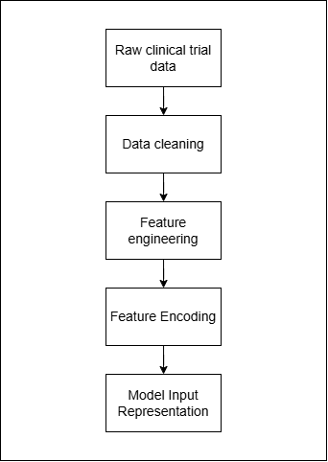
Fig 3.2 Feature engineering and representation pipeline
Firstly data cleaning and preprocessing were performed to remove irrelevant columns and handle missing values. After preprocessing, some new features were derived to represent key characteristics of clinical trials.Trial duration was derived by finding the difference between start and end date to know about the entire duration taken for conduction of trial. Phase information was extracted to understand the trial stage as different phases may vary in duration.Sponsor success rate feature was derived to know about the historical pattern of sponsors as they influence the completion . A risk score was generated using keyword analysis of trial summaries to get insights from textual descriptions to identify potential indicators such as recruitment challenges, delays, or safety concerns.The overall feature engineering and representation pipeline used in the system is illustrated in Figure 2. Categorical attributes such as study phase and study type were transformed using one-hot encoding. Numerical attributes, including enrollment size and duration-related features, were normalized using standard scaling to ensure consistent ranges. Using TF-IDF vectorization textual data from fields such as trial summaries, conditions, and interventions were converted into numerical representations that capture important textual patterns relevant to clinical trial outcomes.
Finally,encoded categorical variables, scaled numerical attributes, and TF IDF text representations were combined into a unified model input representation. This combined feature matrix is used as the input for machine learning models to predict the likelihood of clinical trial completion.
Derived optional features
Numerical features were used to depict feasibility aspects and the complexity of performing the trials. The duration feature was generated based on the computation of the difference between the completion date and start date of the trial, which gives the total number of days taken to complete a study. In order to standardize duration with respect to the phase, an adjusted duration feature was generated from the division of the trial's duration by its phase. This makes it possible to compare the trials that have been performed during various phases without considering the expected variances between these trials due to different phases. The other numerical feature included sponsor reliability, in which success rate scores were derived by computing the percentage of completed trials for all sponsors.

Text based risk indicators
Unstructured textual features capture important context information about the design of the study, problems that may arise, and possible risks associated with the clinical trial. In order to utilize the information contained in the unstructured textual field, the feature 'Risk Score' was engineered through an analysis of keywords present in the summary text of trials. The keywords were chosen based on their relevance to the various risk factors such as possible delays, safety issues, difficulties with patient recruitment, and premature termination of the study. The total number of occurrences for each of these risk factors was captured and then normalized to create the risk score.
Multimodal Feature Representation
The final representation used for prediction purposes included all four types of features, which were combined into a single feature space. First of all, to enable the use of categorical attributes such as trial phase, study type, demographic criteria, and study design in machine learning algorithms, categorical vectors were generated with the use of one-hot encoding. To allow for consistent scaling among all attributes, continuous variables – enrolment, duration-related measures, and engineered numeric features were standardized. Moreover, the TF–IDF vectorization technique was applied to transform text-based features into vectors. Namely, unigrams and bigrams were extracted from textual data, including trial descriptions, conditions, interventions, and outcome descriptions.
All the vectors representing the above features were then concatenated to obtain a single sparse matrix representation of each trial. The feature engineering process was conducted based on domain knowledge and empirical studies demonstrating the importance of specific features (such as the type of trial sponsor, enrolment, and trial phase) for predicting the trial outcome. Thus, the proposed feature representation allows capturing not only numeric values but also important semantic attributes of clinical trials, facilitating accurate predictions and explanation of results.
3.5 Model Development and Selection
In order to find the most effective model, several ml models were trained on the same dataset and evaluated. Models such as Logistic Regression, Random Forest, XGBoost, and LightGBM which are mostly commonly used for classification tasks on structured data were selected for comparison purpose. Training and testing datasets were created and applied to models using stratified sampling to maintain class balance.Performance was analysed using three different train test split ratios such as 90:10, 80:20 and 70:30. Evaluation of the selected models were done using standard metrics such as accuracy, precision, recall, F1-score and ROC AUC . A 5 fold stratified cross validation technique was used for training the model where for each iteration four folds was used for training and one fold was used for validation. The final performance was calculated by taking average of the results across all folds.
The results showed that ensemble based boosting models performed better than traditional linear models. XGBoost delivered the best performance with the 80:20 split, while LightGBM also demonstrated strong and competitive results, particularly with the 70:30 split. These results indicate that gradient boosting models are effective in capturing complex feature interactions within clinical trial data.

3.6 Explainability Module
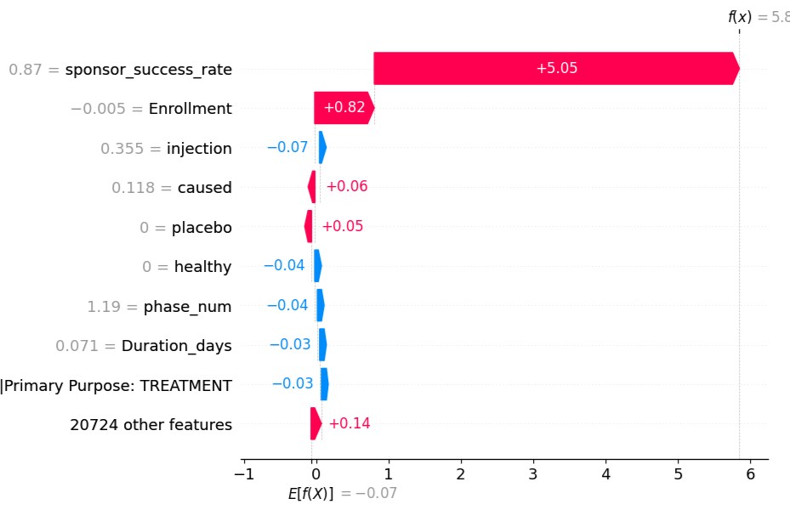
For transparency and interpretability of the prediction model, the proposed system uses an Explainability Module using SHAPley Additive explanations (SHAP). SHAP is an explainable technique which determines the contribution of each feature that influences prediction.This approach helps users understand how different features influence the prediction of clinical trial completion.

Figure 3.3 SHAP Waterfall Plot Showing Feature Contribution for a Single Clinical Trial Prediction
Figure 3.3 shows a local explanation for an individual prediction. As shown in the figure, each feature contributes either positively or negatively to the final prediction value.Features highlighted in red increase the probability of the predicted outcome, while features in blue decrease it. In this figure,the sponsor success rate has the highest positive contribution toward the prediction, showing that trials sponsored by organizations with a strong historical completion record are more easily completed. Similarly, enrollment size also contributes positively, while other features such as phase number, duration, and certain textual indicators show smaller influences on the prediction. This type of explanation helps identify the most influential factors affecting the trial outcome.
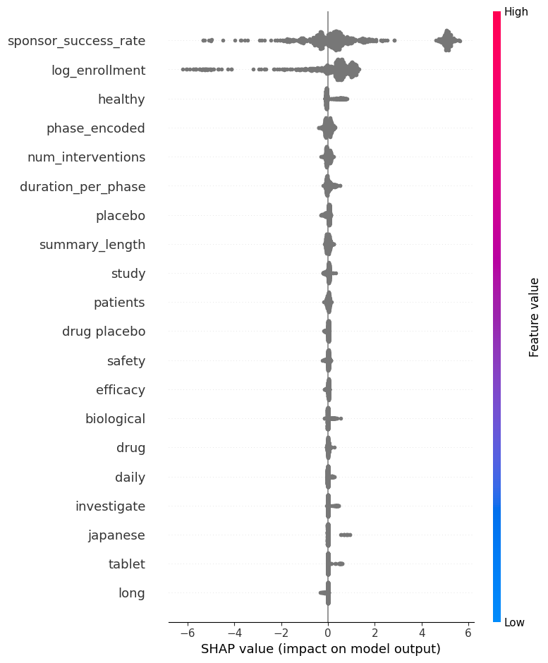

Figure 3.4 SHAP Summary Plot Showing Global Feature Importance for Clinical Trial Completion Prediction
Figure 3.4 represents a SHAP summary plot, which shows the overall importance of features across the entire dataset. Each point in the plot represents a feature value for a particular trial, and the horizontal axis shows the SHAP value indicating the impact on the model output. Features are ranked based on their overall influence on the prediction. From the figure, it can be seen that sponsor success rate and log enrollment are the most important features affecting the prediction of clinical trial completion.Some other factors such as the trial phase, number of interventions, duration of each phase and textual features derived from trial summaries has a major role in influencing model outcome.
In the summary plot shown above, the color gradient can be used to indicate the magnitude of feature values where red represents higher values while blue indicates lower values. So by visual representation it is easier to understand how variations done in feature values severely impact the model’s predictions. Transparency and interpretability is improved by using the SHAP into the system.It helps the researchers in identifying the key factors influencing the prediction that helps in trial planning and decision making.

3.7 Deployment Interface
In order to facilitate its practical use, the model is implemented via an interactive chatbot interface. The interface has been designed to make the process of entering clinical trial information straightforward for the users by providing both structured entry fields and textual information. The chatbot prompts the user to provide all required inputs, including the phase of the trial, number of enrollees, type of sponsors, and information about summary.

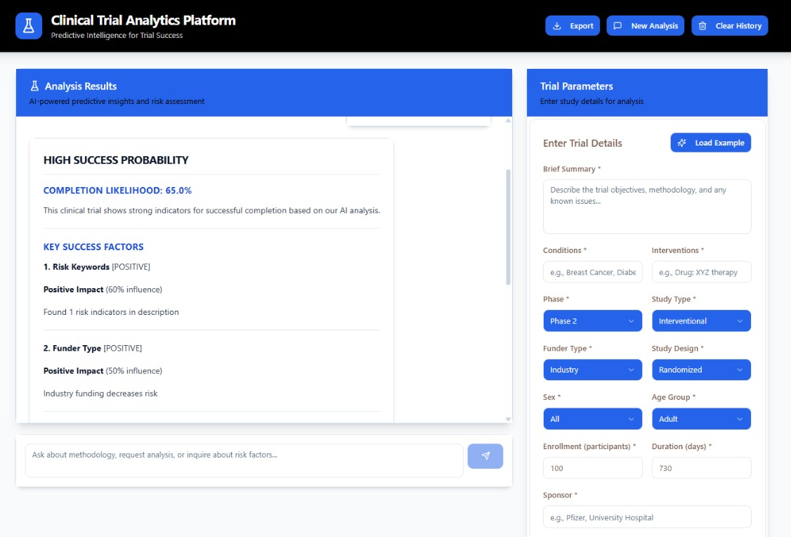
Figure 3.5 User interface of ClinWise
Besides the predictions, the system also offers SHAP explanations which reveal the top feature importance scores responsible for the predictions. This ensures that the user gains insight into the process of making the prediction and not just looking at its results. By combining the user's input, the prediction process, and the explanation all together in one flow, the interface serves as a good decision support system for scientists involved in planning and managing clinical trials.
The interface for the ClinWise system can be seen in Figure 3.5. The interface for the ClinWise system is created in the form of a chatbot. The chatbot interface takes inputs from users in structured formats, such as trial phase, enrollment, and sponsors, as well as descriptive texts regarding the trial being analyzed. Once the inputs are provided by the user, they are processed in the back end of the system, and a result is obtained, along with a probability score. Additionally, SHAP explanations are also shown through the chatbot interface, showing the important features used in the predictions.
3.5 System Requirements
Streamlit
Streamlit is employed for constructing the frontend of the ClinWise platform. The framework creates an easy-to-use interface for the end-users. Using Streamlit, the users can enter the information about the clinical trials in the form of text and numbers, like the phase of the study, patient sample size, and description. Streamlit offers a variety of interactive UI components such as text input, selection boxes, sliders, and output graphs. Moreover, Streamlit provides seamless communication between the frontend and backend components, ensuring instant results of predictions, probabilities, and explanations of the output
FastAPI
FastAPI is used for handling communications between the user interface and machine learning algorithms through backend architecture. FastAPI performs well when handling API requests because it takes input data from the frontend, cleans and transforms the data, and applies feature engineering on the same before passing the data to the machine learning algorithms to make predictions. FastAPI was selected due to its high level of performance, scalability, and capacity for processing asynchronous requests.

Machine Learning Requirements
Multiple machine learning techniques have been utilized to predict the clinical trial completion status, such as Logistic Regression, Random Forest, XGBoost, and LightGBM. The selection of these methods is made on purpose to evaluate the efficacy of different machine learning models, including those that operate based on linear and ensemble methods. The TF-IDF method is used for processing text information, transforming it from textual to numerical form. Furthermore, the SHAP (SHapley Additive Explanations) approach is incorporated into the system to improve the interpretability of the machine learning technique results.
Hardware Requirements
A processor of Intel i5 or above needs to be provided in order to have efficient process execution and efficient computing. It is important to note that at least 8 GB of RAM will be required in order to efficiently conduct data preprocessing, training the model and prediction. It is important to note that the application works on various operating systems such as Windows, Linux, and macOS. The implementation is done via Python through libraries which include Scikit-learn, used for model creation; Pandas and Numpy for efficient data manipulation; and SHAP for model explainability.

CHAPTER 4
RESULTS AND ANALYSIS

The classification models that were used in this study are XGBoost, LightGBM, Random Forest and Logistic Regression.These models were selected since they perform well on both organized and unstructured data.The model performance was tested under different scenarios by using three train-test splits, 70:30, 80:20 and 90:10.The result for XGBoost shows the best score, with a ROC-AUC of 92% and accuracy of 91% for the 80:20 split, logistic regression gave the worst result because it failed to detect complex patterns of the data and LightGBM and Random Forest gave good results but struggled with unbalanced data.
LightGBM also was the best performer with regard to accuracy and ROC-AUC across both models under the 70:30 division whereas XGBoost had similar but slightly inferior performance compared to LightGBM; Random Forest was a mediocre performer, and as before Logistic Regression did the worst of all. However when observing the 90:10 split, a decrease was noticed in accuracy and ROC-AUC, though performance was still generally better across all models. The best performer under the 90:10 division was once again XGBoost with an accuracy and ROC-AUC of 0.92, while LightGBM was again a mediocre performer along with Random Forest, and Logistic Regression was again the worst performing model.

The XGBoost has always presented good performance in the 80:20 and 90:10 splits, particularly in the cases where a greater volume of data is available for training, whereas in the 70:30 split the LightGBM achieved the highest values for the considered performance metrics, in the comparison among all splits. Ensemble boosting algorithms are good for modeling complex feature interactions and non-linear relations of the clinical trial data; consequently, linear and bagging methods are generally outperformed by these algorithms. The XGBoost was chosen as the best model due to its consistency, ability to handle heterogeneous data types and class imbalance and to generate SHAP values for model interpretation. The cross-validation scores are considered for the final model choice to ensure model generalization although better performance is reached with the 90:10 split.
Table 4.1 Results for 80:20 Train–Test Split

Model | Accuracy | Precision | Recall | F1 Score | ROC-AUC
Logistic regression | 0.84 | 0.83 | 0.82 | 0.82 | 0.86
Random Forest | 0.88 | 0.87 | 0.86 | 0.86 | 0.89
XGBoost | 0.91 | 0.91 | 0.90 | 0.90 | 0.92
LightGBM | 0.89 | 0.89 | 0.87 | 0.87 | 0.91

Table 4.1 contains the performance results obtained by the models used when using an 80:20 train-test split. XGBoost performed the best out of all the other models used for all evaluation measurements, proving its highly predictable capabilities. LightGBM and Random Forest also provided good results though at a slightly lower prediction capability to XGBoost. Logistic regression had the worst results proving that the complex relationships are not easily modeled by a linear model.

Table 4.2 Results for 70:30 Train Test Split
Model | Accuracy | Precision | Recall | F1 Score | ROC-AUC
Logistic regression | 0.82 | 0.81 | 0.80 | 0.80 | 0.84
Random Forest | 0.87 | 0.86 | 0.85 | 0.85 | 0.88
XGBoost | 0.89 | 0.88 | 0.87 | 0.87 | 0.90
LightGBM | 0.90 | 0.89 | 0.89 | 0.89 | 0.91

Table 4.2 presents the model performance for the 70:30 split. LightGBM gave the best result, with higher values of accuracy and ROC-AUC values than any of the other models. XGBoost performed well, but did not equal the performance of LightGBM. Logistic Regression was once again somewhat unreliable, but the performance of Random Forest remains moderate.

Table 4.3 Results for 90:10 Train–Test Split
Model | Accuracy | Precision | Recall | F1 Score | ROC-AUC
Logistic regression | 0.85 | 0.84 | 0.83 | 0.83 | 0.87
Random Forest | 0.89 | 0.88 | 0.87 | 0.87 | 0.90
XGBoost | 0.92 | 0.91 | 0.91 | 0.91 | 0.92
LightGBM | 0.91 | 0.90 | 0.90 | 0.90 | 0.92

Table 4.5 Comparison of Best Models for 80:20 and 70:30 Train–Test Splits
Split | Best Model | Accuracy | F1 | ROC-AUC
80:20 | XGBoost | 0.91 | 0.90 | 0.92
70:30 | LightGBM | 0.90 | 0.89 | 0.91
90:10 | XGBoost | 0.92 | 0.91 | 0.92

The evaluated models' performance employing a 90:10 train–test split is shown in Table 4.3. It is evident that most models perform better when the percentage of training data is increased. The best-performing model in this setup was XGBoost, which had the highest accuracy, precision, recall, F1-score, and ROC-AUC. Similar outcomes were also displayed by LightGBM, which closely trailed XGBoost on every statistic. While Logistic Regression had the lowest scores, suggesting its weak capacity to manage complicated feature interactions in the dataset, Random Forest showed steady and consistent performance.
In Table 4.5, the best models are compared over different data split values. From the data, it is observed that the LightGBM performed the best at 70:30 split, which indicates its good generalization performance. Whereas the XGBoost provided consistent performance over the different split values. XGBoost delivered the top performance at 80:20 and 90:10 split, as it had a higher consistent performance when trained with larger data. Hence, it is inferred that boosting models performed better for this task, and XGBoost is the most consistent.

CHAPTER 5
CONCLUSIONS AND FUTURE ENHANCEMENTS
5.1 Conclusions
Clinical trials can fail and cause high risk of delays often as they are complex to execute and involve several factors. This project overcomes these drawbacks by using machine learning framework and prediction engine.It combines both structured and unstructured data to generate predictions and provide explanations along with recommendations providing insights into the underlying factors.
The system is made more user friendly by providing the output in simple and natural language format.Therefore this system helps in proactive clinical trial planning and design thereby minimizing potential errors and wastage of resources.
5.2 Future Enhancements
Additional intelligent features can be used to improve Clinwise to enhance both usability and the prediction performance. One improvement that can be made is the integration of voice based interaction that allows users to use speech to input trial details rather than text so that it makes the system more user-friendly and accessible. Features to store past prediction info in memory can be added so that it can be used to provide more personalized insights based on that previous interactions and chats.
Another possible thing to do is to predict operational delays in clinical trial such as delays in participant enrollment or extensions in timelines as addition. This could help the researchers identify potential risks at an early stage and take preventive measures early itself. Furthermore we can try integrating real-time data retrieval from ClinicalTrials.gov using APIs so that the system can work with the up to date information.All these could help clinical trial decision support system as more useful and planning system that researchers can use to plan risk and design.
Clinical trials are used in medical research and in development of drugs. Numerous scientific studies are performed to assess the safety, efficacy, and functionality of new medications, medical devices, behavioural therapies, and treatment methods. These studies assist in decision-making for the formulation of clinical guidelines and ensuring patient safety. Before any new drug is made available to the public, it must pass through multiple testing phases. These trials need to be conducted successfully as they decide whether treatments reach patients, which ultimately supports progress in medical research and development. Traditionally, clinical trials occur in four phases, each aimed at assessing safety, dosage, effectiveness, and long-term outcomes in wider clinical settings.

APPENDICES
APPENDIX A
RAW EXPERIMENTAL DATA
The dataset used in this work include structured and unstructured features retrieved from a publicly available clinical trial registry. Features include identifiers (NCT number), text (brief summary, conditions, interventions), categorical features (phase, type of study, type of sponsor) , numerical features (enrollment, duration) and target variable (status of study). After preprocessing 73,019 records were created, which contains 26 features and has 26 useful attributes.

Attribute | Description
NCT number | Unique identification code for each clinical study registered at ClinicalTrials.gov. Format: "NCT" followed by an 8-digit number (e.g., NCT00000419).
Study Title | Title of the clinical trial.
Study URL | Link to access the trial details.
Acronym | Short name/initials of the study (if available), e.g., WHI.
Study status | Current status of the study (e.g., Not yet recruiting, Recruiting, Active, Completed, Terminated, etc.).
Brief summary | Short description of the study purpose.
Study results | Summary results including participant flow, baseline data, outcomes, and adverse events.
Conditions/disease | Disease or condition being studied.
Interventions/treatment | Treatment or process being tested (drug, device, procedure, etc.).
Primary outcome measure | Main outcome used to evaluate the treatment’s effectiveness.
Secondary outcome measure | Additional outcomes of interest besides the primary measure.
Other outcome measure | Any additional outcome metrics.
Sponsor | Organization/person responsible for conducting the study.
Collaborator | Supporting organizations involved in funding or execution.
Sex | Eligibility based on sex (All, Male, Female).
Age or age group | Eligible age range (Child, Adult, Older Adult).
Phase | Stage of the clinical trial (Early Phase 1 to Phase 4 or Not Applicable).
Enrollment | Number of participants in the study (actual or estimated).
Funder type | Type of funding organization (NIH, Federal agencies, Industry, Others).
Study type | Type of study (Interventional, Observational, Expanded Access).
Study design | Methodology and structure of the study.
Other IDs | Additional identifiers for the study.
Start date | Date when the first participant was enrolled
Completion date | Final date when all study data collection ended.
First posted | Date when the study was first published on ClinicalTrials.gov.
Results first posted | Date when study results were first published.
Last update posted | Most recent update date of the study record.
Location | Study site or facility location.
Study documents | Documents like protocol, analysis plan, and consent forms.

APPENDIX B
The machine learning models used in this study include Logistic Regression, Random Forest, XGBoost, and LightGBM. The models were trained using stratified sampling with train–test splits of 70:30, 80:20, and 90:10. Evaluation metrics include accuracy, precision, recall, F1-score, and ROC-AUC. A 5-fold cross-validation technique was also applied to ensure model robustness.

CODE SNIPPETS
1. Data Loading and Cleaning
df = pd.read_csv("/content/drive/MyDrive/Final year/usecase_3_.csv")

drop_cols = ['Unnamed: 0.1', 'Unnamed: 0', 'NCT Number']
df.drop(columns=[c for c in drop_cols if c in df.columns], inplace=True, errors='ignore')
df.columns = df.columns.str.strip()
df['Enrollment'] = pd.to_numeric(df['Enrollment'], errors='coerce')
df['Enrollment'] = df['Enrollment'].fillna(df['Enrollment'].median())
Target Variable Creation
def map_status(x):
if str(x).upper() == 'COMPLETED':
return 1
else:
return 0

df['target'] = df['Study Status'].apply(map_status)
df = df.dropna(subset=['target'])

2.Text Preprocessing

def clean_text(text):
text = str(text).lower()
text = re.sub(r'[^a-z0-9\s]', ' ', text)
return re.sub(r'\s+', ' ', text).strip()

df['text_data'] = (
df['Brief Summary'] + ' ' +
df['Conditions'] + ' ' +
df['Interventions']
).apply(clean_text)

3.Exploratory Data Analysis

# Target Distribution
fig, axes = plt.subplots(1, 2, figsize=(14, 5))

# Bar Plot
df['target'].value_counts().plot(kind='bar', ax=axes[0])
axes[0].set_title('Trial Completion Status')
axes[0].set_xlabel('Status')
axes[0].set_ylabel('Count')
axes[0].set_xticklabels(['Completed', 'Not Completed'], rotation=0)

# Pie Chart
df['target'].value_counts().plot(
kind='pie',
ax=axes[1],
autopct='%1.1f%%',
labels=['Not Completed', 'Completed']
)
axes[1].set_title('Class Distribution')

plt.tight_layout()
plt.show()
# Numerical Feature Analysis
numeric_features = ['Enrollment', 'Duration_days']

for feature in numeric_features:
plt.figure(figsize=(6, 4))
df.boxplot(column=feature, by='target')
plt.title(f'{feature} vs Trial Status')
plt.xlabel('Target')
plt.ylabel(feature)
plt.show()
4.Feature Engineering

risk_words = ['terminated', 'withdrawn', 'delay']
def compute_risk_score(text):
return len([word for word in risk_words if word in str(text).lower()])

df['risk_score'] = df['Brief Summary'].apply(compute_risk_score)

df['phase_num'] = df['Phases'].str.extract('(\d+)').fillna(0).astype(int)
df['duration_per_phase'] = df['Duration_days'] / df['phase_num'].replace(0, 1)

5.Feature Transformation

enc = OneHotEncoder(handle_unknown='ignore')
X_cat = enc.fit_transform(df[categorical_cols])
scaler = StandardScaler()
X_num = scaler.fit_transform(df[numeric_cols])
tfidf = TfidfVectorizer(max_features=20000)
X_text = tfidf.fit_transform(df['text_data'])
6.Model Training

lr_model = LogisticRegression(max_iter=1000)
rf_model = RandomForestClassifier(n_estimators=200)
xgb_model = XGBClassifier(eval_metric='logloss')
lgbm_model = LGBMClassifier()
lr_model.fit(X_train, y_train)
rf_model.fit(X_train, y_train)
xgb_model.fit(X_train, y_train)
lgbm_model.fit(X_train, y_train)
7.Model Evaluation

accuracy = accuracy_score(y_test, y_pred)
roc_auc = roc_auc_score(y_test, y_proba)
print("Accuracy:", accuracy)
print("ROC-AUC:", roc_auc)
8.SHAP Explainability

explainer = shap.TreeExplainer(xgb_model)
shap_values = explainer.shap_values(X_test[:100])
shap.summary_plot(shap_values, X_test)
9.Prediction Function

def predict_trial(sample):
X = preprocess(sample)
pred = xgb_model.predict(X)
prob = xgb_model.predict_proba(X)[0][1]
return pred, prob

REFERENCES

[1] Kavalci E, and Hartshorn A, “Improving clinical trial design using interpretable machine learning based prediction of early trial termination,” Scientific Reports, vol. 13, p. 121, 2023, 10.1038/s41598-023-27416-7.
[2] Teodoro D, Naderi N, Yazdani A, et al., “A scoping review of artificial intelligence applications in clinical trial risk assessment,” Digital Medicine, vol. 8, p. 486, 2025, 10.1038/s41746-025-01886-7.
[3] Fu T, Huang K, Xiao C, Glass L M, and Sun J, “HINT: Hierarchical interaction network for clinical-trial-outcome predictions,” Patterns, vol. 3, no. 4, 2022, 100445, 10.1016/j.patter.2022.100445
[4] Wang S, Šuster S, Baldwin T, and Verspoor K, “Predicting Publication of Clinical Trials Using Structured and Unstructured Data: Model Development and Validation Study,” Journal of Medical Internet Research, vol. 24, no. 12, e38859, 2022
[5] Wang Y, Fu T, Xu Y, Ma Z, Xu H, Du B, Lu Y, Gao H, Wu J, and Chen J, “TWIN-GPT: Digital Twins for Clinical Trials via Large Language Model,” ACM Transactions on Multimedia Computing, Communications, and Applications, 2024, 10.1145/3674838.
[6] Wang Z, Xiao C, and Sun J, “SPOT: Sequential Predictive Modeling of Clinical Trial Outcome with Meta-Learning,” Proceedings of ACM BCB ’23, Article 53, pp. 1–11, 2023, 10.1145/3584371.3613001.
[7] Markey N, Howitt B, El-Mansouri I, et al., “Clinical trials are becoming more complex: a machine learning analysis of data from over 16,000 trials,” Scientific Reports, vol. 14, 3514, 2024, 10.1038/s41598-024-53211-z.
[8] Chen D, Cao C, Kloosterman R, Parsa R, and Raman S, “Trial Factors Associated With Completion of Clinical Trials Evaluating AI: Retrospective Case-Control Study,” Journal of Medical Internet Research, vol. 26, e58578, 2024, 10.2196/58578.
[9].Chen J, Hu Y, Cai M, et al., “TrialBench: Multi-Modal AI-Ready Datasets for Clinical Trial Prediction,” Scientific Data, vol. 12, 1564, 2025, 10.1038/s41597-025-05680-8.
[10] Cho J, Xu Q, Wong C H, and Lo A W, “Predicting clinical trial duration via statistical and machine learning models,” Contemporary Clinical Trials Communications, vol. 45, 101473, 2025, 10.1016/j.conctc.2025.101473.
[11] Zhang S, et al., “Enrollment Success, Factors, and Prediction Models in Cancer Trials (2008–2019),” JCO Oncology Practice, vol. 19, pp. 1058–1068, 2023, 10.1200/OP.23.00147
[12] Aliper A, Kudrin R, Polykovskiy D, et al., “Prediction of Clinical Trials Outcomes Based on Target Choice and Clinical Trial Design with Multi-Modal Artificial Intelligence,” Clinical Pharmacology & Therapeutics, vol. 114, pp. 972–980, 2023, 10.1002/cpt.3008.
[13] Long B, Lai S-W, Wu J, and Bellur S, “Predicting Phase 1 Lymphoma Clinical Trial Durations Using Machine Learning,” Clinical Practice, vol. 14, pp. 69–88, 2024, 10.3390/clinpract14010007.
[14] Hulstaert L, Twick I, Sarsour K, and Verstraete H, “Enhancing site selection strategies in clinical trial recruitment using real-world data modeling,” PLoS ONE, vol. 19, no. 3, e0300109, 2024, 10.1371/journal.pone.0300109.
[15] Lu Y, Chen T, Hao N, Van Rechem C, Chen J, and Fu T, “Uncertainty Quantification and Interpretability for Clinical Trial Approval Prediction,” Health Data Science, vol. 4, 0126, 2024, 10.34133/hds.0126.
[16] Lin A, Wang Z, Jiang A, et al., “Large language models in clinical trials: applications, technical advances, and future directions,” BMC Medicine, vol. 23, 563, 2025, 10.1186/s12916-025-04348-9.
[17] Lu X, Yang C, Liang L, Hu G, Zhong Z, and Jiang Z, “Artificial intelligence for optimizing recruitment and retention in clinical trials: a scoping review,” Journal of the American Medical Informatics Association, vol. 31, no. 11, pp. 2749–2759, 2024, 10.1093/jamia/ocae243.
[18] Olawade D B, Fidelis S C, Marinze S, Egbon E, Osunmakinde A, and Osborne A, “Artificial intelligence in clinical trials: A comprehensive review of opportunities, challenges, and future directions,” International Journal of Medical Informatics, vol. 206, 106141, 2026, 10.1016/j.ijmedinf.2025.106141.
[19] Murali V, König C, Nair M, et al., “Predicting clinical trial outcomes using drug bioactivities through graph database integration and machine learning,” Chemical Biology & Drug Design, vol. 100, pp. 169–184, 2022, 10.1111/cbdd.14092
[20]Yue L, Xing S, Chen J, and Fu T, “TrialEnroll: Predicting Clinical Trial Enrollment Success with Deep & Cross Network and Large Language Models,” Proceedings of ACM BCB ’24, Article 43, pp. 1–9, 2024, 10.1145/3698587.3701375.
[21] Anuyah S, Singh M, and Nyavor H, “Advancing clinical trial outcomes using deep learning and predictive modelling,” World Journal of Advanced Research and Reviews, vol. 24, 2024, 10.30574/wjarr.2024.24.3.3671.

