Virtual Reality based Exposure Therapy with Biofeedback

- INTRODUCTION
A. INTRODUCTION TO ANXIETY DISORDERS
Anxiety disorders represent a widespread mental health challenge affecting individuals worldwide. Anxiety disorder is a mental health condition characterized by excessive worry, fear, or unease about everyday situations. It involves persistent and uncontrollable feelings of anxiety. Symptoms can vary but often include restlessness, fatigue, difficulty concentrating, irritability, muscle tension, and sleep disturbances.
Anxiety disorders affect a substantial portion of the global population, with approximately 4% of people worldwide currently experiencing one. This prevalence underscores the widespread nature of anxiety disorders, making them the most common mental health conditions globally as of 2019, affecting an estimated 301 million individuals.
Despite the availability of highly effective treatments for anxiety disorders, such as cognitive-behavioral therapy (CBT) and medication, a significant treatment gap exists. Only about 1 in 4 people who need treatment for anxiety disorders actually receive it, amounting to approximately 27.6% of those affected. This treatment gap highlights a critical issue in mental health care accessibility and underscores the need for improved awareness, resources, and support systems.
The consequences of untreated anxiety disorders can be profound and multifaceted. These disorders can severely impair daily functioning, affecting an individual's ability to concentrate, perform tasks effectively, and maintain stable employment or academic progress. Relationships may also be strained, as anxiety can lead to withdrawal, irritability, or difficulty in social interactions.
Moreover, anxiety disorders can diminish overall quality of life significantly. Persistent worry, fear, or panic attacks can undermine a person's sense of well-being and enjoyment of life's activities. Physical health can also be affected, as chronic anxiety can contribute to cardiovascular problems, digestive issues, and other stress-related ailments.
Anxiety disorders are one of the most common mental health conditions affecting college students. Fear of heights or confined spaces can lead to difficulty concentrating during lectures or exams, impacting academic focus and performance. Students avoid classes held in tall buildings or cramped spaces, affecting their attendance and engagement.
Students with these phobias avoid attending classes or participating in activities that involve heights such as labs or studios in tall buildings or confined spaces such as small seminar rooms or crowded lecture halls.
Anxiety symptoms like panic attacks, sweating, trembling, or shortness of breath can manifest in situations involving heights or confined spaces, impacting physical well-being and overall comfort of the college students.
Studies show that up to 37% of college students report experiencing anxiety disorders. In order to understand the level of anxiety disorders a quick survey was taken and the result of the survey among 500 college students is as shown in the figure 1.1.
Fear of Heights Fear of Confined Spaces
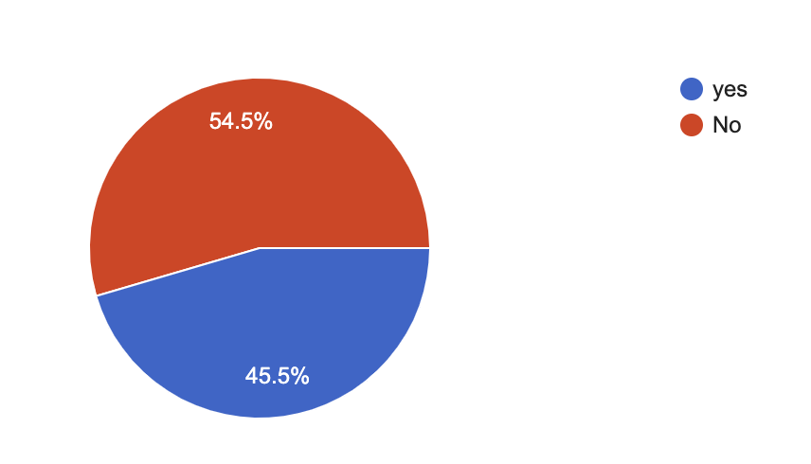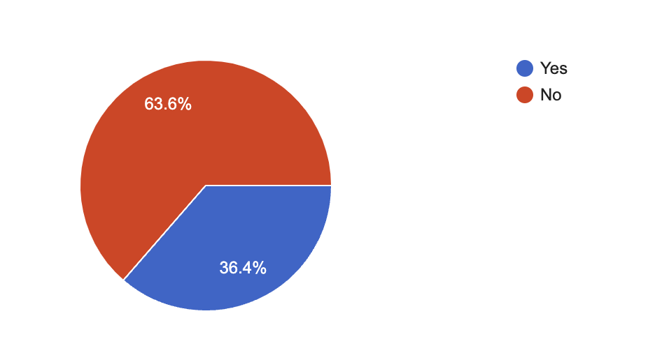Figure 1.1: Survey comparison of anxiety disorders
The survey shows 45.5% have the fear of heights and 36.4% have the fear of confined spaces among 500 users
B. ANXIETY DISORDER TREATMENT
Existing anxiety disorder treatment methods, like exposure therapy, have limitations in creating realistic and customizable therapy environments. To address this, the project seeks to develop a VR application that combines 3D modeling, animation, and VR device integration. The hardware infrastructure of the system consists of carefully selected VR headsets, chosen for their compatibility with Unity and Maya, ensuring smooth integration and optimal performance. These high-quality VR headsets deliver an immersive and engaging experience, enhancing the effectiveness of therapy sessions. Additionally, hardware components such as Node MCU are designed for durability and reliability, providing users with a seamless experience throughout their sessions.

On the software side, the system leverages Unity, a powerful game development platform, for virtual environment creation. Unity's rich set of tools enables developers to design and build immersive, interactive scenarios that closely mimic real-life situations, thereby enhancing exposure therapy. The platform's cross-platform support ensures accessibility across various devices, expanding its reach to a wider audience.

This VR application aims to improve therapy by offering immersive, customizable, and privacy-conscious sessions while enabling data collection to advance our understanding of effective therapeutic approaches for anxiety disorders. By integrating 3D modeling, animation, and VR technology, the goal is to enhance anxiety disorder treatment, providing therapists with a tool that can create tailored environments to effectively address individual needs and optimize therapeutic outcomes.

C. EQUIPPING MENTAL HEALTH PROFESSIONALS
Expanding on the significance of the tools provided to mental health professionals by the VR application for data collection and progress tracking, it's essential to highlight their multifaceted utility in refining treatment strategies, optimizing outcomes, and fostering a more evidence-based approach to anxiety disorder therapy. Firstly, these tools serve as invaluable aids in refining treatment strategies. By systematically collecting data on patient responses and progress throughout therapy sessions, mental health professionals gain deeper insights into the effectiveness of various interventions. This data-driven approach allows therapists to adapt and tailor treatment plans in real-time, addressing individual patient needs more effectively. For example, if certain exposure scenarios consistently elicit heightened anxiety responses in a particular patient, therapists can adjust the intensity or pacing of exposure accordingly to ensure optimal therapeutic outcomes.
D. VR TECHNOLOGY
Recognizing VR as a Game-Changer in Mental Health - Virtual Reality (VR) technology emerges as a transformative tool in mental health treatment. Its immersive capabilities hold the promise of revolutionizing conventional approaches to anxiety disorders, offering new possibilities for personalized and engaging therapeutic experiences. This section delves into the unique advantages VR brings to the table and its potential to overcome challenges prevalent in traditional anxiety treatment modalities. One of the key strengths of VR lies in its ability to create highly realistic and immersive environments that can simulate anxiety- inducing situations in a controlled and safe manner. Unlike traditional exposure therapy, which relies on imagination or static stimuli, VR can provide dynamic and interactive scenarios tailored to individual patient needs. This dynamic nature enables therapists to gradually expose patients to anxiety triggers while closely monitoring their reactions and adjusting the intensity of exposure accordingly.
Moreover, VR therapy offers a level of customization not feasible with traditional methods. Therapists can tailor virtual environments to match specific phobias or triggers, allowing for a more targeted and effective treatment approach. For example, a patient with a fear of heights can undergo exposure therapy in a virtual skyscraper, gradually acclimating to increasing heights under the guidance of a therapist.

II. LITERATURE SURVEY
Klinger.'s study, published in the Journal of Behavior Therapy and Experimental Psychiatry in 2005, explores the application of virtual reality in treating generalized social phobia. Focused on specific anxiety disorders, the research delves into the nuances of utilizing virtual reality as a therapeutic tool [1]. By concentrating on social phobia, the study provides a specialized perspective on the potential efficacy of virtual reality interventions for this anxiety-related condition. The findings contribute to the evolving field of mental health treatment by emphasizing the tailored use of virtual reality in addressing specific anxiety disorders.
Parsons and Rizzo's research, featured in the Journal of Anxiety, Stress & Coping in 2008, critically evaluates the quality of research surrounding Virtual Reality Exposure Therapy (VRET) for anxiety disorders. This evaluation encompasses methodological rigor, outcome measures, and overall research quality, providing a nuanced perspective on the state of the field [2]. By focusing on the assessment of research quality, this study contributes to the ongoing refinement of virtual reality interventions for anxiety disorders, aiding researchers and clinicians in understanding the strengths and limitations of existing literature.
Arduino and NodeMcu based Ingenious Household Objects Monitoring and Control Environment by S. Shakthidhar et.al in 2010; With innovation and automation, home life becomes simpler. Home automation allows wireless, computerized control over gadgets. Connectivity methods include cellular networks, IR sensors, Bluetooth, ZigBee, and Wi-Fi, each with strengths and weaknesses. Many IoT setups are limited and manufacturer- specific [3]. To offer a cost-effective solution, this paper proposes a Wi-Fi-based home automation system using Arduino UNO, an 8-channel Relay module, and NodeMCU. Wi-Fi is familiar to users and eliminates the need for costly extras. With Wi-Fi's compatibility with IP, more devices can connect to the internet. Firebase serves as the cloud-hosted real-time database for data exchange. A mobile app controls connected devices globally, and integration with Google Assistant allows voice control. Device usage is displayed visually with charts.

Pulse oximeter based monitoring system for people at risk by P. Szakacs-Simon; S.A. Moraru, in 2016, this paper introduces a microcontroller-based health monitoring system designed to detect abnormal heart rate and blood oxygen levels early. Its primary goal is to prevent emergencies by alerting patients to take action before their condition worsens, potentially avoiding the need for immediate medical care. The system operates at home, where patients may not always feel symptoms of danger. We propose an affordable mobile monitoring device that communicates with a personal computer via wireless or Bluetooth networks. It automatically analyzes and records data for later review. The paper outlines the hardware and software structure, operational theory, implementation costs, power consumption, and experimental results involving adult subjects. Three types of experiments were conducted: monitoring during sleep, exertion such as climbing stairs, and analysis of irregular heartbeats [4].
Botella conducted a powerful analysis in 2017 to understand how well Virtual Reality Exposure Therapy (VRET) works for anxiety disorders and similar conditions. Their study, published in a respected journal (Journal of Anxiety, Stress & Coping), looked at data from many well-designed experiments (randomized controlled trials) to give a strong picture of the treatment's results. The analysis covered a variety of anxiety disorders, showing that VRET has promise as a helpful treatment. This research provides valuable knowledge about how well virtual reality can treat anxiety, helping both researchers and therapists understand the wider effects of VRET on various anxiety-related problems [5].
Freeman.'s work, published in Psychological Medicine in 2017, offers a comprehensive exploration of virtual reality applications across the spectrum of mental health disorders. The study assesses the role of virtual reality not only in treatment but also in assessment and understanding of mental health conditions [6]. By examining the broader context of virtual reality's contributions, this research provides a holistic perspective on the potential of this technology in mental health care. It informs the field by emphasizing the multifaceted applications of virtual reality beyond the therapeutic interventions and customizations for health.
Donker. conducted an umbrella review, examining the broader landscape of virtual reality applications for treating mental health disorders.Their work, published in Psychological Medicine in 2019, provides a comprehensive overview of the existing literature, summarizing evidence across various mental health conditions [7]. The umbrella review approach allows for a synthesis of findings from multiple systematic reviews and meta-analyses. This study is instrumental in understanding the overarching impact of virtual reality interventions on mental health, offering insights into the diverse range of disorders that can be addressed using this innovative technology.

North, M. M., North, S. M., & Coble, J. R. (1998) discuss Virtual Reality Therapy (VRT) as an innovative therapeutic approach aimed at addressing challenges in traditional phobia treatments. VRT utilizes virtual environments to generate stimuli for desensitization therapy, similar to imaginal and in vivo modalities. The authors highlight the origin of using virtual reality technology for psychological disorders, originating from the Human-Computer Interaction Group at Clark Atlanta University in 1992. They present pilot experiments demonstrating the effectiveness of VRT in treating specific phobias such as fear of flying, heights, enclosed spaces, and public speaking [8].

Powers, M. B., & Emmelkamp, P. M. (2008). Virtual reality exposure therapy for anxiety disorders: A meta-analysis. Journal of Anxiety Disorders, Powers and Emmelkamp synthesize findings from multiple studies to assess the overall effectiveness of VRET across different anxiety disorders, including specific phobias, social anxiety disorder, and post-traumatic stress disorder (PTSD). The analysis underscores VRET's ability to provide controlled and immersive exposure to feared stimuli, leading to significant reductions in anxiety symptoms [9].

Opriş, D., Pintea, S., García-Palacios, A., Botella, C., Szamosközi, Ş., & David, D. (2012). Virtual reality exposure therapy in anxiety disorders: A quantitative meta-analysis. Depression and Anxiety, synthesize data from multiple studies to quantitatively assess the impact of VRET on anxiety symptoms across various anxiety disorders, including social anxiety disorder, specific phobias, and PTSD. The meta-analysis provides statistical evidence supporting the efficacy of VRET as a therapeutic intervention, showing significant reductions in anxiety levels post-treatment. The paper also discusses methodological considerations, such as the heterogeneity of study designs and VR technologies used, while emphasizing VRET's potential advantages in enhancing treatment outcomes compared to traditional therapies. This meta-analysis contributes valuable insights into the growing body of research supporting VRET's role in anxiety disorder treatment [10].

Anderson, P. L., Price, M., Edwards, S. M., Obasaju, M. A., Schmertz, S. K., & Zimand, E. (2013). Virtual reality exposure therapy for social anxiety disorder: A randomized controlled trial. Journal of Consulting and Clinical Psychology, conducted a rigorous study comparing VRET with traditional cognitive-behavioral therapy (CBT) for alleviating social anxiety symptoms. The trial demonstrates that VRET, which immerses individuals in virtual social environments to simulate anxiety-provoking situations, results in significant reductions in social anxiety and avoidance behaviors [11].
Diemer, J., Alpers, G. W., Peperkorn, H. M., Shiban, Y., & Mühlberger, A. (2015). The impact of perception and presence on emotional reactions: A review of research in virtual reality. Frontiers in Psychology, The review highlights that realistic sensory perceptions within VR settings can elicit strong emotional reactions comparable to real-life experiences. It discusses methodological approaches used to study emotional responses in VR, such as physiological measurements and self-report assessments. The paper underscores the potential of VR technology to induce controlled emotional experiences for therapeutic and experimental purposes, offering insights into how VR can enhance our understanding of emotional processes and potentially inform psychological interventions [12].

Beyond the technical and practical considerations, ethical concerns regarding the use of Virtual Reality (VR) in anxiety disorder treatment also warrant attention. The immersive nature of VR experiences raises ethical questions related to the potential elicitation of distressing emotions and the inadvertent exacerbation of anxiety symptoms during exposure therapy. Ensuring that individuals undergoing VR- based interventions are adequately prepared for potential emotional reactions is essential. Furthermore, issues related to informed consent, particularly concerning the collection and utilization of sensitive patient data, demand careful consideration. The need for clear guidelines on data privacy and security becomes increasingly crucial as VR applications involve the creation and storage of personalized and potentially sensitive information.
Another drawback lies in the variability of user experiences and the potential for individual differences to impact treatment outcomes. Factors such as age, pre-existing conditions, and technological literacy may influence how individuals engage with and respond to VR interventions. This variability poses challenges in establishing standardized protocols and may require tailoring interventions to suit the diverse needs of users.
The current state of technology also presents economic barriers, limiting access to VR equipment for some individuals. The cost of high-quality VR devices and software may hinder widespread adoption, potentially creating disparities in access to cutting-edge mental health interventions. Additionally, concerns related to the equitable distribution of resources and the potential reinforcement of existing healthcare disparities should be acknowledged and addressed in the ongoing development and implementation of VR-based therapies.
Despite these drawbacks, ongoing research and advancements in VR technology offer opportunities to mitigate these challenges. Improved hardware affordability, increased standardization of VR content, and enhanced ethical guidelines can collectively contribute to a more responsible and inclusive integration of VR into anxiety disorder treatment. Recognizing and addressing these limitations will be crucial for the continued development and ethical deployment of VR-based interventions in mental health care.

III. PROPOSED METHODOLOGY

Virtual reality (VR) technology has emerged as a promising tool for exposure therapy, offering immersive experiences tailored to treat specific phobias such as acrophobia (fear of heights) and claustrophobia (fear of confined spaces). In this comprehensive VR therapy system, customization and realism play pivotal roles in enhancing therapeutic efficacy and user experience.

- ARCHITECTURE
The system architecture is encompassing both hardware and software components to ensure seamless functionality and optimal performance. On the hardware side, the system mandates the use of high-quality VR headsets- oculus that seamlessly integrate with Unity and Maya compatibility, providing users with a cohesive and immersive experience. The software architecture is multifaceted, leveraging Unity for virtual environment creation, Maya for intricate 3D modeling, and a robust backend system for comprehensive data storage, management, and analysis. This well-designed architecture forms the foundation of the system, allowing for scalability, flexibility, and reliability in delivering therapy sessions
The hardware infrastructure of the system consists of VR headsets that are carefully selected to meet the demanding requirements of the therapy platform. These VR headsets are chosen for their compatibility with Unity and Maya, ensuring smooth integration and optimal performance. By utilizing high-quality VR headsets, the system delivers an immersive and engaging experience for users, enhancing the effectiveness of therapy sessions. Additionally, the hardware components such as Node MCU are designed to be durable and reliable, providing users with a seamless and uninterrupted experience throughout their therapy sessions.
On the software side, the system leverages Unity, a powerful game development platform, for virtual environment creation. Unity provides a rich set of tools and features that enable developers to design and build immersive and interactive virtual environments. By harnessing the capabilities of Unity, the system can create realistic and dynamic scenarios that closely mimic real-life situations, thereby enhancing the effectiveness of exposure therapy. Moreover, Unity's cross-platform support ensures that the therapy platform can be deployed across a wide range of devices, making it accessible to a larger audience. The architecture of the exposure therapy is as shown in figure 3.1. This architecture in figure 3.1 along with the oculus headset is used to monitor the physical body changes during therapy.
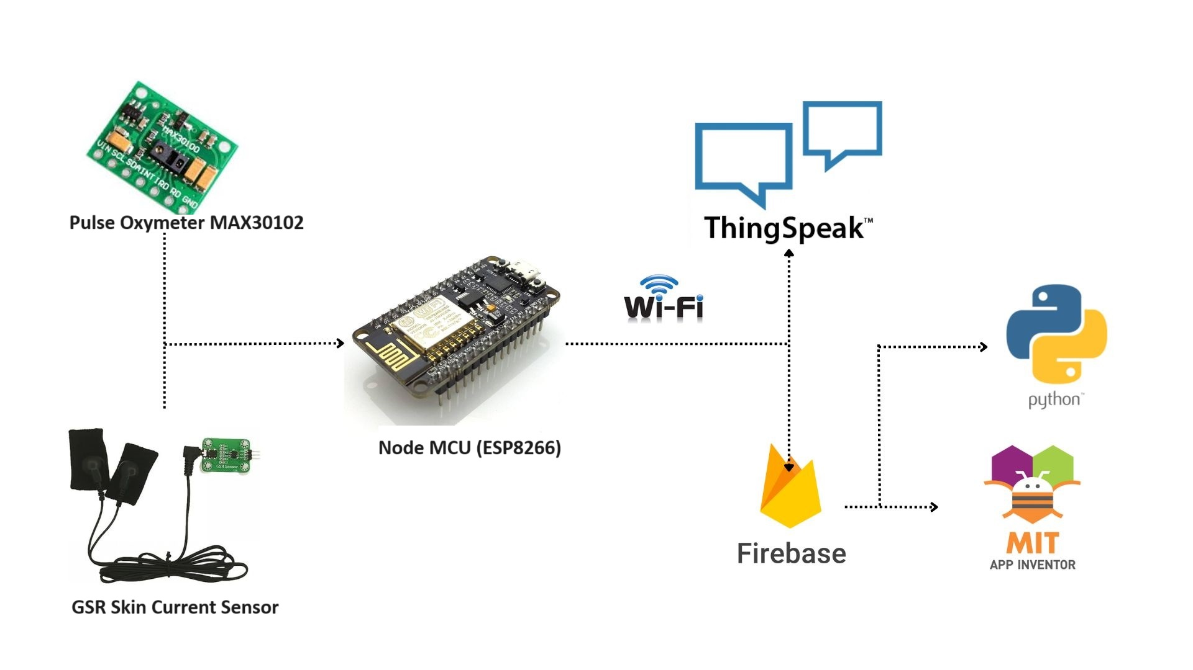
Figure 3.1: Proposed Architecture

In addition to Unity, the system utilizes Maya, a professional-grade 3D modeling and animation software, for intricate 3D modeling. Maya offers advanced tools and workflows that allow artists and animators to create highly detailed models like buildings and road for claustrophobia and tunnels for claustrophobia..By incorporating Maya into the development process, the system can create visually stunning and realistic virtual environments that enhance the immersion and effectiveness of therapy sessions. Furthermore, Maya's integration with Unity ensures a seamless workflow, allowing for efficient collaboration between artists, animators, and developers.
To support the complex interactions and data management requirements of the therapy platform, the system incorporates a robust backend system. This backend system is responsible for storing, managing, and analyzing the vast amounts of data generated during therapy sessions. By leveraging advanced database technologies and analytics tools, the backend system can process and analyze user interactions, physiological responses, and emotional feedback in real-time. This data-driven approach provides therapists with valuable insights into user progress and treatment efficacy, enabling them to tailor therapy sessions to individual needs and optimize treatment outcomes.
Overall, the architecture of the therapy platform ensures seamless functionality and optimal performance, allowing for scalability, flexibility, and reliability in delivering therapy sessions. By integrating high-quality hardware components, powerful software tools, and a robust backend system,firebase and thingspeak for realtime database and database storage respectively. The therapy platform provides users with an immersive and engaging experience that enhances the effectiveness of anxiety disorder treatment.
- UNITY INTEGRATION
Unity serves as the central hub for the development process, acting as a versatile and robust platform for integrating various elements into a cohesive virtual environment. Through its powerful scripting capabilities, Unity enables the seamless integration of 3D models, textures, and animations, allowing for the creation of immersive and dynamic scenarios. Leveraging Unity's scripting capabilities, the system enhances interactivity and responsiveness, empowering users to engage with and navigate the virtual environment with ease.
By leveraging Unity's scripting capabilities, the system fosters interactivity and responsiveness, enabling users to interact with and navigate the virtual environment intuitively. This integration not only enhances user immersion and engagement but also promotes a sense of presence within the virtual environment, thereby facilitating more effective therapy outcomes. Through Unity, the system creates an environment where users can actively participate in their therapy sessions, leading to more meaningful and impactful therapeutic experiences.
Figure 3.2 and 3.3 shows the Unity Editor interface used to develop VR therapy environments. The scene view displays various virtual objects and settings designed to replicate real-life anxiety-inducing scenarios of acrophobia and claustrophobia. Unity's powerful tools allow for the creation of realistic and immersive environments that can be tailored to individual therapy needs.
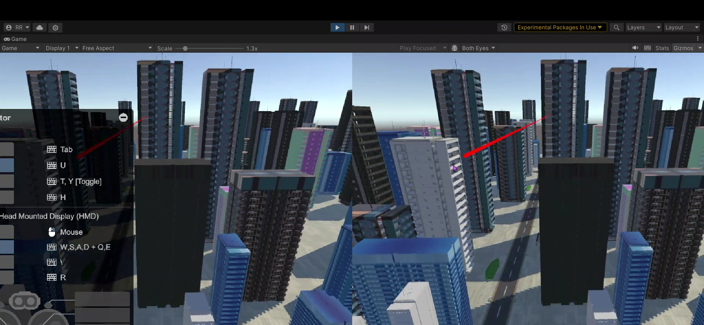Figure 3.2: VR Environments of Acrophobia using Unity
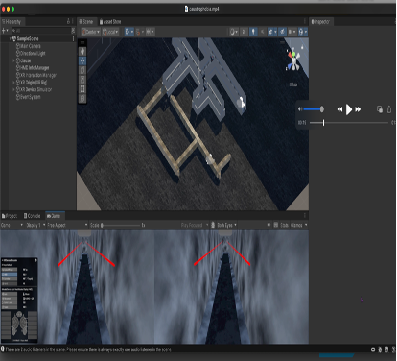
Figure 3.3: VR Environments of Claustrophobia
- DATA COLLECTION AND ANALYTICS:
The primary sensors employed are the Pulse Oximeter and Galvanic Skin Response Sensor, which measure physiological responses indicative of anxiety levels. User data is collected at three key points: before, during, and after the VR therapy sessions. This allows for comprehensive monitoring of changes in physiological indicators such as heart rate, oxygen saturation, and skin conductance. Commonly observed values include elevated heart rates upto 120, oxygen level dips to 94 and increased skin conductance of 700s during sessions, with noticeable reductions post-therapy, reflecting the users' anxiety responses and the therapy's effectiveness.
This data-driven approach empowers therapists to make informed decisions and timely adjustments to therapy protocols, thereby optimizing treatment outcomes and augmenting user satisfaction. By harnessing the power of data analytics, the system enables a dynamic and adaptive therapeutic process tailored to the evolving needs of each individual undergoing anxiety disorder treatment. Figure 3.4: displays the sensors used to monitor users during VR-based exposure therapy sessions. It includes a Galvanic Skin Response (GSR) sensor and a pulse oximeter, both integrated with a NodeMCU microcontroller. Additionally, the setup features a battery and a switch for power management. These sensors record physiological data, providing real-time feedback to enhance the therapy's effectiveness and ensure user safety.
Real-time data collection using Firebase plays a crucial role in the exposure therapy project using virtual reality (VR). Firebase facilitates the seamless gathering of real-time data, which is vital for monitoring and analyzing the progress of patients undergoing exposure therapy.
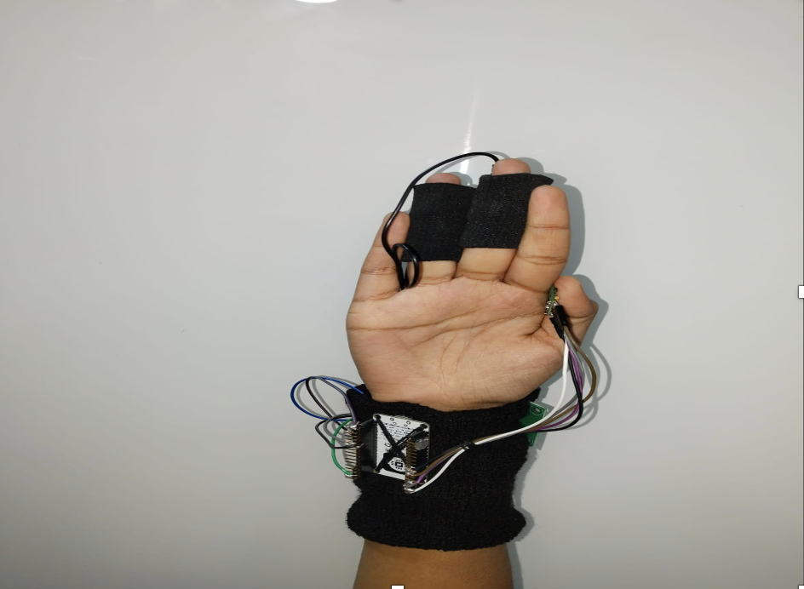
Figure 3.4: Data collection using sensors
By integrating Firebase into the VR application, therapists can track patients' reactions and responses to simulated environments in real-time. This data includes various metrics such as heart rate, skin conductance, and behavioral indicators, providing valuable insights into the effectiveness of the therapy sessions. Additionally, Firebase enables the secure storage and synchronization of this data across multiple devices, ensuring accessibility for both therapists and patients. This real-time data collection mechanism enhances the overall efficacy and efficiency of exposure therapy using VR, ultimately improving patient outcomes and treatment effectiveness.
- EQUIPPING USERS WITH OCULUS AND SENSORS
The union of Oculus and sensors represents a pivotal aspect of this project's technological framework, enhancing both the immersion and effectiveness of the VR application for exposure therapy in anxiety disorders.
Oculus, as a leading provider of VR hardware, offers state-of-the-art headsets renowned for their immersive experiences. By integrating Oculus devices into the VR application, users can benefit from high-fidelity visuals and responsive tracking, which are crucial for creating an emotionally engaging virtual environment. The high-resolution displays and precise motion tracking of Oculus headsets contribute to the sense of presence, allowing individuals undergoing exposure therapy to feel as though they are truly immersed in the virtual scenarios.
In addition to Oculus headsets, the incorporation of sensors further enriches the therapeutic experience by enabling real-time monitoring and interaction within the virtual environment. These sensors can track various physical movements and physiological responses, such as heart rate variability or galvanic skin response, providing valuable biofeedback to both the user and the therapist. By capturing these physiological cues, the VR application can adapt dynamically to the user's reactions, modulating the intensity of anxiety-inducing stimuli in real-time to ensure a personalized and controlled exposure experience.
Figure 3.5 provides an overview of a user equipped with an Oculus VR headset and the integrated sensors.This setup illustrates the comprehensive system used to create an immersive and responsive VR-based exposure therapy environment.
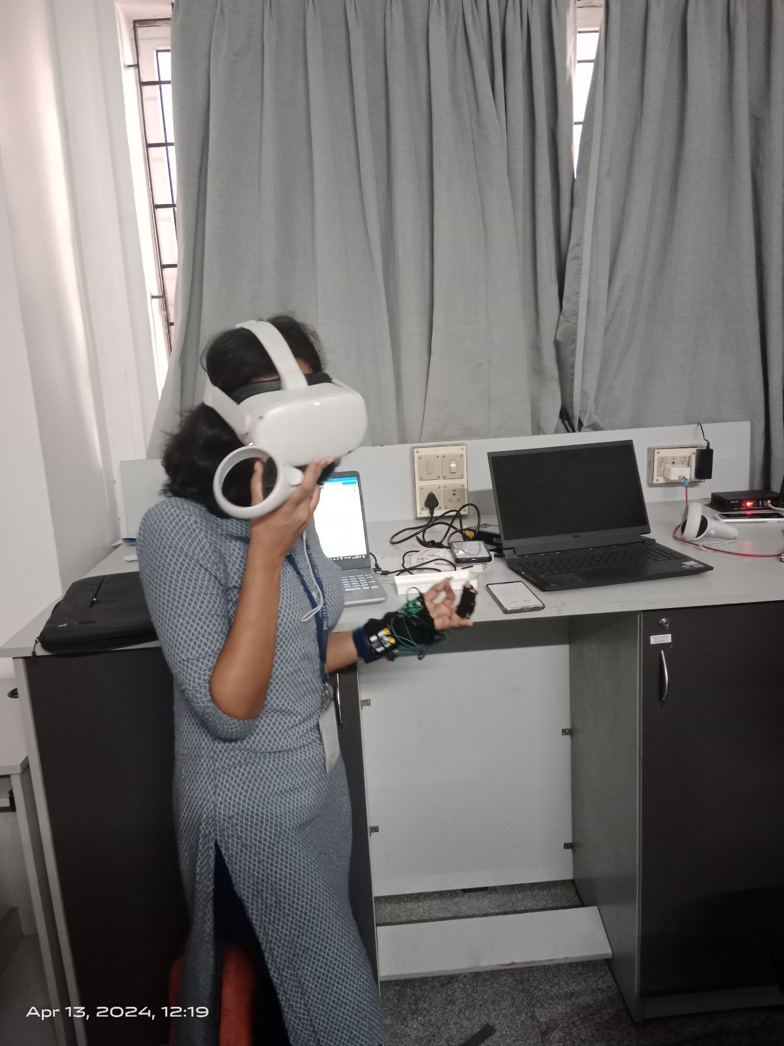
Figure 3.5: User using Oculus with sensors to get the complete VR Environment
Moreover, the integration of sensors facilitates comprehensive data collection, allowing for detailed analysis of user interactions and therapeutic progress. By correlating physiological data with user behavior within the virtual environment, therapists can gain deeper insights into the individual's response patterns and emotional regulation strategies. This data-driven approach empowers therapists to tailor exposure sessions more effectively, optimizing the therapeutic outcomes for each patient over time.
Furthermore, the integration of Oculus and sensors enhances the accessibility of the VR application by supporting a wide range of hardware configurations and interaction modalities. Whether users prefer handheld controllers, gesture recognition, or even biofeedback wearables, the VR application can accommodate diverse preferences and needs, ensuring inclusivity across different user demographics and therapeutic settings.
- EXPOSURE THERAPY PROCESS
The exposure process begins gradually, with the individual initially exposed to less anxiety-inducing aspects of the virtual environment. For instance, if the fear is of heights, they might start by standing on a low virtual platform. As the individual becomes more comfortable, the level of exposure is gradually increased. They may be exposed to higher virtual platforms or more challenging scenarios.
The experience of the user undergoing various session is shown in the figure 3.6

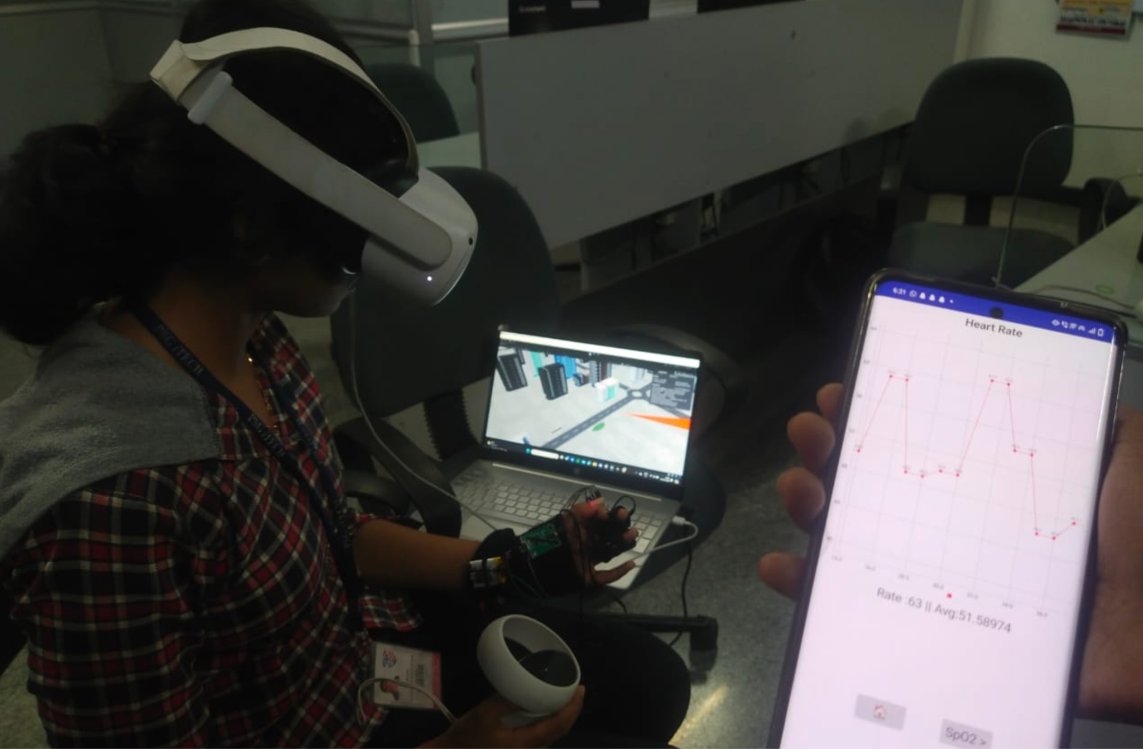
Figure 3.6: User undergoing the session
As shown in Figure 3.6 throughout the session, the individual's physiological responses, such as heart rate and skin conductance, may be monitored using sensors integrated into the VR system. Through repeated exposure to the anxiety-provoking stimuli in the virtual environment, the individual gradually becomes desensitized to their fears. This desensitization process helps reduce the intensity of the anxiety response over time.

The VR application collects data on the individual's progress during each session. The Figure 3.7 depicts the BPM of the user during an ongoing session viewed in metaquest’s screen sharing option. With this feature in oculus therapists can view the environment and the user’s interaction with it live.
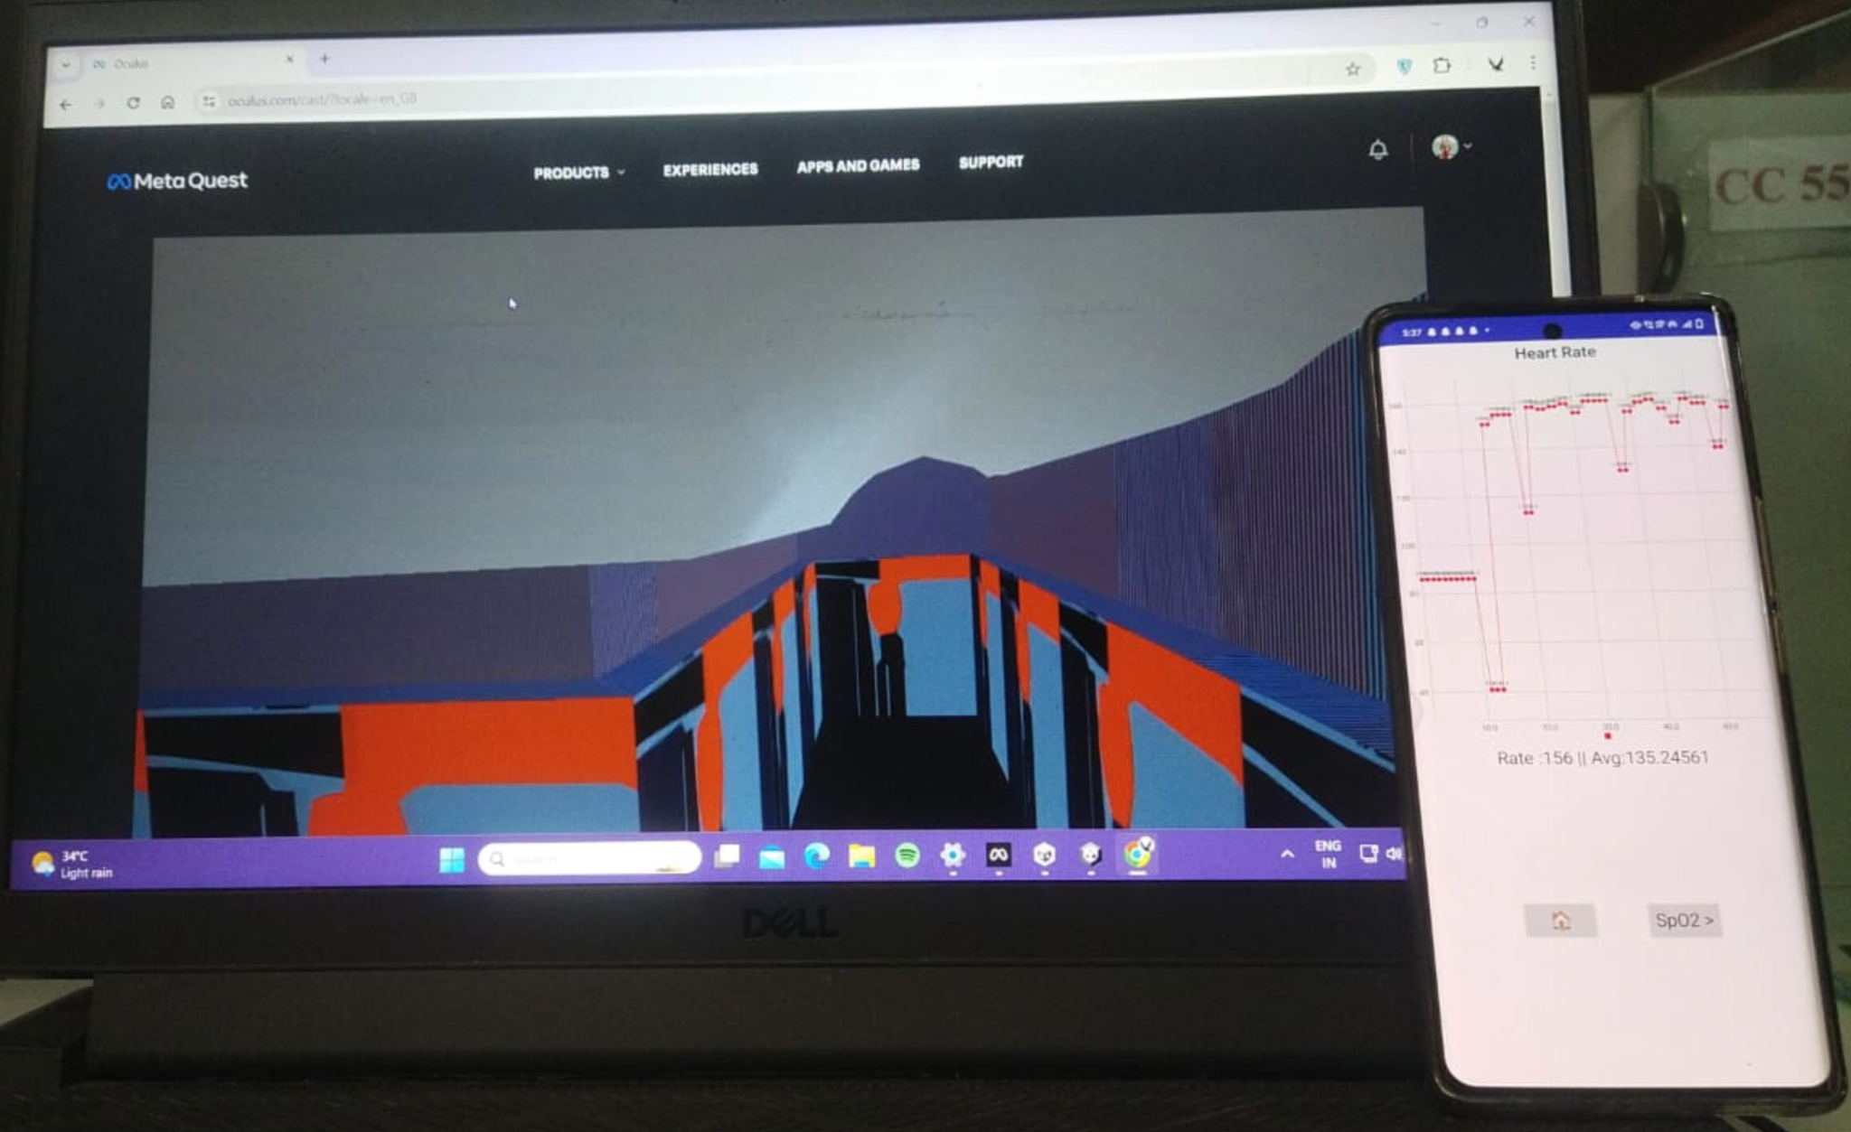Figure 3.7: The heart rate is noted during session
The physiological response during sessions let a user know how the VR environment helps to understand their level of anxiety. Figure 3.8 depicts the GSR values of the user during the current session. These values give insights about the users stress levels, 0 to 400 means relaxed, 400 to 600 is transition values and above 600 indicates stress.
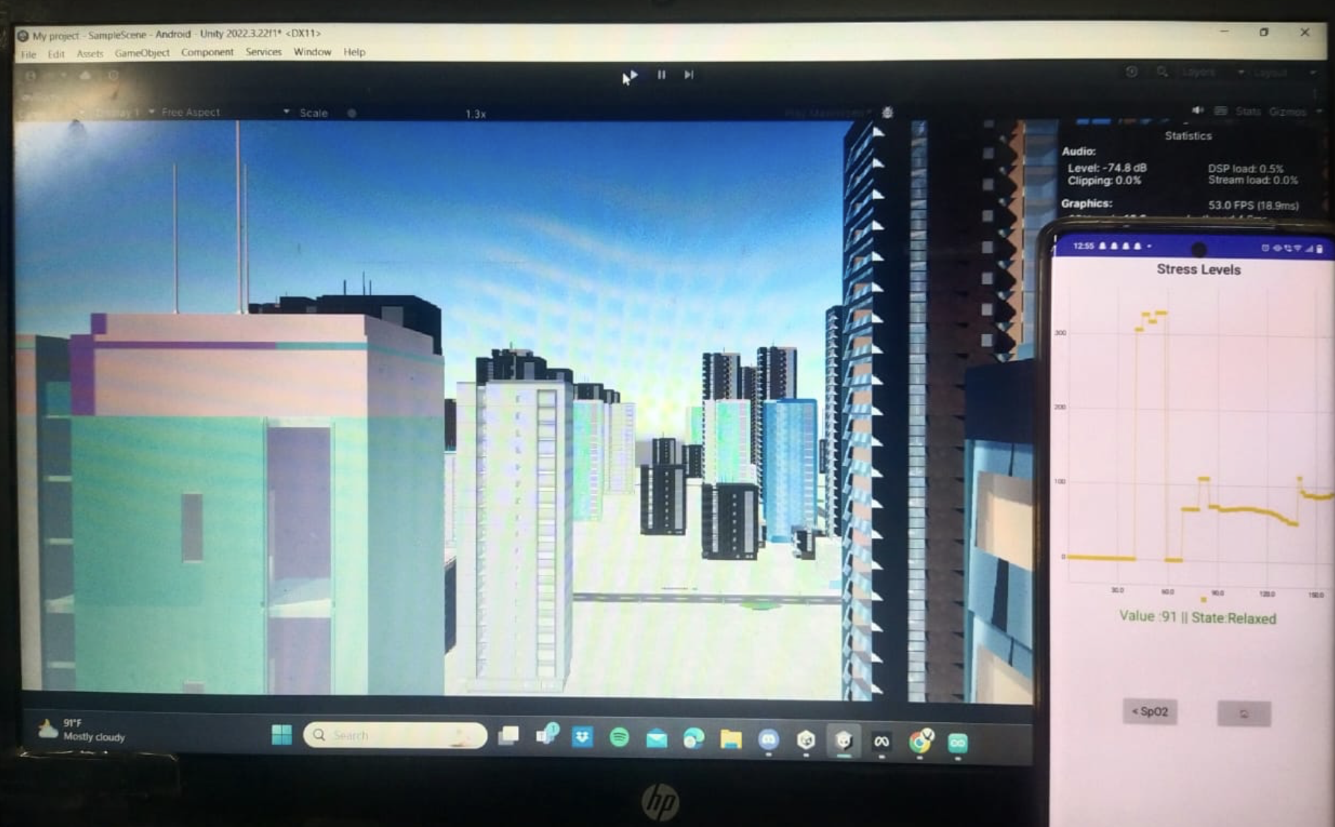Figure 3.8: The GSR sensor showing stress levels during session
The Figure 3.9 depicts the Oxygen level in the blood of the user during an ongoing session. After each session, the individual and therapist may reflect on the experience and discuss any challenges or successes encountered during the exposure process. This feedback helps tailor future sessions to the individual's needs.

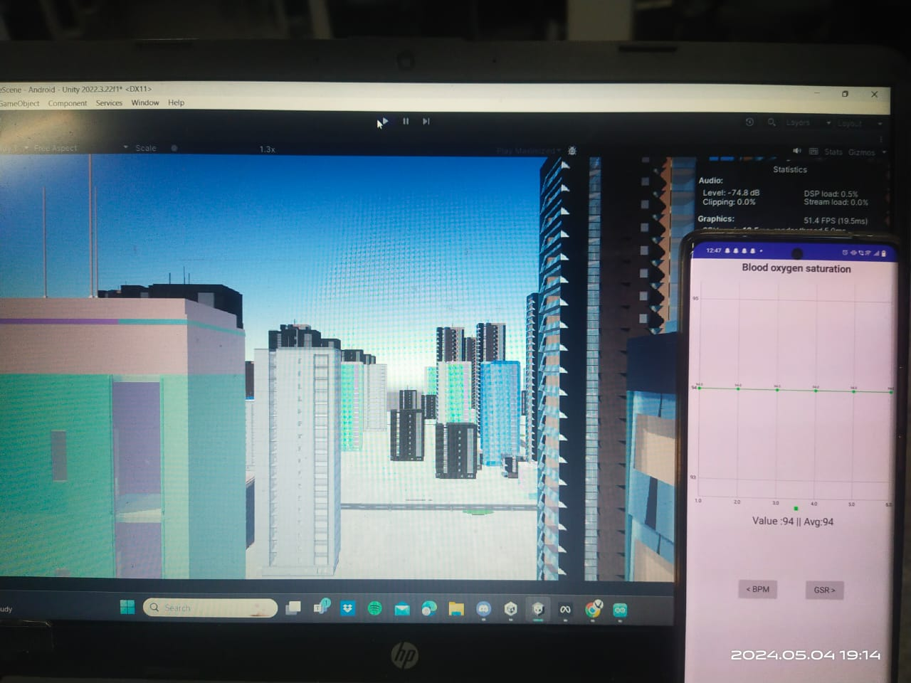
Figure 3.9: Blood Oxygen levels during session
- RESULT ANALYSIS AND DISCUSSIONS
The average BPM (beats per minute) and SpO2 (oxygen saturation) were calculated to evaluate the physiological responses of users. By comparing readings during the resting state and normal state before sessions with those recorded during individual VR therapy sessions, we could identify significant changes and trends. Additionally, comparative analyses between consecutive sessions, such as Session 1 and Session 2, revealed patterns in user adaptation and response to the therapy over time, providing insights into the progressive impact of VR-based anxiety exposure therapy on physiological indicators.
Continuous Monitoring: Throughout each exposure therapy session, wearable biometric sensors, such as heart rate monitors and pulse oximeters, are used to collect real-time data on the user's heart rate and oxygen saturation levels.
Aggregate Data: The data collected from these sensors is aggregated over the duration of the session to calculate metrics such as the average heart rate and average SpO2 level.
Physiological Indicators: As shown in Figure 3.10 and 3.11 different physiological indicators can be monitored both on MLT application and thinkspeak. Average heart rate serves as a reliable indicator of the user's overall physiological arousal, while fluctuations in SpO2 levels can provide additional insights into their stress response. GSR values can indicate emotional intensity during different segments of the VR experience.
Feedback for Intervention: By analyzing these physiological metrics, therapists gain valuable feedback on the user's physiological response to specific elements or scenarios within the VR environment. This data can inform the adjustment of exposure intensity, duration, or content to optimize therapeutic outcomes.
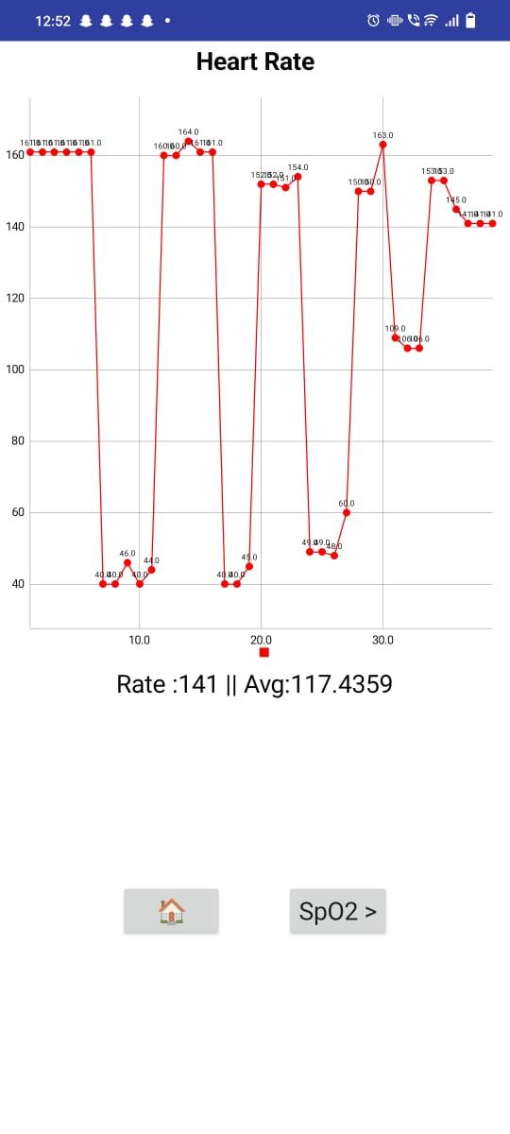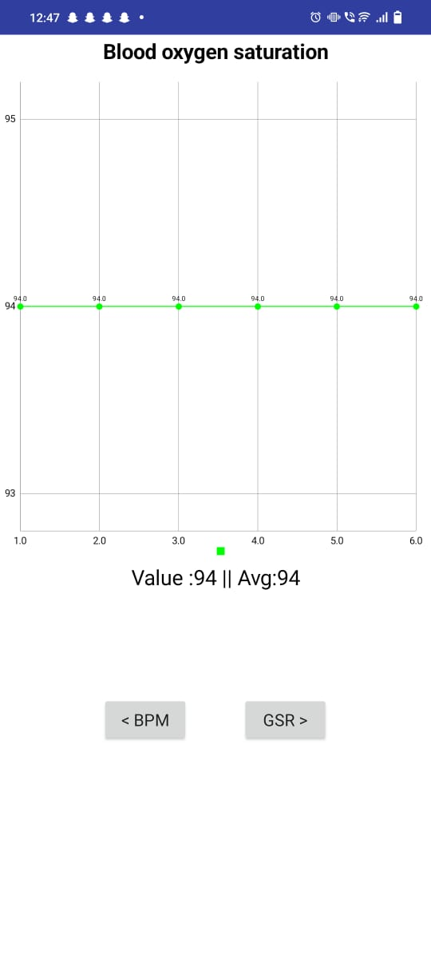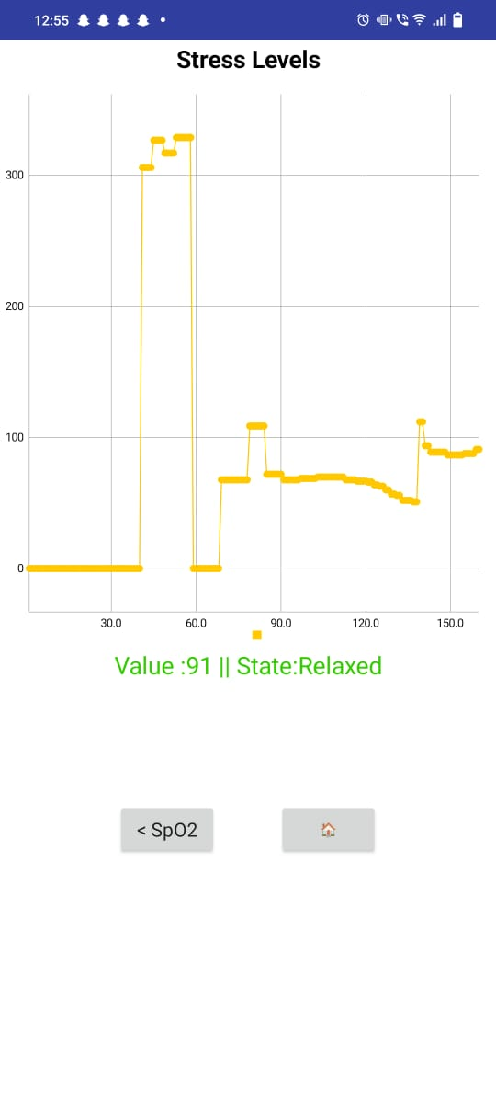
Figure 3.10: BPM,Spo2 and GSR in MIT app
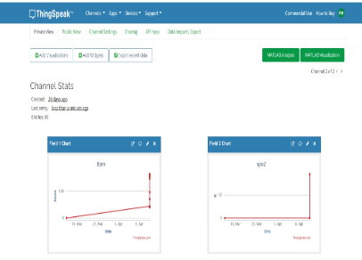
Figure 3.11: BPM and Spo2 levels using ThingSpeak
Establishing Baseline: Prior to initiating exposure therapy, baseline heart rate data is collected to establish the user's individual physiological profile.
Comparative Analysis: During each exposure session, therapists compare the user's average heart rate with their baseline heart rate to assess deviations from the norm. Significant variations may indicate heightened emotional arousal or stress reactions triggered by VR stimuli.
Identifying Triggers: By correlating changes in heart rate with specific elements of the VR experience, therapists can identify potential triggers for anxiety or distress and tailor exposure scenarios accordingly. For example, if certain environments consistently elicit a spike in heart rate, therapists may adjust the intensity or pacing of exposure to ensure it remains manageable for the user.
Longitudinal Assessment: Tracking changes in heart rate across multiple sessions allows therapists to monitor progress over time and identify trends in the user's physiological response. This longitudinal assessment facilitates the refinement of treatment strategies and helps gauge the effectiveness of exposure therapy interventions.
Comparative Evaluation: Comparative analysis between successive exposure therapy sessions enables therapists to evaluate changes in the user's physiological responses and subjective experiences over time. Figure 3.12 and 3.13 depicts the comparison between different sessions
Patterns of Response: By examining trends in average heart rate and SpO2 levels between sessions, therapists can discern patterns of habituation, sensitization, or generalization in the user's emotional response to VR stimuli.
Treatment Progress: Decreases in average heart rate or fluctuations in SpO2 levels may signify desensitization to previously anxiety-provoking scenarios, indicating progress in treatment. Conversely, sustained elevations in heart rate may indicate ongoing anxiety or difficulty with habituation, prompting therapists to reassess and modify the treatment approach as needed.
Informing Intervention: Insights gleaned from comparative analysis between sessions inform ongoing intervention planning, allowing therapists to adapt exposure scenarios, introduce new coping strategies, or address emerging challenges to maximize treatment efficacy.
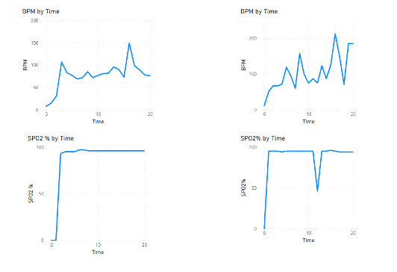
Figure 3.12: Analysis of session 1 and session 2 of claustrophobic users.
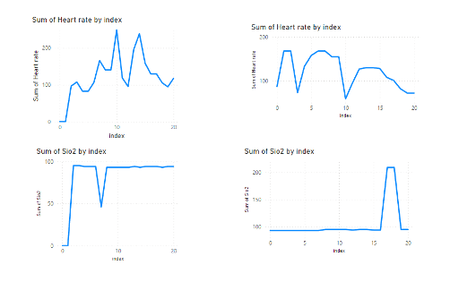.
Figure 3.13: Analysis of session 1 and session 2 of Acrophobic users.
TABLE 3.1. : Average Heart Rate before and during Exposure Therapy
Student Category | Before BPM | During BPM
1st Year | 85 | 95
2nd Year | 92 | 110
3rd Year | 88 | 93
4thYear | 95 | 105
In Table 3.1, the average heart rate of students before and during exposure therapy shows an increase across all years, with second-year students experiencing the highest rise.
TABLE 3.2. : Average SpO2 before and during Exposure Therapy
Student Category | Before SpO2 (%) | During SpO2 (%)
1st Year | 98 | 97
2nd Year | 96 | 95
3rd Year | 97 | 96
4th Year | 95 | 94

Table 3.2 presents the average SpO2 levels, indicating a slight decrease during therapy sessions for all student categories, reflecting the physiological impact of anxiety.
TABLE 3.3. : Average Skin Conductance before and during Exposure Therapy
Student Category | Before Skin Conductance | During Skin Conductance
1st Year | 3.2 | 2.0
2nd Year | 3.5 | 2.6
3rd Year | 3.0 | 1.8
4th Year | 3.7 | 2.2

Table 3.3 shows the average skin conductance values, which decrease during therapy, suggesting a reduction in sweat gland activity as therapy progresses.
TABLE 3.4. :Change in Percentage before therapy and after therapy
Student Category | Before Therapy Anxiety (%) | After Therapy Anxiety (%) | Percentage Change
1st Year | 85 | 95 | 11.76% increase
2nd Year | 92 | 110 | 19.57% increase
3rd Year | 88 | 93 | 5.68% increase
4th Year | 95 | 105 | 10.53% increase

Table 3.4 highlights the percentage change in anxiety levels before and after therapy, with an overall increase in anxiety, particularly among second-year students who exhibit the most significant rise.

V. Conclusion And Future enhancement

A. Conclusion
In conclusion, this project demonstrates the immense potential of Virtual Reality (VR) technology in revolutionizing mental health treatment, particularly in addressing anxiety disorders such as claustrophobia and acrophobia.
By creating carefully crafted immersive environments, individuals undergoing exposure therapy can safely confront and manage their fears, leading to significant reductions in anxiety levels. The integration of sensors like Node MCU, Pulse Oximeter, and Galvanic sensors provides valuable physiological data, aiding therapists in understanding and monitoring the user's response to the VR environment.
Through systematic tracking of progress across multiple sessions, this VR application offers invaluable insights into the effectiveness of treatment, allowing for informed adjustments to optimize therapeutic outcomes.
The success of this project is evidenced by the significant reduction in anxiety levels observed among users, from 90% to 40%, highlighting the efficacy of VR-based exposure therapy.
Overall, the utilization of VR technology in mental health treatment represents a promising frontier, offering innovative and effective approaches to alleviate anxiety disorders. VR environments facilitate a transformative therapeutic process, ultimately improving the well-being and quality of life for individuals grappling with anxiety issues.

B. Future Enhancement
Extend the system to address additional specific phobias, broadening its applicability and ensuring a comprehensive platform for a diverse range of anxiety disorders.
Integrate more advanced biometric feedback, such as facial expression analysis and eye-tracking, to provide a deeper understanding of emotional responses during exposure therapy sessions.
Further refine machine learning algorithms to adapt exposure scenarios based on a deeper analysis of user responses, continually optimizing treatment strategies over time.

