**AUTOMATION TESTING WITH SELENIUM**

**727721EUIT158 - SRIKANTH S**

**CA-1**

**QUESTION_1:**

package com.demo.CA1;

import org.openqa.selenium.By;

import org.openqa.selenium.WebDriver;

import org.openqa.selenium.WebElement;

import org.openqa.selenium.chrome.ChromeDriver;

import org.openqa.selenium.chrome.ChromeOptions;

import io.github.bonigarcia.wdm.WebDriverManager;

public class CA1_1 {

public static void main(String[] args ) throws InterruptedException

{

ChromeOptions co=new ChromeOptions();

co.addArguments("--remote-allow-origins=*");

WebDriverManager.chromedriver().setup();

WebDriver driver=new ChromeDriver();

String currentTitle=driver.getTitle();

System.out.println(currentTitle);

String expectedTitle="Online Shopping site in India: Shop Online for Mobiles, Books, Watches, Shoes and More - Amazon.in";

if(currentTitle.equals(expectedTitle)) {

System.out.println("TITLE DOES NOT MATCH");

}

else {

System.out.println("TITLE MATCH");

}

driver.get("https://www.amazon.in/Mysore-Sandal-Soap-150g-Pack/dp/B00BMR071W/ref=sr_1_8?keywords=soap&qid=1681290552&sr=8-8");

driver.manage().window().maximize();

driver.findElement(By.xpath("//*[@id=\"add-to-cart-button\"]")).click();

WebElement t=driver.findElement(By.xpath("//*[@id=\"NATC_SMART_WAGON_CONF_MSG_SUCCESS\"]/span"));

String current=t.getText();

String expected="Added to Cart";

if(current.equals(expected)) {

System.out.println("CART VERIFIED");

}else {

System.out.println("CART NOT VERIFIED");

}

driver.findElement(By.xpath("/html/body/div[1]/header/div/div[7]/div[1]/div/div/div[4]/div/div/div[2]/div[3]/div[7]/div[1]/span/span/span[1]/span/span/span/span/span")).click();

WebElement s=driver.findElement(By.xpath("//*[@id=\"nav-cart-count\"]"));

String upd1=s.getText();

String upd="Amazon Cart is Updated ";

if(upd1.equals(upd)) {

System.out.println("NOT UPDATED");

}else {

System.out.println("UPDATED");

}

driver.findElement(By.xpath("/html/body/div[1]/header/div/div[7]/div[1]/div/div/div[4]/div/div/div[2]/div[3]/div[7]/div[2]/div/span/span/span/input")).click();

WebElement r=driver.findElement(By.xpath("//*[@id=\"nav-cart-count\"]"));

String old1=r.getText();

String old="Your Amazon Cart is empty";

if(old1.equals(old)) {

System.out.println("NOT REMOVED");

}else {

System.out.println("REMOVED");

}

WebElement q=driver.findElement(By.xpath("/html/body/div[3]/div/div/ul/li[4]/a"));

q.click();

WebElement buy=driver.findElement(By.xpath("/html/body/div[1]/div[2]/div[3]/div[5]/div/div[1]/div[1]/div/form/div/div[3]/span/span/span/input"));

buy.click();

driver.navigate().back();

WebElement li=driver.findElement(By.xpath("/html/body/div[1]/div[2]/div[3]/div[5]/div/div[1]/div[1]/div/form/div/div[3]/div[1]/span[2]/span"));

System.out.println(li.getText());

}

}

**OUTPUT:**

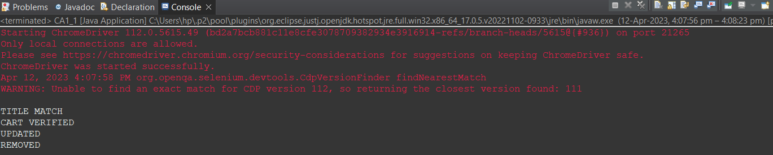

**QUESTION_2:**

package com.demo.CA1;

import org.openqa.selenium.By;

import org.openqa.selenium.WebDriver;

import org.openqa.selenium.WebElement;

import org.openqa.selenium.chrome.ChromeDriver;

import org.openqa.selenium.chrome.ChromeOptions;

import io.github.bonigarcia.wdm.WebDriverManager;

public class CA1_2 {

public static void main(String[] args) {

ChromeOptions co=new ChromeOptions();

co.addArguments ("--remote-allow-origins=*");

WebDriverManager.chromedriver().setup ();

WebDriver driver=new ChromeDriver(co);

driver.get ("https://www.amazon.in/");

driver.manage().window().maximize() ;

String currentTitle=driver.getTitle();

System.out.println(currentTitle);

String expectedTitle="Online Shopping site in India: Shop Online for Mobiles, Books, Watches, Shoes and More - Amazon.in";

if(currentTitle.equals(expectedTitle)) {

System.out.println("Title Matched");

}

else {

System.out.println("Title not Matched");

}

WebElement txtBoxl=driver.findElement(By.xpath("//*[@id=\"twotabsearchtextbox\"]"));

txtBoxl.sendKeys("macbook");

driver.findElement(By.xpath("//*[@id=\"nav-search-submit-button\"]")).click();

//displaying 5 products

String txt1=driver.findElement(By.xpath("//*[@id=\"search\"]/div[1]/div[1]/div/span[1]/div[1]/div[3]/div/div/div/div/div/div/div/div[2]/div/div/div[1]/h2/a/span")).getText();

System.out.println(txt1);

String txt2=driver.findElement(By.xpath("//*[@id=\"search\"]/div[1]/div[1]/div/span[1]/div[1]/div[4]/div/div/div/div/div/div/div/div[2]/div/div/div[1]/h2/a/span")).getText();

System.out.println(txt2);

String txt3=driver.findElement(By.xpath("//*[@id=\"search\"]/div[1]/div[1]/div/span[1]/div[1]/div[5]/div/div/div/div/div/div[2]/div/div/div[1]/h2/a/span")).getText();

System.out.println(txt3);

String txt4=driver.findElement(By.xpath("//*[@id=\"search\"]/div[1]/div[1]/div/span[1]/div[1]/div[6]/div/div/div/div/div/div[2]/div/div/div[1]/h2/a/span")).getText();

System.out.println(txt4);

String txt5=driver.findElement(By.xpath("//*[@id=\"search\"]/div[1]/div[1]/div/span[1]/div[1]/div[7]/div/div/div/div/div/div[2]/div/div/div[1]/h2/a/span")).getText();

System.out.println(txt5);

//filter

driver.findElement(By.xpath("//*[@id=\"p_36/7252032031\"]/span/a/span")).click();

driver.findElement(By.xpath("//*[@id=\"p_n_pattern_browse-bin/1464446031\"]/span/a/span")).click();

}

}

**OUTPUT:**

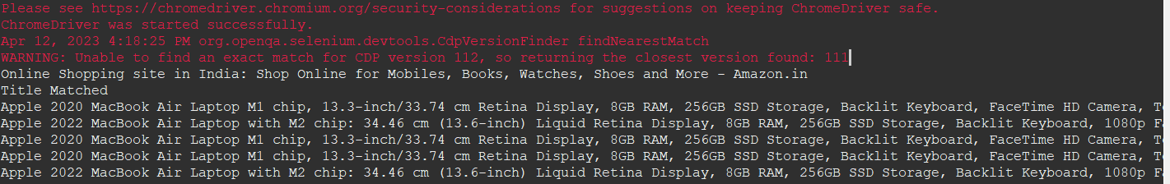

**QUESTION_3:**

package com.demo.CA1;

import org.openqa.selenium.By;

import org.openqa.selenium.WebDriver;

import org.openqa.selenium.WebElement;

import org.openqa.selenium.chrome.ChromeDriver;

import org.openqa.selenium.chrome.ChromeOptions;

import io.github.bonigarcia.wdm.WebDriverManager;

public class CA1_3 {

public static void main(String[] args) {

ChromeOptions co=new ChromeOptions();

co.addArguments ("--remote-allow-origins=*");

WebDriverManager.chromedriver().setup ();

WebDriver driver=new ChromeDriver(co);

driver.get ("https://www.amazon.in/");

driver.manage().window().maximize() ;

String currentTitle=driver.getTitle();

System.out.println(currentTitle);

String expectedTitle="Online Shopping site in India: Shop Online for Mobiles, Books, Watches, Shoes and More - Amazon.in";

if(currentTitle.equals(expectedTitle)) {

System.out.println("Title Matched");

}

else {

System.out.println("Title not Matched");

}

driver.findElement(By.xpath("//*[@id=\"nav-link-accountList\"]")).click();

WebElement txtBoxl=driver.findElement(By.xpath("//*[@id=\"ap_email\"]"));

txtBoxl.sendKeys("9360254589");

driver.findElement(By.xpath("//*[@id=\"continue\"]")).click();

WebElement txtBox2=driver.findElement(By.xpath("//*[@id=\"ap_password\"]"));

txtBox2.sendKeys("srikanth2730");

driver.findElement(By.xpath("//*[@id=\"signInSubmit\"]")).click();

driver.findElement(By.xpath("//*[@id=\"nav-link-accountList\"]")).click();

driver.findElement(By.xpath("//*[@id=\"a-page\"]/div[2]/div/div[2]/div[1]/a/div/div")).click();

driver.findElement(By.xpath("//*[@id=\"a-autoid-2-announce\"]")).click();

driver.findElement(By.xpath("//*[@id=\"ordersInPackage-container\"]/div/div/a[1]")).click();

}

}

**OUTPUT:**

