**AUTOMATION TESTING SELENIUM**

**727721EUIT158 - SRIKANTH S**

**CC_1**

**QUESTION_1:**

package com.demo.CA1;

import org.openqa.selenium.By;

import org.openqa.selenium.WebDriver;

import org.openqa.selenium.WebElement;

import org.openqa.selenium.chrome.ChromeDriver;

import org.openqa.selenium.chrome.ChromeOptions;

import io.github.bonigarcia.wdm.WebDriverManager;

public class CC_1_1 {

public static void main(String[] args ) throws InterruptedException

{

ChromeOptions co=new ChromeOptions();

co.addArguments("--remote-allow-origins=*");

WebDriverManager.chromedriver().setup();

WebDriver driver=new ChromeDriver();

driver.get("https://www.saucedemo.com/");

driver.manage().window().maximize();

WebElement uname=driver.findElement(By.id("user-name"));

uname.sendKeys("standard_user");

WebElement pass =driver.findElement(By.id("password"));

pass.sendKeys("secret_sauce");

driver.findElement(By.xpath("//*[@id=\"login-button\"]")).click();

driver.findElement(By.xpath("//*[@id=\"add-to-cart-sauce-labs-backpack\"]")).click();

driver.findElement(By.xpath("//*[@id=\"shopping_cart_container\"]/a")).click();

WebElement t=driver.findElement(By.xpath("//*[@id=\"cart_contents_container\"]/div/div[1]/div[3]"));

String current=t.getText();

String expected="Added to Cart";

if(current.equals(expected)) {

System.out.println("CART NOT ADDED");

}else {

System.out.println("CART ADDED");

}

Thread.sleep(4000);

driver.navigate().back();

Thread.sleep(4000);

driver.findElement(By.xpath("//*[@id=\"shopping_cart_container\"]/a")).click();

WebElement r=driver.findElement(By.xpath("//*[@id=\"header_container\"]/div[2]/span"));

String view1=r.getText();

String view="viewed the Cart";

if(view1.equals(view)) {

System.out.println("USER NOT VIEWED THE CART");

}else {

System.out.println("USER VIEWD THE CART");

}

Thread.sleep(3000);

driver.findElement(By.xpath("//*[@id=\"checkout\"]")).click();

WebElement s=driver.findElement(By.xpath("//*[@id=\"first-name\"]"));

String verify1=s.getText();

String verify="displayed";

if(verify1.equals(verify)) {

System.out.println("YOUR INFORMATION IS NOT DISPLAYED");

}else {

System.out.println("YOUR INFORMATION IS DISPLAYED");

}

WebElement fname=driver.findElement(By.id("first-name"));

fname.sendKeys("SREEKANTH");

WebElement lname =driver.findElement(By.id("last-name"));

lname.sendKeys("S");

WebElement postal=driver.findElement(By.id("postal-code"));

postal.sendKeys("627818");

driver.findElement(By.xpath("//*[@id=\"continue\"]")).click();

WebElement u=driver.findElement(By.xpath("//*[@id=\"header_container\"]/div[2]/span"));

String test1=r.getText();

String test="viewed the Cart";

if(test1.equals(test)) {

System.out.println("OVERVIEW NOT DISPLAYED");

}else {

System.out.println("OVERVIEW DISPLAYED");

}

WebElement name=driver.findElement(By.xpath("//*[@id=\"item_4_title_link\"]/div"));

System.out.println(name.getText());

WebElement price=driver.findElement(By.xpath("//*[@id=\"checkout_summary_container\"]/div/div[1]/div[3]/div[2]/div[2]/div"));

System.out.println(price.getText());

String acttitle=driver.getTitle();

String exptitle="Swag Labs";

if(acttitle.equals(exptitle)) {

System.out.println("TITLE VALIDATED");

}

else {

System.out.println("TITLE NOT VALIDATED");

}

String acturl=driver.getCurrentUrl();

String expurl="https://www.saucedemo.com/checkout-step-two.html";

if(acturl.equals(expurl)) {

System.out.println("URL VALIDATE");

}

else {

System.out.println("URL NOT VALIDATED");

}

}

}

**OUTPUT:**

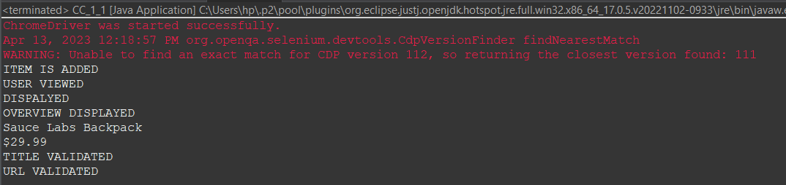

**QUESTION_2:**

package com.demo.CA1;

import org.openqa.selenium.By;

import org.openqa.selenium.WebDriver;

import org.openqa.selenium.WebElement;

import org.openqa.selenium.chrome.ChromeDriver;

import org.openqa.selenium.chrome.ChromeOptions;

import io.github.bonigarcia.wdm.WebDriverManager;

public class CC_1_2 {

public static void main(String[] args) throws InterruptedException {

ChromeOptions co=new ChromeOptions();

co.addArguments ("--remote-allow-origins=*");

WebDriverManager.chromedriver().setup ();

WebDriver driver=new ChromeDriver(co);

driver.get ("https://www.saucedemo.com/");

driver.manage().window().maximize() ;

WebElement txtBoxl=driver.findElement(By.xpath("//*[@id=\"user-name\"]"));

txtBoxl.sendKeys("standard_user");

WebElement txtBox2=driver.findElement(By.xpath("//*[@id=\"password\"]"));

txtBox2.sendKeys("secret_sauce");

driver.findElement(By.xpath("//*[@id=\"login-button\"]")).click();

String txt1=driver.findElement(By.xpath("//*[@id=\"item_4_title_link\"]/div")).getText();

System.out.println(txt1);

driver.findElement(By.xpath("//*[@id=\"header_container\"]/div[2]/div/span/select")).click();

driver.findElement(By.xpath("//*[@id=\"header_container\"]/div[2]/div/span/select/option[2]")).click();

String txt2=driver.findElement(By.xpath("//*[@id=\"item_3_title_link\"]/div")).getText();

System.out.println(txt2);

driver.findElement(By.xpath("//*[@id=\"header_container\"]/div[2]/div/span/select")).click();

driver.findElement(By.xpath("//*[@id=\"header_container\"]/div[2]/div/span/select/option[3]")).click();

String txt3=driver.findElement(By.xpath("//*[@id=\"item_2_title_link\"]/div")).getText();

System.out.println(txt3);

driver.findElement(By.xpath("//*[@id=\"header_container\"]/div[2]/div/span/select")).click();

driver.findElement(By.xpath("//*[@id=\"header_container\"]/div[2]/div/span/select/option[4]")).click();

String txt4=driver.findElement(By.xpath("//*[@id=\"item_5_title_link\"]/div")).getText();

System.out.println(txt4);

Thread.sleep(5000);

}

}

**OUTPUT:**

