**Srikanth Sprint-1 [19/MAR/2025 – 1/APR/2025]**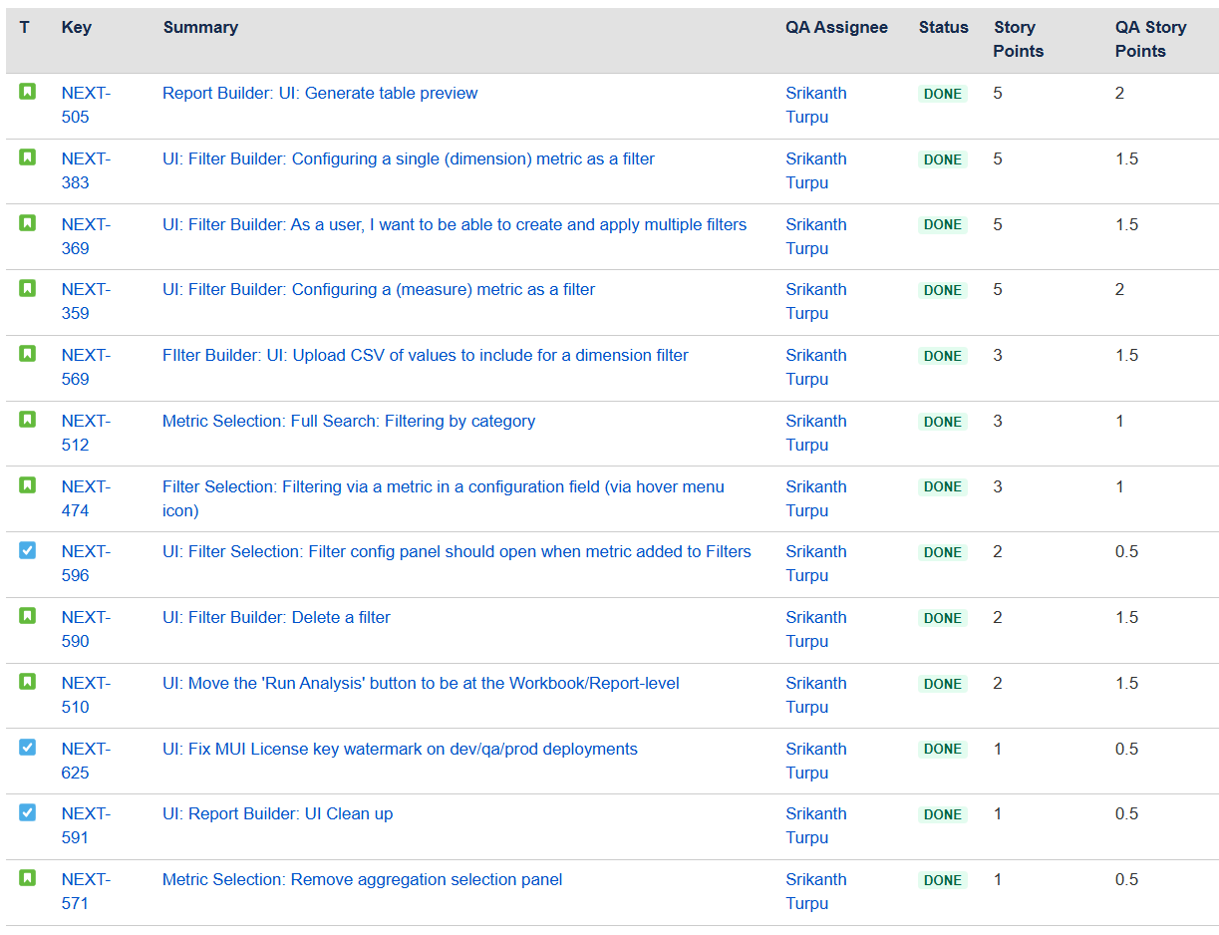

|  |  |
| --- | --- |
| Story Points | Tasks |
| 15.5 SP | NEXT Functional Tickets [Writing Testcases & Validation] |
| 2-SP | CFA Regression Testing |
| 1-SP | PR Review |
| 2.5 | All Meetings |
| **21- SP** | **Total Story Points** |
| **12.5 - SP** | **Available Story Points for Sprint-1** |
| **8.5** | **Extra Load Story Points** |

Meetings

============================================================

128-Min Ramki

081-Min Artemis Team Meeting with Ramki

100-Min Artemis Activity Meeting With ESP

069-Min CFA-QA internal meetings

122-Min Santhosh

054-Min Subha

032-Min Abhi

015-Min Priya

032-Min Other Team Members