PROJECT NAME

**Online Test Application**

***Developer Detail’s:***

**Developer Name:** Prajval Raju Bhale.

**Mail ID:** prajwalbhale007@gmail.com

**Project Start Date:** 16 July 2022

**Project End Date:** 18 July 2022

***Used Technologies:***

* **Framework:** Bootstrap.
* **For Frontend:** HTML, CSS, JavaScript.

**IDE:** Visual Studio Code

**01]. Main Screen :**

On this screen we see only Start Quiz Button if we Click on this Button, then this application goes forward.

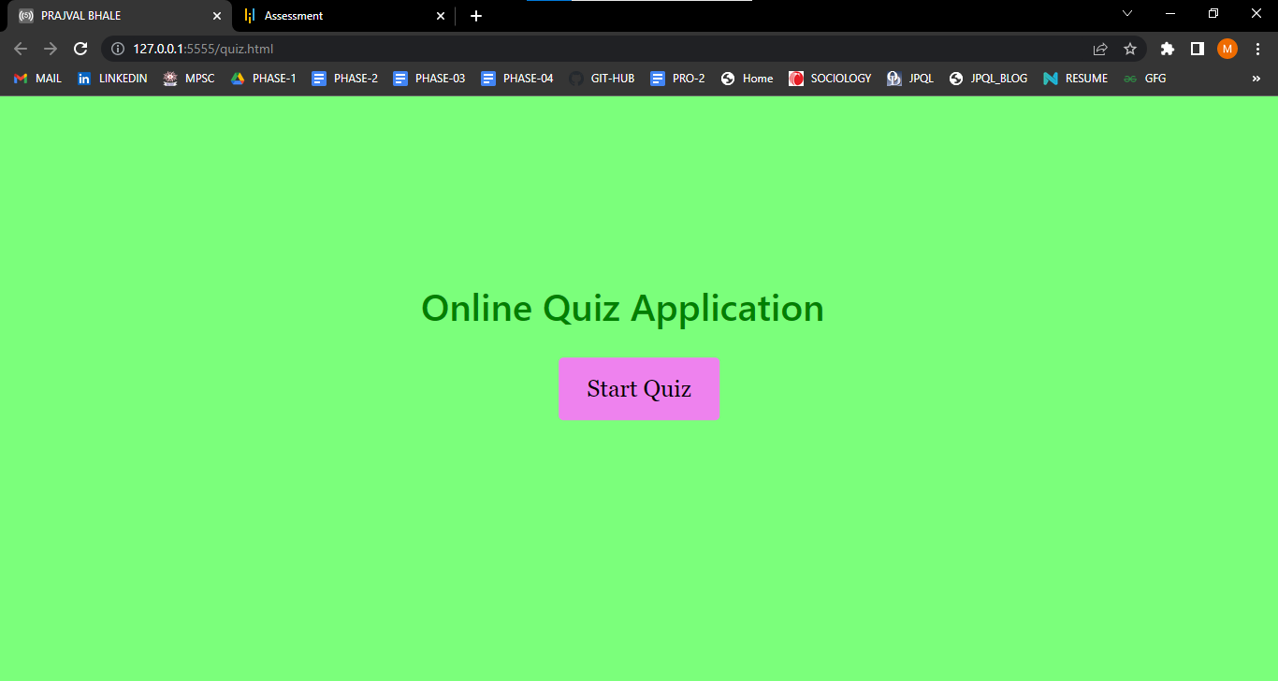

**2]. Instruction Screen**

This screen will shows the Quiz Rule, if we accept and click continue then application goes forward like:

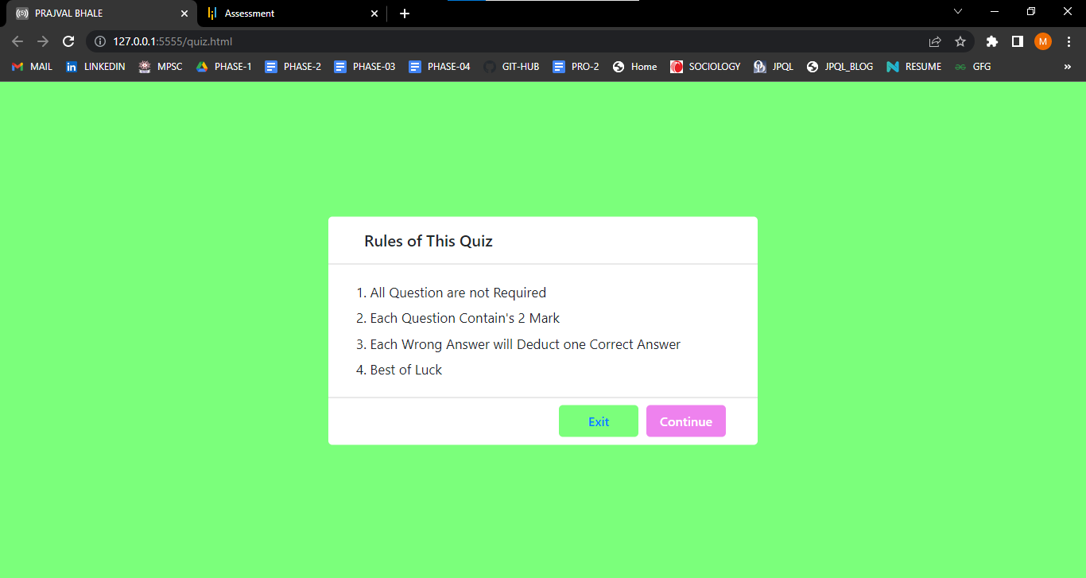

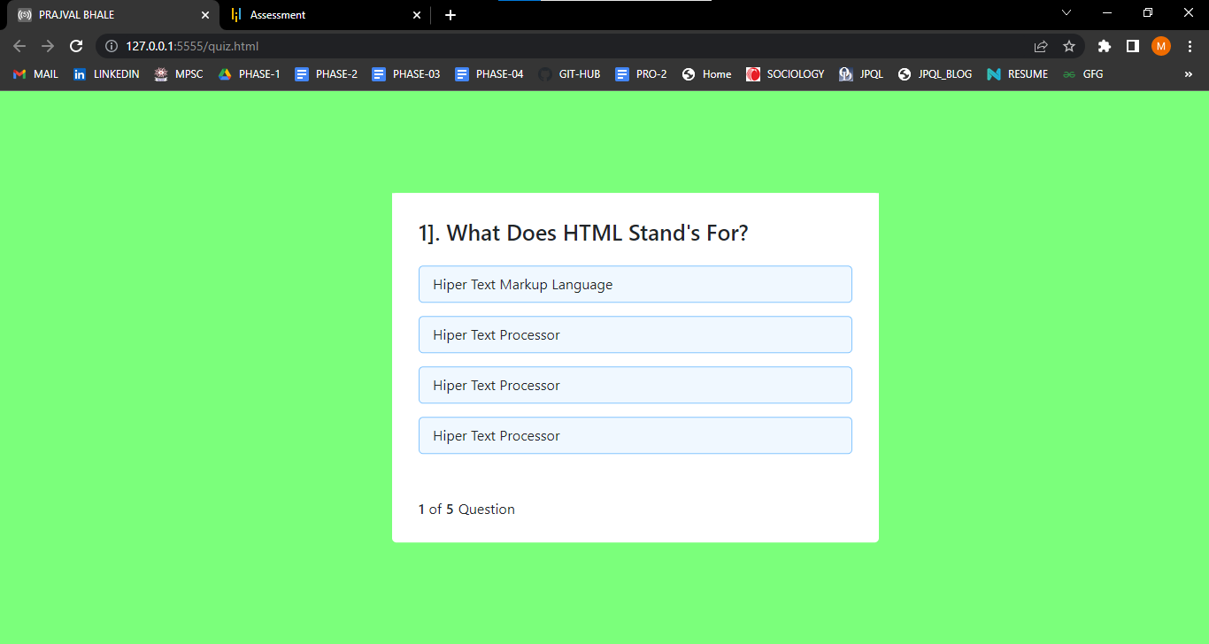

**3]. Exit :**

If we click on Exit button then application will exit like**:**



**4]. Question’s:**

If our Answer is right then Remaining all Options are Automatically Disabled like:

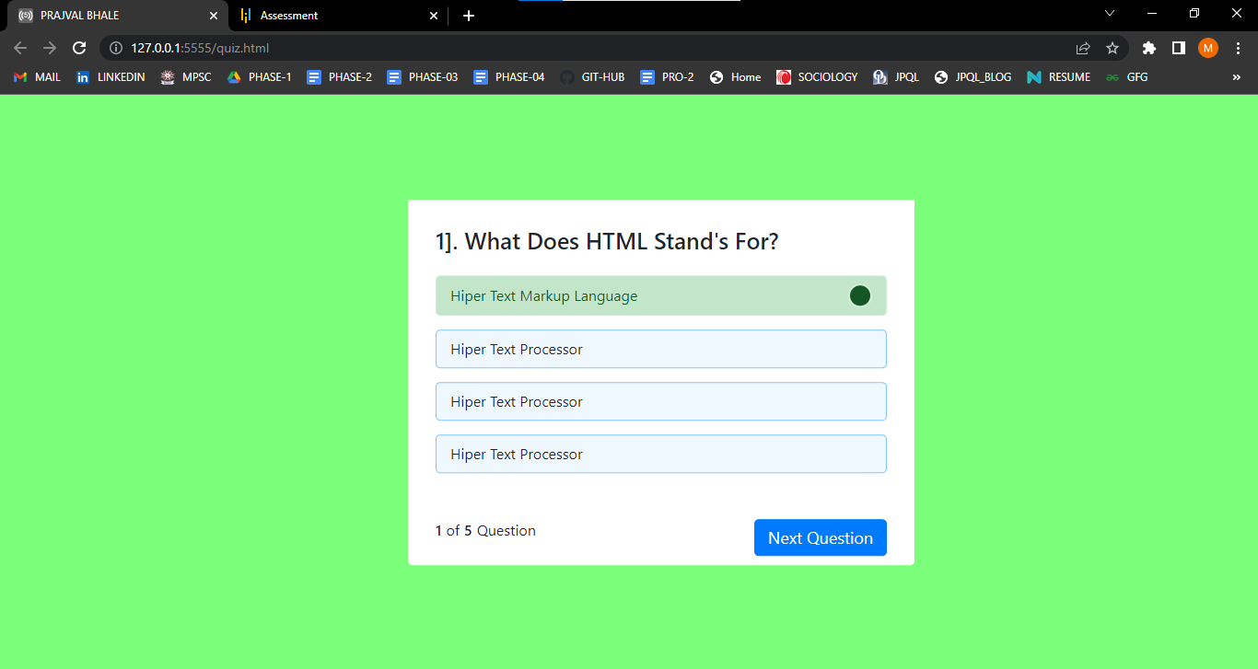

**5]. Question**

If we cannot click on any option then Our Next Option Button is not Visible like:

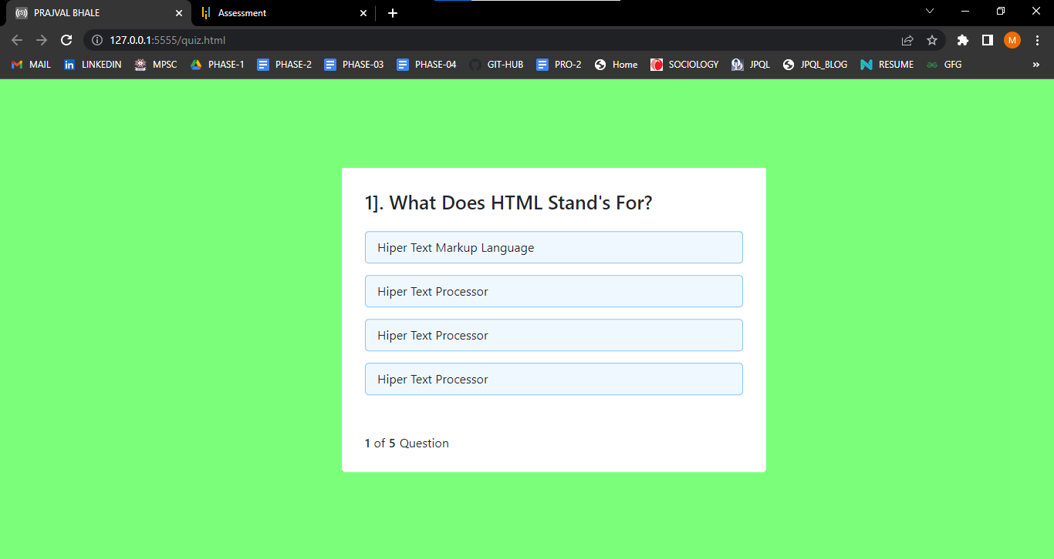

**6]. Question:**

When we click Wrong option then Right Answer is Automatically Shown like:

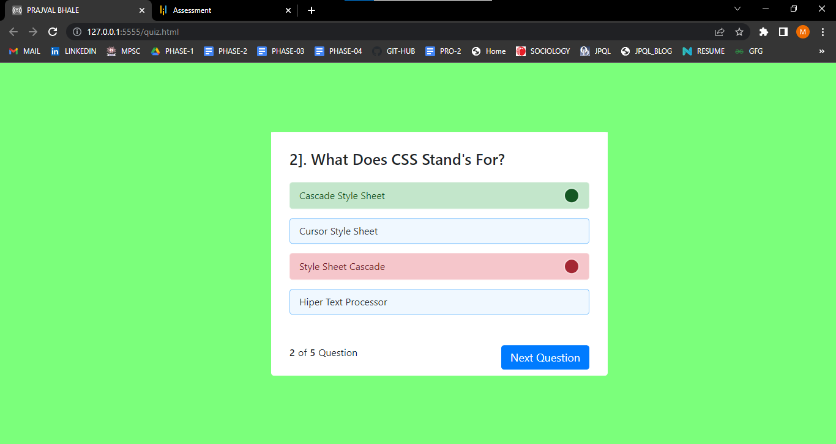

**7]. Result:**

After our Quiz is complete then Score is automatically Shown like:

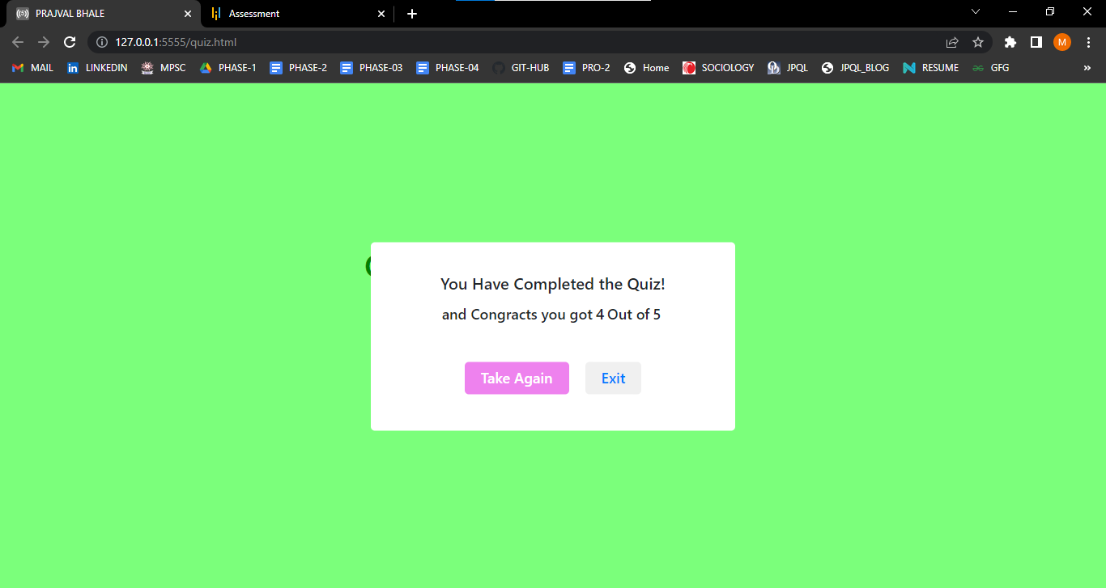

**8]. Retake Quiz:**

After completion our quiz we can also take as Retake like:



**9]. Exit**

After completing quiz we can Quit like:

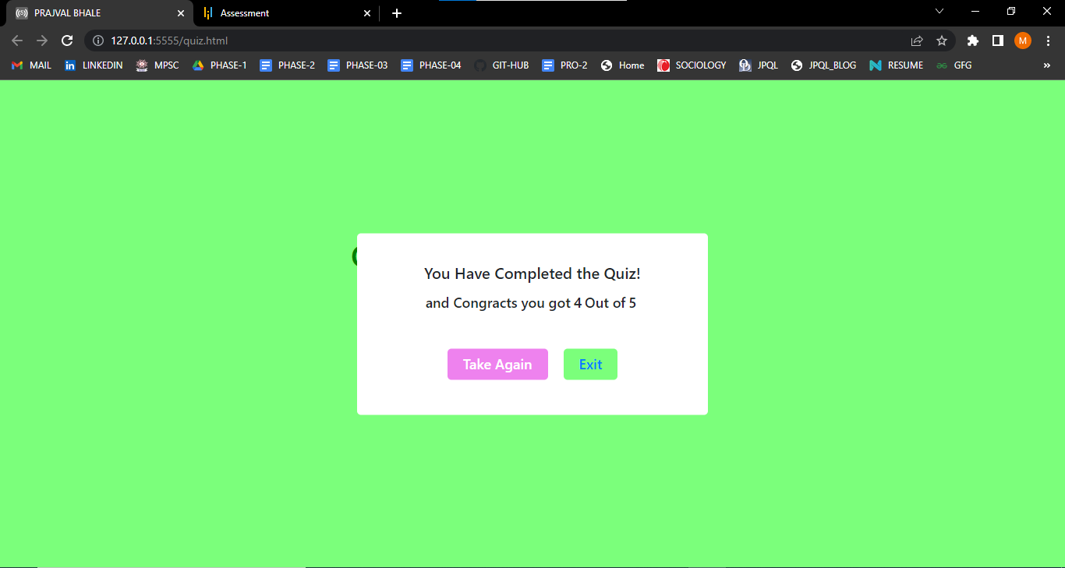

**10]. Exit**

After we click on exit button then we directly redirect on following screen like:

