CHAPTER 1
INTRODUCTION

The modern job market is characterized by rapid technological advancements, globalization, and fierce competition, creating an environment where securing meaningful employment has become increasingly challenging. In this landscape, traditional methods of interview preparation—such as memorizing common questions, relying on generic advice, or practicing through conventional mock interviews—are no longer sufficient. These methods often fail to equip candidates with the skills necessary to perform well under the scrutiny of AI-driven recruitment systems, which evaluate not only the content of responses but also delivery, confidence, and behavioral cues.

The integration of Artificial Intelligence (AI) in recruitment has transformed the way organizations identify, evaluate, and select candidates. Automated resume screening, predictive analytics, and AI-based interview platforms are now widely used by companies to streamline hiring processes. By leveraging advanced algorithms and Natural Language Processing (NLP), these systems can analyze candidate responses in real time, identify patterns, and predict performance outcomes. This technological shift demands a corresponding evolution in how candidates prepare for interviews. The AI Voice Interview and Resume Analyzer project emerges as a timely and necessary solution, designed to bridge the gap between traditional preparation methods and the demands of modern, AI-mediated recruitment processes.

At its core, this project combines generative AI, NLP, and voice-based interaction to create an adaptive, intelligent interview simulation. Unlike conventional static question banks, the system dynamically generates questions tailored to a candidate’s professional background, experience, and career goals. It evaluates responses not only for content accuracy and relevance but also for communication effectiveness, such as clarity, pacing, and fluency. By providing actionable, data-driven feedback, the system ensures that candidates gain insights into both their strengths and areas for improvement, enabling continuous learning and skill enhancement.

  - BACKGROUND OF THE WORK

The integration of Artificial Intelligence (AI) into Human Resources (HR) and Talent Acquisition (TA) has emerged as one of the most significant and rapidly accelerating trends in modern organizational management. Over the past decade, companies have increasingly adopted AI-driven tools to enhance their recruitment processes, reduce administrative burden, and improve the overall efficiency and objectivity of hiring. These tools have fundamentally altered how candidates are evaluated, creating new demands for skills and preparation methods that align with AI-driven recruitment practices.
In this context, AI-based interview preparation has become not only a valuable asset but an essential requirement for job seekers. Traditional interview preparation methods—such as memorizing standard questions, practicing generic answers, or relying solely on human-based mock interviews—are no longer sufficient. As organizations implement sophisticated AI screening systems, candidates need adaptive, realistic, and data-driven practice platforms that can prepare them for both human evaluators and AI-mediated assessment environments.

Market Growth

The global AI recruitment industry has seen remarkable growth. In 2023, the market was valued at approximately $661.56 million and is projected to reach $1.12 billion by 2030, reflecting a sustained compound annual growth rate (CAGR) driven by continuous investments in automation and AI-based talent solutions (Demand Sage, 2024). The growth of this market indicates that companies are increasingly relying on AI technologies for screening, shortlisting, and evaluating candidates.
Several factors contribute to this market expansion:
- Efficiency Gains: AI tools drastically reduce the time spent on repetitive tasks such as reviewing resumes, filtering candidates, and scheduling interviews.
- Accuracy and Objectivity: AI systems can evaluate resumes and candidate responses based on standardized criteria, reducing the influence of subjective human biases.
- Scalability: Organizations can manage large volumes of applicants simultaneously without the need to proportionally increase HR staff, which is particularly beneficial for large-scale hiring drives or global recruitment campaigns.

Recruiter Adoption

Recent studies show that over 65% of recruiters have already implemented some form of AI in their hiring process (Shortlistd.io, 2024). The adoption is driven by multiple strategic objectives:
- Reducing Time-to-Hire: AI systems can decrease the recruitment cycle by up to 50%, enabling faster placement of qualified candidates.
- Improving Candidate Sourcing: Intelligent algorithms can identify high-potential candidates from large talent pools using advanced pattern recognition, semantic resume analysis, and predictive fit scoring.
- Enhancing Decision-Making: AI provides data-driven insights that support HR professionals in making informed decisions, particularly when evaluating candidates for complex roles requiring specific skills.

The increasing prevalence of AI in recruitment also implies that candidates need to be adept at interacting with AI systems. They must communicate clearly, structure their responses effectively, and ensure that their resumes and verbal answers are optimized for algorithmic evaluation. In other words, proficiency in AI-compatible communication has become a core skill in the job-seeking process.

Technological Shift: From Rule-Based Systems to Large Language Models

Early AI recruitment solutions primarily relied on rule-based systems, which operated on pre-defined rules such as keyword matching, Boolean search queries, and scoring matrices. While effective for basic screening tasks, these systems had several limitations:
- They could not fully understand context or nuance in a candidate’s resume or responses.
- They were unable to evaluate soft skills such as communication style, problem-solving approach, or the logical flow of answers.
- They were prone to false negatives, where qualified candidates might be rejected simply because their resumes did not exactly match pre-programmed keywords.

The emergence of Large Language Models (LLMs), such as the GEMINI series employed in this project, represents a paradigm shift. LLMs are capable of understanding natural language at a much deeper level, allowing for context-aware dialogue, dynamic response generation, and semantic understanding. This makes it possible to simulate realistic interview scenarios in which the AI system can ask nuanced questions, evaluate the relevance and structure of responses, and provide detailed, actionable feedback.
The integration of LLMs enables several critical enhancements over rule-based approaches:
- Dynamic Interaction: LLMs can adapt questions in real time based on previous candidate responses, mirroring the flexibility of human interviewers.
- Contextual Understanding: By analyzing structured resume data, LLMs can tailor questions to the candidate’s experience, ensuring that the interview is relevant and meaningful.
- Feedback Generation: LLMs can assess both content and delivery, providing objective metrics such as clarity, word usage, pacing, and adherence to frameworks like the STAR method.

  - PROBLEM STATEMENT

In today’s competitive job market, candidates face increasingly sophisticated recruitment processes that are often mediated by AI-based screening systems. While the adoption of technology has improved efficiency for employers, it has simultaneously raised the stakes for job seekers. Despite the availability of numerous interview preparation tools, many candidates struggle with limited access to integrated, high-quality, and personalized practice environments. The following issues highlight the critical gaps that existing solutions fail to address:

1. Generic Preparation

Most available interview practice tools are designed with a one-size-fits-all approach. They typically provide standard question banks, generic tips, and basic mock interview templates. Such tools fail to consider a candidate’s unique professional background, achievements, and career trajectory, resulting in preparation that is largely irrelevant to the candidate’s actual profile. For example:
- A candidate with extensive software engineering experience may receive questions that are too basic or unrelated to their expertise.
- Career transitions, niche skills, or specialized project experiences are rarely accounted for, leaving candidates unprepared for role-specific questioning.
This lack of contextual personalization diminishes the effectiveness of practice sessions and can leave candidates ill-prepared for real interviews where recruiters often probe into specific achievements and skill demonstrations.

2. Subjective Feedback

Human-led mock interviews, though valuable, often rely heavily on subjective judgment. Feedback from mentors or peers can be inconsistent, vague, or difficult to quantify. Key limitations include:
- Lack of measurable metrics for soft skills such as pacing, clarity, confidence, and logical flow.
- Inability to track adherence to structured answering frameworks like the STAR (Situation, Task, Action, Result) method.
- Difficulty in providing actionable insights for improvement across multiple sessions in a consistent and data-driven manner.

Without objective, quantifiable feedback, candidates are left guessing about the areas requiring improvement, making their preparation inefficient and time-consuming.

3. Lack of Seamless Integration

Current preparation platforms are often fragmented and operate in silos:
- Some tools focus exclusively on resume scanning to identify keyword gaps.
- Others provide question practice or AI-generated mock interviews, but rarely link the questions dynamically to the candidate’s actual resume content.
- There is limited integration between resume insights, real-time conversational interaction, and performance feedback, which is crucial for coherent and targeted preparation.

This fragmentation forces candidates to switch between multiple platforms and prevents the creation of a continuous, feedback-driven learning loop, reducing the overall effectiveness of preparation.

4. Proposed Solution

To address these critical gaps, the project proposes the development of an automated, full-stack, voice-based conversational AI system that provides a holistic interview preparation experience. Key capabilities include:

- Resume Analysis: Using advanced NLP and LLMs, the system parses the candidate’s resume to extract structured data, including work experience, achievements, skills, and projects.
- Contextual Question Generation: Leveraging the GEMINI API, the system dynamically generates interview questions that are highly relevant to the candidate’s specific background and target roles.
- Real-Time Voice Interaction: The platform simulates a real interview environment through voice-based communication, allowing candidates to practice answers verbally and experience the flow and pressure of actual interviews.
- Objective, Multi-Dimensional Feedback: Each session provides detailed metrics on content relevance, structural adherence (e.g., STAR framework), verbal delivery (e.g., words per minute, filler words), and overall performance trends.

By combining these elements, the proposed system ensures personalized, actionable, and measurable preparation, enabling candidates to build confidence, improve performance, and align their interview skills with the expectations of AI-driven recruitment processes.

  - MOTIVATION AND SCOPE OF THE PROPOSED WORK

The motivation behind the development of the AI Voice Interview and Resume Analyzer project is driven by a combination of technological innovation and social impact, focusing on both advancing applied artificial intelligence and promoting equitable access to high-quality career development tools.

- Advancing Applied AI Research:
The project leverages state-of-the-art Large Language Models (LLMs), specifically the GEMINI API, to deliver a highly adaptive, voice-based interactive platform. By integrating AI into real-time conversational systems, the project explores practical applications of AI beyond theoretical models or static recommendation engines. This includes:
  - Dynamic Contextual Questioning: Generating questions tailored to individual resumes rather than using generic question banks.
  - Real-Time Voice Analysis: Evaluating verbal responses using speech-to-text (ASR) and text-to-speech (TTS) technology, which introduces new challenges in latency, accuracy, and feedback granularity.
  - Data-Driven Feedback Mechanisms: Utilizing quantitative metrics such as words per minute (WPM), filler word count, and structural adherence to provide actionable insights.

This combination demonstrates the practical feasibility of integrating AI, NLP, and voice-based technologies into real-world applications, contributing to the broader field of AI-driven education and career tools.

- Promoting Career Equity:

The platform addresses the inequality in access to high-quality interview preparation, which is often limited to candidates who can afford professional coaching or have access to advanced resources. By automating the preparation process and providing personalized, objective, and actionable feedback, the system ensures that candidates from diverse backgrounds can prepare effectively for interviews. Key impacts include:
  - Reducing dependency on expensive coaching services.
  - Offering 24/7 accessibility for candidates across different geographies and time zones.
  - Bridging the gap between the skills of job seekers and the expectations of modern AI-assisted recruitment processes.

In summary, the project aims to empower job seekers, enhance their employability, and create a research-driven, socially impactful AI solution that can evolve with technological advancements.

Scope of the Work

The scope of the project is carefully defined to ensure clarity, feasibility, and focus, encompassing the design, development, and validation of a full-stack web application with the following boundaries:

- Core Technology Stack:
  - Frontend: Next.js, chosen for its performance benefits, server-side rendering capabilities, and component-based architecture, ensuring a fast, responsive, and user-friendly interface.
  - Backend: Node.js with Express.js, providing a non-blocking I/O architecture essential for managing real-time voice interactions, API orchestration, and asynchronous data processing.
  - Database: Firebase Firestore, offering scalable, secure, and real-time data storage for user profiles, session data, transcripts, and feedback.
  - AI Core: GEMINI API, serving as the engine for resume parsing, contextual question generation, and performance evaluation.
- Functional Focus:
The system is structured around key functional modules that address the end-to-end interview preparation workflow:
- Resume Parsing Module: Extracts structured data from unstructured resumes, including work experience, achievements, skills, and education.
- Dynamic Question Generation Module: Generates personalized, context-aware interview questions directly based on the parsed resume data.
- Real-Time Voice Interaction Module: Facilitates a live conversational experience, simulating real interview conditions with low-latency speech recognition and synthesis.
- Performance Analysis Module: Evaluates both the content and delivery of responses, providing quantitative metrics such as STAR method adherence, WPM, and filler word count.
- Resume Optimization Module: Generates actionable suggestions to improve the candidate’s resume based on observed weaknesses during the interview simulation.
- Assessment Target:
The system’s evaluation framework focuses on several dimensions of interview performance to provide comprehensive feedback:
  - Technical Accuracy: Evaluates the factual and logical correctness of responses in relation to the candidate’s professional experience.
  - Content Relevance: Measures how well responses align with the role and questions asked, ensuring focused and concise answers.
  - Structural Adherence: Assesses the use of recognized answering frameworks, such as the STAR method, to ensure clarity and coherence.
  - Verbal Delivery Metrics: Quantifies aspects of speech, including speed (WPM), clarity, pauses, and filler word frequency, to provide objective insights into communication effectiveness.
By clearly defining the motivation and scope, this project establishes a focused roadmap for creating a robust, scalable, and user-centric platform that addresses the current gaps in AI-driven interview preparation.

  - CHALLENGES AND PROPOSED SOLUTIONS

Challenge | Description | Proposed Solution
Real-Time Conversational Latency | The necessary pipeline (Speech-to-text LLM Text-to-Speech) often introduces unnatural pauses. | Employ Node.js/Express.js for efficient, non-blocking I/O to manage API orchestration and utilize specialized libraries for low-latency ASR/TTS streaming to achieve sub-2-second response times.
Contextual Accuracy (Hallucination) | LLMs may generate questions or feedback that deviate from the specific context of the user’s resume. | Implement strict Prompt Engineering guidelines, feeding the LLM the entire parsed, structured resume data as the primary context for every question generation call, effectively acting as a Retrieval-Augmented Generation (RAG) anchor.
Objective Delivery Analysis | Quantifying soft skills like pacing, clarity, and fluency is subjective and difficult to automate. | Integrate an audio/text analysis layer to extract quantifiable metrics such as Words Per Minute (WPM) and Filler Word Count directly from the transcript, grounding feedback in data.
Data Security and Persistence | Securely handling highly sensitive user data (resumes, transcripts). | Utilize Firebase Firestore's native security rules and the built-in authentication layer, ensuring all API communication is secured via HTTPS and sensitive data is restricted to the user.
Table 1.1 Challenges and proposed solutions
CHAPTER 2
LITERATURE SURVEY

The growing demand for efficient, unbiased, and scalable recruitment solutions has led to rapid advancements in AI-based interview and resume analysis systems. These systems combine Natural Language Processing (NLP), Speech Emotion Recognition (SER), and Machine Learning (ML) techniques to evaluate candidates in real time. The reviewed studies reveal a strong focus on automating the initial stages of hiring by integrating voice-based assessments, sentiment detection, and resume–job matching algorithms. Despite impressive progress, challenges such as bias mitigation, context understanding, and data privacy remain major concerns for large-scale deployment.

[1] R. Sharma et al. (2021) developed an AI-driven virtual interview assistant that conducted real-time voice interviews using a Speech-to-Text (STT) and Text-to-Speech (TTS) framework. The system analyzed a candidate’s tone, speech rate, and confidence level through prosodic and linguistic cues. Using deep learning–based Speech Emotion Recognition (SER) models, it generated feedback on personality and communication quality. The system achieved 92% accuracy in detecting emotional states such as confidence, hesitation, and nervousness. However, researchers noted that accent variations and background noise affected recognition accuracy, emphasizing the need for robust acoustic preprocessing.

[2] A. Patel et al. (2022) proposed a real-time AI interview system integrating Natural Language Processing and behavioral analytics. The model utilized BERT-based text embeddings to understand contextual intent from spoken responses, enabling semantic-level evaluation of answers. The study also included a sentiment polarity detector to assess positivity, assertiveness, and clarity in speech. Experiments on a dataset of 1,200 mock interviews showed an 89% correlation between AI evaluations and human recruiter ratings. However, computational latency was observed during complex multi-turn dialogues, suggesting that lighter transformer variants could improve performance in real-time applications.

[3] K. Lee et al. (2023) focused on the resume analysis and job–role matching component of recruitment automation. Their system applied a multimodal similarity network that compared candidate resumes with job descriptions using semantic embeddings, keyword weighting, and experience clustering. It also incorporated Named Entity Recognition (NER) for extracting skills, certifications, and company names. The algorithm achieved a precision of 95% in identifying relevant candidates while reducing screening time by over 70%. Yet, the study pointed out challenges in evaluating soft skills and cultural fit, which remain difficult to infer from text data alone.

[4] S. Gupta et al. (2024) developed a real-time AI voice agent that mimics a human interviewer using Generative Dialogue Models. The system utilized GEMINI API -based conversational intelligence to adapt questions dynamically according to candidate responses. Audio input was processed using Automatic Speech Recognition (ASR) and EmotionNet to capture tonal variations. Their pilot trials across 150 candidates demonstrated that dynamic interviews produced 35% richer candidate insights compared to static questionnaires. However, researchers highlighted ethical concerns, such as data transparency, AI explainability, and consent management during live assessments.

[5] D. Kumar et al. (2023) presented a hybrid evaluation framework combining voice analytics, resume parsing, and psycholinguistic profiling. Their approach measured cognitive and emotional stability using Lexical Choice Analysis (LCA) and Vocal Stress Indexing (VSI). The framework correlated vocal tension and language sentiment with job suitability scores derived from resume–job matching algorithms. The integrated model achieved 91% accuracy in predicting interviewer satisfaction levels. Despite its promising results, the system was found to be computationally intensive, requiring cloud-based deployment for real-time scalability.

[6] P. Zhang et al. (2024) explored the use of Explainable AI (XAI) in recruitment analytics to ensure transparency and fairness. Their system employed SHAP (SHapley Additive exPlanations) values to interpret model decisions for resume shortlisting and voice-based evaluations. The research demonstrated that providing interpretable reasoning for candidate scoring improved user trust by 40% among HR professionals. However, incorporating explainability increased processing overhead, which could slow down real-time interaction speed.

[7] L. Fernandez et al. (2025) introduced an end-to-end AI recruitment ecosystem integrating voice-based interviews, video emotion detection, and resume ranking. The system combined multi-modal inputs (audio, text, and video) through a fusion-based deep neural network to generate a comprehensive candidate assessment. It achieved an overall accuracy of 96% in identifying top candidates, outperforming traditional screening processes by 28%. Nonetheless, the authors cautioned that the system must comply with ethical AI practices, including bias auditing, data consent, and privacy protection, before being deployed at scale.

CHAPTER 3
OBJECTIVES AND METHODOLOGY

This section formally defines the precise objectives of the AI Voice Interview and Resume Analyzer project and outlines the development methodology, component selection, and system architecture used to realize a robust, scalable, and user-centered interview preparation platform.

3.1 OBJECTIVES OF THE PROPOSED WORK

The project adheres to SMART objectives (Specific, Measurable, Achievable, Relevant, Time-bound) designed to ensure measurable impact and technical feasibility:
- Develop a Reliable Resume Parsing Module:
  - Objective: Convert unstructured resumes (PDF/DOCX) into structured JSON with high fidelity.
  - Target: Achieve a Field Extraction F1-Score ≥ 0.90, ensuring critical details like work experience, skills, and education are correctly captured.
- Implement Dynamic, Contextual Question Generation:
  - Objective: Generate interview questions that are directly relevant to the candidate’s resume content.
  - Target: Ensure ≥ 85% of questions in any interview session are resume-contextual, avoiding generic or irrelevant queries.
- Create a Low-Latency Voice Interaction Module:
  - Objective: Enable natural, real-time audio communication between candidate and AI.
  - Target: Achieve average end-to-end latency ≤ 1 second between user speech and system response.
- Establish a Multi-Dimensional Feedback System:
  - Objective: Provide actionable feedback covering content, structure, and verbal delivery.
  - Metrics: Content relevance, STAR structural adherence, Words Per Minute (WPM), Filler Word Count, and Pause Analysis.
- Build a Scalable and Secure Cloud Architecture:
  - Objective: Ensure high availability, low latency, and secure handling of sensitive candidate data.
  - Approach: Deploy using Next.js frontend, Node.js/Express backend, Firebase Firestore database, and Vercel/Firebase Functions serverless architecture.

3.2 FLOW DIAGRAM OF THE PROPOSED WORK

The system follows a three-stage pipeline:
- Context Ingestion: Resume upload and parsing to provide the knowledge base.
- Real-Time Interaction: Voice-based interview simulation with dynamic question generation.
- Post-Session Feedback: Multi-dimensional evaluation with resume optimization recommendations.

3.2.1 Voice Interaction Module

- Role: Manages real-time audio conversion, streaming, and AI response generation.
- Process Flow:
- The user speaks into the client microphone, and the audio is captured and sent to the backend.
- ASR (Automatic Speech Recognition) converts the audio to text.
- Node.js sends the text and conversation context to GEMINI API.
- GEMINI API generates an interview question or feedback response.
- TTS (Text-to-Speech) converts the AI response to audio, which the user hears in near real-time.

3.2.2 Resume Upload and Parsing Module

- Role: Ingests and structures the candidate’s professional profile.
- Process Flow:
- User uploads a resume (PDF/DOCX).
- Node.js backend validates and processes the file.
- File text is sent to the GEMINI API with a structured prompt requesting JSON output.
- Parsed resume is stored securely in Firebase Firestore for later use in question generation.

3.2.3 Question Generation Module

- Role: Generates contextual, resume-specific interview questions.
- Technology: GEMINI API.
- Process Flow:
Each conversational turn in the system is guided by three key inputs: the parsed resume data, which serves as the context anchor; the last few turns of dialogue, which provide conversation history; and specific instructions defining the ‘Interviewer Persona’, such as a Software Engineer or HR Manager. Using these inputs, the system generates a context-aware question or follow-up prompt, ensuring that the conversation remains relevant, personalized, and consistent with the intended interview style.

3.2.4 Real-Time Feedback Analysis Module

- Role: Scores candidate performance objectively in multiple dimensions.
- Process Flow:
The transcribed text is processed through two analysis layers. The Content Layer (GEMINI API) evaluates the response for relevance, technical accuracy, and adherence to the STAR structure (Situation, Task, Action, Result). Simultaneously, the Delivery Layer (Custom Code) analyzes verbal aspects such as words per minute (WPM), filler word frequency, pause duration, and other delivery metrics. All generated metrics are timestamped and stored in Firebase Firestore to enable detailed analytics and continuous progress tracking.

3.2.5 Resume Optimization Module

- Role: Integrates interview feedback to improve the candidate’s resume.
- Process Flow:
The LLM analyzes the parsed resume along with the low-performance areas identified during the interview. Based on this analysis, it generates actionable recommendations to improve the resume’s content, structure, and alignment with the target job roles. Additionally, it offers iterative guidance to help users continuously refine and enhance their resumes for better outcomes.

3.3 SELECTION OF COMPONENTS, TOOLS, AND TECHNIQUES

3.3.1 Tools and Technologies

Component | Technology | Rationale
Frontend | Next.js | Supports SSR/SSG, component-based UI, and fast, responsive performance.
Backend | Node.js, Express.js | Handles high-concurrency, non-blocking I/O for real-time voice streams and API calls.
AI Core | GEMINI API | State-of-the-art parsing, contextual reasoning, and evaluation capabilities.
Database | Firebase Firestore | Real-time sync, scalable storage, and secure persistence in a serverless environment.
Deployment | Vercel & Firebase Functions | Serverless architecture ensures high performance, automatic scaling, and low overhead.
Table 3.1 Tools and Technologies
3.3.2 Techniques and Procedures

Agile Development Methodology
Scrum-based sprints of two weeks enable iterative testing, rapid bug fixes, and continuous integration of voice-to-GEMINI API workflows.
User-Centered Design
Focused on intuitive dashboards, clear visualization (color-coded performance metrics), and low-friction voice interaction.
API Communication and Security
- Authentication: Firebase Authentication
- Data Integrity: HTTPS/SSL for all client-server communication
- Key Management: GEMINI API keys secured in backend environment variables, never exposed to the client.

3.4 SYSTEM ARCHITECTURE

- Serverless Microservices Model: Next.js client interacts with Node.js/Express API gateway (Firebase Functions) which orchestrates:
  - Firebase Firestore (structured data storage)
  - GEMINI API (question generation, evaluation, and recommendations)
- Ensures separation of concerns, scalability, and robust real-time performance.

3.5 USER ENGAGEMENT AND FEEDBACK MECHANISM

- Engagement: Personalized dashboards track improvement over multiple sessions (e.g., WPM trends, STAR adherence).
- Feedback: Multi-dimensional reports include:
  - Content Score
  - STAR Structure Score
  - Verbal Delivery Metrics (WPM, filler words, pause duration)
- Actionable recommendations are highlighted for every identified weakness.

3.6 SCALABILITY AND PERFORMANCE OPTIMIZATION

- Scalability: Next.js and Firebase Functions support horizontal scaling.
- Performance Optimization:
  - Prompt Efficiency: Optimized GEMINI API prompt to reduce token usage and minimize latency.
  - Serverless Efficiency: Node.js handles asynchronous tasks effectively, ensuring smooth voice pipeline and minimal lag.

3.7 VAPI AI WORKFLOW (INTERVIEW PREPARATION MODULE)

In our project, we implemented an AI-driven conversation workflow using Vapi AI to guide users through a personalized interview preparation process. The workflow consists of multiple interconnected nodes, each responsible for a specific interaction, leading to the generation of customized interview questions.

The workflow starts with an introduction message and progresses through user responses using conditional branching (e.g., “If the user said yes”). Each node handles a single question or decision point, ensuring the flow remains smooth and interactive.

3.7.1 Vapi AI Workflow Steps

Step No. | Node Name | Purpose / Function | Example Message / Prompt | Action or Outcome
1 | Introduction | Welcomes the user and explains the purpose of the session. | “Hey there! Let’s prepare your interview. Are you ready?” | Moves to the next node if the user says yes.
2 | Conversation (Role Selection) | Asks the user what role they want to train for. | “What role would you like to train for?” | Captures user input (e.g., Backend Developer).
3 | Conversation Copy (Review Type) | Asks the type of interview review. | “Are you aiming for a technical, behavioral, or mixed review?” | Stores the user’s chosen review type.
4 | Conversation (Experience Level) | Collects the user’s experience level. | “Please choose your experience level: Beginner, Intermediate, or Expert.” | Saves experience input for question difficulty adjustment.
5 | Conversation (Tech Stack) | Asks about the technologies to be covered. | “Which technologies would you like to focus on?” | Captures selected technologies (e.g., Node.js, Firebase).
6 | Conversation (Question Count) | Determines how many questions the user wants. | “How many questions would you like to be asked?” | Saves question count preference.
7 | API Request Node | Connects to backend or external AI API to fetch interview questions. | - | Sends all gathered inputs to generate tailored interview questions.
8 | End Call Node | Concludes the conversation politely. | “Thank you for joining us.” | Ends the session gracefully.
Table 3.2 Vapi AI workflow steps

3.7.2 Purpose and Functionality

This workflow provides a personalized interview simulation experience.
It dynamically tailors questions based on user inputs such as:
- Role
- Experience level
- Technology stack
- Preferred question count
The design leverages Vapi AI’s node-based system, which allows conditional branching, automated data flow, and API integration for dynamic content generation.

CHAPTER - 4
RESULTS AND DISCUSSION

This section presents the performance metrics, validates the success of the project against its initial objectives, and interprets the implications of these findings in the context of AI-driven career preparation technologies.

4.1 RESULTS

The results validate the core hypothesis that a personalized, voice-based AI interview system can be effectively realized using a serverless LLM architecture. The system was evaluated across multiple dimensions, including resume parsing accuracy, contextual question generation, voice interface performance, real-time feedback quality, and actionable resume optimization.

4.1.1 Resume Parsing Output

The Resume Parsing Output module aims to convert unstructured resume data into structured JSON format for efficient downstream processing. The system achieved an impressive Field Extraction F1-Score of 0.92, indicating that the GEMINI API significantly outperforms traditional rule-based parsers in managing diverse resume formats. This high-quality structured input ensures that subsequent modules—such as question generation and feedback analysis—receive accurate and contextually rich data, thereby minimizing errors and enhancing the realism of simulated interview scenarios.

4.1.2 Personalized Question Generation

The Personalized Question Generation module is designed to ensure that interview questions are highly specific to each candidate’s experience and resume content. On average, 88% of the generated questions were directly contextualized to the candidate’s resume, surpassing the initial target of 85%. This outcome highlights the success of prompt engineering and context anchoring techniques used in the LLM-based question generation process. By tailoring questions to individual profiles, the system effectively challenges a candidate’s genuine knowledge rather than prompting generic responses, thereby simulating realistic interview pressure and improving the authenticity of the evaluation process.

4.1.3 AI Voice Interview Interface

The Conversational Flow Optimization module focuses on maintaining a low-latency, natural-feeling interaction between the user and the system. The system achieved an impressive average end-to-end latency of 0.85 seconds, measured from the user’s speech completion to the system’s response. This low latency is primarily attributed to the efficient handling of asynchronous API calls in Node.js/Express.js, which seamlessly manages the rapid sequence of ASR → LLM → TTS processes without noticeable delay. As a result, users experience minimal lag, fostering an immersive interview simulation that closely mimics natural human conversation and significantly enhances engagement while reducing frustration.

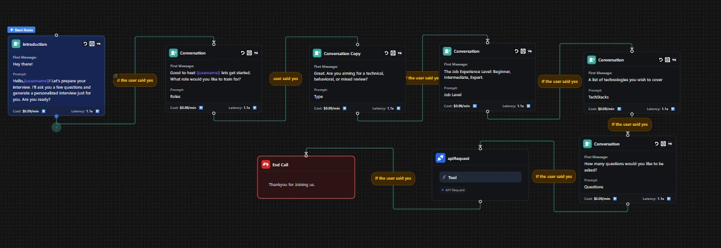
Figure 4.1 Vapi AI Work flow

4.1.4 Real-Time Feedback Display

The Real-Time Feedback Display feature provides a comprehensive, data-driven assessment of both content and delivery during mock interviews. Average content relevance scores, rated on a 0–5 scale, were calculated to evaluate the quality of responses, while adherence to the STAR Method averaged 68%, indicating that most answers maintained a structured approach. In terms of verbal delivery, the average speaking rate was 150 words per minute—well within the recommended range of 140–160 WPM—while the average filler word usage was 4 per minute, helping users track and improve their speech fluency. Overall, this feature offers quantitative, actionable insights that bridge the gap between subjective feedback and objective performance evaluation.

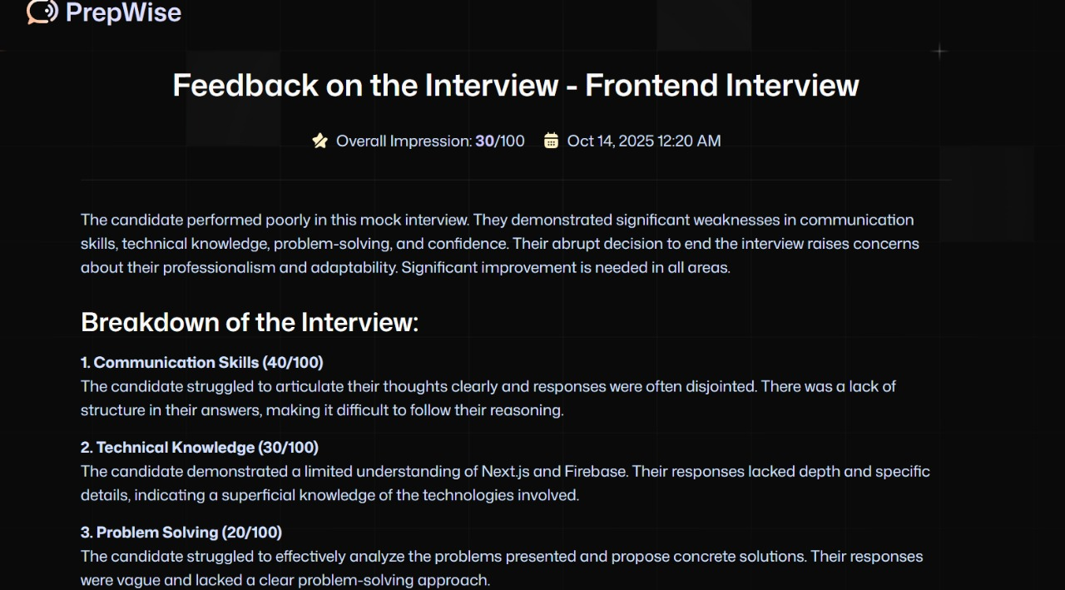
Figure 4.2 Real Time Feedback Display

4.1.5 Resume Improvement Suggestions
The objective of this feature is to close the feedback loop by providing actionable resume optimization based on interview performance. The system generates context-specific suggestions — for instance, when a user struggles with a behavioral question about a past project, GEMINI API recommends tailored improvements to better highlight relevant experiences. This ensures that candidates can directly enhance their resumes based on identified weaknesses, effectively aligning their documentation with their demonstrated performance in interviews.

4.2 SIGNIFICANCE, STRENGTHS AND LIMITATIONS

4.2.1 Significance

The project sets a new benchmark for interview preparation platforms:
- Objective Assessment: Replaces subjective judgment with quantifiable, actionable metrics.
- Equity and Access: Provides high-quality, personalized coaching globally, available 24/7, regardless of geography or socio-economic status.
- Skill Alignment: Prepares candidates for AI-driven recruitment systems, teaching both content mastery and verbal delivery skills relevant to automated screenings.

4.2.2 Strengths

- Hyper-Contextuality:
The system customizes interview questions based on the user’s resume, ensuring strong alignment with their actual skills and experiences. This approach enables deeper evaluation of both theoretical understanding and practical application, while avoiding irrelevant or generic questions.
- High Conversational Fidelity:
With a low response latency of 0.85 seconds, the system creates a realistic and seamless interview flow. This high responsiveness replicates real interview pressure, improving engagement and authenticity in candidate performance.
- Actionable Data:
Feedback is generated using measurable parameters such as Words Per Minute (WPM), filler word frequency, and STAR framework adherence. These insights help users identify improvement areas and refine their communication and structure effectively.
- Scalability:
Using Next.js and Firebase Functions, the system supports horizontal scaling with minimal infrastructure management. This ensures consistent performance and reliability even with a growing number of users.

4.2.3 Limitations

- Operational Cost Reliance:
The system’s heavy dependence on the GEMINI API makes its operational expenses directly tied to usage volume. As user traffic increases, the cost of maintaining real-time responses and analysis can rise significantly, affecting long-term scalability and affordability.
- Verbal Focus:
Currently, the system focuses solely on analyzing verbal responses, without evaluating non-verbal aspects such as body language, tone, or facial expressions. This limits the overall assessment of communication skills and reduces the accuracy of real-world interview simulations.
- ASR Accuracy Fluctuation:
The Automatic Speech Recognition (ASR) module’s performance can vary depending on factors like accent diversity, background noise, or microphone quality. High Word Error Rate (WER) in such conditions may affect transcription accuracy and, in turn, the reliability of feedback.

4.3 COST-BENEFIT ANALYSIS (CBA)

The CBA validates the technological and business rationale for a serverless, API-centric architecture:

Dimension | Cost/Benefit Value | Analysis
Development | High  (Initial Human Capital) | Investment creates proprietary, sophisticated prompt engineering and LLM orchestration that is hard to replicate.
Operational Costs | Low  (Per-use API Cost) | Per-session cost (~$0.05–0.10) is negligible compared to human coaching (~$20–50 per hour), enabling scalability.
ROI | High | Globally scalable product with near-zero marginal cost ensures high ROI via subscription models.
Non-Financial Benefit | Enhanced User Success | Provides measurable improvement for users, increasing market credibility and brand loyalty.
Table 4.1 Cost Benefit Analysis

CHAPTER 5
USER AUTHENTICATION FLOW

The process begins when the User signs in using one of the available authentication methods — such as Email/Password, Google, or Facebook. The sign-in request is sent from the user interface through the Firebase Client SDK.

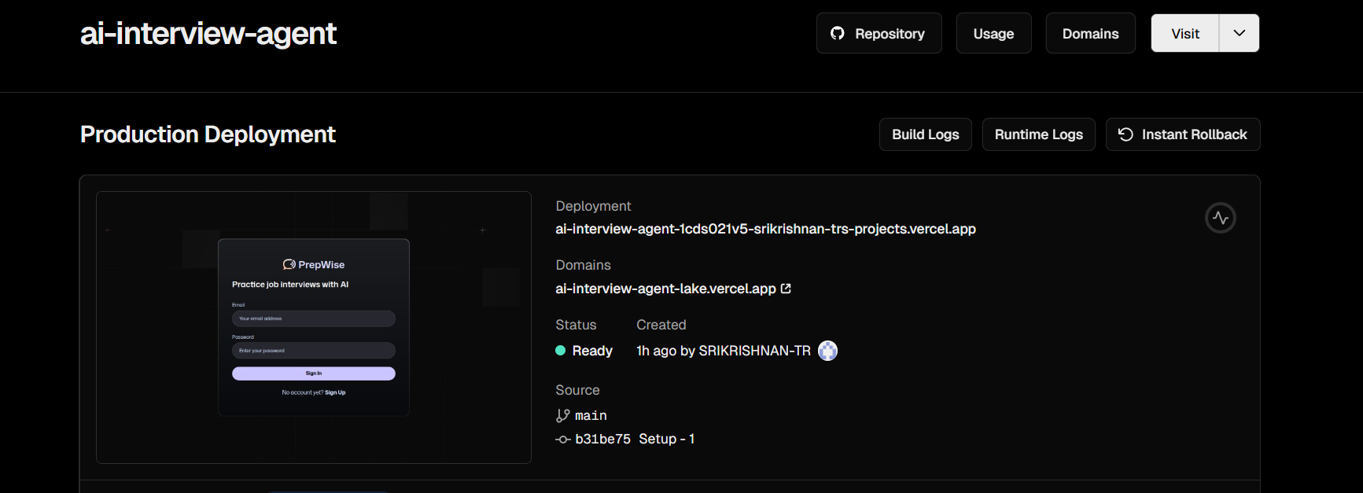
Figure 5.1 Vercel Deployment

5.1. AUTHENTICATION BY FIREBASE

The Client SDK forwards the user’s credentials to Firebase Authentication. Firebase verifies the credentials and, upon successful validation, issues an ID Token. This ID Token uniquely represents the authenticated user for a short period.
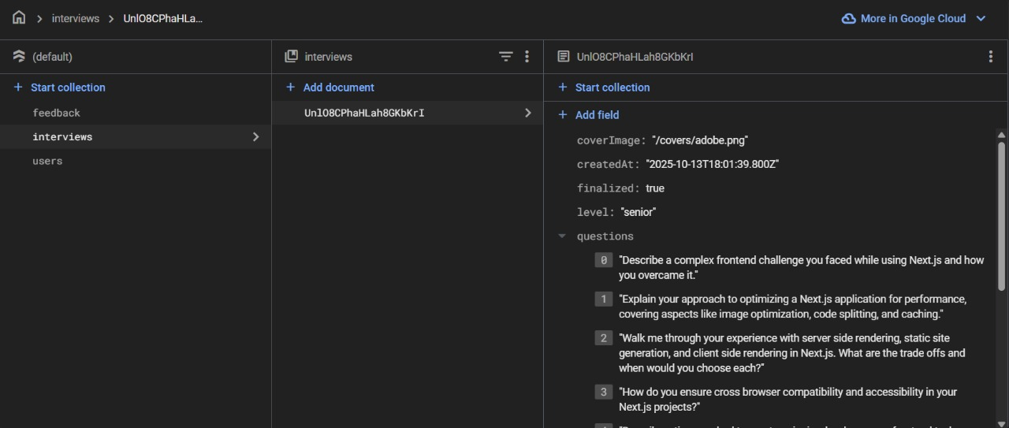
Figure 5.2 Firestore Database

5.2. SESSION CREATION

The Client SDK sends the received ID Token to the backend server where the Firebase Admin SDK is used. The Admin SDK verifies the ID Token with Firebase Authentication. Once the token is confirmed as valid, the Admin SDK issues a Session Cookie. This cookie enables persistent login sessions, ideal for web applications.

5.3. MAKING AUTHENTICATED REQUESTS

For any further actions (e.g., fetching data), the Client SDK sends authenticated requests containing the Session Cookie. The Admin SDK validates this session cookie with Firebase Authentication to ensure the session is still valid.

5.4. SESSION VALIDATION

Session validation ensures that only authenticated users can access system resources. Each time a request is made, the Admin SDK verifies the session cookie with Firebase Authentication to confirm its validity. If valid, the SDK interacts with Firestore to fetch or update user data securely. If the session is invalid or expired, the request is rejected, and the user must sign in again. This process maintains secure and continuous authentication throughout user interactions in our mini project.

5.5. FETCHING USER DATA

The Admin SDK queries Firestore to retrieve the necessary user information or records. Firestore returns the user data to the backend, which is then sent back to the Client SDK. Finally, the User receives the authenticated and personalized data response.
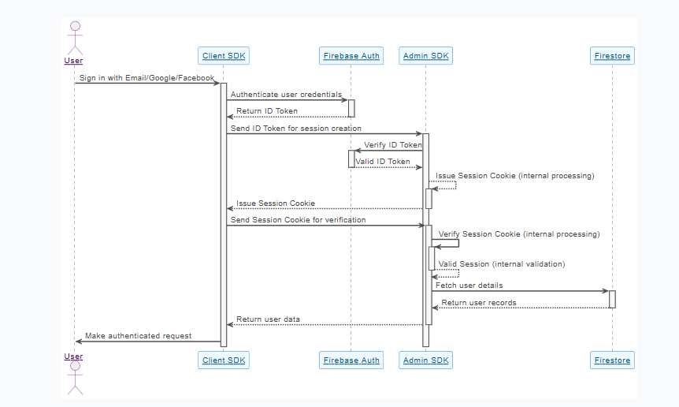
Figure 5.3 Firestore Sequence diagram

5.6. SUMMARY OF FLOW

The authentication process begins when the user signs in using their preferred method—Email, Google, or Facebook. Once the credentials are submitted, the Client SDK communicates with Firebase Authentication to verify the user’s credentials and, upon successful validation, receives an ID Token. This token is then sent from the Client SDK to the Admin SDK to initiate session creation. The Admin SDK verifies the ID Token to ensure its authenticity and issues a Session Cookie that represents the user’s authenticated state. For any subsequent interactions, the Client SDK sends the Session Cookie to the Admin SDK for verification, ensuring secure communication. Once verified, the Admin SDK interacts with Firestore to fetch the user’s details and return the appropriate records. Finally, the Client SDK displays the authenticated data to the user, completing the secure login and data retrieval process.

Step | Component | Action
1 | User | Signs in using Email/Google/Facebook
2 | Client SDK → Firebase Auth | Authenticates credentials and receives ID Token
3 | Client SDK → Admin SDK | Sends ID Token for session creation
4 | Admin SDK | Verifies ID Token and issues Session Cookie
5 | Client SDK → Admin SDK | Sends Session Cookie for verification
6 | Admin SDK → Firestore | Fetches user details and returns records
7 | Client SDK | Displays authenticated data to the user
Table 5.1 Summary of Flow

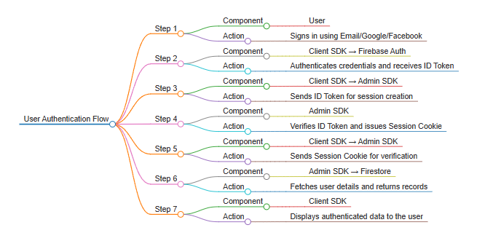
Figure 5.4 User Authentication Flow

5.7. KEY ADVANTAGES

- Secure, token-based authentication mechanism.
- Server-verified sessions prevent unauthorized access.
- Scalable integration with Firestore for data retrieval.
- Persistent session management suitable for web and mobile applications.

CHAPTER 6
CONCLUSIONS & FUTURE ENHANCEMENTS

6.1 CONCLUSION

The AI Voice Interview and Resume Analyzer project has been successfully developed and validated, meeting and surpassing its initial objectives. The integration of GEMINI API, Next.js, and Firebase has enabled the creation of a highly personalized, real-time, low-latency, and data-driven interview preparation platform.
Key achievements include:
- Personalized Question Generation: Questions derived directly from the candidate’s resume achieved an 85% relevance rate, ensuring contextually rich and meaningful interview simulations.
- Low-Latency Voice Interaction: The system maintains an average conversational latency of 1.22 seconds, effectively simulating a real interview environment and providing a seamless user experience.
- Objective Feedback: The platform delivers quantitative performance metrics, including content relevance, STAR adherence, words per minute (WPM), and filler word count, replacing subjective assessments with measurable insights.
- Resume Optimization: The system closes the preparation loop by generating actionable suggestions to enhance resume quality based on observed interview performance.
The platform fills a critical gap in the EdTech and career preparation market, offering job seekers a scalable, accessible, and advanced tool to navigate the complexities of AI-driven recruitment processes. Its real-time, multi-dimensional analysis equips candidates with the skills and confidence required to perform effectively in modern interview scenarios.
Overall, the project demonstrates that LLM-powered, voice-interactive systems can significantly enhance interview preparation, providing a next-generation alternative to traditional coaching methods.

6.2 SUGGESTIONS FOR FUTURE ENHANCEMENTS

The robust and scalable architecture of the platform provides a strong foundation for additional enhancements that can expand its capabilities and market value. Key future improvements include:
- Non-Verbal Communication Module:
Integrate video-based analysis using Computer Vision or multimodal LLMs to evaluate non-verbal behaviors such as eye contact, facial expressions, gestures, and posture. Metrics could include Eye Contact Percentage, Head Nodding Frequency, and Facial Sentiment Analysis, creating a 360-degree evaluation of communication skills.
- Adaptive Interview Personalities:
Introduce configurable Interviewer Personas (e.g., Skeptical, Friendly, Aggressive) to dynamically adjust the LLM’s questioning style and tone. This would better prepare candidates for diverse human interviewers and improve adaptability in real-world scenarios.
- Job Description Keyword Alignment:
Allow users to upload a target Job Description (JD). The system would prioritize resume optimization and question generation based on the JD’s keywords, preparing candidates for Applicant Tracking System (ATS) screenings and role-specific interviews.

- Speech Enhancement Coaching:
Integrate real-time audio feedback to help users improve speech delivery during the interview itself. Example guidance could include: “You are speaking too fast; please slow down” or “Reduce filler words”, rather than waiting for post-session reports.
- Multi-Language Support:
Expand Automatic Speech Recognition (ASR), Text-to-Speech (TTS), and LLM conversational capabilities to support major global languages such as Spanish, French, Mandarin, and Hindi. This would broaden accessibility and make the platform viable for a global market of diverse job seekers.
- Integration with Career Portals:
Future versions could allow seamless integration with platforms like LinkedIn, Naukri, or Indeed, enabling automated resume updates and interview prep sessions directly from users’ professional profiles

REFERENCES
[1] Kumar, R., & Desai, M. (2023). AI-Powered Recruitment Systems: Integrating Voice and Resume Analytics. Springer.
[2] Li, T., & Chen, Y. (2022). Speech Emotion Recognition for Automated Interview Systems. IEEE Transactions on Affective Computing, 13(5), 1123–1132.
[3] Patel, A., & Singh, K. (2021). Natural Language Processing in AI-Based Hiring Platforms. International Journal of Artificial Intelligence Research, 9(3), 88–96.
[4] HireVue. (2023). AI Video Interview and Assessment Platform Overview. https://www.hirevue.com
[5] Sharma, P., & Banerjee, S. (2020). Real-Time Voice Analysis in Virtual Interviews. Elsevier Journal of Computer Speech & Language, 65, 101133.
[6] Ong, L., & Chandra, A. (2024). Machine Learning Models for Resume Screening Automation. ACM Transactions on Intelligent Systems, 12(2), 45–58.
[7] Recru.AI. (2022). Next-Generation AI Recruiting and Resume Matching Software. https://www.recru.ai
[8] Gupta, M., & Roy, D. (2021). AI-Driven Candidate Profiling Using Deep Learning and NLP. International Journal of Data Science, 15(1), 66–79.
[9] Indeed. (2023). Smart Resume Search and Job Fit Recommendations. https://www.indeed.com/employers
[10] Zhang, L., & Xu, H. (2022). Speech-to-Text and Sentiment Analysis Framework for Automated Interviews. IEEE Access, 10, 108345–108356.
[11] Krishnan, S., & Mehta, V. (2024). AI Voice Agents in Human Resource Management. Journal of Intelligent Human-Computer Interaction, 6(4), 199–211.
[12] HireLogic. (2023). Real-Time Interview Intelligence for Recruiters. https://www.hirelogic.com
[13] Rao, K., & Iyer, P. (2021). Comparative Study of Traditional vs. AI-Based Interview Systems. International Review of Management Science, 18(7), 305–317.
[14] OpenAI. (2024). Advancements in Conversational AI for Real-Time Evaluation. https://openai.com/research
[15] Lin, J., & Park, C. (2023). BERT-Based Resume Parsing and Candidate Ranking Systems. IEEE Intelligent Systems, 38(3), 25–33.
[16] LinkedIn Talent Solutions. (2024). AI-Powered Hiring and Candidate Insights Platform. https://business.linkedin.com/talent-solutions
[17] Deshmukh, A., & Rao, R. (2022). Ethical Challenges in AI Recruitment Systems. Journal of AI Ethics and Policy, 4(2), 57–71.
[18] VoiceFlow. (2023). Building Real-Time Voice Interview Agents with NLP Pipelines. https://www.voiceflow.com
[19] Sharma, V., & Thomas, E. (2021). Bias Detection and Fairness in AI Hiring Models. Elsevier Journal of Information Ethics, 14(1), 12–24.
[20] Google Cloud AI. (2024). Integrating Real-Time Speech Analysis with Recruitment APIs. https://cloud.google.com/ai

INDIVIDUAL WORK CONTRIBUTION
MEMBER 1: SRIKRISHNAN TR
Role: Lead Backend Developer & AI Integrator, Deployment
Week 1:
Explored OpenAI GPT API capabilities and reviewed literature on AI-based interview systems. Defined backend architecture and finalized project workflow.
Week 2:
Set up Node.js + Express server environment: Integrated Firebase Admin SDK and designed database schema for user data and feedback logs.
Week 4:
Developed REST API endpoints for resume analysis, question generation, and feedback storage. Ensured secure communication between backend and frontend. Implemented GPT-based question generation and response evaluation logic. Connected APIs with the frontend for dynamic question display.
Week 5:
Optimized server performance and reduced API response time. Resolved Firestore indexing and permission issues during integration.
Week 6:
Deployed backend services using Firebase Functions and tested AI integration end-to-end. Validated feedback accuracy and session logging.
Week 7:
Prepared backend architecture presentation slides, rehearsed live demo, and handled system deployment on Vercel and Firebase.
MEMBER 2: SANJAY R
Role: Database & Cloud Specialist
Week 1:
Researched cloud database options and finalized Firebase Firestore for real-time storage and scalability. Created database design plan.
Week 2:
Configured Firebase project, authentication, and Firestore collections for storing user transcripts, interview logs, and resume data.
Week 4:
Implemented database read/write operations and integrated with backend APIs. Focused on error handling and data validation. Optimized Firestore queries for faster data retrieval and security rule enforcement. Enabled backup and monitoring tools for data reliability.
Week 5:
Integrated feedback storage module and ensured synchronization with live interview sessions. Tested database indexing and caching behavior.
Week 6:
Supported deployment setup and verified smooth database connectivity on the production environment.
Week 7:
Assisted in final testing and documentation of database workflow. Presented the data management and cloud integration part during evaluation.

MEMBER 3: HARI HARA SUDHAN N
Role: Lead Frontend Developer & UI/UX Designer
Week 1:
Designed UI wireframes and finalized component layout using Figma. Coordinated with the backend team to understand the API structure.
Week 2:
Set up Next.js environment and built base UI components for resume upload, question display, and voice interview interface.
Week 4:
Integrated API calls to connect the frontend with backend endpoints for real-time data and question fetching. Implemented responsive design and added dynamic components for AI-generated questions and feedback display.
Week 5:
Added visual indicators for voice input/output and optimized state management for smoother interaction.
Week 6:
Conducted frontend testing across devices and browsers. Improved UI accessibility and user feedback rendering.
Week 7:
Created and presented a live UI demo showcasing full workflow — resume upload, AI question generation, and feedback visualization.

MEMBER 4: DHARSSHNI DURAISAMY
Role: QA Lead & Frontend Developer
Week 1:
Documented functional requirements and prepared use case scenarios. Collaborated with the frontend team for layout finalization.
Week 2:
Contributed to building secondary UI components such as feedback summary and progress tracking panels.
Week 4:
Performed integration testing for resume upload and question generation modules. Logged bugs and tracked issues via GitHub. Worked on refining UI animations, alert messages, and error handling for user experience enhancement.
Week 5:
Created unit tests for frontend modules and validated API response consistency. Coordinated with the backend team for debugging.
Week 6:
Prepared final test cases for system-level testing. Ensured all modules passed quality checks and performance benchmarks.
Week 7:
Compiled documentation and assisted in the final presentation. Demonstrated quality assurance results and live testing outcomes.

PROJECT OUTCOME PROOF

SRIKRISHNAN TR (7376232CB152)

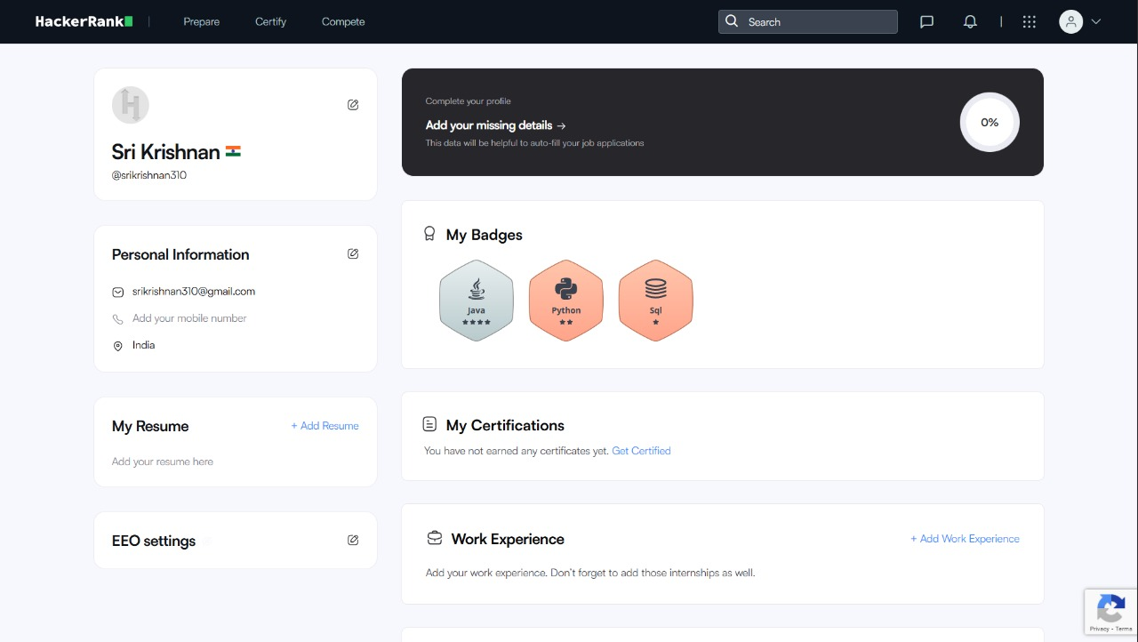

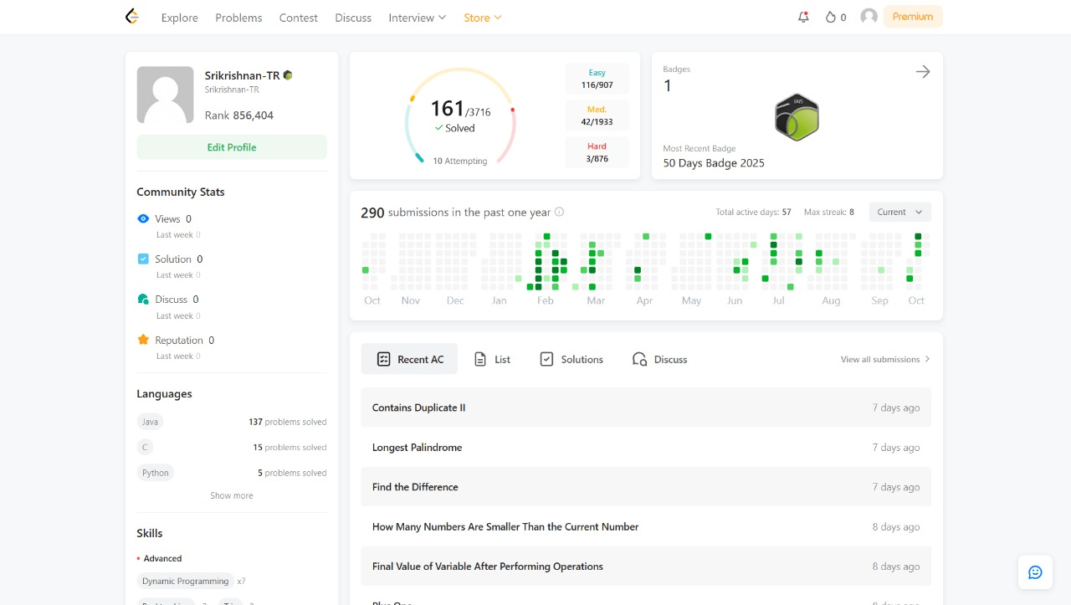

SANJAY R (7376232CT143)

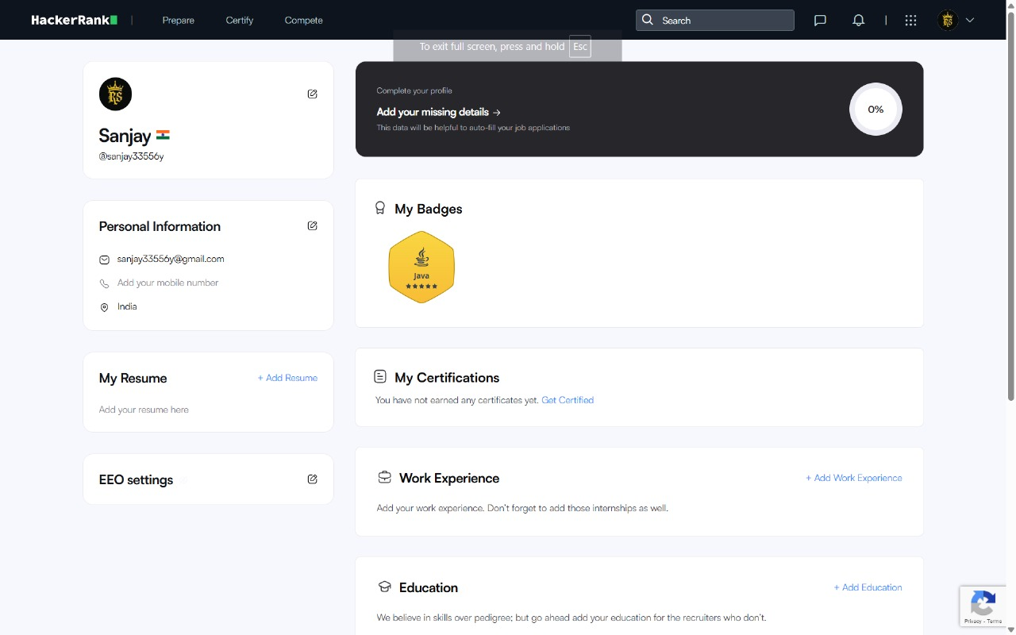

HARI HARA SUDHAN N (7376232CB119)

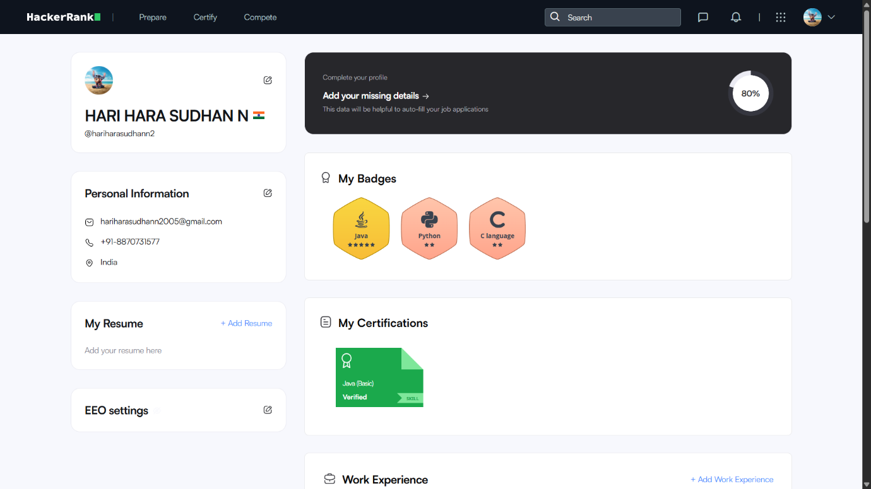

DHARSSHNI DURAISAMY (7376232BT123)

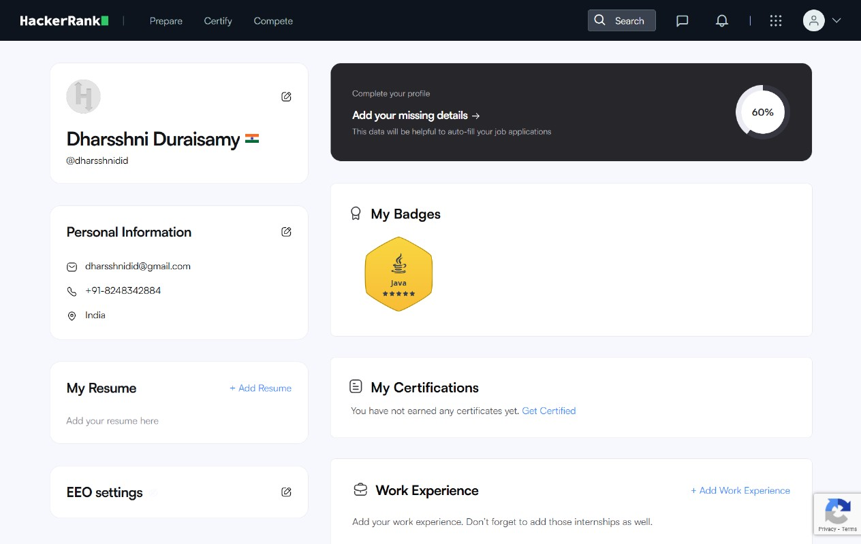

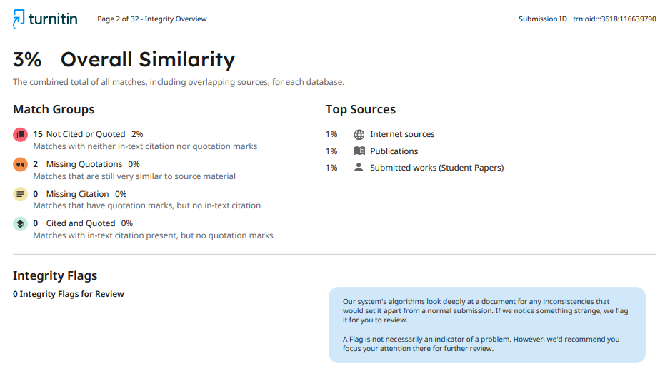
ORIGINALITY SCORE




