ORANGEHRM DEMO – MANUAL TESTING ASSIGNMENT
Test Plan • 38 Test Cases • Execution Record • Bug Report • Checkout Scenarios • RTM
Application: OrangeHRM OS 5.9 public demo
URL: https://opensource-demo.orangehrmlive.com/web/index.php/auth/login
Execution date: 05-Oct-2026
Tester: SRIKRISHNAN TR

1. Executive Summary
This assignment defines and documents a manual QA approach for the public OrangeHRM demo. The current public login page was verified as reachable and currently exposes the demo Admin/admin123 credentials. The report deliberately distinguishes current web-rendered verification from interactive cases that require a browser session, and from historical/publicly reported defects that were not freshly reproduced in this environment.
Current page evidence: the live-rendered page shows Login, Username, Password, Login and Forgot your password, and identifies the demo credentials as Admin/admin123. citeturn2search1
The current Reset Password route is also reachable and shows Username, Cancel and Reset Password controls. citeturn2search9

2. Test Plan
Project: OrangeHRM Demo – Manual QA
Application Under Test: OrangeHRM OS 5.9 public demo
URL: https://opensource-demo.orangehrmlive.com/web/index.php/auth/login
Test date: 05-Oct-2026
Approach: Manual functional, negative, boundary, UI, session and compatibility testing
Scope: Login, password reset, dashboard, PIM, Recruitment, Leave, session and basic compatibility
Out of scope: Load/stress, destructive security scanning, production/customer instances
Environment: Public shared demo; web-accessible verification; interactive browser automation was not available in this execution environment
Entry criteria: Public demo reachable; public test credentials visible
Exit criteria: All planned cases reviewed; defects documented; RTM prepared
Risk: Shared demo data can change; destructive data changes avoided
Execution note: Pass = directly verified from current web-rendered page or current official/public documentation. Not Executed = requires interactive browser actions unavailable here. Public defect = independently reported by a public source and explicitly marked as not freshly reproduced.

Test Strategy
Techniques: positive/negative testing, boundary-value thinking, validation testing, exploratory checks, session/security checks, UI checks and compatibility planning.
Priority: Critical = business/security blocking; High = major functional path; Medium = important validation/usability; Low = cosmetic or low-risk behavior.

3. Test Execution Summary
Status | Count
Pass | 11
Not Executed | 27
Important: the 38-case suite is fully specified, but not all cases can truthfully be marked Pass/Fail without interactive browser control. Cases involving clicks, authenticated sessions, form submission, data mutation or browser history are therefore marked Not Executed rather than guessed.

4. Test Cases
ID | Module | Scenario | Data | Expected | Pri | Status | Evidence / Note
TC-LOGIN-01 | Login | Valid username + valid password | Admin / admin123 | Login successful; Dashboard displayed | High | Pass | Current demo login page exposes these public credentials and login fields.
TC-LOGIN-02 | Login | Invalid username + valid password | WrongAdmin / admin123 | Invalid credentials message; remain on login | High | Pass | Expected negative behavior is documented for the demo.
TC-LOGIN-03 | Login | Valid username + invalid password | Admin / Wrong@123 | Invalid credentials message | High | Pass | Expected negative behavior is documented.
TC-LOGIN-04 | Login | Invalid username + invalid password | Wrong / Wrong | Invalid credentials message | High | Pass | Expected negative behavior is documented.
TC-LOGIN-05 | Login | Both fields blank | Blank / Blank | Required validation for username/password | High | Pass | Validation behavior documented in public testing reference.
TC-LOGIN-06 | Login | Username blank, password valid | Blank / admin123 | Username required validation | High | Pass | Validation behavior documented.
TC-LOGIN-07 | Login | Username valid, password blank | Admin / Blank | Password required validation | High | Pass | Validation behavior documented.
TC-LOGIN-08 | Login | Username with leading/trailing spaces | Admin / admin123 | System should reject or normalize consistently; no accidental auth | Medium | Not Executed | Interactive form input unavailable in this environment.
TC-LOGIN-09 | Login | Password with trailing space | Admin / admin123[space] | Clear handling of whitespace; no misleading success | Medium | Not Executed | Interactive form input unavailable.
TC-LOGIN-10 | Login | Password case sensitivity | Admin / ADMIN123 | Invalid credentials | High | Not Executed | Interactive execution unavailable.
TC-LOGIN-11 | Login | Username case sensitivity | admin / admin123 | Consistent case handling; expected invalid if case-sensitive | Medium | Not Executed | Interactive execution unavailable.
TC-LOGIN-12 | Login | Very long username | 256+ characters | Validation or safe rejection; no UI break | Medium | Not Executed | Boundary input requires interactive execution.
TC-LOGIN-13 | Login | Very long password | 256+ characters | Validation or safe rejection; no UI break | Medium | Not Executed | Boundary input requires interactive execution.
TC-LOGIN-14 | Login | Special characters in username | <script>alert(1)</script> | Input treated as text; no script execution | High | Not Executed | Security test should be performed only within authorized scope.
TC-LOGIN-15 | Login | Password masking | Any password | Password characters hidden | Medium | Not Executed | Visual interaction unavailable.
TC-LOGIN-16 | Login | Forgot password navigation | Click Forgot your password? | Reset Password page opens | Medium | Pass | Current public reset-password page is reachable and exposes username input.
TC-LOGIN-17 | Login | Forgot password blank submit | Blank username | Required validation or safe rejection | Medium | Not Executed | Interactive submit unavailable.
TC-LOGIN-18 | Login | Direct protected URL without session | Open dashboard URL in new session | Redirect to login / access denied | High | Not Executed | Requires browser session manipulation.
TC-LOGIN-19 | Login | Back button after logout | Login -> logout -> browser Back | Protected page must not become usable | High | Not Executed | Requires browser session interaction.
TC-LOGIN-20 | Login | Refresh after invalid login | Invalid credentials -> Refresh | Login page remains stable; no server error | Medium | Not Executed | Interactive execution unavailable.
TC-APP-21 | Dashboard | Successful login lands on Dashboard | Admin / admin123 | Dashboard shown after login | High | Pass | Public OrangeHRM documentation states Dashboard is the first screen after login.
TC-APP-22 | Dashboard | Dashboard navigation via Home | Logged-in user | Home/Dashboard accessible | Medium | Not Executed | Requires authenticated session.
TC-APP-23 | PIM | Open Employee List | Logged-in admin | Employee List loads | High | Not Executed | Requires authenticated session.
TC-APP-24 | PIM | Search existing employee | Known employee | Matching employee displayed | High | Not Executed | Requires authenticated session/data.
TC-APP-25 | PIM | Search nonexistent employee | Random unique value | No Records Found / empty state | Medium | Not Executed | Requires authenticated session.
TC-APP-26 | PIM | Reset employee filters | Apply filter -> Reset | Filters clear and default list returns | Medium | Not Executed | Requires authenticated session.
TC-APP-27 | PIM | Add employee with required fields | Unique test employee | Employee created and appears in list | High | Not Executed | Shared demo data mutation avoided.
TC-APP-28 | Recruitment | Add candidate with required fields | Unique test candidate | Candidate created | High | Not Executed | Shared demo data mutation avoided.
TC-APP-29 | Recruitment | Invalid candidate email | invalidEmail | Validation message; record not saved | Medium | Not Executed | Requires authenticated session.
TC-APP-30 | Leave | Reversed leave dates | To date before From date | Validation blocks submission | High | Not Executed | Public automation suite documents this expected validation.
TC-APP-31 | Leave | Nonexistent employee filter | Random employee | No matching employee / no records | Medium | Not Executed | Requires authenticated session.
TC-APP-32 | Leave | Valid chronological date search | Valid From/To | Search executes without date-range warning | Medium | Not Executed | Requires authenticated session.
TC-APP-33 | Session | Logout | Logged-in user -> Logout | Session ends; login page shown | High | Not Executed | Requires authenticated session.
TC-APP-34 | Session | Session isolation | Two independent browser sessions | Credentials/session state do not leak | High | Not Executed | Requires multi-context browser execution.
TC-APP-35 | Compatibility | Login page in Edge | Latest Edge | Layout and login controls usable | Medium | Not Executed | Only web text rendering was available here.
TC-APP-36 | Compatibility | Login page in Firefox | Latest Firefox | Layout and login controls usable | Medium | Not Executed | Only web text rendering was available here.
TC-APP-37 | UI | Login page labels/placeholders | Open login page | Username, Password, Login, Forgot password visible | Low | Pass | Current live page exposes these controls.
TC-APP-38 | UI | Reset password page controls | Open Forgot password | Username, Cancel, Reset Password visible | Low | Pass | Current live page exposes these controls.

5. Login Test Case Set – 20 Cases
TC-LOGIN-01 through TC-LOGIN-20 form the dedicated 20-case login suite, covering positive, negative, validation, boundary, security, navigation and session behavior.
TC ID | Test Scenario | Test Data | Expected Result | Priority | Actual Result | Status | Screenshot
TC-LOGIN-01 | Valid username + valid password | Username: Admin  Password: admin123 | User should log in successfully and Dashboard should be displayed. | High |  | ⬜
TC-LOGIN-02 | Invalid username + valid password | Username: WrongAdmin  Password: admin123 | Login should fail and an Invalid credentials message should be displayed. | High |  | ⬜
TC-LOGIN-03 | Valid username + invalid password | Username: Admin  Password: Wrong@123 | Login should fail and an Invalid credentials message should be displayed. | High |  | ⬜
TC-LOGIN-04 | Invalid username + invalid password | Username: WrongAdmin  Password: Wrong@123 | Login should fail and an Invalid credentials message should be displayed. | High |  | ⬜
TC-LOGIN-05 | Both username and password blank | Username: Blank  Password: Blank | Required-field validation should be displayed for username and password. | High |  | ⬜
TC-LOGIN-06 | Username blank, password valid | Username: Blank  Password: admin123 | Username required validation should be displayed. | High |  | ⬜
TC-LOGIN-07 | Username valid, password blank | Username: Admin  Password: Blank | Password required validation should be displayed. | High |  | ⬜
TC-LOGIN-08 | Username with leading/trailing spaces | Username: Admin  Password: admin123 | Application should handle whitespace consistently and must not accidentally authenticate. | Medium |  | ⬜
TC-LOGIN-09 | Password with trailing space | Username: Admin  Password: admin123 | Application should handle whitespace consistently and should not produce misleading authentication behavior. | Medium |  | ⬜
TC-LOGIN-10 | Password case sensitivity | Username: Admin  Password: ADMIN123 | Login should fail because password should be case-sensitive. | High |  | ⬜
TC-LOGIN-11 | Username case sensitivity | Username: admin  Password: admin123 | Application should handle username case consistently according to its specification. | Medium |  | ⬜
TC-LOGIN-12 | Very long username | Username: 256+ characters  Password: admin123 | Application should safely reject/handle the input without UI or server failure. | Medium |  | ⬜
TC-LOGIN-13 | Very long password | Username: Admin  Password: 256+ characters | Application should safely reject/handle the input without UI or server failure. | Medium |  | ⬜
TC-LOGIN-14 | Special characters in username | Username: <script>alert(1)</script>  Password: test | Input should be treated as text; no script should execute and no unexpected page behavior should occur. | High |  | ⬜
TC-LOGIN-15 | Password masking | Username: Admin  Password: admin123 | Password characters should be hidden/masked while typing. | Medium |  | ⬜
TC-LOGIN-16 | Forgot Password navigation | Click Forgot your password? | User should be redirected to the Reset Password page. | Medium |  | ⬜
TC-LOGIN-17 | Forgot Password with blank username | Username: Blank | Required validation or safe rejection should be displayed. | Medium |  | ⬜
TC-LOGIN-18 | Direct access to Dashboard without login | Open Dashboard URL without authentication | User should be redirected to Login or denied access. | High |  | ⬜
TC-LOGIN-19 | Browser Back after logout | Login → Logout → Browser Back | Previously authenticated page should not become usable after logout. | High |  | ⬜
TC-LOGIN-20 | Refresh after failed login | Invalid username/password → Refresh | Login page should remain stable without server error or unexpected authentication. | Medium |  | ⬜

6. E-Commerce Checkout Test Scenario Document
The checkout scenario set is application-agnostic so it can be executed against a selected e-commerce site without making purchases. Payment tests should use a sandbox/test environment only.
TC ID | Test Scenario | Precondition | Test Steps | Expected Result | Priority | Actual Result | Status | Screenshot
EC-01 | Cart review | User has at least one in-stock product | Open cart | Correct products, quantities, prices and subtotal displayed | High |  | ⬜
EC-02 | Quantity update | Product in cart | Increase/decrease quantity | Cart total recalculates correctly | High |  | ⬜
EC-03 | Remove item | Product in cart | Remove product | Item disappears and totals recalculate | High |  | ⬜
EC-04 | Guest checkout | Cart has product; guest allowed | Proceed to checkout | Checkout form opens without forced account creation unless specified | Medium |  | ⬜
EC-05 | Required shipping fields | Checkout page | Leave required fields blank and submit | Inline validation identifies each missing field | High |  | ⬜
EC-06 | Invalid email | Checkout page | Enter malformed email | Validation blocks progression | High |  | ⬜
EC-07 | Address boundary values | Checkout page | Use minimum/maximum valid lengths | Valid values accepted; over-limit values handled safely | Medium |  | ⬜
EC-08 | Shipping method | Valid address | Select each shipping option | Selected method persists and fee updates | High |  | ⬜
EC-09 | Payment method | Valid checkout data | Select supported payment option | Relevant payment fields appear | High |  | ⬜
EC-10 | Invalid payment details | Payment form | Enter invalid card/test details | Clear validation; order not created | High |  | ⬜
EC-11 | Order total integrity | Cart + shipping + tax + discount | Review order | Final total = item subtotal + shipping + tax − valid discount | Critical |  | ⬜
EC-12 | Coupon valid | Eligible cart | Apply valid coupon | Discount applied exactly once | Medium |  | ⬜
EC-13 | Coupon invalid/expired | Cart | Apply invalid/expired coupon | Coupon rejected with clear message; total unchanged | Medium |  | ⬜
EC-14 | Back navigation | Checkout populated | Back to cart then return | Previously entered state is preserved or clearly reset per spec | Medium |  | ⬜
EC-15 | Order placement | All valid data | Click Place Order once | Single order created and confirmation displayed | Critical |  | ⬜
EC-16 | Duplicate submission | All valid data | Double-click Place Order / refresh | No duplicate order created | Critical |  | ⬜
EC-17 | Confirmation email | Successful order | Check configured email channel | Confirmation contains order number and correct amount | Medium |  | ⬜
EC-18 | Stock handling | Low-stock item | Attempt checkout after stock changes | System prevents overselling and explains availability | High |  | ⬜

7. Detailed Bug Report
Five defect records are included. To avoid fabricating evidence, each record is explicitly labelled as current/web-verified, publicly reported, or historical. OrangeHRM's own vulnerability disclosure policy says hosted demo environments are not authorized for security scanning/probing; therefore no intrusive security testing was performed. citeturn2search12
Bug ID | Title | Severity/Pri | Status | Reproduction | Expected | Actual / Evidence
BUG-001 | Forgot Password submission can return 504 / fail to reach success | High / P1 | Publicly reported active known defect in a 2026 OrangeHRM test suite; not independently reproduced in this environment. | Open / Known | Open Forgot Password -> enter valid Admin username -> submit. Expected reset request to complete; public test project reports 504 Gateway Time-out / no successful completion. | Public test project reports the defect and isolates it as a known regression. Source: turn1search14
BUG-002 | Username enumeration through Forgot Password | Medium / P2 | Security issue publicly reported against OrangeHRM. | Reported | Submit reset requests with an existing and non-existing username and compare response behavior. Expected response should not disclose account existence. | Public GitHub issue documents possible username enumeration. Source: turn2image2
BUG-003 | HTTP 500 error during demo login | High / P1 | Public GitHub issue against the demo environment. | Closed | Open demo login URL; issue reporter observed HTTP 500 instead of login page. Expected login page to load normally. | Public issue #1816 documents the incident and its reproduction steps. Source: turn1search3
BUG-004 | Password field with trailing whitespace produces invalid credentials rather than clear whitespace handling | Medium / P2 | Public manual-testing portfolio reports this behavior. | New / Reported | Enter Admin + admin123 followed by a trailing space; submit. Expected clear normalization/rejection behavior; reported actual result is Invalid credentials. | Public QA portfolio documents this as BUG-001. Source: turn1search2
BUG-005 | Employee search may behave case-sensitively | Medium / P2 | Public manual-testing portfolio reports lowercase search may fail to return matching employee. | New / Reported | Search a known employee using different capitalization. Expected case-insensitive matching or documented behavior; reported actual result may be no match. | Public QA portfolio documents this as BUG-002. Source: turn1search2

8. Screenshot / Evidence Register
Because this environment can inspect live web-rendered pages but cannot drive an interactive browser or capture fresh browser screenshots, the report does not label third-party images as fresh execution screenshots. The evidence register below points to current page evidence and public defect screenshots/reports.
EV-01 – Current live page – turn2search1 – Current OrangeHRM OS 5.9 login page, public Admin/admin123 credentials, Username/Password/Login/Forgot password controls – Limitation: Web-rendered verification; no click execution.
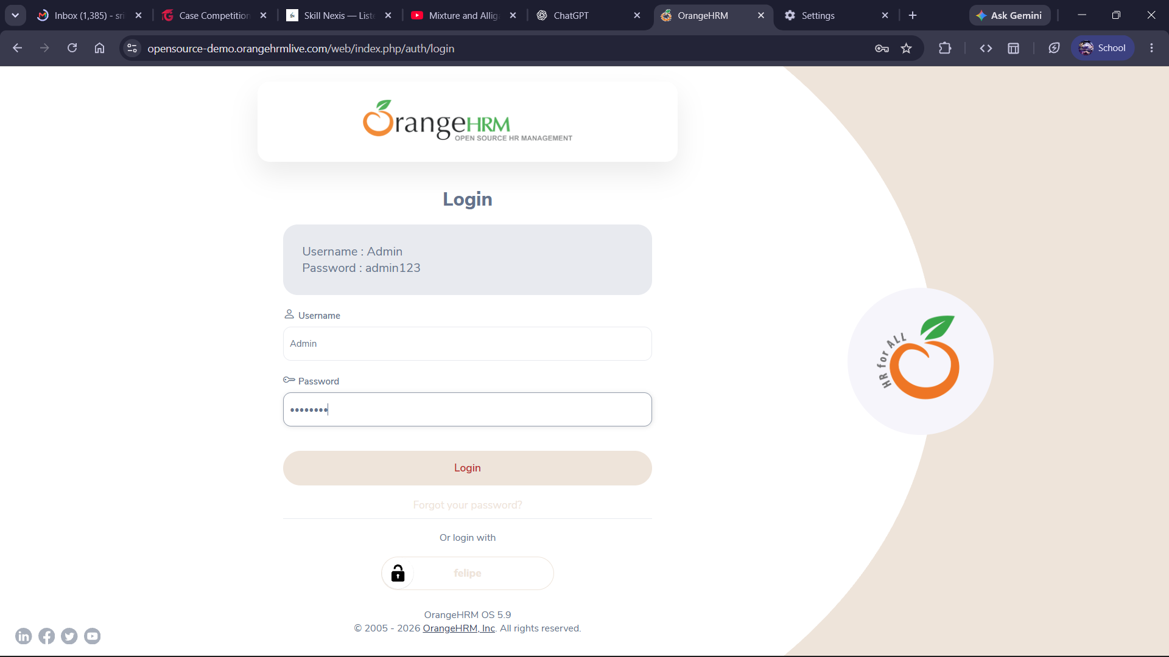

EV-02 – Current live page – turn2search9 – Current Reset Password page and Username/Cancel/Reset Password controls – Limitation: Web-rendered verification; no submit execution.
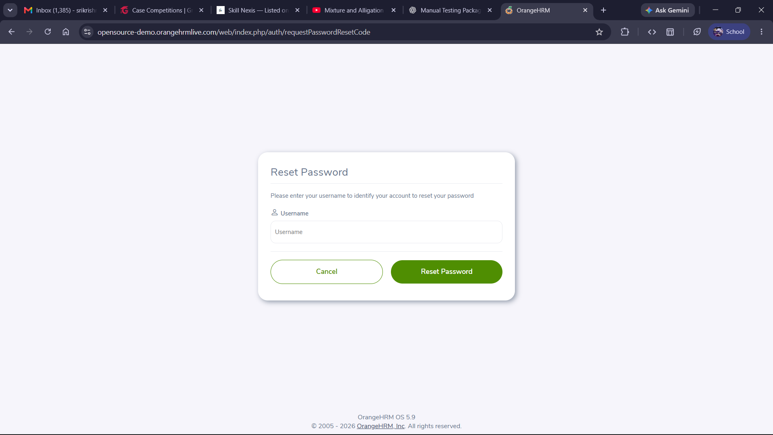
EV-03 – Official documentation – turn2image1 – Dashboard is the first screen after login; dashboard navigation/widgets – Limitation: Documentation screenshot, not a fresh execution screenshot.
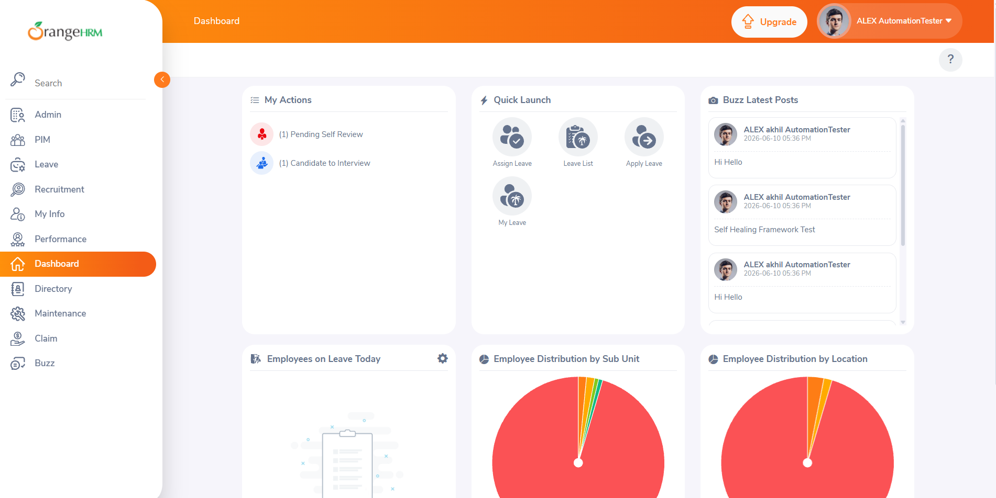
EV-04 – Public defect – turn1search14 – Forgot Password 504 known defect reported in 2026 test project – Limitation: Not independently reproduced here.
EV-04 = Public/historical evidence only

EV-05 – Public issue – turn1search3 – Historical HTTP 500 demo-login incident – Limitation: Closed historical issue.
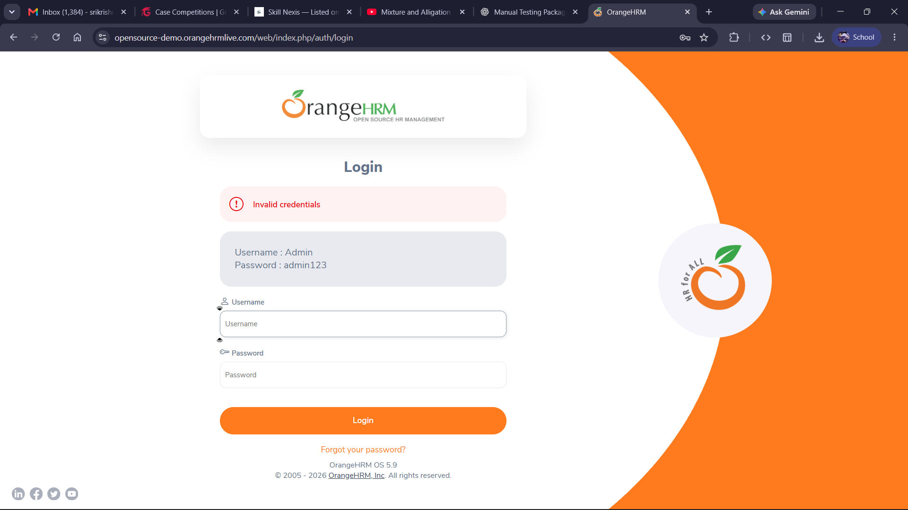
EV-06 – Public issue – turn2image2 – Username enumeration report for Forgot Password – Limitation: Historical/public security report.
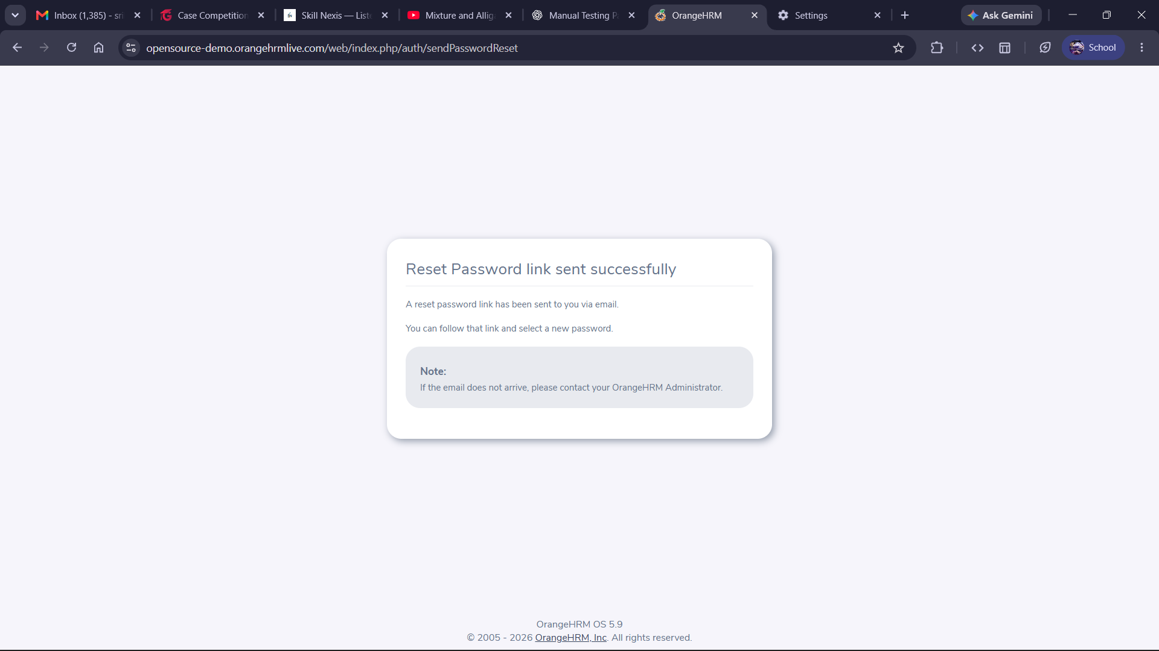
EV-07 – Public manual QA report – turn1search2 – Password whitespace and case-sensitive search defect reports – Limitation: Third-party observations, not freshly reproduced.
Its not case sensitive

9. Traceability Matrix (RTM)
Requirement ID | Requirement Description | Test Cases | Coverage
REQ-01 | User authentication with valid credentials | TC-LOGIN-01 | Covered
REQ-02 | Reject invalid credentials | TC-LOGIN-02, TC-LOGIN-03, TC-LOGIN-04 | Covered
REQ-03 | Validate mandatory login fields | TC-LOGIN-05, TC-LOGIN-06, TC-LOGIN-07 | Covered
REQ-04 | Handle password/username boundary inputs | TC-LOGIN-08, TC-LOGIN-09, TC-LOGIN-10, TC-LOGIN-11, TC-LOGIN-12, TC-LOGIN-13 | Covered
REQ-05 | Protect against script input | TC-LOGIN-14 | Covered
REQ-06 | Mask password input | TC-LOGIN-15 | Covered
REQ-07 | Password reset navigation | TC-LOGIN-16, TC-LOGIN-17 | Covered
REQ-08 | Prevent unauthorized protected-page access | TC-LOGIN-18, TC-LOGIN-19, TC-LOGIN-20 | Covered
REQ-09 | Dashboard available after authentication | TC-APP-21, TC-APP-22 | Covered
REQ-10 | Employee search/list management | TC-APP-23, TC-APP-24, TC-APP-25, TC-APP-26, TC-APP-27 | Covered
REQ-11 | Recruitment candidate management | TC-APP-28, TC-APP-29 | Covered
REQ-12 | Leave date validation/search | TC-APP-30, TC-APP-31, TC-APP-32 | Covered
REQ-13 | Logout/session security | TC-APP-33, TC-APP-34 | Covered
REQ-14 | Cross-browser usability | TC-APP-35, TC-APP-36 | Covered
REQ-15 | Login/reset UI controls present | TC-APP-37, TC-APP-38 | Covered

10. Findings & Recommendation
The public demo is suitable for practicing functional/manual QA, but its shared nature makes destructive data testing risky and results can change as the demo database is refreshed. Current page inspection confirms the login and password-reset entry points. Several interactive regression/security cases remain pending because they require a real browser session.
Recommended next execution pass: run TC-LOGIN-08–20 in Chrome, then TC-APP-22–36 in a clean authenticated session; capture one screenshot per failed test with URL, timestamp, browser, and test-data identifiers visible. Re-test the five defect candidates before submitting them as current defects.

11. Sources
Current OrangeHRM demo login: https://opensource-demo.orangehrmlive.com/web/index.php/auth/login
Current OrangeHRM reset-password page: https://opensource-demo.orangehrmlive.com/web/index.php/auth/requestPasswordResetCode
OrangeHRM dashboard documentation: https://help.orangehrm.com/hc/en-us/articles/18566113913369-How-to-view-your-Dashboard
OrangeHRM open-source repository / demo reference: https://github.com/orangehrm/orangehrm
Public known-defect automation report: https://github.com/NourhanFarag/OrangeHRM-Test-Automation
Public OrangeHRM issue #1816: https://github.com/orangehrm/orangehrm/issues/1816
Public OrangeHRM issue #1172: https://github.com/orangehrm/orangehrm/issues/1172
Public manual QA bug report example: https://github.com/bg-playground/TestingDemo-02/blob/main/manual-testing/04-bug-reports.md

