1. After pom.xml
2. Change the password in the log.

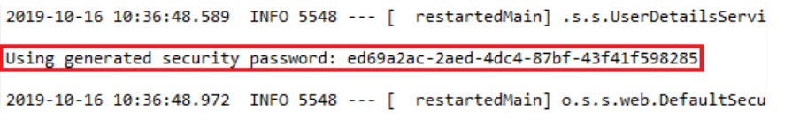

1. Now, we have to send POST request in POSTMAN

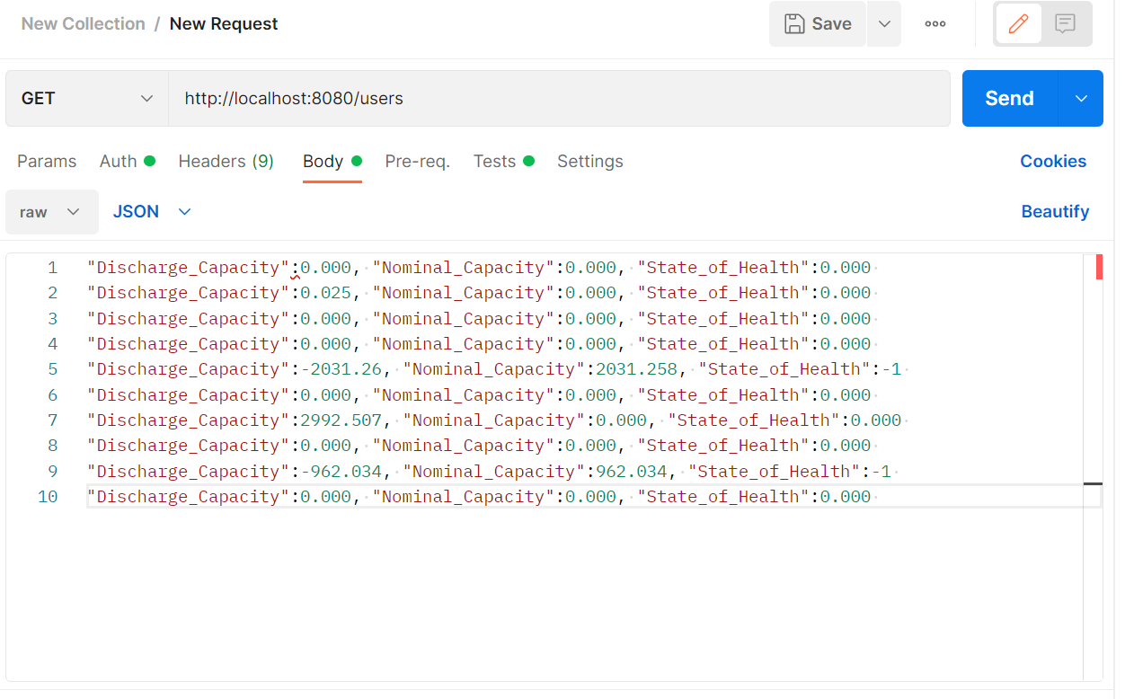

In the REST client Postman, click on the Authorization tab and do the following:

1. Select the type of authentication Basic Auth.
2. Provide the Username. The default username is user.
3. Paste the password, which we have copied from the log.
4. Click on the Send button.

