Jenkins

What is Jenkins?
Jenkins is an open-source automation tool used for Continuous Integration (CI) and Continuous Deployment (CD).
It automatically:
- Builds code
- Tests code
- Deploys applications
Whenever changes are pushed to GitHub.

Why Jenkins is Used
- Automates manual work
- Saves time
- Reduces human errors
- Ensures code is always tested and ready

How Jenkins is Used in Your Project (Git + Docker Example)
You are using:
- Ubuntu
- GitHub
- Node.js app
- Docker
Here’s how Jenkins fits:

Step-by-Step Flow

1️ Developer pushes code to GitHub
git add .
git commit -m "Updated app"
git push

2️ Jenkins Detects Change
Jenkins is connected to GitHub.
When new code is pushed, Jenkins automatically starts a job.

3️ Jenkins Builds the Project
Jenkins:
- Pulls latest code from GitHub

- Runs:
- docker build -t myapp .

4 Jenkins Runs or Deploys Container

Jenkins can run:

docker run -d -p 3000:3000 myapp

Now the updated app is deployed automatically.

Simple Architecture Flow

Developer → GitHub → Jenkins → Docker Build → Docker Run → Application Live

Important Jenkins Concepts Job
A task Jenkins performs (build, test, deploy).

Pipeline

A series of steps automated in order (build → test → deploy).

Plugin

Extra tools to connect Jenkins with GitHub, Docker, etc.

Jenkins Installation - (Ubuntu 24.04)

Install Java (Required for Jenkins)

Jenkins needs Java to run.

  - Update system (already done):
  - sudo apt update
  - sudo apt upgrade
  - Install Java 21 (Eclipse Temurin)
  - Verify:
  - java –version

Add Jenkins Repository & Install

  - Add Jenkins GPG key and repository
  - Update package list
  - Install Jenkins:
  - sudo apt install jenkins
  - Check status:
  - systemctl status jenkins

Jenkins service should be active and running. 3 Customize Jenkins Service
  - Stop Jenkins:
  - sudo systemctl stop jenkins
  - Edit service configuration:
  - sudo systemctl edit jenkins
  - Add custom JAVA_OPTS or plugin directory if needed.
  - Reload and restart Jenkins.

This allows changing:

  - Java options
  - Temp directory
  - Plugin directory

Fix Directory Permissions

  - Create required directories
  - Change ownership:
  - sudo chown -R jenkins:jenkins /path

Ensures Jenkins has proper access.

Start Jenkins & Check Logs

  - Start service:
  - sudo systemctl start jenkins
  - View logs:
  - journalctl -u jenkins Confirms Jenkins started successfully. 6 Web UI Setup
- Open browser:
- http://your-server-ip:8080
- Copy initial admin password from:
- /var/lib/jenkins/secrets/initialAdminPassword
- Paste password
- Install suggested plugins
- Create admin user

Now Jenkins dashboard is ready.

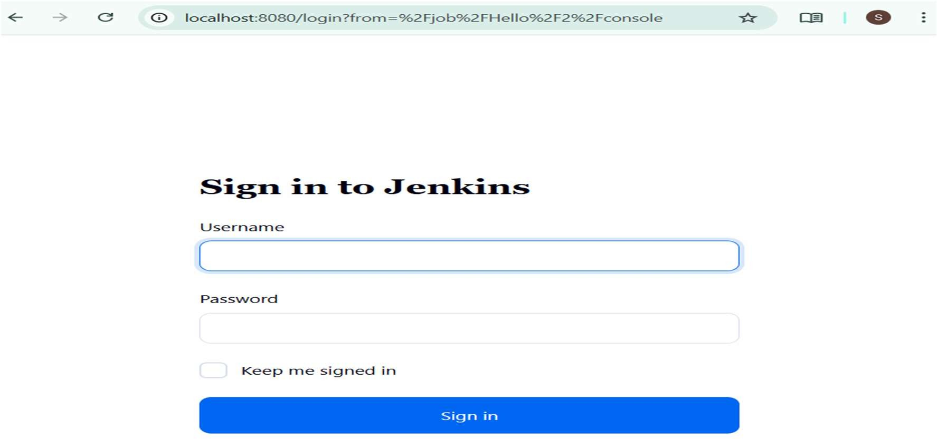

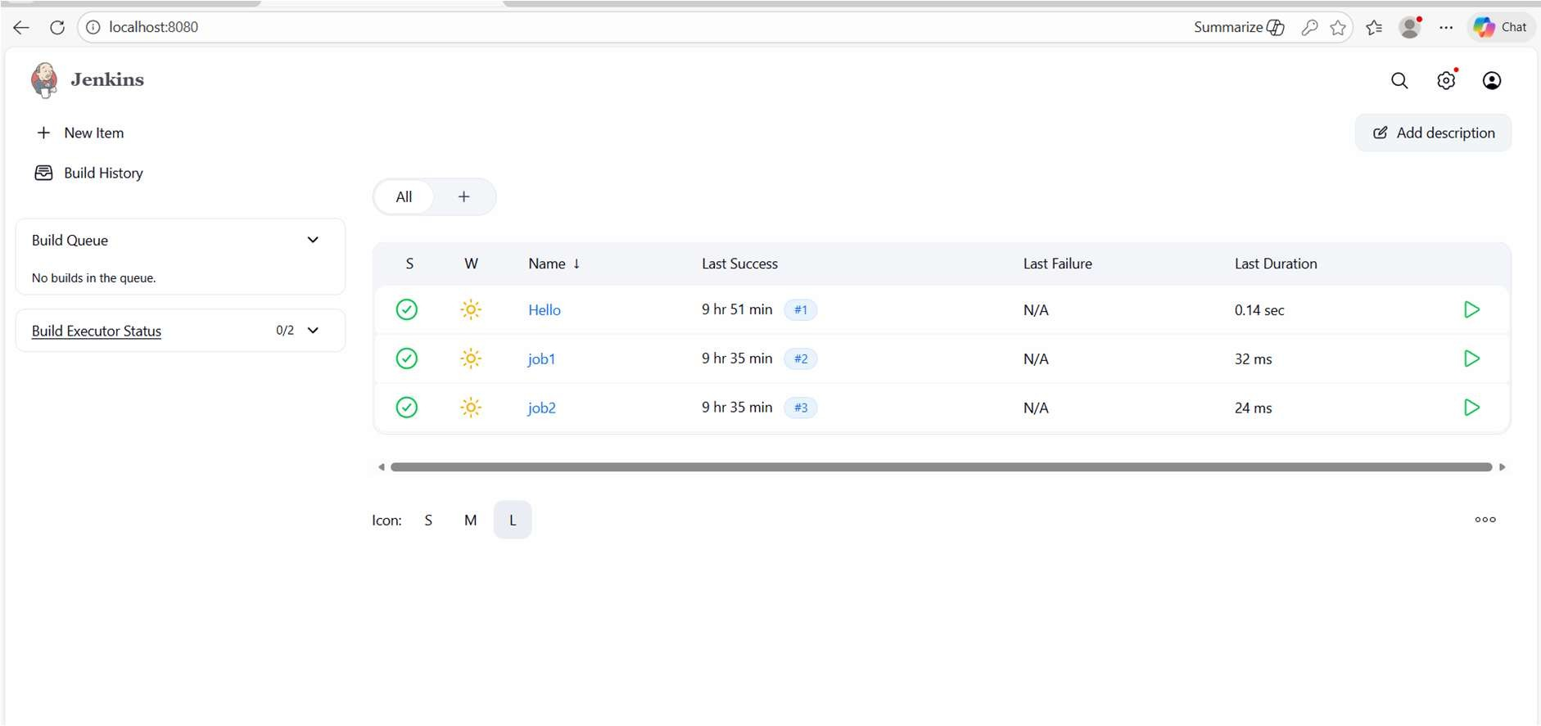

Jenkins Freestyle Job – Step by Step

1 Create Job1 (Normal Freestyle Job)

- Open Jenkins → Click New Item
- Enter Job1 as name → Select Freestyle project → Click OK
- In Build section → Click Add build step → Execute shell
- Enter commands:

echo "Hello World" pwd

- Click Save

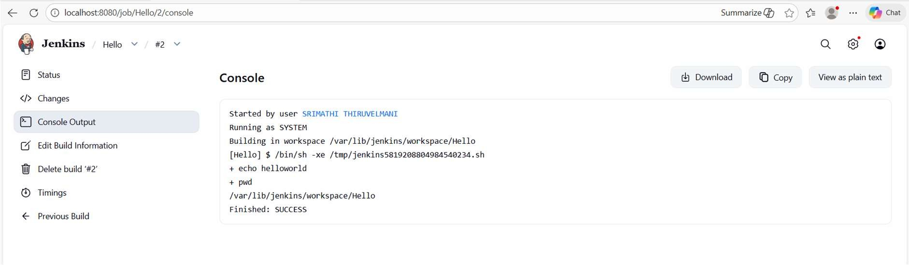

2 Run Job1

  - Click Build Now
  - Check Console Output
  - Hello World
  - /var/lib/jenkins/workspace/job1

3 Trigger Job2 from Job1

- Open Job1 → Configure → Post-build Actions
- Select Build other projects
- Enter Job2 as the project to build
- Save
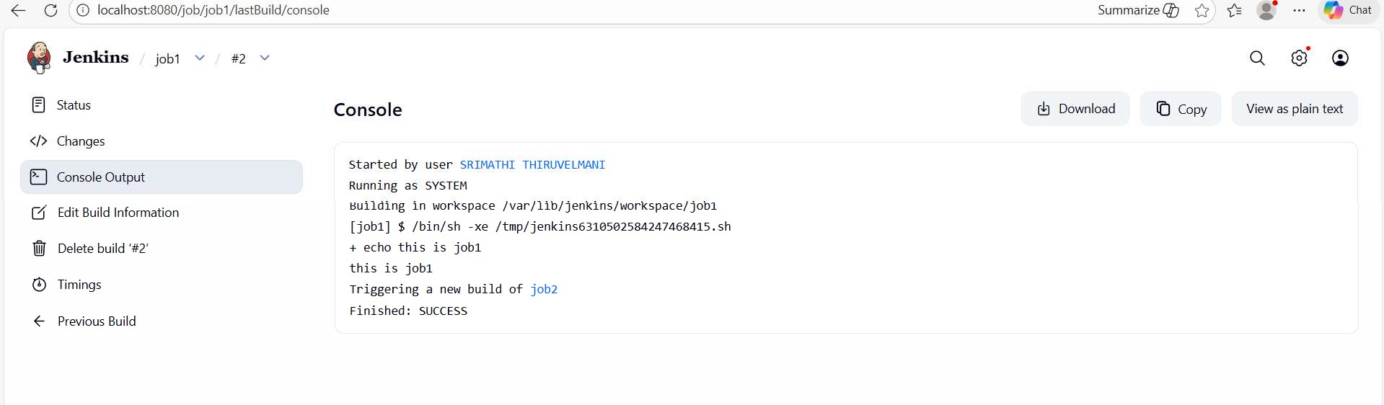

Pipeline Implementation
Instead of multiple freestyle jobs, we can use a Pipeline.

Example Pipeline Script
pipeline {
agent any stages {
stage('Clone') { steps {
git branch: 'main', url: 'https://github.com/yourrepo.git'
}
}
stage('Build Docker Image') {

steps {
sh 'docker build -t webapp .'
}
}
stage('Run Container') { steps {
sh 'docker run -d -p 5000:5000 webapp'
}
}
}
}

Possible Output

- Pipeline starts
- Git repository cloned
- Docker image built
- Container started
- Status: SUCCESS

Build Queue Workflow (Chained Jobs)

Builder Job
Clones repository:

git clone https://github.com/yourrepo.git cd project-folder

Image Job
Build Docker image:

docker build -t appimage .

Run Job
Run container:

docker run -d -p 8050:5000 appimage

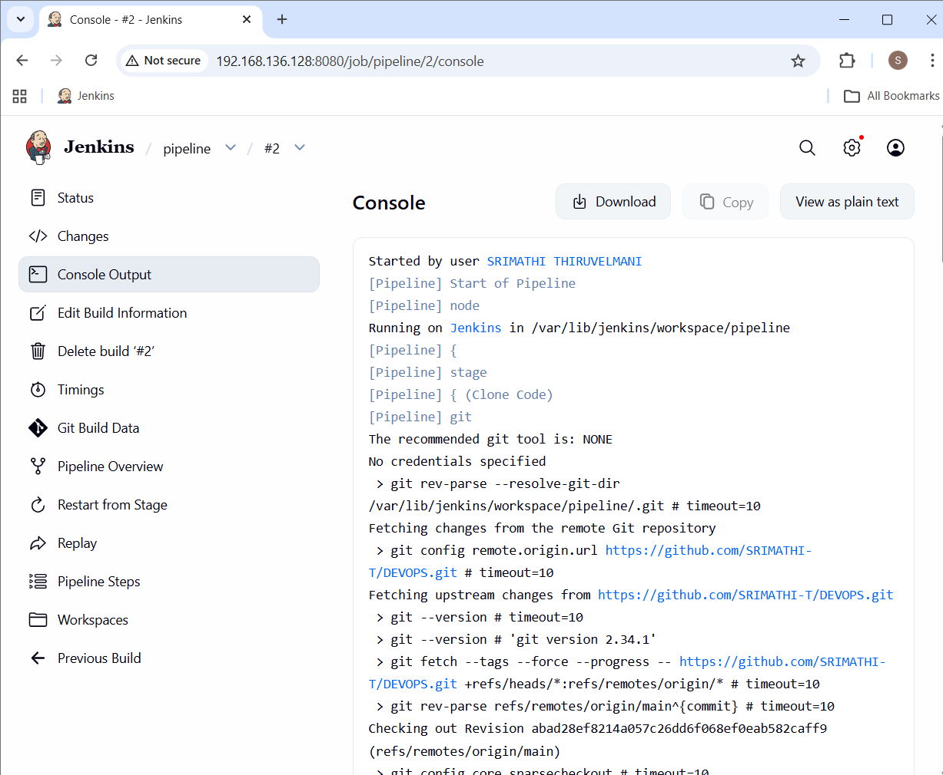
This demonstrates job chaining: Builder → Image → Run
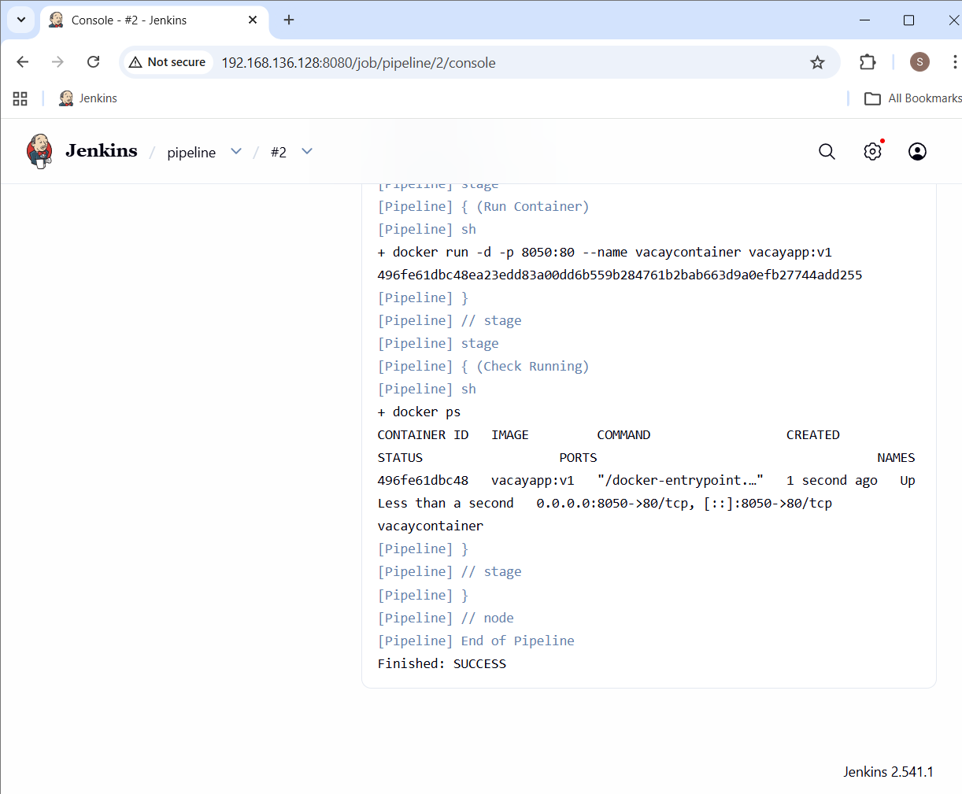



Jenkins CI/CD Pipeline – Simple Explanation

1. Clone Code:
Jenkins pulls the latest project code from GitHub repository.
2. Build Docker Image:
Jenkins builds a Docker image using the Dockerfile inside the project.
3. Remove Old Container:
If an old version of the app is running, Jenkins stops and removes it.
4. Run New Container:
Jenkins starts a new Docker container using the newly built image.
Port Mapping: 8050 (server) → 80 (container)
5. Verify Deployment:
Jenkins checks running containers using 'docker ps'.
Final Result:
The application is live at: http://<server-ip>:8050
Whenever code is pushed to GitHub, Jenkins can automatically rebuild and redeploy the application. This is Continuous Integration and Continuous Deployment (CI/CD).

