Docker
Docker is a container platform used to run applications in isolated environments called

containers.

A container includes:

- Application code
- Required libraries
- Runtime
- Configuration

So the application runs the same on any system.

Why Docker is Used

- Portability – Runs anywhere (local, server, cloud)
- Lightweight – Faster and uses less memory than Virtual Machines
- Consistency – Same environment in dev, test, and production

Important Terms
- Image – Blueprint of the application
- Container – Running instance of an image
- Dockerfile – File used to create a Docker image

Eg:docker_sample
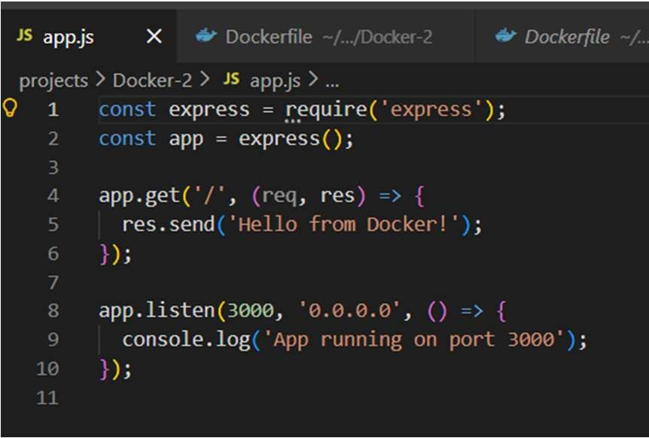
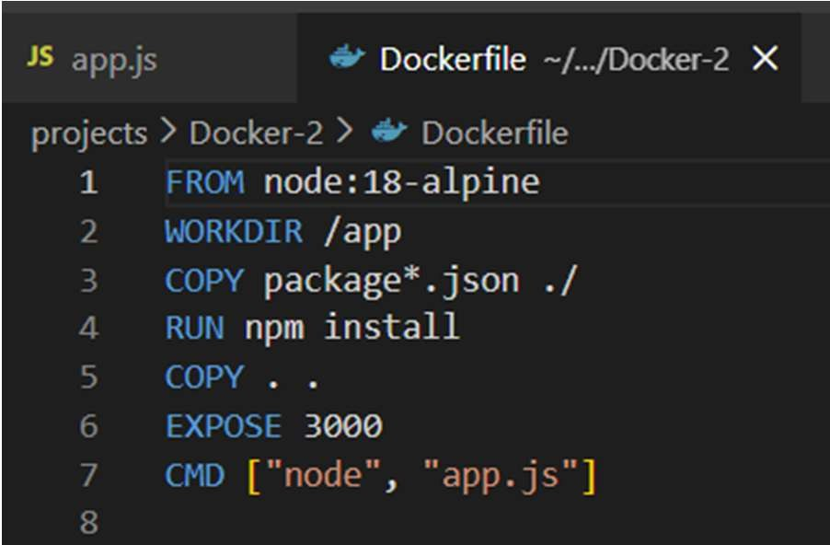
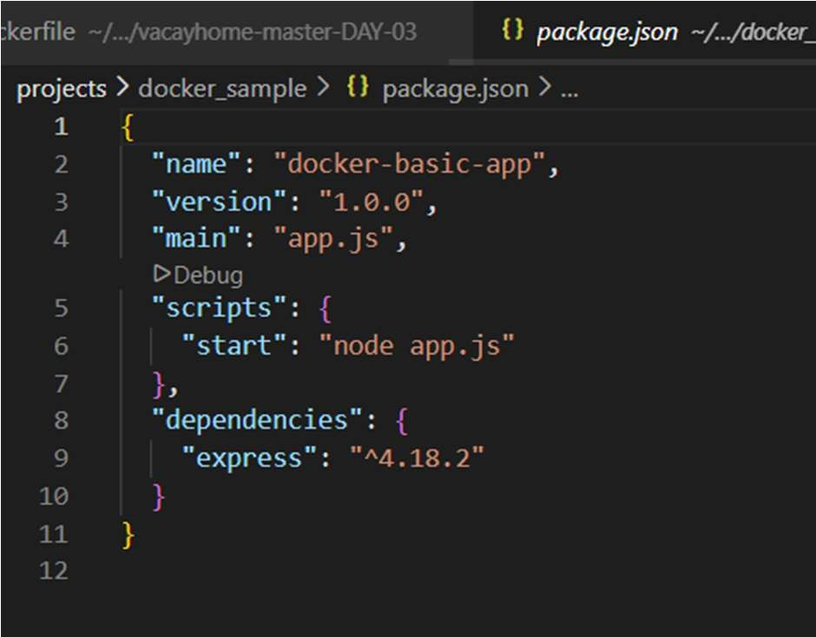

CODE AND EXPLANATION:

Application Code (app.js)

This is a simple Express server that runs on port 3000.

const express = require('express'); const app = express();

app.get('/', (req, res) => { res.send('Hello from Docker!');
});

app.listen(3000, '0.0.0.0', () => {
console.log('App running on port 3000');
});

Explanation:

- express → Web framework for Node.js
- app.get('/') → Defines route for homepage
- res.send() → Sends response to browser
- app.listen(3000) → Runs server on port 3000
- '0.0.0.0' → Makes app accessible outside container

package.json

This file contains project details and dependencies.

{
"name": "docker-basic-app",
"version": "1.0.0",
"main": "app.js", "scripts": {
"start": "node app.js"
},
"dependencies": { "express": "^4.18.2"
}
}

Explanation:

- "name" → Project name
- "version" → App version
- "main" → Entry file
- "scripts" → Start command
- "dependencies" → Required packages (Express)

Dockerfile

This file is used to create the Docker image.

FROM node:18-alpine

WORKDIR /app

COPY package*.json ./ RUN npm install
COPY . . EXPOSE 3000
CMD ["node", "app.js"]

Explanation:

- FROM node:18-alpine → Uses lightweight Node.js base image
- WORKDIR /app → Sets working directory inside container
- COPY package*.json ./ → Copies dependency files
- RUN npm install → Installs dependencies
- COPY . . → Copies application code
- EXPOSE 3000 → Opens port 3000
- CMD → Starts the application

Build and Run Commands

Build Docker Image:

docker build -t docker-basic-app .

Run Container:

docker run -p 3000:3000 docker-basic-app

Now open browser:

http://localhost:3000 eg:http:// 192.168.136.128:3000

You will see:

Hello from Docker!

Output:
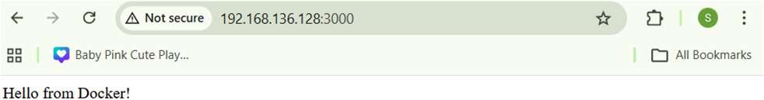

History:
srimathi@ubs2204vm:~/projects/docker_sample$ history
- whoami
- sudo apt update
- sudo apt upgrade -y
- sudo apt update
- sudo apt upgrade -y
- sudo apt install -y ca-certificates curl gnupg lsb-release
- sudo mkdir -p /etc/apt/keyrings
- curl -fsSL https://download.docker.com/linux/ubuntu/gpg | sudo gpg --dearmor -o
/etc/apt/keyrings/docker.gpg
- sudo mkdir -p /etc/apt/keyrings
- curl -fsSL https://download.docker.com/linux/ubuntu/gpg | sudo gpg --dearmor -o
/etc/apt/keyrings/docker.gpg
- echo "deb [arch=$(dpkg --print-architecture) signed-by=/etc/apt/keyrings/docker.gpg] \
- https://download.docker.com/linux/ubuntu \
- $(lsb_release -cs) stable" | sudo tee /etc/apt/sources.list.d/docker.list > /dev/null
- sudo apt update
- sudo apt install -y docker-ce docker-ce-cli containerd.io docker-buildx-plugin docker-compose- plugin
- sudo systemctl status docker
- docker --version
- mkdir projects
- cd projects
- pwd
- git clone https://github.com/jagadeeshkanna97/docker_sample
- ls -a
- ls
- cd docker_sample
- ls
- docker build -t docker-sample .
- sudo docker build -t docker-sample .

- sudo docker build --network=host -t docker-sample .
- sudo docker run -d -p 3000:3000 --name docker_sample docker-sample
- sudo docker ps
- sudo docker build --no-cache -t docker-sample .
- rm -rf ~/.vscode-server
- exit
- more /etc/os-release
- ifconfig
- sudo apt install net-tools
- ip addr
- ifconfig
- sudo apt update && sudo apt upgrade
- ip a
- ping -c 3 google.com
- ip a
- sudo systemctl status ssh
- ping -c 33 google.com
- sudo nano /etc/resolv.conf
- ip a
- nano reboot
- sudo reboot
- mkdir -p ~/.vscode-server/bin/591199df409fbf59b4b52d5ad4ee0470152a9b31
- cd ~/.vscode-server/bin/591199df409fbf59b4b52d5ad4ee0470152a9b31
- wget https://update.code.visualstudio.com/commit:COMMIT_ID/server-linux-x64/stable -O vscode-server.tar.gz
- ip a
- sudo apt update
- sudo apt install openssh-server -y
- sudo systemctl status ssh
- sudo ufw allow ssh
- sudo ufw reload

- sudo ufw status
- sudo ufw allow ssh
- sudo ufw enable
- sudo ufw status
- ip a
- ssh srimathi@192.168.136.128
- ip a
- cd projects
- cd docker_sample
- ls
- docker --version
- sudo docker build -t docker-sample .
- sudo docker images
- sudo docker run -d -p 3000:3000 --name docker_sample_app docker-sample
- sudo docker ps
- sudo apt update
- sudo apt install gh -y
- sudo apt update
- sudo apt install gh -y
- ssh-keygen -t ed25519 -C "srimathit.23cse@kongu.edu"
- eval "$(ssh-agent -s)"
- ssh-add ~/.ssh/id_ed25519
- cat ~/.ssh/id_ed25519.pub
- ls
- git init
- git add .
- git commit -m "Initial commit"
- git config --global user.name "SRIMATHI-T"
- git config --global user.email "srimathit.23cse@kongu.edu"
- git config --global --list
- git commit -m "Initial commit"

- git branch -M main
- git push -u origin main
- git config --global --unset credential.helper
- git push -u origin main
- git config --global --unset credential.helper
- git config --global --unset-all credential.helper
- git config --global credential.helper store
- git push -u origin main
- ssh -T git@github.com
- git push -u origin main
- git remote -v
- git remote remove origin
- git remote -v
- git remote add origin git@github.com:SRIMATHI-T/devops.git
- git remote -v
- git branch -M main
- git push -u origin main

Docker – Build, Push, Pull, Run

Build Docker Image

Inside your project folder (where Dockerfile exists):

docker build -t vacayhome-nginx .

Explanation:

  - build → create image
  - -t → tag name
  - . → current folder

Run Docker Container
docker run -d -p 8080:80 vacayhome-nginx

Explanation:

  - -d → run in background

  - -p 8080:80 → hostPort:containerPort Open in browser:
http://localhost:8080

Login to Docker Hub
docker login

Enter username & password.

Tag Image for Docker Hub

docker tag vacayhome-nginx srimathi2t/vacayhome:latest

Format:

docker tag <local-image> <dockerhub-username>/<repo>:tag

- Push to Docker Hub
docker push srimathi2t/vacayhome:latest

Now image is online.

Pull from Docker Hub (Friend System)

docker pull srimathi2t/vacayhome:latest

Run Pulled Image
docker run -d -p 8080:80 srimathi2t/vacayhome

Git – Push Project to GitHub

Initialize Git
git init

Add Files
git add .

Commit
git commit -m "Initial commit"

Connect to GitHub Repo
git remote add origin https://github.com/USERNAME/REPO.git

Push to GitHub
git branch -M main
git push -u origin main

Force Push (Replace Old Files)
git push -f origin main

Pull Code from GitHub

If your friend wants your project:

git clone https://github.com/USERNAME/REPO.git

Then:

cd REPO

eg:nginx:

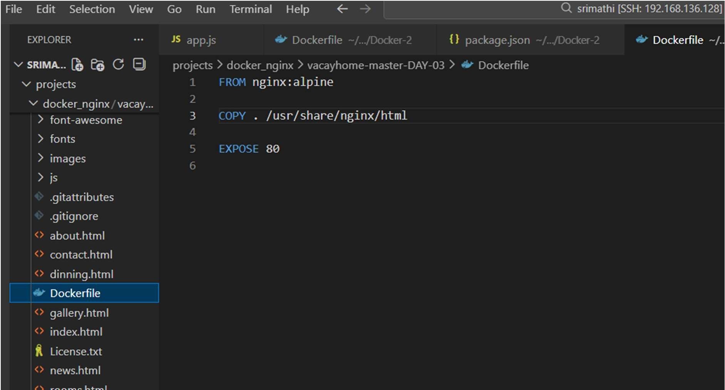

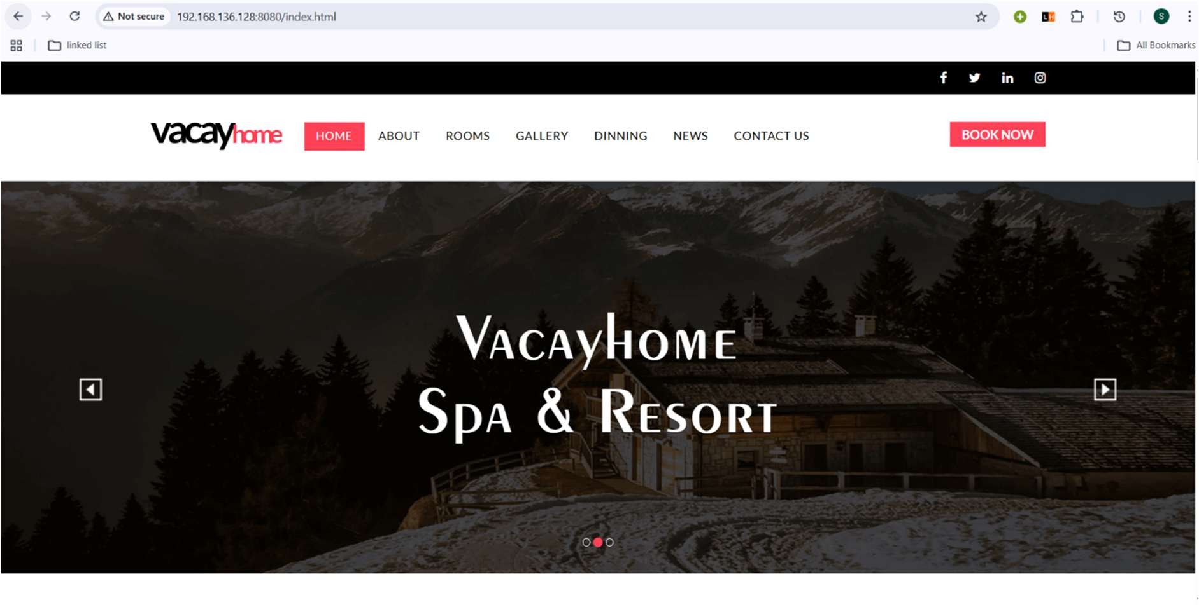

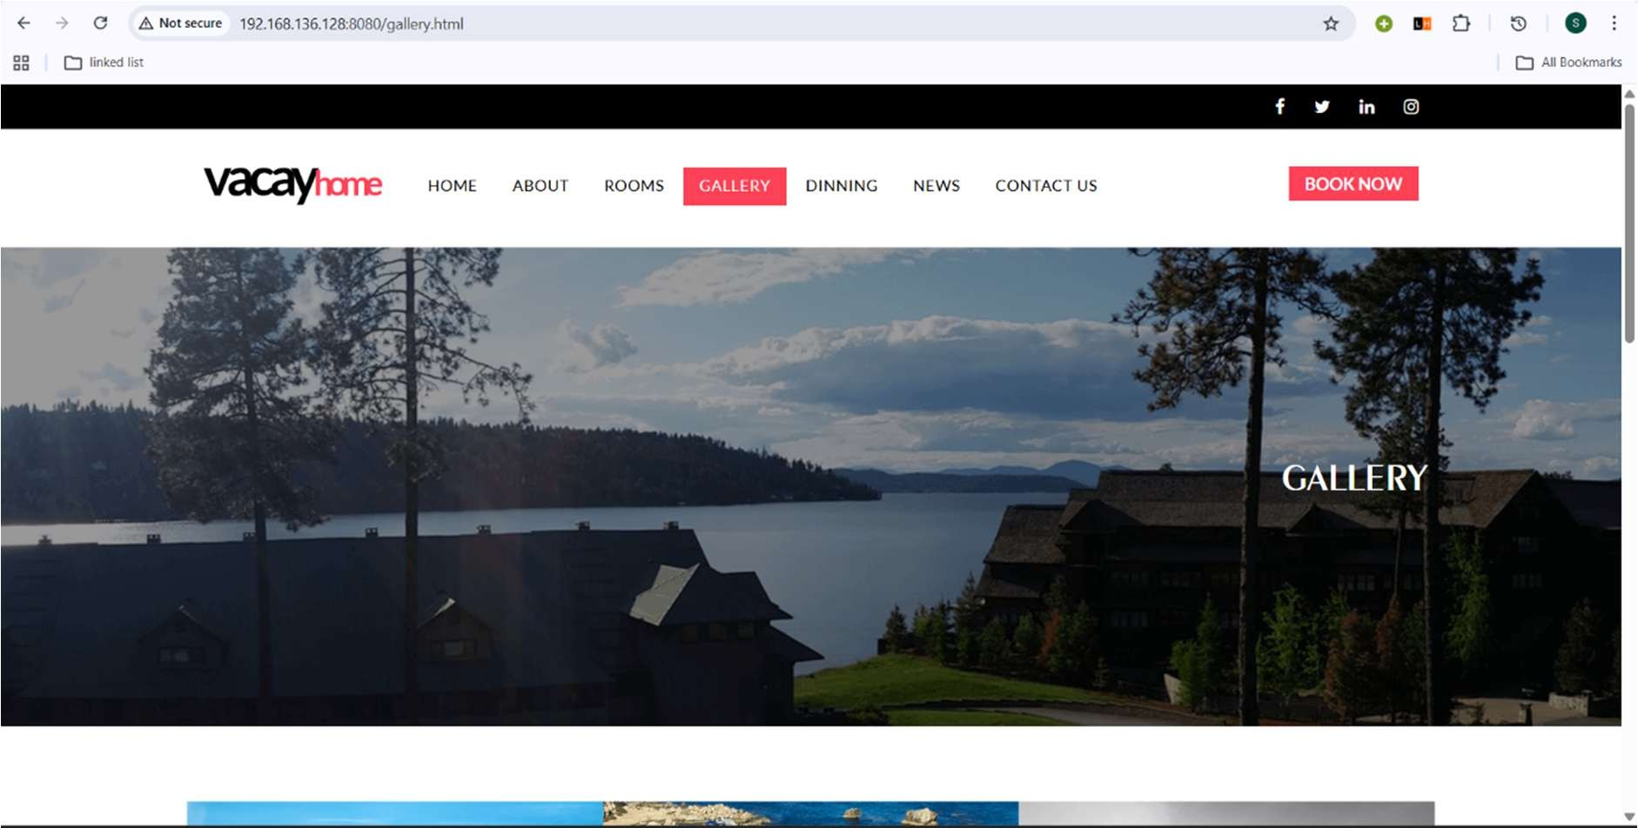

Ubuntu Docker-push and github-push command:
76 sudo docker login
- vacayhome
- docker tag vacayhome-nginx srimathi2t/vacayhome:latest
- docker push srimathi2t/vacayhome:latest
- cd ..
- git init

- git add .
- git commit -m "New vacayhome project"
- git remote remove origin https://github.com/SRIMATHI-T/devops.git
- git remote add origin https://github.com/SRIMATHI-T/devops.git
- git remote -v
- git branch -M main
- git push -f origin main
- git init
- git add .
- git commit -m "New vacayhome project"
- git remote remove origin https://github.com/SRIMATHI-T/DEVOPS.git
- git remote add origin https://github.com/SRIMATHI-T/DEVOPS.git
- git remote -v
- git branch -M main
- git push -f origin main

Vmware Ubunutu commands:-
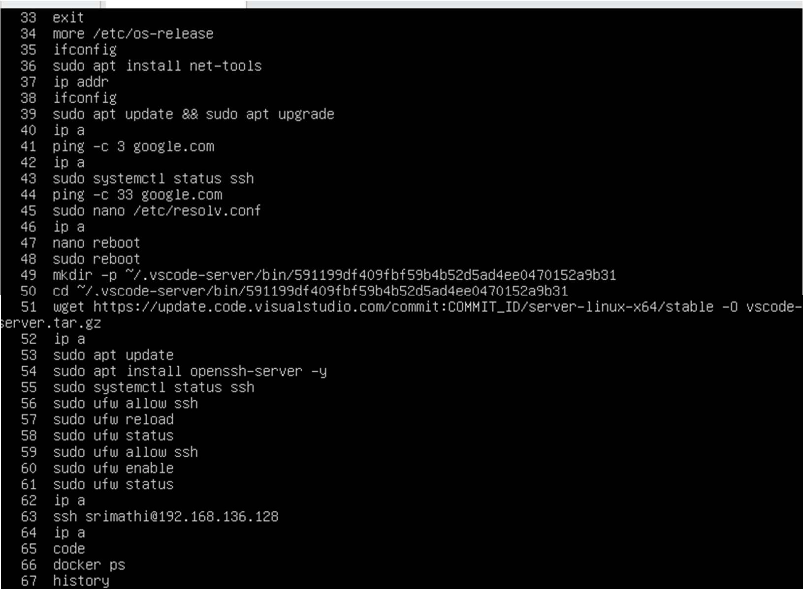

System and Network Checks

  - more /etc/os-release → Check Ubuntu version info.
  - ifconfig / ip addr / ip a → Show network interfaces and IP addresses.
  - ping -c 3 google.com → Test internet connectivity.

Git – Basic Explanation

What is Git?+-------------

Git is a version control system used to track changes in source code. It helps developers manage project history and work together.

Main Branch

  - The default branch of a repository.
  - Usually called main (or master).
  - Contains stable and production-ready code.

Sub Branch (Feature Branch)

  - Created from the main branch.
  - Used to develop new features or fix bugs.
  - Later merged back into the main branch.

Example:

main → feature-login → merge → main

Git Commands (From Ubuntu to GitHub Repository)

1 Initialize Git

git init

Creates a new Git repository in your project folder.

2 Add Files (Insert into Git)

git add filename

OR

git add .

Adds files to staging area.

3 Commit Changes

git commit -m "Initial commit"

Saves changes with a message.

4 Connect to Remote Repository

git remote add origin https://github.com/username/repo.git

5 Push to GitHub
git push -u origin main Uploads code to remote repository. Append / Insert in Git
When you modify a file:

- Edit the file
- Run:
- git add .
- git commit -m "Updated file"
- git push

This appends new changes to Git history.

Branch and History

  - Git keeps a complete history of changes.
  - Each commit has a unique ID (hash).
  - You can view history using:
  - git log

HEAD and Tail (Simple Meaning)

  - HEAD → Points to the latest commit in the current branch.
  - It shows where you are currently working.
  - Tail → The first (oldest) commit in the history.

Example:

Tail ---- Commit1 ---- Commit2 HEAD

Git Commands – From Ubuntu to GitHub

1 Create a Project Folder
mkdir myproject cd myproject

2 Initialize Git Repository
git init

This creates a hidden .git folder and starts version control.

3 Create Files in Ubuntu

Create empty file
touch file.txt

Insert text into file (overwrite)
echo "Hello World" > file.txt

Append text into file

echo "Second line" >> file.txt

- > → Overwrites file
- >> → Appends (adds) content

4 Add File to Git (Insert into Git)
git add file.txt

OR add all files:

git add .
This moves files to the staging area. 5 Commit the Changes
git commit -m "Added file.txt"

This saves changes into Git history.

6 Connect Ubuntu to GitHub Repository
git remote add origin https://github.com/username/repository.git

7 Push Code to GitHub
git push -u origin main

Now the file is uploaded from Ubuntu to GitHub.

