**CIA2 SRIMAYURI A**

**727721EUIT159**

**QUESTION-1:**

**package** com.CA2.ca2;

**import** org.openqa.selenium.By;

**import** org.openqa.selenium.WebDriver;

**import** org.openqa.selenium.chrome.ChromeDriver;

**import** org.openqa.selenium.chrome.ChromeOptions;

**import** org.testng.annotations.Test;

**import** io.github.bonigarcia.wdm.WebDriverManager;

**public** **class** Q1 {

@Test

**public** **void** f() **throws** InterruptedException{

ChromeOptions co=**new** ChromeOptions();

co.addArguments("--remote-allow-origins=*");

WebDriverManager.*chromedriver*().setup();

WebDriver driver=**new** ChromeDriver(co);

driver.get("https://www.trivago.in/");

driver.manage().window().maximize();

String currtitle=driver.getTitle();

System.***out***.println(currtitle);

String exptitle="trivago.in - Compare hotel prices worldwide";

**if**(currtitle.equals(exptitle)) {

System.***out***.println("Title Matched");

}

**else** {

System.***out***.println("Title not Matched");

}

Thread.*sleep*(3000);

driver.findElement(By.*xpath*("//*[@id=\"input-auto-complete\"]")).click();

Thread.*sleep*(3000);

driver.findElement(By.*xpath*("//*[@id=\"suggestion-list\"]/ul/li[1]/div/div")).click();

Thread.*sleep*(3000);

driver.findElement(By.*xpath*("//*[@id=\"__next\"]/div[1]/div[1]/section/div[2]/div[3]/div/div[2]/div/div/div/div[2]/div/div[1]/div[2]/button[24]/time")).click();

Thread.*sleep*(3000);

driver.findElement(By.*xpath*("//*[@id=\"__next\"]/div[1]/div[1]/section/div[2]/div[3]/div/div[2]/div/div/div/div[2]/div/div[1]/div[2]/button[26]/time")).click();

Thread.*sleep*(3000);

driver.findElement(By.*xpath*("//*[@id=\"__next\"]/div[1]/div[1]/section/div[2]/div[3]/div/div[2]/div/div/div[1]/div/div[1]/div[1]/div/button[2]")).click();

Thread.*sleep*(3000);

driver.findElement(By.*xpath*("//*[@id=\"__next\"]/div[1]/div[1]/section/div[2]/div[3]/div/div[2]/div/div/div[1]/div/div[1]/div[3]/div/button[2]")).click();

Thread.*sleep*(3000);

driver.findElement(By.*xpath*("/html/body/div[1]/div[1]/div[1]/section/div[2]/div[3]/div/div[2]/div/div/div[1]/div/div[2]/div[2]/input")).click();

Thread.*sleep*(3000);

driver.findElement(By.*xpath*("//*[@id=\"__next\"]/div[1]/div[1]/section/div[2]/div[3]/div/div[2]/div/div/div[2]/div/button[2]")).click();

}

}

**OUTPUT:**

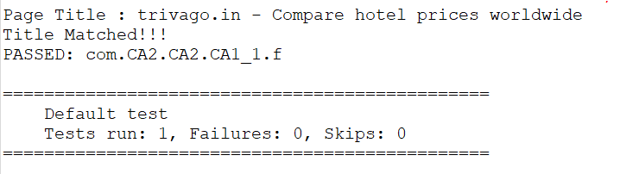

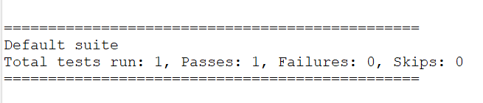

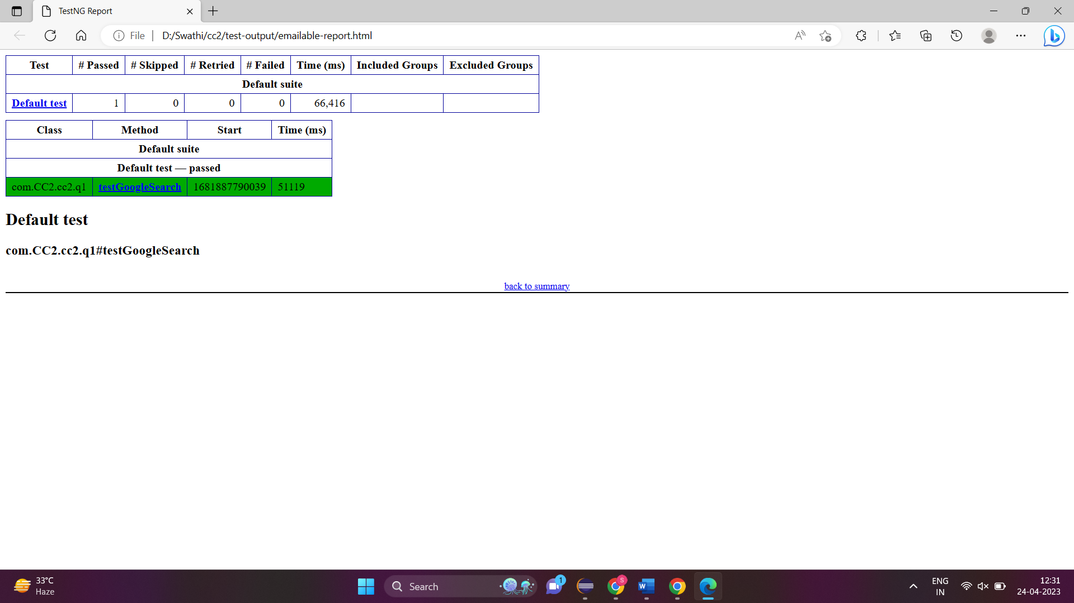

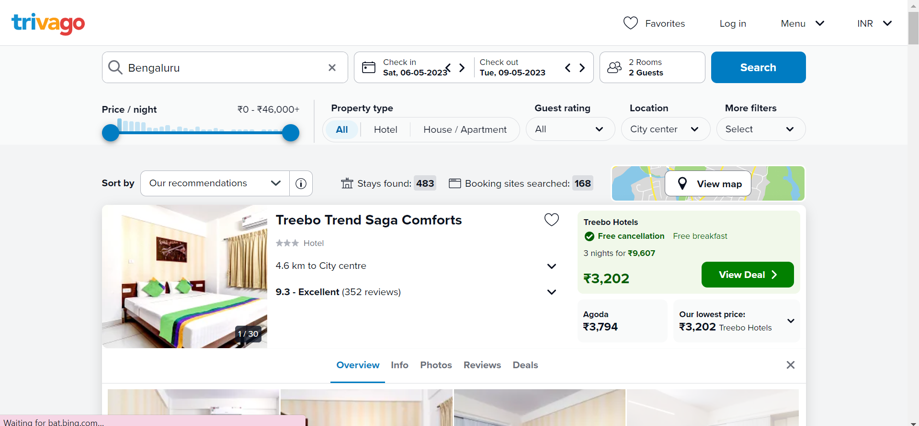

**QUESTION-2:**

**package** com.CA2.CA2;

**import** org.openqa.selenium.By;

**import** org.openqa.selenium.WebDriver;

**import** org.openqa.selenium.chrome.ChromeDriver;

**import** org.openqa.selenium.chrome.ChromeOptions;

**import** org.testng.Assert;

**import** org.testng.annotations.Test;

**import** io.github.bonigarcia.wdm.WebDriverManager;

**public** **class** CA2_2 {

@Test

**public** **void** f() **throws** InterruptedException {

ChromeOptions co=**new** ChromeOptions();

co.addArguments("--remote-allow-origins=*");

WebDriverManager.*chromedriver*().setup();

WebDriver driver=**new** ChromeDriver(co);

driver.get("https://www.trivago.in/");

driver.manage().window().maximize();

System.***out***.println("Page Title : "+driver.getTitle());

String atitle=driver.getTitle();

String etitle="trivago.in - Compare hotel prices worldwide";

Assert.*assertEquals*(atitle,etitle);

System.***out***.println("Title Matched!!!");

Thread.*sleep*(3000);

driver.findElement(By.*xpath*("//*[@id=\"sorting-selector\"]")).click();

Thread.*sleep*(3000);

driver.findElement(By.*xpath*("//*[@id=\"sorting-selector\"]/option[3]")).click();

Thread.*sleep*(3000);

String txt1=driver.findElement(By.*xpath*("//*[@id=\"__next\"]/div/div[1]/main/div[3]/div[1]/div/div[3]/div/div/ol/li/div/article/div[2]/div[1]/section/h2/button/span")).getText();

System.***out***.println(txt1);

Thread.*sleep*(3000);

String txt2=driver.findElement(By.*xpath*("//*[@id=\"__next\"]/div/div[1]/main/div[3]/div[1]/div/div[3]/div/div/ol/li/div/article/div[2]/div[2]/div[1]/div/div[3]/div[1]/div/p")).getText();

System.***out***.println(txt2);

Thread.*sleep*(3000);

driver.findElement(By.*xpath*("//*[@id=\"sorting-selector\"]")).click();

Thread.*sleep*(3000);

driver.findElement(By.*xpath*("//*[@id=\"sorting-selector\"]/option[6]")).click();

Thread.*sleep*(3000);

String txt3=driver.findElement(By.*xpath*("//*[@id=\"__next\"]/div/div[1]/main/div[3]/div[1]/div/div[3]/div/div/ol/li/div/article/div[2]/div[1]/section/h2/button/span")).getText();

System.***out***.println(txt3);

Thread.*sleep*(3000);

String txt4=driver.findElement(By.*xpath*("//*[@id=\"__next\"]/div/div[1]/main/div[3]/div[1]/div/div[3]/div/div/ol/li/div/article/div[2]/div[2]/div[1]/div/div[3]/div[1]/div/p")).getText();

System.***out***.println(txt4);

String txt5=driver.findElement(By.*xpath*("//*[@id=\"__next\"]/div/div[1]/main/div[3]/div[1]/div/div[2]/div[1]/div[2]/div[2]/div/div/div[1]/span[2]/strong")).getText();

System.***out***.println("Stay Found : " + txt5);

Thread.*sleep*(3000);

String txt6=driver.findElement(By.*xpath*("//*[@id=\"__next\"]/div/div[1]/main/div[3]/div[1]/div/div[3]/div/div/ol/li/div/article/div[2]/div[2]/div[1]/div/div[3]/div[1]/div/p")).getText();

System.***out***.println("Booking site Searched : "+txt6);

}

}

**OUTPUT:**



**QUESTION-3:**

**package** com.test.CA_2;

**import** java.util.List;

**import** org.openqa.selenium.By;

**import** org.openqa.selenium.WebDriver;

**import** org.openqa.selenium.WebElement;

**import** org.openqa.selenium.chrome.ChromeDriver;

**import** org.openqa.selenium.chrome.ChromeOptions;

**import** org.testng.annotations.Test;

**import** io.github.bonigarcia.wdm.WebDriverManager;

@Test

**public** **class** Q1 {

WebDriver driver;

**public** **void** TC_003() {

WebDriverManager.*chromedriver*().setup();

ChromeOptions co=**new** ChromeOptions();

co.addArguments("--remote-allow-origins=*");

driver=**new** ChromeDriver(co);

driver.get("https://www.trivago.in/");

driver.manage().window().maximize();

List<WebElement> hotelNames = driver.findElements(By.*xpath*("//span[@data-qa='item-name']"));

**for** (**int** i = 0; i < 5; i++) {

System.***out***.println(hotelNames.get(i).getText());

}

WebElement viewDeal = driver.findElement(By.*xpath*("//span[@data-qa='recommended-price']"));

viewDeal.click();

String parentWindow = driver.getWindowHandle();

**for** (String childWindow : driver.getWindowHandles()) {

driver.switchTo().window(childWindow);

}

WebElement selectedHotelPrice = driver.findElement(By.*xpath*("//strong[@class='deal-price__amount']"));

System.***out***.println("Selected hotel price: " + selectedHotelPrice.getText());

WebElement selectRoom = driver.findElement(By.*xpath*("//button[contains(@class,'js-book-button')]"));

selectRoom.click();

WebElement firstName = driver.findElement(By.*xpath*("//input[@name='firstname']"));

firstName.sendKeys("mayu");

WebElement lastName = driver.findElement(By.*xpath*("//input[@name='lastname']"));

lastName.sendKeys("A");

WebElement email = driver.findElement(By.*xpath*("//input[@name='email']"));

email.sendKeys("mayu@gmail.com");

WebElement confirmEmail = driver.findElement(By.*xpath*("//input[@name='email_confirm']"));

confirmEmail.sendKeys("mayu@gmail.com");

WebElement cancellationPolicy = driver.findElement(By.*xpath*("//h4[text()='Cancellation policy']/following-sibling::div/p"));

String cancellationPolicyText = cancellationPolicy.getText();

System.***out***.println("Check-in and Checkout dates: " + cancellationPolicyText);

driver.switchTo().window(parentWindow);

driver.close();

}

}**OUTPUT:**

