**CIA-1 SRIMAYURI A**

**727721EUIT159**

**QUESTION-1:**

**package** com.exam.exam;

**import** org.openqa.selenium.By;

**import** org.openqa.selenium.WebDriver;

**import** org.openqa.selenium.WebElement;

**import** org.openqa.selenium.chrome.ChromeDriver;

**import** org.openqa.selenium.chrome.ChromeOptions;

**import** io.github.bonigarcia.wdm.WebDriverManager;

**public** **class** Exe1 {

**public** **static** **void** main(String[] args) **throws** InterruptedException {

ChromeOptions co=**new** ChromeOptions();

co.addArguments("--remote-allow-origins=*");

WebDriverManager.*chromedriver*().setup();

WebDriver driver=**new** ChromeDriver(co);

driver.get("https://www.amazon.in/");

driver.manage().window().maximize();

System.***out***.println(driver.getTitle());

String atitle=driver.getTitle();

String etitle="Online Shopping site in India: Shop Online for Mobiles, Books, Watches, Shoes and More - Amazon.in";

**if**(etitle.equals(atitle)) {

System.***out***.println("Title Matched!!!");

}

driver.get("https://www.amazon.in/Mysore-Sandal-Soap-150g-Pack/dp/B00BMR071W/ref=sr_1_8?keywords=soap&qid=1681290552&sr=8-8");

driver.manage().window().maximize();

driver.findElement(By.*xpath*("//*[@id=\"add-to-cart-button\"]")).click();

WebElement t=driver.findElement(By.*xpath*("//*[@id=\"NATC_SMART_WAGON_CONF_MSG_SUCCESS\"]/span"));

String current=t.getText();

String expected="Added to Cart";

**if**(current.equals(expected)) {

System.***out***.println("CART VERIFIED");

}**else** {

System.***out***.println("CART NOT VERIFIED");

}

driver.findElement(By.*xpath*("/html/body/div[1]/header/div/div[7]/div[1]/div/div/div[4]/div/div/div[2]/div[3]/div[7]/div[1]/span/span/span[1]/span/span/span/span/span")).click();

WebElement s=driver.findElement(By.*xpath*("//*[@id=\"nav-cart-count\"]"));

String upd1=s.getText();

String upd="Amazon Cart is Updated ";

**if**(upd1.equals(upd)) {

System.***out***.println("NOT UPDATED");

}**else** {

System.***out***.println("UPDATED");

}

driver.findElement(By.*xpath*("/html/body/div[1]/header/div/div[7]/div[1]/div/div/div[4]/div/div/div[2]/div[3]/div[7]/div[2]/div/span/span/span/input")).click();

WebElement r=driver.findElement(By.*xpath*("//*[@id=\"nav-cart-count\"]"));

String old1=r.getText();

String old="Your Amazon Cart is empty";

**if**(old1.equals(old)) {

System.***out***.println("NOT REMOVED");

}**else** {

System.***out***.println("REMOVED");

}

driver.findElement(By.xpath("//*[@id=\"sc-buy-box-ptc-button\"]/span/input")).click();

WebElement txtBoxl=driver.findElement(By.xpath("//*[@id=\"ap_email\"]"));

txtBoxl.sendKeys("7448901316");

driver.findElement(By.xpath("//*[@id=\"continue\"]")).click();

WebElement txtBox2=driver.findElement(By.xpath("//*[@id=\"ap_password\"]"));

txtBox2.sendKeys("srimayuri16@gmail.com");

driver.findElement(By.xpath("//*[@id=\"signInSubmit\"]")).click();

// driver.navigate().back();

// Thread.sleep(5000);

// driver.findElement(By.xpath("//*[@id=\"Mod112\"]/div/div/ul/li[1]/h4/a")).click()

}

}

**OUTPUT:**

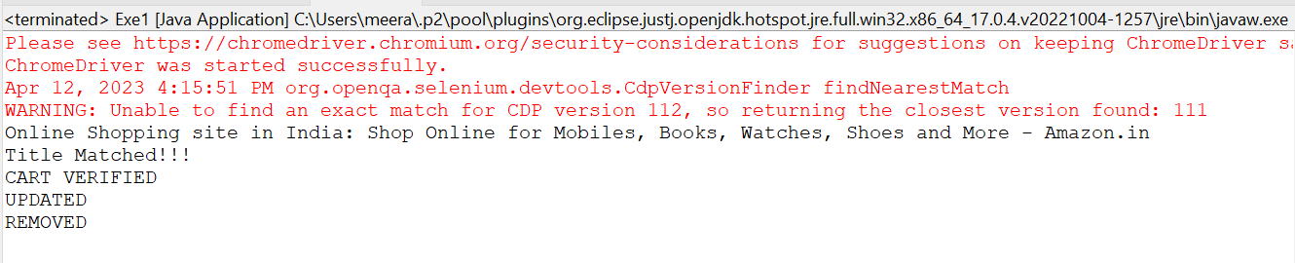

**QUESTION-2:**

**package** com.exam.exam;

**import** java.util.List;

**import** org.openqa.selenium.By;

**import** org.openqa.selenium.JavascriptExecutor;

**import** org.openqa.selenium.Keys;

**import** org.openqa.selenium.WebDriver;

**import** org.openqa.selenium.WebElement;

**import** org.openqa.selenium.chrome.ChromeDriver;

**import** org.openqa.selenium.chrome.ChromeOptions;

**import** io.github.bonigarcia.wdm.WebDriverManager;

**public** **class** Exe2 {

**public** **static** **void** main(String[] args) **throws** InterruptedException {

ChromeOptions co=**new** ChromeOptions();

co.addArguments("--remote-allow-origins=*");

WebDriverManager.*chromedriver*().setup();

WebDriver d=**new** ChromeDriver(co);

d.get("https://www.amazon.in/");

d.manage().window().maximize();

System.***out***.println(d.getTitle());

String atitle=d.getTitle();

String etitle="Online Shopping site in India: Shop Online for Mobiles, Books, Watches, Shoes and More - Amazon.in";

**if**(etitle.equals(atitle)) {

System.***out***.println("Title Matched!!!");

}

d.findElement(By.*xpath*("//*[@id=\"twotabsearchtextbox\"]")).sendKeys("Kurtas");

d.findElement(By.*xpath*("//*[@id=\"twotabsearchtextbox\"]")).sendKeys(Keys.***ENTER***);

String eurl="https://www.amazon.in/s?k=Kurtas&ref=nb_sb_noss";

Thread.*sleep*(2000);

String aurl=d.getCurrentUrl();

Thread.*sleep*(2000);

**if**(eurl.equals(aurl)) {

System.***out***.println("Search Matched");

}

String text1=d.findElement(By.*xpath*("//*[@id=\"search\"]/div[1]/div[1]/div/span[1]/div[1]/div[3]/div/div/div/div/div/div/div[2]/div[1]/h2/a/span")).getText();

System.***out***.println(text1);

Thread.*sleep*(2000);

String text2=d.findElement(By.*xpath*("//*[@id=\"search\"]/div[1]/div[1]/div/span[1]/div[1]/div[4]/div/div/div/div/div/div/div[2]/div[2]/h2/a/span")).getText();

System.***out***.println(text2);

Thread.*sleep*(2000);

String text3=d.findElement(By.*xpath*("//*[@id=\"search\"]/div[1]/div[1]/div/span[1]/div[1]/div[5]/div/div/div/div/div/div/div[2]/div[1]/h2/a/span")).getText();

System.***out***.println(text3);

Thread.*sleep*(2000);

String text4=d.findElement(By.*xpath*("//*[@id=\"search\"]/div[1]/div[1]/div/span[1]/div[1]/div[9]/div/div/div/div/div[2]/div[2]/h2/a/span")).getText();

System.***out***.println(text4);

Thread.*sleep*(2000);

String text5=d.findElement(By.*xpath*("//*[@id=\"search\"]/div[1]/div[1]/div/span[1]/div[1]/div[14]/div/div/div/div/div[2]/div[2]/h2/a/span")).getText();

System.***out***.println(text5);

Thread.*sleep*(2000);

d.findElement(By.*xpath*("//*[@id=\"n/1968253031\"]/span/a/span")).click();

JavascriptExecutor js=(JavascriptExecutor) d;

js.executeScript("window.scrollBy(0,800)", "");

Thread.*sleep*(2000);

d.findElement(By.*xpath*("//*[@id=\"p_36/4595085031\"]/span/a/span")).click();

}

}

**OUTPUT:**

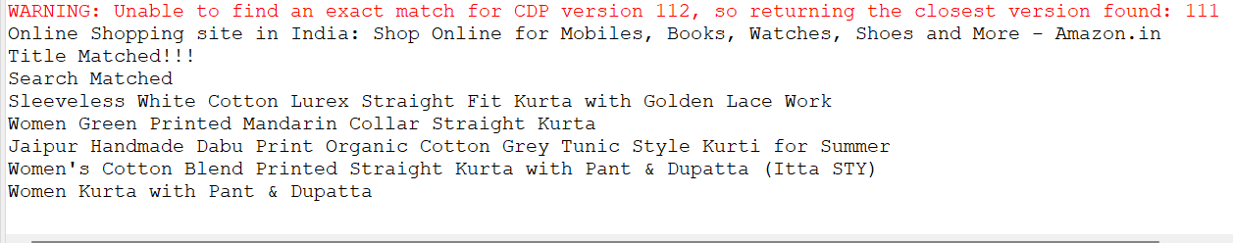

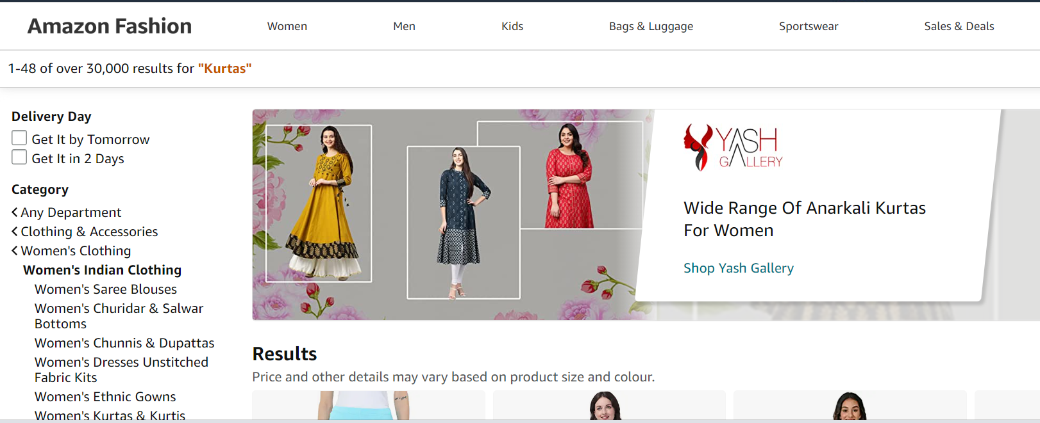

**QUESTION-3:**

**package** com.exam.exam;

**import** org.openqa.selenium.By;

**import** org.openqa.selenium.WebDriver;

**import** org.openqa.selenium.chrome.ChromeDriver;

**import** org.openqa.selenium.chrome.ChromeOptions;

**import** io.github.bonigarcia.wdm.WebDriverManager;

**public** **class** Exe3 {

**public** **static** **void** main(String[] args) **throws** InterruptedException {

ChromeOptions co=**new** ChromeOptions();

co.addArguments ("--remote-allow-origins=*");

WebDriverManager.*chromedriver*().setup ();

WebDriver driver=**new** ChromeDriver(co);

driver.get ("https://www.amazon.in/Spigen-Urban-Fabric-Compatible-MacBook/dp/B09R2KCXD2/?_encoding=UTF8&pd_rd_w=hN3t9&content-id=amzn1.sym.e0e8ce89-ede3-4c51-b6ad-44989efc8536&pf_rd_p=e0e8ce89-ede3-4c51-b6ad-44989efc8536&pf_rd_r=10MH3SN3ES208H0RRNSQ&pd_rd_wg=wPWJi&pd_rd_r=13f23fa2-e355-40ad-a989-abace7275caf&ref_=pd_gw_ci_mcx_mr_hp_d");

driver.manage().window().maximize() ;

String currentTitle=driver.getTitle();

System.***out***.println(currentTitle);

String expectedTitle="Spigen Urban Fit Fabric Case Cover Compatible with MacBook Pro 14 inch (2021) - Black - Buy Spigen Urban Fit Fabric Case Cover Compatible with MacBook Pro 14 inch (2021) - Black Online at Low Price in India - Amazon.in";

**if**(currentTitle.equals(expectedTitle)) {

System.***out***.println("Title Matched");

}

**else** {

System.***out***.println("Title not Matched");

}

driver.findElement(By.*xpath*("//*[@id=\"nav-link-accountList\"]")).click();

driver.findElement(By.*xpath*("//*[@id=\"ap_email\"]")).sendKeys("7448901316");

driver.findElement(By.*xpath*("//*[@id=\"continue\"]")).click();

driver.findElement(By.*xpath*("//*[@id=\"ap_password\"]")).sendKeys("Mayu@123");

driver.findElement(By.*xpath*("//*[@id=\"signInSubmit\"]")).click();

Thread.*sleep*(1000);

driver.findElement(By.*xpath*("//*[@id=\"nav-orders\"]")).click();

String order = driver.findElement(By.*xpath*("//*[@id=\"a-page\"]/section/div[1]/div[4]/form/label")).getText();

System.***out***.println("Your last Order:"+order);

}

}

**OUTPUT:**

