**DAY-4**

**CE1)**

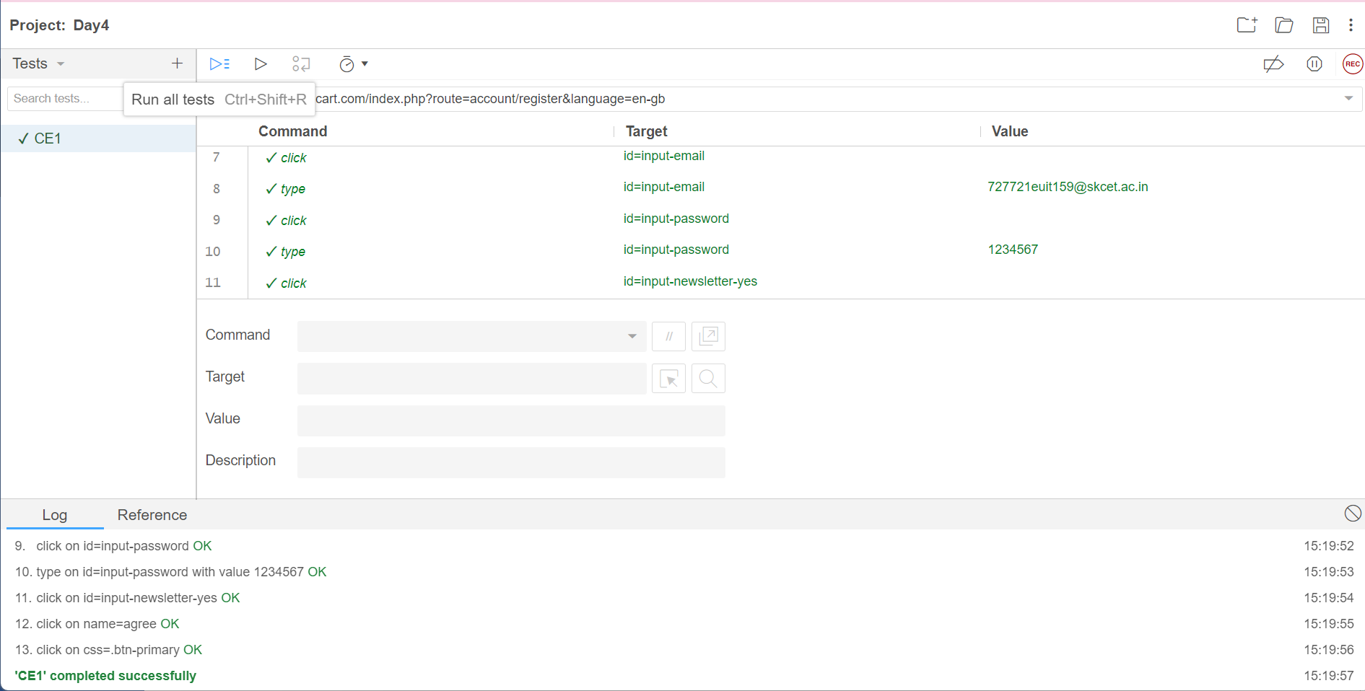

**CE2)**

**package** com.test.test;

**import** org.openqa.selenium.By;

**import** org.openqa.selenium.JavascriptExecutor;

**import** org.openqa.selenium.WebDriver;

**import** org.openqa.selenium.WebElement;

**import** org.openqa.selenium.chrome.ChromeDriver;

**import** org.openqa.selenium.chrome.ChromeOptions;

**import** io.github.bonigarcia.wdm.WebDriverManager;

**public** **class** App

{

**public** **static** **void** main( String[] args ) **throws** InterruptedException

{

ChromeOptions co=**new** ChromeOptions();

co.addArguments("--remote-allow-origins=*");

WebDriverManager.*chromedriver*().setup();

WebDriver d=**new** ChromeDriver(co);

d.get("https://demo.opencart.com/index.php?route=account/register&language=en-gb");

d.manage().window().maximize();

WebElement fname=d.findElement(By.*id*("input-firstname"));

fname.sendKeys("Srimayuri");

WebElement lname=d.findElement(By.*xpath*("//input[@id=\"input-lastname\"]"));

lname.sendKeys("A");

WebElement email=d.findElement(By.*cssSelector*("input#input-email"));

email.sendKeys("abc@gmail.com");

d.findElement(By.*id*("input-password")).sendKeys("pass@123");

JavascriptExecutor js=(JavascriptExecutor) d;

js.executeScript("window.scrollBy(0,500)", "");

Thread.*sleep*(1000);

d.findElement(By.*xpath*("//*[@id=\"input-newsletter-yes\"]")).click();

Thread.*sleep*(1000);

d.findElement(By.*xpath*("//*[@id=\"form-register\"]/div/div/div/input")).click();

Thread.*sleep*(1000);

d.findElement(By.*xpath*("//*[@id=\"form-register\"]/div/div/button")).click();

}

}

**CE3)**

**package** com.test.test;

**import** org.openqa.selenium.By;

**import** org.openqa.selenium.JavascriptExecutor;

**import** org.openqa.selenium.WebDriver;

**import** org.openqa.selenium.chrome.ChromeDriver;

**import** org.openqa.selenium.chrome.ChromeOptions;

**import** io.github.bonigarcia.wdm.WebDriverManager;

**public** **class** D4_3 {

**public** **static** **void** main( String[] args ) **throws** InterruptedException

{

ChromeOptions co=**new** ChromeOptions();

co.addArguments("--remote-allow-origins=*");

WebDriverManager.*chromedriver*().setup();

WebDriver d=**new** ChromeDriver(co);

d.get("https://demo.opencart.com/index.php?route=checkout/voucher&language=en-gb");

d.manage().window().maximize();

d.findElement(By.*xpath*("//input[@id=\"input-to-name\"]")).sendKeys("Meera");

Thread.*sleep*(1000);

d.findElement(By.*xpath*("//input[@id=\"input-to-email\"]")).sendKeys("abc@gmail.com");

Thread.*sleep*(1000);

d.findElement(By.*xpath*("//input[@id=\"input-from-name\"]")).sendKeys("Mayu");

Thread.*sleep*(1000);

d.findElement(By.*xpath*("//input[@id=\"input-from-email\"]")).sendKeys("def@gmail.com");

JavascriptExecutor js=(JavascriptExecutor) d;

js.executeScript("window.scrollBy(0,500)", "");

Thread.*sleep*(2000);

d.findElement(By.*xpath*("//input[@id=\"input-theme-7\"]")).click();

Thread.*sleep*(1000);

d.findElement(By.*xpath*("//textarea[@id=\"input-message\"]")).sendKeys("Happy Birthday !!!");

Thread.*sleep*(1000);

d.findElement(By.*xpath*("//input[@name=\"agree\"]")).click();

Thread.*sleep*(3000);

d.findElement(By.*xpath*("//button[@class=\"btn btn-primary\"]")).click();

}

}

**CE4)**

**package** com.test.test;

**import** org.openqa.selenium.By;

**import** org.openqa.selenium.WebDriver;

**import** org.openqa.selenium.chrome.ChromeDriver;

**import** org.openqa.selenium.chrome.ChromeOptions;

**import** io.github.bonigarcia.wdm.WebDriverManager;

**public** **class** D4_4 {

**public** **static** **void** main( String[] args )

{

ChromeOptions co=**new** ChromeOptions();

co.addArguments("--remote-allow-origins=*");

WebDriverManager.chromedriver().setup();

WebDriver d=**new** ChromeDriver(co);

d.navigate().to("https://j2store.net/free/");

d.manage().window().maximize();

d.findElement(By.xpath("//*[@id=\"Mod112\"]/div/div/ul/li[1]/h4/a")).click();

d.navigate().back();

d.navigate().forward();

d.navigate().refresh();

d.close();

}

}

**CE5.1)**

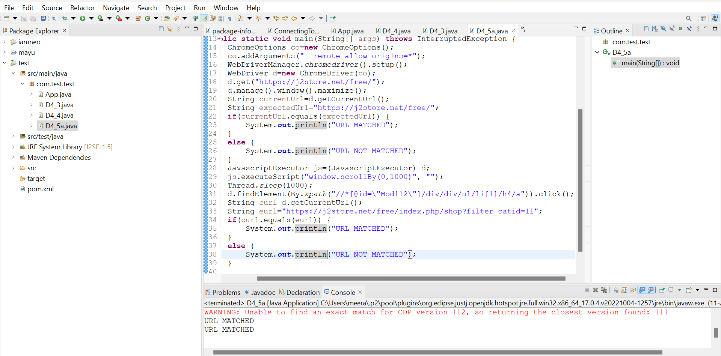

**CE5b)**

