**Case Study for Automation Project**

**Read the below instructions before you take up the assessment:**

**Performing test automation for the specifications below using Selenium**

**Strategy:**

**Framework to be used**

POM (Page Object Model)

TestNg with POM. and XML.

Modular concept framework.

Data driven concept – Using TestNG or Excel

**Other strategy:**

Multibrowser execution

Coding standards to be followed

Screen shots to be taken

**Case Study 1: Functional testing using Selenium**

Notes:

Make sure Test environment is up and running

Perform Smoke and Exploratory testing to Know more about the application

A web-based scenario of **medium** complexity would be provided. Associate should utilize automation testing project on THE NINJA STORE

**Points to be noted during your manual project:**

* Followed POM (Page Object Model) standards and organizing pages/java class files
* Implemented TestNg with POM. Proper TestNG concepts and XML to run the project.
* Should have implemented reusable functions separately to improve more readability.
* Multi browser execution- Should have handled at least two browsers (Firefox and IE/Chrome). Optional - desired capabilities/driver setup
* Data driven concept - Input data should be imported from an external excel sheet (Ex: using Apache PoI libraries in case of Java) or Properties file or flat file
* Handled exceptions with exception handling & error messages
* Should have used relative Xpath
* Check code is syntactically correct and executes end to end successfully
* Coding standard should be followed, which includes variable, object naming convention, script headers & comments
* Used ID or Name locator instead of XPATH
* Functions should have header, comments wherever applicable to improve readability and maintainability
* Should handle page synchronization issues using industry standard best practices. Use Timeout instead of Sleep statement wherever applicable.
* Validation messages should be logged into the Test Results with screenshot. Log mandatory test-steps in reporting statement
* Should have used relative Xpath

**Read the requirement carefully and submit Test Automation Solution as mentioned below:**

**Case Study 1:**

**Note:**

* Before you start automating the case study, execute the given test case scenario manually to understand the application flow better.
* Implement the code using TestNg with POM(Page Object Model). Proper TestNG concepts and XML to run the project with specific Folder structure and Class files.
* Implement code for at least 2 Browsers by handling exceptions & error messages.

**Case Study Name:** THE NINJA STORE

**Website** http: <http://tutorialsninja.com/demo/index.php?route=common/home>**Steps to be followed:**

1. Navigate to <http://tutorialsninja.com/demo/index.php?route=common/home>
2. Searching for a Product
3. Registering a new User account
4. Login to the User account
5. Logout from the Application
6. Forgot Password Scenario
7. Adding Items to Cart
8. Purchasing an item by placing an order as a guest user
9. Purchasing an item by placing an order as a registered user

Deliverables:

* Create new folder in your system and save the all file in the folder

Home Page

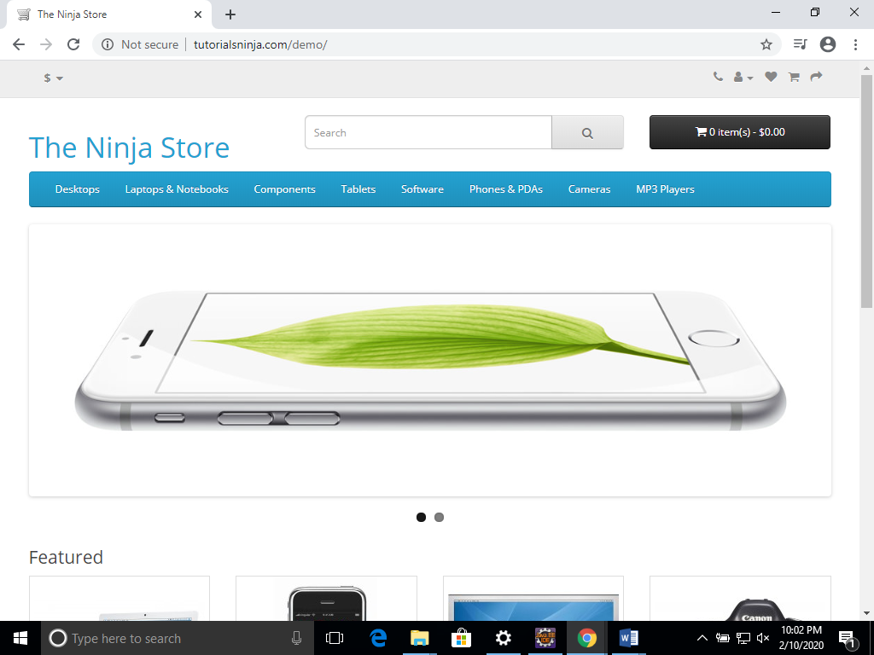

Login Page

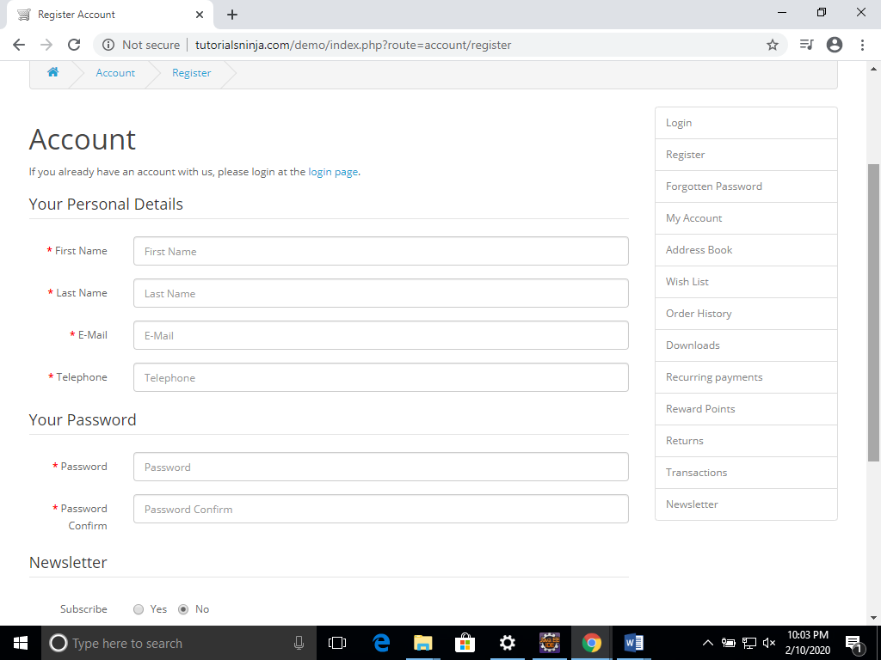

Checkout Page

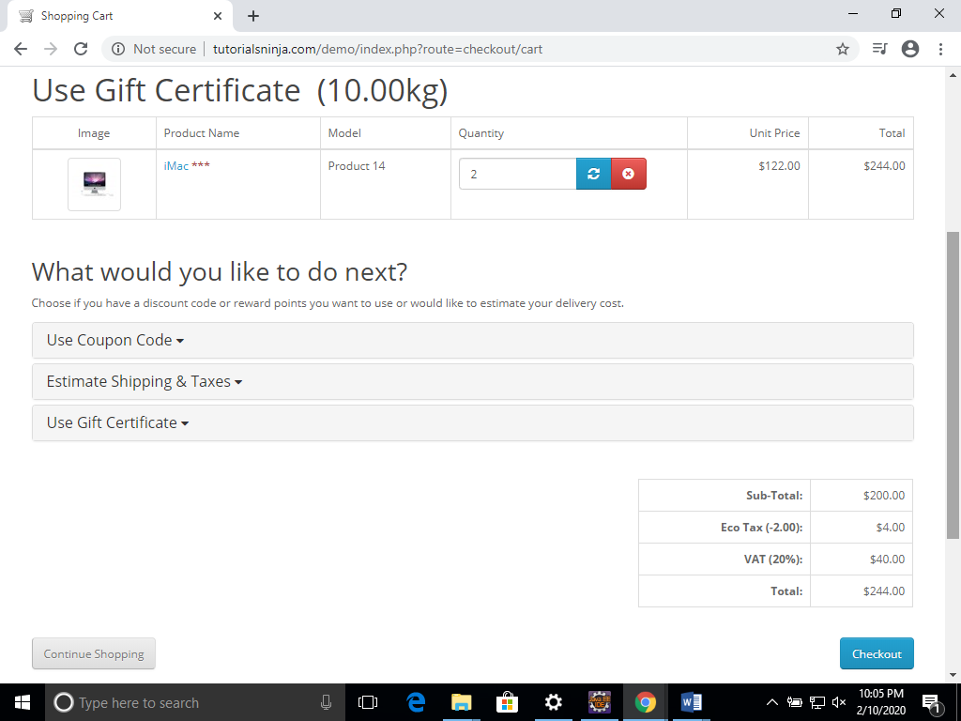

View Product

