Exploratory Data Analysis
& Visualization Framework
A reusable Python-based plan for understanding datasets
Week 2 Deliverable • Conceptual framework • No dataset required
Planned effort: 33 hours
Status: Framework design, not a completed analysis

Executive Summary
This document defines a repeatable framework for Exploratory Data Analysis (EDA) and visualization using Python. Because no dataset is supplied, it describes the steps, decision rules, charts, libraries, and reporting practices that would be applied after a dataset is received. The framework begins with context and data inspection, checks quality and variable types, proceeds through univariate, bivariate, and multivariate exploration, and ends with interpretation and reproducible reporting. The approach is designed to adapt to tabular, time-based, categorical, text, and geographic data while avoiding unsupported conclusions.

1. Introduction to EDA
Exploratory Data Analysis is the structured examination of data before formal statistical inference or machine learning. It combines summary statistics, visual inspection, data-quality checks, and domain questions to reveal distribution shapes, relationships, anomalies, potential bias, and limitations. EDA helps analysts decide whether the data is suitable for the intended question and what additional checks or transformations may be needed.

1.1 Why EDA matters
- Understand dataset size, structure, variable meaning, and coverage before making assumptions.
- Detect missing, duplicated, invalid, inconsistent, or unexpectedly encoded values.
- Identify distributions, rare categories, skewness, unusual observations, trends, and relationships.
- Generate hypotheses and guide later analysis without treating visual association as proof of causation.
- Communicate data limitations and analytical choices clearly to technical and non-technical audiences.

1.2 Guiding principles
- Start with the question and context, not with plotting every column indiscriminately.
- Use both numerical summaries and visualizations; neither is sufficient alone.
- Preserve raw data and make transformations traceable.
- Treat outliers as observations to investigate, not automatic errors to remove.
- Record uncertainty, sample size, definitions, and data coverage alongside findings.
- Avoid causal claims unless the study design and evidence support them.

2. Framework Scope and Inputs
The framework is dataset-independent and can be used for customer, operations, finance, education, health, environmental, or other tabular analysis, subject to relevant privacy and governance requirements. The actual analysis plan must be adapted to the dataset’s purpose, data-generating process, permissions, and user needs.
Input / prerequisite | Questions to resolve
Business or research context | What decision or question should the analysis support?
Data dictionary | What does each field mean, and what are its units and allowed values?
Source and provenance | Who created the data, when was it collected, and what is the coverage?
Privacy and permissions | May the data be inspected, stored, shared, and visualized?
Target or outcome (if relevant) | Is there an outcome variable, and how is it defined?
Known constraints | Are there sampling, measurement, timing, or representation limitations?

3. Potential Data Types
Data type | Examples | Recommended first checks
Integer / count | Number of orders, visits, defects | Range, zeros, negative values, count distribution
Continuous numeric | Price, temperature, distance | Units, scale, skewness, range, outliers
Nominal categorical | Region, product, department | Unique values, spelling variants, rare categories
Ordinal categorical | Low/medium/high, satisfaction rating | Order definitions, invalid levels, category balance
Boolean / binary | Yes/no, active/inactive | Encoding consistency and class proportions
Date/time | Signup date, timestamp, duration | Timezone, parse failures, gaps, duplicates, granularity
Text | Comments, descriptions, reviews | Empty strings, language, length, sensitive content
Identifier | Customer ID, transaction ID | Uniqueness expectations; do not treat arbitrary IDs as measurements
Geospatial | Latitude/longitude, region geometry | Coordinate ranges, coordinate system, spatial coverage
A column’s storage dtype may not match its analytical meaning. For example, a numeric code for a region is usually categorical, while a date stored as text should be parsed as datetime only after checking its format. Identifiers should generally not be included in correlation analysis as if they were continuous measurements.

4. Initial Data Inspection
- Load the data with pandas and record the source, file format, extraction date, and row/column count.
- Inspect a sample of rows, column names, dtypes, memory use, and basic summary statistics.
- Compare the actual schema with the data dictionary and flag unexpected or ambiguous columns.
- Check key uniqueness, duplicate rows, expected time coverage, and consistency of units.
- Create a concise data profile with row counts, distinct values, missing-value rates, and likely type corrections.

5. Data Quality Assessment

5.1 Missing data
Calculate missing counts and percentages by column and, where useful, by group or time period. Visualize missingness with a bar chart or matrix. Investigate whether values are missing due to collection failures, not-applicable cases, or systematic patterns. Possible responses include retaining missingness as informative, dropping records or columns when justified, or imputing with a documented method. Imputation must not hide meaningful missingness or use information unavailable at the intended prediction time.

5.2 Duplicates and inconsistent values
- Identify exact duplicate rows and duplicates in fields expected to be unique.
- Normalize whitespace and case where appropriate; map category variants only with documented rules.
- Check units, date formats, impossible ranges, inconsistent labels, and conflicting records.

5.3 Outliers and unusual observations
Use box plots, histograms, scatter plots, robust summaries, and domain rules to flag unusual values. The IQR rule (below Q1 − 1.5×IQR or above Q3 + 1.5×IQR) can be a screening tool, not a universal deletion rule. Investigate source records and business context. Retain valid extremes, correct verified errors, and document any exclusion or transformation with a reason and sensitivity check.

5.4 Quality decision log
Issue | Decision to record
Missing values | Affected fields/rows, likely cause, chosen handling, expected impact
Outliers | Detection rule, review result, retained/corrected/excluded status
Duplicates | Definition, count, resolution rule, effect on row totals
Type or unit mismatch | Original representation, conversion, validation rule
Coverage gaps | Missing time periods, groups, regions, or populations and implications

6. Exploration Techniques

6.1 Univariate analysis: one variable
Purpose: understand each variable’s distribution, scale, common values, spread, and unusual values.
- Numeric: count, mean, median, standard deviation, quartiles, min/max, histogram, density plot, and box plot.
- Categorical: frequency and percentage tables, bar charts, distinct-value counts, and rare-category checks.
- Date/time: earliest/latest timestamps, frequency over time, gaps, and seasonal patterns where relevant.
- Text: empty rate, character/word length, frequent terms, and privacy review before showing examples.

6.2 Bivariate analysis: two variables
Variable pairing | Techniques | Questions
Numeric + numeric | Scatter plot, correlation, grouped scatter or hexbin for dense data | Is there an association, nonlinearity, or influential point?
Categorical + numeric | Box plot, violin plot, grouped summaries | Do distributions differ across groups?
Categorical + categorical | Contingency table, stacked/grouped bar chart | How do proportions vary by category?
Time + numeric | Line chart, rolling summary | Are there trends, cycles, sudden shifts, or gaps?
Outcome + predictor | Group comparison, suitable plots, effect-size summary | Does the predictor vary with the outcome? Is confounding possible?

6.3 Multivariate analysis: several variables
- Use correlation matrices for suitable numeric variables, while noting that correlation captures only certain forms of association.
- Use pair plots for a manageable number of numeric variables; avoid unreadable charts for very wide datasets.
- Use faceting, color, shape, or small multiples to compare groups without overcrowding a single plot.
- Use grouped summaries and stratification to investigate whether relationships differ across segments.
- Check for redundant variables, multicollinearity signals, confounding, and potential data leakage when preparing for modeling.
- For high-dimensional data, consider PCA or another dimensionality-reduction technique only when appropriate, and explain that projected axes may be difficult to interpret.

6.4 Time-series and geographic exploration
- Time series: verify regularity, timezone, aggregation level, gaps, trends, seasonality, and structural breaks.
- Geographic data: map coverage and spatial patterns only when location quality and aggregation are appropriate; avoid exposing sensitive locations.
- Do not infer individual-level behavior from aggregate group patterns (ecological fallacy).

7. Visualization Strategy
Choose a chart based on the analytical question, variable types, number of observations, and intended audience. Use the simplest chart that makes the relevant comparison visible. Every chart should have a descriptive title, clear axis labels, units, readable scales, source/context, and a note when data is filtered or aggregated.
Analytical goal | Recommended visualization | Design considerations
View numeric distribution | Histogram; KDE as a supplement; box plot | Choose sensible bins; show skew and outliers; KDE can mislead with small samples
Compare categories | Sorted bar chart | Use a zero baseline for bar lengths; group rare categories thoughtfully
Compare numeric values across groups | Box plot or violin plot with sample counts | Show distribution and sample size; violin shapes need enough data
Explore two numeric fields | Scatter plot | Use transparency or hexbin for overplotting; distinguish association from causation
Show numeric relationships | Correlation heat map | Select appropriate correlation; annotate sample size or missingness when relevant
Show change over time | Line chart | Sort timestamps; label units and aggregation interval; avoid connecting unexplained gaps
Show missingness | Missing-value bar chart or matrix | Show denominator and distinguish structural missingness from collection failures
Show composition | Stacked bar chart; 100% stacked bar for proportions | Use when components sum meaningfully; too many segments reduce readability
Show geographic distribution | Choropleth or point map | State projection/scale, coverage, aggregation, and privacy caveats
Show text patterns | Term frequency chart or carefully designed word-frequency display | Remove sensitive content; avoid presenting frequency as sentiment or importance
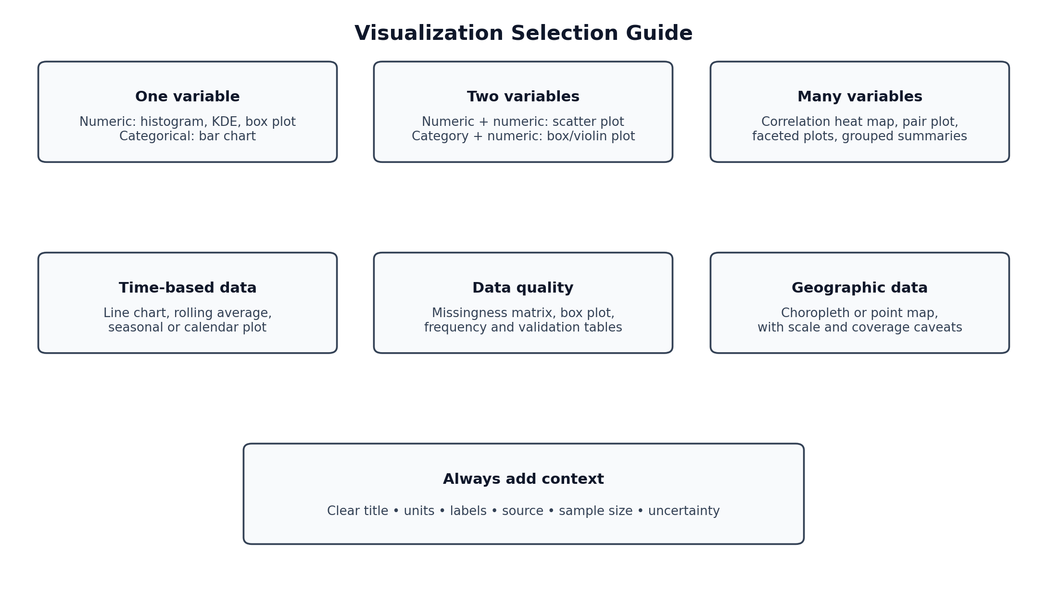
Figure 1. A practical guide for choosing visualizations by data type and analytical goal.

7.1 Visualization quality checklist
- The chart answers one clear question and uses an appropriate visual encoding.
- Titles, axis labels, units, legends, source, and date range are included where relevant.
- Color is used consistently and is not the only way information is conveyed.
- Scales are not misleading; transformations and truncated axes are clearly disclosed.
- The plot remains legible in the final report and is accessible to the intended audience.
- The narrative explains the finding and its limitation instead of merely restating the chart.

8. Python Tools and Libraries
Tool / library | Role in the framework
Python | Core language for reproducible data analysis.
pandas | Reading files, inspecting schema, cleaning, grouping, joining, reshaping, and time-series operations.
NumPy | Numerical arrays and efficient calculations.
Matplotlib | Fine-grained static chart control and publication-ready figures.
Seaborn | Convenient statistical plots and distribution/relationship visualizations.
Plotly | Interactive charts for exploration and dashboards when interactivity is useful.
Jupyter Notebook / JupyterLab | Combines code, explanation, tables, charts, and outputs in one exploratory document.
SciPy / statsmodels (optional) | Statistical summaries, tests, and time-series tools when assumptions and questions warrant them.
missingno (optional) | Quick visualization of missingness patterns.
Git / GitHub | Version control for code, documentation, and analysis decisions.

8.1 Tool-selection principles
- Prefer pandas and Matplotlib/Seaborn for reproducible, report-friendly workflows.
- Use Plotly when interactive exploration adds value; do not add interactivity merely for decoration.
- Use optional statistical libraries only when a specific analytical question requires them.
- Record package versions and random seeds where relevant; do not commit sensitive raw data to a public repository.

9. Recommended EDA Workflow
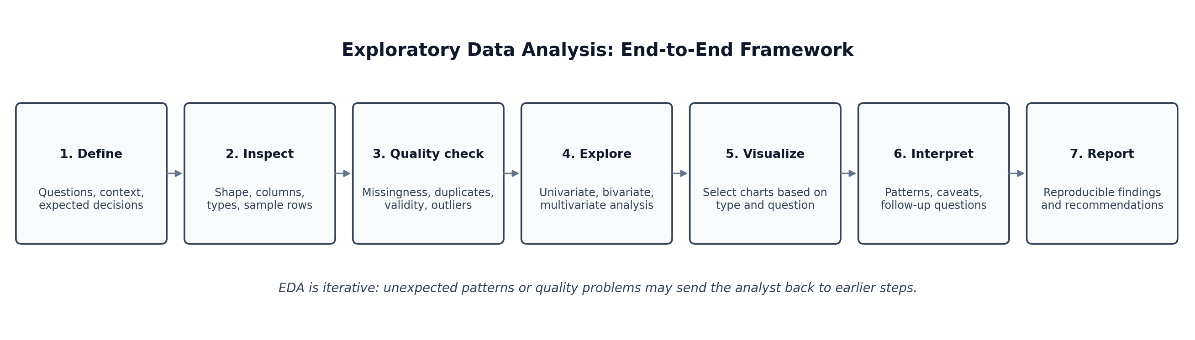
Figure 2. End-to-end EDA process. Steps are iterative rather than strictly linear.

9.1 Suggested implementation sequence
- Define the purpose, stakeholders, analysis questions, and constraints.
- Load and profile the dataset; create a source and schema record.
- Validate types, units, duplicates, missingness, and expected ranges.
- Create a quality log and apply only justified cleaning transformations.
- Perform univariate analysis for every relevant variable.
- Perform bivariate and multivariate analysis guided by the questions.
- Create focused visualizations and investigate surprising patterns.
- Summarize findings, caveats, unresolved questions, and recommended next steps.
- Review reproducibility, privacy, chart quality, and report consistency.

10. Reporting and Documentation Plan
The final EDA report should distinguish observations from interpretations and recommendations. Each important finding should be supported by a statistic, chart, or table and should state the population, time range, and limitations relevant to that result.
Report section | Contents
1. Executive summary | Purpose, dataset scope, 3–5 main findings, major limitations, recommended actions.
2. Context and questions | Business/research problem, intended decisions, assumptions, and analysis questions.
3. Dataset overview | Sources, row/column counts, time range, data dictionary, privacy and coverage notes.
4. Data-quality assessment | Missingness, duplicates, invalid values, outliers, corrections, and decisions.
5. Univariate findings | Important distributions, category frequencies, and unusual values.
6. Relationship analysis | Bivariate/multivariate patterns, subgroup comparisons, and uncertainty.
7. Visual findings | Charts with captions, definitions, source, and concise interpretations.
8. Limitations | Sampling bias, missing coverage, measurement error, small groups, and non-causal interpretation.
9. Recommendations and next steps | Data improvements, questions for stakeholders, further tests, and modeling readiness.
10. Appendix | Reproducible code, package versions, definitions, additional charts, and decision log.

10.1 Reproducibility and file organization
eda-project/
├── README.md
├── requirements.txt
├── data/
│ ├── raw/ # restricted or private data; do not publish
│ └── processed/
├── notebooks/
│ └── 01_eda.ipynb
├── src/
│ ├── data_profile.py
│ ├── quality_checks.py
│ └── visualization.py
├── reports/
│ ├── figures/
│ └── eda_report.docx
└── logs/
└── data_quality_decisions.md
The repository structure is a suggestion, not a requirement. Raw data should not be committed if it contains personal, confidential, licensed, or otherwise restricted information. A report should identify the dataset version and analysis date so results can be reproduced.

11. Timeline and Work Allocation (33 Hours)
Work package | Activities | Hours | Output
1. Objectives and context | Define questions, audience, assumptions, constraints | 3 | EDA brief
2. Data structure and types | Profile fields, schema, data dictionary, variable types | 4 | Dataset profile plan
3. Data quality assessment | Missingness, duplicates, outliers, validation rules | 5 | Quality checklist and decision log
4. Univariate and bivariate EDA | Summaries, distributions, pairwise comparisons | 5 | Exploration plan
5. Multivariate and time-based EDA | Grouped patterns, correlations, trends, spatial options | 4 | Advanced EDA plan
6. Visualization design | Select plots, layout, labels, accessibility, chart review | 4 | Visualization guide
7. Interpretation and reporting | Findings template, limitations, recommendations | 4 | Report outline
8. Final review and formatting | Check clarity, diagrams, consistency, and formatting | 4 | Final deliverable
Total |  | 33 | Completed framework document
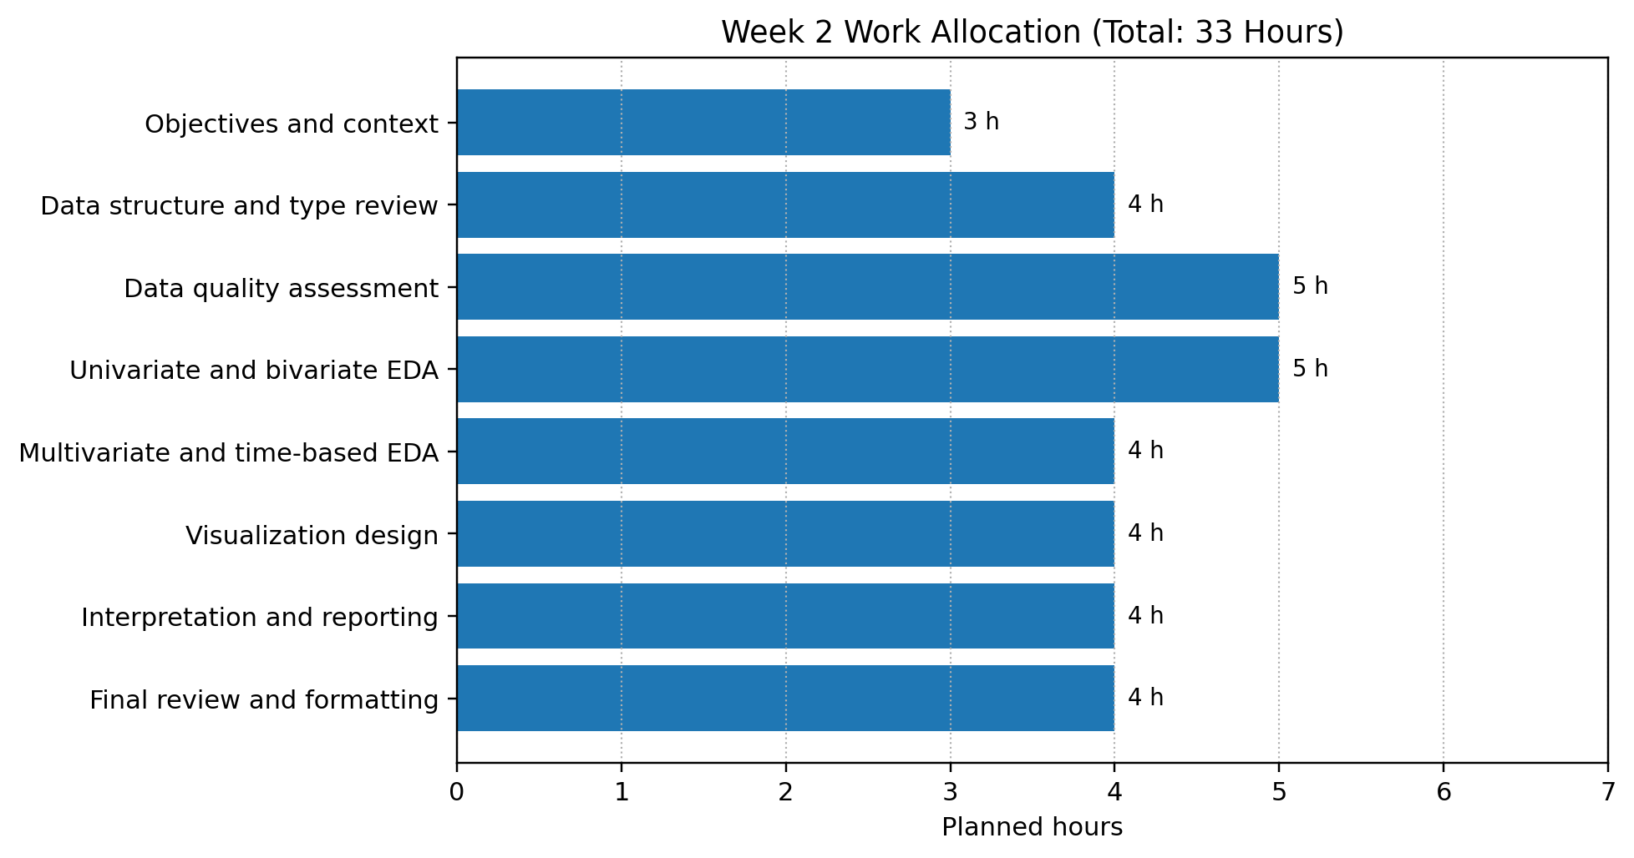
Figure 3. Proposed work allocation across the 33-hour plan.

12. Expected Outcomes
- A reusable, question-led EDA checklist that works across different dataset types.
- A systematic method for profiling variables and identifying data-quality problems.
- A reasoned approach to choosing visualizations rather than plotting without a purpose.
- A documented record of cleaning decisions, assumptions, patterns, and unresolved issues.
- A clearer assessment of whether the dataset is suitable for further statistical analysis or machine learning.
- A reproducible report that communicates findings and limitations to stakeholders.

13. Common Challenges and Mitigations
Challenge | Mitigation
Dataset is large or wide | Start with profiling and targeted samples; use aggregation and focused plots.
Many missing values | Investigate causes and patterns; compare handling choices and document impact.
Outliers dominate charts | Use robust summaries or transformed views where appropriate, while preserving original values.
Too many categories | Sort categories, group only when justified, or use faceting and focused subsets.
Spurious correlations | Use domain reasoning, subgroup checks, and cautious language; do not infer causation from correlation.
Biased or incomplete coverage | Document who/what is absent and how this limits generalization.
Misleading charts | Review scales, labels, denominators, sample sizes, and color accessibility.
Poor reproducibility | Version code and dependencies; save source metadata and cleaning decisions.
Sensitive information exposed | Remove or aggregate identifying details and follow data permissions before sharing outputs.

14. Evaluation Checklist
- EDA purpose and importance are clearly explained.
- Potential data types and type-specific checks are covered.
- Univariate, bivariate, multivariate, time-based, and relevant geographic techniques are described.
- Missing data, duplicates, inconsistent values, and outliers have explicit handling plans.
- Visualization choices are linked to analytical questions and data types.
- Python libraries are listed with practical roles.
- Reporting, documentation, reproducibility, and limitations are included.
- The work plan totals 30–35 hours (33 hours planned).
- Workflow, chart-selection, and timeline diagrams are embedded.
- The document makes no claim to have analyzed a dataset that was not provided.

15. Conclusion
This framework provides a clear and adaptable process for turning an unfamiliar dataset into a well-documented understanding of its structure, quality, distributions, and relationships. It emphasizes that EDA is iterative, question-driven, and dependent on data context. By combining pandas-based profiling, appropriate statistical summaries, carefully selected visualizations, explicit quality decisions, and reproducible reporting, an analyst can identify limitations early and make better-informed decisions about the next stage of a data science project.

Appendix: Example EDA notebook outline
- 01 — Context, questions, source, and reproducibility metadata
- 02 — Load data and inspect shape, schema, and sample rows
- 03 — Data dictionary and data-quality profile
- 04 — Missingness, duplicates, invalid values, and outliers
- 05 — Univariate summaries and charts
- 06 — Bivariate and multivariate relationships
- 07 — Time-based or geographic analysis where relevant
- 08 — Key findings, limitations, and recommendations
- 09 — Export figures and report outputs

