Data Science Project
Planning & Strategy
Smart Flood Risk Analysis and Early-Warning Planning
Week 1 Deliverable • Conceptual plan • Python-based workflow
Prepared for: Data Science Project Planning Assignment
Planned effort: 33 hours
Status: Planning document — no model trained and no real-world warning claims

Executive Summary
This document proposes a Python-based data science project to estimate short-term flood risk for defined geographic zones using rainfall, river or drainage measurements, historical flood reports, and contextual location information. The goal is to design a responsible analytical workflow—not to deploy a life-safety system in Week 1. The plan covers problem definition, data sourcing, quality checks, exploratory analysis, feature engineering, candidate models, evaluation, communication, risks, and a 33-hour schedule.
The project will be treated as a decision-support prototype. Any risk category must include uncertainty, be evaluated against historical events, and be reviewed by a human. The project will not claim that a model can guarantee safety or replace official warnings.

1. Introduction and Project Background
Flooding can disrupt transport, damage property, affect agriculture, and put people at risk. Heavy rainfall may lead to local flooding, but the relationship depends on factors such as rainfall intensity and duration, river level, drainage capacity, terrain, land cover, and the location’s history. These interacting factors make flood risk a useful candidate for structured data analysis.
The proposed project, Smart Flood Risk Analysis, explores whether historical weather and flood observations can support a simple estimate of risk for a defined area and time window. Python is suitable because it offers libraries for tabular data handling, visualization, machine learning, and reproducible evaluation.

1.1 Motivation and justification
- Create a repeatable process for turning multiple data sources into a documented risk estimate.
- Identify which data-quality gaps and variables matter most before investing in a full application.
- Compare a transparent baseline with a more flexible model rather than assuming a complex model is better.
- Communicate uncertainty and limitations so the output is not mistaken for an official emergency alert.

2. Problem Statement
Given historical observations for a geographic zone, can a Python workflow estimate the likelihood of a flood-related event within a defined future window (for example, the next 24 hours), using only information that would have been available at prediction time?
The initial unit of analysis will be a zone-day or zone-hour, depending on the resolution and reliability of the available data. The target label must be defined before modeling—for example, whether an officially recorded flood event occurred in that zone during the forecast window. The label definition and forecast horizon must remain consistent throughout evaluation.

3. Project Objectives and Success Criteria
- Define stakeholders, decisions, target label, geographic unit, and forecast horizon.
- Identify realistic data sources and document their coverage, licensing, update frequency, and limitations.
- Create a data dictionary and a data-quality plan for timestamps, units, missingness, duplicates, and outliers.
- Plan exploratory data analysis (EDA) to investigate trends, seasonality, class imbalance, and relationships.
- Specify a baseline and at least one candidate classification model, with leakage-aware validation.
- Choose metrics suited to an imbalanced, safety-relevant problem and document the cost of false negatives and false positives.
- Produce clear diagrams, a 33-hour work plan, a risk register, and recommendations for a later implementation phase.

3.1 Planning-stage success criteria
- Every required section in the assignment is present and internally consistent.
- The target, prediction horizon, input features, validation strategy, and metrics are explicitly defined.
- The schedule totals 33 hours and includes time for quality review and documentation.
- Diagrams accurately distinguish the proposed analytical workflow from a deployed operational system.
- No unsupported performance claim is made before data collection and evaluation.

4. Scope and Assumptions

4.1 In scope
- A conceptual prototype for one selected region or a small set of geographic zones.
- Historical rainfall, river/water-level observations where available, historical flood-event records, and static zone attributes.
- Python-based ingestion, validation, cleaning, EDA, feature engineering, baseline modeling, candidate-model comparison, and reporting.
- Offline evaluation and a written recommendation about whether the available data supports further development.

4.2 Out of scope
- A production emergency-warning service, guaranteed prediction, or replacement for official disaster-management guidance.
- Live hardware sensors, embedded devices, or deployment of a physical monitoring network.
- A public mobile application, automated SMS delivery, cloud production infrastructure, or 24/7 operations.
- High-resolution hydraulic simulation, detailed hydrological calibration, or claims of coverage for every location.
- Using personal or sensitive individual-level data; the first version should use area-level observations.

4.3 Assumptions and dependencies
- Suitable historical records and timestamps can be obtained for at least a subset of the selected region.
- Data-use permissions and any applicable attribution requirements will be checked before use.
- If real observations are unavailable for planning exercises, synthetic data may be used to test the pipeline structure only; synthetic results cannot establish real-world predictive performance.

5. Stakeholders and Intended Use
Stakeholder | Potential need | How the project responds
Local planners / analysts | Understand area-level patterns and data gaps | Exploratory charts, documented assumptions, and risk summaries
Disaster-management teams | Review whether a signal merits further investigation | Human-reviewed decision support; no autonomous official alerts
Residents / community groups | Understand the limits of area-level risk information | Plain-language explanations and prominent uncertainty statements
Project evaluator | Assess process and strategic thinking | Reproducible plan, diagrams, timeline, metrics, and risk register

6. Data Strategy

6.1 Candidate data inputs
Data group | Example fields | Purpose / checks
Rainfall | timestamp, zone/station, rainfall_mm, duration | Intensity and accumulated rainfall; check units, station coverage, and missing intervals
Water level | timestamp, gauge_id, level_m, alert_threshold_source | Potential river/drainage response; check gauge datum and sensor consistency
Flood-event records | event_id, zone, start/end time, severity/source | Target label; verify event dates, geographic precision, and reporting bias
Zone context | zone_id, elevation/terrain summary, land-cover class | Contextual features; check spatial resolution and date validity
Weather context (optional) | forecast issue time, forecast rainfall | Only use forecasts available at prediction time; avoid using future-observed values
Possible sources include national or regional meteorological agencies, water-resource departments, open government data portals, and documented research datasets. Availability, licensing, and access are not assumed: the implementation phase must verify each source. A source register should record owner, URL, download date, license, geographic coverage, temporal resolution, units, and known limitations.

6.2 Data dictionary and quality rules
- Use a consistent timestamp standard (preferably UTC internally) while retaining the original timezone and source.
- Normalize measurement units and document conversions; never silently mix millimetres and inches or incompatible water-level datums.
- Check duplicate records, impossible values, gaps, stale readings, inconsistent zone identifiers, and out-of-order timestamps.
- Preserve raw inputs read-only; write cleaned data to a separate versioned output.
- Do not automatically delete extreme rainfall values: investigate whether they are genuine events or recording errors.
- Track missingness by source, zone, season, and target class; document every imputation rule.

6.3 Target and feature definition
Target proposal: flood_event_within_next_24h = 1 if a verified flood event begins in the zone during the next 24 hours; otherwise 0, subject to the source’s reporting limitations. Features may include rainfall over the previous 1, 3, 6, 12, and 24 hours; rolling rainfall totals; recent water-level changes; month or season; and static zone characteristics. Only information available at the prediction timestamp may be used.
The target should be revised if event records are too sparse or too imprecise. A proxy label such as a threshold crossing must be explicitly described as a proxy, not presented as verified flood occurrence.

7. Methodology and Strategy

7.1 Phase A — Problem framing
Confirm the decision to support, target population, zone definition, prediction horizon, and consequences of errors. Define the baseline question and establish a data feasibility gate: if target labels or temporal coverage are inadequate, stop modeling and report the limitation rather than manufacture confidence.

7.2 Phase B — Data collection and versioning
- Build a source register and obtain only data whose use is permitted.
- Keep raw files unchanged and record download date, source version, and checksum where practical.
- Load data using pandas; use explicit dtypes, parsed timestamps, and documented schema checks.
- If using simulated data for pipeline testing, label it clearly and keep it separate from real evaluation.

7.3 Phase C — Cleaning and preparation
- Standardize column names, units, timezones, zone identifiers, and measurement conventions.
- Remove exact duplicate rows; investigate conflicting duplicates rather than choosing arbitrarily.
- Quantify missingness and decide whether to drop, impute, or flag missing values based on source meaning.
- Inspect outliers with domain context; retain plausible extreme events.
- Join datasets using explicit temporal and geographic rules, checking row counts before and after each join.
- Prevent leakage by ensuring all predictors precede the prediction timestamp and by fitting preprocessing only on training data.

7.4 Phase D — Exploratory data analysis
- Summarize record counts, date coverage, missingness, duplicate rates, and zone coverage.
- Plot rainfall and water-level time series, seasonal patterns, distributions, and extreme-event windows.
- Compare feature distributions between event and non-event periods, while avoiding causal claims from correlation.
- Measure class imbalance and investigate whether events are under-reported in some zones or periods.
- Use EDA to refine features and data requirements; record hypotheses before model comparison.

7.5 Phase E — Feature engineering and modeling
Start with a transparent baseline, such as a majority-class predictor or a simple rule based on a documented rainfall/water-level threshold. Then compare a regularized logistic regression and a tree-based model such as Random Forest or HistGradientBoostingClassifier. The exact model choice depends on data size, missingness, interpretability needs, and validation results.
- Candidate features: lagged rainfall, rolling sums/maxima, recent water-level change, season, and zone context.
- Use a chronological train/validation/test split; if multiple zones are present, also test whether performance generalizes across zones.
- Fit imputers, scalers, encoders, and feature selection only on training folds using a scikit-learn Pipeline.
- Keep a simple baseline so that any complex model must demonstrate measurable value over it.

7.6 Phase F — Evaluation and decision thresholds
Accuracy alone is inadequate when flood events are rare. Report confusion matrix, precision, recall/sensitivity, F1, precision-recall AUC, and calibration where sample size permits. Emphasize recall for missed events while also tracking false alarms, because both have operational costs. Choose thresholds on validation data based on a documented trade-off; evaluate the final choice once on a held-out test period.
- Compare model performance with the baseline and inspect errors by zone, season, and event severity where data permits.
- Use confidence intervals or resampling when sample size permits; state when results are too uncertain.
- Check probability calibration before interpreting model outputs as likelihoods.
- Do not define an arbitrary performance target without examining label quality and the intended decision.

7.7 Phase G — Communication and reproducibility
- Prepare a concise report with the data source register, data limitations, key EDA findings, metrics, and error analysis.
- Record environment/package versions, random seeds, preprocessing steps, and model configuration.
- Use risk categories only if a defensible thresholding method is established; show uncertainty and the last data timestamp.
- Document what would be needed before operational use: expert validation, prospective testing, monitoring, incident procedures, and official-agency coordination.

7.8 Workflow diagram
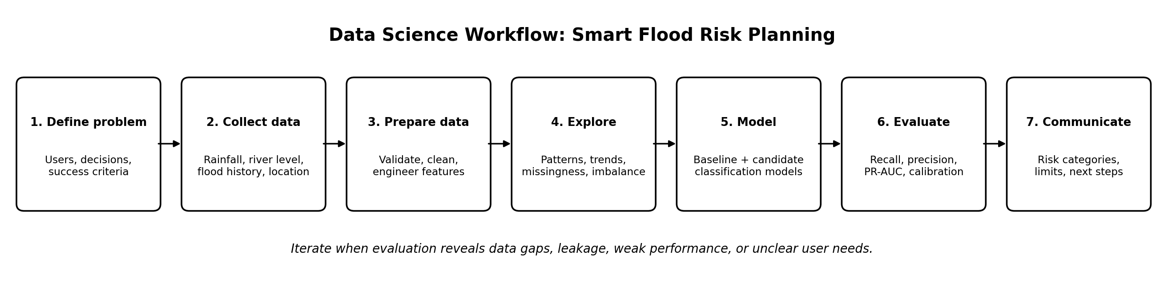
Figure 1. End-to-end analytical workflow. The process is iterative: evaluation can send the project back to data-quality review or feature design.

8. Conceptual Architecture
The architecture separates source data, validation, feature preparation, modeling, evaluation, and eventual delivery. The Week 1 assignment covers the plan and diagrams; implementation and operational deployment are future phases subject to data feasibility and safety review.
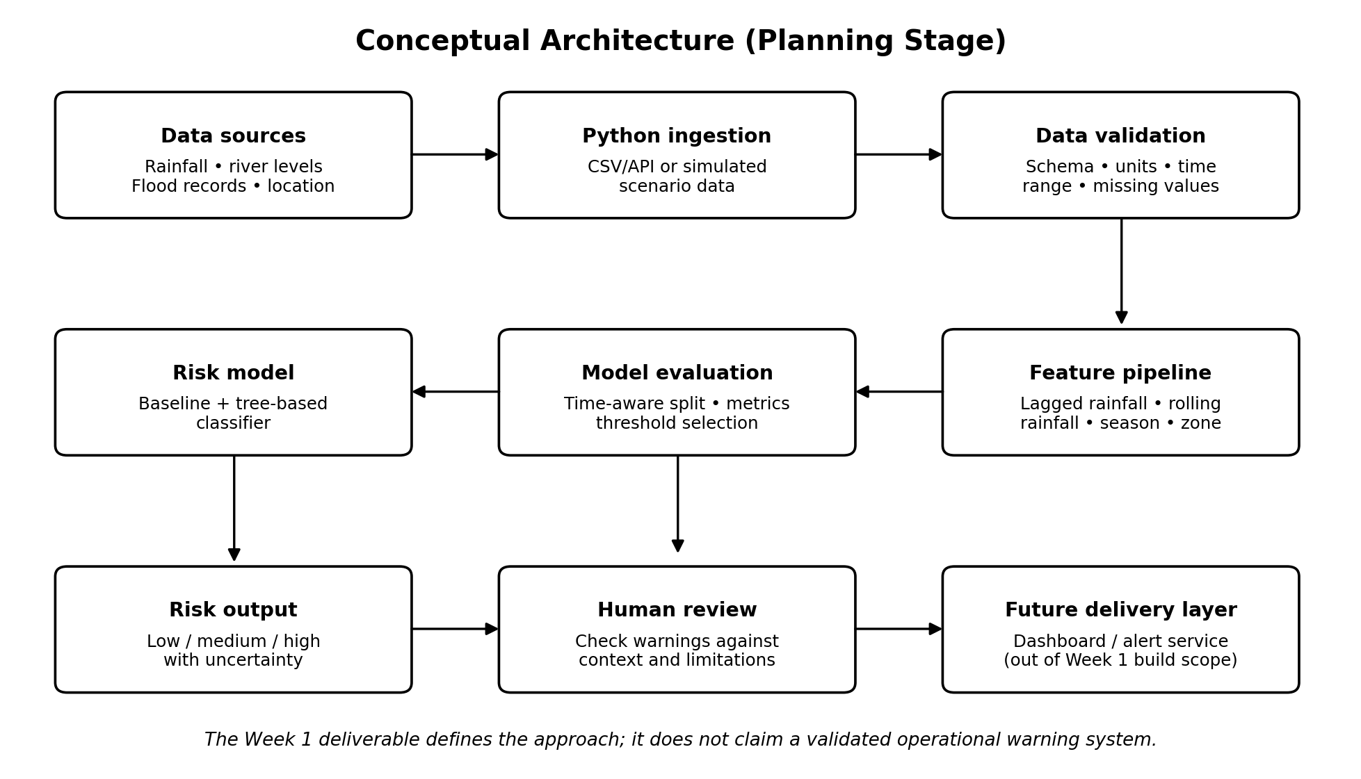
Figure 2. Conceptual architecture. The delivery layer is a future possibility, not a completed feature.

9. Tools and Technology
Tool / library | Planned role | Reason for selection
Python 3.x | Core language and reproducible workflow | Broad ecosystem and readable analytical code
Jupyter Notebook / JupyterLab | Exploration and narrative analysis | Supports iterative analysis with visual outputs
pandas | Tabular ingestion, joins, cleaning, time-series preparation | Flexible data manipulation
NumPy | Numerical operations | Efficient array and numerical support
Matplotlib / Seaborn | Charts for EDA and reporting | Clear distributions, trends, and comparison plots
scikit-learn | Pipelines, baselines, models, validation, metrics | Consistent preprocessing and evaluation APIs
SciPy / statsmodels (optional) | Statistical tests or interpretable statistical summaries | Use only when the question requires it
Git and GitHub (or another Git host) | Version control and collaboration | Change history and reproducibility
CSV / Parquet; optionally SQLite | Interim storage and simple structured persistence | Portable data exchange; Parquet for efficient tabular data
draw.io / diagrams.net or LibreOffice Draw | Editable planning diagrams | Free-form diagram creation and export to image
The project can be completed with free and open-source tools. Exact package versions should be pinned in a requirements.txt or environment file during implementation. A cloud account is not required for the planning stage.

10. Timeline and Work Allocation (33 Hours)
The schedule below is a realistic planning allocation for Week 1. It totals 33 hours and includes both analysis design and the work required to produce a polished submission.
Work package | Activities | Hours | Output
1. Problem framing | Problem statement, users, target, horizon, scope | 3 | Project brief and success criteria
2. Data-source research | Identify candidate sources; document access, coverage, license | 4 | Source register
3. Data dictionary and quality plan | Fields, units, schema checks, missingness and outlier rules | 4 | Data dictionary and validation checklist
4. Cleaning and feature strategy | Joins, timestamp handling, leakage prevention, feature ideas | 5 | Preparation plan
5. EDA plan | Charts, hypotheses, imbalance and bias checks | 4 | EDA checklist
6. Modeling plan | Baseline, candidate models, chronological validation | 4 | Model comparison strategy
7. Evaluation, ethics, and risks | Metrics, threshold trade-offs, limitations, mitigation | 3 | Evaluation and risk register
8. Diagrams, writing, review | Create visuals, assemble document, verify consistency | 6 | Final Week 1 document
Total |  | 33 | Submission-ready plan
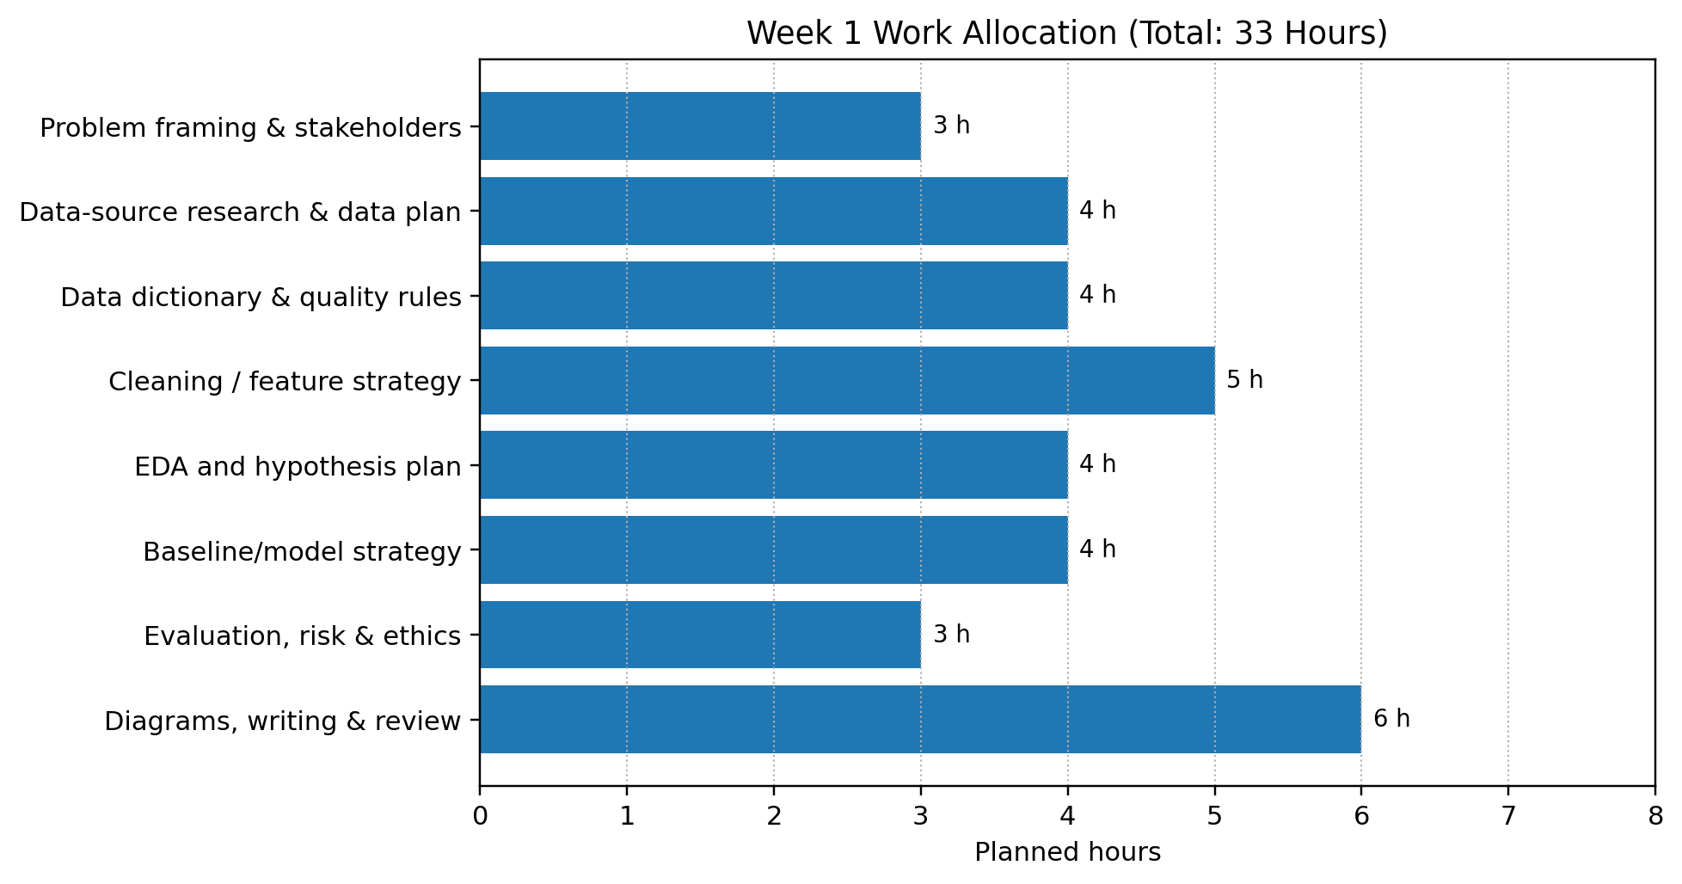
Figure 3. Planned effort by work package. Hours are estimates and can be adjusted if source discovery takes longer.

11. Expected Outcomes and Benefits
- A documented, reproducible blueprint for a Python-based flood-risk analysis project.
- A source register and explicit assessment of whether the available data can support the target definition.
- A defensible cleaning, EDA, feature-engineering, validation, and evaluation strategy.
- A baseline-versus-candidate model comparison plan that prioritizes event detection, calibration, and error analysis.
- A clear set of limitations and next steps for a later implementation phase.
- Improved stakeholder understanding of how data quality, leakage, rare events, and uncertainty affect model trustworthiness.

12. Anticipated Challenges and Mitigation
Challenge | Why it matters | Mitigation strategy
Missing or inconsistent measurements | Can bias patterns and reduce usable coverage | Profile missingness by source/zone/time; document imputation; test sensitivity
Rare flood events / class imbalance | A model can appear accurate while missing events | Use precision-recall metrics, class-aware methods where justified, and a baseline
Reporting bias in flood records | Events may be under-recorded or geographically imprecise | Cross-check sources, document label confidence, avoid unsupported claims
Temporal leakage | Future information can make offline scores misleading | Chronological splits; features restricted to data available at prediction time
Changing weather and infrastructure | Historical relationships may not remain stable | Evaluate by time period; plan drift monitoring and periodic review
False alarms and missed events | Both can cause harm or reduce trust | Document error costs, tune threshold on validation data, retain human review
Spatial generalization | Performance may differ between zones | Hold out zones where possible and report subgroup performance
Overstated certainty | Risk scores could be mistaken for official warnings | Communicate uncertainty, timestamp, intended use, and non-operational status
Data access / licensing | A source may be unavailable or restricted | Verify permissions early and record approved alternatives without mixing source assumptions

13. Ethical, Safety, and Governance Considerations
- Treat model output as decision support, not as a substitute for emergency services or official alerts.
- Avoid publishing precise location-level risk claims unless spatial accuracy and data provenance support them.
- Document data coverage gaps that may systematically underrepresent some communities or zones.
- Keep audit records of source versions, transformations, model versions, thresholds, and evaluation results.
- Before any real deployment, obtain domain-expert review, conduct prospective testing, define escalation procedures, and coordinate with responsible authorities.

14. Deliverables and Acceptance Checklist
- Project background and motivation are clearly described.
- Problem statement, objectives, scope, assumptions, and target are explicit.
- Data collection, cleaning, EDA, feature engineering, modeling, and evaluation are planned.
- Python libraries and supporting tools are identified with justifications.
- Work allocation totals 30–35 hours (planned total: 33 hours).
- Workflow, architecture, and timeline visuals are embedded in the document.
- Expected outcomes, risks, mitigations, ethics, and limitations are included.
- No real model performance or operational readiness is claimed without evidence.
- The final document has been reviewed for spelling, formatting, and consistency.

15. Conclusion and Next Steps
This plan defines a structured and responsible route from a flood-risk question to a testable Python analysis. The first implementation milestone should be a feasibility review of real data: source permissions, temporal coverage, target quality, and spatial consistency. If the data is adequate, the next phase can build a small reproducible pipeline and compare a baseline with candidate models using time-aware evaluation. If the data is not adequate, the correct outcome is to document the gap and revise the project question—not to imply that synthetic data proves predictive value.

Appendix A. Suggested Initial Repository Structure
smart-flood-risk/
├── README.md
├── requirements.txt
├── data/
│ ├── raw/ # unchanged source files; do not commit restricted data
│ ├── interim/
│ └── processed/
├── notebooks/
│ ├── 01_data_audit.ipynb
│ ├── 02_eda.ipynb
│ └── 03_baseline_model.ipynb
├── src/
│ ├── ingest.py
│ ├── validate.py
│ ├── features.py
│ ├── train.py
│ └── evaluate.py
├── reports/
│ ├── figures/
│ └── project_plan.md
└── tests/
└── test_data_quality.py

Appendix B. Example Evaluation Report Template
Item | What to record
Data | Sources, time range, zones, number of records, label prevalence, missingness
Split | Train/validation/test periods and any held-out zones
Baseline | Baseline method and metrics
Candidate model | Algorithm, preprocessing pipeline, and selected features
Metrics | Precision, recall, F1, PR-AUC, confusion matrix, calibration if feasible
Error review | False negatives, false positives, patterns by zone/season
Limitations | Label quality, coverage, uncertainty, generalization limits
Decision | Proceed, revise data strategy, or stop pending additional evidence

