CLOUD COMPUTING

Introduction to Cloud Computing

Cloud Computing has fundamentally changed how businesses and individuals store, access, and manage data. It is a technology that allows you to use data and applications over the internet, moving beyond the limitations of a local computer's hard drive or a private server. But to truly understand its impact, we must first look at the problems it solved.

The Problem Cloud Computing Solves: The "Old Way" vs. The "New Way"

Before the cloud, if a company wanted to launch a website or an application, it had to follow a slow and expensive process:

The "Old Way" (On-Premises): The company had to buy powerful physical servers, storage disks, and networking equipment. This required a huge upfront investment, known as Capital Expenditure (CapEx). They had to guess their peak traffic needs, often buying far more capacity than they used day-to-day, leading to wasted resources. If they needed a new server, the process of ordering, installing, and configuring it could take weeks or even months.

The "New Way" (Cloud Computing): The cloud changes this model entirely. Instead of buying hardware, you rent computing power from a cloud provider (like AWS, Google, or Microsoft). This shifts the cost from a large upfront investment to a manageable monthly bill, known as an Operational Expenditure (OpEx). This model eliminates guesswork, long waiting times, and wasted resources.

What is Cloud Computing?

Cloud Computing is a technology that allows you to store and access data and applications over the internet instead of using your computer’s hard drive or a local server.
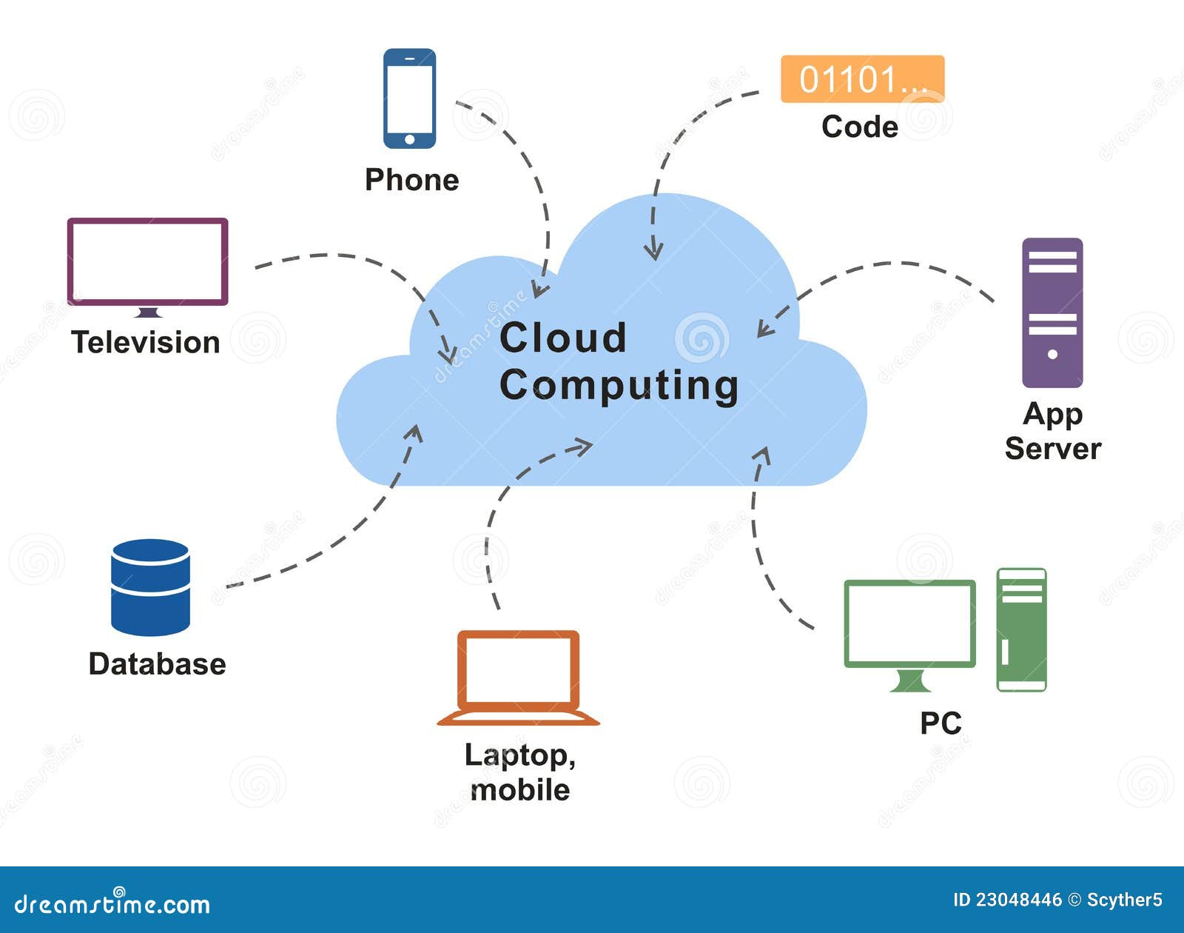
Architecture Of Cloud Computing
Cloud computing architecture refers to the components and sub-components required for cloud computing. These components typically refer to:

- Front end ( Fat client, Thin client)
- Back-end platforms ( Servers, Storage )
- Cloud-based delivery and a network ( Internet, Intranet, Intercloud )

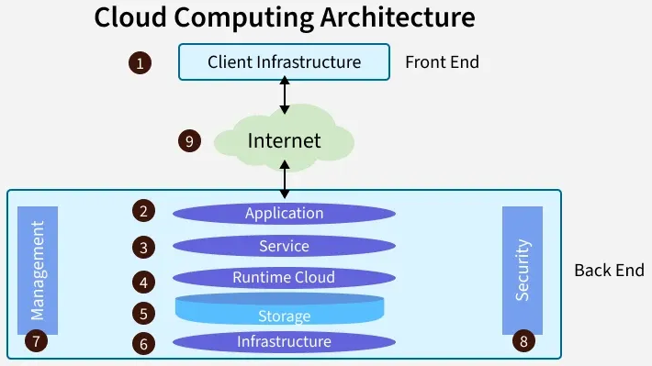

1. Front End ( User Interaction Enhancement )
The User Interface of Cloud Computing consists of 2 sections of clients. The Thin clients are the ones that use web browsers facilitating portable and lightweight accessibilities and others are known as Fat Clients that use many functionalities for offering a strong user experience.

2. Back-end Platforms ( Cloud Computing Engine )
The core of cloud computing is made at back-end platforms with several servers for storage and processing computing. Management of Applications logic is managed through servers and effective data handling is provided by storage. The combination of these platforms at the backend offers the processing power, and capacity to manage and store data behind the cloud.

3. Cloud-Based Delivery and Network
On-demand access to the computer and resources is provided over the Internet, Intranet, and Intercloud. The Internet comes with global accessibility, the Intranet helps in internal communications of the services within the organization and the Intercloud enables interoperability across various cloud services. This dynamic network connectivity ensures an essential component of cloud computing architecture on guaranteeing easy access and data transfer.

Key Characteristics
- On-demand self-service: Users can provision resources without human interaction.
- Broad network access: Accessible from anywhere via the internet.
- Resource pooling: Shared resources among multiple customers.
- Rapid elasticity: Scale resources up or down as needed.
- Measured service: Pay-as-you-go pricing model.

Types of Cloud Services
- IaaS (Infrastructure as a Service): Provides virtualized computing resources (e.g., AWS EC2, Azure VMs).
- PaaS (Platform as a Service): Provides a platform for app development (e.g., Google App Engine).
- SaaS (Software as a Service): Delivers software over the internet (e.g., Microsoft 365, Salesforce).

Advantages of Cloud Computing

- Cost Efficiency - No upfront hardware costs; Pay only for what you use. Example: A startup using AWS instead of buying servers.
- Scalability - Easily scale resources up or down. Example: E-commerce sites scaling during festive sales.
- Accessibility - Access from anywhere with an internet connection. Example: Remote teams using Google Workspace.
- Disaster Recovery - Built-in backup and recovery options. Example: Azure Backup for enterprise data.
- Automatic Updates - Providers handle software and security updates. Example: SaaS apps like Microsoft 365 auto-update.
- Performance - High-speed infrastructure with global data centers. Example: Netflix uses AWS for streaming globally.

On-Premises Deployment vs Cloud Deployment

Feature | On-Premises Deployment | Cloud Deployment
Infrastructure | Owned and managed by the organization | Managed by cloud provider
Cost Model | High upfront CAPEX (hardware, licenses) | OPEX (pay-as-you-go)
Scalability | Limited, requires hardware purchase | Highly scalable instantly
Maintenance | Organization responsible for updates and security | Provider handles maintenance
Accessibility | Limited to internal network | Accessible globally via internet
Deployment Speed | Slow (weeks/months) | Fast (minutes/hours)
Disaster Recovery | Requires separate setup | Built-in redundancy

Real-World Examples

- Netflix: Uses AWS for global streaming and scalability.
- Dropbox: Migrated from on-prem to cloud for better storage management.
- Government Agencies: Often use hybrid models for sensitive data.

Deployment Models

- Public Cloud: Services offered over the public internet (AWS, Azure).
- Private Cloud: Dedicated infrastructure for one organization.
- Hybrid Cloud: Combination of public and private clouds.
- Multi-Cloud: Using multiple cloud providers for flexibility.

