BIG DATA

1. Introduction to Big Data
Big Data refers to extremely large and complex datasets that traditional data processing tools cannot handle efficiently. It is generated from various sources such as social media, sensors, transactions, and more. Big Data enables organizations to gain insights, improve decision-making, and innovate.

2. The Four V’s of Big Data
Big Data is characterized by four key dimensions:
- Volume: Represents the amount of data generated and stored. Example: Social media platforms generate petabytes of data daily.
- Velocity: Indicates the speed at which data is generated, processed, and analyzed. Example: Stock market data updates every millisecond.
- Variety: Refers to the different types and formats of data: structured, semi-structured, and unstructured. Example: Tweets, images, videos.
- Veracity: Denotes the quality, accuracy, and trustworthiness of data. Example: Filtering fake news or incorrect sensor readings.

Visual representation of the Four V’s:
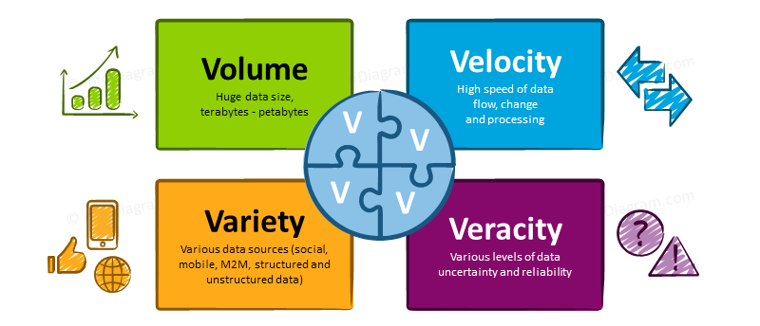

3. Big Data Technologies
Hadoop: An open-source framework for distributed storage and processing of large datasets using clusters of computers.
Spark: A fast, in-memory data processing engine for big data analytics and machine learning.
NoSQL Databases: Databases like MongoDB and Cassandra designed to handle unstructured and semi-structured data.
Kafka: A distributed streaming platform for building real-time data pipelines and streaming applications.

4. Big Data Architecture Overview
A typical Big Data architecture consists of data sources, ingestion layer, storage layer, processing layer, and analytics/visualization layer.
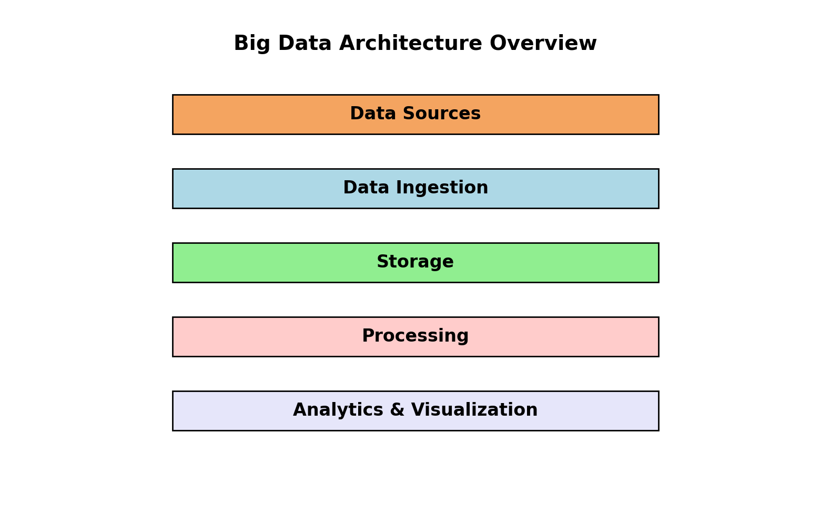

5. Real-World Use Cases
- E-commerce: Personalized recommendations and dynamic pricing.
- Healthcare: Predictive analytics for patient care and drug discovery.
- IoT: Real-time monitoring and predictive maintenance for connected devices.
- Finance: Fraud detection and risk management using streaming data.

6. Advantages and Challenges of Big Data

Advantages:
- Improved decision-making through data-driven insights.
- Enhanced customer experience and personalization.
- Operational efficiency and cost reduction.

Challenges:
- Data privacy and security concerns.
- High infrastructure and maintenance costs.
- Complexity in managing and integrating diverse data sources.

7. Future Trends in Big Data
- Integration with Artificial Intelligence and Machine Learning.
- Edge computing for faster data processing closer to data sources.
- Increased focus on data governance and compliance.

