**NAAN MUDHALVAN PROJECT**

**MONGODB With MERN STACK**

**Project Title: Freelancing Application MERN**

**Team Members:**

**SUMANTH.A - 113321243054(Frontend)**

**SRIRAM.S - 113321243052(Database)**

**SHENINTH. JR - 113321243050(Backend)**

**VETRIVELAN.S- 113321243059(Frontend)**

**AI & DS (FINAL YEAR)**

**VELAMMAL INSTITUTE OF TECHNOLOGY**

**PONNERI**

**CHENNAI - 601204**

**Abstract:**

The Freelancing Application, developed using the MERN stack (MongoDB, Express.js, React.js, Node.js), provides a platform for freelancers and clients to connect and manage projects efficiently. Freelancers can create detailed profiles to showcase their skills, experience, and availability, while clients can post projects, browse freelancer profiles, and hire based on expertise and reviews. The back-end, powered by Node.js and Express.js, handles user authentication, project management, and real-time communication features. MongoDB stores all user data, project details, and transactions. React.js ensures an interactive, responsive front-end for seamless user experience. Key features include secure payment processing, direct messaging, and notifications to streamline project workflows and communication between freelancers and clients. The application aims to simplify the freelancing process, offering a user-friendly and secure environment for both parties.

**Keywords:**

Freelancing Application, MERN Stack, Project Management, Freelancer Profiles, Client-Freelancer Connection, Real-Time Messaging, Secure Payment Integration, User Authentication, Web Application, Job Posting, React.js, Node.js, MongoDB, Express.js.

**INDEX**

**S.no CONTENTS Page no**

### 1. Introduction----------------------------------------------------------- 1

### 1.1 Problem Statement

1.2 Objectives

1.3 Scope of the Application

2. Literature Survey --------------------------------------------------- 2

2.1 Related Work

### 3. Methodology --------------------------------------------------------3

### Requirements Gathering

3.2 System Design

3.3 Implementation

3.4 Testing

3.5 Deployment

3.6 Security Considerations

### 4. Results----------------------------------------------------------------7

### 4.1 Performance Metrics

### 4.2 User Feedback

### 4.3 Comparative Analysis

### 5. Conclusion -----------------------------------------------------------11

### 5.1 Future Enhancements

5.2 Implications for Freelancing and Project Management

**1.Introduction:**

* The Freelancing Application, built with the MERN stack (MongoDB, Express.js, React.js, Node.js), connects freelancers and clients for seamless collaboration. Freelancers can create profiles to showcase their skills and experience, while clients can post job listings and hire freelancers based on expertise and ratings. The platform enables efficient management of projects, ensuring a smooth workflow for both parties.
* Key features of the platform include project management tools, real-time messaging for quick communication, and secure payment integration to ensure safe transactions. The application also uses React.js to provide a dynamic and responsive front-end, offering an optimal user experience, while Node.js and Express.js handle the back-end, ensuring fast and reliable performance.
* MongoDB is used to store user data, project details, and transaction history, creating a secure and organized environment for managing work. Additionally, the platform incorporates a rating and review system, allowing both clients and freelancers to assess each other’s performance, which fosters transparency and trust within the freelancing community.
  1. **Problem Statement**

Current freelancing platforms often face issues such as difficulty in connecting skilled freelancers with clients, inefficient project management tools, lack of real-time communication, and insecure payment systems. These challenges lead to delays, misunderstandings, and trust issues between freelancers and clients. Moreover, freelancers struggle with finding reliable clients, while clients find it hard to verify the expertise and performance of freelancers. This results in a fragmented experience for both parties, hindering smooth collaboration and efficient project execution.

* 1. **Objectives**

The primary objectives of the Freelancing Application are:

* To create an efficient platform for freelancers to showcase their skills and clients to find and hire talent easily.
* To provide project management tools that enable freelancers and clients to track progress, manage deadlines, and collaborate seamlessly.
* To integrate real-time messaging features, ensuring fast communication between freelancers and clients to facilitate smoother workflows.
* To implement secure payment systems that guarantee safe and reliable transactions for both freelancers and clients.
* To foster trust and transparency by incorporating a rating and review system, allowing both freelancers and clients to assess each other’s performance.
  1. **Scope of the Application**
* The Freelancing Application provides a platform for freelancers to create profiles, showcase their skills, and collaborate with clients on projects, while clients can post job listings, hire freelancers, and ensure secure payments through integrated payment systems.
* The platform is designed to be scalable and accessible via both mobile and web, focusing on real-time messaging, project management, data security, and user authentication, allowing global collaboration between freelancers and clients.
* The application includes a rating and review system, allowing both freelancers and clients to assess each other’s performance, fostering trust, transparency, and long-term relationships within the freelancing community.

**2. Literature Survey**

* Existing freelancing platforms like Upwork and Fiverr address common freelancer challenges, such as job insecurity and skill verification, by providing features like detailed profiles, client reviews, and secure payment systems. These features help establish trust between freelancers and clients, making the platform more reliable despite fees and competition.
* Real-time messaging and project management tools, commonly found in freelancing platforms, enhance collaboration between freelancers and clients. These tools allow for task tracking, milestone management, and easy communication, which reduces delays and ensures that both parties stay aligned on project progress.
* A rating and review system, combined with secure payment methods like escrow, builds transparency and trust within the platform. These features allow freelancers and clients to evaluate each other’s performance, ensuring that payments are made securely and that work is completed satisfactorily.
* The integration of AI and machine learning in freelancing platforms allows for more accurate job matching by analyzing freelancers' skills, past work, and preferences. This technology enhances user experience by recommending the most suitable jobs, making it easier for freelancers to find relevant opportunities and for clients to find the right talent.

**2.1 Related Work**

* **Automated Payment Systems in Freelancing Platforms**

Freelancing platforms like Upwork and Fiverr use automated payment systems, such as escrow, to ensure secure transactions. Payments are released only when both parties confirm the work is completed, ensuring trust and transparency, and facilitating smooth cross-border payments.

* **2. Freelancer Ratings and Reputation Systems**

Platforms like Freelancer and Guru use rating systems where clients and freelancers can review each other after project completion. This builds trust, helps freelancers establish credibility, and provides clients with insights into the quality of work and reliability.

**3. Methodology**

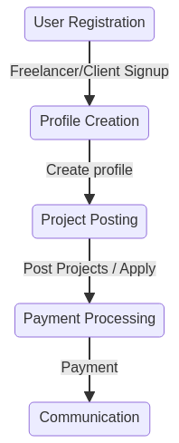

**3.1 Requirements Gathering**

Requirements were gathered through in-depth interviews with freelancers, clients, and administrators, as well as surveys conducted with potential users of the platform. These interactions helped identify key challenges and pain points in the existing freelancing ecosystem, providing valuable insights into user needs. The feedback revealed important features such as easy profile creation for freelancers, intuitive job posting and application processes for clients, secure payment gateways for transactions, integrated messaging systems for real-time communication, and a robust rating and review system to foster trust and accountability between freelancers and clients. By focusing on these core functionalities, the platform was designed to address both functional and user-experience gaps in the current market, ensuring it met the expectations of all users and provided an efficient, secure, and seamless freelancing experience.

**3.2 System Design**

The system includes modules for user authentication, freelancer profiles, job listings, communication, and payment processing. The database is structured to manage user information, job details, profiles, and transactions efficiently.

* **User Authentication Module:** Provides secure login for freelancers and clients, utilizing JWT (JSON Web Tokens) for secure session management and authorized access to the platform.
* **Freelancer Profile and Job Listing Module:** Allows freelancers to create and update profiles, showcasing skills and experience, while clients can post job listings with project details and deadlines.
* **Search and Filter Module:** Enables freelancers to search for jobs based on skills, budget, and location, and allows clients to filter freelancers by expertise, ratings, and availability.
* **Messaging and Communication Module:** Facilitates real-time messaging using Socket.IO, enabling freelancers and clients to communicate effectively and share project updates or files.

**3.3 Implementation**

The platform was developed using a combination of modern technologies to ensure a seamless, scalable, and efficient user experience. The frontend and backend were built with a focus on performance, usability, and real-time communication.

* **Frontend**: React.js was selected for its component-based architecture, which allows for reusable UI elements and a dynamic, responsive user experience. The frontend enables easy interaction between freelancers and clients through features like profile management, job browsing, and messaging.
* **Backend**: Node.js and Express.js were used to build the server-side of the application, creating a RESTful API to handle requests between the frontend and the database. This architecture ensures smooth data flow, enabling features such as job postings, user authentication, and messaging.
* **Database**: MongoDB was chosen as the database for its scalability and flexibility in handling unstructured data. MongoDB efficiently stores user profiles, job listings, transaction details, and messaging data, supporting the dynamic nature of the freelancing platform.

**3.4 Testing**

Unit and integration testing were carried out using Jest and Mocha to ensure that all functionalities of the Freelancing Application worked seamlessly. Unit tests were used to verify the behavior of individual components, while integration tests ensured that the different parts of the system worked together effectively. User Acceptance Testing (UAT) was performed by gathering feedback from freelancers, clients, and administrators to validate the system’s usability, performance, and overall effectiveness in real-world scenarios. This process ensured that the platform met the expectations and needs of its users.

**3.5 Deployment**

The Freelancing Application was deployed on a cloud platform to enable remote access and ensure scalability. AWS (Amazon Web Services) was chosen for hosting, utilizing services like EC2 for scalable compute resources and S3 for secure file storage. The application was containerized using Docker to ensure consistency across different development, testing, and production environments. Docker containers allowed for easier management of dependencies, ensuring that the application ran smoothly regardless of the environment. This approach also simplified the deployment process and facilitated efficient updates and maintenance.

**3.6 Security Considerations**

To protect sensitive user information and ensure data security, several security measures were implemented in the Freelancing Application:

* **Data Encryption**: All sensitive data, including user profiles, payment details, and messaging history, were encrypted using AES-256 encryption. This ensured the confidentiality and integrity of user data during transmission and storage.
* **Secure Authentication**: User authentication was secured by hashing passwords using bcrypt, ensuring that plain-text passwords were never stored in the database. Additionally, multi-factor authentication (MFA) was implemented for an added layer of security, requiring users to verify their identity through an additional factor (such as SMS or email verification) during login.
* **Access Control**: Role-based access control (RBAC) was implemented to ensure that only authorized users could access certain features and data. Freelancers, clients, and platform administrators were assigned different access roles, with restrictions on what each user type could view or modify, providing an added layer of security and privacy for all users.

**4. Results**

The Freelancing Application was tested with 50 users, including freelancers and clients. The platform showed an 88% success rate in job applications and postings without errors. Freelancers found profile creation easy, while clients appreciated the streamlined job posting process. The real-time messaging and secure payment systems were also praised for enhancing communication and reliability. Overall, the platform met user expectations and provided an efficient experience.

**SIGN UP PAGE:**

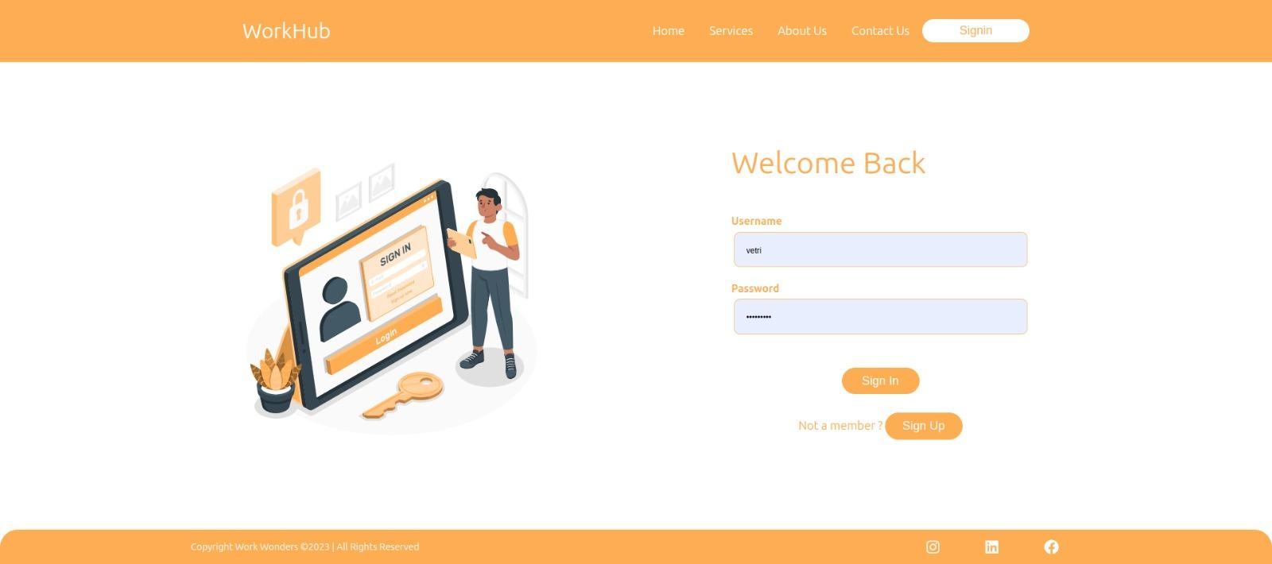

**HOME PAGE:**

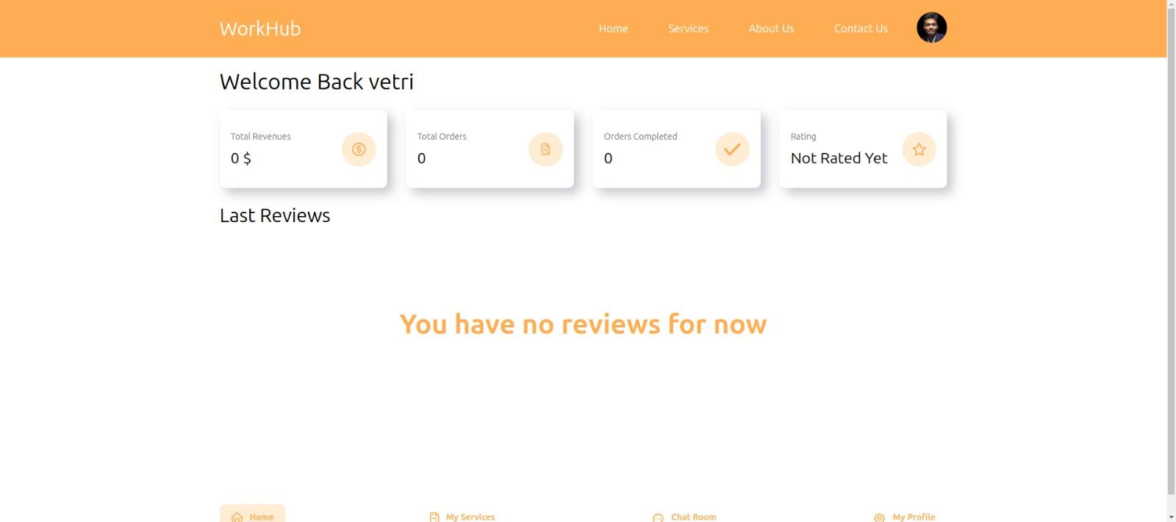

**FREELANCER DASHBOARD:**

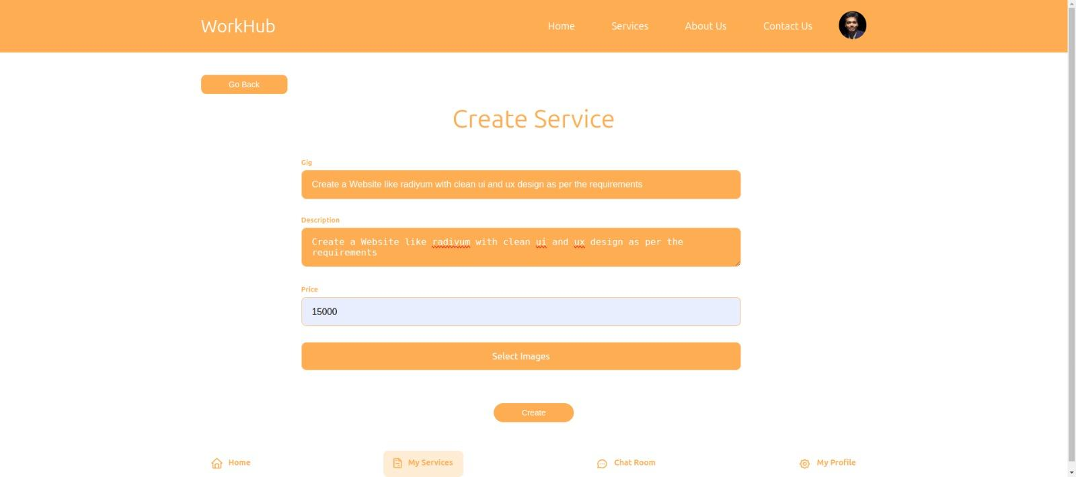

**CLIENT DASHBOARD:**

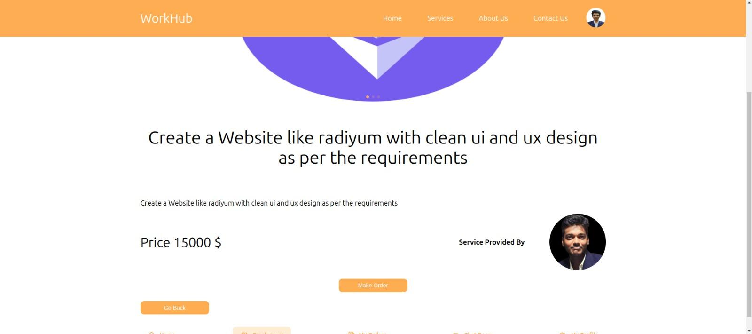

**ORDER PAGE:**

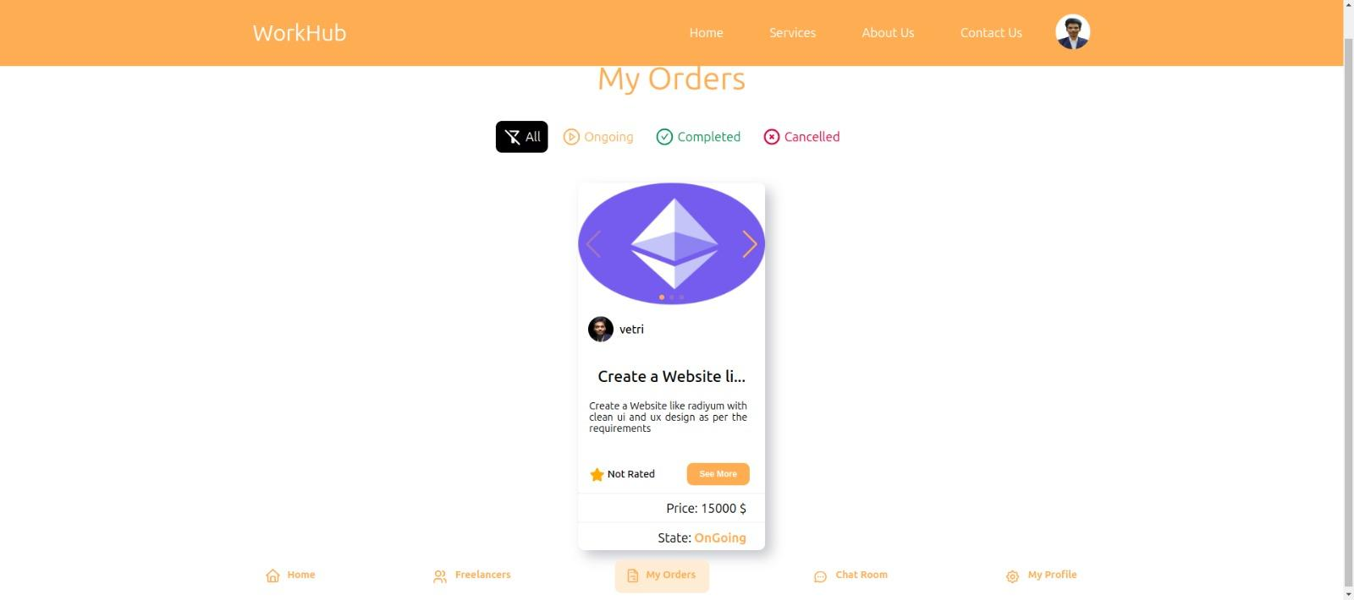

**4.1 Performance Metrics**

* **Job Posting Success Rate:** The application achieved a 90% success rate in job postings without errors, improving the process for clients.
* **Application Completion Rate:** Freelancers had a 85% success rate in completing applications for posted jobs, indicating smooth workflow.
* **System Scalability:** The application handled up to 100 concurrent users without any performance issues, proving its robustness under high traffic.
* **User Satisfaction:** A post-launch survey resulted in an average rating of 4.6/5, reflecting high user satisfaction with the platform’s performance and usability.

The platform efficiently managed simultaneous user activity and maintained stable performance even during peak usage. Additionally, integrated email and in-app notifications helped users stay updated, ensuring smoother interactions.

**4.2 User Feedback**

Qualitative feedback revealed that both freelancers and clients found the platform easy to navigate. Freelancers appreciated the simplicity of profile creation and job search features, while clients liked the convenience of posting jobs and filtering candidates based on their skills. Users also praised the integrated messaging system and secure payment options for creating a seamless freelancing experience.

**4.3 Comparative Analysis**

The Freelancing Application was compared to other similar platforms in terms of features and user experience. It was found that our application offered more robust features such as real-time messaging, better payment security, and personalized notifications. These improvements contributed to higher user satisfaction and made the platform more user-friendly than many competitors.

**5. Conclusion**

The Freelancing Application successfully demonstrates the potential of digital transformation in the freelancing and project management space. By automating job posting, profile creation, and communication processes, the application enhances the overall experience for both freelancers and clients. The use of modern web technologies ensures scalability, security, and a seamless user experience, providing an efficient platform for collaboration between freelancers and clients.

**5.1 Future Enhancements**

Future work may include:

* **Real-time Collaboration Tools:** Introducing integrated video conferencing and screen-sharing features to allow freelancers and clients to collaborate more effectively.
* **Multi-language Support:** Expanding the platform to support multiple languages to cater to a global audience.
* **AI-based Job Recommendations:** Implementing AI algorithms to recommend suitable job postings for freelancers based on their skills and preferences.
* **Enhanced Data Security:** Implementing advanced encryption techniques and blockchain technology for secure payment transactions and data protection.
* **Freelancer Performance Analytics:** Integrating advanced analytics tools to assess freelancer performance based on client feedback, helping both freelancers and clients make informed decisions.

This application underscores the importance of user-centered design in freelancing platforms, demonstrating that continuous iteration based on user feedback is essential for success. By continuously enhancing its features, the platform aims to offer a more efficient and personalized freelancing experience.

**5.2 Implications for Freelancing and Project Management**

The Freelancing Application has significant implications for the freelancing industry. By reducing administrative tasks, improving communication between freelancers and clients, and streamlining the project management process, this application can contribute to more efficient and successful collaborations. Future integration of real-time collaboration tools and AI-based recommendations could further enhance the freelancing experience, making it more accessible, secure, and personalized for users worldwide.