LIGHTWEIGHT WEARABLE DEVICE FOR REAL-TIME CYBER THREAT DETECTION IN WIRELESS NETWORKS
A project report submitted in partial fulfillment of the requirements for the degree of
Bachelor of Technology
in
Electronics & Computer Engineering
by
LIKHIT VARDHAN REDDY (22BLC1312)
ADIVI SRIRAM CHINMAY (22BLC1309)
L JANARDAN (22BLC1312)



School of Electronics Engineering, Vellore Institute of Technology Chennai, Vandalur-Kelambakkam Road,
Chennai - 600127, India.

November 2025

Declaration

We hereby declare that the report titled “ Lightweight wearable device for real-time cyber threat detection in wireless networks” submitted by us to the School of Electronics Engineering, Vellore Institute of Technology, Chennai in partial fulfillment of the requirements for the award of Bachelor of Technology in Electronics and Computer Engineering is a bonafide record of the work carried out by me under the supervision of Dr. Saravana Kumar R .
We further declare that the work reported in this report, has not been submitted and will not be submitted, either in part or in full, for the award of any other degree or diploma of this institute or of any other institute or University.

Sign:

Name & Reg. No.:

Date:

Sign:

Name & Reg. No.:

Date:

Sign:

Name & Reg. No.:

Date:



School of Electronics Engineering

Certificate
This is to certify that the project report titled “Lightweight wearable device for real-time cyber threat detection in wireless networks” submitted by Likhit Vardhan Reddy (22BLC1312), Adivi Sriram Chinmay(22BLC1309) and L Janardan(22BLC1312) to Vellore Institute of Technology Chennai, in partial fulfillment of the requirement for the award of the degree of Bachelor of Technology in Electronics and Computer Engineering is a bonafide work carried out under my supervision. The project report fulfills the requirements as per the regulations of this University and in my opinion meets the necessary standards for submission. The contents of this report have not been submitted and will not be submitted either in part or in full for the award of any other degree or diploma and the same is certified.

Supervisor Head of the Department

Signature: | .................... | Signature: | ....................
Name: | .................... | Name: | ....................
Date: |  | Date:

Examiner
Signature: ....................
Name: ....................
Date:

(Seal of the School)

Abstract

Wireless Fidelity or Wi-Fi as we generally call it has become a very important part of our lives.Whether it is offices, classrooms, airports, or even hospitals we always seem to need Wi-Fi.

This dependency also opens the door to several cybersecurity vulnerabilities. The weaknesses present in Wi-Fi management frames thus become the prime target for attackers through attacks like deauthentication floods, evil twin access points, beacon flooding, and probe request spoofing. These attacks can cause various levels of damage to users including but not limiting to loss of connectivity, data interception and unauthorized network access.

Our aim through this project is to provide a lightweight, wearable solution capable of detecting such real-time cyber threats in Wi-Fi environments. The proposed system uses an ESP8266 microcontroller operating in promiscuous mode to capture 802.11 management frames and identify abnormal transmission patterns. Behind the scenes a Random Forest classifier is deployed on a ML server to further analyze the metadata collected from the ESP-01 to differentiate between normal and malicious traffic. The proposed model also compromises of an OLED display to provide instant on-screen alerts.

The wearable device we designed, titled ‘WATCHOUT’,can be used as a watch when the user isn’t worried about attacks and used to detect attacks by just pressing the button. Experimental testing carried out by us confirmed the device is able to detect attacks with high accuracy and minimal latency. The project aims to bridge the gap between theoretical wireless intrusion detection systems and real-time threat monitoring,hoping to contribute to development of affordable and light-weight Wi-Fi security solutions

Acknowledgements

We wish to express our sincere thanks and deep sense of gratitude to our project guide, Dr. Saravana Kumar R, Professor, School of Electronics Engineering, for his consistent encouragement and valuable guidance offered to us in a pleasant manner throughout the course of the project work.
We are extremely grateful to Dean Dr. Ravi Sankar A, Associate Dean (Academics) Dr. Mohana Prasad K, & Associate Dean (Research) Dr. Chitra K, of the School of Electronics Engineering, VIT Chennai, for extending the facilities of the school towards our project and for his unstinting support.
We express our thanks to our Head of the Department Dr. Vijayakumar P for his support throughout the course of this project.
We also take this opportunity to thank all the faculty of the School for their support and their wisdom imparted to us throughout the course.
We thank our parents, family, and friends for bearing with us throughout the course of our project and for the opportunity they provided us in undergoing this course in such a prestigious institution.

Contents

Declaration ii
Certificate iii
Abstract iv
Acknowledgements v
List of Figures
- Introduction 6
- Literature Survey 2
  - Real-Time Data ETL Framework for Big Real-Time Data Analysis 2
  - Data Integration using Webservices 2
  - Data Integration as a Service for Applications Deployment on the SaaS Platform 3
  - Mining Unstructured Data in Software Repositories: Current and Future Trends 3
  - Challenges of Data Integration and Interoperability in Big Data 3
  - Analysis and Optimization of Big-Data Stream Processing 4
  - An Overview and Implementation of Extraction-Transformation-Loading (ETL) Process in Data Warehouse 4
- Methodology 5
  - Data Warehouse 5
    - Data Warehouse Architecture 5
    - Scalable DWH Architecture 6
  - Process Work Flow 6
    - Data Aggregator Architecture 7
    - Proposed Data Integration and Analytics architecture 7
    - Database WebSerivces 8
  - ELT (Extraction, Loading and Transformation) 8
    - ELT concept 8

Contents
  - Data Connectors 9
    - Data Connector as a driver 10
    - Web Data Connector 10
    - Web Connector from a Database 11
  - Definition and Description of Technologies used 11
  - JPublisher 11
    - Requirements 11
    - Overview of JPublisher generation 12
    - JPublisher support for Webservice call-out 12
    - Sample Java Static Proxy Class Load and JPublisher commands . 13
  - Sample webservice invocation 13
  - Multi-Table invocation 13
  - Incremental Refresh 14
- Results and Discussions 16
  - Results and Comparison 16
    - Size vs Extraction time - Traditional 17
    - Size vs Generation time - Traditional 17
    - Size vs Extraction - New 17
    - traditional and the new method 19
- Standards 20
- Conclusion and Future Scope 21
- Appendix 22

List of Figures
  - A DWH with Web service call-out 6
  - A simple work flow diagram 7
  - Data Aggregator architecture 7
  - Proposed DI & A architecture 8
  - ELT data flow 10
  - A simple Data Connector architecture 10
  - A simple Data Connector architecture 12
  - Size of Data vs Extraction Time - Traditional 18
  - Size of Data vs Report Generation Time - Traditional 18
  - Size of Data vs Extraction Time - New 18
  - Extraction Time Old vs New vs Report Generation Time 19

Chapter 1

Introduction

In the recent years, Wi-Fi has become a very important part of our lives. Whether it is offices, classrooms, airports or even hospitals, Wi-Fi has become an essential necessity for most of us. However this growing dependence on Wi-Fi has also made it an attractive and easy target for cybercriminals who attack its vulnerabilities and weaknesses for malicious purposes.

Although there are various technologies including but not limiting to modern encryption standards like WPA2 and WPA3 to protect data transmission, there is still one big weakness in management frames used by Wi-Fi networks. The weakness being connecting, disconnecting and scanning for access points. These management frames are often not encrypted and unauthenticated thus making it easy for attackers to attack. There are many common attacks like deauthentication floods, evil twin access points, beacon flooding and probe request spoofing. These attacks can cause various levels of damage to users including but not limiting to loss of connectivity, data interception and unauthorized network access. It can even eventually lead to stealing of sensitive information or tricking users into connecting to fake networks.

Upon doing a thorough literature survey we found that most of the existing solutions for detecting these type of cyber attacks are complex and resource heavy as they were designed for enterprise or server level setups rather than everyday users. Most of the existing solutions require powerful systems and/or professional configuration. It was very hard to find a portable system to detect cyber attacks.

This led us to understand and identify that a clear need for something lightweight, affordable, and accessible that can detect such attacks in real time. This is where the solution proposed by us, our product titled ‘WATCHOUT’ comes in. Watchout is a wearable device designed to detect Wi-Fi based cyber threats in real time. ‘Watchout’ uses an ESP8266 microcontroller operating in promiscuous mode to capture 802.11 management frames and identify abnormal transmission patterns.

To make sure there is a good detection accuracy , watchout uses a machine learning model hosted on a backend server. After trying various classifiers we found that Random Forest classifier worked the best for our data producing an accuracy of 90%. The system works by analyzing captured data such as frame type, signal strength, and packet frequency to classify attacks more precisely.

Along with its technical function ‘Watchout’ aims to make cybersecurity awareness more personal and accessible for everyone. It is designed to be lightweight and affordable and portable allowing anyone, even laymen to wear it like a watch and get instant alerts about suspicious Wi-Fi or network related activity around them.

In simple terms Watchout bridges the gap between professional network security systems and everyday Wi-Fi users. It combines practical hardware, realtime monitoring and quick, intelligent analysis to make wireless security accessible to everyone right from their wrist.

Literature Survey

Enhanced Anomaly Detection in Wireless 5G Networks With Hybrid Learning Technique Using AWID3 Dataset
In the study done by Dashitfard et al. in 2025 titled “Enhanced Anomaly Detection in Wireless 5G Networks with Hybrid Learning Technique Using AWID3 Dataset” Dashitfard et al. have proposed a hybrid intelligent machine learning model combining Deep Neural Networks , Random Forest and XGBoost with a meta logistic regression layer. Their model was trained and tested using the AWID3 dataset , the same dataset we have used thus making this a good paper to study and learn from. They also achieved an impressive accuracy of 99.75%, mainly due to their efficient feature selection.
However as a big drawback the study did not evaluate the feasibility of deploying this solution in real time or low power environments such as the ESP32 which limited its practical implementation and gave us a challenge to approach.

An Intrusion Detection System for IoT networks through machine learning techniques: an examination utilizing the AWID dataset

Thabit et al. in their research “An Intrusion Detection System for IoT Networks Through Machine Learning Techniques: An Examination Utilizing the AWID Dataset” introduced a new lightweight intrusion detection model using Logistic Regression and Boosted Trees combined with feature selection methods. Their approach mainly showed that simple models could achieve high accuracy when added with optimized preprocessing.

The key limitation of this work was its restricted focus on unknown and evolving attack patterns that may come up in future and lack of testing on resource constrained hardware which raised concerns and
reduces embedded system feasibility of it.

Wi-Fi Network Intrusion Detection: Enhanced with Feature Extraction and Machine Learning Algorithms
“Wi-Fi Network Intrusion Detection: Enhanced with Feature Extraction and Machine Learning Algorithms” by Şolpan et al was a very helpful paper to read as it applied various classifying algorithms like K-Nearest Neighbour (KNN), Support Vector Machine (SVM), and Gradient Boosted Trees integrated with CNN-based feature extraction on the AWID3 dataset, the same dataset used by us.
However, the study did not include an analysis of real time deployment making it less practical for wearable device.

Transferability Evaluation in Wi-Fi Intrusion Detection Systems Through Machine Learning and Deep Learning Approaches
Yonbawi et. al came upwith “Transferability Evaluation in Wi-Fi Intrusion Detection Systems Through Machine Learning and Deep Learning Approaches” in 2024. The paper focuses on federated learning combined with transformer-based architectures.
The only drawback was that the study’s relevance to Wi-Fi intrusion detection was limited as the AWID3 dataset was not used.

Intrusion Detection System for Wireless Sensor Networks: A Machine Learning-Based Approach

In “Intrusion Detection System for Wireless Sensor Networks: A Machine Learning-Based Approach”
Sadia et al. focused on hybrid deep learning models using Convolutional Neural
Networks (CNNs), Autoencoders (AEs) and Bidirectional Gated Recurrent Units (Bi-GRU) to detect anomalies across various different datasets. This turned out to be very helpful .Their model also clearly achieved good results and high accuracy using the hybrid feature learning and multi-model fusion.

An Effective Network Intrusion Detection Approach Based on Hybrid Harris Hawks and Multi-Layer Perceptron
Alazab et al in their research titled “An Effective Network Intrusion Detection Approach Based on Hybrid Harris Hawks and Multi-Layer Perceptron” proposed a hybrid intrusion detection system(IDS) that integrated machine learning techniques with different access controls to make detection accuracy better in IoT environments. However their approach did not focus specifically on wireless packet structures like IEEE 802.11 thus limiting its direct application to Wi-Fi environments such as the one our project is based on.

Lightweight Real-Time Wi-Fi-Based Intrusion Detection System Using LightGBM

Ahmed et al. presented “Lightweight Real-Time Wi-Fi-Based Intrusion Detection System Using LightGBM” in 2023. The paper was based on the deployment of intrusion detection on ESP32-WROOM-DA hardware which was equiped with dual antennas. They used Light Gradient Boosting machine also known as LightGBM to classify efficiently. This paper proved to be very helpful for us as it gave us the demonstration of real-time IDS feasibility on low-power IoT hardware, proving that meaningful network analysis can be performed locally and helping us learn more about it for our project.

Self-Supervised Transformer-Based Contrastive Learning for Intrusion Detection Systems

“Self-Supervised Transformer-Based Contrastive Learning for Intrusion Detection Systems”by koukalis et al. taught us usage of self supervised transformers added with various different contrastive learning techniques to improve and make better generalization across new and unseen attack patterns. Although it had great accuracy it is also very resource intensive making it hard for us to implement similar models as we were aiming for something light weight.

Detection of Deauthentication Threats in Wi-Fi Channels Using Machine Learning Strategies

Latha and B.R.M. through “Detection of Deauthentication Threats in Wi-Fi Channels Using Machine Learning Strategies” showed us the use of supervised ML classifiers to analyze Wi-Fi deauthentication frame patterns and identifying of various different anomalous network behaviors.

EvilScout: Detection and Mitigation of Evil Twin Attack in SDN-Enabled Wi-Fi

The research paper “EvilScout: Detection and Mitigation of Evil Twin Attack in SDN-Enabled Wi-Fi” turned out to be very helpful for us as Shrivastava et al. had designed and implemented a Software Defined Networking (SDN) based detection system that usedd access point fingerprinting and network telemetry to identify Evil Twin attacks. However this was very resource dependent too.

  - Wi-Fi Deauth and Cloning using ESP8266

In the study titled “Wi-Fi Deauth and Cloning using ESP8266,” R. Singh et al. had demonstrated
a practical and low cost implementation of cyberattacks using ESP8266 module, this made their paper one to read and learn from as usage of ESP was properly explained. The study majorly highlights the risks of unprotected management frames and helps us gather wireless security awareness. However, the major limitation of this paper was that it was a purely offensive based concept and didn’t have any proposed defensive countermeasures or strategies.

  - RIDS: Real-Time Intrusion Detection System for WPA3-Enabled
Enterprise Networks

In “RIDS: Real-Time Intrusion Detection System for WPA3-Enabled Enterprise Networks” Rahul
Saini et al. introduced a two stage detection architecture combining lightweight access point
Side anomaly monitoring with a controller level machine learning classifier.
This paper was pretty much the closest to our model idea wise and helped us learn a lot before
starting the implementation of our project

  - Classification of IoT-Based DDoS Attacks Using Machine Learning Techniques

In “Classification of IoT-Based DDoS Attacks Using Machine Learning Techniques,” M. F. Ashfaq
et al have shown the application of various different supervised ML algorithms such as Support Vector Machine (SVM),Random Forest and Decision Tree for detecting Distributed Denial-of-Service (DDoS) patterns in IoT network traffic. This paper helped us visualize how different ML algorithms will work for our project and helped us learn about those algorithms usage for our purpose.

  - Improved Preprocessing for Machine Learning Intrusion Detection in IEEE 802.11

In “Improved Preprocessing for Machine Learning Intrusion Detection in IEEE 802.11”
P. Škrak et al. proposed a refined pre processing framework for wireless intrusion
detection in their paper. The paper helped us learn impact of pre processing on classifier accuracy, showing that protocol aware data preparation significantly enhances ML model performance compared to naïve preprocessing methods.

2.15 Detecting Flooding, Impersonation, and Injection Attacks on AWID Dataset Using ML-Based Methods

Mayank Agarwal in “Detecting Flooding, Impersonation, and Injection Attacks on AWID Dataset
Using ML-Based Methods” has done a very detailed study of supervised ML algorithms applied to the same AWID3 dataset that we have used in our project. The research focused on detecting flooding, impersonation and injection attacks thus helping us to learn about it as we aimed to do focus on the same in our project

Chapter 3

Methodology

‘Watchout’-The proposed model

Definition

The ‘Watchout’ is a lightweight, wearable cyber-threat detection system designed to identify and alert users about Wi-Fi management frame based attacks in real time. These attacks include Deauthentication flood attack, Evil Twin access point spoofing attack , Beacon flooding attack , and Probe request flooding attack. These attacks are aimed to exploit the inherent vulnerabilities in the IEEE 802.11 protocol.

The present, conventional Wi-Fi security technologies and architectures, Intrusion Detection Systems (IDS) are centralized, resource intensive and not portable. To bridge this gap our proposed solution makes intrusion detection into a decentralized, wearable process capable of monitoring the surrounding Wi-Fi networks.

System Architecture

The ‘Watchout’ System Architecture is designed as a hybrid cyber threat detection framework that integrates on device monitoring, real time data transmission and machine learning based classification in a single system. The architecture follows a distributed yet lightweight design where computationally intensive processes such as model training and inference are carried out on a backend server, while the wearable device focuses on activities like packet capture, filtering and user alerting.
The overall architecture is composed of four major components:
- ESP8266 Sniffer Module
- Machine Learning Backend Server
- User Alert Interface (OLED Display)

5

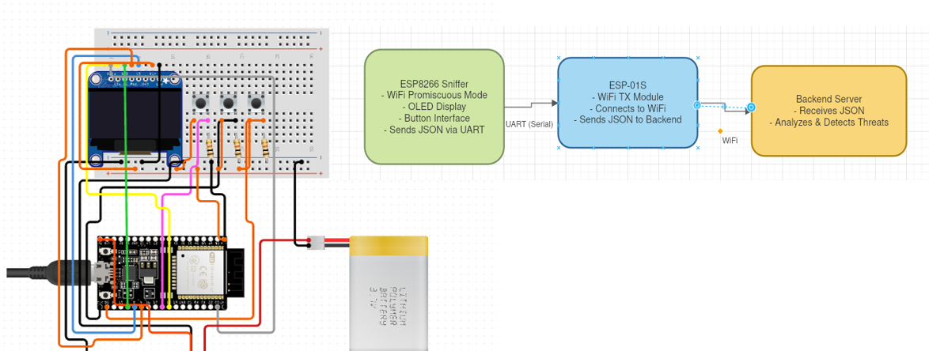

Figure 3.1: The system architecture and design of the model

Hardware Layer

At the hardware level the system consists of the following components:

ESP8266(Node MCU)

0.96 inch OLED Display

Button Interface

Lithium Battery

3.1.2.1 ESP8266(Node MCU)

The ESP8266 acts as the primary sensing and control unit of ‘Watchout’. It is configured to operate in promiscuous mode which allows it to capture all nearby IEEE 802.11 management frames, including Beacon frames, Probe Requests,Disassociations, and Deauthentication frames.

Functional Workflow:

The module constantly and continuously scans the Wi-Fi range to find the management frames.

When packets are detected it filters unnecessary data and extracts key features such as SSID, BSSID,RSSI,Frame Type and Timestamp.

The processed data is changed into JSON format.

Through UART serial communication this JSON data is sent to the ESP-01s module for transmission.

3.1.2.2 OLED display

The OLED display acts as the user interface and displays real time information of the network

status and detected threats.

Display Modes:

Packet Mode: Works as a normal watchuntil the button is pressed.

Watchout Mode: Once the button is pressed, it starts the process of checking nearby wi-fi spectrum and notifies if any anomaly is found.

3.1.2.3 Power management system

A Li-ion battery powers the system making sure of portability and continuous operation.

Backend Server and ML Layer

The backend server acts the brain of our system or in better terms the analytical core of our system. It is responsible for processing and classifying the received Wi-Fi traffic data sent by the wearable device or more specifically the ESP-01S from the wearable device.

Functions:

Receives the packets sent from the ESP-01S in JSON format.

2 Extracts the key features such as packet rate, RSSI variance and timestamp for analysis.

3 The Random Forest Classifier trained on the AWID3 identifies the type of the attack.

4 Sends detection results back to the ESP-01s to notify the user.

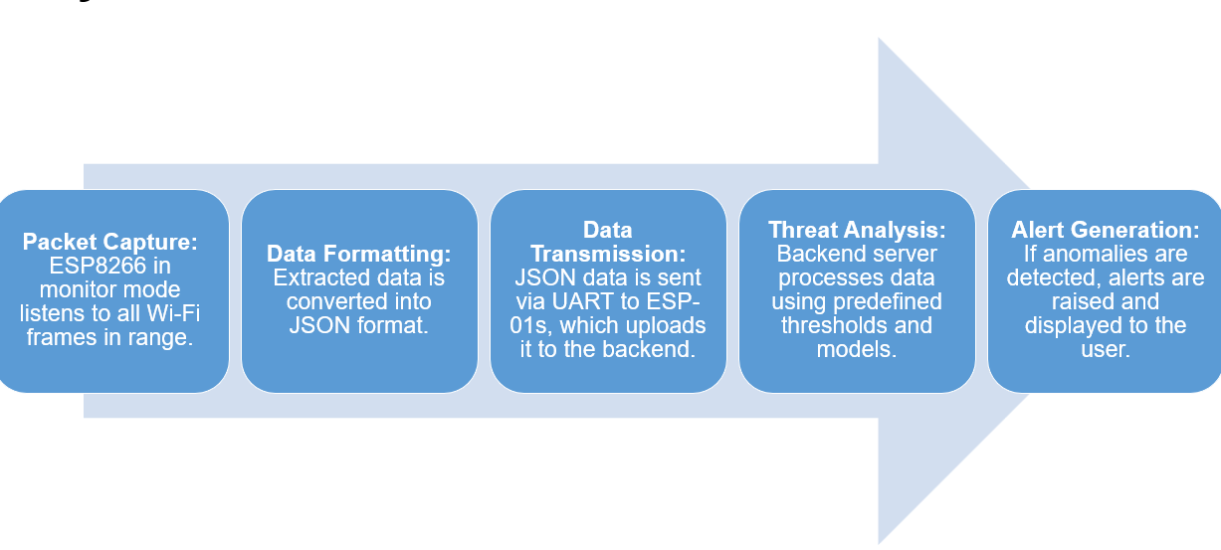
Process Work Flow

Figure 3.2: A simple work flow diagram

Figure 3.2 illustrates the step by step data flow and also shows the interaction that goes on between various modules present in ‘Watchout . The detailed process flow is as follows:

3.2.1 Step 1: Packet Capture

The process of working of ‘Watchout’ begins with the ESP8266 module being configured to operate in Wi-Fi promiscuous mode. When the ESP is in this mode it can capture all nearby Wi-Fi frames transmitted in the spectrum in the certain range around it.

The microcontroller used continuously scans all active channels to find any IEEE 802.11 management frames.

The different types of frames that are generally found include:
- Deauthentication Frames: it is used by attackers to disconnect users from legitimate or proper access points near them.

- Beacon Frames: Beacon frames are used by access points to advertise their presence. We can think of it as access points saying “hello, I am here” to the entire spectrum in the range. It is often exploited in beacon flooding.

- Probe Requests: they are used in scanning networks and can potentially be spoofed in Evil Twin attacks.

Each captured frame is stored temporarily in memory and converted to JSON format before being passed on to the preprocessing module for analysis.

3.2.2 Step 2: Data Filtering and Preprocessing

The frames captured in STEP 1 are then used by the ESP to perform lightweight pre processing so that redundant and/or irrelevant packets can eliminated and only the useful parameters can be extracted.

The parameters extracted for the model are:
- BSSID (MAC address of the source AP)
- SSID (Network name)
- RSSI (Signal Strength)
- Frame Type and Subtype
- Timestamp and Channel Number

This raw packet data is then changed into a JSON format for easier transmission and easier compatibility with the backend server.

3.2.3 Step 3: Data Transmission

The data transmission of the data captured in STEP 2 is carried out by the ESP module used in our project Once a specific buffer of 200 packets arrives, The ESP flushes the arrived to the backend server which is hosted.

3.2.4 Step 4: Backend Data Reception and Machine Learning algorithms

Once the JSON data transmitted in our STEP 3 is received by the backend server of our model, we
can enter the Machine Learning analysis phase.

The backend server, built using Python (Flask) and powered by Scikit-learn contains a trained Random Forest classifier which helps to identify if there is some attack and if yes also classify the type of attack
Using the received data. The ML model was trained using AWID 3 dataset .
The process includes:
- Feature Extraction: The server first extracts the needed metrics like BSSID,SSID,RSSI,Frame Type and Subtype,Timestamp and Channel Number

- Identification:: The Random Forest model which was trained using the AWID3 dataset then classifies the incoming data as either Normal or Malicious.

- Classification : If found malicious the model determines the specific type of attack e.g., Deauth Flood, Beacon Flood, Evil Twin, or Probe Request Flood.

- Alert Generation: Once classification is complete, the server sends an appropriate response message back to the ESP-01s module

3.2.5 STEP 5: Step 5: Displaying the message

When the last part of STEP 4 that is, server sending back the detection result is completed, it is forwarded to the ESP8266 via UART.
The ESP8266 upon recieving it updates the OLED display to inform the user about the current Wi-Fi environment.
The display with the help of buttons allows the user to toggle between “Packet Monitor” and “Handshake capture mode” by pressing the button. The display also shows if the wifi environment is safe or unsafe by showing “safe” or if under attack, the type of attack and then we can single out the attacker and deauthenticate him/her from our network.

Chapter 4

Implementation Details

The implementation of ‘Watchout’ took place step by step starting from the inception of this idea
till its successful completion.

The first step towards its implementation was:

  - Circuit Design

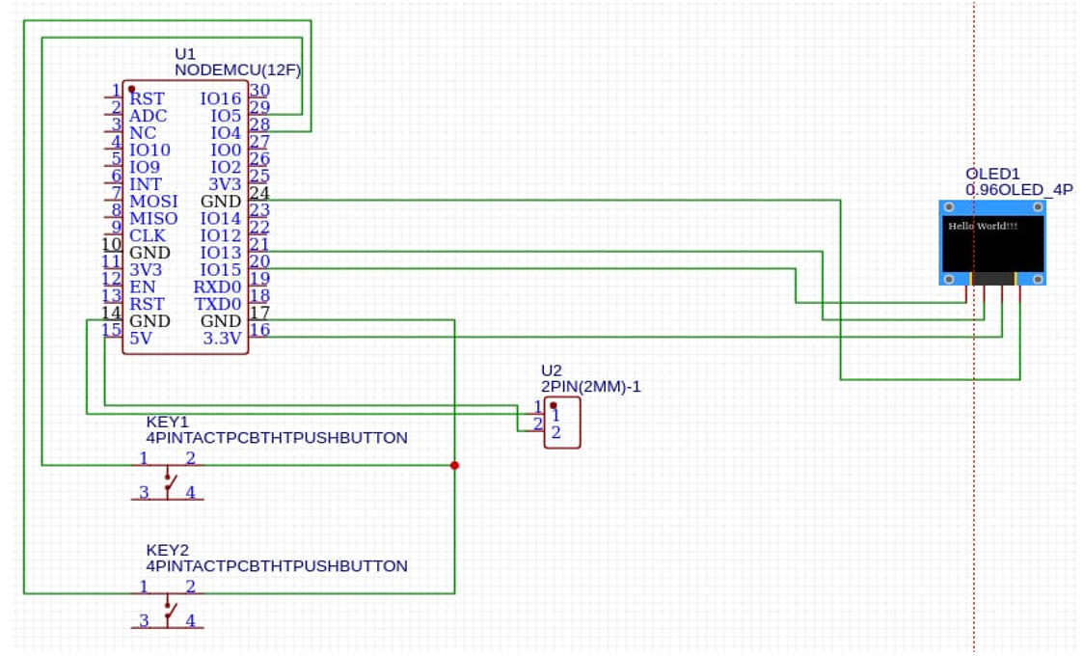

Figure 4.1: Circuit Design

The figure added above (figure 4.1) shows our circuit design for ‘Watchout’ prototype designed around the ESP8266 microcontroller with two push buttons for user control and a 0.96-inch OLED display for real time monitoring. This circuit design forms the base of the wearable threat detection device responsible for both input and visual feedback during operation.

Description of the Circuit:

- ESP8266 Microcontroller :
The ESP 8266 acts as the central control unit of the system. It operates at 3.3V and does the Wi-Fi packet capture when configured in promiscuous mode.

- OLED Display (0.96” I²C, SSD1306):

- It is connected to the ESP via the I ² C communication interface of the OLED (SDA and SCL pins)

- The display is powered by the 3.3V output pin of the ESP and shares a common ground.

- Push Buttons (KEY1,KEY2,KEY 3):

- Three push buttons are connected to digital GPIO pins of the ESP to help navigate through the menu of the wearable device

- Power Connections:

- The circuit is powered by a 3200MAH lithium battery

Functionality of the Setup:

- The NodeMCU initializes the OLED display and begins scanning for nearby Wi-Fi management frames in promiscuous mode.

- The buttons allow the user to interact with the device, toggle views and manually initiate scans.

- The display outputs real time information such as the number of detected networks, signal strengths and potential deauthentication warnings.

  - System Architecture/Design

The next step towards implementing our project after the circuit design was working on a
proper architecture and have a good idea about what we are going to implement. Image 4.2 explains our earliest architecture/design of the project.

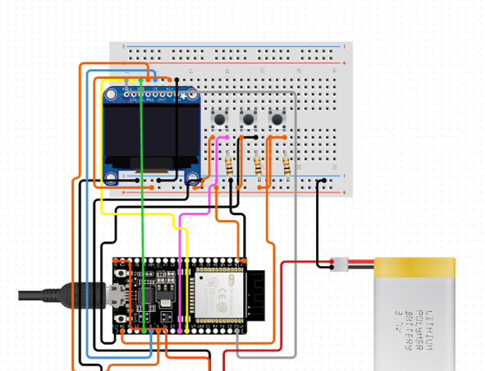

Figure 4.2: System Design

  - Firmware Implementation (ESP8266)

The firmware for our project runs on a ESP8266 module and implements two primary operation modes: ‘Packet Monitor’ and ‘Handshake Capture’.

The Packet Monitor mode enables the user to enter Wi-Fi promiscuous mode and captures metadata for incoming 802.11 frames and then stores them in a packet buffer and then prints the collected records to Serial UART when the capture period ends.

In Handshake Capture mode the firmware scans for nearby APs and thus allows the user to select a target and then alternates between sniffing for EAPOL frames and sending periodic deauthentication bursts to force reauthentication.

    - User Menu & Mode Selection

The implementation of firmware begins with a simple graphical menu interface displayed on the 0.96” OLED screen it has three push buttons added to it to be used for navigation. The user can scroll through available modes i.e Packet Monitor mode and Handshake Capture mode and confirm their selection using those buttons.
The buttons are read through a de bounced input routine to avoid multiple triggers and ensures that the navigation of the menu is smooth and user friendly.
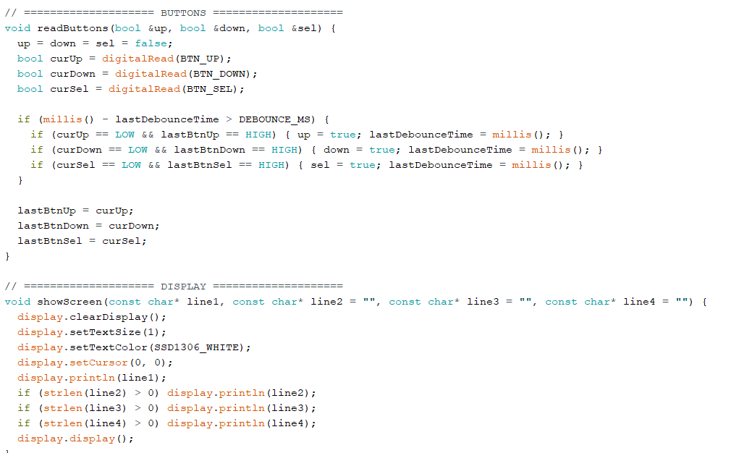

Figure 4.3: Code snippet of integrating the buttons and display

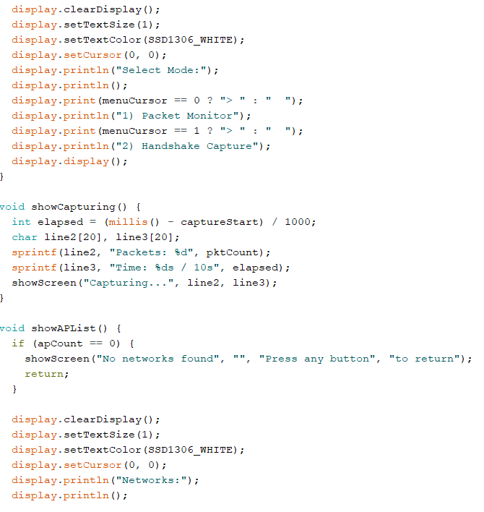

Figure 4.4: Code snippet showing setting up of user menu and mode selection

    - Packet Capture

When the device enters Packet Capture mode it is made to be in promiscuous mode so that it will
be able to capture all the Wi-Fi frames within its range.

A light wieght callback function is used in the code to store essential and releavant metadata from each frame such as source MAC, destination MAC, signal strength (RSSI), channel, and packet length in a local memory buffer.

The device continues collecting frames until either the capture duration (10 seconds) expires or the buffer reaches its maximum capacity (500 packets). As soon as this capture ends the system disables monitor mode and prints a detailed packet dump to the Serial Monitor for analysis.
The OLED display simultaneously shows live packet counts and elapsed capture time, providing real time feedback to the user.

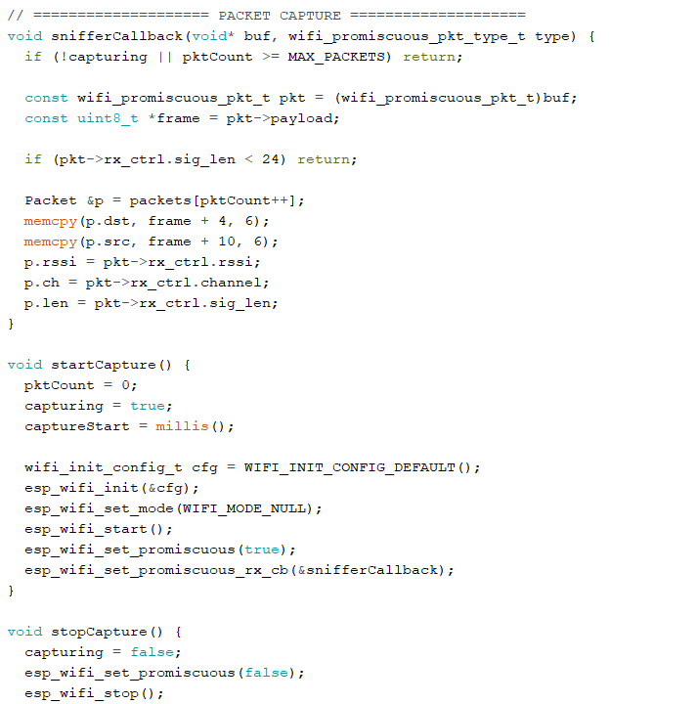

Figure 4.4: Code snippet showing implementation of Packet Capture mode

    - Handshake capture

We designed this mode to capture WPA/WPA2 4-way handshakes for security analysis.
First of all, we made the device perform a network scan to find out and list nearby access Points(Aps) and with their SSIDs, BSSIDs and channels. The user will be able to select the target AP from this
list using the buttons provided on the device.

When the user enters this mode, the ESP goes into a special mode that combines packet sniffing and controlled frame injection. We designed it in a way that it sends periodic deauthentication bursts to force nearby clients to reconnect to the target AP.

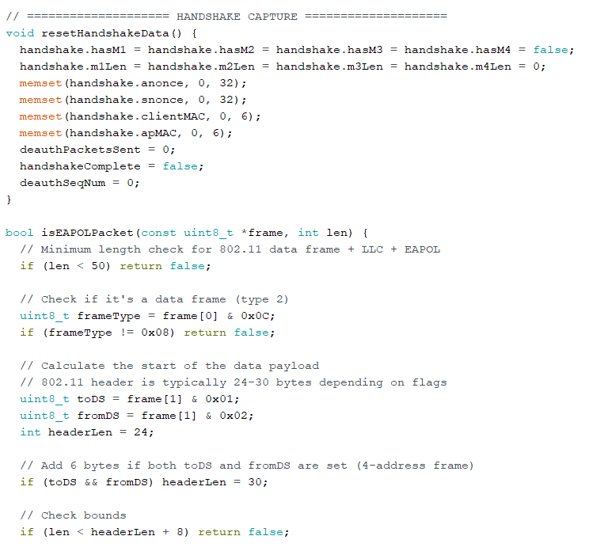

Figure 4.5: Code snippet showing the implementation of Handshake Capture mode

4.4 Backend Machine Learning Model Implementation

While working on the ESP codes and integration of the firmware, we were parallelly also working on the ML model and had started its implementation from the scratch.

4.4.1 Model architecture

The architecture of the model consists of many dense fully connected layers with dropout regularization
so that overfitting could be prevented. The input layer size is kept as the same as the number of extracted network features after scaling and normalization.
Each layer uses the ReLU activation for non-linearity except the final layer which uses Softmax so that we can get class probabilities as the output.

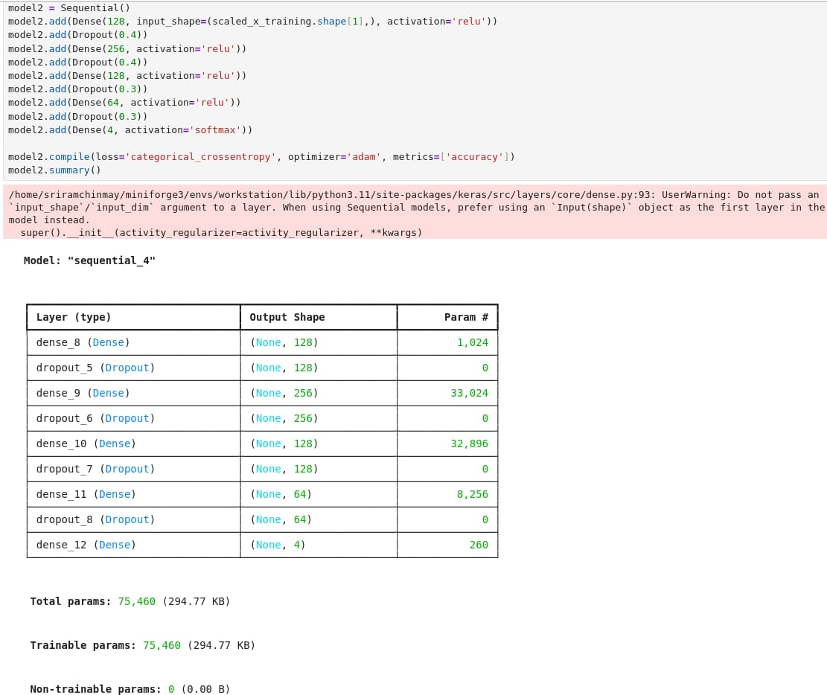

Figure 4.6: Code snippet showing the architecture of the ML model implemented

4.4.2 Implementation of SMOTE and Class Balancing

Before training the model we found that the dataset was found to be exhibiting a class imbalance in the places/cases where the normal traffic class was heavily dominating the attack classes.
To address this issue we decided to implement SMOTE which stands for Synthetic Minority Oversampling Technique to generate synthetic samples for minority classes and to ensure a balanced
class distribution for better learning performance.

SMOTE is a common data balancing method mostly used to handle imbalanced datasets during the training phase of a machine learning model. In real world network traffic data especially intrusion detection datasets like AWID which we are using or custom Wi-Fi captures the normal class usually has far more samples compared to attack classes.This causes imbalance. This imbalance then goes on to
cause the model to become biased toward the normal class and thus resulting in poor detection accuracy for the rarer but much more critical attack types.

SMOTE works by creating new synthetic examples of the minority classes instead of the general way which is duplicating existing samples. It does this by identifying feature space similarities between existing minority class samples and generating new points that lie along the line segments connecting a sample and its nearest neighbours. And thus the new samples are not exact copies but realistic variations that improve the diversity of training data.
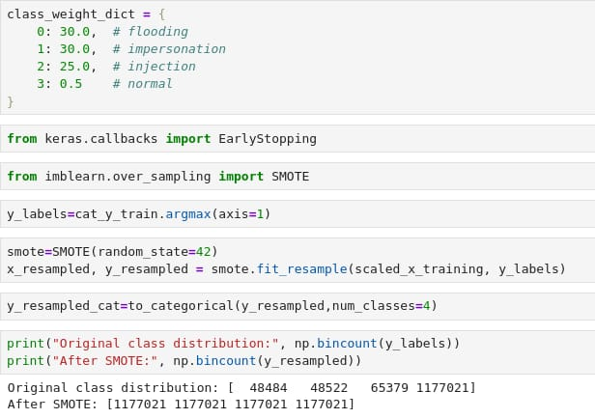

Figure 4.7: Code snippet showing the implementation of SMOTE

This preprocessing step that we used significantly improved our model’s ability to detect less frequent attacks (like impersonation or injection) while maintaining precision in detecting normal traffic.
It also helped in preventing overfitting and achieved consistent generalization during backend testing.

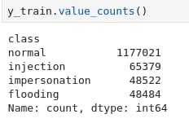

Figure 4.8: Class distributions

The image above shows the class distribution of the training labels before applying the SMOTE method. As we can clearly see the dataset is highly imbalanced with the normal class having 1,177,021 samples and the attack classes such as injection, impersonation, and flooding have only 65,379, 48,522, and
48,484 samples.This heavy imbalance can cause the machine learning model to become biased toward
the majority class leading to poor detection of rare but critical attacks.

4.4.3 Model Training and Evaluation

We then trained the model on the resampled dataset for 30 epochs with a batch size of 64 and a 10% validation split. We used early stopping at epoch 14 where we found that the validation accuracy reached its best value before flattening. The accuracy during training increased steadily reaching around 0.94 and the validation accuracy consistently remained between 0.996 and 0.999 showing us good outcome
and strong and positive generalization capability.

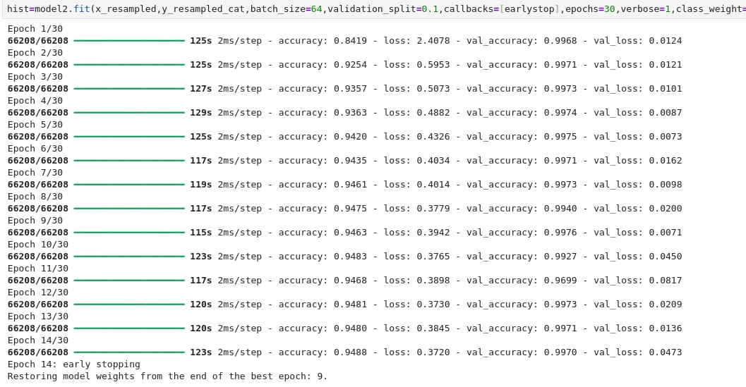
Figure 4.9: Model training

After training we evaluated the model on both the training and testing datasets. The training accuracy reached 94.39% and the testing accuracy was 85.78%. These values showed us that the model was able
to learn patterns effectively while maintaining good performance on unseen data. The loss during evaluation was stable and consistent showing that the model was successfully avoiding overfitting.

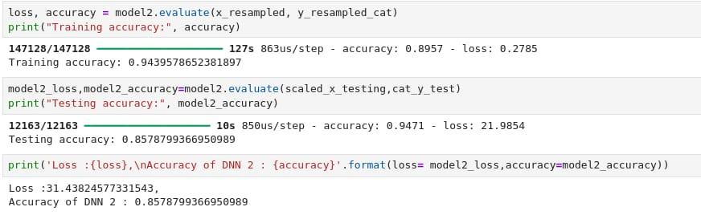

Figure 4.10: Model evaluation

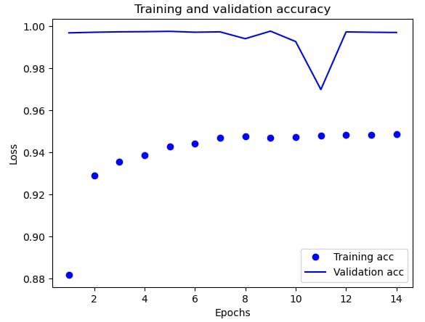

Figure 4.11: Training and validation accuracy

4.4.4 Implementation of Random Forest classifier

After trying various different classifiers and comparing their accuracies and performances we decided to go ahead with Random Forest classifier as it had the most positive performance for our project.

Random Forest was chosen as it is easy to interpret and has very good efficiency in handling complex and non linear relationships between features. As it is an ensemble of multiple decision trees it provided robust predictions. As in random forest classiifier each tree in the forest votes independently and the final prediction is made based on the decision taken my majority or most of the trees it was found to reliable for our model.

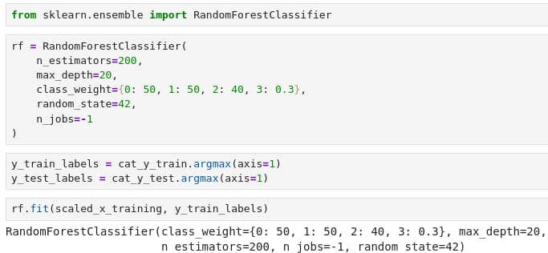

Figure 4.12: Implementation of Random Forest Classifier

After training the Random Forest classifier we them evaluated the model was on the scaled test dataset
to assess its detection capability across all Wi-Fi attack categories. At first the standard predictions were made using the model’s default probability thresholds. But eventually since impersonation and injection attacks often have subtle feature differences compared to normal traffic the default threshold was found
to be too conservative for these cases.

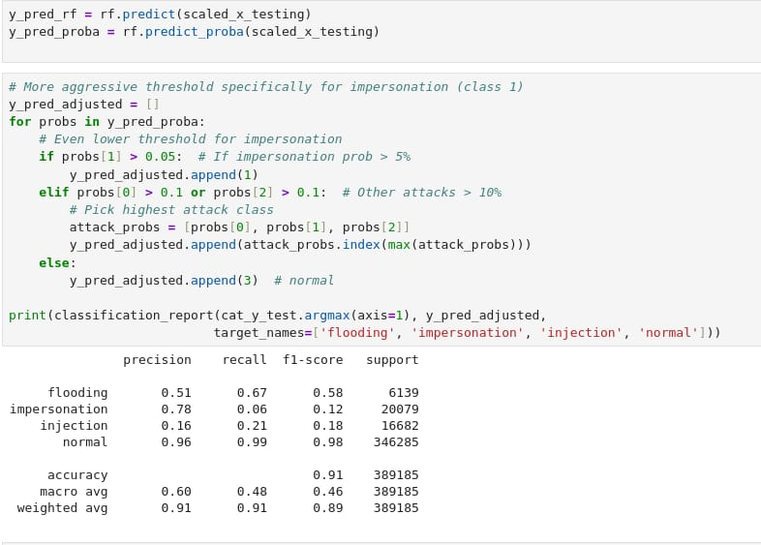

Figure 4.13: Results after the implementation of Random Forest Classifier
  - Hardware Model Implementation

As the coding parts came to an end we started implementing the Hardware Model of the project which is the wearable ‘Watchout’ as we call it.

We started with making a prototype for the final design by making PCB design and 3D Model
which were purely prototypes for our project.

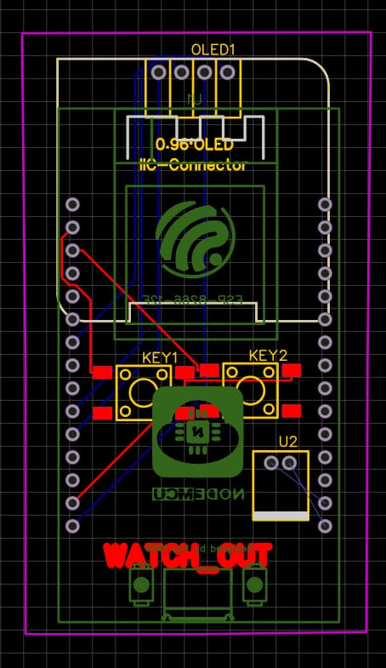

Figure 4.13: A prototype PCB design

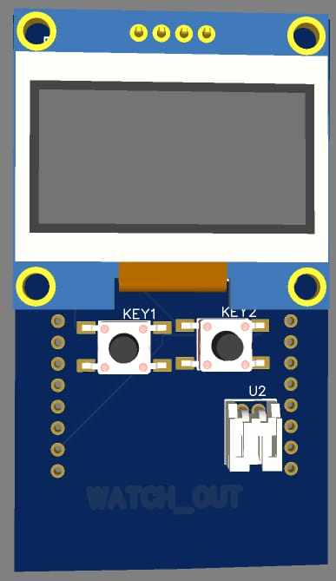
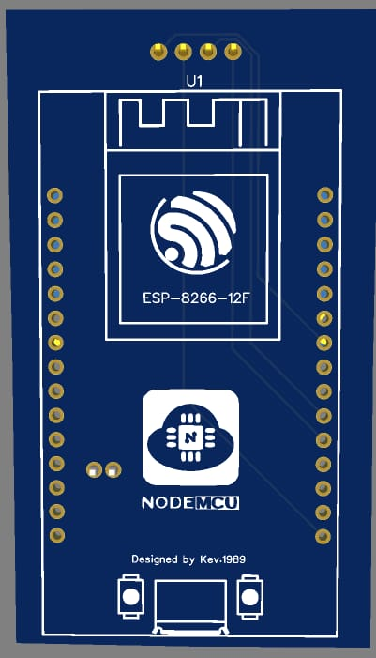

Figure 4.14: An early prototype 3D model

With time and progress in the project we had to make evident changes to the implementation of the hardware and had to differ from the prototype and early designs slightly according to the new findings and constraints.

We first implemented the model on a bread board to test the working and made the complete
circuit on the breadboard using the OLED screen, ESP8266 Module and Jumper wires.
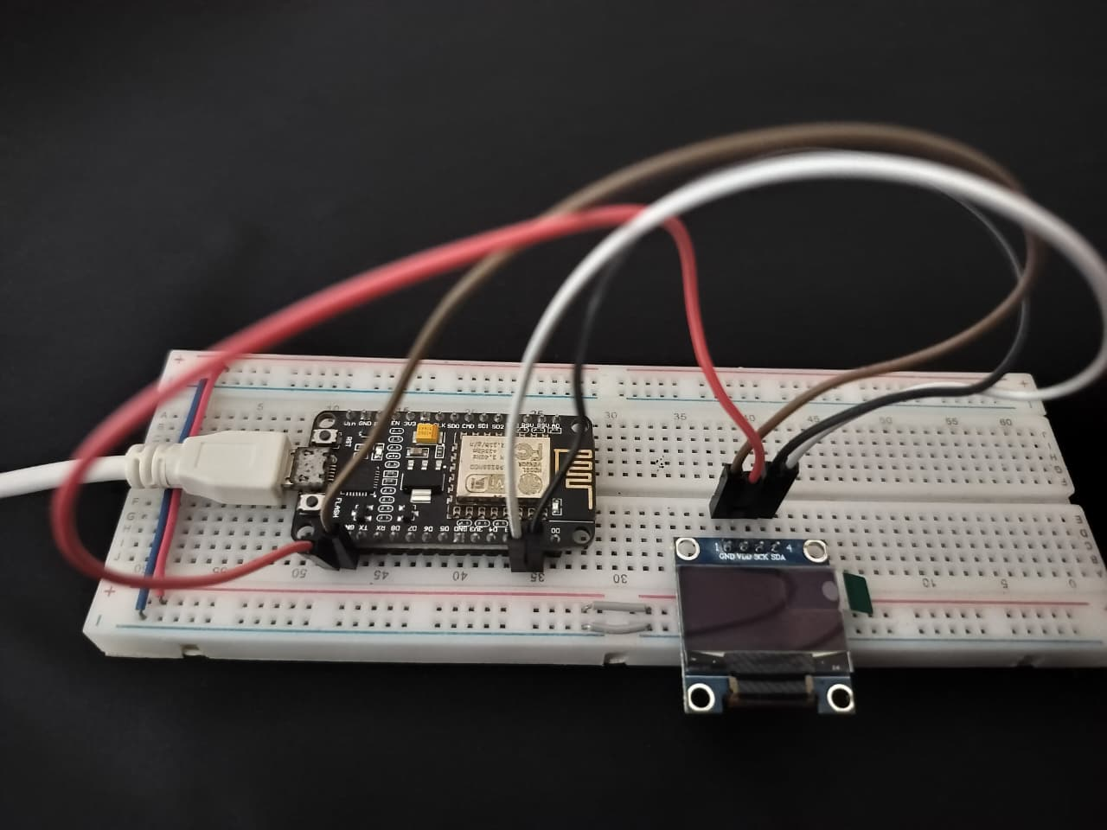

Figure 4.15: An early implementation of circuit

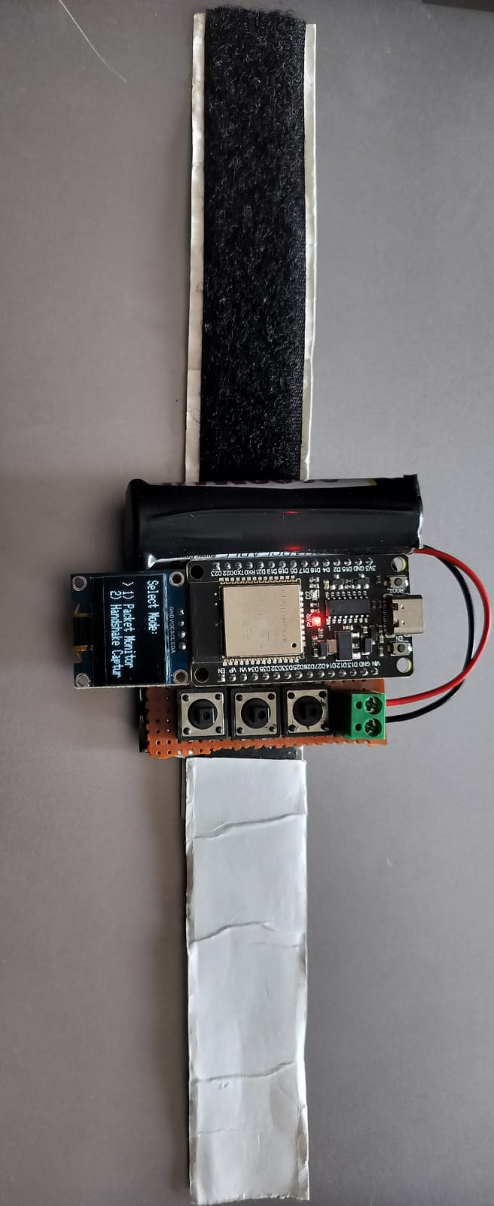
After fetching and procuring all the required hardware components needed including the 3800MAH lithium ion battery,perf board, female headers and other required assistances we set on to building the final model the wearable ‘Watchout’. This time the whole circuit was soldered on the perf

board staying true to “Lightweight wearable device” promised in our project title. The implementation of this final model meant careful circuit completion and soldering.To make it “wearable” as promised we also added a watch like strap to it.

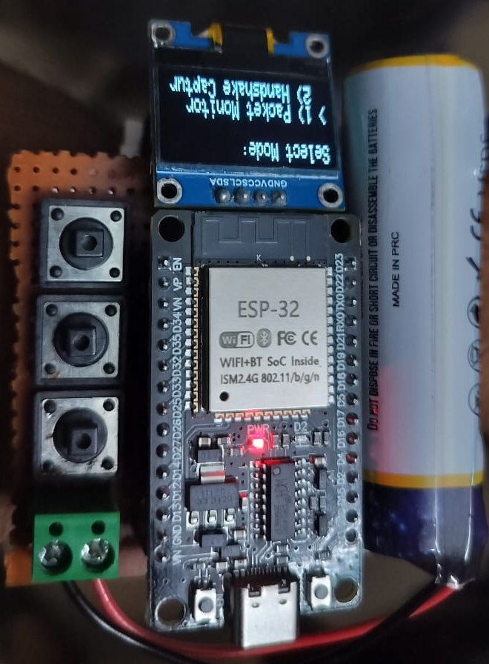

Figure 4.16 and 4.17: The final implementation of ‘Watchout’

Chapter 5

Results and Analysis

Objective

The main objective of our project was to design and implement a compact and real time wireless intrusion detection system capable of identifying and alerting users about Wi-Fi based attacks.

We aimed to provide a low cost,portable and intelligent solution using the ESP8266 microcontroller as a packet capturing device and a backend machine learning model for classification and threat detection. By facing the challenge of combining hardware level packet monitoring with data driven analysis our project

aims to bridge the gap between lightweight IoT based monitoring tools and advanced intrusion detection techniques.

Results and Comparison

The system was evaluated in two stages: packet level data collection and processing using the ESP8266 sniffer and backend model testing using pre trained machine learning models for Wi-Fi intrusion detection. The objective was to assess how effectively the system will be able to differentiate between normal and malicious traffic and to analyze the performance of the implemented algorithms.

5.1 Dataset and Preprocessing

We used the infamous AWID3 dataset for model training and evaluation. It includes four main classes
of network traffic: normal, flooding, impersonation and injection. As shown below distribution results,
the dataset is highly imbalanced with over 1.17 million normal samples compared to only a few tens of thousands of attack samples.

Figure 5.1: Class distributions

To address this issue we decided to implement SMOTE which stands for Synthetic Minority Oversampling Technique to generate synthetic samples for minority classes and to ensure a balanced
class distribution for better learning performance.

The results before SMOTE and after SMOTE can be seen below.

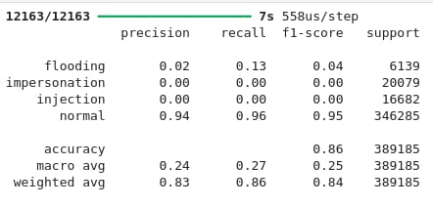

Figure 5.2: Before SMOTE

As we can see the minority classes are not being detected at all before usage of SMOTE.

Figure 5.3: After SMOTE

Now we can clearly see the minority classes also getting detected thus fulfilling the aim of usage of SMOTE.

5.2 Deep Neural Network Training

We implemented a Deep Neural Network (DNN) using TensorFlow and Keras with four dense layers
and dropout regularization. We used ReLU activation for hidden layers and a Softmax output for multi class classification. We also applied early stopping to prevent overfitting.

The model achieved a validation accuracy close to 99% and a training accuracy of around 94%. The training graph, shown below, illustrates the convergence behaviour of both training and validation accuracy over multiple epochs. The validation curve remained stable and confirming that the model effectively learned discriminative features without overfitting.

Figure 5.4: Accuracy results of DNN

Figure 5.4: Graphical representation of Accuracy of DNN

5.3 Random Forest Classifier Results

We trained our Random Forest model with 200 estimators and we adjusted the class weights in such a way that detection of minority attack classes is prioritized while also maintaining balance with normal traffic samples. Our model was able to achieve an overall accuracy of 90.6% with macro average precision and recall of 0.60 and 0.48 respectively.The weighted averages were significantly much higher reaching 0.91 for precision and 0.90 for recall indicating that there was a strong overall performance despite some class-level imbalance.

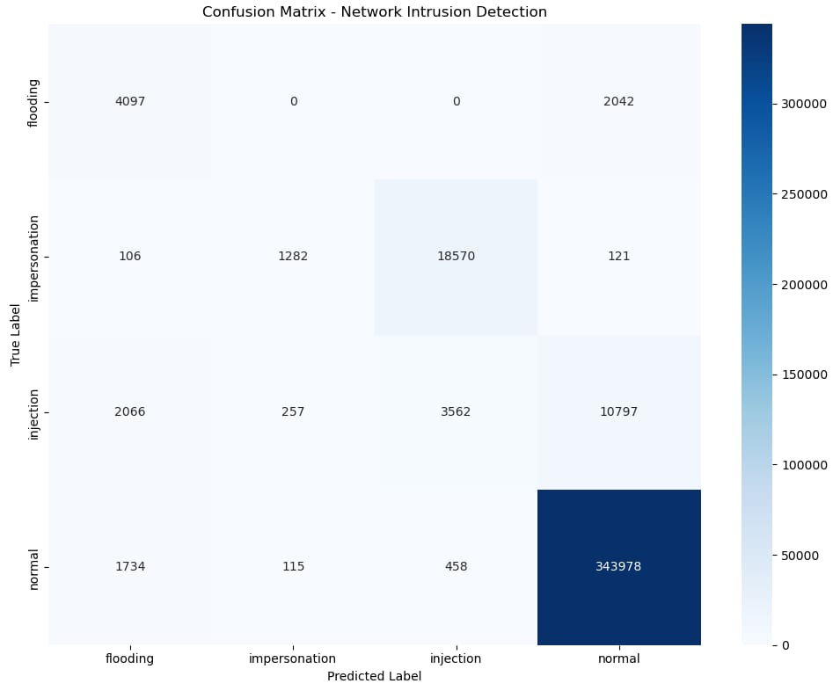

Figure 5.5: Confusion matrix

The confusion matrix helps us see that the model performed exceptionally well in identifying normal traffic and flooding attacks while impersonation and injection attacks remained more challenging due to overlapping traffic patterns and fewer training samples.

5.4 Real Time Packet Classification

When we deployed the backend server and fed it with live data from the ESP8266 sniffer the model analysed 389,185 packets. Out of these 91.7% were classified as normal traffic and the rest 8.29% were identified as potential attack traffic. Among the detected attacks injection and flooding packets constituted the majority with impersonation events appearing less frequently but being successfully identified due to the lowered detection threshold.

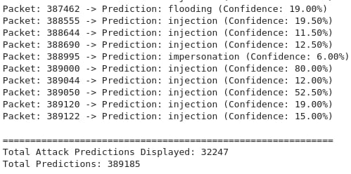
Figure 5.6: Output from the model

From the output we can see that the model is able to classify attacks and display it with confidence levels assigned to each packet type.

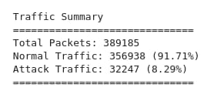

Figure 5.7: Traffic summary

  - Performance Summary

The final performance metrics of the Random Forest model are:
- Overall Accuracy : 90.68%
- Macro Average Precision : 0.6021
- Macro Average Recall : 0.4845
- Weighted Precision : 0.9123
- Weighted Recall : 0.9068
- Weighted F1-score : 0.8935

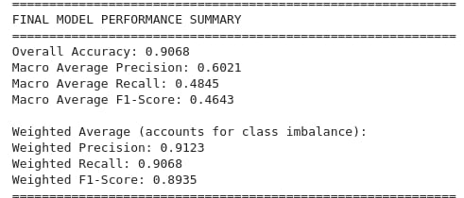

Figure 5.8: Performance summary of the model

  - Working Model

The final result is the completion of the hardware model and having the screen interactable and able to carry out the two modes- Packet capture and Handshake capture. The final working model can thus monitor all the wifi packets around it and detect anomalies and will also be able to deauthenticate the network found out to be the attacker or cause of anomalies.

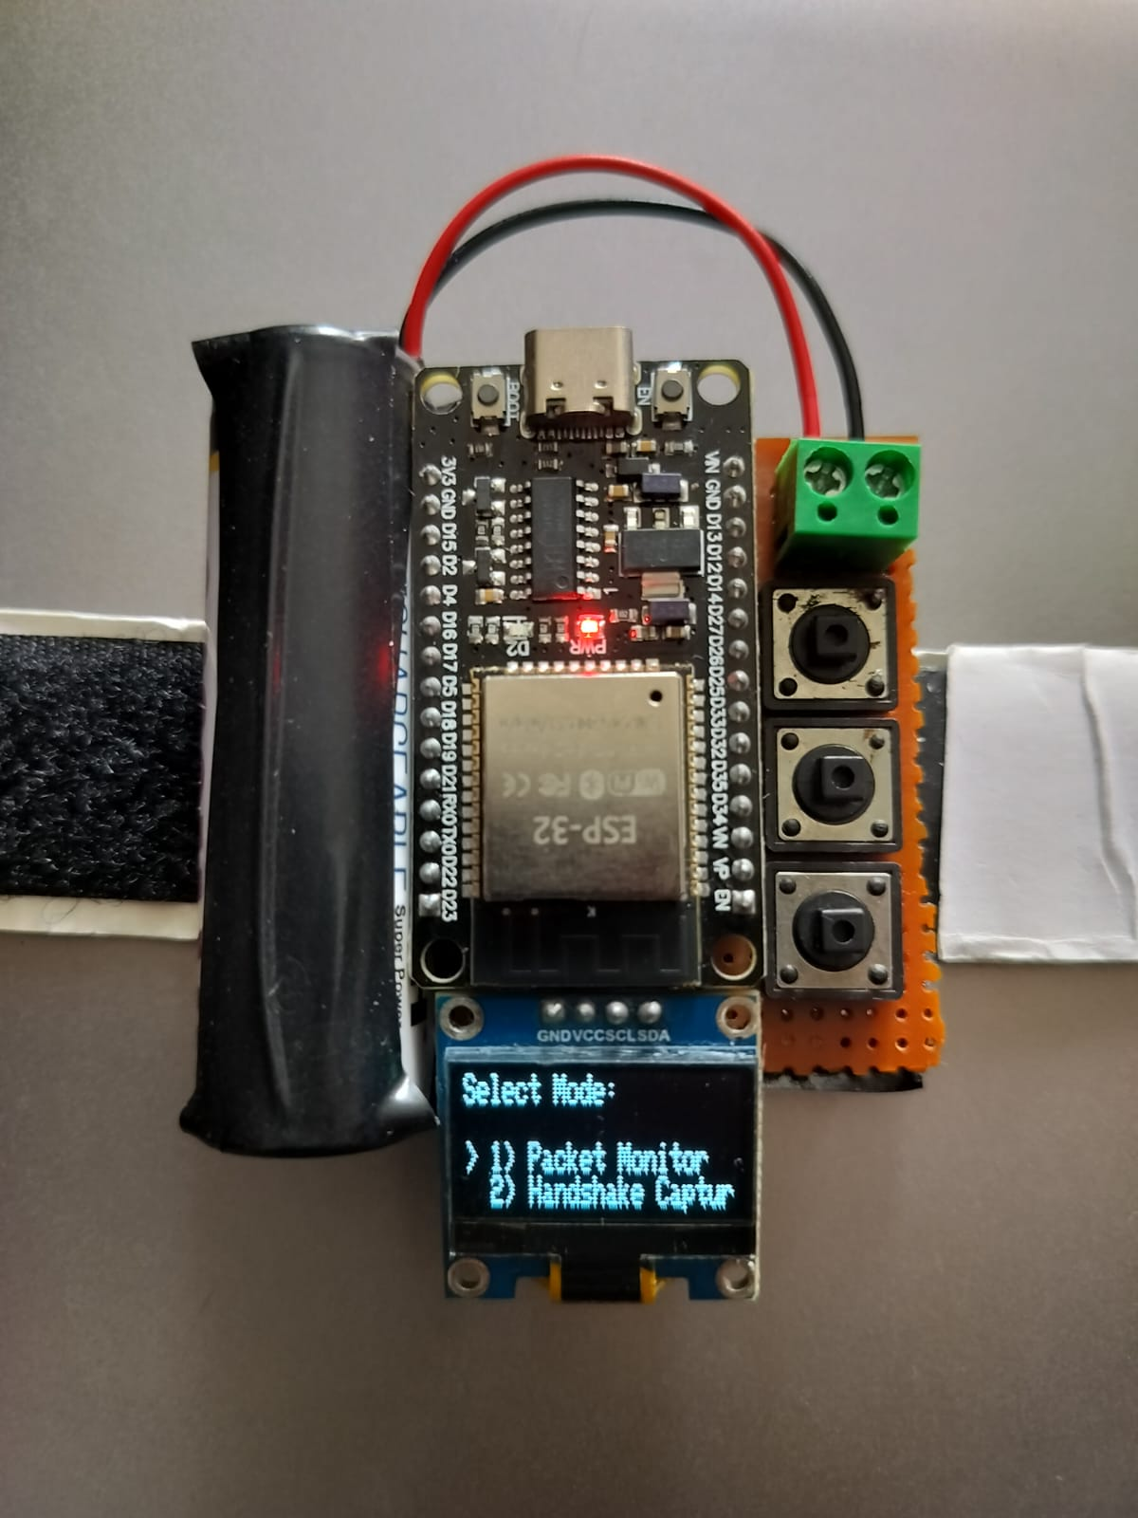

Figure 5.9 and 5.10: The working model

Standards

The ‘Watchout’ project follows several internationally recognized standards related to wireless communication and network security.

  - Standards Followed

1.The IEEE 802.11 Standard

Our whole project is built around and revolves around IEEE 802.11 standard which is the wifi communication protocol. This standard defines the physical and MAC (Medium Access Control) layers for wireless local area networks. The ESP8266 module used in our project operates according to the 802.11 specifications.The packet capture and analysis processes strictly adheres to the 802.11 frame formats.

2. Bureau of Indian Standards (BIS)

The hardware components that we have used in our project comply with the BIS safety and compatibility
Guidelines thoroughly.

3. IEEE 802.1X (Network Access Control):
Our project uses and references authentication mechanisms defined by the IEEE 802.1X standard to understand EAPOL message structures during WPA2 handshake capture and analysis.

Conclusion and Future Scope

7.1 Conclusion

Appendix

Your codes

21

Bibliography

- Mark Hansen, Stuart Madnick and Michael Siegel. ’ Data Integration using Web Services.’ MIT Sloan School of Management : MIT Sloan, 2002.
- David Ostrowski, Nestor Rychtyckyj, Perry MacNeill. ’ Integration of Big Data Us- ing Semantic Web Technologies.’ eFord Motor Company. Mira Kim Dept. of EECS, University of CA, Irvine.: IEEE Tenth International Conference on Semantic Com- puting (ICSC), 2016.
- Bo Zhou. D ata Integration as a Service for Applications Deployment on the SaaS Platform. Hechi University, Yizhou City, Guangxi, China : 6th International Conference on Biomedical Engineering and Informatics (BMEI), 2013.
- Decheng Qiu, Junning Liu and Guoying Zhao. ’ Design and Application of Data Integration Platform Based on Web Services and XML.’ Hexi University & Fudan University, Artillery Training Base, PLA 371Hospital, China. : 6th International Conference on Electronics Information and Emergency Communication (ICEIEC), 2016.
- Gabriele Bavota. ’ Mining Unstructured Data in Software Repositories: Current and Future Trends.’ Free University of Bozen-Bolzano, Bolzano, Italy : IEEE 23rd International Conference on Software Analysis, Evolution, and Reengineering (SANER), 2016.
- Tulika Das, Sheryl Maring, Rick Sapir, Michael Wiesenberg. ’ Oracle Database Java Developer’s Guide 11g Release 1(11.1) B31225-05.’ Oracle Corporation, USA. December 2009.
- Rahmadi Wijaya. Bambang Pudjoatmodjo2. ’ An Overview and Implementation of Extraction-Transformation-Loading (ETL) Process in Data Warehouse.’ Telkom University, Bandung, Indonesia : 3rd International Conference on Information and Communication Technology (ICoICT), 2015.

22

Bibliography. 23

- Xindong Wu, Xingquan Zhu, Gong-Qing Wu, and Wei Ding. ’ Data Mining with Big Data.’ Fellows IEEE : IEEE Transactions on Knowledge and Data Engineer- ing, VOL. 26, NO. 1, 2014.
- Yingchi Mao, Wei Min, Jiulong Wang, Bicong Jia, Qing Jie. ’ Dynamic Mirror Based Real-Time Query ContentionSolution for Support Big Real-Time Data Anal- ysis.’ College of Computer and Information Engineering, Hohai University, Nanjing, China. : 2nd International Conference on Information Technology and Electronic Commerce (ICITEC) 2014.
- Xiaofang Li, Yingchi Mao. ’ Real-Time Data ETL Framework for Big Real-Time Data Analysis.’ Changzhou Institute of Technology, China. Hohai University, China : IEEE International Conference on Information and Automation, 2015.
- Shahin Vakilinia, Xinyao Zhang and Dongyu Qiu. ’ Analysis and Optimization of Big-Data Stream Processing.’ Department of Electrical and Computer Engineer- ing, Concordia University, Montreal, QC, Canada. : IEEE Global Communications Conference (GLOBECOM), 2016.
- Libina Rose Sebastian, Sheeba Babu, and Dr. Jubilant J Kizhakkethottam. ’ Challenges with Big Data Mining: A Review.’ Dept. of Computer Science and En- gineering, St. Joseph’s College of Engineering and Technology, Palai, Kerala, India : International Conference on Soft-Computing and Network Security (ICSNS), 2015.

Biodata

Name:
Mobile No.:
E-mail:
Permanent Address:

Name:
Mobile No.:
E-mail:
Permanent Address:

24

