A Deep Learning Facial Expression Recognition Based Scoring System For Restaurants

Now-a-days in advance countries automated unmanned restaurants are more popular as this restaurants will not have any human power to take customer feedbacks about food quality and service and to automate this process author has introduce concept called ‘Deep Learning Facial Expression Recognition Based Scoring System For Restaurants’ where customers will be asked to give rating to food and upload his photo and based on user facial expression application will inform whether customer was satisfied or not. To extract facial expressions from photo we are using CNN (Convolution Neural Networks) machine learning algorithm. This algorithm can predict 3 different expression from photo such as satisfied, neutral or disappointed.

In this paper author is using android devices to capture photo and using webserver to send capture photo to server where machine learning algorithms will be running to predict expression from photo and this customer data with photo will be saved in MYSQL database.

Here we don’t have any android devices so we have design this as a web application using python DJANGO web server. This application can run on user browser where he can upload his photo with rating, uploaded photo will be sent to webserver where machine learning algorithm will be used to extract expression from photo and then saved result to MYSQL database.

Another user called ‘admin’ can login to application and see all users visited to restaurant and can view all customer feedback with facial expression and photo. By seeing this result admin can understand whether customers are happy with their services and foods or not.

CNN working procedure

To demonstrate how to build a convolutional neural network based image classifier, we shall build a 6 layer neural network that will identify and separate one image from other. This network that we shall build is a very small network that we can run on a CPU as well. Traditional neural networks that are very good at doing image classification have many more parameters and take a lot of time if trained on normal CPU. However, our objective is to show how to build a real-world convolutional neural network using TENSORFLOW.

Neural Networks are essentially mathematical models to solve an optimization problem. They are made of neurons, the basic computation unit of neural networks. A neuron takes an input (say x), do some computation on it (say: multiply it with a variable w and adds another variable b) to produce a value (say; z= wx + b). This value is passed to a non-linear function called activation function (f) to produce the final output (activation) of a neuron. There are many kinds of activation functions. One of the popular activation function is Sigmoid. The neuron which uses sigmoid function as an activation function will be called sigmoid neuron. Depending on the activation functions, neurons are named and there are many kinds of them like RELU, TanH.

If you stack neurons in a single line, it’s called a layer; which is the next building block of neural networks. See below image with layers

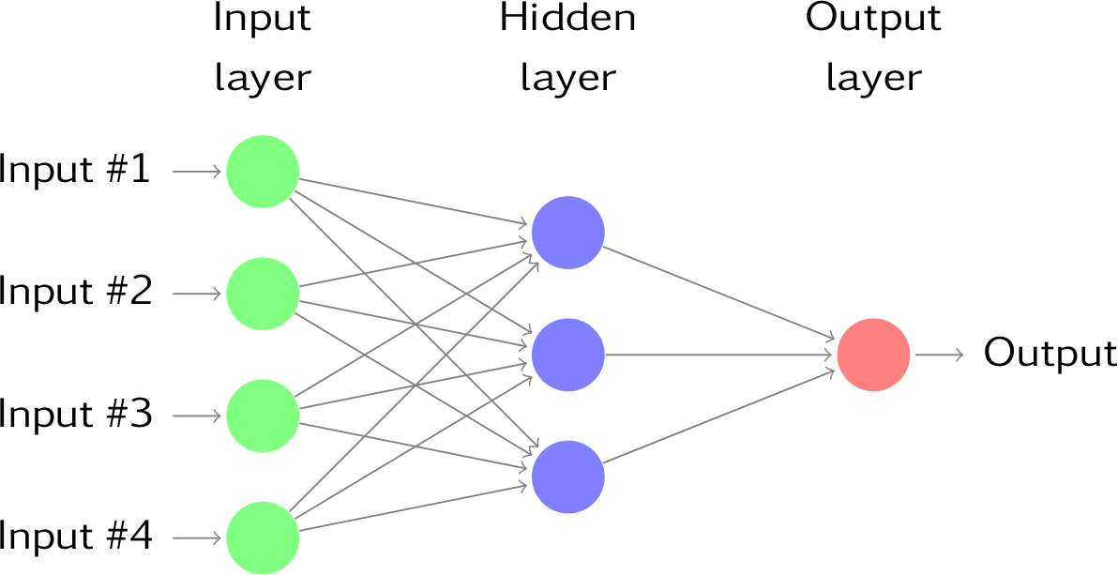

To predict image class multiple layers operate on each other to get best match layer and this process continues till no more improvement left.

Technologies used to implement this project

Python : 3.7 version

Webserver : DJANGO

Database : MYSQL

Web technologies: HTML, CSS, Java Scripts

Project Abstract or Description

Recently, the popularity of automated and unmanned restaurants has increased. Due to the absence of staff, there is no direct perception of the customers' impressions in order to find out what their experiences with the restaurant concept are like. For this purpose, this paper presents a rating system based on facial expression recognition with pre-trained convolutional neural network (CNN) models. It is composed of an Android mobile application, a web server, and a pre-trained Artificial Intelligence server also called as Machine Learning based facial expression prediction. Both the food and the environment are supposed to be rated. Currently, three expressions (satisfied, neutral and disappointed) are provided by the scoring system.

Screen shots

To run this project install MYSQL and then create database by copying content from ‘DB.txt’ file and paste in MYSQL. Install python and then install DJANGO web server and deploy code on DJANGO. After deployment start server and run the code from browser.

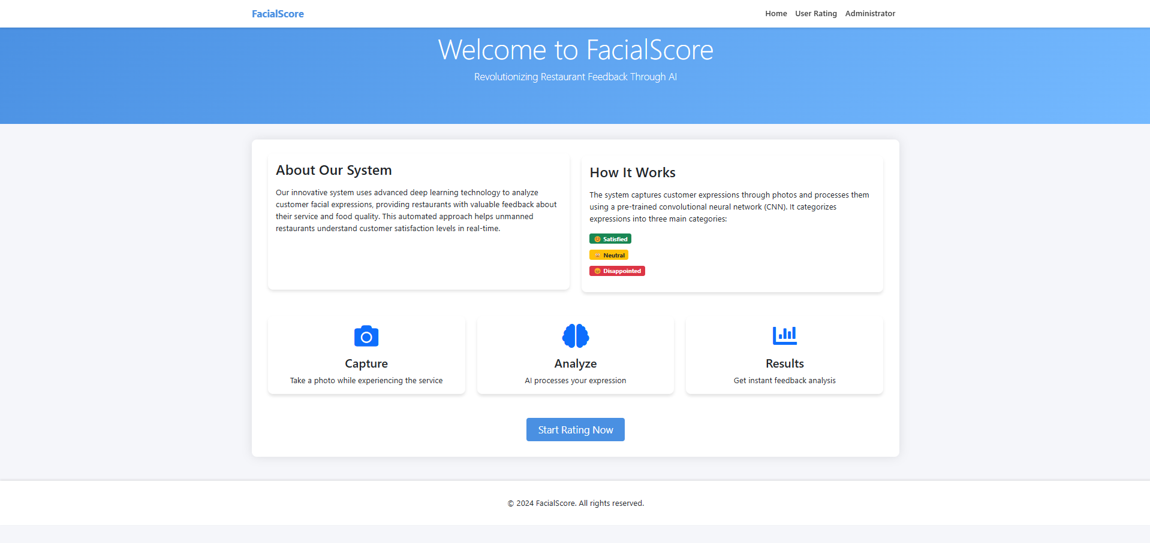

In above screen click on ‘User’ link to get below screen where user can upload photo and give ratings

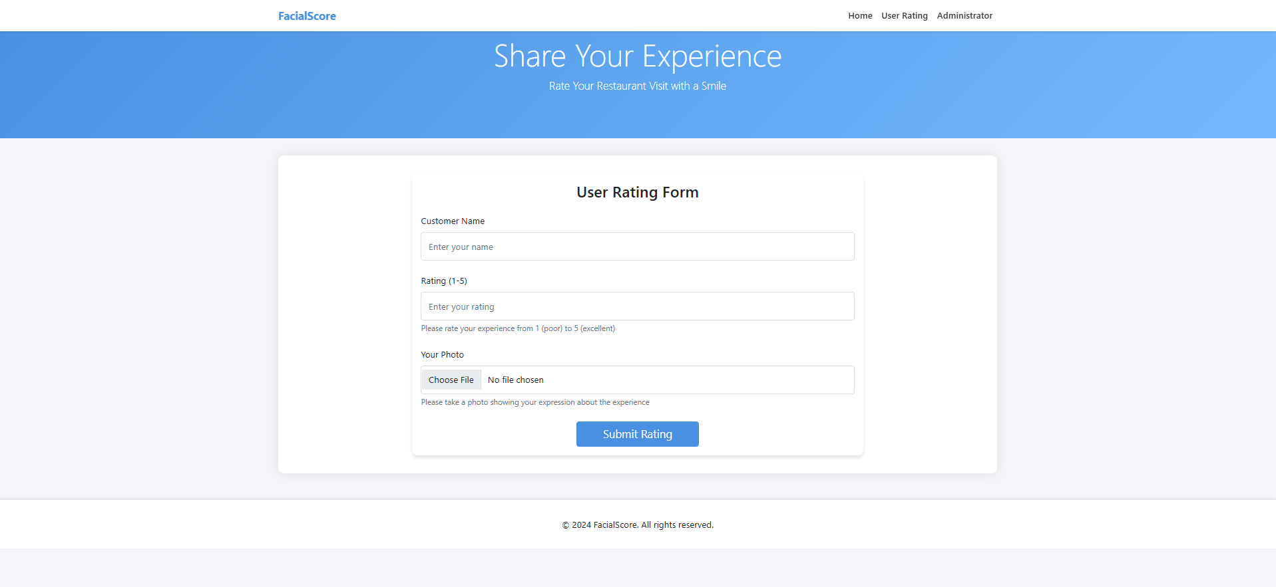

User will fill above from and upload photo

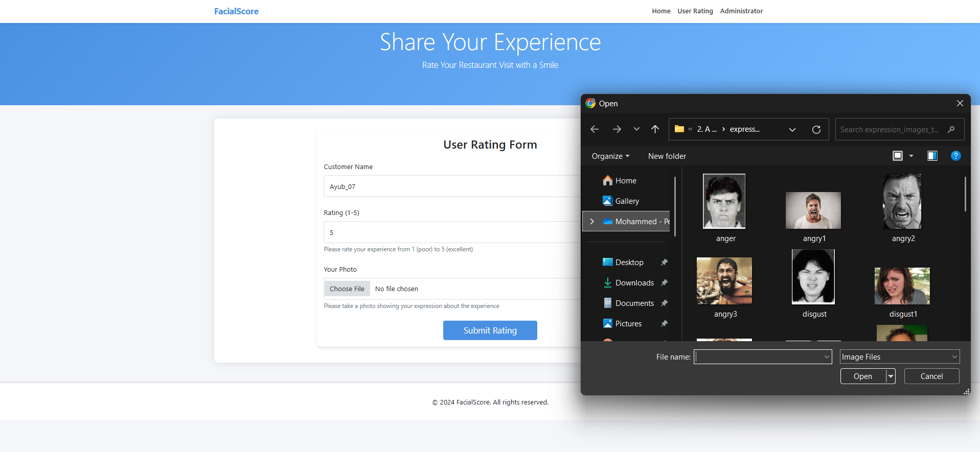

In above screen I filled form and uploading one happy image and then click on ‘Open’ button and then click ‘Submit’ button to send data to webserver. After processing above data will get below results.

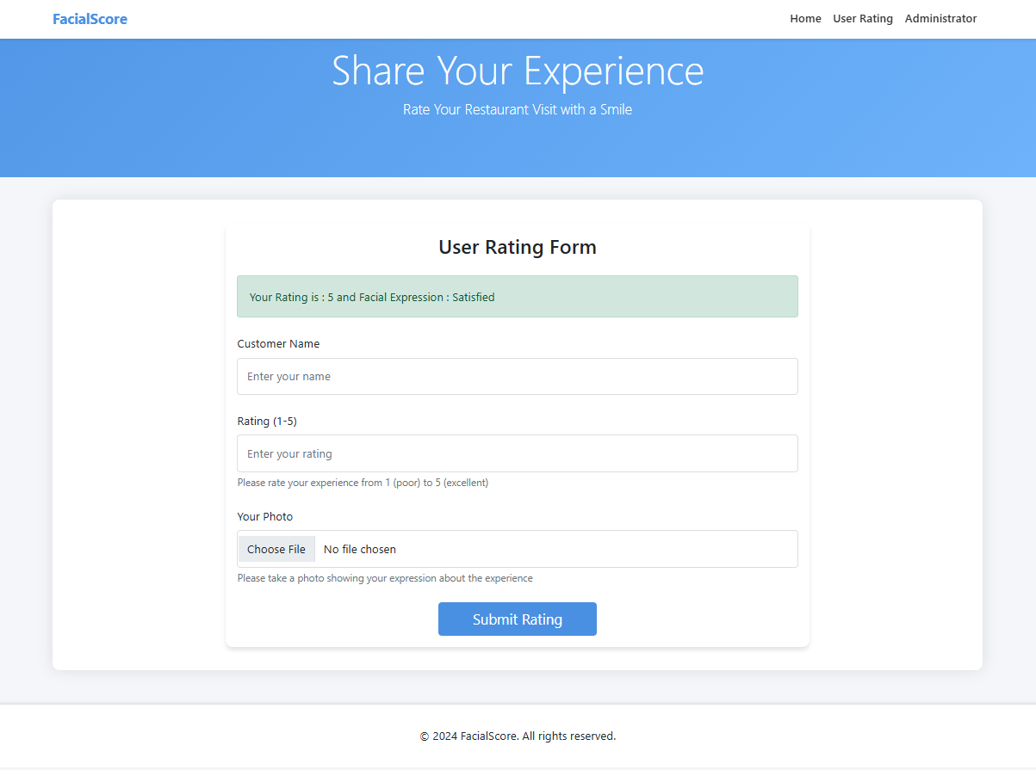

In above screen we can see output message as given rating and from photo extracted facial expression is satisfied. Now go to ‘Administrator’ link and login as admin by giving username as ‘admin’ and password as ‘admin’. See below screen.

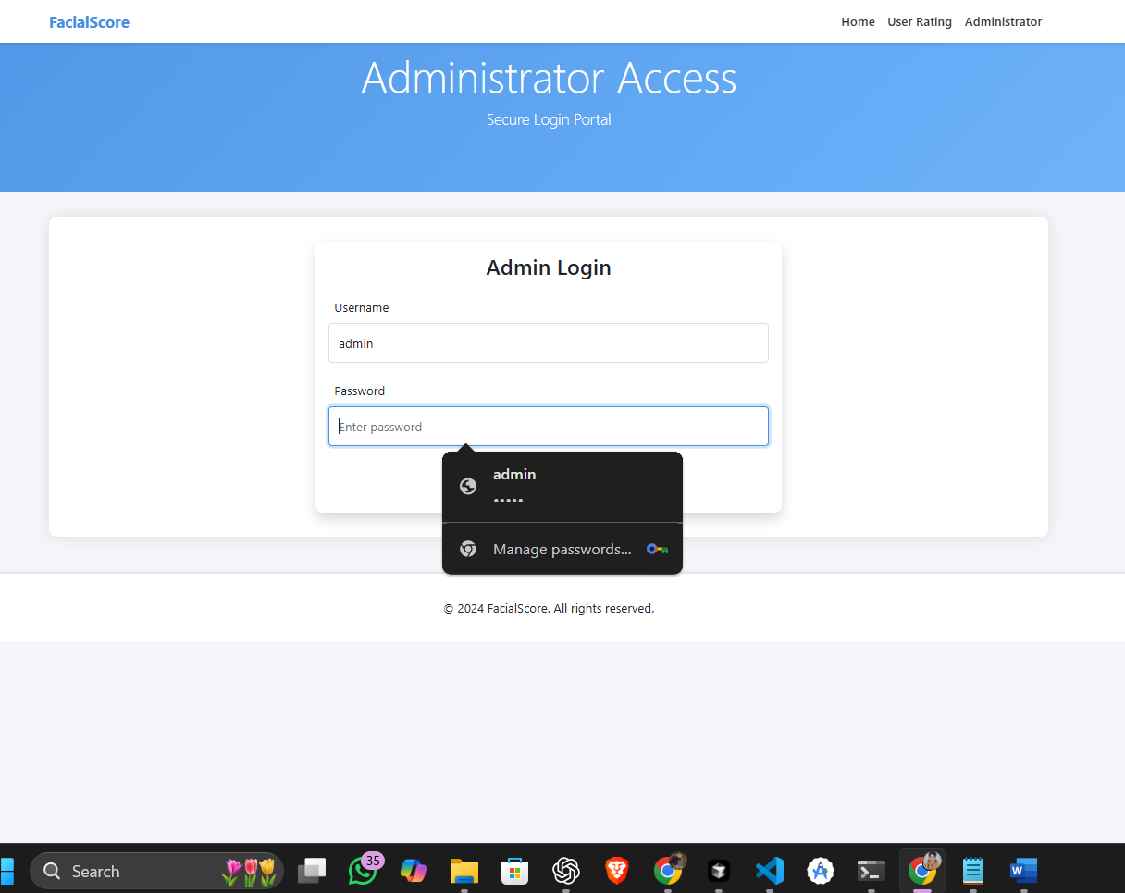

After login will get below screen

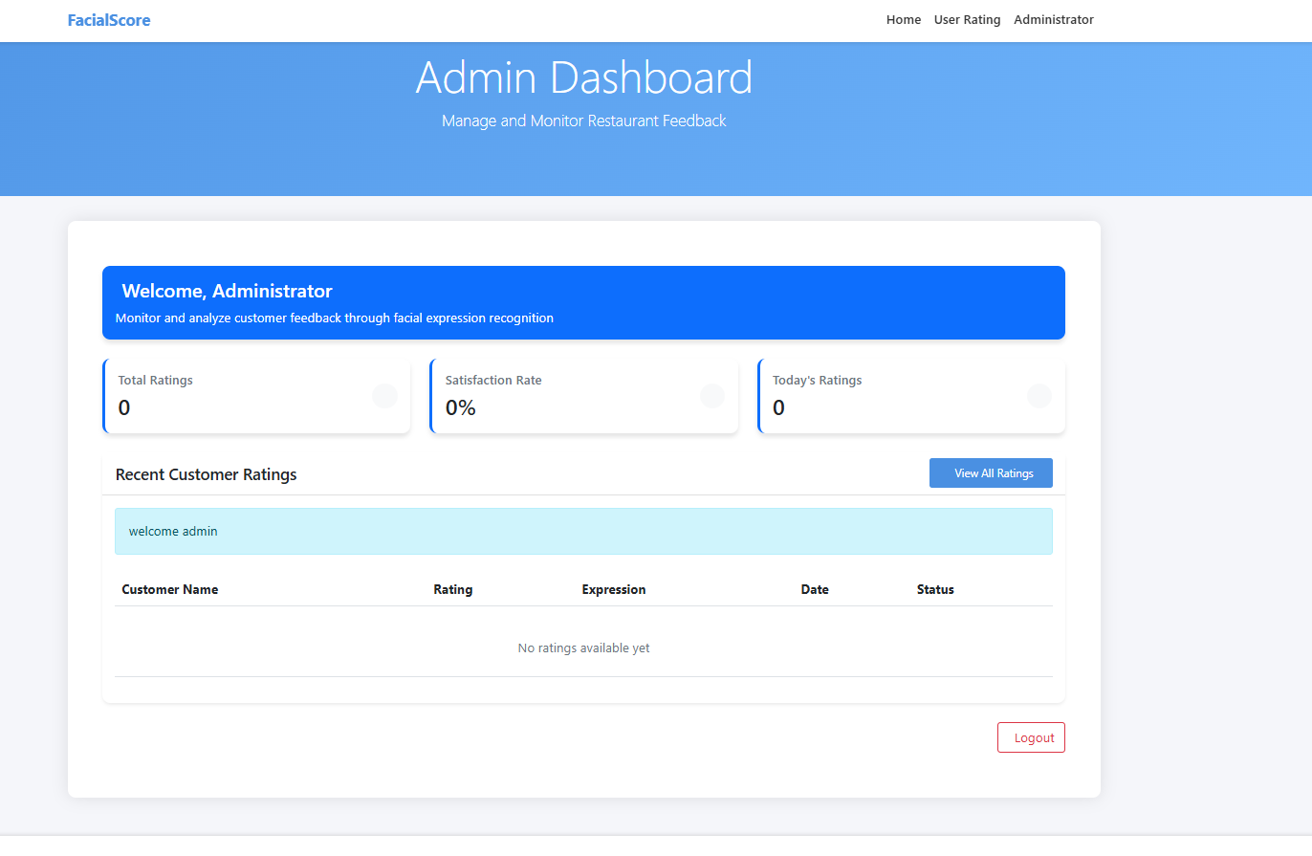

In above screen click admin can click on ‘View Users Rating’ link to get all customers feedback. See below screen

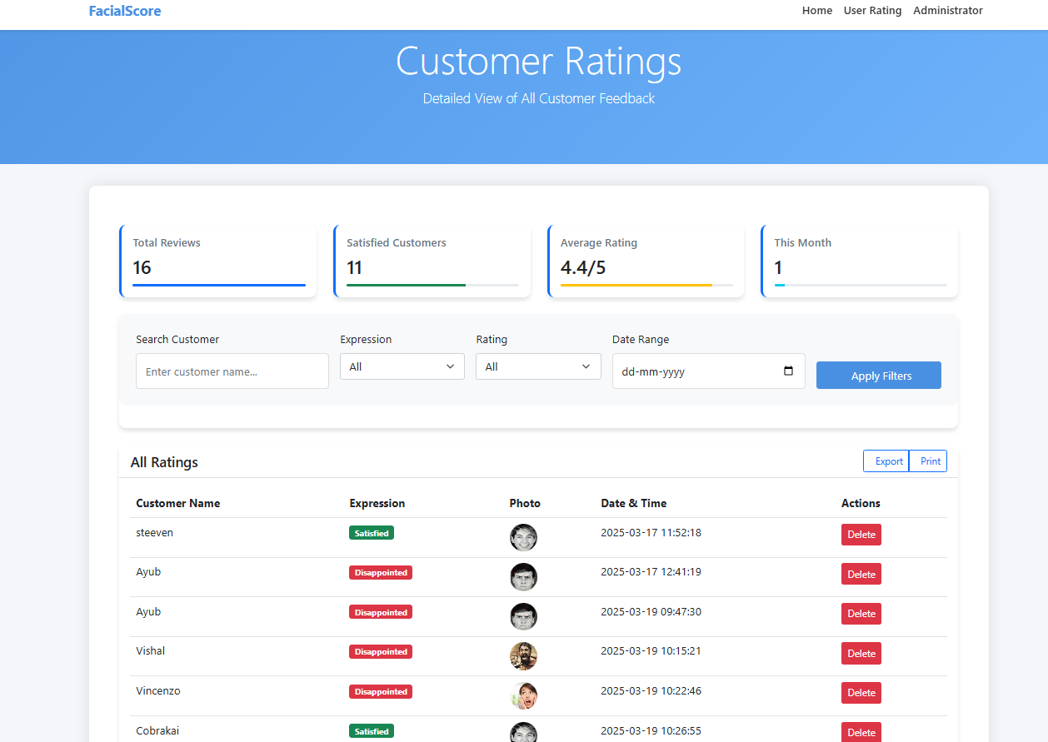

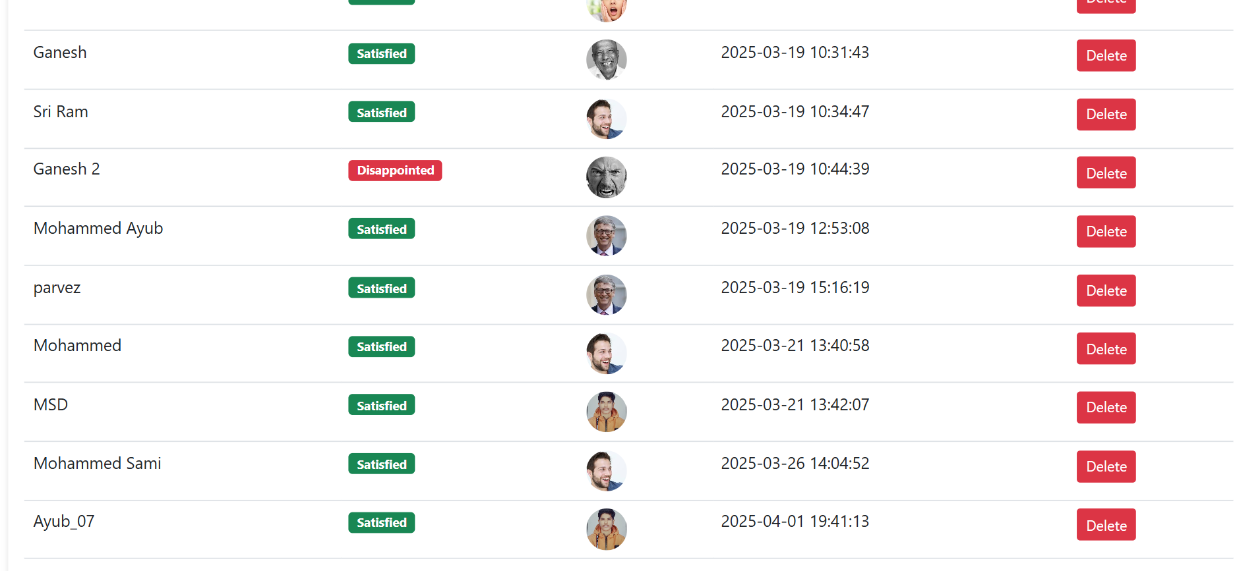

From above screens admin can see photos and their facial expressions