SIMATS ENGINEERING
CO3-ASSESSMENT TOOL 2

COURSE NAME: ANALOG CIRCUIT S COURSE CODE: ECA04

COURSE OUTCOME COVERED

CO3: Examine the frequency response characteristics of BJT and FET amplifiers at low and high frequencies to determine bandwidth, gain variation, and overall amplifier performance (BTL 2,3, 4), (WK1,WK2,WK3,WK4)

Assessment Tool number : AT2
Assessment Tool Weightage : 35%
Assessment Tool Name : Circuit Debugging
Duration of this assessment : 90 Minutes
Marks : 20
Type of Assessment conduction : Inside Class
Evaluation Type : Manual Correction

Description:

- Each student will be assigned one Circuit debugging problem 20 marks inside class. Analyze and debug one faulty analog circuit.
- Simulate the corrected circuit using LTspice and verify results.
- Document the debugging process, observations, and conclusions.
- Upload LTspice files, simulation results, and report to GitHub.
- Evaluation is based on fault identification, debugging approach, simulation accuracy, documentation, and GitHub submission.

Topics Covered In this assessment:
General shape of frequency response of amplifiers - Low frequency analysis of BJT/ FET amplifiers to obtain Lower cut off frequency - High frequency analysis of BJT amplifiers to obtain Upper cut off frequency- rise time and sag and their relation to cut off frequencies-High frequency analysis of FET amplifiers- High frequency equivalent circuit of FETs.

S.NO | QUESTION BANK | BTL | MARKS
23 | 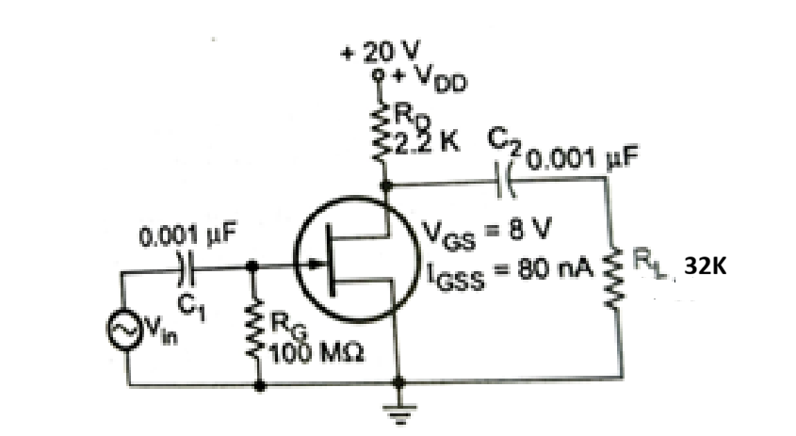  The measured DC drain voltage is found to be nearly equal to the supply voltage (+20 V), whereas the expected operating point should allow maximum symmetrical signal swing. Investigate the circuit to identify possible faults such as an open drain resistor, disconnected source terminal, incorrect gate bias, or a damaged JFET model. Explain how you would verify the Q-point using LTspice and recommend suitable corrections. | 4 | 20
ANS | 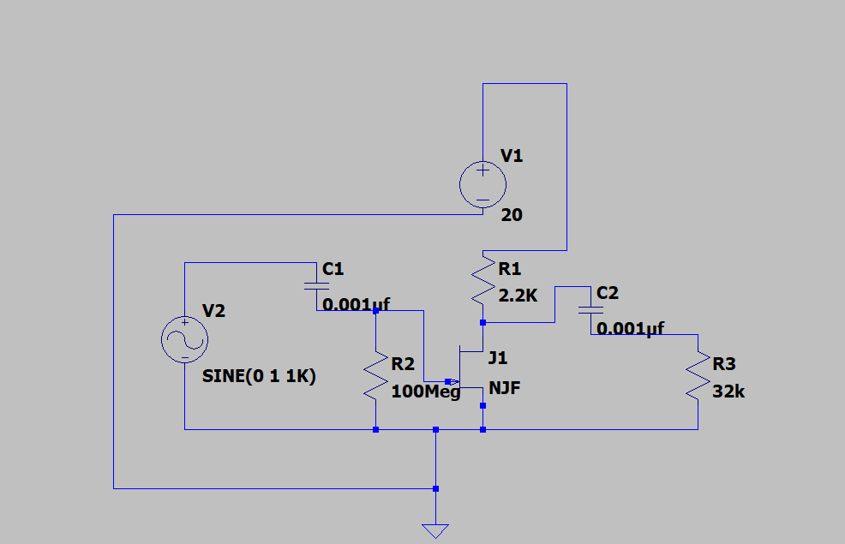
 | 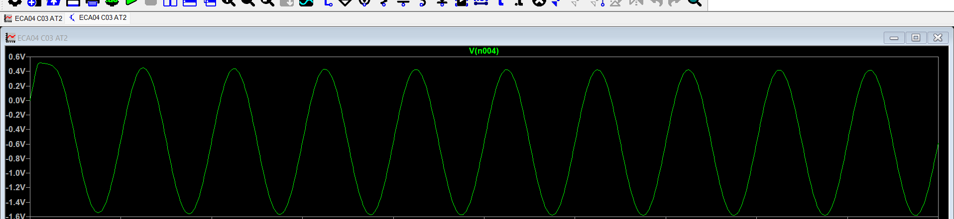
When the DC drain voltage measures approximately $+20\text{ V}$ ($V_{D}≈V_{DD}$), no drain current flows through the load resistor ($I_{D}=0$). This rules out an open drain resistor, as an open $R_{D}$ would isolate the drain node from the supply rather than pulling it up to $+20\text{ V}$. The primary cause is the excessively large gate resistor ($R_{G}=100\text{ M}Ω$). The reverse gate leakage current ($I_{GSS}=80\text{ nA}$) flowing through $R_{G}$ produces a substantial negative gate-to-source voltage:
$$V_{GS}≈-I_{GSS}×R_{G}=-\left(80\text{ nA}\right)\left(100\text{ M}Ω\right)=-8\text{ V}$$
Since the JFET pinch-off voltage is approximately $-8\text{ V}$, this self-induced negative bias pushes the transistor into deep cutoff. Secondary hardware faults that produce the same symptom include an open source-to-ground connection or an internally damaged JFET with an open channel.
To verify the operating point in LTspice, construct the schematic and run a DC Operating Point analysis using the .op command to monitor the node voltages at the drain, gate, and source. To rectify the issue and achieve maximum symmetrical swing ($V_{D}≈V_{DD}/2=10\text{ V}$), reduce $R_{G}$ to a standard value between $1\text{ M}Ω$ and $10\text{ M}Ω$ to keep the leakage voltage drop negligible, and introduce a self-biasing source resistor $R_{S}$ paired with a bypass capacitor $C_{S}$ to establish a stable operating current.

Code of Conduct:

I ____________________ (Name / Reg No) certify that this submission is my original work and that I have adhered to the guidelines specified for this assessment.
I understand that any violation of academic integrity rules will result in disciplinary action.

Signature of the student:

RUBRICS FOR CALCULATION:

Criteria | Weightage | Level 3 (Exemplary) | Level 2 (Proficient) | Level 1 (Beginning)
Fault Identification | 30% | Correctly identifies the faulty component/connection and recognizes all affected circuit elements accurately. (6 Marks) | Identifies the fault with minor errors or incomplete understanding.. (4-5 Marks) | Unable to identify the fault or identifies an incorrect component. (1-3 Marks)
Technical Analysis and Explanatio | 45% | Provides a logical explanation of how the fault affects biasing, current flow, operating region, gain, or circuit performance using appropriate engineering concepts. (9 Marks) | Explains the effect of the fault with minor conceptual errors or incomplete reasoning (5–8 Marks) | Shows little understanding of circuit operation and provides incorrect or unclear explanation (1–4 Marks)
Corrective Action and Prediction using Simulation | 25% | Suggests the correct remedy and accurately predicts the expected circuit behavior after correction with proper engineering justification. (5 Marks) | Suggests a partially correct correction and provides limited prediction of circuit behavior. (3–4 Marks) | Unable to suggest a suitable correction or predict the circuit response. (1-2 Marks)

Student:
Criteria | Student 1
 | H | M | L
Fault Identification
Technical Analysis and Explanation
Corrective Action and Prediction using Simulation
TOTAL

