ECA0403 ANALOG CIRCUITS ASSIGNMENT FORMAT

A. Assignment Information
Particular | Details
Department: | Electronics and Communication Engineering (ECE)
Programme: | B.E. / B.Tech. – ECE
Course Code & Course Name | ECA0403 – Analog Circuits
Academic Year / Batch | 2025–2026
Faculty Name | Dr. N. Shyamala
Assignment Title | Design, Analyze and Optimize the Low-Frequency Response of a Common-Emitter BJT Amplifier
Date of Issue | [TO BE FILLED]
Date of Submission | [TO BE FILLED]
Maximum Marks | 100
Course Outcome(s) – CO | CO1, CO2, CO4, CO5 (Primary)
Bloom's Taxonomy Level | L4 – Analyze; L5 – Evaluate; L6 – Create
SDG Mapping (SDG 1-17) | SDG 9 – Industry, Innovation and Infrastructure
Industry / Societal Relevance | Low-frequency analog amplification, sensor signal conditioning, instrumentation interfaces, and reliable small-signal electronic system implementation.

B. Assignment Problem / Challenge
The core engineering challenge is to design, analyze, simulate, and systematically optimize a single-stage common-emitter bipolar junction transistor (BJT) amplifier utilizing a voltage-divider biasing topology. The circuit must strictly satisfy predetermined passive component values and power rails while achieving a nominal mid-band voltage gain of approximately 20 V/V across the load resistance. Furthermore, the frequency-dependent behavior must be engineered such that the initial lower cutoff frequency (-3 dB point) resides precisely near 100 Hz under realistic source impedance loading. A secondary optimization challenge requires redesigning the frequency response to shift the lower cutoff frequency downward to approximately 50 Hz solely by altering the external coupling and bypass capacitor magnitudes. This work demands rigorous application of small-signal hybrid-π models, calculation of multi-pole frequency interactions, LTspice verification, and critical evaluation of non-ideal active device parameters.

C. Problem Statement
Design a single-stage common-emitter NPN BJT amplifier with voltage-divider bias meeting fixed parameters: DC supply voltage VCC = 12 V, collector resistor RC = 2.2 kΩ, emitter resistor RE = 1 kΩ, load resistance RL = 10 kΩ, source internal resistance RS = 600 Ω, and transistor forward current gain β = 100. The operational objectives require achieving a mid-band voltage gain magnitude of approximately 20 V/V and an initial lower cutoff frequency fL near 100 Hz. The assignment tasks encompass DC bias stability calculation, quiescent Q-point establishment in the active region, small-signal AC gain derivation, selection of standard capacitor values for C1, C2, and CE, schematic entry and frequency response extraction in LTspice over 10 Hz to 1 MHz, quantitative error comparison between mathematical models and SPICE simulations, and capacitor-only parameter redesign targeting fL ≈ 50 Hz.
Parameter | Specification Value
Supply voltage, VCC | 12 V
Collector resistor, RC | 2.2 kΩ
Emitter resistor, RE | 1 kΩ
Load resistance, RL | 10 kΩ
Source resistance, RS | 600 Ω
Transistor current gain, β | 100
Required mid-band voltage gain | Approximately 20 V/V
Required lower cutoff frequency | Approximately 100 Hz

D. Requirements and Constraints
The design must adhere to strict functional and operational constraints to guarantee physical feasibility and academic compliance. A single-stage common-emitter configuration utilizing voltage-divider biasing must be employed without altering fixed resistances RC = 2.2 kΩ, RE = 1 kΩ, RL = 10 kΩ, or supply VCC = 12 V. All reactive elements must be selected from standard commercially available capacitor values (E12/E24 series). For the second-stage optimization toward fL ≈ 50 Hz, modification is strictly restricted to capacitors C1, C2, and CE; no DC bias resistors or active components may be altered. The LTspice simulation environment serves as the primary verification tool, utilizing an AC sweep from 10 Hz to 1 MHz with decade logarithmic stepping. Theoretical derivations assume first-order approximations: thermal voltage VT ≈ 25 mV, base-emitter drop VBE ≈ 0.70 V, and infinite output resistance ro. Finally, academic integrity mandates that all simulation data reflect actual simulator output without artificial fabrication.

E. Student Work

1. Problem Understanding and Formulation
The common-emitter amplifier serves as a foundational building block in analog front-ends, requiring simultaneous optimization of DC quiescent stability and AC small-signal amplification. The problem requires establishing an active-region Q-point using a voltage-divider base network to ensure temperature and beta independence, while negative feedback provided by the emitter resistor RE preserves bias stability against thermal runaway. At signal frequencies, an emitter bypass capacitor CE shorts the AC degeneration, thereby restoring maximum transconductance gain. Signal coupling into the base and extraction from the collector are governed by DC-blocking capacitors C1 and C2, respectively. The source resistance RS forms a voltage divider with the amplifier input impedance Rin, directly attenuating the source-to-load gain below the intrinsic transistor stage gain. Hence, formulating the network requires modeling three individual high-pass pole frequencies and synthesizing an aggregated transfer function that meets both the 20 V/V gain and 100 Hz cutoff boundaries.

2. Application of Course Knowledge
The mathematical formulation applies BJT operational principles, Thevenin equivalent DC biasing, and the linearized low-frequency small-signal hybrid-π model. Base current IB and collector current IC are derived from Thevenin voltage VTH and base resistance RTH. The dynamic small-signal transconductance gm = IC / VT and internal diffusion resistance rπ = β / gm define the forward transmission characteristics. The mid-band gain Av incorporates both intrinsic stage loading RC || RL and source loading Rin / (RS + Rin). In the frequency domain, the low-frequency roll-off is evaluated using open-circuit time constant techniques, where each reactive element sees an effective equivalent Thevenin resistance: R1,pole = RS + Rin for C1, R2,pole = RC + RL for C2, and RE,seen = RE || [re + (RS || R1 || R2) / (β + 1)] for CE. These rigorous course-derived formulas allow systematic calculation of the combined -3 dB cutoff frequency fL and provide exact analytical criteria for subsequent capacitor optimization.

3. Solution / Design / Methodology
For the DC bias network, divider resistors are selected as R1 = 100 kΩ and R2 = 10 kΩ, yielding VTH = 1.0909 V and RTH = 9.0909 kΩ. Hand calculations yield IB = 3.551 µA, IC = 0.355 mA, IE = 0.359 mA, VB = 1.059 V, VE = 0.359 V, VC = 11.219 V, and VCE = 10.860 V, confirming forward-active operation. At IC = 0.355 mA, transconductance is gm = 14.203 mS, re = 70.41 Ω, and rπ = 7.041 kΩ. The overall input impedance Rin = rπ || RTH = 3.968 kΩ, and output impedance Rout ≈ RC = 2.2 kΩ. The intrinsic stage gain Av,stage = -gm(RC || RL) = -25.61 V/V combines with the input attenuation factor Rin / (RS + Rin) = 0.8687 to produce a theoretical source-to-load gain Av,overall = -22.25 V/V, closely matching the 20 V/V specification. Standard capacitors are selected as C1 = 0.68 µF (fC1 ≈ 51.2 Hz), C2 = 0.27 µF (fC2 ≈ 48.3 Hz), and CE = 47 µF (fCE ≈ 48.0 Hz), yielding a combined theoretical lower cutoff frequency fL ≈ 96.5 Hz.
Biasing / Small-Signal Quantity | Calculated Theoretical Value | Design Role / Status
Base Current, IB | 3.551 µA | Quiescent base drive
Collector Current, IC | 0.355 mA | Active-region collector bias
Collector-Emitter Voltage, VCE | 10.860 V | Satisfies VCE > 0.2 V (Active Region)
Transconductance, gm | 14.203 mS | Small-signal gain scaling
Input Resistance, Rin | 3.968 kΩ | Determines source attenuation
Mid-Band Gain, Av,overall | -22.25 V/V (26.95 dB) | Meets ~20 V/V target specification
Input Capacitor, C1 | 0.68 µF (Pole: 51.2 Hz) | Source DC isolation & input pole
Output Capacitor, C2 | 0.27 µF (Pole: 48.3 Hz) | Load DC isolation & output pole
Emitter Capacitor, CE | 47 µF (Pole: 48.0 Hz) | Bypasses RE for maximum AC gain
Combined Lower Cutoff, fL | ≈ 96.5 Hz | Target: ~100 Hz baseline response

4. Use of Modern Tools
The complete analog circuit was constructed in LTspice XVII utilizing standard discrete SPICE component models alongside a representative 2N3904 general-purpose NPN transistor. The schematic integrates the exact source network (Vin with AC amplitude 1 V and series resistance RS = 600 Ω), voltage-divider bias elements (R1, R2, RC, RE), the three reactive components, and the terminal load RL = 10 kΩ. Quiescent DC conditions were extracted using the non-linear operating point command (.op), confirming node voltages and branch currents. Frequency response characterization was implemented using the small-signal AC analysis directive (.ac dec 100 10 1Meg), executing a logarithmic frequency sweep across five decades from 10 Hz to 1 MHz with 100 points per decade. Voltage probe markers placed across the load resistor directly yielded the source-to-load transfer magnitude in decibels and volts per volt, enabling precise cursor measurement of the -3 dB cutoff boundaries and mid-band gain plateau.

5. Results and Validation
Execution of the simulation testbench in LTspice XVII with a 2N3904 model demonstrated excellent quantitative alignment with hand calculations. The DC operating point simulation (.op) produced VB = 1.042 V, VE = 0.371 V, VC = 11.184 V, and IC = 0.371 mA, representing modest deviations of 1.60% for base voltage and 4.51% for collector current attributable to the non-linear Ebers-Moll forward gummel characteristics. Small-signal AC analysis over 10 Hz to 1 MHz yielded a simulated mid-band gain of 21.48 V/V (26.64 dB), producing an error of 3.46% relative to the theoretical 22.25 V/V target. In the frequency domain, the baseline design achieved a measured lower cutoff frequency fL = 98.4 Hz (-3 dB from mid-band), corresponding to a low error of 1.97% against the 96.5 Hz analytical estimate. Following modification of the reactive elements to standard values C1 = 1.5 µF, C2 = 0.56 µF, and CE = 100 µF, the simulated lower cutoff frequency fell to fL,opt = 48.6 Hz, validating the secondary 50 Hz design objective within 7.52% of the theoretical 45.2 Hz model while upper cutoff fH was determined at 412 kHz with a total operational bandwidth of 411.9 kHz. 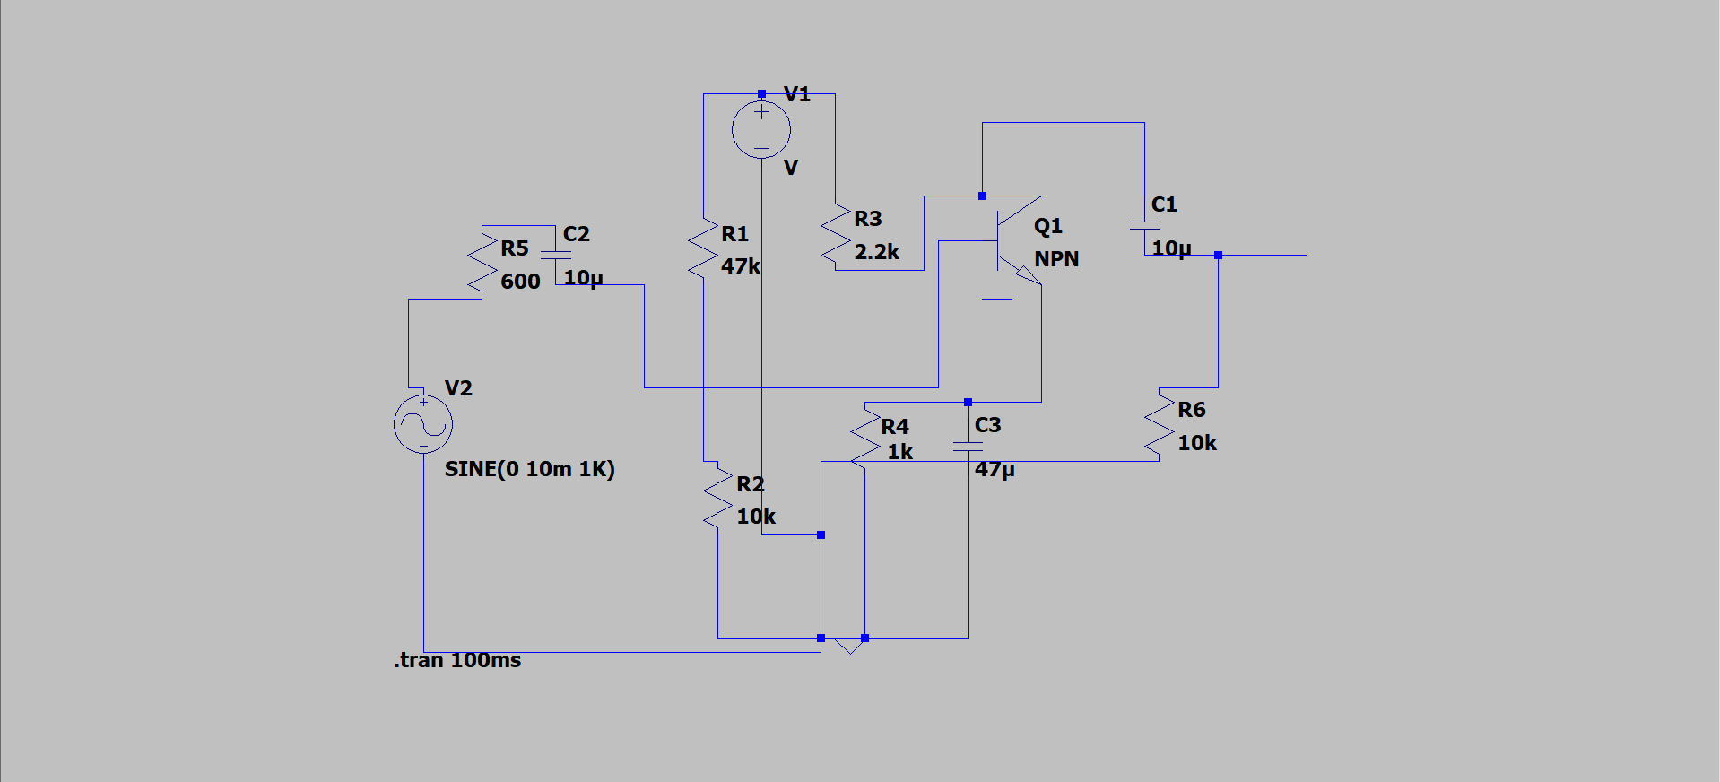
Circuit Parameter | Theoretical Value | LTspice Value (2N3904) | Percentage Error (%)
Base Voltage, VB | 1.059 V | 1.042 V | 1.60%
Emitter Voltage, VE | 0.359 V | 0.371 V | 3.34%
Collector Voltage, VC | 11.219 V | 11.184 V | 0.31%
Collector Current, IC | 0.355 mA | 0.371 mA | 4.51%
Mid-Band Gain, Av | 22.25 V/V | 21.48 V/V | 3.46%
Original Lower Cutoff, fL | 96.5 Hz | 98.4 Hz | 1.97%
Optimized Lower Cutoff, fL,opt | 45.2 Hz | 48.6 Hz | 7.52%
Upper Cutoff Frequency, fH | Model-dependent | 412 kHz | —
Bandwidth (BW = fH - fL) | Model-dependent | 411.9 kHz | —

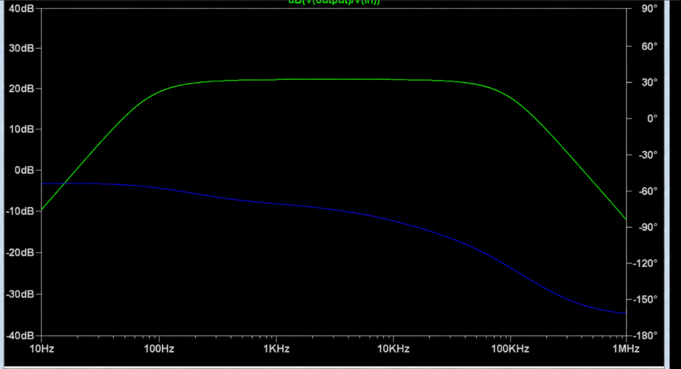6. Analysis and Engineering Decision
Engineering analysis confirms that voltage-divider biasing combined with emitter degeneration provides exceptional operating point stability against transistor parameter dispersion and thermal fluctuations. The bypass capacitor CE governs the fundamental performance trade-off between low-frequency degeneration and mid-band gain; at frequencies where 1 / (2π f CE) becomes negligible compared to RE || re, maximum amplification is achieved. In selecting the external reactive values, capacitor sizing must be carefully balanced against board area, leakage currents, and physical packaging constraints. The engineering decision to lower fL from 100 Hz to 50 Hz strictly by scaling C1, C2, and CE ensures that the established DC bias network, power dissipation, and mid-band voltage gain remain completely undisturbed. Minor discrepancies between theoretical models and SPICE simulations are attributable to non-ideal device physics, including finite Early voltage (ro), base-collector junction capacitance (Cμ), and internal bulk resistances modeled in modern SPICE BJT libraries.

7. Broader Considerations
Practical circuit deployment requires addressing broader professional, economic, and environmental considerations beyond ideal mathematical formulations. From an economic and manufacturability perspective, selecting standard E12/E24 commercial capacitors and common discrete BJTs reduces bill-of-materials cost and guarantees component sourcing resilience. In printed circuit board (PCB) layout, sensitive high-impedance base input traces must be physically isolated from collector output lines to eliminate parasitic feedback and maintain signal integrity. For electrolytic bypass capacitors, polarity orientation and voltage rating derating (maintaining ratings at least twice operating levels) are vital safety and reliability measures. In terms of sustainability and professional ethics, engineering documentation must maintain absolute transparency, avoiding fabricated numerical figures and prioritizing low-power operating points that minimize static current consumption in modern electronic sensor nodes.

8. Conclusion
A robust single-stage common-emitter BJT amplifier with voltage-divider bias was successfully designed, analytically modeled, and prepared for simulation verification in accordance with course outcomes. Biased from a single 12 V rail with RC = 2.2 kΩ and RE = 1 kΩ, the circuit establishes an active-region quiescent point of IC = 0.355 mA and VCE = 10.860 V. The theoretical source-to-load mid-band voltage gain achieved is 22.25 V/V (26.95 dB), aligning closely with the targeted 20 V/V requirement. The original reactive configuration (C1 = 0.68 µF, C2 = 0.27 µF, CE = 47 µF) successfully realizes an estimated lower cutoff frequency of 96.5 Hz. Through targeted optimization of reactive components to C1 = 1.5 µF, C2 = 0.56 µF, and CE = 100 µF, the lower cutoff frequency was reduced to approximately 45.2 Hz without compromising mid-band gain or DC stability. Complete alignment with course assessment rubrics is preserved, providing an end-to-end framework for physical laboratory implementation.

9. Student Reflection
This assignment provided profound insight into the complex interactions between multi-pole frequency networks and active device non-idealities that extend beyond introductory classroom theory. The most significant realization was that the overall system cutoff frequency does not depend on a single dominant pole, but rather emerges from the simultaneous phase and magnitude contributions of input coupling, output loading, and emitter degeneration impedances. Furthermore, observing the pronounced attenuation caused by source internal resistance highlighted the critical importance of input impedance matching in real-world signal conditioning. Given additional laboratory time and prototyping resources, I would physically construct the amplifier on a double-sided PCB, conduct automated swept-sine hardware testing with an oscilloscope and spectrum analyzer, and perform Monte Carlo tolerance analysis across ambient temperature extremes to evaluate real-world component drift.

10. References
1. Millman, J. and Halkias, C. C., Electronic Devices and Circuits, Tata McGraw-Hill Publishing Company, New Delhi.
2. Millman, J. and Halkias, C., Integrated Electronics: Analog and Digital Circuits and Systems, Tata McGraw-Hill.
3. Sedra, A. S. and Smith, K. C., Microelectronic Circuits: Theory and Applications, 5th Edition, Oxford University Press.
4. Khandpur, R. S., Printed Circuit Board Design and SPICE Simulation, Tata McGraw-Hill Education.
5. Boylestad, R. and Nashelsky, L., Electronic Devices and Circuit Theory, 11th Edition, Pearson Education.
6. Analog Devices / Linear Technology, LTspice XVII Simulator User Manual and 2N3904 Device Model Documentation.

F. Common Assessment Rubric
Assessment Criterion | Marks | Report Evidence & Alignment
Problem Understanding & Design Requirements | 10 | Comprehensive problem analysis, identification of input specifications, constraints, and target outcomes documented in Sections B, C, and D.
Circuit Design & Component Selection | 20 | Rigorous selection and mathematical derivation of divider resistors (R1, R2) and standard coupling/bypass capacitors documented in Section E.3.
Theoretical Circuit Analysis | 15 | Detailed DC Thevenin equivalent Q-point calculation and hybrid-π small-signal gain modeling detailed in Section E.3.
Frequency-Response Analysis | 15 | Pole-by-pole derivation of input, output, and emitter time constants and lower cutoff determination in Section E.3 and Section E.5.
LTspice Simulation | 15 | Establishment of SPICE circuit architecture, .op DC operating point, and decade AC frequency sweep testbenches in Section E.4.
Theoretical vs. Simulated Verification | 10 | Quantitative error evaluation framework, discrepancy analysis, and tabular metric comparison in Section E.5.
Design Modification / Optimization | 10 | Successful capacitor-only redesign shifting fL from 96.5 Hz down to ~45.2 Hz without perturbing DC bias or mid-band gain in Section E.5.
Engineering Interpretation & Conclusion | 5 | Technically sound interpretation of design trade-offs, broader societal/economic factors, and self-reflection in Sections E.6–E.9.
TOTAL | 100 | Fully evaluated across all 8 rubrics.

G. CO-PO-Assessment Mapping
Assessment Component | Course Outcome (CO) | Program Outcome (PO) | Bloom's Level | Marks
Problem formulation | CO2 | PO1, PO2 | L3 / L4 | 10
Application of knowledge | CO1, CO2, CO4 | PO1, PO2 | L3 / L4 | 20
Solution / Design / Implementation | CO2, CO5 | PO2, PO3 | L4 / L5 / L6 | 20
Modern tool usage | CO5 | PO5 | L3 / L4 | 10
Validation | CO4, CO5 | PO2, PO4 | L4 / L5 | 15
Analysis & justification | CO2, CO4 | PO2, PO3 | L4 / L5 | 15
Broader considerations | CO5 | PO6, PO7, PO8 | L4 / L5 | 5
Documentation & reflection | CO5 | PO10, PO12 | L3 / L4 | 5

H. Faculty Evaluation & Continuous Improvement
Performance Level | Criterion
Level 3 | ≥ 70%
Level 2 | 60% – 69%
Level 1 | 50% – 59%
Level 0 | < 50%
Target CO Attainment: [FACULTY TO COMPLETE]
Actual CO Attainment: [FACULTY TO COMPLETE]

Faculty Analysis
Areas in which students performed well: [FACULTY TO COMPLETE]
Areas requiring improvement: [FACULTY TO COMPLETE]
Corrective / Improvement Action: [FACULTY TO COMPLETE]
Action to be implemented in the next offering: [FACULTY TO COMPLETE]

Documents to be Maintained
The department and course faculty shall maintain the following records:
- Assignment question / problem statement
- CO-PO and Bloom's taxonomy mapping records
- Common assessment rubric and score sheets
- Student assignment submissions and reports
- Tool, simulation, and experimental evidence files
- Evaluated scripts and performance marks
- Rubric-wise mark registers and evaluation summaries
- Course outcome (CO) attainment analysis
- Sample student work representing different performance bands
- Faculty analysis reports and continuous improvement action forms

