Ex.No:1 Learn to use commands like tcpdump, netstat, ifconfig, nslookup and traceroute.Capture ping and traceroute PDUs using a network protocol analyzer and examine

AIM: To Learn to use commands like tcpdump, netstat, ifconfig, nslookup and traceroute

Tcpdump:
The tcpdump utility allows you to capture packets that flow within your network to assist in network troubleshooting. The following are several examples of using tcpdump with different options. Traffic is captured based on a specified filter.

Netstat
Netstat is a common command line TCP/IP networking available in most versions of Windows, Linux, UNIX and other operating systems.
Netstat provides information and statistics about protocols in use and current TCP/IP network connections.

ipconfig
ipconfig is a console application designed to run from the Windows command prompt. This utility allows you to get the IP address information of a Windows computer.
From the command prompt, type ipconfig to run the utility with default options. The output of the default command contains the IP address, network mask, and gateway for all physical and virtual
network adapter.

nslookup
The nslookup (which stands for name server lookup) command is a network utility program used to obtain information about internet servers. It finds name server information for domains by querying the Domain Name System.

Trace route:
Traceroute is a network diagnostic tool used to track the pathway taken by a packet on an IP network from source to destination. Traceroute also records the time taken for each hop the packet makes during its route to the destination

Display traffic between 2 hosts

To display all traffic between two hosts (represented by variables host1 and host2):# tcpdump host host1 and host2

Display traffic from a source or destination host only
To display traffic from only a source (src) or destination (dst) host: # tcpdump src host
# tcpdump dst host
- Display traffic for a specific protocol

Provide the protocol as an argument to display only traffic for a specific protocol, for example tcp, udp, icmp, arp:

# tcpdump protocol

For example to display traffic only for the tcp traffic :

# tcpdump tcp

- Filtering based on source or destination port
To filter based on a source or destination port: # tcpdump src port ftp
# tcpdump dst port http

2. Netstat
Netstat is a common command line TCP/IP networking available in most versions of Windows, Linux, UNIX and other operating systems. Netstat provides information and statistics about protocols in use and current TCP/IP network connections. The Windows help screen (analogous to a Linux or UNIX for netstat reads as follows:
Displays protocol statistics and current TCP/IP network connections. NETSTAT -a -b -e -n -o -p proto -r -s -v interval
 | -a | Displays all connections and listening ports.
 | -b | Displays the executable involved in creating each connection or listening port. In some cases well-known executables host multiple independent components, and in these cases the sequence of components involved in creating the connection or listening port is displayed. In this case the executable name is in [] at the bottom, on top is the component it called, and so forth until TCP/IP was reached. Note that this option can be time- consuming and will fail unless you have sufficient permissions.
 | -e | Displays Ethernet statistics. This may be combined with the -s option.
 | -n | Displays addresses and port numbers in numerical form.
 | -o | Displays the owning process ID associated with each connection.
 | -p proto | Shows connections for the protocol specified by proto; proto may be any of: TCP, UDP, TCPv6, or UDPv6. If used with the -s option to display per-protocol statistics, proto may be any of: IP, IPv6, ICMP, ICMPv6, TCP, TCPv6, UDP, or UDPv6.
 | -r | Displays the routing table.
 | -s | Displays per-protocol statistics. By default, statistics are shown for IP, IPv6, ICMP, ICMPv6, TCP, TCPv6, UDP, and UDPv6; the -p option may be used to specify a subset of the default.
 | -v | When used in conjunction with -b, will display sequence of components involved in creating the connection or listening port for all executables.

interval | Redisplays selected statistics, pausing interval seconds between each display. Press CTRL+C to stop redisplaying statistics. If omitted, netstat will print the current configuration information once.
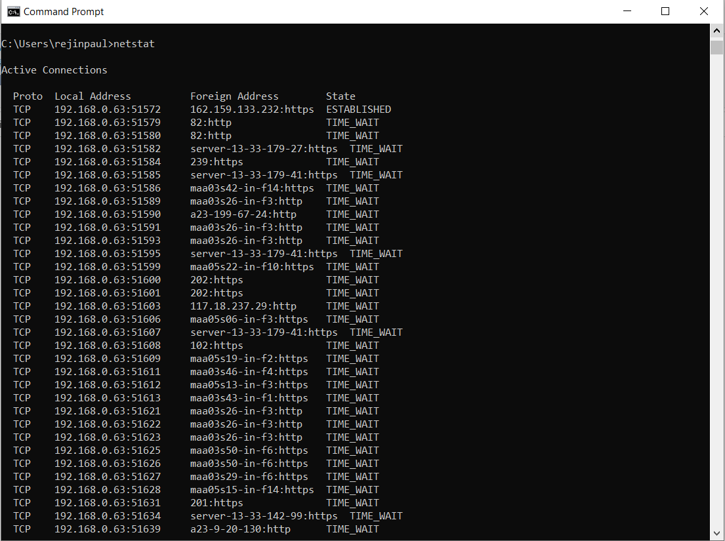

Syntax

netstat [-a] [-e] [-n] [-o] [-p Protocol] [-r] [-s] [Interval]

Parameters

Used without displays active TCP connections. parameters
-a Displays all active TCP connections and the TCP and UDP ports on which thecomputer is listening.
-e Displays Ethernet statistics, such as the number of bytes and packets sent and
received. This parameter can be combined with -s.
-n Displays active TCP connections, however, addresses and port numbers are expressed numerically and no attempt is made to determine names.
Displays active TCP connections and includes the process ID (PID) for each
-o connection. You can find the application based on the PID on the Processes tab in Windows Task Manager. This parameter can be combined with -a, -n,
and -p.
Shows connections for the protocol specified by Protocol. In this case, the
-p Protocol can be tcp, udp, tcpv6, or udpv6. If this parameter is used with -s to display statistics by protocol, Protocol can be tcp, udp, icmp, ip, tcpv6, udpv6,
icmpv6, or ipv6.
Displays statistics by protocol. By default, statistics are shown for the TCP,
-s UDP, ICMP, and IP protocols. If the IPv6 protocol for Windows XP is installed,statistics are shown for the TCP over IPv6, UDP over IPv6,
ICMPv6, and IPv6
protocols. The -p parameter can be used to specify a set of protocols.
-r Displays the contents of the IP routing table. This is equivalent to the route print command.
Redisplays the selected information every Interval seconds. Press CTRL+C toInterval stop the redisplay. If this parameter is omitted, netstat prints the selected
information only once.
/? - Displays help at the command prompt.

Ifconfig

In Windows, ipconfig is a console application designed to run from the Windows command prompt. This utility allows you to get the IP address information of a Windows computer. It also allows some control over active TCP/IP connections. Ipconfig replaced the older winipcfg utility.

Using ipconfig

From the command prompt, type ipconfig to run the utility with default options. The outputof the default command contains the IP address, network mask, and gateway for all physical and virtual network adapter

Syntax

ipconfig [/all] [/renew [Adapter]] [/release [Adapter]] [/flushdns] [/displaydns] [/registerdns] [/showclassid Adapter] [/setclassid Adapter [ClassID]]

Parameters
Used without parameters | Displays the IP address, subnet mask, and default gateway for all adapters.
/all | Displays the full TCP/IP configuration for all adapters. Without this parameter, ipconfig displays only the IP address, subnet mask, and default gateway values for each adapter. Adapters can represent physical interfaces, such as installed network adapters, or logical interfaces, such as dial-up  connections.
/renew [Adapter] | Renews DHCP configuration for all adapters (if an adapter is not specified) or for a specific adapter if the Adapter parameter is included. This parameter is available only on computers with adapters that are configured to obtain an IP address automatically. To specify an adapter name, type the adapter name that appears when you use ipconfig without parameters.
/release [Adapter] | Sends a DHCPRELEASE message to the DHCP server to release the current DHCP configuration and discard the IP address configuration for either all adapters (if an adapter is not specified) or for a specific adapter if the Adapter parameter is included. This parameter disables TCP/IP for adapters configured to obtain an IP address automatically. To specify an adapter name, type the adapter name that appears when you use ipconfig without parameters.
/flushdns | Flushes and resets the contents of the DNS client resolver cache. During DNS troubleshooting, you can use this procedure to discard negative cache entries from the cache, as well as any other entries that have been added dynamically.
/displaydns | Displays the contents of the DNS client resolver cache, which includes both entries preloaded from the local Hosts file and any recently obtained resource records for name queries resolved by the computer. The DNS Client service uses this information to resolve frequently queried names quickly, before querying its configured DNS servers.
/registerdns | Initiates manual dynamic registration for the DNS names and IP addresses that are configured at a computer. You can use this parameter to troubleshoot a failed DNS name registration or resolve a dynamic update problem between a client and the DNS server without rebooting the client computer. The DNS settings in the advanced properties of the TCP/IP protocol determine which names are registered in DNS.
/showclassid | Adapter Displays the DHCP class ID for a specified adapter. To see the DHCP class ID for all adapters, use the asterisk (*) wildcard character in place of Adapter. This parameter is available only on computers with adapters thatare configured to obtain an IP address automatically.
/setclassid | Adapter [ClassID] Configures the DHCP class ID for a specified adapter. To set the DHCP class ID for all adapters, use the asterisk (*) wildcard character in place of Adapter. This parameter is available only on computers with adapters that are configured to obtain an IP address automatically. If a DHCP class ID is not specified, the current class ID is removed.

Examples:

Ipconfig | To display the basic TCP/IP configuration for all adapters
ipconfig /all | To display the full TCP/IP configuration for all adapters
ipconfig /renew "Local Area Connection" | To renew a DHCP-assigned IP address configuration for onlythe Local Area Connection adapter
ipconfig /flushdns | To flush the DNS resolver cache when troubleshooting DNS name resolution problems
ipconfig /showclassid Local | To display the DHCP class ID for all adapters with names that start with Local
ipconfig /setclassid "Local Area Connection" TEST | To set the DHCP class ID for the Local Area Connection adapter to TEST

- Nslookup

The nslookup (which stands for name server lookup) command is a network utility program used to obtain information about internet servers. It finds name server information for domains by querying the Domain Name System.

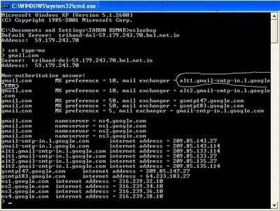

traceroute

Traceroute is a network diagnostic tool used to track the pathway taken by a packet on an IP network from source to destination. Traceroute also records the time taken for each hop the packet makes during its route to the destination.

Traceroute uses Internet Control Message Protocol (ICMP) echo packets with variable time to live (TTL) values. The response time of each hop is calculated. To guarantee accuracy, each hop is queried multiple times (usually three times) to better measure the response of that particular hop.

tracert www.google.com
With the tracert command shown above, we're asking tracert to show us the path from the local computer all the way to the network device with the hostname www.google.com.

Tracing route to www.l.google.com [209.85.225.104] over a maximum of 30 hops:
1 <1 ms <1 ms <1 ms 10.1.0.1
2 35 ms 19 ms 29 ms 98.245.140.1
3 11 ms 27 ms 9 ms te-0-3.dnv.comcast.net [68.85.105.201]
...
13 81 ms 76 ms 75 ms 209.85.241.37
14 84 ms 91 ms 87 ms 209.85.248.102
15 76 ms 112 ms 76 ms iy-f104.1e100.net [209.85.225.104]
Trace complete.

tracert -j 10.12.0.1 10.29.3.1 10.1.44.1 www.google.com
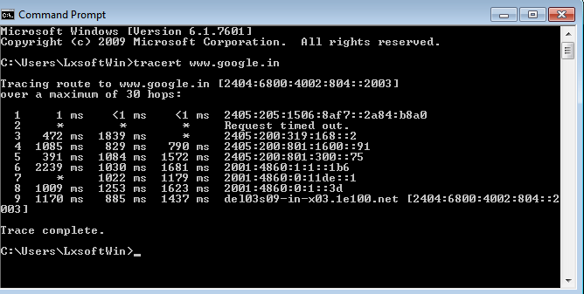

RESULT:
Thus the various networks commands like tcpdump, netstat, ifconfig, nslookup and tracerouteping are executed successfully.

Ex.No: 2 Write a HTTP web client program to download a web page using TCP sockets Aim:
To write a java program for socket for HTTP for web page upload and download .

Algorithm:

- Start the program.
- Get the frame size from the user
- To create the frame based on the user request. 4.To send frames to server from the client side.
- If your frames reach the server it will send ACK signal to client otherwise it will send NACK signal to client.
- Stop the program

Program :

import java.io.*; import java.net.*;
public class SocketHTTPClient
{
public static void main(String[] args)
{
String hostName = "www.sunnetwork.in"; int portNumber = 80;
try
{
Socket socket = new Socket(hostName, portNumber);
PrintWriter out = new PrintWriter(socket.getOutputStream(), true); BufferedReader in =new BufferedReader(new InputStreamReader(socket.getInputStream()));
out.println("GET / HTTP/1.1\nHost: www.sunnetwork.in\n\n"); String inputLine;
while ((inputLine = in.readLine()) != null)
{
System.out.println(inputLine);
}
}
catch (UnknownHostException e)
{
System.err.println("Don't know about host " + hostName); System.exit(1);
}
catch (IOException e)
{
System.err.println("Couldn't get I/O for the connection to " + hostName); System.exit(1);
}
}
}

Output:

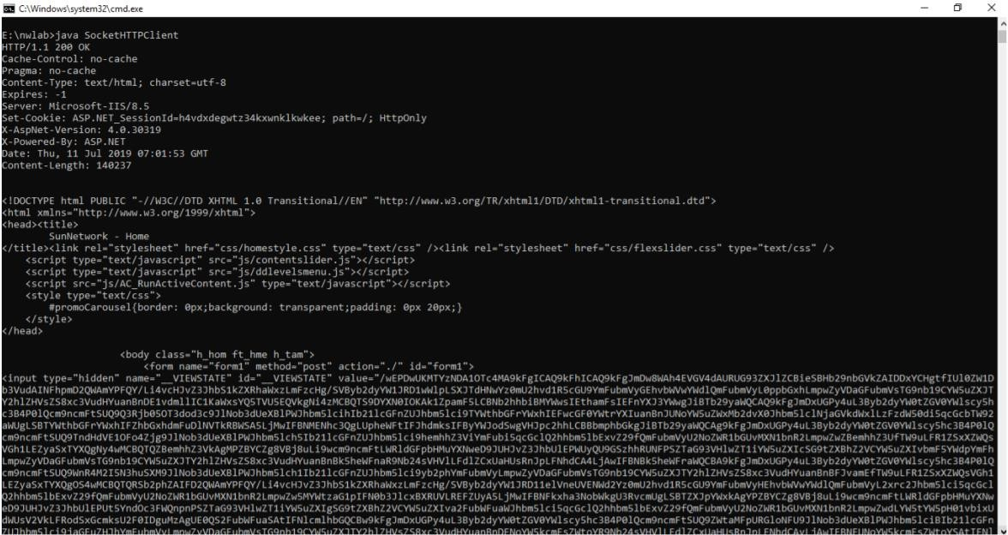

Result:
Thus the program for creating sockets for HTTP web page to download was implemented.

Ex.No 3(A) Applications using TCP sockets like Echo client and Echo server Aim
To write a java program for applications using TCP sockets like Echo client and Echo server

Client

- Start
- Create the TCP socket
- Establish connection with the server
- Get the message to be echoed from the user 5.Send the message to the server
6.Receive the message echoed by the server 7.Display the message received from the server 8.Terminate the connection
9.Stop

Server

- Start
- Create TCP socket, make it a listening socket
- Accept the connection request sent by the client for connection establishment 4.Receive the message sent by the client
- Display the received message
- Send the received message to the client from which it receives
- Close the connection when client initiates termination and server becomes a listening server, waiting for clients.
- Stop.

Program: EchoServer.Java:

import java.io.*; import java.net.*;
public class EchoServer
{
public EchoServer(int portnum)
{
try
{
server = new ServerSocket(portnum);
}
catch (Exception err)
{
System.out.println(err);
}
}
public void serve()
{
try
{
while (true)
{
Socket client = server.accept(); BufferedReader r = new BufferedReader(new

InputStreamReader(client.getInputStream()));
PrintWriter w = new PrintWriter(client.getOutputStream(), true); w.println("Welcome to the Java EchoServer. Type 'bye' to close."); String line;
do
{
line = r.readLine(); if ( line != null )
w.println("Got: "+ line); System.out.println (line);
}
while ( !line.trim().equals("bye") ); client.close();
}
}
catch (Exception err)
{
System.err.println(err);
}
}
public static void main(String[] args)
{
EchoServer s = new EchoServer(9999); s.serve();
}
private ServerSocket server;
}

EchoClient.java :

import java.io.*; import java.net.*; public class EchoClient
{
public static void main(String[] args)
{
try
{
Socket s = new Socket("127.0.0.1", 9999); BufferedReader r = new BufferedReader(new
InputStreamReader(s.getInputStream()));
PrintWriter w = new PrintWriter(s.getOutputStream(), true);
BufferedReader con = new BufferedReader(new InputStreamReader(System.in)); String line;
do
{
line = r.readLine(); if ( line != null )
System.out.println(line); line = con.readLine(); w.println(line);
}
while ( !line.trim().equals("bye") );
}
catch (Exception err)
{
System.err.println(err);
}
}
}

Output:

Server
C:\Program Files\Java\jdk1.5.0\bin>javac Server.java C:\Program Files\Java\jdk1.5.0\bin>java Server C:\Program Files\Java\jdk1.5.0\bin>
Client
C:\Program Files\Java\jdk1.5.0\bin>javac EClient.java C:\Program Files\Java\jdk1.5.0\bin>java EClient Client: Hai Server
Server:Hai Server Client: Hello Server:Hello Client:end Server:end Client:ds
Socket Closed!

Result:

Thus, the java program to concurrently communicate using TCP Sockets was executed Successfully

EX.NO 3(B) Implement a Chat Applications using TCP sockets

AIM:
To implement a CHAT application using TCP Socket.
Algorithm Client 1.Start
- Create the TCP socket
- Get the request message to be sent from the user 4.Send the request message to the server
5.Wait for the reply message from the server 6.Receive the reply message sent by the server 7.Display the reply message received from the server 8.Stop

Server

- Start
- Create TCP server socket, make it a listening socket 3.Receive the request message sent by the client
4.Retrieve the client’s IP address from the request message received 5.Display the received message
6.Get the reply message from the user 7.Send the reply message to the client 8.Stop.

Program:

Chatserver.java:
import java.net.*; import java.io.*;

public class chatserver
{
public static void main(String args[]) throws Exception
{
ServerSocket ss=new ServerSocket(2000); Socket sk=ss.accept();
BufferedReader cin=new BufferedReader(new InputStreamReader(sk.getInputStream()));
PrintStream cout=new PrintStream(sk.getOutputStream());
BufferedReader stdin=new BufferedReader(new InputStreamReader(System.in)); String s;
while ( true )
{
s=cin.readLine();
if (s.equalsIgnoreCase("END"))
{
cout.println("BYE"); break;
}
System. out.print("Client : "+s+"\n"); System.out.print("Server : "); s=stdin.readLine();
cout.println(s);
}
ss.close();
sk.close();
cin.close();
cout.close(); stdin.close();
}
}

Chatclient.java

import java.net.*; import java.io.*; public class chatclient
{
public static void main(String args[]) throws Exception
{
Socket sk=new Socket("127.0.0.1",2000); BufferedReader sin=new BufferedReader(new InputStreamReader(sk.getInputStream()));
PrintStream sout=new PrintStream(sk.getOutputStream());
BufferedReader stdin=new BufferedReader(new InputStreamReader(System.in)); String s;
while ( true )
{
System.out.print("Client : "); s=stdin.readLine(); sout.println(s); s=sin.readLine();
System.out.print("Server : "+s+"\n"); if ( s.equalsIgnoreCase("BYE") ) break;
}
sk.close();
sin.close();
sout.close(); stdin.close();
}
}

OUTPUT:

Server:

E:\nwlab>javac *.java E:\nwlab>java chatserver Client : hi
Server : hi

Client:

E:\nwlab>java chatclient Client : hi
Server : hi Client :

Result:

CHAT application using TCP Socket is implemented successfully

EX.NO 3(C) Implement a File Transfer using TCP sockets

AIM:
To write a java program for file transfer using TCP Sockets.

Algorithm Server
1.Import java packages and create class file server. 2.Create a new server socket and bind it to the port. 3.Accept the client connection
4. Get the file name and stored into the BufferedReader. 5.Create a new object class file and realine.
- If file is exists then FileReader read the content until EOF is reached.
- Stop the program.

Client

1. Import java packages and create class file server. 2.Create a new server socket and bind it to the port. 3.Now connection is established.
- The object of a BufferReader class is used for storing data content which has been retrieved from socket object.
- The connection is closed.
- Stop the program.

Program File Server :

import java.io.BufferedInputStream; import java.io.File;
import java.io.FileInputStream; import java.io.OutputStream; import java.net.InetAddress; import java.net.ServerSocket; import java.net.Socket;
public class FileServer
{
public static void main(String[] args) throws Exception
{
ServerSocket ssock = new ServerSocket(5000); Socket socket = ssock.accept();
InetAddress IA = InetAddress.getByName("localhost"); File file = new File("e:\\Bookmarks.html"); FileInputStream fis = new FileInputStream(file); BufferedInputStream bis = new BufferedInputStream(fis); OutputStream os = socket.getOutputStream();
byte[] contents;
long fileLength = file.length(); long current = 0;
long start = System.nanoTime(); while(current!=fileLength){
int size = 10000;
if(fileLength - current >= size) current += size;
else{
size = (int)(fileLength - current); current = fileLength;
}
contents = new byte[size]; bis.read(contents, 0, size); os.write(contents);
System.out.print("Sending file ... "+(current*100)/fileLength+"% complete!");
}
os.flush(); socket.close(); ssock.close();
System.out.println("File sent succesfully!");
}
}

File Client

import java.io.BufferedOutputStream; import java.io.FileOutputStream; import java.io.InputStream;
import java.net.InetAddress; import java.net.Socket; public class FileClient {
public static void main(String[] args) throws Exception{
Socket socket = new Socket(InetAddress.getByName("localhost"), 5000); byte[] contents = new byte[10000];
FileOutputStream fos = new FileOutputStream("e:\\Bookmarks1.html"); BufferedOutputStream bos = new BufferedOutputStream(fos); InputStream is = socket.getInputStream();
int bytesRead = 0; while((bytesRead=is.read(contents))!=-1) bos.write(contents, 0, bytesRead); bos.flush();
socket.close();
System.out.println("File saved successfully!");
}
}

Output:

server

E:\nwlab>java FileServer Sending file ... 9% complete! Sending file ... 19% complete! Sending file ... 28% complete! Sending file ... 38% complete! Sending file ... 47% complete! Sending file ... 57% complete! Sending file ... 66% complete! Sending file ... 76% complete! Sending file ... 86% complete! Sending file ... 95% complete! Sending file ... 100% complete! File sent successfully!

client:

E:\nwlab>java FileClient File saved successfully!

RESULT:

Thus the java program file transfer application using TCP Sockets was executed

EX.NO 4. Simulation of DNS using UDP sockets. Aim :
Write java program Simulation of DNS using UDP Sockets

Algorithm:

- Start the program.
- Get the frame size from the user
- To create the frame based on the user request. 4.To send frames to server from the client side.
- If your frames reach the server it will send ACK signal to client otherwise it will send NACK signal to client.
- Stop the program

Program:

UDP DNS Server

import java.io.*; import java.net.*; public class dnsserver
{
private static int indexOf(String[] array, String str)
{
str = str.trim();
for (int i=0; i < array.length; i++)
{
if (array[i].equals(str)) return i;
}
return -1;
}
public static void main(String arg[])throws IOException
{
String[] hosts = {"zoho.com", "gmail.com","google.com", "facebook.com"}; String[] ip = {"172.28.251.59", "172.217.11.5","172.217.11.14","31.13.71.36"};
System.out.println("Press Ctrl + C to Quit"); while (true)
{
DatagramSocket serversocket=new DatagramSocket(1362); byte[] senddata = new byte[1021];
byte[] receivedata = new byte[1021];
DatagramPacket recvpack = new DatagramPacket(receivedata,receivedata.length); serversocket.receive(recvpack);
String sen = new String(recvpack.getData()); InetAddress ipaddress = recvpack.getAddress(); int port = recvpack.getPort();
String capsent;
System.out.println("Request for host " + sen); if(indexOf (hosts, sen) != -1)
capsent = ip[indexOf (hosts, sen)]; else
capsent = "Host Not Found"; senddata = capsent.getBytes(); DatagramPacket pack = new DatagramPacket (senddata, senddata.length,ipaddress,port);
serversocket.send(pack); serversocket.close();
}
}
}

UDP DNS Client:

import java.io.*; import java.net.*; public class dnsclient
{
public static void main(String args[])throws IOException
{
BufferedReader br = new BufferedReader(new InputStreamReader(System.in));
DatagramSocket clientsocket = new DatagramSocket(); InetAddress ipaddress;
if (args.length == 0)
ipaddress = InetAddress.getLocalHost(); else
ipaddress = InetAddress.getByName(args[0]); byte[] senddata = new byte[1024];
byte[] receivedata = new byte[1024]; int portaddr = 1362;
System.out.print("Enter the hostname : "); String sentence = br.readLine();
senddata = sentence.getBytes();
DatagramPacket pack = new DatagramPacket(senddata,senddata.length,ipaddress,portaddr); clientsocket.send(pack);
DatagramPacket recvpack =new DatagramPacket(receivedata,receivedata.length); clientsocket.receive(recvpack);
String modified = new String(recvpack.getData()); System.out.println("IP Address: " + modified); clientsocket.close();
}
}

OUTPUT

Server

E:\nwlab>java dnsserver Press Ctrl + C to Quit Request for host google.com Request for host flipkart.com

Client

E:\nwlab>java dnsclient
Enter the hostname : google.com IP Address: 172.217.11.14
E:\nwlab>java dnsclient
Enter the hostname : flipkart.com IP Address: Host Not Found E:\nwlab>

Result:

Thus the DNS application program was executed successfully

EX.NO 5(A) Program for Address Resolution Protocol (ARP) using TCP Aim:
To write a java program for simulating ARP protocols using TCP

Client

- Start the program
- Create socket and establish connection with the server.
- Get the IP address to be converted into MAC address from the user. 4.Send this IP address to server.
5.Receive the MAC address for the IP address from the server. 6.Display the received MAC address
7.Terminate the connection

Server

- Start the program
- Create the socket, bind the socket created with IP address and port number and make it a listening socket.
- Accept the connection request when it is requested by the client.
- Server maintains the table in which IP and corresponding MAC addresses are stored. 5.Receive the IP address sent by the client.
- Retrieve the corresponding MAC address for the IP address and send it to the client.
- Close the connection with the client and now the server becomes a listening server waiting for the connection request from other clients
- Stop

Program Client:

import java.io.*; import java.net.*; import java.util.*; class Clientarp
{
public static void main(String args[])
{
try
{
BufferedReader in=new BufferedReader(new InputStreamReader(System.in)); Socket clsct=new Socket("127.0.0.1",5604);
DataInputStream din=new DataInputStream(clsct.getInputStream()); DataOutputStream dout=new DataOutputStream(clsct.getOutputStream()); System.out.println("Enter the Logical address(IP):");
String str1=in.readLine(); dout.writeBytes(str1+'\n'); String str=din.readLine();
System.out.println("The Physical Address is: "+str); clsct.close();
}
catch (Exception e)
{
System.out.println(e);
}
}
}

Server:

import java.io.*; import java.net.*; import java.util.*;
class Serverarp
{
public static void main(String args[])
{
try
{
ServerSocket obj=new ServerSocket(5604); Socket obj1=obj.accept(); while(true)
{
DataInputStream din=new DataInputStream(obj1.getInputStream()); DataOutputStream dout=new DataOutputStream(obj1.getOutputStream()); String str=din.readLine();
String ip[]={"165.165.80.80","165.165.79.1"};
String mac[]={"6A:08:AA:C2","8A:BC:E3:FA"};
for(int i=0;i<ip.length;i++)
{
if(str.equals(ip[i]))
{
dout.writeBytes(mac[i]+'\n'); break;
}
}
obj.close();
}
}
catch(Exception e)
{
System.out.println(e);
}
}
}

Output:

E:\networks>java Serverarp E:\networks>java Clientarp Enter the Logical address(IP):
165.165.80.80
The Physical Address is: 6A:08:AA:C2

Result:

Thus, the ARP protocol using TCP Sockets program was executed.

EX.NO 5(B) Program for Reverse Address Resolution Protocol (RARP) using TCP

Aim:
To write a java program for simulating RARP protocols using UDP

ALGORITHM:

Client

1.Start the program 2.Create datagram socket
3.Get the MAC address to be converted into IP address from the user. 4.Send this MAC address to server using UDP datagram.
5.Receive the datagram from the server and display the corresponding IP address. 6.Stop

Server

- Start the program.
- Server maintains the table in which IP and corresponding MAC addresses are stored. 3.Create the datagram socket
4.Receive the datagram sent by the client and read the MAC address sent. 5.Retrieve the IP address for the received MAC address from the table.
6.Display the corresponding IP address. 7.Stop

Program Client:

import java.io.*; import java.net.*; import java.util.*; class Clientrarp
{
public static void main(String args[])
{
try
{
DatagramSocket client=new DatagramSocket(); InetAddress addr=InetAddress.getByName("127.0.0.1"); byte[] sendbyte=new byte[1024];
byte[] receivebyte=new byte[1024];
BufferedReader in=new BufferedReader(new InputStreamReader(System.in)); System.out.println("Enter the Physical address (MAC):");
String str=in.readLine(); sendbyte=str.getBytes();
DatagramPacket sender=new DatagramPacket(sendbyte,sendbyte.length,addr,1309); client.send(sender);
DatagramPacket receiver=new DatagramPacket(receivebyte,receivebyte.length); client.receive(receiver);
String s=new String(receiver.getData()); System.out.println("The Logical Address is(IP): "+s.trim()); client.close();
}
catch(Exception e)
{
System.out.println(e);
}
}
}

Server:

import java.io.*; import java.net.*; import java.util.*; class Serverrarp
{
public static void main(String args[])
{
try
{
DatagramSocket server=new DatagramSocket(1309); while(true)
{
byte[] sendbyte=new byte[1024]; byte[] receivebyte=new byte[1024];
DatagramPacket receiver=new DatagramPacket(receivebyte,receivebyte.length); server.receive(receiver);
String str=new String(receiver.getData()); String s=str.trim();
InetAddress addr=receiver.getAddress(); int port=receiver.getPort();
String ip[]={"165.165.80.80","165.165.79.1"};
String mac[]={"6A:08:AA:C2","8A:BC:E3:FA"};
for(int i=0;i<ip.length;i++)
{
if(s.equals(mac[i]))
{
sendbyte=ip[i].getBytes();
DatagramPacket sender=new DatagramPacket(sendbyte,sendbyte.length,addr,port); server.send(sender);
break;
}
}
break;
}
}
catch(Exception e)
{
System.out.println(e);
}
}
}

Output:

I:\ex>java Serverrarp12

I:\ex>java Clientrarp12

Enter the Physical address (MAC): 6A:08:AA:C2

The Logical Address is(IP): 165.165.80.80

Result :

Thus, the RARP program using UDP was executed

Ex. No 6 Study of Network simulator (NS)

AIM:

To study about NS2 simulator in detail.

THEORY:

Network Simulator (Version 2), widely known as NS2, is simply an event driven simulation tool that has proved useful in studying the dynamic nature of communication networks.
Simulation of wired as well as wireless network functions and protocols (e.g., routing algorithms, TCP, UDP) can be done using NS2. In general, NS2 provides users with a way of specifying such network protocols and simulating their corresponding behaviors. Due to its flexibility and modular nature, NS2 has gained constant popularity in the networking research community since its birth in 1989.

Basic Architecture of NS2:
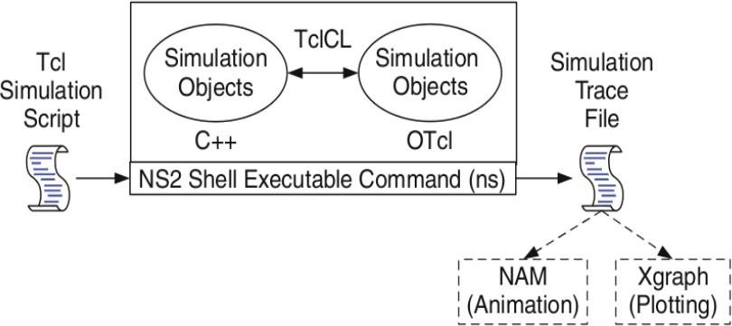

The above figure shows the basic architecture of NS2. NS2 provides users with an executable command ns which takes on input argument, the name of a Tcl simulation scripting file. Users are feeding the name
of a Tcl simulation script (which sets up a simulation) as an input argument of an NS2 executable command ns. In most cases, a simulation trace file is created, and is used to plot graph and/or to create animation.
NS2 consists of two key languages: C++ and Object-oriented Tool Command Language (OTcl). While the C++ defines the internal mechanism (i.e., a backend) of the simulation objects, the OTcl sets up simulation by assembling and configuring the objects as well as scheduling discrete events (i.e., a frontend).

The C++ and the OTcl are linked together using TclCL. Mapped to a C++ object, variables in the OTcl domains are sometimes referred to as handles. Conceptually, a handle (e.g., n as a Node handle) is just a string
in the OTcl domain, and does not contain any functionality. instead, the functionality (e.g., receiving a packet) is defined in the mapped C++ object (e.g., of class Connector). In the OTcl domain, a handle acts as a frontend which interacts with users and other OTcl objects. It may defines its own procedures and variables to facilitate the interaction. Note that the member procedures and variables in the OTcl domain are called instance procedures (instprocs) and instance variables (instvars), respectively

Tcl scripting:

- Tcl is a general purpose scripting language. [Interpreter]

- Tcl runs on most of the platforms such as Unix, Windows, and Mac.

- The strength of Tcl is its simplicity.

- It is not necessary to declare a data type for variable prior to the usage

Basics of TCL

Syntax: command arg1 arg2 arg3 Hello World!
puts stdout{Hello, World!} Hello, World!

Variables

Command Substitution
set a 5 set len [string length foobar]
set b $a set len [expr [string length foobar] + 9]

Simple Arithmetic expr 7.2 / 4 Procedures
proc Diag {a b} {
set c [expr sqrt($a * $a + $b * $b)] return $c }
puts ―Diagonal of a 3, 4 right triangle is [Diag 3 4]‖ Output: Diagonal of a 3, 4 right triangle is 5.0

Loops

while{$i < $n} {
. . .
} for {set i 0} {$i < $n} {incr i}
{
. . .
}

NS Simulator Preliminaries.

1.Initialization and termination aspects of the ns simulator. 2.Definition of network nodes, links, queues and topology. 3.Definition of agents and of applications.
4.The nam visualization tool. 5.Tracing and random variables.

Initialization and Termination of TCL Script in NS-2

An ns simulation starts with the command

set ns [new Simulator]

Which is thus the first line in the tcl script? This line declares a new variable as using the set command, you can call this variable as you wish, In general people declares it as ns because it is an instance of the Simulator class, so an object the code[new Simulator] is indeed the installation of the class Simulator using the reserved word new.

In order to have output files with data on the simulation (trace files) or files used for visualization (nam files), we need to create the files using ―”open” command:

#Open the Trace file

set tracefile1 [open out.tr w]

$ns trace-all $tracefile1 #Open the NAM trace file set namfile [open out.nam w]

$ns namtrace-all $namfile

The above creates a dta trace file called ―out.tr‖ and a nam visualization trace file called
―out.nam‖.Within the tcl script,these files are not called explicitly by their names, but instead by pointers that are declared above and called ―tracefile1 and ―nam file respectively. Remark that they begins with a # symbol.The second line open the file ―out.tr‖ to be used for writing, declared with the letter ―w‖.
The third line uses a simulator method called trace-all that have as parameter the name of the file where the traces will go. The last line tells the simulator to record all simulation traces in NAM input format. It also gives the file name that the trace will be written to later by the command $ns flush-trace. In our case, this will be the file pointed at by the pointer ―$namfile ,i.e the file ―out.tr.

The termination of the program is done using a ―finish‖ procedure.

#Define a ‘finish’ procedure Proc finish { } {
global ns tracefile1 namfile
$ns flush-trace Close $tracefile1 Close $namfile Exec nam out.nam & Exit 0

The word proc declares a procedure in this case called finish and without arguments. The word global is used to tell that we are using variables declared outside the procedure. The simulator method ―flush-trace” will dump the traces on the respective files. The tcl command ―close” closes the trace files defined before and exec executes the nam program for visualization.

The command exit will ends the application and return the number 0 as status to the system.
Zero is the default for a clean exit. Other values can be used to say that is a exit because something fails.
At the end of ns program we should call the procedure ―finish‖ and specify at what time the termination should occur.

For example,
$ns at 125.0 “finish”

will be used to call ―finish‖ at time 125sec.Indeed,the at method of the simulator allows us to schedule events explicitly.

The simulation can then begin using the command

$ns run

Definition of a network of links and nodes
The way to define a node is

set n0 [$ns node]

The node is created which is printed by the variable n0. When we shall refer to that node in the script we shall thus write $n0.
Once we define several nodes, we can define the links that connect them. An example of a definition of a link is:

$ns duplex-link $n0 $n2 10Mb 10ms DropTail

Which means that $n0 and $n2 are connected using a bi-directional link that has 10ms of propagation delay and a capacity of 10Mb per sec for each direction. To define a directional link instead of a bi-directional one, we should replace “duplexlink” by “simplex- link”.

In NS, an output queue of a node is implemented as a part of each link whose input is that node. The definition of the link then includes the way to handle overflow at that queue. In our case, if the buffer capacity of the output queue is exceeded then the last packet to arrive is dropped. Many alternative options exist, such as the RED (Random Early Discard) mechanism, the FQ (Fair Queuing), the DRR (Deficit Round Robin), the stochastic Fair Queuing (SFQ) and the CBQ (which including a priority and a round-robin scheduler).

In ns, an output queue of a node is implemented as a part of each link whose input is that node. We should also define the buffer capacity of the queue related to each link. An example would be:

#set Queue Size of link (n0-n2) to 20
$ns queue-limit $n0 $n2 20 Agents and Applications
We need to define routing (sources, destinations) the agents (protocols) the application that use them

FTP over TCP

TCP is a dynamic reliable congestion control protocol. It uses Acknowledgements created by the destination to know whether packets are well received.
There are number variants of the TCP protocol, such as Tahoe, Reno, NewReno, Vegas. The type of agent appears in the first line:

set tcp [new Agent/TCP]

The command $ns attach-agent $n0 $tcp defines the source node of the tcp connection.
The command

set sink [new Agent /TCPSink]

Defines the behavior of the destination node of TCP and assigns to it a pointer called sink

#Setup a UDP connection set udp [new Agent/UDP]
$ns attach-agent $n1 $udp set null [new Agent/Null]
$ns attach-agent $n5 $null
$ns connect $udp $null
$udp set fid_2

#setup a CBR over UDP connection

set cbr [new Application/Traffic/CBR]
$cbr attach-agent $udp
$cbr set packetsize_ 100
$cbr set rate_ 0.01Mb
$cbr set random_ false

Above shows the definition of a CBR application using a UDP agent. The command $ns attach-agent $n4 $sink defines the destination node. The command $ns connect $tcp $sink finally makes the TCP connection between the source and destination nodes.
TCP has many parameters with initial fixed defaults values that can be changed if mentioned explicitly. For example, the default TCP packet size has a size of 1000bytes.This can be changed to another value, say 552bytes, using the command $tcp set packetSize_ 552. When we have several flows, we may wish to distinguish them so that we can identify them with different colors in the visualization part. This is done by the command $tcp set fid_ 1 that assigns to the TCP connection a flow identification of “1”.We shall later give the flow identification of “2” to the UDP connection.

CBR over UDP

A UDP source and destination is defined in a similar way as in the case of TCP. Instead of defining the rate in the command $cbr set rate_ 0.01Mb, one can define the time interval between transmission of packets using the command.

$cbr set interval_ 0.005 The packet size can be set to some value using
$cbr set packetSize_ <packet size> Scheduling Events
NS is a discrete event based simulation. The tcp script defines when event should occur.
The initializing command set ns [new Simulator] creates an event scheduler, and events are then scheduled using the format:

$ns at <time> <event>

The scheduler is started when running ns that is through the command $ns run. The beginning and end of the FTP and CBR application can be done through the following command

$ns at 0.1 “$cbr start”
$ns at 1.0 “ $ftp start”
$ns at 124.0 “$ftp stop”
$ns at 124.5 “$cbr stop”

RESULT:

Thus, the Network Simulator 2 is studied in detail.

Ex.No: 7 Study of TCP/UDP performance using Simulation tool. AIM:
To simulate the performance of TCP/UDP using NS2.

TCP Performance Algorithm:

- Create a Simulator object.
- Set routing as dynamic.
- Open the trace and nam trace files. 4.Define the finish procedure.
5.Create nodes and the links between them. 6.Create the agents and attach them to the nodes.
7.Create the applications and attach them to the tcp agent. 8.Connect tcp and tcp sink.
9.Run the simulation.

UDP Performance Algorithm:

- Create a Simulator object.
- Set routing as dynamic.
- Open the trace and nam trace files. 4.Define the finish procedure.
5.Create nodes and the links between them. 6.Create the agents and attach them to the nodes.
7.Create the applications and attach them to the UDP agent. 8.Connect udp and null agents.
9.Run the simulation.

PROGRAM:

TCP Performance:

set ns [new Simulator]
$ns color 0 Blue
$ns color 1 Red
$ns color 2 Yellow set n0 [$ns node] set n1 [$ns node] set n2 [$ns node] set n3 [$ns node] set f [open tcpout.tr w]
$ns trace-all $f
set nf [open tcpout.nam w]
$ns namtrace-all $nf
$ns duplex-link $n0 $n2 5Mb 2ms DropTail
$ns duplex-link $n1 $n2 5Mb 2ms DropTail
$ns duplex-link $n2 $n3 1.5Mb 10ms DropTail
$ns duplex-link-op $n0 $n2 orient right-up
$ns duplex-link-op $n1 $n2 orient right-down
$ns duplex-link-op $n2 $n3 orient right
$ns duplex-link-op $n2 $n3 queuePos 0.5 set tcp [new Agent/TCP]
$tcp set class_ 1
set sink [new Agent/TCPSink]
$ns attach-agent $n1 $tcp
$ns attach-agent $n3 $sink
$ns connect $tcp $sink
set ftp [new Application/FTP]
$ftp attach-agent $tcp
$ns at 1.2 "$ftp start"
$ns at 1.35 "$ns detach-agent $n1 $tcp ; $ns detach-agent $n3 $sink"
$ns at 3.0 "finish" proc finish {}
{
global ns f nf
$ns flush-trace close $f close $nf
puts "Running nam.."
exec xgraph tcpout.tr -geometry 600x800 & exec nam tcpout.nam & exit 0
}
$ns run

UDP Performance Program

set ns [new Simulator]
$ns color 0 Blue
$ns color 1 Red
$ns color 2 Yellow set n0 [$ns node] set n1 [$ns node] set n2 [$ns node] set n3 [$ns node] set f [open udpout.tr w]
$ns trace-all $f
set nf [open udpout.nam w]
$ns namtrace-all $nf
$ns duplex-link $n0 $n2 5Mb 2ms DropTail
$ns duplex-link $n1 $n2 5Mb 2ms DropTail
$ns duplex-link $n2 $n3 1.5Mb 10ms DropTail
$ns duplex-link-op $n0 $n2 orient right-up
$ns duplex-link-op $n1 $n2 orient right-down
$ns duplex-link-op $n2 $n3 orient right
$ns duplex-link-op $n2 $n3 queuePos 0.5 set udp0 [new Agent/UDP]
$ns attach-agent $n0 $udp0
set cbr0 [new Application/Traffic/CBR]
$cbr0 attach-agent $udp0 set udp1 [new Agent/UDP]
$ns attach-agent $n3 $udp1
$udp1 set class_ 0
set cbr1 [new Application/Traffic/CBR]
$cbr1 attach-agent $udp1 set null0 [new Agent/Null]
$ns attach-agent $n1 $null0 set null1 [new Agent/Null]
$ns attach-agent $n1 $null1
$ns connect $udp0 $null0
$ns connect $udp1 $null1
$ns at 1.0 "$cbr0 start"
$ns at 1.1 "$cbr1 start"
puts [$cbr0 set packetSize_] puts [$cbr0 set interval_]
$ns at 3.0 "finish" proc finish {} { global ns f nf
$ns flush-trace close $f close $nf
puts "Running nam.." exec nam udpout.nam & exit 0
}
$ns run

Output
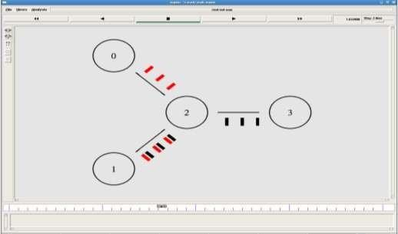

RESULT :
Thus the study of TCP/UDP performance is done successfully.

Ex.No: 8 Simulation of Distance Vector/ Link State Routing algorithm. AIM:
To simulate the Distance vector and link state routing protocols using NS2.

ALGORITHM:

- Create a Simulator object.
- Set routing as dynamic.
- Open the trace and nam trace files. 4.Define the finish procedure.
5.Create nodes and the links between them. 6.Create the agents and attach them to the nodes.
7.Create the applications and attach them to the udp agent. 8.Connect udp and null..
9.At 1 sec the link between node 1 and 2 is broken. 10.At 2 sec the link is up again.
11.Run the simulation.

LINK STATE ROUTING PROTOCOL PROGRAM
set ns [new Simulator]
$ns rtproto LS
set nf [open linkstate.nam w]
$ns namtrace-all $nf
set f0 [open linkstate.tr w]
$ns trace-all $f0 proc finish {} { global ns f0 nf
$ns flush-trace close $f0 close $nf
exec nam linkstate.nam & exit 0
}
for {set i 0} {$i <7} {incr i} { set n($i) [$ns node]
}
for {set i 0} {$i <7} {incr i} {
$ns duplex-link $n($i) $n([expr ($i+1)%7]) 1Mb 10ms DropTail
}
set udp0 [new Agent/UDP]
$ns attach-agent $n(0) $udp0
set cbr0 [new Application/Traffic/CBR]
$cbr0 set packetSize_ 500
$cbr0 set interval_ 0.005
$cbr0 attach-agent $udp0 set null0 [new Agent/Null]
$ns attach-agent $n(3) $null0
$ns connect $udp0 $null0
$ns at 0.5 "$cbr0 start"
$ns rtmodel-at 1.0 down $n(1) $n(2)
$ns rtmodel-at 2.0 up $n(1) $n(2)
$ns at 4.5 "$cbr0 stop"
$ns at 5.0 "finish"
$ns run

DISTANCE VECTOR ROUTING ALGORITHM ALGORITHM:
- Create a simulator object
- Set routing protocol to Distance Vector routing
- Trace packets on all links onto NAM trace and text trace file 4.Define finish procedure to close files, flush tracing and run NAM 5.Create eight nodes
6.Specify the link characteristics between nodes 7.Describe their layout topology as a octagon 8.Add UDP agent for node n1
9.Create CBR traffic on top of UDP and set traffic parameters. 10.Add a sink agent to node n4
- Connect source and the sink
- Observe the traffic route when link is up and down 13.View the simulated events and trace file analyze it 14.Stop

Program

set ns [new Simulator]
$ns rtproto DV
set nf [open out.nam w]
$ns namtrace-all $nf set nt [open trace.tr w]
$ns trace-all $nt proc finish {}
{
global ns nf
$ns flush-trace close $nf
exec nam -a out.nam & exit 0
}
set n1 [$ns node] set n2 [$ns node] set n3 [$ns node] set n4 [$ns node] set n5 [$ns node] set n6 [$ns node] set n7 [$ns node]
set n8 [$ns node]
$ns duplex-link $n1 $n2 1Mb 10ms DropTail
$ns duplex-link $n2 $n3 1Mb 10ms DropTail
$ns duplex-link $n3 $n4 1Mb 10ms DropTail
$ns duplex-link $n4 $n5 1Mb 10ms DropTail
$ns duplex-link $n5 $n6 1Mb 10ms DropTail
$ns duplex-link $n6 $n7 1Mb 10ms DropTail
$ns duplex-link $n7 $n8 1Mb 10ms DropTail
$ns duplex-link $n8 $n1 1Mb 10ms DropTail
$ns duplex-link-op $n1 $n2 orient left-up
$ns duplex-link-op $n2 $n3 orient up
$ns duplex-link-op $n3 $n4 orient right-up
$ns duplex-link-op $n4 $n5 orient right
$ns duplex-link-op $n5 $n6 orient right-down
$ns duplex-link-op $n6 $n7 orient down
$ns duplex-link-op $n7 $n8 orient left-down
$ns duplex-link-op $n8 $n1 orient left set udp0 [new Agent/UDP]
$ns attach-agent $n1 $udp0
set cbr0 [new Application/Traffic/CBR]
$cbr0 set packetSize_ 500
$cbr0 set interval_ 0.005
$cbr0 attach-agent $udp0 set null0 [new Agent/Null]
$ns attach-agent $n4 $null0
$ns connect $udp0 $null0
$ns at 0.0 "$n1 label Source"
$ns at 0.0 "$n4 label Destination"
$ns at 0.5 "$cbr0 start"
$ns rtmodel-at 1.0 down $n3 $n4
$ns rtmodel-at 2.0 up $n3 $n4
$ns at 4.5 "$cbr0 stop"
$ns at 5.0 "finish"
$ns run

Output :

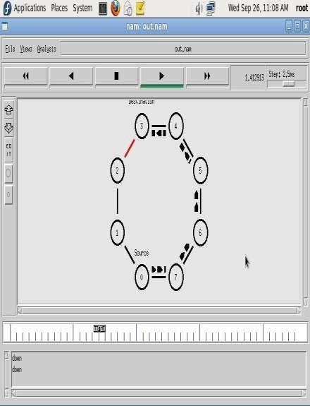

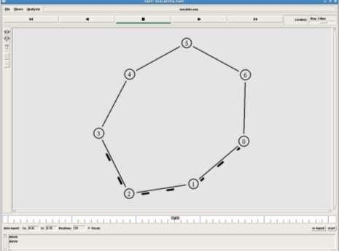

RESULT:

Thus the simulation for Distance vector and link state routing protocols was done using NS2.

Ex.No:9(A) Performance Evaluation of Unicast Routing protocols using Simulation tool. AIM:
To write a ns2 program for implementing unicasting routing protocol.

ALGORITHM:

- Start the program.
- Declare the global variables ns for creating a new simulator. 3.Set the color for packets.
4.Open the network animator file in the name of file2 in the write mode. 5.Open the trace file in the name of file 1 in the write mode.
6.Set the unicast routing protocol to transfer the packets in network. 7.Create the required no of nodes.
8.Create the duplex-link between the nodes including the delay time,bandwidth and dropping queue mechanism. 9.Give the position for the links between the nodes.
10.Set a tcp reno connection for source node. 11.Set the destination node using tcp sink.
- Setup a ftp connection over the tcp connection.
- Down the connection between any nodes at a particular time. 14.Reconnect the downed connection at a particular time.
- Define the finish procedure.
- In the definition of the finish procedure declare the global variables ns, file1, and file2. 17.Close the trace file and name file and execute the network animation file.
18.At the particular time call the finish procedure. 19.Stop the program.

PROGRAM:

set ns [new Simulator]
#Define different colors for data flows (for NAM)
$ns color 1 Blue
$ns color 2 Red #Open the Trace file set file1 [open out.tr w]
$ns trace-all $file1
#Open the NAM trace file set file2 [open out.nam w]
$ns namtrace-all $file2 #Define a 'finish' procedure proc finish {}
{
global ns file1 file2
$ns flush-trace close $file1 close $file2 exec nam out.nam &
exit 3
}
# Next line should be commented out to have the static routing
$ns rtproto DV #Create six nodes set n0 [$ns node] set n1 [$ns node]
set n2 [$ns node] set n4 [$ns node] set n4 [$ns node] set n5 [$ns node]

#Create links between the nodes
$ns duplex-link $n0 $n1 0.3Mb 10ms DropTail
$ns duplex-link $n1 $n2 0.3Mb 10ms DropTail
$ns duplex-link $n2 $n3 0.3Mb 10ms DropTail
$ns duplex-link $n1 $n4 0.3Mb 10ms DropTail
$ns duplex-link $n3 $n5 0.5Mb 10ms DropTail
$ns duplex-link $n4 $n5 0.5Mb 10ms DropTail

#Give node position (for NAM)
$ns duplex-link-op $n0 $n1 orient right
$ns duplex-link-op $n1 $n2 orient right
$ns duplex-link-op $n2 $n3 orient up
$ns duplex-link-op $n1 $n4 orient up-left
$ns duplex-link-op $n3 $n5 orient left-up
$ns duplex-link-op $n4 $n5 orient right-up

#Setup a TCP connection
set tcp [new Agent/TCP/Newreno]
$ns attach-agent $n0 $tcp
set sink [new Agent/TCPSink/DelAck]
$ns attach-agent $n5 $sink
$ns connect $tcp $sink
$tcp set fid_ 1

#Setup a FTP over TCP connection set ftp [new Application/FTP]
$ftp attach-agent $tcp
$ftp set type_ FTP

$ns rtmodel-at 1.0 down $n1 $n4
$ns rtmodel-at 4.5 up $n1 $n4
$ns at 0.1 "$ftp start"
$ns at 6.0 "finish"
$ns run

Output:

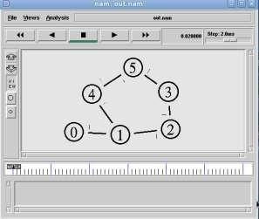
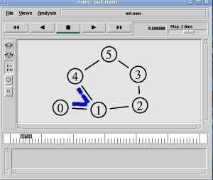

Result:

Thus, the Performance Evaluation of Unicast Routing protocols using Simulation tool have been evaluated

Ex.No:9(B) Performance Evaluation of Multicast Routing protocols using Simulation tool.

AIM:

To write a ns2 program for implementing multicasting routing protocol.

ALGORITHM:

- Start the program.
- Declare the global variables ns for creating a new simulator. 3.Set the color for packets.
4.Open the network animator file in the name of file2 in the write mode. 5.Open the trace file in the name of file 1 in the write mode.
6.Set the multicast routing protocol to transfer the packets in network. 7.Create the multicast capable no of nodes.
8.Create the duplex-link between the nodes including the delay time,bandwidth and dropping queue mechanism. 9.Give the position for the links between the nodes.
- Set a udp connection for source node.
- Set the destination node ,port and random false for the source and destination files. 12.Setup a traffic generator CBR for the source and destination files.
- Down the connection between any nodes at a particular time.
- Create the receive agent for joining and leaving if the nodes in the group. 15.Define the finish procedure.
16.In the definition of the finish procedure declare the global variables. 17.Close the trace file and namefile and execute the network animation file. 18.At the particular time call the finish procedure.
19.Stop the program.

Program:

# Create scheduler
#Create an event scheduler wit multicast turned on set ns [new Simulator -multicast on] #$ns multicast #Turn on Tracing
set tf [open output.tr w]
$ns trace-all $tf
# Turn on nam Tracing set fd [open mcast.nam w]
$ns namtrace-all $fd # Create nodes
set n0 [$ns node] set n1 [$ns node] set n2 [$ns node] set n3 [$ns node] set n4 [$ns node] set n5 [$ns node] set n6 [$ns node] set n7 [$ns node] # Create links
$ns duplex-link $n0 $n2 1.5Mb 10ms DropTail
$ns duplex-link $n1 $n2 1.5Mb 10ms DropTail
$ns duplex-link $n2 $n3 1.5Mb 10ms DropTail
$ns duplex-link $n3 $n4 1.5Mb 10ms DropTail
$ns duplex-link $n3 $n7 1.5Mb 10ms DropTail
$ns duplex-link $n4 $n5 1.5Mb 10ms DropTail
$ns duplex-link $n4 $n6 1.5Mb 10ms DropTail

# Routing protocol: say distance vector #Protocols: CtrMcast, DM, ST, BST set mproto DM
set mrthandle [$ns mrtproto $mproto {}]

# Allocate group addresses set group1 [Node allocaddr] set group2 [Node allocaddr]

# UDP Transport agent for the traffic source set udp0 [new Agent/UDP]
$ns attach-agent $n0 $udp0
$udp0 set dst_addr_ $group1
$udp0 set dst_port_ 0
set cbr1 [new Application/Traffic/CBR]
$cbr1 attach-agent $udp0

# Transport agent for the traffic source set udp1 [new Agent/UDP]
$ns attach-agent $n1 $udp1
$udp1 set dst_addr_ $group2
$udp1 set dst_port_ 0
set cbr2 [new Application/Traffic/CBR]
$cbr2 attach-agent $udp1

# Create receiver
set rcvr1 [new Agent/Null]
$ns attach-agent $n5 $rcvr1
$ns at 1.0 "$n5 join-group $rcvr1 $group1" set rcvr2 [new Agent/Null]
$ns attach-agent $n6 $rcvr2
$ns at 1.5 "$n6 join-group $rcvr2 $group1" set rcvr3 [new Agent/Null]
$ns attach-agent $n7 $rcvr3
$ns at 2.0 "$n7 join-group $rcvr3 $group1" set rcvr4 [new Agent/Null]
$ns attach-agent $n5 $rcvr1
$ns at 2.5 "$n5 join-group $rcvr4 $group2" set rcvr5 [new Agent/Null]
$ns attach-agent $n6 $rcvr2
$ns at 3.0 "$n6 join-group $rcvr5 $group2" set rcvr6 [new Agent/Null]
$ns attach-agent $n7 $rcvr3
$ns at 3.5 "$n7 join-group $rcvr6 $group2"
$ns at 4.0 "$n5 leave-group $rcvr1 $group1"
$ns at 4.5 "$n6 leave-group $rcvr2 $group1"
$ns at 5.0 "$n7 leave-group $rcvr3 $group1"
$ns at 5.5 "$n5 leave-group $rcvr4 $group2"
$ns at 6.0 "$n6 leave-group $rcvr5 $group2"
$ns at 6.5 "$n7 leave-group $rcvr6 $group2" # Schedule events
$ns at 0.5 "$cbr1 start"
$ns at 9.5 "$cbr1 stop"
$ns at 0.5 "$cbr2 start"
$ns at 9.5 "$cbr2 stop" #post-processing
$ns at 10.0 "finish" proc finish {}
{
global ns tf
$ns flush-trace close $tf
exec nam mcast.nam & exit 0
}
# For nam
#Colors for packets from two mcast groups
$ns color 10 red
$ns color 11 green
$ns color 30 purple
$ns color 31 green
# Manual layout: order of the link is significant! #$ns duplex-link-op $n0 $n1 orient right
#$ns duplex-link-op $n0 $n2 orient right-up #$ns duplex-link-op $n0 $n3 orient right-down # Show queue on simplex link n0->n1
#$ns duplex-link-op $n2 $n3 queuePos 0.5

# Group 0 source
$udp0 set fid_ 10
$n0 color red
$n0 label "Source 1"

# Group 1 source
$udp1 set fid_ 11
$n1 color green
$n1 label "Source 2"
$n5 label "Receiver 1"
$n5 color blue
$n6 label "Receiver 2"
$n6 color blue
$n7 label "Receiver 3"
$n7 color blue
#$n2 add-mark m0 red #$n2 delete-mark m0" # Animation rate
$ns set-animation-rate 3.0ms
$ns run

Output:

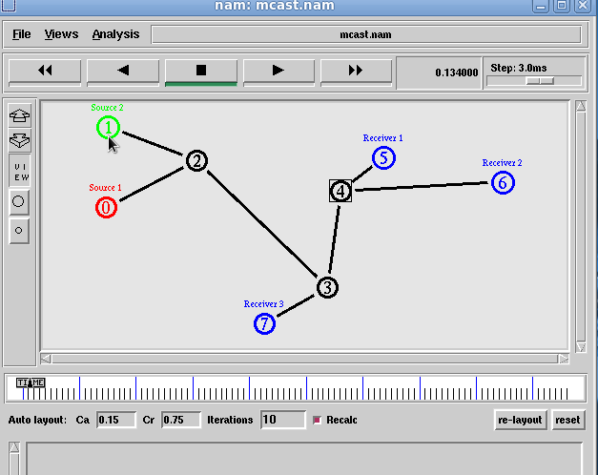

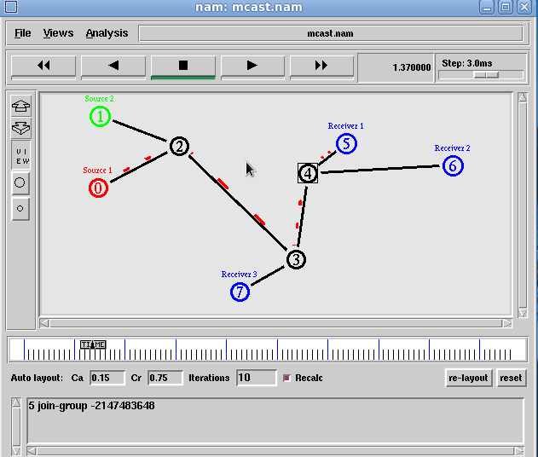

Result:

Thus the Performance Evaluation of Multicast Routing protocols using Simulation tool have been evaluated

Ex.No:10 Simulation of Error Detection Code (like CRC) AIM:
To implement error checking code using java.

ALGORITHM:

- Start the Program
- Given a bit string, append 0S to the end of it (the number of 0s is the same as the degree of the generator polynomial) let B(x) be the polynomial corresponding to B.
- Divide B(x) by some agreed on polynomial G(x) (generator polynomial) and determine the remainder R(x).
This division is to be done using Modulo 2 Division.
- Define T(x) = B(x) –R(x) 5.(T(x)/G(x) => remainder 0)
- Transmit T, the bit string corresponding to T(x).
- Let T’ represent the bit stream the receiver gets and T’(x) the associated polynomial. The receiver divides T1(x) by G(x). If there is a 0 remainder, the receiver concludes T = T’ and no error occurred otherwise, the receiver concludes an error occurred and requires a retransmission
- Stop the Program

PROGRAM:

import java.io.*; class crc_gen
{
public static void main(String args[]) throws IOException {
BufferedReader br=new BufferedReader(new InputStreamReader(System.in)); int[] data;
int[] div; int[] divisor; int[] rem;
int[] crc;
int data_bits, divisor_bits, tot_length; System.out.println("Enter number of data bits : "); data_bits=Integer.parseInt(br.readLine()); data=new int[data_bits]; System.out.println("Enter data bits : ");
for(int i=0; i<data_bits; i++) data[i]=Integer.parseInt(br.readLine()); System.out.println("Enter number of bits in divisor : "); divisor_bits=Integer.parseInt(br.readLine()); divisor=new int[divisor_bits]; System.out.println("Enter Divisor bits : ");
for(int i=0; i<divisor_bits; i++) divisor[i]=Integer.parseInt(br.readLine()); System.out.print("Data bits are : "); for(int i=0; i< data_bits; i++)
System.out.print(data[i]); System.out.println(); System.out.print("divisor bits are : "); for(int i=0; i< divisor_bits; i++) System.out.print(divisor[i]); System.out.println();
*/ tot_length=data_bits+divisor_bits-1; div=new int[tot_length];
rem=new int[tot_length]; crc=new int[tot_length];

/* CRC GENERATION */

for(int i=0;i<data.length;i++) div[i]=data[i];
System.out.print("Dividend (after appending 0's) are : "); for(int i=0; i< div.length; i++)
System.out.print(div[i]); System.out.println();
for(int j=0; j<div.length; j++)
{
rem[j] = div[j];
}
rem=divide(div, divisor, rem); for(int i=0;i<div.length;i++)
{
//append dividend and remainder crc[i]=(div[i]^rem[i]);
}
System.out.println(); System.out.println("CRC code : "); for(int i=0;i<crc.length;i++) System.out.print(crc[i]);

/* ERROR DETECTION */

System.out.println();
System.out.println("Enter CRC code of "+tot_length+" bits : "); for(int i=0; i<crc.length; i++) crc[i]=Integer.parseInt(br.readLine());
System.out.print("crc bits are : "); for(int i=0; i< crc.length; i++) System.out.print(crc[i]); System.out.println();
for(int j=0; j<crc.length; j++)
{
rem[j] = crc[j];
}
rem=divide(crc, divisor, rem); for(int i=0; i< rem.length; i++)
{
if(rem[i]!=0)
{
System.out.println("Error"); break;
}
if(i==rem.length-1)

System.out.println("No Error");
}
System.out.println("THANK YOU. )");
}
static int[] divide(int div[],int divisor[], int rem[])
{
int cur=0; while(true)
{
for(int i=0;i<divisor.length;i++) rem[cur+i]=(rem[cur+i]^divisor[i]); while(rem[cur]==0 && cur!=rem.length-1) cur++;
if((rem.length-cur)<divisor.length) break;
}
return rem;
}
}

OUTPUT :

Enter number of data bits :
7
Enter data bits :
1
0
1
1
0
0
1
Enter number of bits in divisor :
3
Enter Divisor bits :
1
0
1
Dividend (after appending 0's) are : 101100100 CRC code :
101100111

Enter CRC code of 9 bits : 1 0
1
1
0
0
1
0
1
crc bits are : 101100101 Error THANK YOU. )
BUILD SUCCESSFUL (total time: 1 minute 34 seconds)

RESULT:

Thus the above program for error checking code using was executed successfully.

