SQL Projects – MySQL Workbench Output Screenshots
Prepared for GitHub project documentation
Movies Database – MOVIES table output
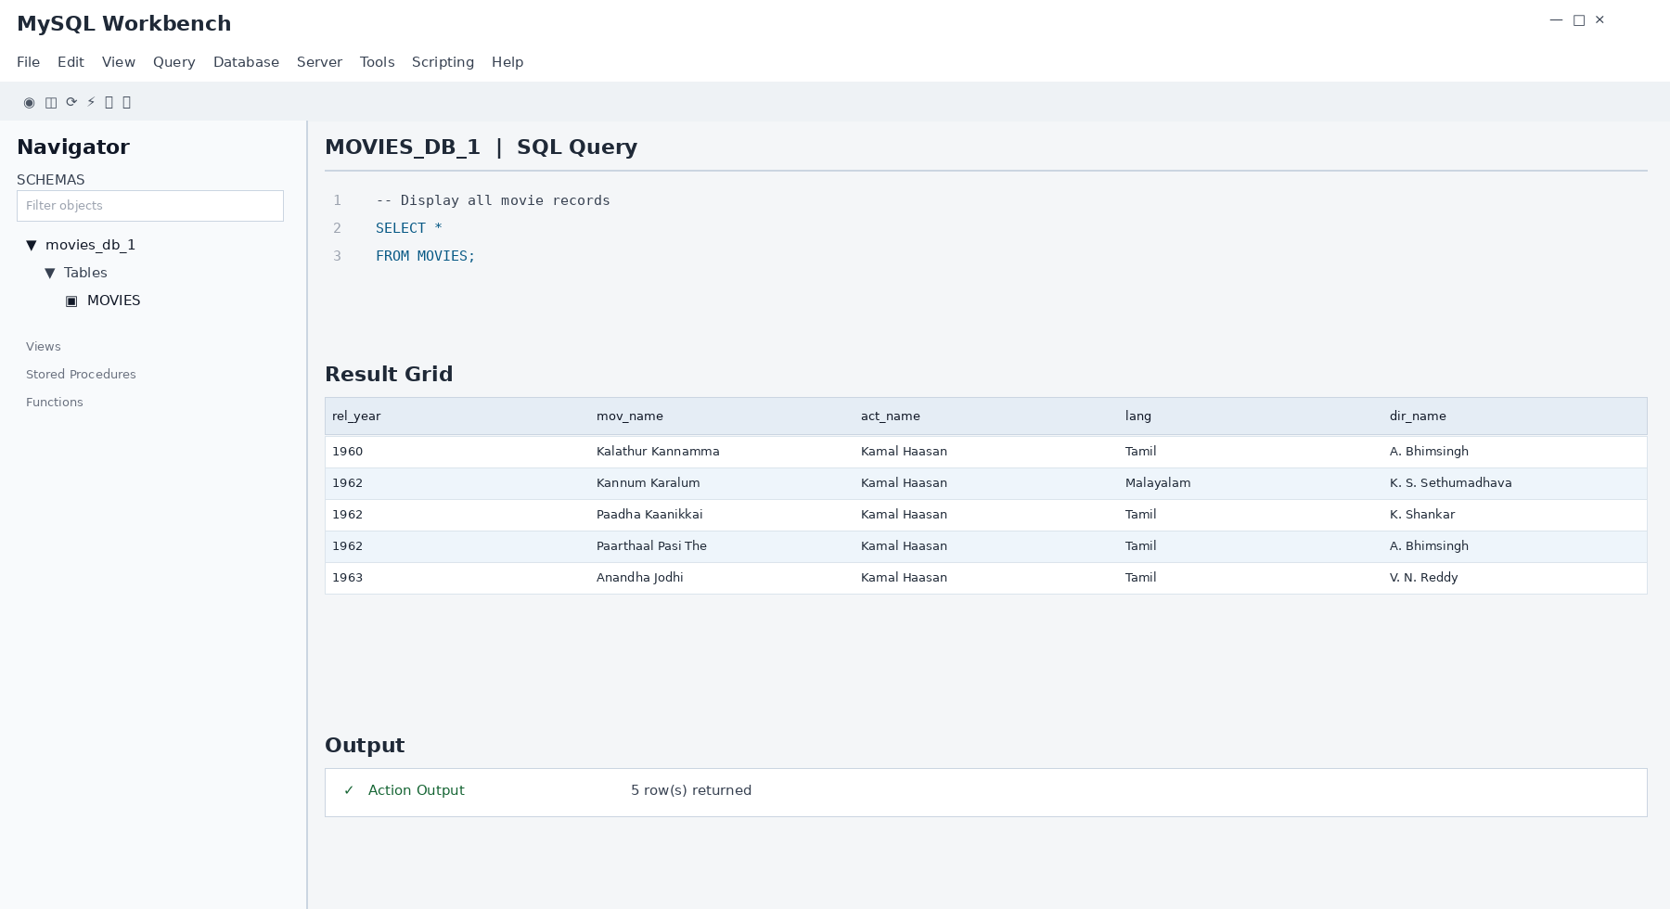

Employee Database – employee table output
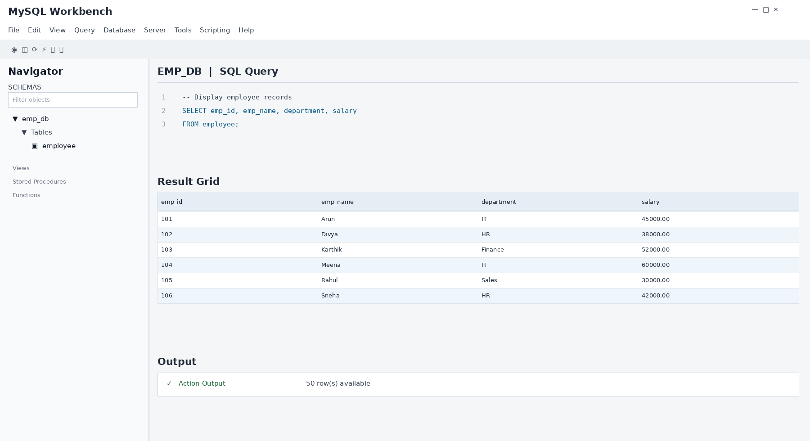

Student Career Database – StudentCareer table output
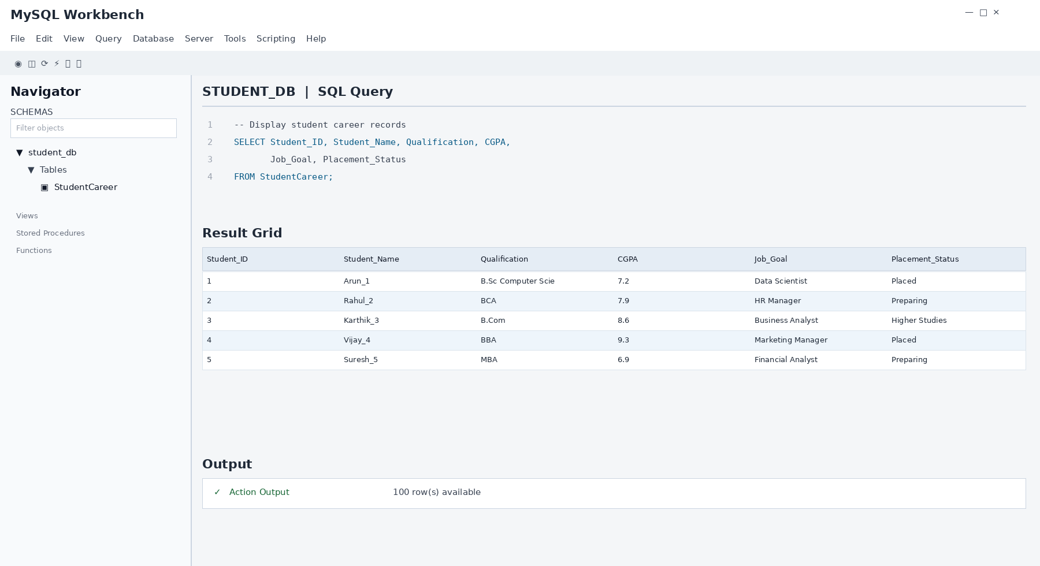

Hospital Database – PatientRecords table output
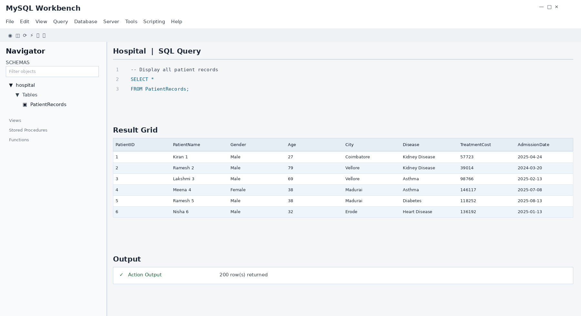

Swiggy Database – Customers table output
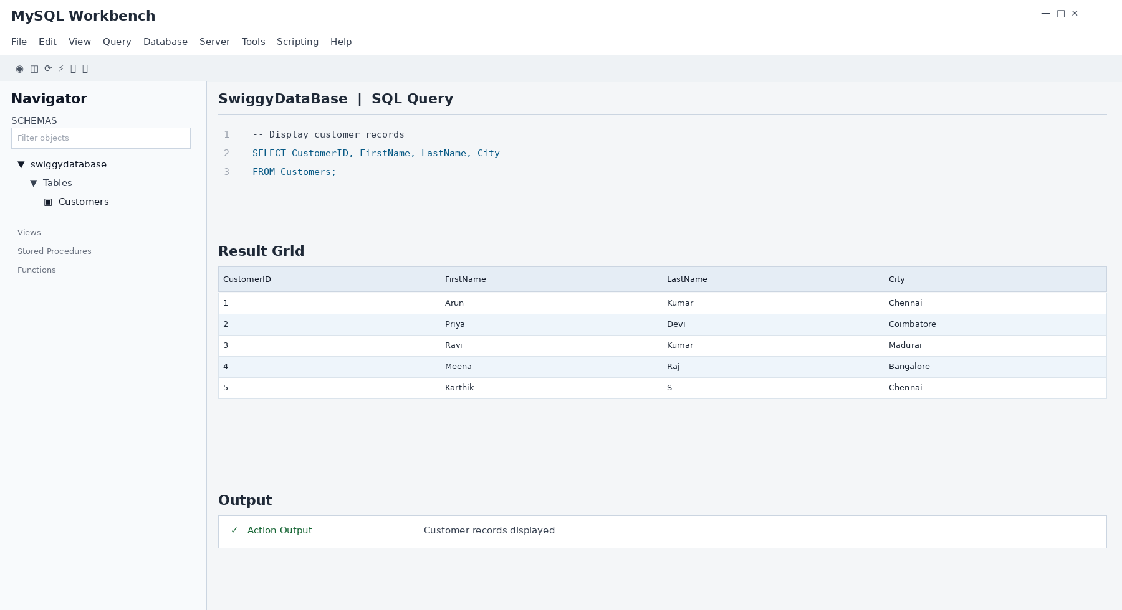

Normalized Movies Database – joined table output
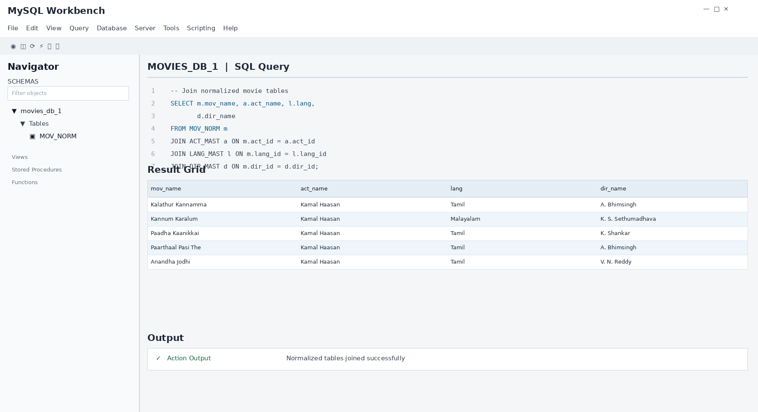

Banking Database – Accounts, procedure and function output
